Example Report

library(masemDataUnderstanding)  
library(ggplot2)

## Warning: package 'ggplot2' was built under R version 3.6.3

## R Markdown

This is an R Markdown document. Markdown is a simple formatting syntax for authoring HTML, PDF, and MS Word documents. For more details on using R Markdown see <http://rmarkdown.rstudio.com>.

When you click the **Knit** button a document will be generated that includes both content as well as the output of any embedded R code chunks within the document. You can embed an R code chunk like this:

Variables <- c("cyl", "gear", "vs")  
for (i in Variables) {  
 print(FeatureByTargetVariable(DataFrame = mtcars,   
 Feature = i,   
 TargetVariable = "am"))  
 }

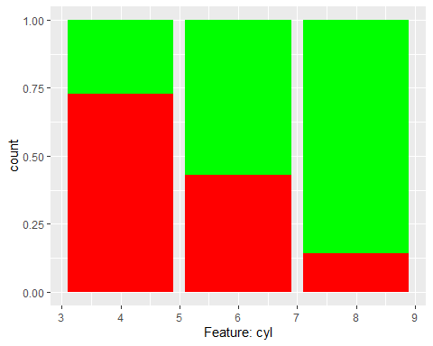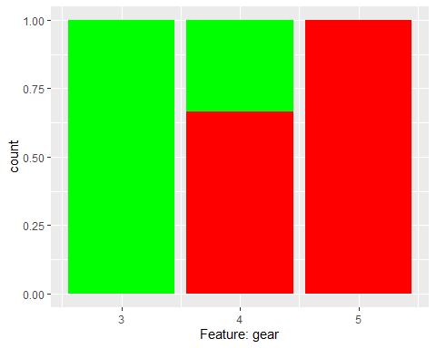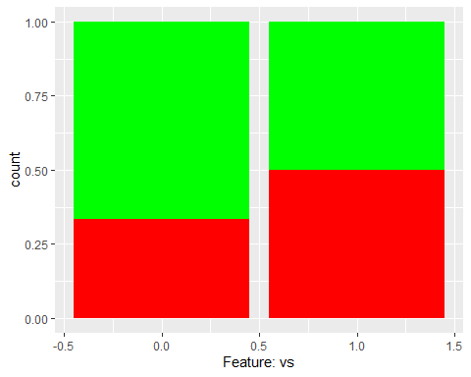

## Including Plots

You can also embed plots, for example:



Note that the echo = FALSE parameter was added to the code chunk to prevent printing of the R code that generated the plot.