FORM 3 160042



THE FISH ACT, CAP. 197 THE FISH (FISHING) RULES, 2010

FISHING VESSEL LICENCE (LAKES: VICTORIA, ALBERT, KYOGA, EDWARD, GEORGE AND WAMALA)

Name: HATEGEKA AROZIOUS (ARREARS 2020)

Address: MUKONO

Vessel Registration Number:N/A Date of Issue: 10 August, 2021

Registered with/place of issue (BMU):KIMMI District:Mukono

Expiry Date: 31st December 2021

Licensee authorised to fish in Lake:VICTORIA Fee for Licence : 100,000/=

Type of fish targeted:SILVER FISH

The licence is issued under the following conditions: -

1. **License is not transferable**
2. **Subject to the provisions of the Fish Act. Cap. 197.**
3. **In case of any change of vessel ownership, licensee must notify the licensing authority within thirty days.**
4. **The licence to be displayed in its original form.**
5. **Must declare daily fish catch to the BMU office.**

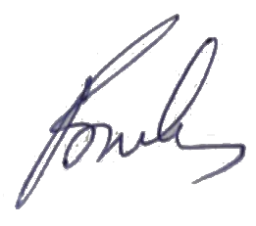

Tom Mukasa

