LIBRARY MANAGEMENT SYSTEM


DEPARTMENT OF COMPUTER SCIENCE & ENGINEERING.

BANGLADESH UNIVERSITY OF BUSINESS & TECHNOLOGY. (BUBT)

MIRPUR-2, DHAKA.

July 15, 2021

i
LIBRARY MANAGEMENT SYSTEM

A project

Submitted to the Department of Computer Science and Engineering Bangladesh University of Business and Technology (BUBT), Dhaka in partial fulfillment of requirements
for the 7Th Semester degree (software development-II project)
of

BACHELOR OF SCIENCE

IN

COMPUTER SCIENCE AND ENGINEERING.

BY-

S M Masfequier Rahman Swapno (ID: 18192103087)

Mafuja Akter Mitu (ID: 18192103068)

Md Ariful Islam (ID: 18192103059)

SUPERVISED BY-

Md. Sahiduzzaman

Assistant Professor,

Department of Computer Science and Engineering (CSE) Bangladesh University of Business and Technology (BUBT) Mirpur-2, Dhaka-1216, Bangladesh

ii
Abstract

The Library Management System is an application for assisting a librarian in managing a book library in a university. The system would provide basic set of features to add/update members, add/update books, and manage check in specifications for the systems based on the client’s statement of need. Library management system is a typical management Information system (MIS), its Development include the establishment and maintenance of back-end database and front-end application development aspects. For the former require the establishment of data consistency and integrity of the strong data security and good libraries. As for the latter requires the application fully functional, easy to use and so on.

iii
DECLARATION

We hereby declare that the project entitled “LIBRARY MANAGEMENT SYSTEM” submitted in partial fulfillment by us for the Advanced Programming Lab of B.Sc. Engineering in Computer Science and Engineering in the faculty of Computer Science and Engineering of Bangladesh University of Business and Technology (BUBT) under the guidance of our supervision of Md. Sahiduzzaman, Assistant professor, department of Computer Science and Engineering is our own work and it contains no material which has been accepted for the award to the candidates of any other disciplines expect few references which is taken from various books and authors to enrich our knowledge about the topic of our project.

-------------------------------- | -------------------------- | ---------------------------
S M Masfequier Rahman Swapno | Mafuja Akter Mitu | Md Ariful Islam
ID: 18192103087 | ID: 18192103068 | ID: 18192103059
Intake: 41 | Intake: 41 | Intake: 41

iv
CERTIFICATE

TO WHOM IT MAY CONCERN

That is to certify that S M Masfequier Rahman Swapno, Mafuja Akter Mitu, Md Ariful Islam, students of B.Sc. in CSE has completed their project work titled “Library Management System” satisfactorily in partial fulfillment for the requirements of B.Sc. in Computer Science and Engineering from Bangladesh University of Business and Technology.

-------------------------------- | -------------------------- | ---------------------------
S M Masfequier Rahman Swapno | Mafuja Akter Mitu | Md Ariful Islam
ID: 18192103087 | ID: 18192103068 | ID: 18192103059
Intake: 41 | Intake: 41 | Intake: 41

---------------------------------------------------------------

Md. Sahiduzzaman

Assistant Professor

Department of CSE,

Bangladesh University of Business and Technology (BUBT).

Mirpur-2, Dhaka-1216.

v

DEDICATION

Dedicated to our parents for all their love and inspiration.

vi
Acknowledgments

We have learned a lot and really enjoyed working on this project. We thank God Almighty who by His Grace and Mercy we have been able to complete this project.

Our appreciation to our parents and guardians who have motivated us in diverse ways to come this far in our educational journey.

We are deeply indebted to our supervisor, Md. Sahiduzzaman for his valuable guidance, stimulating suggestions, patience and for encouraging us to go ahead with our project. Thanks to them for his advice and useful feedback regarding the final project either in documentation parts or technical parts. In addition, their guideline and briefing on how to produce a good quality report for this project also provided to us. We are grateful.

We would like to sincerely thank all those who helped us with their valuable support during the entire process of this project.

vii

APPROVAL

This project “Library Management System” submitted by S M Masfequier Rahman Swapno, Mafuja Akter Mitu, and Md Ariful Islam, ID.No. 18192103087, 18192103068, and 18192103059, students of B.Sc. in Computer Science and Engineering from Bangladesh University of Business and Technology under the supervision of Md. Sahiduzzaman, Assiantant professor Department of Computer Science and Engineering has been accepted as satisfactory for the partial fulfillment for the requirements of B.Sc. in Computer Science and Engineering and approved as to its style and contents.

---------------------------------------------------------------

Md. Sahiduzzaman

Assistant Professor

Department of CSE,

Bangladesh University of Business and Technology (BUBT).
Mirpur-2, Dhaka-1216.

viii

COPYRIGHT

© Copyright by S M Masfequier Rahman Swapno(18192103087), Mafuja Akter Mitu(18192103068), and Md Ariful Islam(18192103059)

All Right Reserved

ix
Table of Contents

Page No

Abstract……………………………………………………………………………… ........... iii
Declaration…………………………………………………………………………….......... iv
Certificate………………………………………………………………………………….. ...v
Dedication………………………………………………………………………………….. . vi
Acknowledgement ……………………...………………………………………………… . vii
Approval…………………………………………………………………………….......... . viii
Copyright……………………………………………………………………………........... . ix

Chapter-1: Introduction…………………………………………………………………01-03

1.1 Introduction……………………………………………………………………………….01

1.2 Motivation………………………………………………………………………………...01

1.3 Project Aim and Objectives………………………………………………………………02

1.4 Background of project…………………………………………………………………….02

1.5 Operation environment……………………………………………………………………03

Chapter-2: SYSTEM ANALYSIS………………………………………………………04-12

2.1 Introduction……………………………………………………………………………….04

2.2 Software requirement specification……………………………………………………04-09

2.3 Existing vs proposed system………………………………………………………………10

2.4 Software tools used…………………………………………………………………….10-12

Chapter-3: Methodology…………………………………………………………………13-18

3.1 Introduction to project…………………………………………………………………….13

3.2 SSADM Methodology…………………………………………………………………13-14

3.3 DSDM Methodology…………………………………………………………………...14-15

3.4 SCRUM Methodology…………………………………………………………………15-17

3.5 Extreme programming…………………………………………………………………….18

Chapter-4: System design………………………………………………………………..19-25

4.1 Table design……………………………………………………………………………19-21

4.2 Data flow diagram……………………………………………………………………..22-24

4.3 ER diagram………………………………………………………………………………..25

x

Chapter-5: User manual and interface…………………………………………………..26-31

5.1 Login page………………………………………………………………………………….26

5.2 Signup page………………………………………………………………………………...27

5.3 Homepage…………………………………………………………………………………..28

5.4 Addbook page………………………………………………………………………………29

5.5 Addstudent page……………………………………………………………………………30

5.6 Issuebook page……………………………………………………………………………...31

5.7 Returnbook page……………………………………………………………………………31

Chapter-6: System test…………………………………………………………………….32-33

6.1 Introduction…………………………………………………………………………………32

6.2 Unit testing………………………………………………………………………………32-33

6.3 Integration testing…………………………………………………………………………...33

Chapter-7: Conclusion…………………………………………………………………….34-37

7.1 Introduction…………………………………………………………………………………34

7.2 Project management issues………………………………………………………………….34

7.3 Evaluation of project strengths and weakness………………………………………………35

7.4 Suggestion for future enhancement…………………………………………………………36

7.5 Personal reflection……………………………………………………………………….36-37

Refference………………………………………………………………………………………38

xi
CHAPTER 1

INTRODUCTION

___________________________________________________________________________

1.1 INTRODUCTION

A library is a collection of organized information and resources which is made accessible to a well-defined community for borrowing or reference sake. The collection of the resources and information are provided in digital or physical format in either a building/room or in a virtual space or even both. Library’s resources and collections may include newspaper, books, prints, maps, CDs, tapes, videotapes, database etc. The main system is to develop a new programmed system that will conveying ever lasting solution to the manual base operations and to make available a channel through which staff can maintain the record easily and customers can access the information about the library at whatever place they might find themselves. The project titled “Library Management System” is a Library management software for monitoring and controlling the transactions in a library.

1.2 Motivation

In today’s world most of the things are automated like bank operations and college management process etc. In the digital world the library process still maintains the bookkeeping manual. It is providing through library card for issuing books and maintains the record in books. When we want to borrow a book from library.

Firstly, the librarian sees the book and then he or she recorded details of the book in a library card or the registers book. It is an annoying process, at the same time it’s a time-consuming process for the librarian as well as library users.

So, we think if we can have made an automatic library management system in digital way, then it can help at the same time the librarian and the students who want to borrow book from the library.

1

1.3 PROJECT AIMS AND OBJECTIVES

The project aims and objectives that will be achieved after completion of this project are discussed in this subchapter. The aims and objectives are as follows:

- Online book issue

- Request column for librarian for providing new books

- A separate column for digital library

- Student login page where student can find books issued by him/her and date of return.

- A search column to search availability of books

- A teacher login page where teacher can add any events being organized in the college and important suggestions regarding books.

- Online notice board about the workshop.

1.4 BACKGROUND OF PROJECT

Library Management System is an application which refers to library systems which are generally small or medium in size. It is used by librarian to manage the library using a computerized system where he/she can record various transactions like issue of books, return of books, addition of new books, addition of new students etc.

Books and student maintenance modules are also included in this system which would keep track of the students using the library and also a detailed description about the books a library contains. With this computerized system there will be no loss of book record or member record which generally happens when a non-computerized system is used.

In addition, report module is also included in Library Management System. If user’s position is admin, the user is able to generate different kinds of reports like lists of students registered, list of books, issue and return reports.

All these modules are able to help librarian to manage the library with more convenience and in a more efficient way as compared to library systems which are not computerized.

2
1.5 OPERATION ENVIRONMENT

PROCESSOR | INTEL CORE PROCESSOR OR
 | BETTER PERFORMANCE
OPERATING SYSTEM | WINDOWS VISTA ,WINDOWS7,
 | UBUNTU
MEMORY | 1GB RAM OR MORE
HARD DISK SPACE | MINIMUM 3 GB FOR DATABASE
 | USAGE FOR FUTURE
DATABASE | MY SQL

3
CHAPTER 2

SYSTEM ANALYSIS

___________________________________________________________________________

2.1 INTRODUCTION

In this chapter, we will discuss and analyze about the developing process of Library Management System including software requirement specification (SRS) and comparison between existing and proposed system. The functional and nonfunctional requirements are included in SRS part to provide complete description and overview of system requirement before the developing process is carried out. Besides that, existing vs proposed provides a view of how the proposed system will be more efficient than the existing one.

2.2 SOFTWARE REQUIREMENT SPECIFICATION

2.2.1 GENERAL DESCRIPTION

PRODUCT DESCRIPTION:

Library Management System is a computerized system which helps user(librarian) to manage the library daily activity in electronic format. It reduces the risk of paper work such as file lost, file damaged and time consuming.

It can help user to manage the transaction or record more effectively and time-saving.

PROBLEM STATEMENT:

The problem occurred before having computerized system includes:

- File lost

When computerized system is not implemented file is always lost because of human environment. Sometimes due to some human error there may be a loss of records.

4
- File damaged

When a computerized system is not their file is always lost due to some accident like spilling of water by some member on file accidentally. Besides some natural disaster like floods or fires may also damage the files.

- Difficult to search record

When there is no computerized system there is always a difficulty in searching of records if the records are large in number.

- Space consuming

After the number of records become large the space for physical storage of file and records also increases if no computerized system is implemented.

- Cost consuming

As there is no computerized system the to add each record paper will be needed which will increase the cost for the management of library.

2.2.2 SYSTEM OBJECTIVES

- Improvement in control and performance

The system is developed to cope up with the current issues and problems of library. The system can add user, validate user and is also bug free.

- Save cost

After computerized system is implemented less human force will be required to maintain the library thus reducing the overall cost.

- Save time

Librarian is able to search record by using few clicks of mouse and few search keywords thus saving his valuable time.

- Option of online Notice board

Librarian will be able to provide a detailed description of workshops going in the college as well as in nearby colleges

- Lecture Notes

Teacher have a facility to upload lectures notes in a pdf file having size not more than 10mb.

5
2.2.3 SYSTEM REQUIREMENTS

2.2.3.1 NON FUNCTIONAL REQUIREMENTS

EFFICIENCY REQUIREMENT

When a library management system will be implemented librarian and user will easily access library as searching and book transaction will be very faster.

RELIABILITY REQUIREMENT

The system should accurately perform member registration, member validation, report generation, book transaction and search.

USABILITY REQUIREMENT

The system is designed for a user friendly environment so that student and staff of library can perform the various tasks easily and in an effective way.

ORGANIZATIONAL REQUIREMENT

IMPLEMENTATION REQUIREMNTS

In implementing whole system, it uses html in front end with php as server side scripting language which will be used for database connectivity and the backend i.e. the database part is developed using MySQL.

DELIVERY REQUIREMENTS

The whole system is expected to be delivered in six months of time with a weekly evaluation by the project guide.

6
2.2.3.2 FUNCTIONAL REQUIREMENTS

- USER LOGIN Description of feature

This feature used by the user to login into system. They are required to enter user id and password before they are allowed to enter the system. The user id and password will be verified and if invalid id is there user is allowed to not enter the system.

Functional requirements

-user id is provided when they register

-The system must only allow user with valid id and password to enter the system

-The system performs authorization process which decides what user level can acess to.

-The user must be able to logout after they finished using system.

- REGISTER NEW USER Description of feature

This feature can be performed by all users to register new user to create account.

Functional requirements

-System must be able to verify information

-System must be able to delete information if information is wrong

7

- REGISTER NEW BOOK Description of feature

This feature allows to add new books to the library Functional requirements

-System must be able to verify information

-System must be able to enter number of copies into table.

  - System must be able to not allow two books having same book id.

- ISSUE BOOKS AND RETURN BOOKS

DESCRIPTION OF FEATURE

This feature allows to issue and return books and also view reports of book issued.

Functional requirements

-System must be able to enter issue information in database.

-System must be able to update number of books.

- System must be able to search if book is available or not before issuing books. -System should be able to enter issue and return date information.

- EVENT ADDITION DESCRIPTION OF FEATURE

This feature allows teacher and student to add information about various workshops being conducted in college and colleges nearby.

8
Functional requirements

-System should be able to add detailed information about events.

-System should be able to display information on notice board available in the homepage of site.

2.2.4 SOFTWARE AND HARDWARE REQUIREMENTS

This section describes the software and hardware requirements of the system.

2.2.4.1 SOFTWARE REQUIREMENTS

- Operating system- Windows 7 is used as the operating system as it is stable and supports more features and is more user friendly

- Database MYSQL-MYSQL is used as database as it easy to maintain and retrieve records by simple queries which are in English language which are easy to understand and easy to write.

- Development tools and Programming language- JAVA is used to write the whole code.

2.2.4.2 HARDWARE REQUIREMENTS

- Intel core i5 2nd generation is used as a processor because it is fast than other processors a provide reliable and stable and we can run our pc for longtime. By using this processor, we can keep on developing our project without any worries.

- Ram 1 gb is used as it will provide fast reading and writing capabilities and will in turn support in processing

9
2.3 EXISTING VS PROPOSED SYSTEM

i. Existing system does not have any facility of teacher’s login or student login whereas proposed system will have a facility of student login as well as teacher’s login

- Existing system does not have a facility of online reservation of books whereas proposed system has a facility of online reservation of books

- Existing system does not have any facility of online notice board where description of workshops happening in our college as well as nearby colleges is being provided.

- Existing system does not have any option of lectures notes uploaded by teachers whereas proposed system will have this facility

- Existing system does not have any facility to generate student reports as well book issue reports whereas proposed system provides librarian with a tool to generate reports

- Existing system does not have any facility for book request and suggestions where as in proposed system after logging in to their accounts student can request books as well as provide suggestions to improve library

2.4 SOFTWARE TOOLS USED

2.3.1: Front end: It is difficult to provide a single reason as to why the Java programming language has become so ubiquitous. However, the language's major characteristics have all played a part in its success, including the following components:

- Programs created in Java offer portability in a network. Source code is compiled into what Java calls bytecode, which can run anywhere in a network, on a server or on a client that has a Java virtual machine (JVM). The JVM interprets the bytecode into code that will run on computer hardware. In contrast, most programming languages, such as COBOL or C++, will compile code into a binary file. Binary files are platform-specific, so a program written for an Intel-based Windows machine cannot on run a Mac, a Linux-based device or an IBM mainframe. As an alternative to interpreting one bytecode

10

instruction at a time, the JVM includes an optional just-in-time (JIT) compiler which dynamically compiles bytecode into executable code. In many cases, the dynamic JIT compilation is faster than the virtual machine interpretation.

- Java is object-oriented. An object is made up of data as fields or attributes and code as procedures or methods. An object can be a part of a class of objects to inherit code common to the class. Objects can be thought of as "nouns" that a user can relate to "verbs." A method is the object's capabilities or behaviors. Because Java’s design was influenced by C++, Java was mainly built as an object-orientated language. Java also uses an automatic garbage collector to manage object lifecycles. A programmer will create objects, but the automatic garbage collector will recover memory once the object is no longer in use. However, memory leaks may occur when an object which is no longer being used is stored in a container.

- The code is robust. Unlike programs written in C++, Java objects contain no references to data external to themselves or other known objects. This ensures that an instruction cannot include the address of data stored in another application or in the operating system itself, either of which would cause the program and perhaps the operating system to terminate or crash. The JVM makes a number of checks on each object to ensure integrity.

- Data is secure. Unlike C++, Java does not use pointers, which can be unsecured. Data converted to bytecode by Java is also not readable to humans. Additionally, Java will run programs inside a sandbox to prevent changes from unknown sources.

- Applets offer flexibility. In addition to being executed on the client rather than the server, a Java applet has other characteristics designed to make it run fast.

- Developers can learn Java quickly. With syntax similar to C++, Java is relatively easy to learn, especially for those with a background in C

2.3.2 BACK END- The back end is designed using MySQL which is used to design the databases

- MYSQL- MySQL ("My S-Q-L", officially, but also called "My Sequel") is (as of July 2013) the world's second most widely used open-source relational database management system (RDBMS). It is named after co-founder Michael Wideners daughter, My. The SQL phrase stands for Structured Query

11

Language. The MySQL development project has made its source code available under the terms of the GNU General Public License, as well as under a variety of proprietary agreements. MySQL was owned and sponsored by a single for-profit firm, the Swedish company MySQL AB, now owned by Oracle Corporation. MySQL is a popular choice of database for use in web applications, and is a central component of the widely used LAMP open source web application software stack (and other 'AMP' stacks). LAMP is an acronym for "Linux, Apache, MySQL, Perl/PHP/Python." Free-software-open source projects that require a full-featured database management system often use MySQL. For commercial use, several paid editions are available, and offer additional functionality. Applications which use MySQL databases

12
CHAPTER 3

Methodology

___________________________________________________________________________

3.1 Introduction to project

The project is on Library Management which currently has a manual system of handling member registration, book issuance, book returning etc. This report intends to provide a full specification for the development of Automated Library System. The project is carried out through XP methodology with previous comparison of methodology done.

The various possibilities for the development of Library Management could be the following methodologies:

- SSADM

- DSDM

- Scrum and

- XP

3.2 SSADM Methodology

SSADM is a waterfall method for the analysis and design of information systems. SSADM can be thought to represent a pinnacle of the rigorous documented approach to system design, and contrasts with more contemporary agile methods such as DSDM or Scrum.

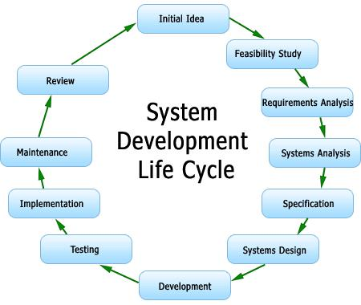

13

Figure 1: SSADM life cycle (System Development Life Cycles (SDLC) – Sharper Tutorials.)

For SSADM puts special emphasis on the analysis of the system and its documentation, this causes the danger of overanalyzing, which can be very time and cost consuming (Kanban. 2012). Due to various types of description methods, checks of consistency cannot be carried out. Especially with large systems, the outline diagram can become very unclear, because all relevant data flows have to be included. (ITC Infotech, India, 2012.) SSADM can’t be used for the development of Library for the following reasons:

1 SSADM puts special emphasis on the analysis of the system and its documentation which causes the danger of overanalyzing and can be time and cost consuming ( Kanban. 2012). For the development of Library, we do not need an absolute documentation for the system.

2 Due to various types of description methods, checks of consistency cannot be carried out.

3.The outline diagram can become very unclear, because all relevant data flows have to be included. (ITC Infotech, India, 2012.). As the system of Library is s mall and medium sized systems in which we do not include all the data flows.

3.3 DSDM Methodology

The another possibility for the development of Library, DSDM, is the robust Agile

framework for effective Project Management and Delivery; providing best practice guidance for

on time, in budget delivery of projects – with proven scalability to address projects of all sizes

and for any Business Sector. (DSDM Atern – DSDM Atern. 2012)

14
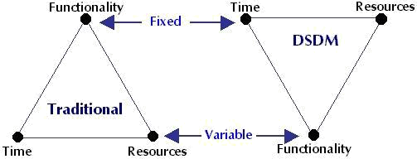

Figure 2: DSDM lifecycle (DSDM Atern Project Structure; Overview | M.C. Partners &amp; Associates)

Yet, DSDM can’t be used for the development of Library for the following reasons:

1 DSDM places relatively little emphasis on quality delivering solid prototypes quickly, rather than the actual product quickly.( Compare Dsdm And Xp. 2012) So, DSDM is generally for RAD no matter what the coding approach is. Since library has got clear requirements and has to be delivered a solid product, there is no necessity of building a quick prototype being ignorant on coding approach.

2 DSDM does not recognize that the Cost Of Change Curve may be flattened. (Compare Dsdm And Xp. 2012) This is another reason for not choosing DSDM for development of Library, because changes can always not be expected in a monster way. They can appear with a constant line of curve, when cost is considered.

3 DSDM uses timeboxing to manage risk per iteration while the other methodology like XP uses more responsive techniques. (Compare Dsdm And Xp. 2012) Timeboxes are generally of longer periods, hence making it quite tedious process of development, which may affect the development process of library because there is nothing amazing and much interesting about project tasks, as it revolves only around the Library.

3.4 SCRUM Methodology

The Library management system can also be developed using the scrum methodology. Among all the agile methodologies, Scrum is unique because it introduces the idea of “empirical process control.” It uses a real world progress of the project. In Scrum, projects are divided into succinct work cadences, known as sprints, which are typically one week, two weeks, or three weeks’ induration. At the

15

end of each sprint, stakeholders and team members meet to assess the progress of a project and plan its next steps. This allows a project’s direction to be adjusted or reoriented based on completed work, not speculation or predictions (Scrum Methodology & Agile Scrum Methodologies. 2012). Scrum has certain practices and is also a commitment and result oriented. In SCRUM project is delivered using increments of the shippable products. Here on each day the task to be done is discussed before starting it and at the end what is achieved is also discussed. After the delivery of each parts of the product a group meeting between the developing and stakeholder teams takes place which focuses on quality assurance they want to have in their system
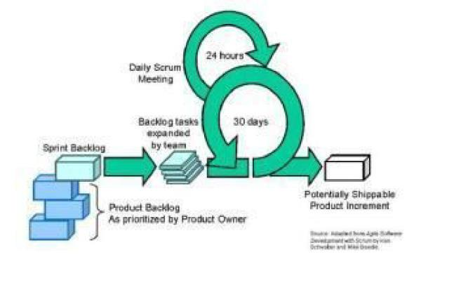

Figure 3: SCRUM lifecycle

Development of Library management system may be beneficial by using the

SCRUM because in SCRUM:

- The principles are easy to understand as well as easy to implement.

- All the rules and development is technological and tools agnostics.

- The system is built and tested several times focuses on each drawback as well as on its removal and modifications.

16

Instead of its advantages there are also several points which are briefly discussed below about why not to use SCRUM for the development of the library management system.

- The library management is not such a big project and all the additional programmed planning and the changing requirements are not all required here. Using SCRUM costs bit more and also needs additional documentations prepared that’s way using the SCRUM for its development may not be appropriate.

- I n our project we are going to have all the previous requirements required for the development of the system and all are previously set, which means we are not going to change any requirements. The scrum mainly focuses on the changing requirement that’s way we may not have to use it.

- Management systems such as Library Management system needs lots of integration between its modules like as: student, teachers and so on so the developer needs to be together during the development but SCRUM developer may be personally dedicated i.e. Chickens, but in our project all the developer teams needs to be together that’s way scrum may not be appropriate.

- The daily meeting is the main agenda of the scrum which is not needed in our project. Because all the necessary requirements and the task according to the priorities are all set up earlier which all are required to set up before starting project.

- SCRUM focuses on the shorter more structured sprints, and prioritizes backlog items Scrum's aim goal is to get estimations of how long development will take (agile What is the difference between Scrum and Extreme Programming? Stack Overflow. 2012.)

- I t does not address the practices required to create "goods" of any kind, but instead gives us the process that will take us from the inception of a vision to the final product, regardless of the actual development process. (Agile What is the difference between Scrum and Extreme Programming? Stack Overflow. 2012.)

- Scrum has nothing to say about programming. (Agile What is the difference between Scrum and Extreme Programming? Stack Overflow. 2012.)

17
3.5 Extreme Programming

The methodology that suits the best for the development of library is XP.

Extreme Programming is a discipline of software development based on values of simplicity, communication, feedback, and courage. It works by bringing the whole team together in the presence of simple practices, with enough feedback to enable the team to see where they are and to tune the practices to their unique

situation. (xProgramming.com. 2012.)

The reasons for using XP for the Library are as follows:

1 Focuses of XP are more on paired programming, prioritizing the tasks, and more test driven development. (agile What is the difference between Scrum and Extreme Programming? Stack Overflow. 2012.) This feature helps the development of the Library software with great quality.

2 XP is more about helping developers get things done as quickly and maintainable as possible. (agile What is the difference between Scrum and Extreme Programming? Stack Overflow. 2012.)

3 It gives us a process with which to create software in an agile and productive way. It deals with, though doesn't specialize in the management of the development process, and focuses mostly on the engineering practices required to deliver software, with quality. (agile What is the difference between Scrum and Extreme Programming? Stack Overflow. 2012.)

18
CHAPTER 4

SYSTEM DESIGN

___________________________________________________________________________

4.1 TABLE DESIGN

VARIOUS TABELS TO MAINTAIN INFORMATION

ACCOUNT TABLE FOR KEEPING TRACK OF ACCOUNTS

 | Field Name |  |  |  | Datatype
 | username |  | varchar(20)
 | name |  | varchar(25)
 | password |  | varchar(25)
 | sec_q |  | varchar(25)
 | sec_ans |  | varchar(25)
BOOK TABLE FOR KEEPING TRACK OF BOOKS
 |  |  |  |  |  | Datatype
 | Field Name |  |  |  |  | Datatype
 | book_id |  |  |  | varchar(10)
 | name |  |  |  | varchar(40)
 | isbn |  |  |  | varchar(20)
 | publisher |  |  |  | varchar(30)
 | edition |  |  |  | varchar(10)
 | price |  |  |  | varchar(10)
 | pages |  |  |  | varchar(10)
 |  | 19

STUDENT TABLE FOR KEEPING TRACK OF STUDENTS

 | Field Name |  |  |  | Datatype
student_id |  |  |  | varchar(10)
name |  |  |  | varchar(25)
father |  |  |  | varchar(25)
course |  |  |  | varchar(10)
branch |  |  |  | varchar(10)
year |  |  |  | varchar(10)
semester |  |  |  | varchar(10)

ISSUEBOOK TABLE FOR KEEPING TRACK OF ISSUED BOOKS

Field Name |  |  |  | Datatype
book_id |  |  | varchar(10)
student_id |  |  | varchar(10)
bname |  |  | varchar(40)
sname |  |  | varchar(40)
course |  |  | varchar(20)
branch |  |  | varchar(10)
dateOfIssue |  |  | varchar(30)
 | 20

RETURNBOOK TABLE FOR KEEPING TRACK OF RETURNED BOOKS

 | Field Name |  |  |  | Datatype
book_id |  |  |  | varchar(10)
student_id |  |  |  | varchar(10)
bname |  |  |  | varchar(40)
sname |  |  |  | varchar(40)
course |  |  |  | varchar(20)
branch |  |  |  | varchar(10)
dateOfIssue |  |  |  | varchar(30)
dateOfReturn |  |  |  | varchar(30)

21
4.2 DATA FLOW DIAGRAMS

DATA FLOW DIAGRAM FOR LOGIN
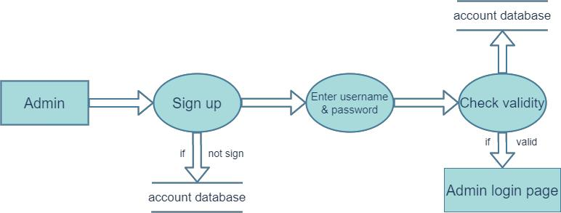

If an admin doesn’t have any account, he or she has to sign up. When he or she enter his or her details, it will go to account table. After signup, admin have to login for monitoring everything. Then admin has to use his username and password. If the username and password will correct, he will go to the homepage.

DATA FLOW DIAGRAM FOR ADD BOOKS
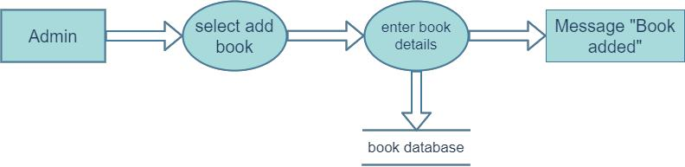

If admin wants to add any books in library, he has to add book details in book section, and this information will add in the book table.

22

DATA FLOW DIAGRAM FOR ADD STUDENTS
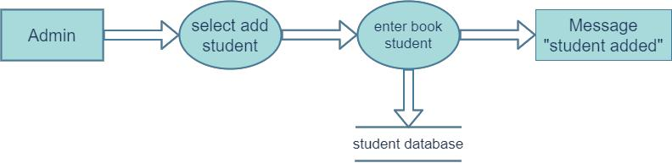

Similarly, when admin wants to add student, he has to enter details in student section and then student information will go to student table.

DATA FLOW DIAGRAM FOR ISSUE BOOKS
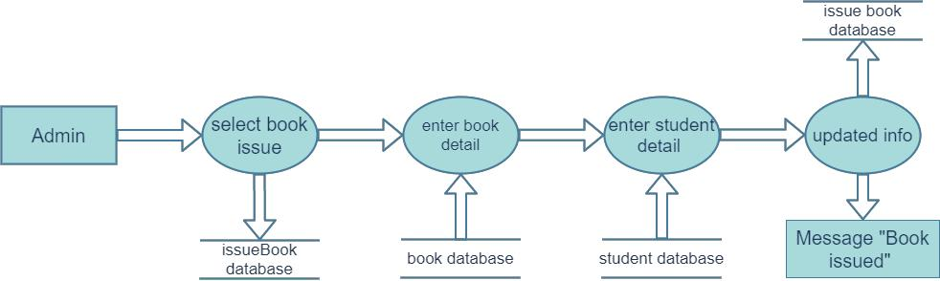

If any student wants to borrow a book, admin has to give his id and book id in mention sections. Then student information and book information will come from student table and book table. When admin issue a book, the information will go to issuebook table.

23

DATA FLOW DIAGRAM FOR RETURN BOOKS
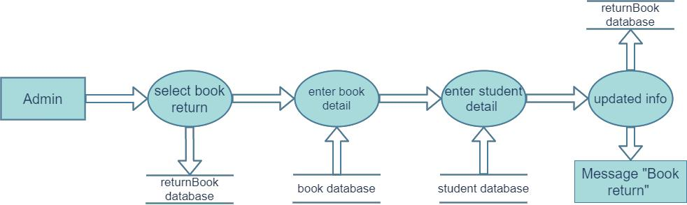

If any student wants to return the book, admin has to give required information.

When this process become done, the information will go to the returnbook table.

24
4.3 ER Diagram:
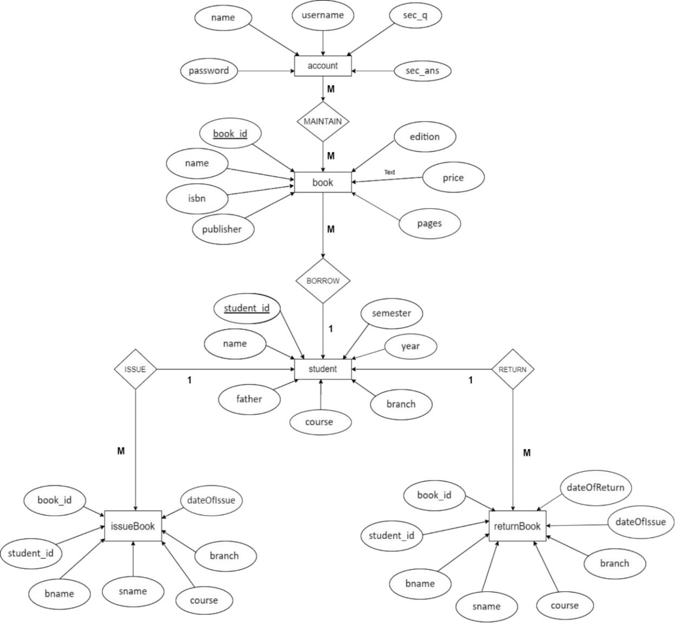

An account maintains books and students and students borrow books. A student will borrow a book and return it on time.

25
CHAPTER 5

USER MANUAL AND INTERFACE

___________________________________________________________________________

5.1 Login page
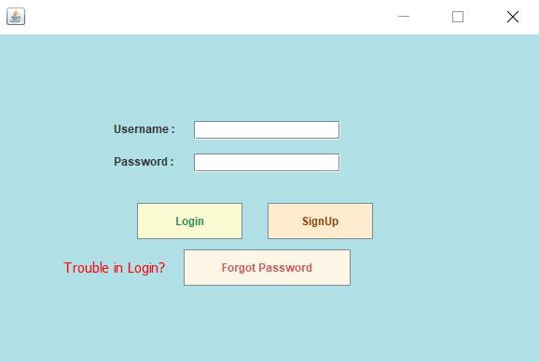

This is the login page. If admin have any account, then he or she can login to the system by giving username and password. If admin forgot his or her password, then he can get the password.

26

5.2 Signup page
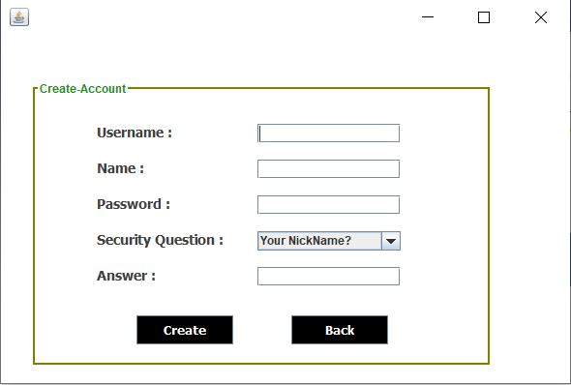

If any admin doesn’t have any account, then he or she have to sign up. After giving information, he or she can create an account.

27

5.3 Homepage
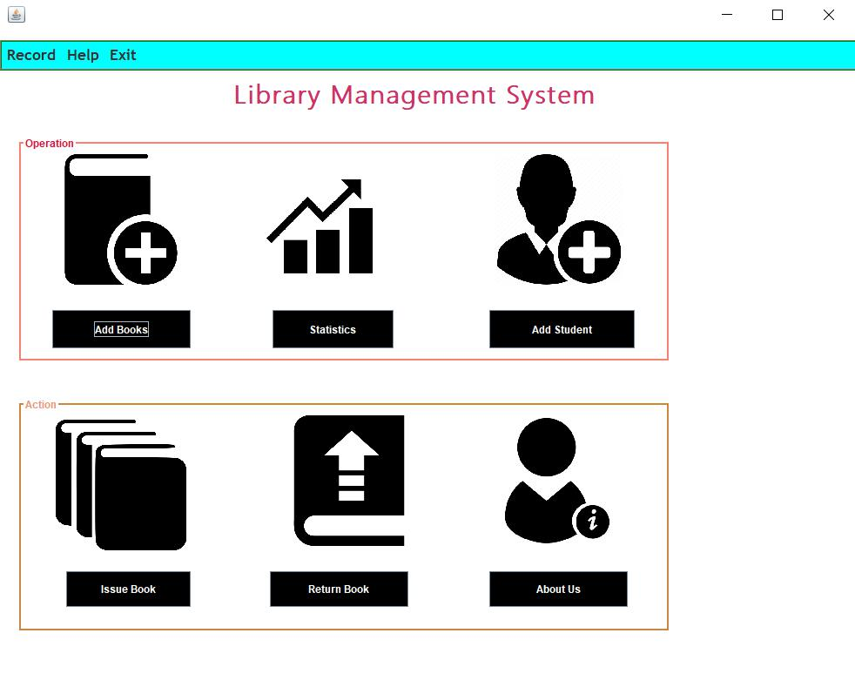

After login to the system, admin can see the homepage. This is main page of our software. Here admin finds all the functionalities of our software.

28

5.4 Add book
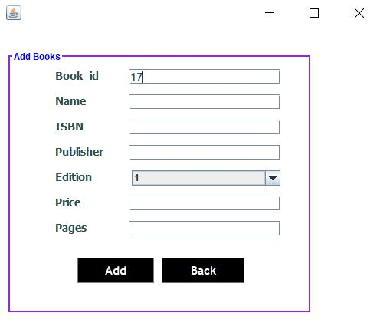

When admin want to add any book in the library, he or she can add books by giving information.

29

5.5 Add student
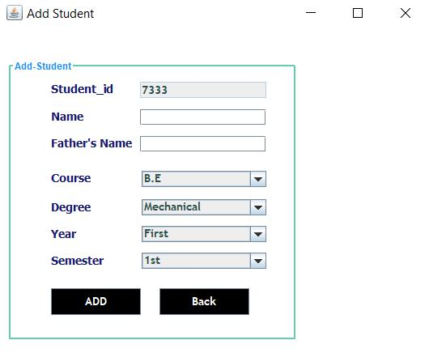

If any student wants to admit in the library, admin can add him by giving his or her required information.

30
5.6 Issue book
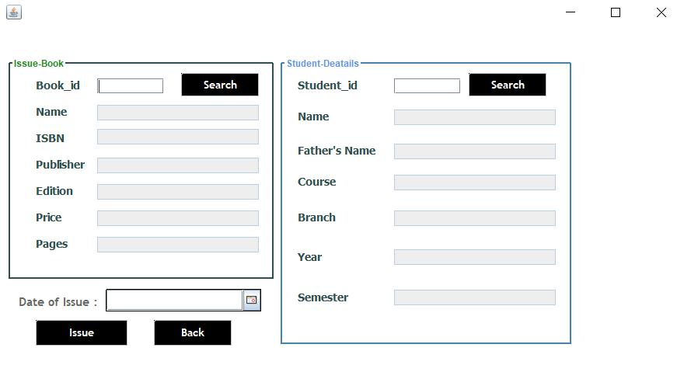

When any student want to borrow a book, then he or she have to go to the librarian and librarian will issue the book by giving required information.

5.7 Return book
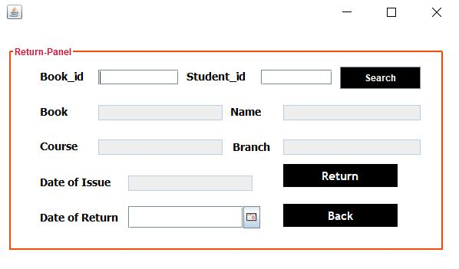

When any student wants to return any book, then he or she have to go to the librarian and librarian return the book from student.

31
CHAPTER 6

SYSTEM TEST

___________________________________________________________________________

6.1 INTRODUCTION

The aim of the system testing process was to determine all defects in our project. The program was subjected to a set of test inputs and various observations were made and based on these observations it will be decided whether the program behaves as expected or not.

Our Project went through two levels of testing

1.Unit testing

2.integration testing

6.2 UNIT TESTING

- Unit testing is undertaken when a module has been created and successfully reviewed. In order to test a single module, we need to provide a complete environment i.e. besides the module we would require

- The procedures belonging to other modules that the module under test calls

- Non local data structures that module accesses

- A procedure to call the functions of the module under test with appropriate parameters.

- Unit testing was done on each and every module that is described under module description of chapter 4

- Testing admin login form-This form is used for log in of administrator of the system. In this we enter the username and password if both are correct administration page will open otherwise if any of data is wrong it will get redirected back to the login page and again ask for username and password

- Student account addition- In this section the admin can verify student details from student academic info and then only add student details to main library database it contains add and delete buttons if user click add button data will be added to student database and if he clicks delete button the student data will be deleted

32

  - Book Addition- Admin can enter details of book and can add the details to the main book table also he can view the books requests.

- Test for Student login module

  - Test for Student Login Form-This form is used for log in of Student. In this we enter theileriid, username and password if all these are correct student login page will open otherwise if any of data is wrong it will get redirected back to the login page and again ask for librarian, username and password.

  - Test for account creation- This form is used for new account creation when student does not fill the form completely it asks again to fill the whole form when he fills the form fully it gets redirected to page which show waiting for conformation message as his data will be only added by administrator after verification.

- Test for teacher login module-

  - Test for teacher login form- This form is used for log in of teacher. In this we enter the username and password if all these are correct teacher login page will open otherwise if any of data is wrong it will get redirected back to the login page and again ask for username and password.

6.3 INTEGRATION TESTING

In this type of testing we test various integration of the project module by providing the input. The primary objective is to test the module interfaces in order to ensure that no errors are occurring when one module invokes the other module.

33
CHAPTER 7

CONCLUSION

___________________________________________________________________________

7.1 Introduction

In this final chapter, the final evaluation and conclusion will be performed on the testing and analyzing process that done in previous chapter including seminar linkage, strengths, weakness and future enhancement of the Library Management System. In addition, personal reflection also includes in final part of this chapter.

7.2 Project Management Issues

During the development process of Library Management system, there are a lot issues encountered. Firstly, I don’t have much knowledge about how library process the book transaction and the business logic in the library. Thus, a lot research has been done to refer and to get more understanding about the library management.

Besides, I have met some problem regarding the member id generator module. In that module, I need to print out the member details such as name, id and also photo. In this case, never learn how to print the detail in A4 size paper. With the help of Google and my friend, finally I know the method to use is Drawstring and DrawImage.

On the other hand, I met problem of constructing the DFD and ERD due to the less understanding of the diagram such as entity and relationship. With the help of Diploma studies materials, finally I successful construct the ERD and DFD diagrams.

Finally, the biggest problem I met is the documentation format. Although I have been provided with the document guidelines, but the instruction and guide is too much to follow especially the Reference part.

34

7.3 Evaluation of Projects Strengths and Weaknesses Strengths
- System response is fast after user press a button to perform some actions.

- User interface is considered user friendly and ease of use.

- Validation has been done to avoid some functional error in later time.

- Some list view control has been included to allow user view the history or some important data without print out the report.

- Some important data is generated automatically such as Member ID, and member registration date to minimize user input error.

- Search features are included in several modules to ease user so that they can filter the data easily.

- Allow user to keep track member renting history.

- Member card can be generated by using the system.

- No additional/unnecessary steps required to perform the task.

- Allow user to keep track the lost book.

- System is able to check the book whether is under reservation or not.

Weakness

- The user interface of this system is suitable for screen resolution 1024 x 768 only.

- The reservation that make by member online unable to update the database immediately.

- The member id generated is in A4 format. Not in proper Member card size.

- System didn’t implement smart card technology.

35
7.4 Suggestion for Future Enhancement

For future enhancement, there are few suggestions to improve the system abilities. Firstly, the library system should implement smart card technology which will log in the member by scanning the smart card. The smart card can act as a unique identifier of a member. The smart card technology is more advanced and is able to store all the information inside the chips. By implements this, the book transaction process will be enhanced and save time.

Next, the wide screen monitor is getting more popular day by day. Library Management System should able to support the wide screen resolution such as 1152 x 648 or 1280 x 720 so that user can view the system in perfect view.

More information can be inserted into book table such as product version, type of product (magazine, encyclopedia or newspaper) to enhance the system to be more perfect. In addition, the system should be enhanced so that one book can have more than one author. Currently the system only supports one author per book. Some book is having more than one author and user may miss to search the book.

Currently, the reservation made cannot be detected without restart the system. The system should be enhancing so that the data can be updated in short time or pressing a button to avoid any error.

7.5 Personal Reflection

In this project development process, I have learnt a lot of new knowledge and programming code from this project. Besides that, there are also some problems that appears as biggest challenge during the development process.

During system design stages, the problem appears on how to construct the Entity-Relationship diagram and Data Flow Diagram. Assignments and studies materials in Diploma level studies materials are referred back. Some sample diagram and researches are done via Internet for more reference.

On the other hand, the biggest harvest gained through this project development process is the importance of communication between teammates. The communication is very important because there must be integration between 2 teammate’s systems. In this project, I do library system and my friend do library web site. We share one database server and so that we must communicate at early stage so that there is no crash when integration. In addition, discussion is needed in

36

developing the project to match among library system and library web site. A good communication is needed to avoid unnecessary problems appear and delay the completion time.

37
REFFERENCE

- http://en.wikipedia.org/wiki/Library_automation_system

- http://www.slideshare.net/vimal0212/open-source-library-managementsystems

- http://www.apache.org/dist/httpd/binaries/win32/ (apache_2.0.47-win32-x86-no_ssl.msi)

- http://www.activestate.com/store/download.aspx?prdGUID=81fbce82-6bd5-49bc-a915-08d58c2648ca(Perl)

- http://dev.mysql.com/downloads/mysql/4.1.html (mysql-4.1 for windows)

- https://www.mysql.com/

- https://www.w3schools.com/sql/default.asp

- https://netbeans.org/downloads/6.1/index.html

- https://www.apachefriends.org/index.html

10. https://app.diagrams.net/

11. https://www.academia.edu/37726542/Library_Management_System_Mini_ Project_Report_On_LIBRARY_MANAGEMENT_SYSTEM

12. https://www.daitm.org.in/wp-content/uploads/2019/04/Gr.-06library-project-report.pdf

13. https://www.slideshare.net/Kaisermasum/library-management-system-project-report

14. https://www.docsity.com/en/library-management-system-project-report/2738491/

15. https://sites.google.com/site/ignoubcafinalyearprojects/project-report/library-management-system-project-report

16. https://www.freestudentprojects.com/java-projects/library-management-system-project-report/

17. https://www.startertutorials.com/uml/resources/lms/LMS6.pdf

18. https://www.researchgate.net/publication/323994063_A_Java_based_Univer sity_Library_Management_System

19. https://myschoolr.medium.com/why-need-a-library-management-system-1d36b8eabc95#:~:text=A%20Library%20management%20system%20is,late %20fine%20charge%20record%2C%20etc.

20. https://www.educative.io/courses/grokking-the-object-oriented-design-interview/RMlM3NgjAyR

38

