**CHAPTER-1**

**INTRODUCTION**

**___________________________________________________________________________**

**1.1 Introduction**

Our project title is Resort Management System. We have tried our best to make the complicated process of Resort Management System as simple as possible using Structured & Modular technique & also Menu oriented interface. We have tried to design the Project in such a way that user may not have any difficulty in using this package & further expansion is possible without much effort. Even though we cannot claim that this work to be entirely exhaustive, the main purpose of our exercise is booking Resort rooms in online process instead manually. We are confident that this package can be used more nicely and accurately. This project is used by one type of user.

i) Administrator (Management Team of the Resort).

Administrator can maintain daily updates all types of Resort records. All types of functional and non-functional activities of the Resort Management System are concerned by the Administrator panel.

**1.2 Problem Statement**

Now days all the new product of intelligence carries out some new flavor of technology. But some are still referring manual procedure to book a new resort room. Their system is like you have to go to their resort location and then make some paper ready and then pay on notes. Also they are not providing online map facilities. That is not appropriate for modern day software. Some are also backdated version that till they are not eligible to provide food facilities.

Payments in now-days peoples like to use Bkash Dutch-Bangla Mobile Banking . Not different for Resort Management System. In developed countries they are used to with card payment. But the developing like Bangladesh, it is still a unknown chapter for most of the Resort booking system. We are looking a Resort management system that is providing a full version of payment system. Those can be Bkash payment. The country like Bangladesh here Bkash is mostly popular choice for payment. Also Dutch-Bangla Mobile Banking is also a good choice for payment. Their task is like to booking only. They are not providing extra facilities that’s why a customer can’t get extra facilities. But adding some extra taste in any kinds of activities is make our mind happy. We have tried our best to make some steps about these. Actually one system is developed for its criteria and restrictions. The project named Resort Management System has also have some criteria and restrictions. That’s why we are willing to develop this management. First of all payment and booking. It is very common case in developing country like Bangladesh that here we have to go to the resort and then check the room availability and then book their expected Resort rooms. Bills on notes. A very backdated and complex and time costing management system. Food serving can be an opportunity for the resort management system that’s why they can get interest from their payment. We pointed out some necessary featured those should be included in nowadays Resort Management System.

But still most of the Resort Management System can’t providing these facilities and extra support. They can’t provide the food serving options and also can’t get feedback from the Resort stuff for nearest place to visit. Then comes extra facilities. Customers wants some extra facilities from any kinds of services. Resort Management is a very dynamic and mostly popular option for travel and spend some times with their family or friends. Like providing magazine and latest news on their software’s are also a great invention of modern day technology.

Then come location or map on google. Google mapping is the mostly popular way to finding any places. We provided our google location to find our Resort more easily. Any customer from any places through the world can see our resort rooms and exact address. By watching our Resort rooms they can be ensure about our Resort categories and resort rate. But now-days most of the Resort don’t have that eligibility to produce.

We are going through to recover the problems in existing system that we can find in ongoing conditions. Though almost all the Resort have their own software for their business purpose. Also for making their Resort more popular and famous, most of them are still not able to provide a good interface for their users. As a result the online customers can’t get a great opportunity to fulfill their expected booking. So, we want to solve the existing problems. We have to add new features and functionalities those are necessary. The system will be flourished and more useful and decorated if the user feel satisfied from using it. On the other hand the system is not for the some specific period of time. Day by day time will be changed and more technologies and ideas will be invented. So we have to keep in mind that future is always challenging. That’s why we have to add feature for much more longevity.

**1.3 Motivation**

If we think about our countries resort management or software, there are too many lacking and some issues those are should be removed. We had found some procedure to make some solution for those issues. That’s why we were willing to make a system like this. The reasons for what we motivated and started our job for this system are given below.

i) There are too many resort in our country. But as a developing country we feel there are too many options should be included in resort reservation systems. The manual way of booking, where we have to go to the resort receptions and then choose our rooms, paper on hands and then deal. We feel it’s quite inappropriate in now days. So we felt it should be changed and started to create this project.

ii) If we think about payment for booking in our country, the manual procedure of payment looks unfamiliar. But we have survey the top class Resort sites. And there we have seen very flourished and very well organized execution of payment option. Like BKash and Dutch Bangla Mobile Banking are available in Bangladesh and these are easier to execute. And form every corner of our country know about these payment method. So we thought if we include these payment method into our system it will be great for payment. So we believed in our self and started our job.

iii) We have seen there are too many recourses are available to make a dynamic process like this. We had tried to establish a well organized project like this. We have survey too many research papers and review many top ranking resort management software’s. Finally we have decided to work with this project that we can do with best of our knowledge.

**1.4 Objectives**

During the past personnel function has been transformed from a relatively obscure record keeping staff to central and top level management function. There are many factors that have influenced this transformation like technological advances, professionalism, and general recognition of human beings as most important resources. A computer based management system is designed to handle all the primary information of resort those are required to calculate monthly statements. Separate database is maintained to handle all the details required for the correct statement calculation of the whole system.

This project intends to introduce more user friendliness in the various activities such as record update of resort, maintenance, and searching. The searching of record has been made quite simple as all the details of the customer can be obtained by simply keying in the identification of that customer. The entire information has maintained in the database or Files and whoever wants to retrieve can’t retrieve, only authorization user can retrieve the necessary information which can be easily be accessible from the file. And these processes are mostly necessary for any management system.

The main objective of the entire activity is to automate the process of day to day.

And the activities of our Resort are going to be like:

1. Book a Room,
2. View customer Record,
3. Delete Customer Record
4. Search customer Record
5. Edit customer Record
6. Exit

**1.5 Contributions**

A group teamwork is all about contribution and sacrifice. Not different for us. We three have tried our best to make a best effort in our project. The contributions are described below.

1. **View Customer :**

The user can get all the information of the customer .When user try to find all customer records then user easily can get all the information of every customer at a time.

1. **Search Customer Record:**

If user inputs only room number then he can get the information of the customer who is staying in the following room.

1. **Edit Customer Record :**

If user inputs wrong information of any customer then user can change every information such as name, phone number, address, arrival date, etc.

**1.6 Organization of Project Report**

We have tried to decorate this contain as we put our all the topic and their abbreviation.

So, first come chapter one. Here all the works we do are introducing our project. The existing system that is presently using in manual procedure. Then the problems those are noticed by the users from existing system.

It is all about how we monitored our works and contribution to execute our goal. The works and which works we have tried to implement. These are all from chapter one.

In chapter two we described the existing system and their supporting literature. Some diagram have been introduced. Some facilities and some technologies those are used in this project have been explained. Also the overall concept about the restrictions of existing system introduced in this section.

In chapter three we have discussed about our proposed model. How to and what to included in our project are well discussed on that chapter. The feasibility studies are included on that chapter. Also there are many purpose model and goal statement are written. Different types of diagram, database design and pseudo code are provided also.

In chapter four the implementation parts are given sequentially. The database schema and the others testing result are included in this chapter.

Chapter five is all about result analysis. The screenshots and analytical results are shown in this chapter. We also provided the main elementary parts for the best output to make clear concept about this project.

Conclusion and future possibility of working with this project are discussed in chapter six. The overall working experiences and future enhancements are shown here.

**1.7 Conclusions**

The C language based project is always challenging to create or development. As a fresher it is more difficult to establish a dynamic project like this. Resort Management Project is not about just booking resort rooms. The others facilities of this project was more than a resort management. The facilities we have provided in this project was just fabulous to see. It was not a easy task for us. As inexperienced developers, to create dynamic project like this was too tough. We have tried all the basic knowledge what we know. We have produced our university life experienced on it. We had to face some critical problems. Thanks to almighty, we were able to recover that situations. We three were really well connected every single time to give our hundred percent on it. Hopefully this will be able to ensure that all the requirements are available as a dynamic Resort Management System.

**CHAPTER 2**

**EXISTING SYSTEM**

**__________________________________________________­­­­­­­­­­­­­­­­­­­­­­­­­­­­­­­_________________________**

**2.1 Introduction**

Our Resort Management System is producing some specific feature through the modern era of technology. If we look at the present curriculum of our existing system then we see that almost all the Resort are following the traditional rules of payment and booking. Their systems also not maintaining the outdated interfaces. It is so much inappropriate for our digital era. But our goal is to change this system. Changing the system where the user can be flexible with it. To produce an easier and flexible way of booking. Payment is the issues what can be effective. We have tried our best to make the complicated process of Resort Management System as simple as possible using Structured & Modular technique & also Menu oriented interface. We have tried to design the Project in such a way that user may not have any difficulty in using this package & further expansion is possible without much effort. Even though we cannot claim that this work to be entirely exhaustive, the main purpose of our exercise is booking resort rooms in online process instead manually. We are confident that this package can be used more nicely and accurately.

**2.2 EXISTING SYSTEM**

The Resort Management Systems currently runs a manual booking system and therefore requires customers to only book for rooms or any other service by walking to the receptionist or calling them on phone or using a third party option. Any enquiry to be made demanding feedback must usually be forwarded to the Resort in person. A lots of restrictions are founded in existing system. Those are discussed below.

Our proposed Resort management system hardly advertises and depends on word of mouth adverts by some loyal customers in and around its vicinity.

**2.3 Supporting Literature**

If we look at our present online services around country we will see different types of management systems are available. Several govt sites and managerial sites are now very keen about services to attract users. Not only for our country those services almost every sides of the word has been introduced. Like Bus Ticket Reservation System, Payroll Management System, Airline Reservation System, School Management System etc. They all looks good when we want manually use them. And also want to find our expected features from those sites.

But the matter is not every system are providing the best features. If we look at the maximum number of management types software’s we will not find goggle map on those. But we all know google map is one the mostly used feature for finding any location. Also not all the softwares are providing food serving facilities .Payment on Bkash and Dutch-Bangla Mobile Banking always a good option for users to pay their bills. But not every softwares are providing these.

Online system has evolved to be a cornerstone in support of computer software users of all kinds. It is an electronic interactive system that delivers information to users via telephone lines to personal computers (PCs) or via cables to terminals. Such a service provides information, usually in text form, about news, education, business, entertainment, shopping, and more. Resort reservations are becoming a very popular method for booking Resort rooms. Travelers can book rooms from home by using online security to protect their privacy and financial information and by using several travel agents to compare prices and facilities at different Resorts. People can book directly on an individual Resort’s software. An increasing number of Resorts are building their own softwares to allow them to market their Resorts directly to consumers.

**i) Computer**

A computer is a device that can be [instructed](https://en.wikipedia.org/wiki/Computer_programming) to carry out arbitrary sequences of [arithmetic](https://en.wikipedia.org/wiki/Arithmetic) or [logical](https://en.wikipedia.org/wiki/Boolean_algebra) operations automatically. The ability of computers to follow generalized sets of operations, called program enables them to perform an extremely wide range of tasks.

**2.3.1 Used Diagrams**

When we are going to implement a project on basis on it’s all the requirements and objectives we need some extra activities those are essential to execute that system more easily and more systematically. Diagrams are those elements which are responsible to help us to make our job more comfortable. Here we have discussed about some diagrams. Those are given bellow-

**2.3.1.1 Use Case Diagrams**

A use case diagram can summarize the details of your system's users and their interactions with the system. To build one, we'll use a set of specialized symbols and connectors. An effective use case diagram can help our team discuss and represents:

1. Scenarios in which our system or application interacts with people, organizations, or external systems
2. Goals that our system or application helps those entities (known as actors) achieve
3. The scope of our system.

A use case diagram doesn't go into a lot of details. For example, we don't expect it to model the order in which steps are performed. Instead, a proper use case diagram depicts a high-level overview of the relationship between use cases, actors, and systems. An example of a use case diagram has been shown in Figure 2.1. The experts recommend that use case diagrams be used to supplement a more descriptive textual use case.

UML is the modeling toolkit that we can use to build our diagrams. Use cases are represented with a labeled oval shapes. Stick figure represents actors in the process, and the actor's participation in the system is modeled with a line between the actor and use case. To depict the system boundary, drawing a box around the use case itself.

Example:

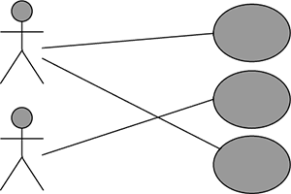

**Figure 2.1: Use Case Diagram**

Use Case diagrams are ideal for:

1. Representing the goals of our system-user interactions.
2. To define and organize functional requirements in a system.
3. To specify the context and requirements of a system.
4. Modeling the basics flow of events in a use case.

**2.3.2 Technology Used**

**2.3.2.1Code Blocks**

Source code blocks have features specifically designed to simplify and speed up input of source code, such as [syntax highlighting](https://en.wikipedia.org/wiki/Syntax_highlighting), [indentation](https://en.wikipedia.org/wiki/Indent_style), [auto complete](https://en.wikipedia.org/wiki/Autocomplete) and [brace matching](https://en.wikipedia.org/wiki/Brace_matching) functionality. These blocks also provide a convenient way to run a compiler, interpreter, [debugger](https://en.wikipedia.org/wiki/Debugger), or other program relevant for the [software development process](https://en.wikipedia.org/wiki/Software_development_process). So, while many text blocks can be used to edit source code, if they don't enhance, automate or ease the editing of code, they are not source code blocks, but simply text blocks that can also be used to edit source code.

[Structure blocks](https://en.wikipedia.org/wiki/Structure_editor) are a different form of source code block, where instead of editing raw text, one manipulates the code's structure, generally the [abstract syntax tree](https://en.wikipedia.org/wiki/Abstract_syntax_tree). In this case features such as syntax highlighting, validation, and code formatting are easily and efficiently implemented from the [concrete syntax tree](https://en.wikipedia.org/wiki/Concrete_syntax_tree) or abstract syntax tree, but editing is often more rigid than free-form text. Structure blocks also require extensive support for each language, and thus are harder to extend to new languages than text blocks, where basic support only requires supporting syntax highlighting or indentation. For this reason, strict structure blocks are not popular for source code editing, though some IDEs provide similar functionality.

For code block, we have used:

i) Sublime Text Block (Version 13.3)

ii) Dreamweaver (Version 8.5)

**2.4 Conclusions**

The new era of technology has changed our life by providing more and more facilities. Not different for the Resort management. Is has tried to change the manual process of booking. Resort Management Project is not about just booking Resort rooms. The others facilities of this project was more than a resort management. We have tried to make our system as we want and the user want. Only an user friendly system can be successful otherwise it will go to vain. We have tried to make our system more eye catchy and more user friendly. It was not an easy task for us. Everything was not always gone at our side. We had to face some critical problems. Thanks to almighty, we were able to recover that situations. We three were really well connected every single time to give our hundred percent on it.

**CHAPTER-3**

**PROPOSED MODLE**

**___________________________________________________________________________**

**3.1 Introduction**

Our proposed model stands for adding new facilities that is not present existing system. Some developed countries are providing all the requirements as the users expect. But the country like Bangladesh here we can see that most of the Resort Management system are following their traditional system and procedure. Almost all the managerial sites are manual. That’s why the customers form along country and also from the others countries are not happy with these kind of system. As a result the whole business system suffers. We have put all the procedure schedule and technique so that anybody can understand how the project established. We have tried to design the Project in such a way that user may not have any difficulty in using this package & further expansion is possible without much effort. Even though we cannot claim that this work to be entirely exhaustive, the main purpose of our exercise is booking Resort rooms in online process instead manually. The diagrams and the flow chart have been introduced. And also shown for our Resort Management System.

**3.2 Feasibility Study**

Feasibility study for our Online Resort Management System evaluated our project’s potential for success; therefore, perceived objectivity is an important factor in the credibility of the study for potential investors and lending institutions. The way we want to establish and want to refer for online. The operational, technical and economical statements are introduced for our system. The always gives very important services through any kinds of online and office management system. We also need feasibility study. Because a dynamic project like Online Resort Management System here, we had to thought about all the environment for this system. If we think about operational and technical feasibility, these two are mostly high rated topic. And everybody who wants to build a project read all the module of these study and make decisions of planning. Because only providing a project is not acceptable if we not think about our whole environment. So, if we think about our nowadays system then it is most important.

Feasibility Studies were important for our Online Resort Management System. Because-

The information we gather and present in our feasibility study helped us are:

i) Identifying all the things we need to make for the Resort management work.

ii) Pinpointing logistical and other management-related problems and solutions.

iii) Serving as a solid foundation for developing our system plan.

We are introduced with different types feasibility study. Their explanations are given right below.

**3.2.1 Technical Feasibility**

Technical Feasibility for our Online Resort Management System is we focused on the technical resources available to the organization. It will helps organizations determine whether the technical resources meet capacity and whether the technical team is capable of converting the ideas into working systems. Technical feasibility also involves evaluation of the hardware, software, and other technology requirements of the proposed system. As an exaggerated example.

Technical feasibility study for our project examined a number of variables and can reveal that even though a project might be profitable or beneficial to our project, we don’t have the resources to pull it off. A technical feasibility study might show that you should go forward with a project but at a specific time. Conducting a feasibility study helps you determine our likelihood of success and can indicate how and when to do a project.

**3.2.2 Operational Feasibility**

This kind of feasibility assessment involves undertaking a study to analyze and determine whether and how well the our organization’s needs can be met by completing the project. For our Online Resort Management System operational feasibility studies also analyze how we planned for our project satisfies the requirements identified in the requirements analysis phase of whole project.

Operational feasibility for our project studies are generally utilized to answer the following questions:

**i) Process**

How we decorated our project for the users as they want to use.

**ii) Evaluation**

Evaluating the whole program for all the contents.

**iii) Implementation**

Stakeholder of Resort Management, Resort Manager, and end-user tasks.

**iv) Resistance**

Resort Management Team, and individual resistance and how that [resistance will be handled](https://www.brighthubpm.com/change-management/34940-overcoming-resistance-ignorance-and-denial-in-change-management/).

**3.2.3 Economical Feasibility**

For the dynamic project like Resort Management System, Economic Feasibility typically involves a cost or benefits analysis of the project, helping organizations determine the viability, cost, and benefits associated with a project before financial resources are allocated. It also serves as an independent project assessment and enhances project credibility—helping us to determine the positive economic benefits to the organization that the proposed project will provide.

Also virtual services is an ideal destination for an organization, need to do an economic feasibility for a project. And when it comes Online Resort Management System then

the highly qualified and experienced professionals from the relative field perform the research with excellent proficiency. While we have done the study we always take care of the essential factors needed to carry out a successful project like this.

Our study was based on cost and time. Under the cost based study we have evaluate the development cost and the operating cost. We also calculated an approximate time frame to receive returns against investment keeping in mind the future value of the project. During the process of economic feasibility study we followed certain best practices to get the desired result. We do certain assumptions on the basis of which we give you solid plan of investment.

**3.3 Non-Functional Requirement**

For our Resort Management System, a non-functional requirements are some requirements those specified the criteria’s that can be used to judge the operation of a system, rather than specific behaviors. They are contrasted with functional requirements that define specific behavior or functions of our project.

**3.3.1** **Performance Requirement**

Performance requirements define acceptable response times for system functionality.

i) The load time for user interface screens shall take no longer than two seconds.

ii) The log-in information shall be verified within five seconds.

iii) Queries shall return results within five seconds.

**3.3.2** **Logical Database Requirement**

The logical database requirements include the retention of the following data elements.

This list is not a complete list and is designed as a starting point for development.

**1.User-Friendly Interface**

A Resort booking engine with a good user-friendly interface will allow customers to easily navigate through our software. Thus, increasing the chances for booking as customers prefer to stay longer on a seamless software.

**2. Easy Booking Process**

The booking process should include minimal steps. If it takes a long time to fill unnecessary forms, chances are that the customer will abandon the booking and head to other softwares.

**3. Offline Booking**

A Resort booking should be able to offer users options to handle them on-desk and online bookings. If a customer walks in they should be able to book rooms from the back-end of the system.

**4. Easy Room Management**

Adding the details like the amenities and features of rooms, editing the status of rooms when the time arises and also room a reallocation facility to change rooms at a customer's demand.

**6. Easy Search Option**

Customers must able search for Resorts in a particular location and view the availability of rooms in between the preferred dates.

**3.3.3 Design Constraints**

The Resort Management System stand-alone system running in a Windows environment. The system has been developed using C language our main target to build up this project. Everything was not always gone at our side. We had to face some critical problems. Thanks to almighty, we were able to recover that situations. We three were really well connected every single time to give our hundred percent on it.

**3.3.4** **Reliability**

Specify the factors required to establish the required reliability of the software system at time of delivery. For Resorts if those are very expensive, they seem to offer lower than "rack" rates (the highest rate that a Resort will charge), but for a lot of less expensive Resorts, user can find better rates at the Resort than through any booking software. Booking softwares contract with Resorts to be listed. We always thought that the contract prevented the Resort from offering a lower rate than that shown on the booking software. However, there are tricks that resorts can use to charge user less for booking online [18]. But the biggest difference, user have found, is that most Resorts don't contract with a booking software because they won't pay the any commission that the booking site takes, so they are not listed on any booking software. Time after time, we've found 2 to 3 times as many places offered on a town's software vs what are available from booking softwares, and the extra places on the town's software are the less expensive half or 2/3rds of the places in town. True, they might not be good Resorts with twenty-four-hour room service and heated towel racks, but I don't

shall be available during normal Resort operating hours. Because user can access Resort rooms from anywhere at anytime, users are not tied to your reception desk. Resort Management System is based in C programming. Whether user are using a laptop at Resort, Resort Management demand those things. We have tried to ensure these issues in our system.

**3.3.6** **Security**

Customer Service Representatives and Managers will be able to log in to the Resort Management System. Managers will have access to the Management subsystem as well as the Booking. Access to the various subsystems will be protected by a user log-in screen that requires a user-name and password.

**3.3.7** **Maintainability**

The Resort Management System is being developed in C language.Also used File that work in runtime and familiar to maintain.. Maintenance Engineering is the discipline and profession of applying [engineering](https://en.wikipedia.org/wiki/Engineering) concepts for the optimization of equipment, procedures, and departmental budgets to achieve better [maintainability](https://en.wikipedia.org/wiki/Maintainability), [reliability](https://en.wikipedia.org/wiki/Reliability_engineering), and availability of equipments.

Maintenance, and hence maintenance engineering, is increasing in importance due to rising amounts of equipment, systems, machineries and infrastructure. Since the [Industrial Revolution](https://en.wikipedia.org/wiki/Industrial_Revolution), devices, equipment, machinery and structures have grown increasingly complex, requiring a host of personnel, vocations and related systems needed to maintain them. Maintenance is to ensure a unit is fit for purpose, with maximum availability at minimum costs. Our Resort Management system is providing all these maintenances through customers demand.

**3.4 Functional Requirement**

In Software engineering and systems engineering, a functional requirement defines a function of a system or its component. Functional requirements may be calculations, technical details, data manipulation and processing and other specific functionality that define what a system is supposed to accomplish. Here the functions is described as a set of inputs, the behavior, and outputs.

Functional Requirements for our system are-

**i) Admin Login**

For user login we have require some key values those are very important for any types of login system.

a) User name

b) Password

**ii) Main Manu**

There are six systems in our menu.

1. Book a Room,
2. View customer Record,
3. Delete Customer Record
4. Search customer Record
5. Edit customer Record
6. Exit

**i) Booking a Room**

Booking procedure is one of the most important procedure in our system. For booking rooms users will find the facilities of-

a) At First enter room number

b) Customer name

c) Customer address

d) Customer phone number

e) Customer nationality

f) Period time to stay

g) Customer arrival date

When all information is correctly input then a room is successfully booked

**ii)View customer record**

The user can get all the information of the customer .When user try to find all customer records then user easily can get all the information of every customer at a time.

**iii) Delete customer record**

When any customer want to cancel his other room then user can delete his or her booking by searching the room number

**iv)Search Customer Record:**

If user inputs only room number then he can get the information of the customer who is staying in the following room.

**v)Edit Customer Record :**

If user inputs wrong information of any customer then user can change every information such as name, phone number, address, arrival date etc.

**vi)Exit system**

**3.5 System Design**

Systems design is the process of defining the architecture, components, modules, interfaces, and data for a system to satisfy specified requirements. System designing in terms of software engineering has its own value and importance in the system development process as a whole. For our Resort Management System we have described all these step by step.

**3.5.1 Flow Chart**

A flowchart is a diagram that depicts a process, system or computer algorithm. They are widely used in multiple fields to document, study, plan, improve and communicate often complex processes in clear, easy-to-understand diagrams. Flowcharts, sometimes spelled as flow charts, use rectangles, ovals, diamonds and potentially numerous other shapes to define the type of step, along with connecting arrows to define flow and sequence. They can range from simple, hand-drawn charts to comprehensive computer-drawn diagrams depicting multiple steps and routes. If we consider all the various forms of flowcharts, they are one of the most common diagrams on the planet, used by both technical and non-technical people innumerous fields. The flow chart for our Resort management system is given below.

The flow chart for our Online Resort Management System is shown below in figure 3.6 in the next page.

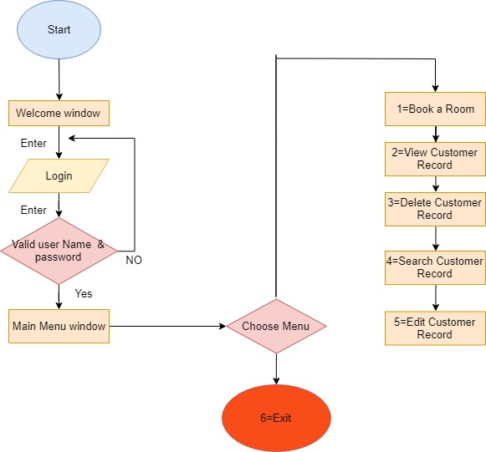

**Figure 3.5.1: Flow Chart**

**3.5.2 Use Case Diagram**

In software and systems engineering, a use case is a list of actions or event steps typically defining the interactions between a role known in the Unified Modeling Language as an actor and a system to achieve a goal. The actor can be a human or other external system. In this section we will discuss about Use Case Diagram on basis of our Resort management system.

**3.5.2.1 Use Case Diagram for Admin**

Admin is one of the major part of our system. Admin has a huge impact on our system. The Use case formalities for admin panel are login, edit rooms details, manage booking, manage feedback, manage extra services-

**I) Login**

For admin, there are separate user id and password to login

**II) Book a Room**

Here customer book a room by user

**III) View customer Record**

Here we find all the customer record

**IV) Delete Customer Record**

Here we delete any customer record

**V) Search customer Record**

For find any customer details

**VI) Edit customer Record**

If user input wrong information then user edit the record

**VII) Exit**

An use case diagram for User is drawn below in figure 3.5. Here we can see the admins activity relationships.

Login

Admin

Book a room

View customer record

Delete customer record

Search customer record

Edit record

**Figure 3.5: Use Case Diagram for Admin**

**i) Search Customer Record:**

If user inputs only room number then he can get the information of the customer who is staying in the following room.

**ii) Book Rooms**

By fulfilling all the requirements and procedure, they can book any Resort rooms from our Resort management system.

**iii)View customer record**

The user can get all the information of the customer .When user try to find all customer records then user easily can get all the information of every customer at a time.

**3.7 Conclusions**

A good project depends on good design and good implementation according to the design. This chapter is actually about the design analysis, which contains mainly used method to draw up the system procedure through diagrams, flowcharts, database schemas and user modules. That means how the system we have designed and implemented. Various types of system test are also included here with database and error handling. We have tried to make our system, as we want and the user want. Only an user friendly system can be successful otherwise it will go to vain. We have tried to make our system more eye catchy and more user friendly. We have shown different table and figure in this chapter those are very necessary to implement. Figures are drawn so that to clarify how our project works gone through and how we implemented our project. Some topics are allowed to described in this chapter to explain their works and procedural method. The necessity of this chapter is all about practical implementation of our works strategy. Several types of diagrams are shown in this chapter. Diagrams on basis of our Resort management system allowed to add in this system so that anybody can find our system procedure. Because diagram are more effective than theoretical elements to understand system procedure and task categories.

**CHAPTER- 4**

**EXPERIMENTAL RESULT**

**___________________________________________________________________________**

**4.1 Introduction**

In this chapter, we are going to describe all the experimental and outcomes of our developing project Resort Management System. We have put all the procedure schedule and technique so that anybody can understand how the project established. We have tried to design the Project in such a way that user may not have any difficulty in using this package & further expansion is possible without much effort. Even though we cannot claim that this work to be entirely exhaustive, the main purpose of our exercise is booking Resort rooms process instead manually. The diagrams and the flow chart have been introduced. And also shown for our Resort Management System.

**4.2 Testing of Various Function**

Testing of various functions are discussed below.

**i) Invalid User name or Password**

If user puts an wrong user name and password then it shows login is unsuccessful.

**ii) Offline Access**

Offline accessible procedures are available in our Resort Management System.

**iii) Confirmation**

A confirmation message will be shown after implementing all the procedure.

**4.3 Result Analysis**

After implementation we have find out our expected result. Every implementation we have carried out different result. This section shows all the various test result just to insure that the system is working.

**4.3.1 Unit Test Cases**

Unit testing is a software development process in which the smallest testable parts of an application, called units, are individually and independently scrutinized for proper operation. Unit testing can be done manually but is often automated.

The testing elements are-

**i) Input Values**

The values of empty field should be filled to go to the next procedure.

**ii) Expected Functionalities**

All the functionalities are tested to ensure that they are available to implant their procedural works.

**iii) Output Values**

For the correct input our project will be ok to give perfect reply.

**iv) Path Coverage**

Cover aging the path where all the functionalities are processed also tested and they are absolutely fine.

**vi) Error Message**

For incorrect inputs the system will show the error message.

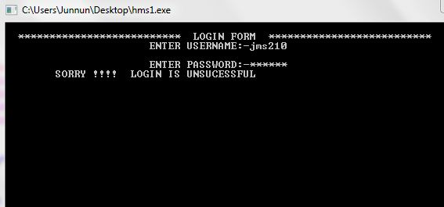

**Figure: 4.3 Showing Error Message**

**vii) Screen Layout**: Had a good look on screen layout and its fine to proceed.

**4.3.2 Test Scenario for room booking**

**i) Book a Room**

1. User can view rooms and rooms details

**ii) Search Rooms**

Search room any time for searching the customer information.

|  |  |  |
| --- | --- | --- |
| **Serial No.** | **Test** | **Result** |
| Test 1 | Customer Details | Customer details are Shown |
| Test 2 | Search Rooms | Rooms information are Shown |
| Test 3 | Book Room | Room Selected for reserve |
| Test 3 | Delete Room | Room is successfully delete |

**Table 4.4 Test Case of Room Booking**

**4.5 Application Outcome**

Our project has been developed for several uses in different applications and organizations. The main applications for our system are given below-

**i) Resort Reservation System**

For any kind of Resort reservation system our system is reliable to use.

**ii) Train Reservation**

Train reservation can be consider as a application for our system. Because this reservation is containing the reservation and the cancellation. Also providing the well organized admin panel facilities.

**iii) Hostel Reservation**

Hostel reservation is quite similar to Resort reservation system. So it can be considered as our systems application outcome.

**iv) Airline Reservation**

Airline reservation needs cancellation and reservation modules. Our system has those facilities. So airline reservation is our another application for use.

Also for any kind of reservation system our system can be used.

**4.6 Conclusions**

The system will built such a way that it will be useful and user friendly to general user. Result analysis has given a brief that how we execute our overall system through testing, observing and analyzing. This was the proper way to know whether the system is working properly or not. It also means the system provides mainly what kind of facilities and if it’s better and reliable option for people to get online bus ticket services through our system .Actually different management have different knowledge to implement their system procedure. We have tried to make our system as we want and the user want. Only an user friendly system can be successful otherwise it will go to vain. We have tried to make our system more eye catchy and more user friendly. We have shown different table and figure in this chapter those are very necessary to implement. Figures are drawn so that to clarify how our project works gone through and how we implemented our project. Some topics are allowed to described in this chapter to explain their works and procedural method. The necessity of this chapter is all about practical implementation of our works strategy. The database in our project, how we execute it has been carries out. The tables are defined in a well defined way. Its has been a great task for us to make it possible. This application of system also belongs in this part that clear we have created our expected online Resort Management System to support people with saving their time and energy.

**CHAPTER 5**

**USER MAMUAL**

**___________________________________________________________________________**

**5.1 Introduction**

This chapter contains all the hardware and software requirements for using the system and also user manual for both admin and user. User manual is directional system of a project. It provides the direction to the users who don’t know how to use the software. It denotes which page will come after which one. It also denotes which task we have to do after which one, how to book rooms etc.

**5.2 System Requirements**

Our project is a web based system. So it will be seated up into a server, from which user and admin can access the software. So both user and admin don’t need any special requirement to browse our software. But sometimes for a reason, for smooth performance user or admin need at least a computer those have some qualities.

**5.2.1 Hardware Requirements**

To be used efficiently, all computer software needs certain hardware components or other software resources to be present on a computer. Most software defines two sets of system requirements: minimum and recommended. Minimum requirements means we should have minimum range of hardware that can supports our whole system. And recommended requirements means our system is going to require a set of hardware’s that must be need to work with our system. Our project named Online Resort Management System is requires some of the hardware’s that should be provided by the Resort authority. Those all are computer components. Computer hardware is the collection of physical parts of a computer system. This includes the computer case, monitor, keyboard, and mouse. It also includes all the parts inside the computer case, such as the hard disk drive, motherboard and many others. Computer hardware is what we can physically touch.

**5.2.1.2 For Client Sides**

**i) Computer**

The System needs

1) Pentium IV 1GHz

2) Minimum of 512 MB RAM (Recommended)

3) Minimum 40Gb Hard disk for storage

**5.2.2 Software Requirements**

To be used efficiently, all [computer software](https://en.wikipedia.org/wiki/Computer_software) needs certain [hardware](https://en.wikipedia.org/wiki/Computer_hardware) components or other software resources to be present on a [computer](https://en.wikipedia.org/wiki/Computer).  These prerequisites are known as software requirements and are often used as a guideline as opposed to an absolute rule. System requirements tend to increase over time. Management analysts like Resort Management system suggest that this trend plays a bigger part in driving upgrades to existing computer systems than technological advancements. A second meaning of the term of System requirements is a generalization of this first definition, giving the requirements to be met in the design of a system or sub-system.

**5.3 Admin Site**

This part will introduce how will be the admins plan to this system. How will be his contribution in this system? He will be able to see all the data from anywhere of the system. If we look at the admins User Interface then we will see some procedure that is ready for the admin. 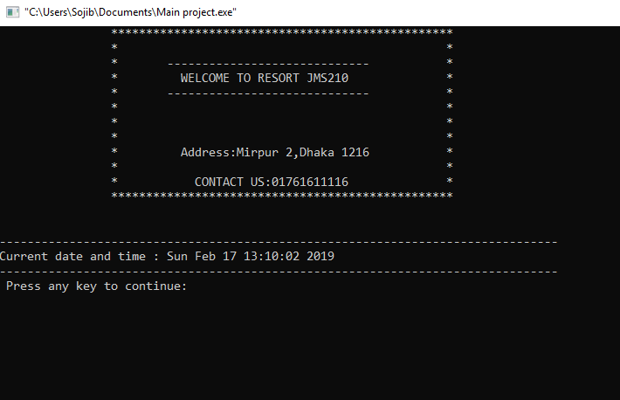 **5.0: Welcome Page**

**1) Admin’s Login Page**

This is the what that admin can see after login. The admins login page and the users homepage after connecting our software are almost same. The main difference between admins page and the users page is admin have to be provided his user id and password but users don’t need to provide his user id and password. Here it is shown in figure 5.1.

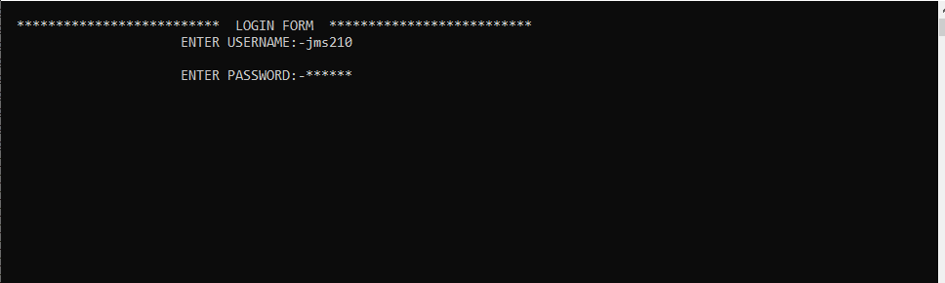

**Figure 5.1: Admin Login Page**

**2) Book a Room**

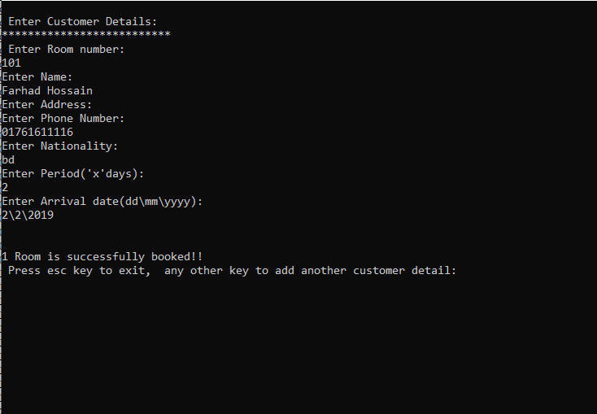

**Figure 5.2:Book a Room**

**3) Delete customer record**

Cancelled rooms will helps to the admin to check how many rooms are cancelled after booking. User can cancel their booked rooms if they have number code they get after payment. If they cant provide their code they wont be able to cancel their booked Resort. It is shown in figure 5.3

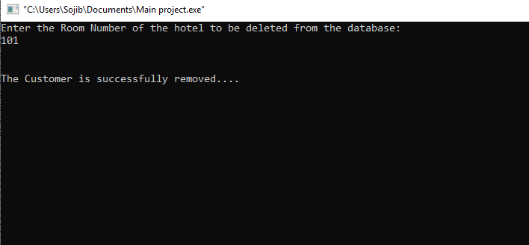

**Figure 5.3: Cancelled Rooms**

**4) Edit Customer Record**

This page will show the Edit system of the our Resort Management System. The admin can edit all the information about any categories of Resort rooms. It is shown in figure 5.4.

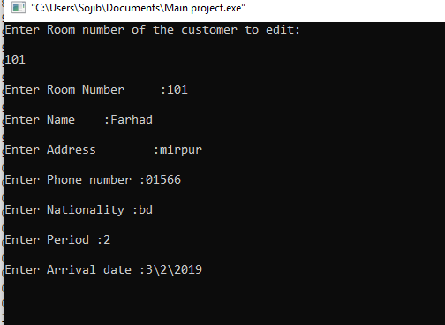

**Figure 5.4: Edit system**

**5) User Feedback**

From this page admin will get the feedback from the users message. For this procedure the users information will be provided to the admin. The amount of total users message or feedback will be save to the admins panel. It is shown in figure 5.5.

**6) Search**

Searching rooms by the clients will be like as figure 5.5.

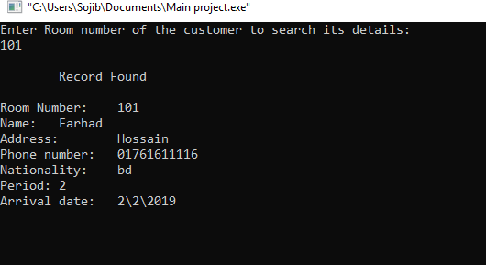

**5.5: Search system**

**5.4 Conclusions**

User manual or GUI is a program interface that takes advantages of the computers graphics capabilities to make the problem easier to use. Well-designed graphical user interfaces can free the user from learning complex command languages. On the other hand, many users will find this easier and effective. They will find it with a command-driven interface, specially if they already know the command language. But it also help those users who have not more knowledge about the program or system easily. It shows the direction to the user and admin from which page to go to which one. User can know the system facilities from here. Actually different management have different knowledge to implement their system procedure. We have tried to make our system as we want and the user want. Only an user friendly system can be successful otherwise it will go to vain. We have tried to make our system more eye catchy and more user friendly. If anybody visit our software he will find our all the services and all the features in a single page. We have designed our homepage so that anybody can find all the facilities. From homepage they also can go through different options and services. Hopefully it will be helpful for any management system.

**CHAPTER 6**

**CONCLUSIONS AND FUTURE PLAN**

**___________________________________________________________________________**

**6.1 Conclusions**

It was a great opportunities for us to work in “Online Resort Management System” as an intern and design a system of it but there were surely some limitations while implementing this system. To reduce those limitations we have some future plans also. This project is designed to meet requirements of a Resort management system. By using this application, the company can provide reservation service and information to their customers without limitations of office hours and manpower. Customers will get the Email if their payment process is correct and completed. It is also for the admins of the whole system who can look at the system like room edit, approval, getting feedback from customers. It is designed for use by the company internally manage their business processes; minimizing human errors and overcoming difficulties and problems that arose in the manual system.

The previous booking system was manual. It was not effective and time saving for the both customers and admins. Customers had to go to the booking counter, had to paper on hand, had to queue in hours. But sometimes they had to go at home with empty hands because of unavailable rooms. On the other hand for admins, they also had to keep paper records. For a system like Resort management system here it is too difficult to maintain all the requirements on papers. In the era of twenty first century any softwares of any institution is necessary for all kinds of business purposes and to to introduce themselves more easier and efficient way. The online based project is always challenging to create or development. As a fresher it is more difficult to establish a dynamic project like this. Resort Management Project is not about just booking Resort rooms. The others facilities of this project was more than a Resort management. The facilities we have provided in this project was just fabulous to see. It was not a easy task for us. As inexperienced developers, to create dynamic project like this was too tough. We have tried all the basic knowledge what we know. We have produced our university life experienced on it. Everything was not always gone at our side. We had to face some critical problems. Thanks to almighty, we were able to recover that situations. We three were really well connected every single time to give our hundred percent on it. Hopefully this will be able to ensure that all the requirements are available as a dynamic Resort Management System.

**6.2 Future Plan**

The limitations of the study are those characteristics of design are methodology that impacted or influenced the interpretation of the findings from our research. Though we have tried our level best to make our system more user friendly and flawless by using the modern technologies, some minor functionalities exist in our system due to time constraints. The limitations of the system are-

1) Without computer no one won’t be able to access this system .

2) Available room facilities isn’t available in our system.

3) Room with cost suggestions are not available in our system.

4) No Error system when two room are booked at a time

The project made here just to ensure that is project could be valid in today’s real challenging world. Here all the facilities are made and tested to ensure easy and secure online booking sytem. In future the overall system will be extended when we will improve our project. Then the users will get more services from our system.

In future these features will be added in our system-

1) Available room facilities

2) Error system add when two room are booked at a time.

3) Room cost will be add in our future project .

**REFERENCE**

[1]. SumanthDeeti, SravaniManne, VeerendraVundavalli, January- 2016, “*OPUS Open Portal to University Scholarship*”, Governors State University, India.

[2]. Stephen Haag, 2011, “*Software Information System*”, Aniels College of Business at the University of Denver.

[3].S.Koolmanojwong,Thailand 2000, "Analysis and Design of B to C E-Marketplace for Tourism with UML *" M.S. Thesis, Faculty of Science and Technology*, Assumption University, Bangkok,.

[4].M. J. O'Fallon and D. G. Rutherford. 2011. “*ResortManagement and Operations”* | CA College of Ayurveda.

# [5]. Kenneth C Laudon, 2016, “*Management Information System*”, Stern Graduate School of Business, New York.

[6] IanSommerville,Software Engineering 8th edition.Pearson education,2008. [2] ElmasriNavathe,Fundamentals of Database System 3rd edition.Pearson education,2000. *Resort Management System Salman Rana BCS02133279*

[7] RaguRamakrishnan/JohnesGehrke,Database Management Systems 3rdedition.McGrow-HILL,2003. [4] Gerald W. Latin, Modern Resort management, W.H.Freeman, 2011. [5] Michael J. O'Fallon, Denney G. Rutherford*, Resort Management and Operations illustrated edition*, John Wiley & Sons, 2001

[8].E. W. T. Ngai and F. K. T. Wat, "Design and development of a fuzzy expert system for Resortselection," Omega, vol. 31, pp. 275-286, 2003.

[9].W. S. Grayand S. C. Liguori, Resort*and Motel Management and Operations,* Fourth Edition ed.: Prentice Hall, 2002.

# [10] Darren DeMatas, “*Mystery Out of Ecommerce*”, Second edition ed: Newyork, 2015.

# [11][Melissa Hall](https://www.quora.com/profile/Melissa-Hall-86),, “*super cool SaaS product*”, Quarterly, vol. 30, pp. 40-45, 1989, 2013.

[12]M. S. Islam, et al.,in 2009 "*An Automated Intelligent ResortManagement System,*" Interdisciplinary Conference in Chemical, Mechanical and Materials Engineering (2009 ICCMME), Melbourne, Australia, 2009.

[13]. Joel Murach, Michael Urban., 2014 *,JAVA servlets,* Mike Murach,

[14]OgirimaSanniOmuya “*Computerized ResortManagement”.*Unpublished Higher National Diploma (HND) dissertation, Department of Compter Science, Kwara State Polytechnic, Ilorin, Nigeria.

[15]. Bryan Basham, Kathy Sierra ., , 2008 ,*Head First EJB* ,O'Reilly Media; Second edition .

[16]Landvogt, M. (2004) *Online booking engines for small and medium-sizedenterprises*as a tool for improved distribution and yield management in New Zealand’s tourism industry.

[17]In Smith, K. A. and Schott, C. (2004) eds. *Proceedings of New Zealand Tourism and Hospitality Research Conference 2004.* Wellington, 8-10 December. pp. 191-198.

[18]Susmitapaul,Paul Neel [2011],Software Engineering 8th edition.Pearson education,2008.

[19].Law, R., J. Wong (2003) *Successful factors for a travel web Journal of Hospitality and Tourism Research* 27(1), pp. site: Perceptions of online purchasers in Hong Kong. 118-124.

[20]Law, R., K. Leung (2005*) Online airfare reservation services*: A study of Asian-based and North

[21]American-based travel softwares*. Information Technology and Tourism* 5(1), pp. 25-33

[22]Schegg, R., T. Steiner, S. Frey, J. Murphy (2002*) Benchmarks of software design and marketing by Swiss Resorts.* Information Technology and Tourism 5(2), pp. 73-89

[23].Ivanov, S (2002) *Online Resort reservation systems*. Proceedings of “Tourismin 21st Century” Conference, Sofia University, 29th November 2002, Sofia, Bulgaria, pp. 248-254(inBulgarian).

[24]. Rene Enriquez .,2014 *, JAVA Security, Packt Publishing*

[25]. Shadabsiddiqui.,, 2002*.J2EE Professional, Premier Press*; 1 edition[15].G. Jingzhi, et al., "Alibaba International: Building a Global Electronic Marketplace," in e-Business Engineering, 2006. ICEBE '06. IEEE International Conference on, 2006, pp. 545-548.

[27]. Steven Feuerstein, Bill Pribyl ., 2014,*PL/SQL Programming*, O’Reilly Media

[28]. Jon Duckett ., 2014,*Java Script Programming*, Wiley []. Fatima Al Ghannan, Fatima Al Tuhaifa, June-2011, “*Resort Management System*”, ASSE 4311- Assesmant 1, Dubai.

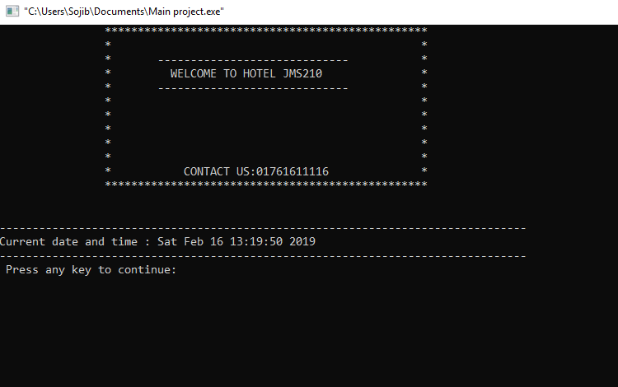

**1.Welcome screen**

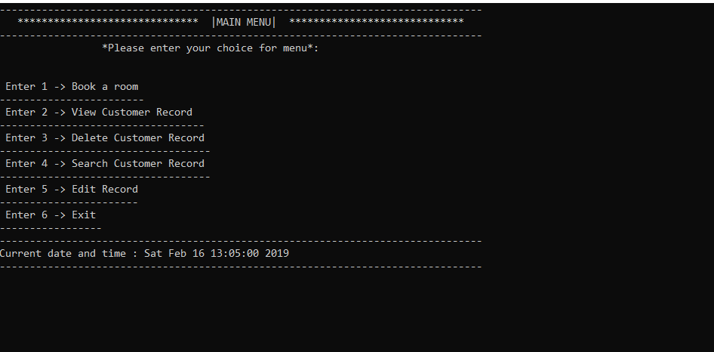

**2.Main manu**



**3. Edit window**



**4.Search Customer Record**



**5.Delete Customer Record**

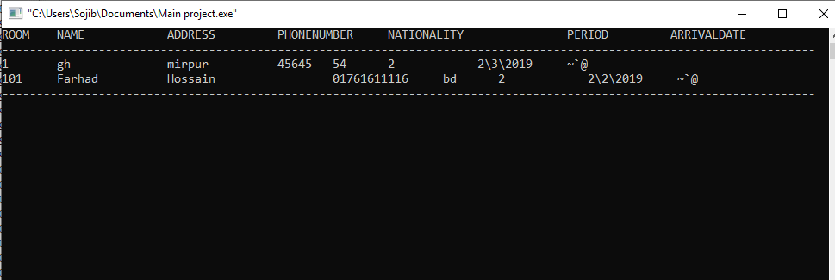

**6.View Record**



**6. Customer Details**



**7. Login**