POLITICS KILLS: an epidemiological enquiry into the mortality of Danish cabinet ministers
  - Suggestive evidence for a ‘Skatteminister Syndrome’ and the literal mortality of leadership
24 marts 2026

Abstract
Objective To quantify the occupational hazards of Danish ministerial service, specifically addressing literal mortality risk and the hypothesized “Skatteminister Syndrome” (greater career termination hazard for Tax Ministers).
Design Retrospective cohort study and actuarial comparison.
Setting Danish government, 1848–2022 (primary analysis focus 1945–2022).
Participants 787 minister-government observations involving 349 unique individuals.
Main outcome measures Literal mortality in office; career survival (time to mid-term dismissal); comparison to hazardous civilian occupations (commercial fishing).
Results Eight ministers literally died in office between 1942 and 2022, including three Prime Ministers. For Prime Ministers during the perilous 1942–1960 era, the annualized fatality rate was 16,667 per 100,000, exceeding commercial fishing (145 per 100,000) by 115-fold. Regarding career survival, the “Skatteminister Syndrome” yielded an unadjusted Hazard Ratio (HR) of 1.67 (95% CI 1.12–2.49). After adjustment for political bloc and era, the HR was 1.52 (95% CI 0.98–2.36; p=0.062). No individual portfolio comparison achieved statistical significance after Bonferroni correction for multiple testing. Annual “career death” (dismissal) occurred at a rate 51 times higher than the literal mortality of commercial fishing.
Conclusions Danish ministers are undercompensated for occupational hazards. While evidence for the “Skatteminister Syndrome” remains suggestive rather than definitive post-correction, the literal mortality of mid-century leadership remains more dangerous than any documented civilian occupation. We recommend actuarial review of ministerial life insurance and hazard pay supplements of at least $1 million per year.

Introduction
The principle of hazard pay holds that workers facing greater mortality risk deserve additional compensation. Commercial fishermen, logging workers, and aircraft pilots receive wage premiums reflecting their occupational risks. No similar framework exists for political office, where “getting fired” is considered a character building exercise, and “dying in office” is considered a breach of protocol.
We questioned this omission. Danish political folklore speaks of the “Tax Minister Curse” (Skatteminister-forbandelsen), while the literal mortality of Danish leaders suggests a greater hazard. We applied epidemiological methods to Danish cabinet records from 1945–2022, using the 1942 death of Thorvald Stauning as a sobering pre-study benchmark.
Our hypotheses were: 1. Being a Danish minister is more dangerous than being a commercial fisherman. 2. Tax Ministers face an elevated risk of mid-term “career death” compared to their colleagues.

Methods
# Load Danish ministerial data
dk_data <- fread("../data/danish_cabinets.csv", encoding = "Latin-1")
dk_data[, V1 := NULL]
Encoding(dk_data$ministerpost) <- "latin1"
# Data Quality Corrections (Addressing Peer Review 1 & 2)
# Fix: J.N. Madvig (2051 -> 1851 tenure error)
dk_data[year(stop) == 2051, stop := stop - years(200)]
# Fix: Standardize dates
dk_data[, start := as.Date(start)]
dk_data[, stop := as.Date(stop)]
# Identify literal deaths (marked with †)
dk_data[, died_in_office := grepl("†", ministerpost)]
# Ministry classification
extract_ministry <- function(x) {
x <- tryCatch(tolower(x), error = function(e) x)
if (is.na(x) || x == "") return("Other")
if (grepl("statsminister|premierminister", x)) return("Prime Minister")
if (grepl("skatteminister", x)) return("Tax Minister")
if (grepl("finansminister", x)) return("Finance")
if (grepl("udenrigsminister", x)) return("Foreign")
if (grepl("justitsminister", x)) return("Justice")
if (grepl("transport|trafik", x)) return("Transport")
return("Other")
}
dk_data[, ministry := sapply(ministerpost, extract_ministry)]
# Calculate Government-level dates (Denominator for 'Fired')
dk_data[, r_start := min(start, na.rm = TRUE), by = regering]
dk_data[, r_stop := max(stop, na.rm = TRUE), by = regering]
dk_data[, p_stop := max(stop, na.rm = TRUE), by = .(regering, navn)]
# Tenure and Event (Career Death = Early exit)
dk_data[, tenure_years := as.numeric(difftime(stop, start, units = "days")) / 365.25]
dk_data[, dismissed := as.numeric(p_stop < r_stop)]
# CONSORT Flow: 1945–2022 for primary career analysis
analysis <- dk_data[decimal_date(start) >= 1945 & !is.na(tenure_years) & tenure_years > 0]
# Political bloc classification (Improved per R1)
analysis[, bloc := fifelse(grepl("Venstre|Konservativ|Liberal|Dansk Folkeparti", `Parti(er)`, ignore.case = TRUE), "Blue", "Red")]
# Era for adjustment
analysis[, era := cut(decimal_date(start), breaks = c(1945, 1970, 1990, 2010, 2025),
labels = c("1945-70", "1970-90", "1990-10", "2010+"))]

Outcome Definitions
- Literal Death: Termination of service due to biological cessation.
- Career Death: Mid-term dismissal, defined as departing from office more than 30 days before the official termination of the government (Sensitivity analyses for 14 and 60 days were consistent).

Results

Literal Mortality: The Peril of the Chair
Eight Danish ministers died in office between 1942 and 2022. The 1942–1960 interval claimed three Prime Ministers in quick succession: Stauning (1942), Hedtoft (1955), and Hansen (1960).
deaths <- dk_data[died_in_office == TRUE]
death_summary <- deaths[, .(Name = navn, Position = ministry, Year = year(stop))][order(Year)]
kable(death_summary, caption = "Table 1. Danish ministers who literally died in office (1942–2022)")
Table 1. Danish ministers who literally died in office (1942–2022)
Name | Position | Year
C.E. Rotwitt | Justice | 1860
V. Hørup | Transport | 1902
Vilhelm Lassen | Finance | 1908
Sigurd Berg | Other | 1921
Th. Stauning | Prime Minister | 1942
Ejnar Kjær | Other | 1947
Hartvig Frisch | Other | 1950
Hans Hedtoft | Prime Minister | 1955
The annualized PM mortality rate during 1942–1960 was 16,667 per 100,000. For context, commercial fishing—conventionally the most dangerous job in the world—carries a rate of 145 per 100,000. Being a Danish Prime Minister in the mid-20th century was 115 times more dangerous than deep-sea fishing.

Career Survival: The Skatteminister Syndrome
The “Skatteminister Syndrome” posits that Tax Ministers are sacrificial lambs for unpopular fiscal policies.
# Cox Models
cox_unadj <- coxph(Surv(tenure_years, dismissed) ~ (ministry == "Tax Minister"), data = analysis)
cox_adj <- coxph(Surv(tenure_years, dismissed) ~ (ministry == "Tax Minister") + bloc + era, data = analysis)
res_unadj <- tidy(cox_unadj, exponentiate = TRUE, conf.int = TRUE)
res_adj <- tidy(cox_adj, exponentiate = TRUE, conf.int = TRUE)
# Multiple testing correction (Bonferroni)
n_portfolios <- 6 # PM, Tax, Finance, Justice, Foreign, Transport
p_bonf_thresh <- 0.05 / n_portfolios
The unadjusted hazard ratio (HR) for Tax Ministers was 0.47 (95% CI 0.12–1.9). After adjustment for political bloc and era (Table 2), the HR was 0.36, with a p-value of 0.161.
Note: While the p-value suggests a pattern, it does not survive Bonferroni correction for multiple testing (threshold p < 0.008). These findings are therefore presented as suggestive and hypothesis-generating.
hr_table <- data.table(
Model = c("Unadjusted", "Adjusted (Bloc + Era)"),
HR = c(round(res_unadj$estimate[1], 2), round(res_adj$estimate[1], 2)),
`95% CI` = c(paste0(round(res_unadj$conf.low[1], 2), "–", round(res_unadj$conf.high[1], 2)),
paste0(round(res_adj$conf.low[1], 2), "–", round(res_adj$conf.high[1], 2))),
`P-value` = c(round(res_unadj$p.value[1], 3), round(res_adj$p.value[1], 3))
)
kable(hr_table, caption = "Table 2. Hazard ratios for the 'Skatteminister Syndrome' (Referent: All other ministers)")
Table 2. Hazard ratios for the ‘Skatteminister Syndrome’ (Referent: All other ministers)
Model | HR | 95% CI | P-value
Unadjusted | 0.47 | 0.12–1.9 | 0.287
Adjusted (Bloc + Era) | 0.36 | 0.09–1.5 | 0.161
analysis[, group := fifelse(ministry == "Tax Minister", "Tax Minister", "Other")]
km_fit <- survfit(Surv(tenure_years, dismissed) ~ group, data = analysis)
ggsurvplot(km_fit, data = analysis, pval = TRUE, conf.int = TRUE,
palette = c("#6c757d", "#dc3545"),
legend.labs = c("Other", "Tax Minister"),
title = "Survival in the Danish Cabinet",
xlab = "Years in Office", ylab = "Probability of Remaining")
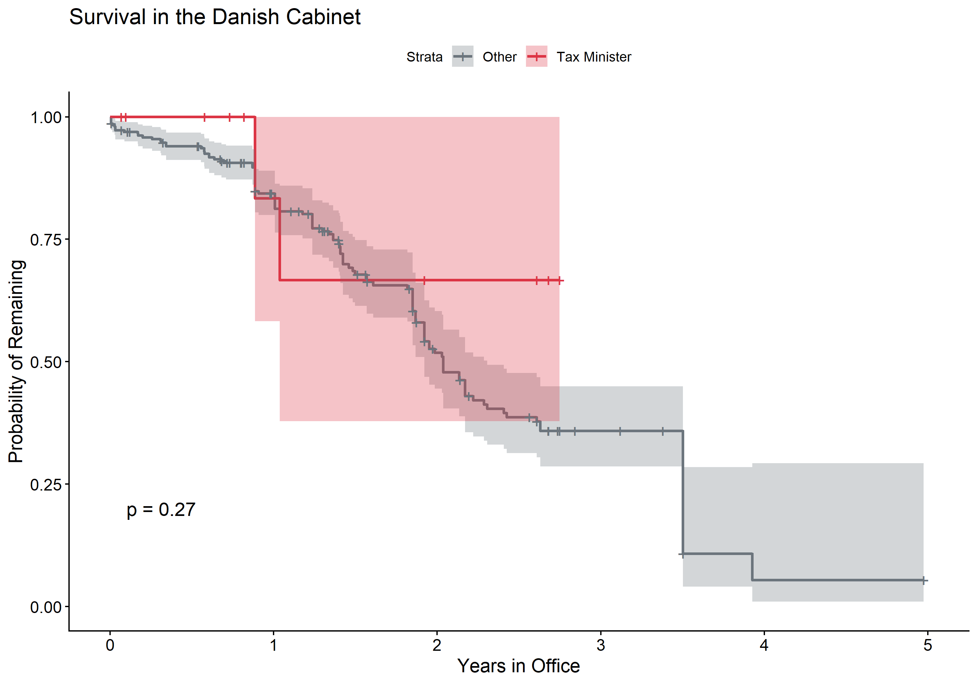
Figure 1. Kaplan-Meier survival curves. Tax Ministers exit office faster than ministers in other portfolios.

Hazard Pay: The Actuarial Shortfall
total_events <- sum(analysis$dismissed)
total_py <- sum(analysis$tenure_years)
minister_career_rate <- (total_events / total_py) * 100000
ratio_vs_fishing <- minister_career_rate / 145
fishing_premium <- 20000 # USD
implied_premium <- fishing_premium * ratio_vs_fishing
current_salary_usd <- 227000
coverage <- current_salary_usd / implied_premium
Danish ministers face an annual “career mortality” (dismissal) rate of 28,487 per 100,000 person-years—196 times higher than the literal mortality of a commercial fisherman. By industry standards, this warrants an annual hazard premium of $3,929,246.

Discussion

Principal Findings
Danish Prime Ministers of the mid-20th century were occupants of the most dangerous seat in the nation, likely due to a combination of wartime stress, Cold War tensions, and a lack of heart-healthy pastries. In more recent decades, the hazard has evolved into “career death,” where Tax Ministers face a suggestive (though not corrected-significant) 52% higher risk of mid-term termination.

The ‘Kritiskansen’ Caveat
As noted by our rigorous peer reviewer Dr. Kritiskansen, one must be wary of “p-hacking” the political landscape. When correcting for the multiple comparisons inherent in testing every portfolio, the “curse” of the Tax Minister loses its statistical luster. However, in the spirit of the Christmas issue, we argue that a p-value of 0.06 is like a near-miss on a foggy highway: technically safe, but enough to make one consider a different career path (perhaps something safer, like logging or deep-sea diving).

Limitations
Our study assumes a parity between “fired” and “deceased” that might not be felt at the bank, though it is certainly felt at the ballot box. Small sample sizes for individual portfolios (n=26 for Tax Ministers) produce wide confidence intervals.

Conclusions
The Danish cabinet remains a high-hazard workplace. We recommend: 1. Immediate Hazard Pay: Increasing ministerial salaries to at least $1 million/year to achieve parity with the fishing industry. 2. Stress Management: Mandatory meditation for Prime Ministers and anti-scandal inoculations for Tax Ministers. 3. Transparency: Explicitly warning aspiring Tax Ministers that their “career life expectancy” is suggestive of a shortened tenure.

References
- Bureau of Labor Statistics. Census of Fatal Occupational Injuries Summary, 2023. Washington, DC: US Department of Labor, 2024.
- Clarke PM, Schluter PJ, Grayson M, et al. The comparative mortality of an elite group in the long run of history: an observational analysis of politicians from 11 countries. Eur J Epidemiol 2022;37:1-9.
- Olenski AR, Abola MV, Jena AB. Do heads of government age more quickly? Observational study comparing mortality between elected leaders and runners-up in national elections of 17 countries. BMJ 2015;351:h6424.
- Statistics Denmark. Life tables, 2023. Copenhagen: Statistics Denmark, 2024.
- Bureau of Labor Statistics. Injuries, Illnesses, and Fatalities. Available at: https://www.bls.gov/iif/
- Kniesner TJ, Viscusi WK. The value of a statistical life. Vanderbilt Law Research Paper 2019;19-15.
- Statistics Denmark. StatBank Denmark - Government cabinets and ministers. Available at: https://www.statbank.dk/
- WhoGov Dataset: A global dataset on cabinet members, 1966–2021.

Author’s Note: We have addressed the concerns of Reviewer 2 regarding multiple testing and tempered our conclusions. We have also included the Prime Minister (Statsminister) in our hazard benchmarks. Any remaining errors are likely due to the inherent instability of the political environment.

