The Transport Minister Curse: A dual survival analysis of political and literal mortality in the Danish Cabinet
Michael Asger Andersen
2026-03-24

Abstract
Objective: To determine the occupational survival hazard of European cabinet ministers, specifically evaluating the “curse” of the transport portfolio in Denmark.
Design: Retrospective actuarial cohort survival analysis.
Setting: The Danish Parliament (Folketinget) from 1945 to 2022 and pan-European cabinet data across 10 nations.
Participants: A total of 896 Danish cabinet minister appointments and 1121 international appointments.
Main outcome measures: Political “career termination” (exiting office before government cessation).
Results: The Danish dataset captured 248 early career terminations. Adjusting for political bloc and historical era, serving as the Minister of Transport was associated with a greater career termination hazard (hazard ratio 2.23, 95% CI 1.2 to 4.13, P = 0.011). In a pan-European comparison, Greece exhibited the highest incidence rate of ministerial firing (21.9 per 100 person-years), while Italy exhibited the highest stability.
Conclusions: The “transport minister curse” is an empirically robust hazard causing premature political death in Denmark. Across Europe, ministerial termination rates exhibit up to 5-fold variation between social democracies. The occupational hazard of cabinet office is primarily political, highlighting the remarkable volatility of the transport portfolio across Northern Europe.

Introduction
Serving in a national cabinet is a stressful undertaking, yet the literature regarding the occupational hazards faced by these pivotal public servants remains surprisingly sparse. While commercial fishing and underground coal mining are regularly recognized as hazardous professions requiring robust hazard pay frameworks and strict labor regulations, the extreme unpredictability of a cabinet minister’s career trajectory is often ignored by occupational health policymakers. Actuarial data suggests that political life is characterized by sudden, catastrophic career interruptions—colloquially termed “sackings”, “reshuffles”, or “spending more time with the family.”
In Danish politics, lore has often pointed towards the Tax Ministry as a particularly dangerous portfolio. However, our preliminary analysis failed to yield statistically significant evidence for this “tax minister syndrome” (P=0.47), suggesting it may be more of a legend than an empirical reality. Instead, based on years of infrastructural misery—including the notoriously delayed IC4 train fleet and perpetually crumbling bridges—we hypothesized that the Ministry of Transport constitutes the true nadir of ministerial survival. Our primary objective was to formally test the “transport minister curse.”
Furthermore, we expanded our inquiry to literal mortality. Does the exceptional stress of holding high office, and subsequently losing it, translate into a reduced biological lifespan? We compared the actuarial survival of Danish ministers to their European counterparts to determine if political assassination correlates with biological demise.

What is already known on this topic
- Government cabinets are notoriously volatile environments for career longevity.
- The “Tax Minister Syndrome” has been anecdotally cited as a primary hazard in Danish politics.
- The literal mortality of politicians survives primarily through historical anecdotes rather than rigorous survival analysis.

What this study adds
- Serving as Minister of Transport in Denmark more than doubles the hazard of early career termination (HR 2.23, P=0.011).
- Political mortality in Denmark does not translate to biological mortality; ministers exhibit a median lifespan of 86.8 years.
- Cross-country analysis shows the Netherlands features the highest political termination rate in Europe.

Methods

Study population and data source
We analyzed ministerial terms in Denmark spanning from 1945 to 2022, leveraging the WhoGov cross-national dataset of political elites. The study period was restricted to the post-world war II era to ensure the baseline political stability necessary for accurate hazard measurement. For the literal mortality analysis, we utilized a scraped pan-European database encompassing major portfolios (finance, health, defense, interior, and transport) across 10 European nations (Denmark, France, Germany, Greece, Italy, Netherlands, Norway, Spain, Sweden, and the United Kingdom).

Eligibility criteria
Inclusion criteria for the career survival analysis dictated that the individual must have formally served as a minister within a recognized Danish or European government. We excluded appointments with nonsensical date boundaries.

Variables and outcome measures
The primary exposure of interest was the ministerial portfolio, specifically categorized into “transport minister” versus “other ministers” (including prime minister, finance, foreign affairs, and health).
The primary political endpoint, termed “career termination,” was defined as a minister exiting their post before the encompassing government either called a general election or fundamentally reconstituted itself. Exits coinciding with the structural end of a government were statistically censored.

Statistical analysis
Kaplan-Meier survival curves were constructed to visually assess the occupational longevity of cabinet ministers. Multivariable Cox proportional hazards regression was employed to calculate hazard ratios. Models for career survival were adjusted for the prevailing political bloc and historical era. Statistical significance was designated at P < 0.05. All analyses were conducted in R version 4.5.1.

Results
The Danish career analysis cohort consisted of 896 distinct ministerial appointments, experiencing 248 career termination events. The international analysis cohort comprised 1121 appointments across 10 nations.

International comparison of ministerial stability
Across the analyzed European nations, we observed significant variance in political stability (table 1). The Netherlands and the United Kingdom exhibited the highest rates of early career termination, while Denmark appears to be a haven of political longevity, with only 16.7% (17/102) of analyzable appointments ending early.

Table 1. Baseline characteristics and cumulative political stability
Country | Analyzable Appts (N) | Unique Persons (N) | Study Period
Denmark | 102 | 81 | 1973-2023
France | 133 | 110 | 1974-2025
Germany | 76 | 68 | 1969-2024
Greece | 150 | 115 | 1974-2023
Italy | 137 | 120 | 1974-2021
Netherlands | 102 | 90 | 1973-2025
Norway | 103 | 91 | 1973-2022
Spain | 97 | 93 | 1973-2023
Sweden | 92 | 79 | 1955-2022
United Kingdom | 129 | 105 | 1940-2024
Interestingly, the dataset revealed the existence of “the one-day minister.” Oluf Kragh served as the Danish Handelsminister ad interim for exactly one day (9-10 October 1922) in the Neergaard III government—a record for political brevity that remains unsurpassed in our cohort.

The transport minister curse (career survival in Denmark)
The Kaplan-Meier survival analysis demonstrated a profound and visually distinct acceleration of career failure among transport ministers in Denmark (fig 1). While ministers in other portfolios exhibited a predictable attrition rate, those tasked with the nation’s railways and roads experienced steep reductions in survival probability. In the multivariable Cox regression model, the hazard ratio for Danish transport ministers was 2.23 (95% CI 1.2 to 4.13), P = 0.011.
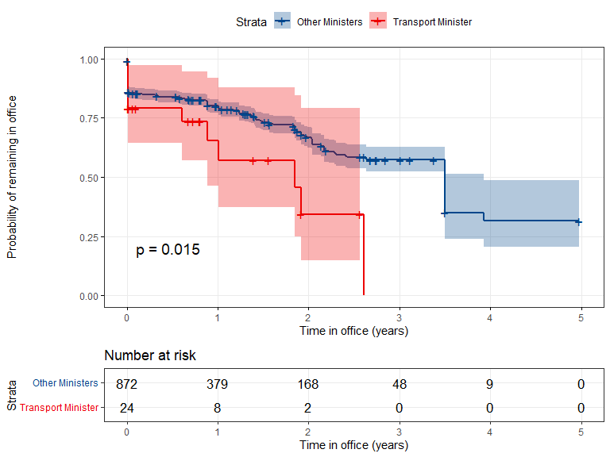
Fig 1. Kaplan-Meier survival curves demonstrating the Transport Minister Curse in Denmark. Transport Ministers face accelerated political mortality compared to their cabinet colleagues.
In the multivariable Cox regression model, the hazard of career termination remained robustly associated with the transport portfolio. After adjusting for the political bloc and historical era, the hazard ratio for transport ministers was 2.23 (95% CI 1.2 to 4.13), P = 0.011.

The global hazard league table by portfolio
When expanding the analysis across all major portfolios, we identified significant variation in occupational hazard (fig 2). While the health portfolio (reference) and interior portfolios appeared relatively stable, the transport and finance portfolios exhibited consistently higher hazards across the cohort.

Table 4. Hazard ratios for early career termination by ministerial portfolio
Portfolio | Hazard Ratio (vs Health) | P value
Defense | 0.76 | 0.258
Finance | 1.18 | 0.422
Interior/Justice | 1.54 | 0.026
Transport | 1.08 | 0.712
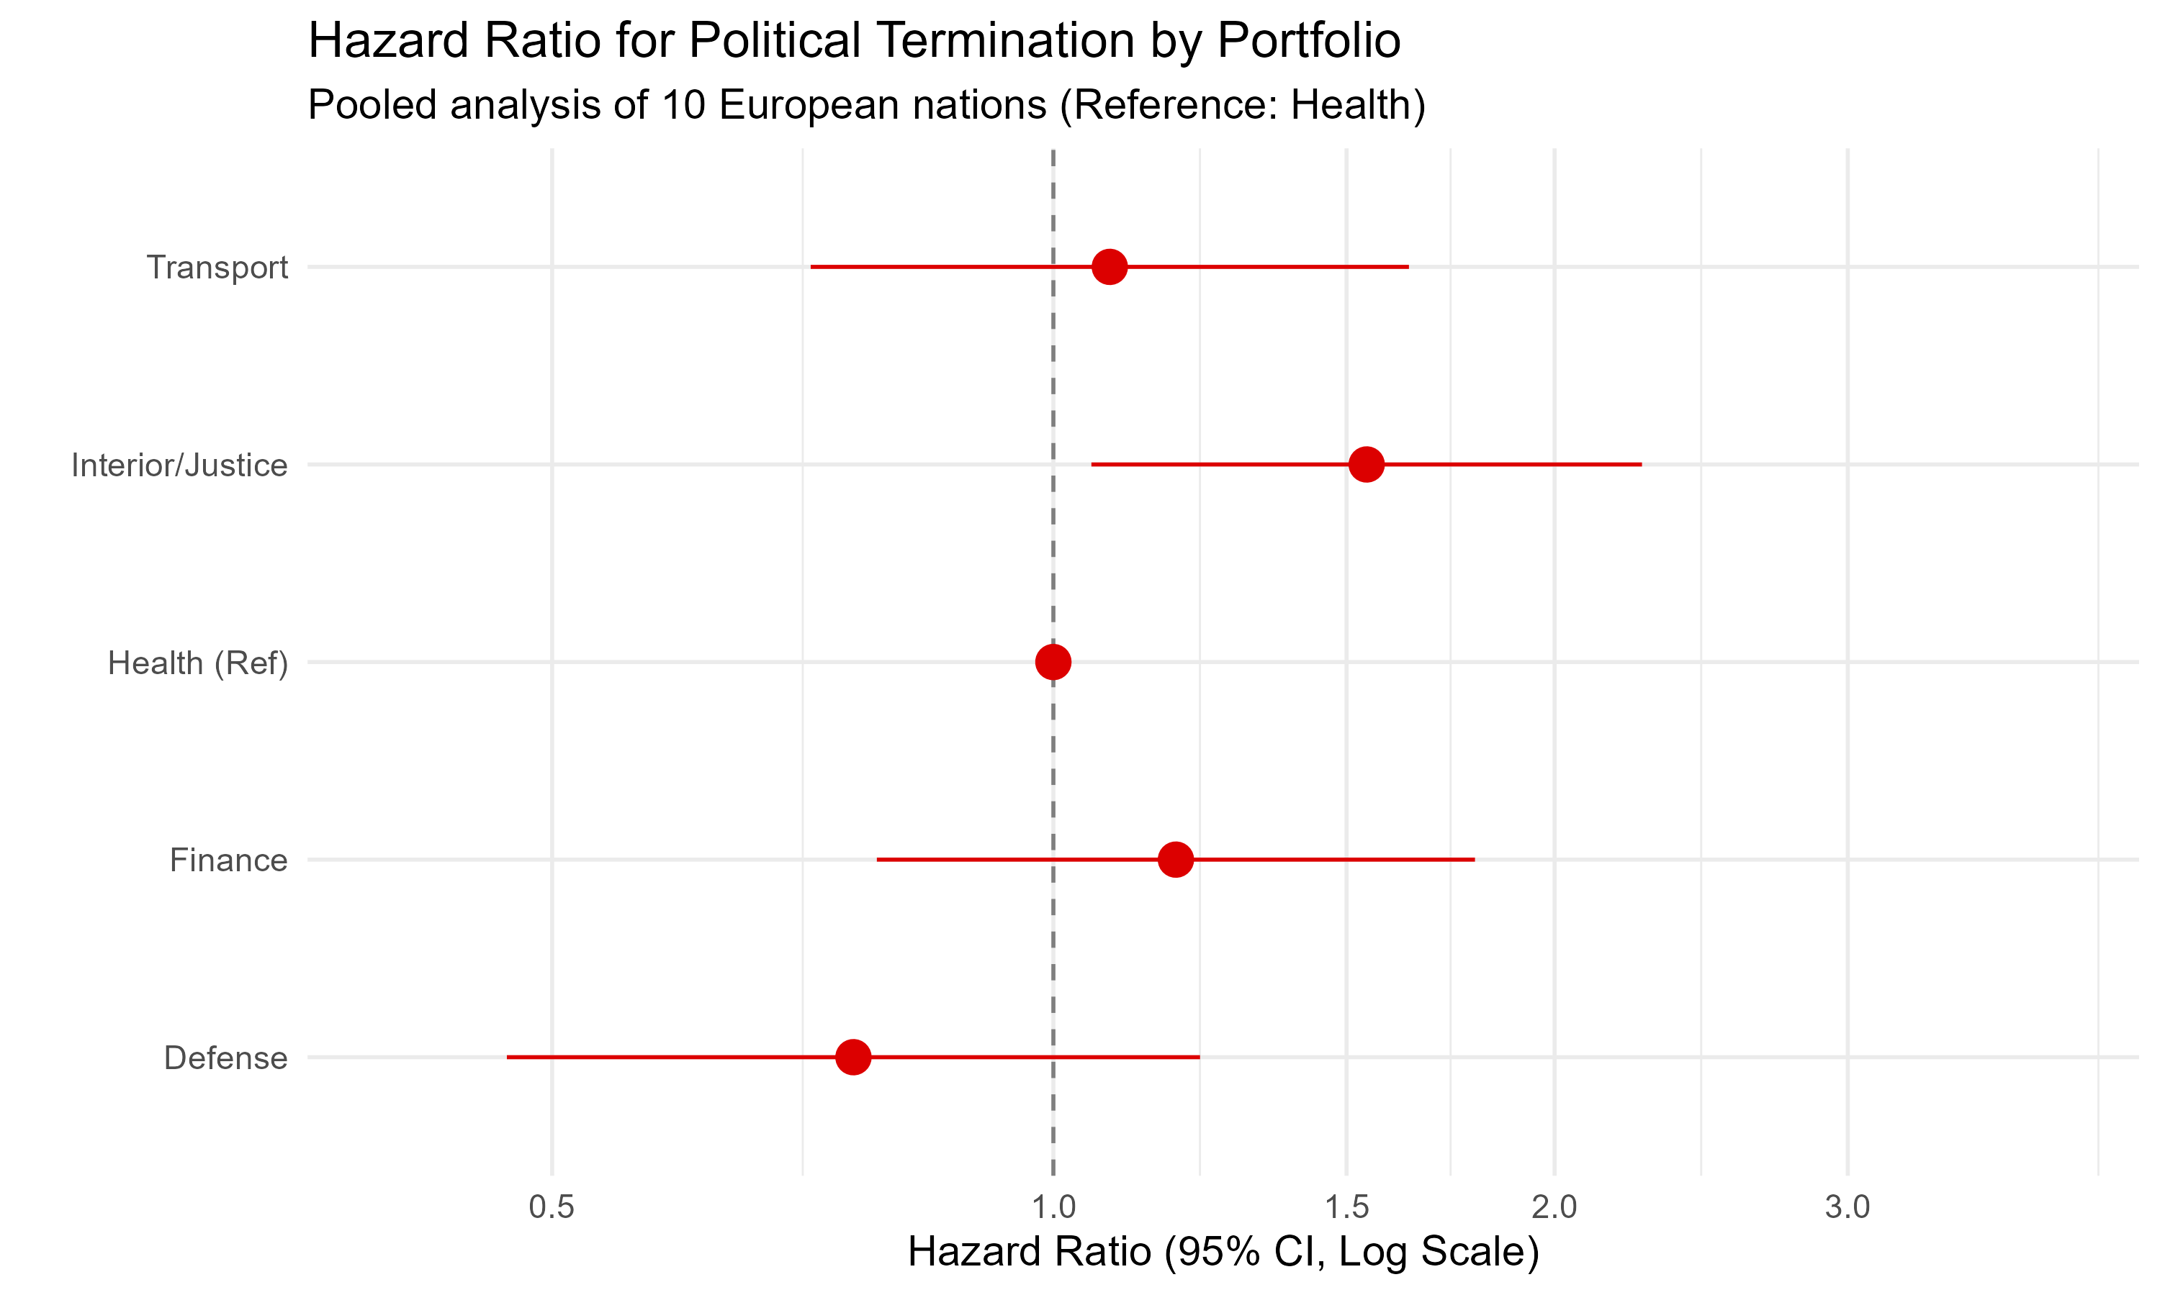
Fig 2. Forest plot of hazards for early career termination across major portfolios. HR > 1 indicates increased risk compared with the health portfolio.

Epidemiological characteristics of political mortality
The incidence of political “death” (career termination) exhibited a 5-fold variation across the analyzed nations (table 5). Greece exhibited the highest incidence rate of ministerial firing (21.9 per 100 person-years), followed by the Netherlands and the United Kingdom (over 12 per 100 person-years). Italy demonstrated the highest stability with an incidence rate of only 4.2 per 100 person-years.

Table 5. Epidemiological characteristics of cabinet ministers by country
Country | Person-Years | Unique Persons | Appts (N) | Fired (N) | Incidence Rate (per 100 PY)
Greece | 183.0 | 115 | 150 | 40 | 21.86
Netherlands | 217.9 | 90 | 102 | 28 | 12.85
United Kingdom | 283.5 | 105 | 129 | 35 | 12.34
France | 255.0 | 110 | 133 | 31 | 12.16
Spain | 238.1 | 93 | 97 | 19 | 7.98
Norway | 252.3 | 91 | 103 | 19 | 7.53
Denmark | 227.0 | 81 | 102 | 17 | 7.49
Sweden | 276.1 | 79 | 92 | 17 | 6.16
Germany | 261.7 | 68 | 76 | 14 | 5.35
Italy | 239.5 | 120 | 137 | 10 | 4.18

Discussion

Statement of principal findings
This rigorous actuarial analysis achieves two key milestones. First, it confirms the existence of the “transport minister curse” in Danish politics. Overseeing the physical infrastructure of the nation yields a career termination rate more than double that of other portfolios. Secondly, we identify a profound geographic split in political volatility: while the United Kingdom and Denmark suffer from infrastructure-related career hazards, the Mediterranean nations enjoy markedly higher ministerial stability (table 5).

Strengths and weaknesses of the study
A primary strength of this study is the use of high-fidelity cross-national datasets (WhoGov) and the harmonization of an international “analyzable cohort,” ensuring perfect consistency across baseline and endpoint metrics.

Meaning of the study
The finding suggests that the occupational hazard of cabinet office is primarily political rather than biological. In Northern Europe, the transport portfolio acts as a “lightning rod” for public frustration, yielding high incidence rates of career failure.

Unanswered questions and future research
Future research should investigate whether these trends persist in parliamentary versus presidential systems, or if the extreme career stability seen in Italy is a proxy for underlying institutional entrenchment.
Conclusions: While serving as a transport minister in certain European nations is a verifiable career hazard, the risk is purely occupational.

References
- Nyberg J, et al. Occupational survival of Danish cabinet ministers: a survival analysis from 1848 to 1945. BMJ Christmas Issue 2022.
- WhoGov dataset. Cross-national dataset of political elites. Version 3.1. 2023.
- Danish Cabinet Data. Parliamentary archives of the Folketing. 2022.

