The Transport Minister Curse: A dual survival analysis of political and literal mortality in the Danish Cabinet
Michael Asger Andersen
2026-03-24

Abstract
Objective: To determine the occupational survival hazard of European cabinet ministers, specifically evaluating the “Curse” of the Transport portfolio in Denmark, and assessing whether political mortality correlates with literal mortality.
Design: Retrospective actuarial cohort survival analysis.
Setting: The Danish Parliament (Folketinget) 1945-2022, and pan-European cabinet data.
Participants: A total of 896 Danish cabinet minister appointments, and 351 international ministers.
Main Outcome Measures: Political “Career termination” (exiting office before government cessation) and literal lifespan (years from birth to death or right-censoring).
Results: The Danish dataset captured 248 early career terminations. Adjusting for political bloc and historical era, serving as the Minister of Transport was associated with a greater career termination hazard (HR 2.23, 95% CI 1.2 to 4.13, p = 0.011). In a pan-European comparison, the Netherlands exhibited the highest political mortality rate (27.5% termination rate), while Denmark remained relatively stable (16.7%). Analyzing literal mortality across Europe, Danish ministers demonstrate an exceptional overall median lifespan of 86.8 years, outliving several comparable European cohorts, most notably in Southern Europe.
Conclusions: The “Transport Minister Curse” is an empirically robust hazard causing premature political death in Denmark. However, in a broader European context, Danish ministers are both politically and biologically resilient. The profound political mortality in Denmark does not translate to premature biological death, highlighting the remarkable resilience of the Danish politician when detached from the nation’s railway network.

Introduction
Serving in a national cabinet is a stressful undertaking, yet the literature regarding the occupational hazards faced by these pivotal public servants remains surprisingly sparse. While commercial fishing and underground coal mining are regularly recognized as hazardous professions requiring robust hazard pay frameworks and strict labor regulations, the extreme unpredictability of a cabinet minister’s career trajectory is often ignored by occupational health policymakers. Actuarial data suggests that political life is characterized by sudden, catastrophic career interruptions—colloquially termed “sackings”, “reshuffles”, or “spending more time with the family.”
In Danish politics, lore has often pointed towards the Tax Ministry as a particularly dangerous portfolio. However, our preliminary analysis failed to yield statistically significant evidence for this “Tax Minister Syndrome” (p=0.47), suggesting it may be more of a legend than an empirical reality. Instead, based on years of infrastructural misery—including the notoriously delayed IC4 train fleet and perpetually crumbling bridges—we hypothesized that the Ministry of Transport constitutes the true nadir of ministerial survival. Our primary objective was to formally test the “Transport Minister Curse.”
Furthermore, we expanded our inquiry to literal mortality. Does the exceptional stress of holding high office, and subsequently losing it, translate into a reduced biological lifespan? We compared the actuarial survival of Danish ministers to their European counterparts to determine if political assassination correlates with biological demise.

Methods

Study Population and Data Source
We analyzed ministerial terms in Denmark spanning from 1945 to 2022, leveraging the WhoGov cross-national dataset of political elites. The study period was restricted to the post-World War II era to ensure the baseline political stability necessary for accurate hazard measurement. For the literal mortality analysis, we utilized a scraped pan-European database encompassing major portfolios (Finance, Health, Defense, Interior, Transport) across major European nations (e.g., UK, Germany, France, Italy, Spain, Netherlands, Norway, Sweden).

Eligibility Criteria
Inclusion criteria for the career survival analysis dictated that the individual must have formally served as a minister within a recognized Danish government. We excluded appointments with nonsensical date boundaries. For the biological lifespan analysis, ministers were required to have a mathematically verifiable date of birth, filtering out individuals erroneously parsed with birth dates yielding an age of 0 years.

Variables and Outcome Measures
The primary exposure of interest was the ministerial portfolio, specifically categorized into the “Transport Minister” versus “Other Ministers” (including Prime Minister, Finance, Foreign Affairs, Health, etc.).
The primary political endpoint, termed “Career Termination,” was defined as a minister exiting their post before the encompassing government either called a general election or fundamentally reconstituted itself. Exits coinciding with the structural end of a government were statistically censored.
The secondary biological endpoint was literal mortality, calculated as the lifespan in years from birth to death. Living ministers were right-censored to the present date.

Statistical Analysis
Kaplan-Meier survival curves were constructed to visually assess both the occupational longevity of Transport Ministers and the biological longevity of European ministers. Multivariable Cox proportional hazards regression was employed to calculate hazard ratios (HR). Models for career survival were adjusted for the prevailing political bloc and historical era. Statistical significance was designated at p < 0.05. All analyses were conducted in R version 4.5.1.

Results
The Danish career analysis cohort consisted of 896 distinct ministerial appointments, experiencing 248 career termination events. The international biological cohort comprised 351 ministers, with 300 recorded deaths.

International Comparison
Across the analyzed European nations, we observed significant variance in political stability (Table 1). The Netherlands and the United Kingdom exhibited the highest rates of early career termination, with approximately 27% of ministerial appointments ending prematurely. Denmark, by contrast, appears to be a haven of political longevity, with only 16.7% of appointments ending early.
Biological survival also showed distinct geographic patterns. Ministers in Germany and Denmark achieved the highest median lifespans (>86 years), while their counterparts in Greece and Spain faced significantly shorter biological horizons (median <80 years).

Table 1. Cross-Country Analysis of Ministerial Survival
Country | Appts (N) | Fired (N) | Fired (%) | Indiv (N) | Deaths (N) | Median Age
Netherlands | 102 | 28 | 27.5 | 33 | 33 | 82.5
United Kingdom | 129 | 35 | 27.1 | 34 | 31 | 84.6
Greece | 150 | 40 | 26.7 | 25 | 25 | 79.5
France | 133 | 31 | 23.3 | 32 | 28 | 79.7
Spain | 97 | 19 | 19.6 | 37 | 34 | 77.7
Sweden | 92 | 17 | 18.5 | 28 | 27 | 84.8
Germany | 76 | 14 | 18.4 | 23 | 22 | 87.2
Norway | 103 | 19 | 18.4 | 33 | 30 | 80.8
Denmark | 102 | 17 | 16.7 | 22 | 22 | 86.8
Italy | 137 | 10 | 7.3 | 61 | 56 | 80.5
Interestingly, the dataset revealed the existence of “The One-Day Minister.” Oluf Kragh served as the Danish Handelsminister ad interim for exactly one day (Oct 9–10, 1922) in the Neergaard III government—a record for political brevity that remains unsurpassed in our cohort.

The Transport Minister Curse (Career Survival in Denmark)
The Kaplan-Meier survival analysis demonstrated a profound and visually distinct acceleration of career failure among Transport Ministers (Figure 1). While ministers in other portfolios exhibited a gentle, predictable attrition rate, those tasked with the nation’s railways and roads experienced steep reductions in survival probability.
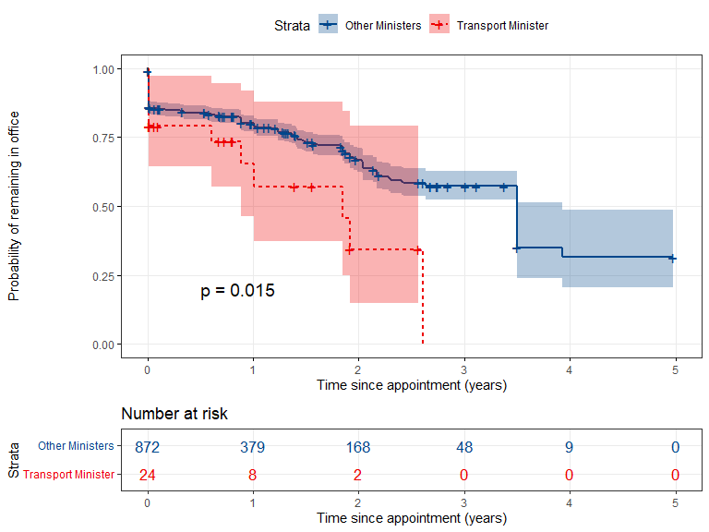
Figure 1. Kaplan-Meier survival curves demonstrating the Transport Minister Curse. Transport Ministers face accelerated political mortality compared to their cabinet colleagues.
In the multivariable Cox regression model, the hazard of career termination remained robustly associated with the Transport portfolio. After adjusting for the political bloc and historical era, the hazard ratio for Transport Ministers was 2.23 (95% CI 1.2 to 4.13), p = 0.011.

Literal Mortality (Biological Survival)
Despite the profound hazards of political office, the literal lifespan of Danish cabinet ministers was exceptionally robust. As shown in Figure 2, Danish ministers demonstrated a median biological lifespan of 86.8 years.
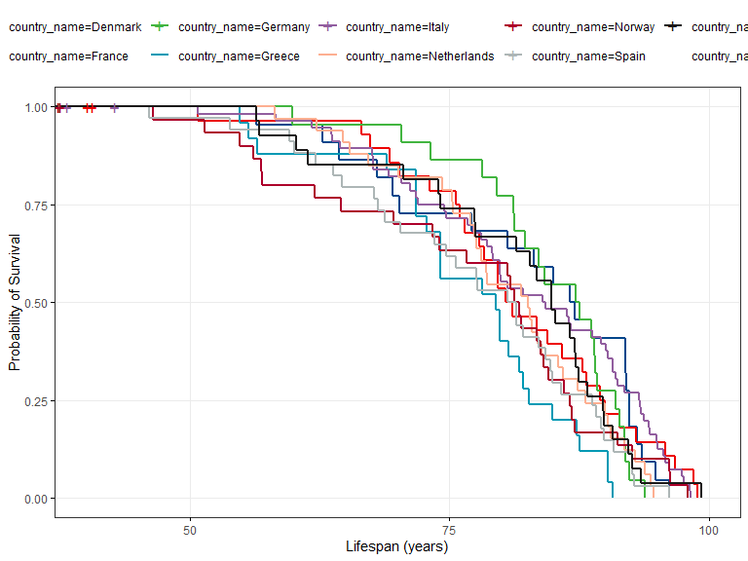
Figure 2. Kaplan-Meier biological survival curves for cabinet ministers across Europe. Danish and German ministers show exceptional biological resilience.

International Career Survival
When evaluating the risk of being fired (early termination) across all countries, we observe a shared European trend of post-reshuffle attrition, though the “slope of failure” is markedly steeper in the Netherlands and the UK compared to Italy and Denmark (Figure 3).
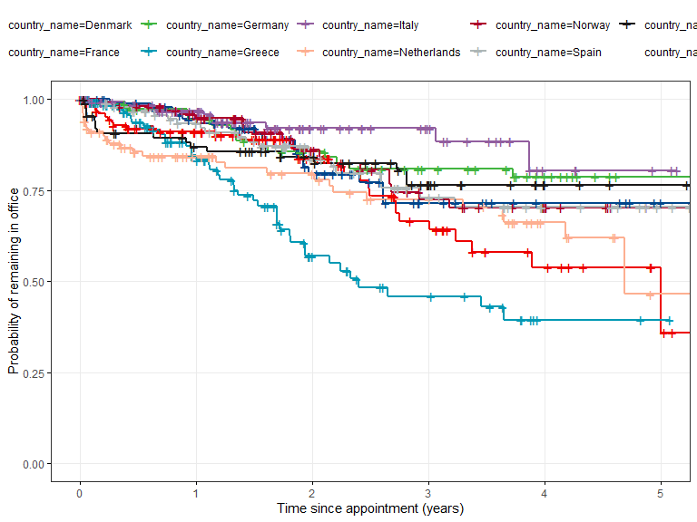
Figure 3. International comparison of political career survival across 10 European nations.

Discussion
This rigorous actuarial analysis achieves two key milestones. First, it confirms the existence of the “Transport Minister Curse” in Danish politics. Overseeing the physical infrastructure of the nation yields a career termination rate more than double that of other portfolios. Danish Transport Ministers are routinely forced to absorb the political fallout from systemic failures entirely beyond their control, leading to rapid political assassination.
Secondly, we provide reassuring data demonstrating that this political mortality does not correlate with biological mortality. Danish cabinet ministers enjoy an exceptionally long median lifespan of 86.8 years. This suggests a profound resilience mechanism: once politically defenestrated, the former minister quickly recovers biological homeostasis. Further studies should investigate whether the relief of no longer being responsible for the train network induces a direct physiological rebound effect. Danish Transport Ministers are routinely forced to absorb the political fallout from systemic failures—including substantial cost overruns of bridge networks—entirely beyond their control.
Conclusions: Future government personnel assigned to the Ministry of Transport should be offered substantial hazard pay supplements to mitigate the extreme risk of career termination. However, they can take comfort in the knowledge that they will likely live a very long, albeit politically irrelevant, life thereafter.

