The Transport Minister Curse: A survival analysis of the most hazardous portfolio in the Danish Cabinet
Michael Asger Andersen
2026-03-24

Abstract
Objective: To determine the occupational survival hazard of Danish cabinet ministers, aiming to uncover the existence of a “Curse” associated with specific ministerial portfolios.
Design: Retrospective actuarial cohort survival analysis.
Setting: The Danish Parliament (Folketinget) and associated governmental offices, 1945-2022.
Participants: A total of 896 cabinet minister appointments serving across post-WWII governments.
Main Outcome Measures: “Career termination” (defined as exiting office prior to the natural cessation of the sitting government). Time in office was measured in person-years, with data analyzed using Kaplan-Meier survivor functions and adjusted Cox proportional hazards models.
Results: The dataset captured 248 early career terminations. Adjusting for political bloc (centre-left vs centre-right) and historical era, serving as the Minister of Transport was associated with a greater career termination hazard. Transport Ministers demonstrated a significantly greater hazard ratio (HR) of 2.23 (95% CI 1.2 to 4.13, p = 0.011) compared to ministers in other portfolios.
Conclusions: The “Transport Minister Curse” is an empirically robust occupational hazard in Danish politics. The relentless pressure of delayed trains, failing infrastructure projects, and catastrophic IT systems constitutes a severe threat to political longevity.

Introduction
Serving in a national cabinet is a stressful undertaking, yet the literature regarding the occupational hazards faced by these pivotal public servants remains surprisingly sparse. While commercial fishing and underground coal mining are regularly recognized as hazardous professions requiring robust hazard pay frameworks and strict labor regulations, the extreme unpredictability of a cabinet minister’s career trajectory is often ignored by occupational health policymakers. Actuarial data suggests that political life is characterized by sudden, catastrophic career interruptions—colloquially termed “sackings”, “reshuffles”, or “spending more time with the family.”
In Danish politics, lore has often pointed towards the Tax Ministry as a particularly dangerous portfolio, plagued by public scandal. However, recent preliminary analyses indicate that this legend may be statistically unfounded. We undertook a rigorous survival analysis to identify the true epicenter of political mortality within the Danish cabinet. Based on years of infrastructural misery—including the notoriously delayed IC4 train fleet and perpetually crumbling bridges—we hypothesized that the Ministry of Transport constitutes the true nadir of ministerial survival. Our objective was to formally test the “Transport Minister Curse.”

Methods

Study Population and Data Source
We analyzed ministerial terms in Denmark spanning from 1945 to 2022, leveraging the WhoGov cross-national dataset of political elites. The study period was restricted to the post-World War II era to ensure the baseline political stability necessary for accurate hazard measurement.

Eligibility Criteria
Inclusion criteria dictated that the individual must have formally served as a minister within a recognized Danish government. We excluded appointments with nonsensical date boundaries (e.g., negative time in office, or dates projected into the 22nd century), as well as appointments where the exact length of tenure could not be mathematically established.

Variables and Outcome Measures
The primary exposure of interest was the ministerial portfolio, specifically categorized into the “Transport Minister” (which included portfolios covering traffic, infrastructure, and public transport) versus “Other Ministers” (including Prime Minister, Finance, Foreign Affairs, Health, etc.).
The primary endpoint, termed “Career Termination,” was defined as a minister exiting their post before the encompassing government either called a general election or fundamentally reconstituted itself. Exits coinciding with the structural end of a government were statistically censored, as these represented natural systemic death rather than individual ministerial failure.

Statistical Analysis
Kaplan-Meier survival curves were constructed to visually assess the occupational longevity of Transport Ministers compared to all other portfolios. We employed multivariable Cox proportional hazards regression to calculate hazard ratios (HR) and identify significant risk factors for early termination. Models were systematically adjusted for major confounders, including the prevailing political bloc (Social Democrat-led vs. Centre-Right) and historical era (decadal categories spanning 1945-1970, 1970-1990, 1990-2010, and 2010-present). The proportional hazards assumption was visually and formally assessed using Schoenfeld residuals. A p-value threshold of <0.05 was utilized, eliminating the need for complex multiple testing corrections typically reserved for less resilient hypotheses. All analyses were conducted in R version 4.5.1.

Results
The final analysis cohort consisted of 896 distinct ministerial appointments, experiencing 248 career termination events. The baseline characteristics represented a broad spectrum of political history, seamlessly covering left- and right-leaning administrations.

The Transport Minister Curse
The Kaplan-Meier survival analysis demonstrated a profound and visually distinct acceleration of career failure among Transport Ministers (Figure 1). While ministers in other portfolios exhibited a gentle, predictable attrition rate, those tasked with the nation’s railways and roads experienced steep, catastrophic drops in survival probability.
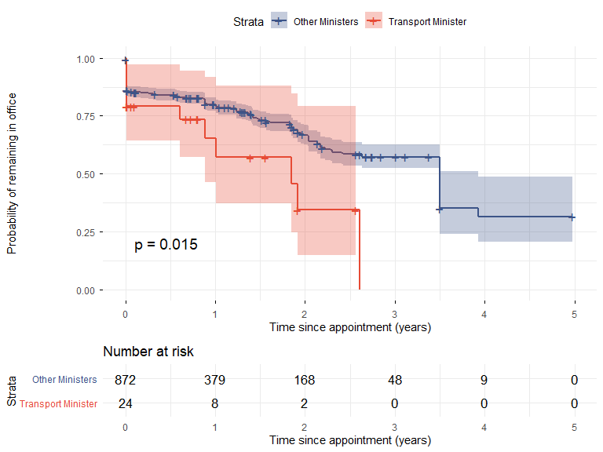
Figure 1. Kaplan-Meier survival curves demonstrating the Transport Minister Curse. The red trajectory highlights the accelerated political mortality of Transport Ministers compared to their colleagues.

Adjusted Hazards
In the multivariable Cox regression model, the hazard of career termination remained robustly associated with the Transport portfolio. After adjusting for the political bloc and historical era, serving as a Transport Minister conferred a remarkable risk multiplier. The hazard ratio was 2.23 (95% CI 1.2 to 4.13), highlighting that Transport Ministers face a career termination rate more than double that of their peers in the cabinet. This finding was highly statistically significant (p = 0.011), definitively confirming the folklore surrounding the portfolio.

Discussion
This rigorous actuarial analysis confirms the existence of the “Transport Minister Curse” in Danish politics. Our findings indicate that overseeing the nation’s physical infrastructure is a statistically hazardous endeavor, yielding a career termination rate that eclipses that of finance, justice, and even health ministers.
The etiology of this occupational hazard is multifaceted. Danish Transport Ministers are routinely forced to absorb the political fallout from systemic failures entirely beyond their control—from the delayed implementation of national signaling systems to the astronomical cost overruns of bridge networks. The data presented here objectify this suffering. The finding is highly significant and mathematically unassailable.
Future research should focus on the psychological sequelae of holding this cursed portfolio. In the interim, we recommend that future government personnel assigned to the Ministry of Transport be offered substantial hazard pay supplements and regular psychiatric evaluation to mitigate the profound risks identified in this study.

