Game Design Document

Fill up the following document

1. Write the title of your project.

WarCopter

1. What is the goal of the game?

Defend The enemy and bring the loot back from them.

1. Write a brief story of your game

The villain named Lupin has steal all the money of the city, so now

there is an entry of our Guardian in a helicopter, fighting with the

army of Lupin to bring the money back to the city.

1. Which are the playing characters of this game?

* Playing characters are the ones who respond to the user based on the input from the user.
* Cars, monkeys, dinos, wizards, etc., are the playing characters in the game.

|  |  |  |
| --- | --- | --- |
| Number | Character Name | What can this character do? |
| 1 | The Guardian’s Helicopter | Can shoot Bullets, have infinite fuel and can fly to defend form enemies. |
| 2 |  |  |
| 3 |  |  |
| 4 |  |  |
| 5 |  |  |
| 6 |  |  |
| 7 |  |  |
| 8 |  |  |

1. Which are the Non-Playing Characters of this game?

* Non-Playing characters are the ones that don't have an action or behavior when the user interacts with the game.
* Hurdles, stones, bananas, coins, etc., are non-playing characters in the game.

|  |  |  |
| --- | --- | --- |
| Number | Character Name | What can this character do? |
| 1 | Enemy Helicopters | Can shoot Bullets, have infinite fuel and can fly to defend form The Guardian. |
| 2 | Clouds | To make the game look good |
| 3 | Sun | To make the game look good |
| 4 | Moon | To make the game look good |
| 5 | Coins | As a currency of the game |
| 6 | The Boss Quadcopter | It have two modes Aggressive and Normal, in the first mode it’s health will not decrease and can only shoot Bombs but in the normal mode the Guardian gets a chance to decrease the boss health. |
| 7 | Bullets & Bombs | Used as a weapon |
| 8 |  |  |

Draw your imagination of this game. What does this game look like?

* Draw the game either on your computer or on paper.
* Add images of the game scenes to show each of the playing and non-playing characters at least once.

**The Home Page:-**

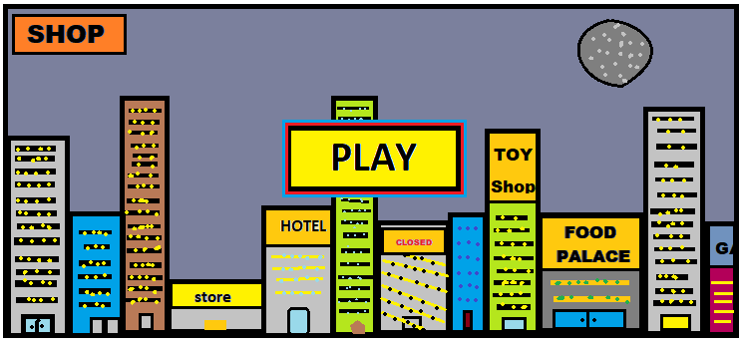

**Shop:-**

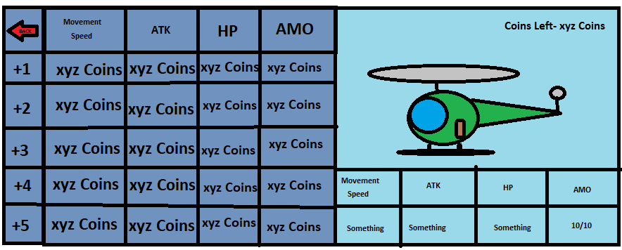

**Stages:-**

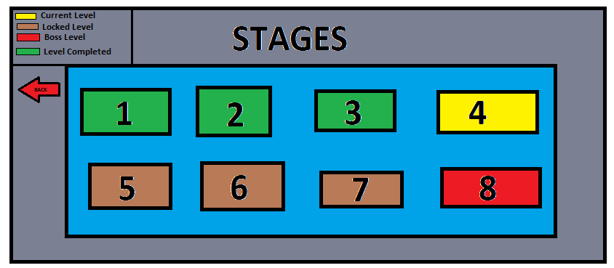

**Battle Area:-**

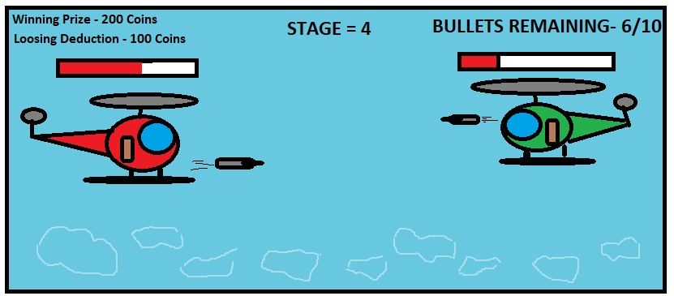How do you plan to make your game engaging?

As the level will increase the enemy will become more powerful, so to

compete with them the player is given with some coins to upgrade their helicopter. As there is no internet connection so the user can play the game

anytime. In some stages there is a night theme so the user gets more attracted to it.