

Cell

Bitumen impregnated fibreboard

**4.**

Slabs**:**

When used in in-situ concrete, PH Cell is to be placed against the shuttering before the pour begins. It can be fixed with copper nails for suspended slabs or bonded with a suitable contact adhesive to existing concrete. Care must be taken not to contaminate the surfaces of the sealing slot with adhesive.

Supply**:**

Storage**:**

Store under cover in cool, dry conditions.

Health**:** There are no known health hazards

associated with PH Cell in normal use.

Fire**:** PH Cell is combustible and will ignite if exposed to flame or other sources of ignition.

**Important Note:**

PILE HEAD products are guaranteed against defective materials and manufacture. This information is based on current tests and is provided in good faith. All data sheets are updated regularly; it is the userʼs responsibility to obtain the latest version.

HEAD

Page 2 of 2

Email: [sales@pilehead.com](mailto:sales@pilehead.com)

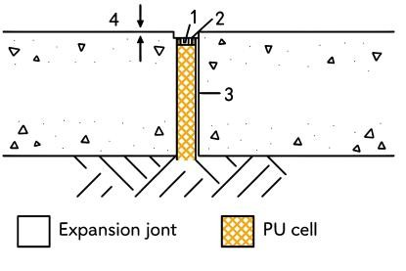

Cell

**Bitumen impregnated fibreboard**

PH Cell is a compressible joint filler and protection board manufactured from high-quality, bitumen-impregnated wood fibres. It is supplied in sheet form and is designed to form and fill

expansion joints in in-situ and precast concrete construction.

**2.** Uses

PH Cell is a compressible, non-extruding, bitumen-impregnated fibreboard expansion joint filler. It is suitable for forming structural expansion and separation joints in a wide range of applications and also serves to protect waterproof membranes against physical or mechanical damage.

Applications**:**

Concrete pavements and floors Roads, ramps, and runways Pedestrian areas

Concrete retaining walls and bridges

Concrete basement structures and subways

**3.** Advantages

Handling**:** Easy to handle, cut, and tamp on-site.

Resilience**:** A resilient filler that will not extrude under compression.

Performance**:** Offers high recovery and low distortion characteristics.

HEAD

Page 1 of 2

Email: [sales@pilehead.com](mailto:sales@pilehead.com)

|  |  |  |
| --- | --- | --- |
|  |  |  |
| **PROPERTY** | **PERFORMANCE** | **STANDARD** |
| Form | Compressible sheet |  |
| Solids Content | 100% |  |
| Recovery | Pass | ASTM D1751 |
| Weathering | No disintegration | DTp CI 1015 |
| Extrusion | Pass | ASTM D1751 |
| Distortion | Pass | ASTM D994 |
| Brittleness | Does not crack or shatter | ASTM D994 |