a

**PH Cell**

**Bitumen impregnated fibreboard**

**PILE HEAD\**

**1. Description**

PH Cell is a compressible joint filler and protection board manufactured from high-quality, bitumen-impregnated wood fibres. It is supplied in sheet form and is designed to form and fill expansion joints in in-situ and precast concrete construction.

**2. Uses**

PH Cell is a compressible, non-extruding, bitumen-impregnated fibreboard expansion joint filler. It is suitable for forming structural expansion and separation joints in a wide range of applications and also serves to protect waterproof membranes against physical or mechanical damage.

**Primary Applications:**

Concrete pavements and floors Roads, ramps, and runways Pedestrian areas

Concrete retaining walls and bridges

Concrete basement structures and subways

**3. Advantages**

**Handling:** Easy to handle, cut, and tamp on-site.

**Resilience:** A resilient filler that will not extrude under compression. **Performance:** Offers high recovery and low distortion characteristics. **Compliance:** Meets the requirements of major international standards.

**PILE HEAD**

Website: [www.pilehead.com](http://www.pilehead.com/) Email: [sales@pilehead.com](mailto:sales@pilehead.com)

Page 1 of 2

**PH Cell**

Bitumen impregnated fibreboard

**PILE EAD**

**4. Properties**

**5. Application Instructions**

**Slabs:**

When used in in-situ concrete, PH Cell is to be placed against the shuttering before the pour begins. It can be fixed with copper nails for suspended slabs or bonded with a suitable contact adhesive to existing concrete. Care must be taken not to contaminate the surfaces of the sealing slot with adhesive.

**6. Supply & Storage**

**7. Health & Safety**

**Supply:**

**Sheet Size:** 1.22 m x 2.20 m

**Thickness:** 12 mm, 13 mm, 18 mm, 25 mm

**Storage:**

Store under cover in cool, dry conditions.

**Health:** There are no known health hazards

associated with PH Cell in normal use.

**Fire:** PH Cell is combustible and will ignite if exposed to flame or other sources of ignition.

**Important Note:**

PILE HEAD products are guaranteed against defective materials and manufacture. This information is based on current tests and is provided in good faith. All data sheets are updated regularly; it is the userʼs responsibility to obtain the latest version.

**PILE HEAD**

Website: [www.pilehead.com](http://www.pilehead.com/) Email: [sales@pilehead.com](mailto:sales@pilehead.com)

Page 2 of 2

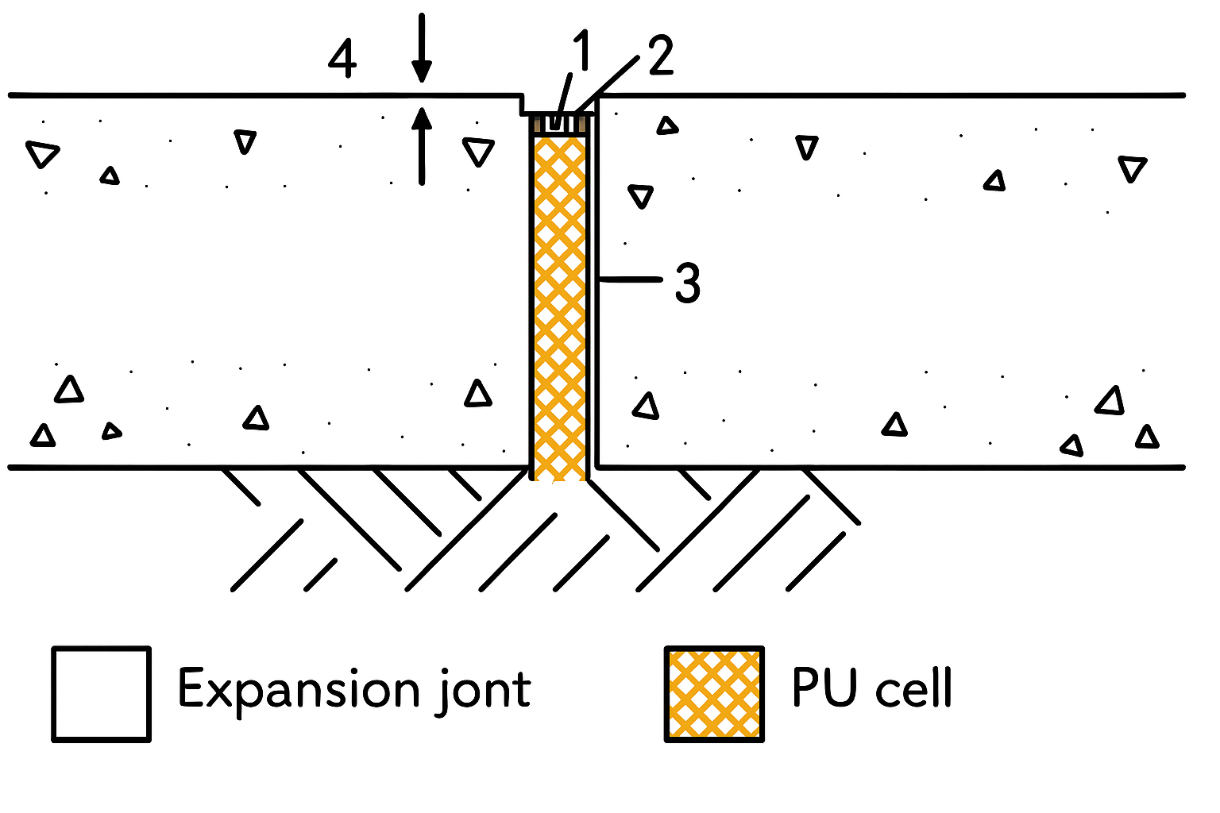

|  |  |  |
| --- | --- | --- |
| **PROPERTY** | **PERFORMANCE** | **STANDARD** |
| Form | Compressible sheet |  |
| Solids Content | 100% |  |
| Recovery | Pass | ASTM D1751 |
| Weathering | No disintegration | DTp CI 1015 |
| Extrusion | Pass | ASTM D1751 |
| Distortion | Pass | ASTM D994 |
| Brittleness | Does not crack or shatter | ASTM D994 |