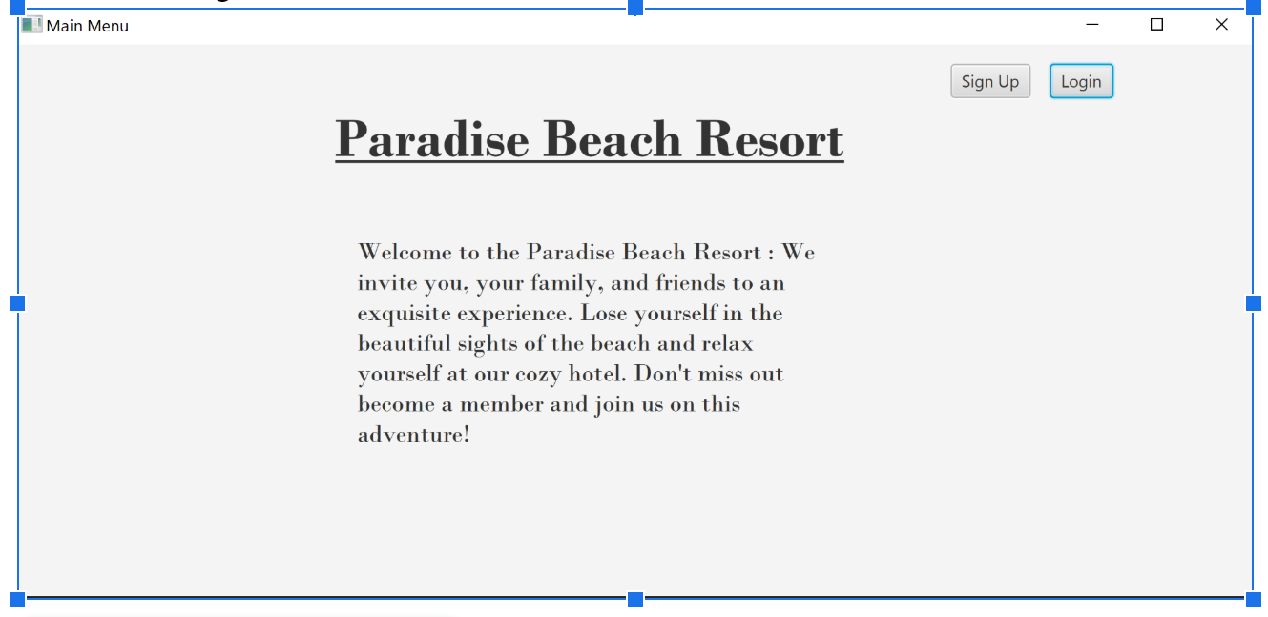

**Hotel Resort**

**User Guide**

© The Resorters. Romanov Andre, Mushfique Shafi, Stephen Aranda. 12/2019.

Table of Contents

Introduction 1

Getting Started 2

System Requirements 2

Quick Start 2

Software Usage 12

Click to document main user interface (main menu) 1

Glossary 18

# Introduction

Click to insert brief paragraph on reason for making software

The Hotel Resort application is a java-based software. It is being designed with the purpose of simplifying the process of hosting a resort for all parties involved (customers and owners). In the case of a customer, the software allows them to reserve a spot at the resort; and to view and book hotel rooms with the aid of a virtual transaction system. In the case of an owner, the software allows them to receive payments, view transactions, and monitor employees (custodians and receptionists).

The Hotel Resort software allows you to:

* Book a room at a hotel including payment
* Manage account
* Monitor employees
* Add new employees
* Update room status at the hotel

Hotel Resort is accessible using the runnable jar file and this interface is chosen due to it being quicker to implement until we can make an applet version to embed it in a browser.

# Getting Started

## System Requirements

Java Oracle software in order to run a Java jar file.

## Quick Start

1. Click here to go to Main menu  
   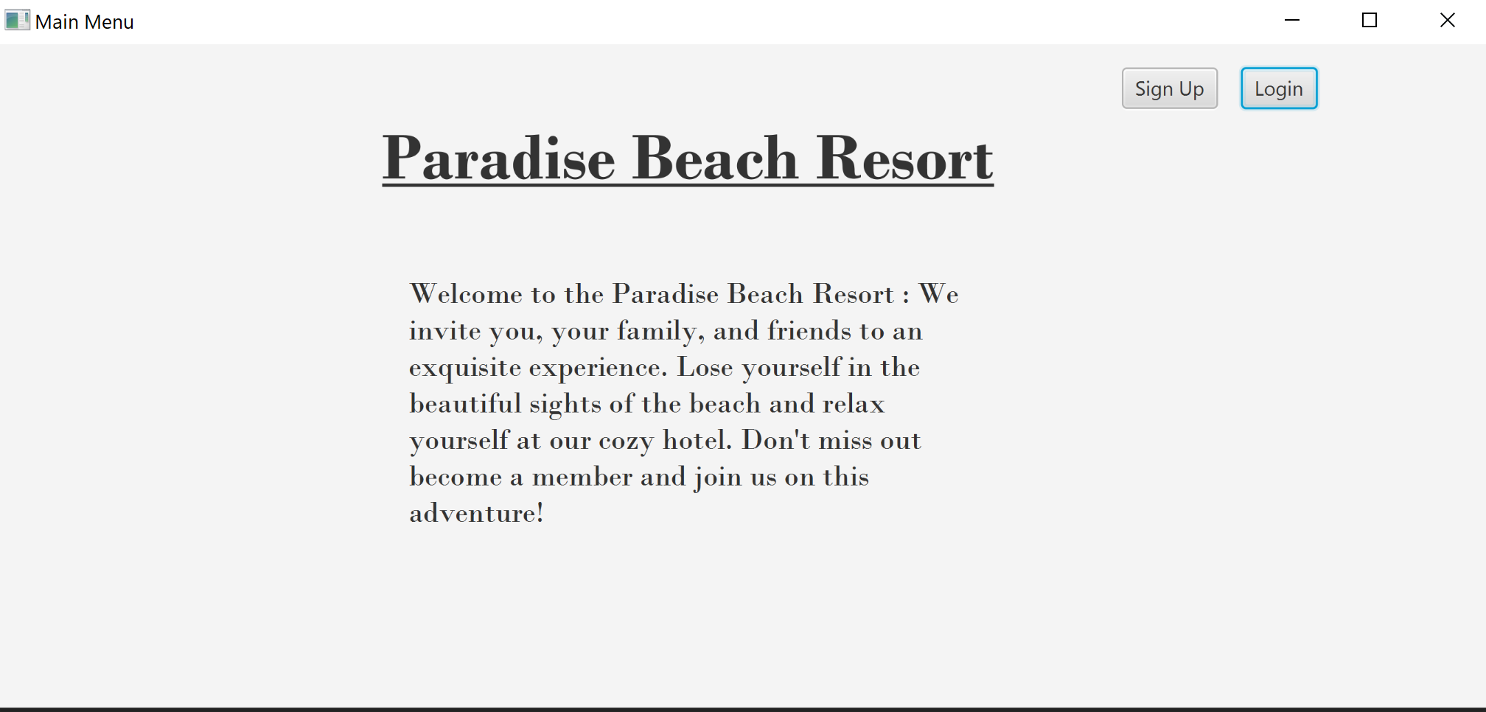
2. Click here to go to Sign-up Interface  
   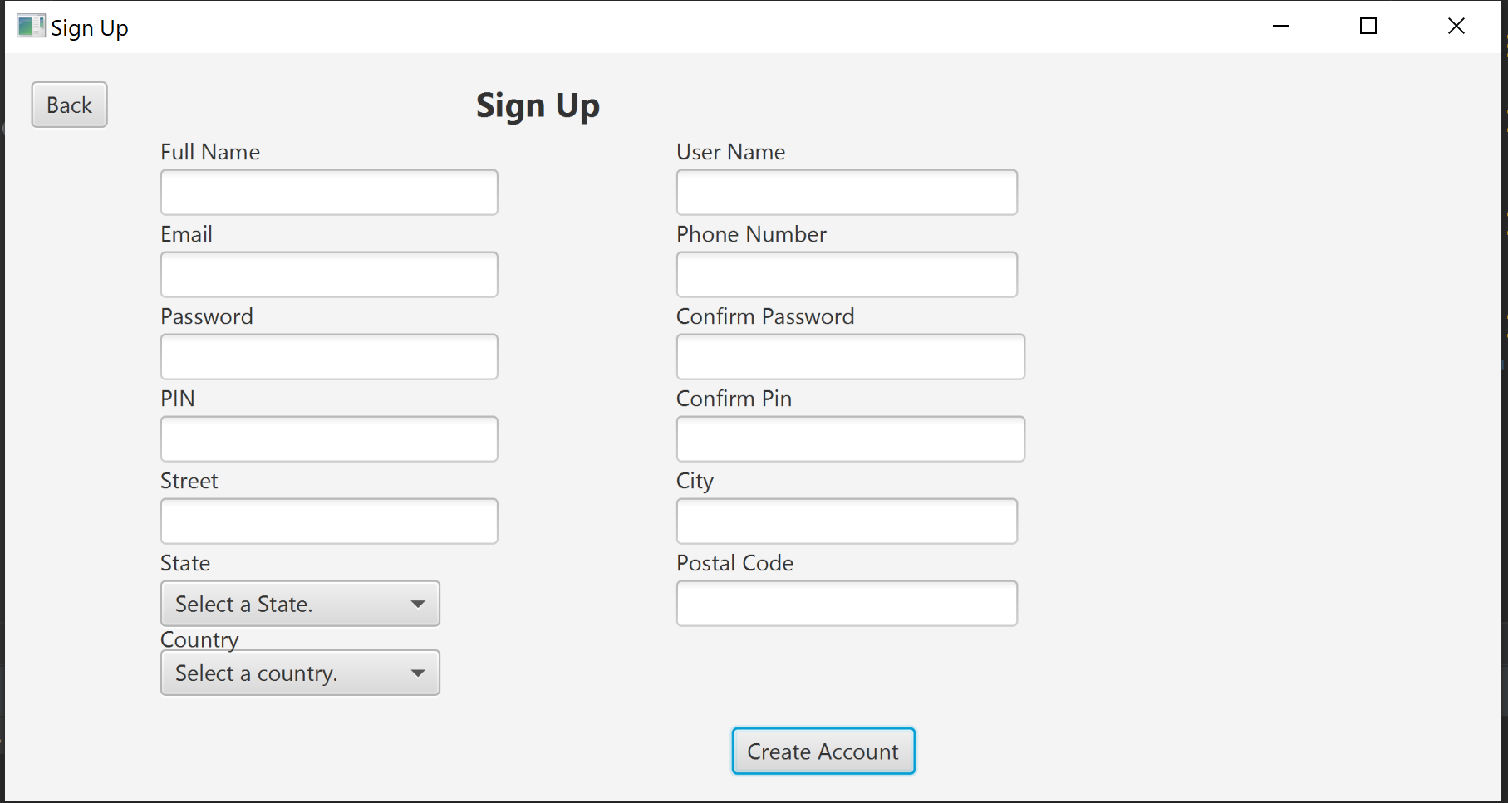
3. Click here to go to Sign-in Interface

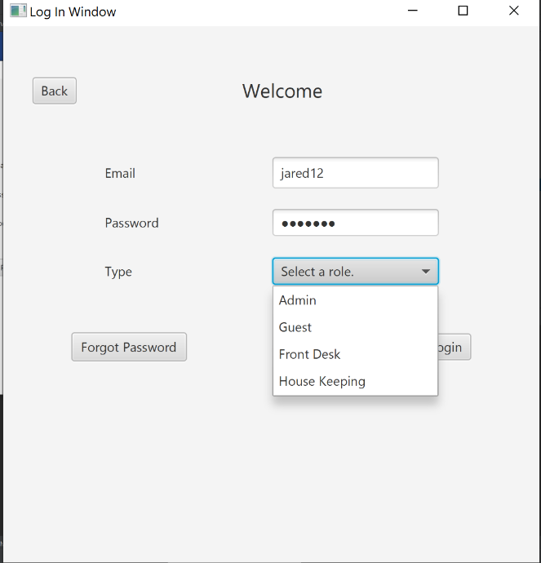

1. Click here to go to Owner Interface

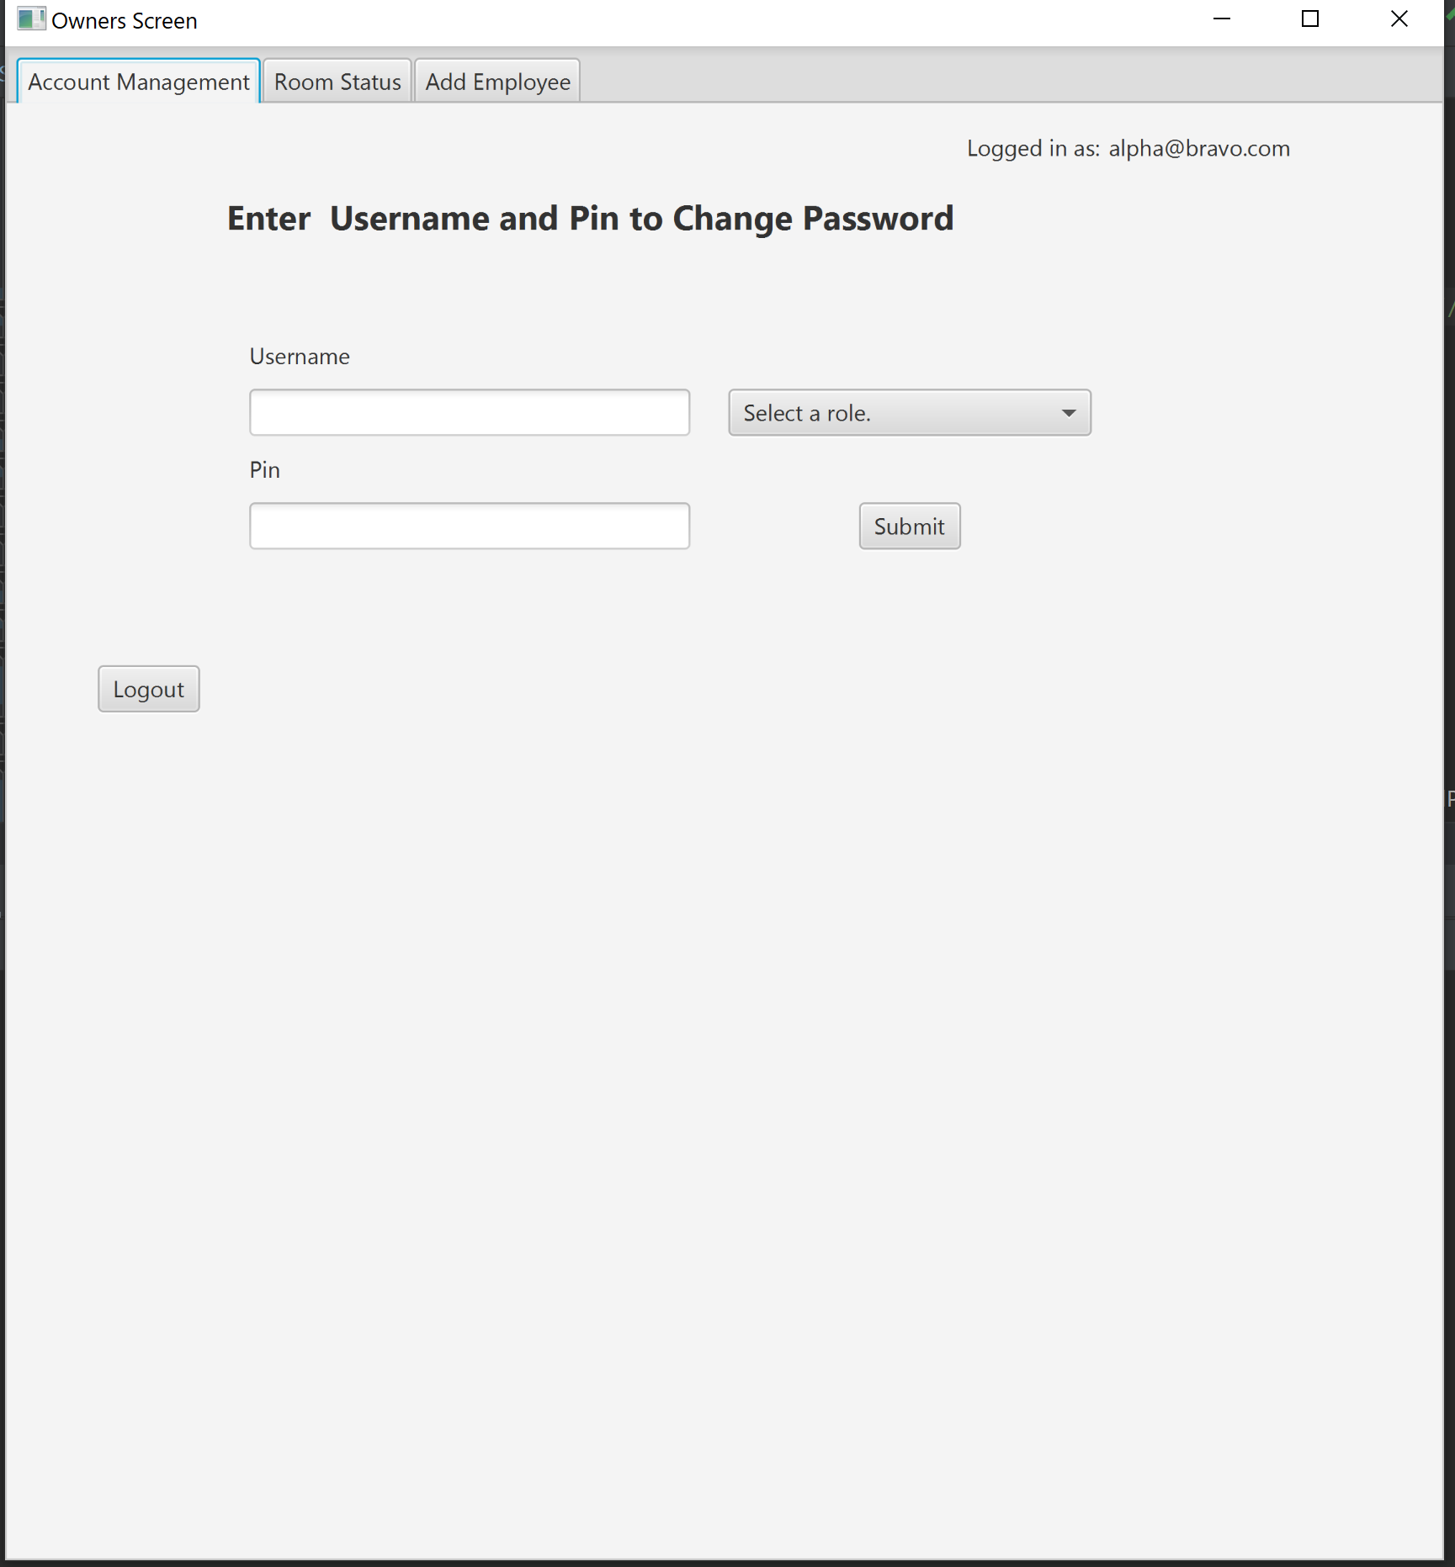

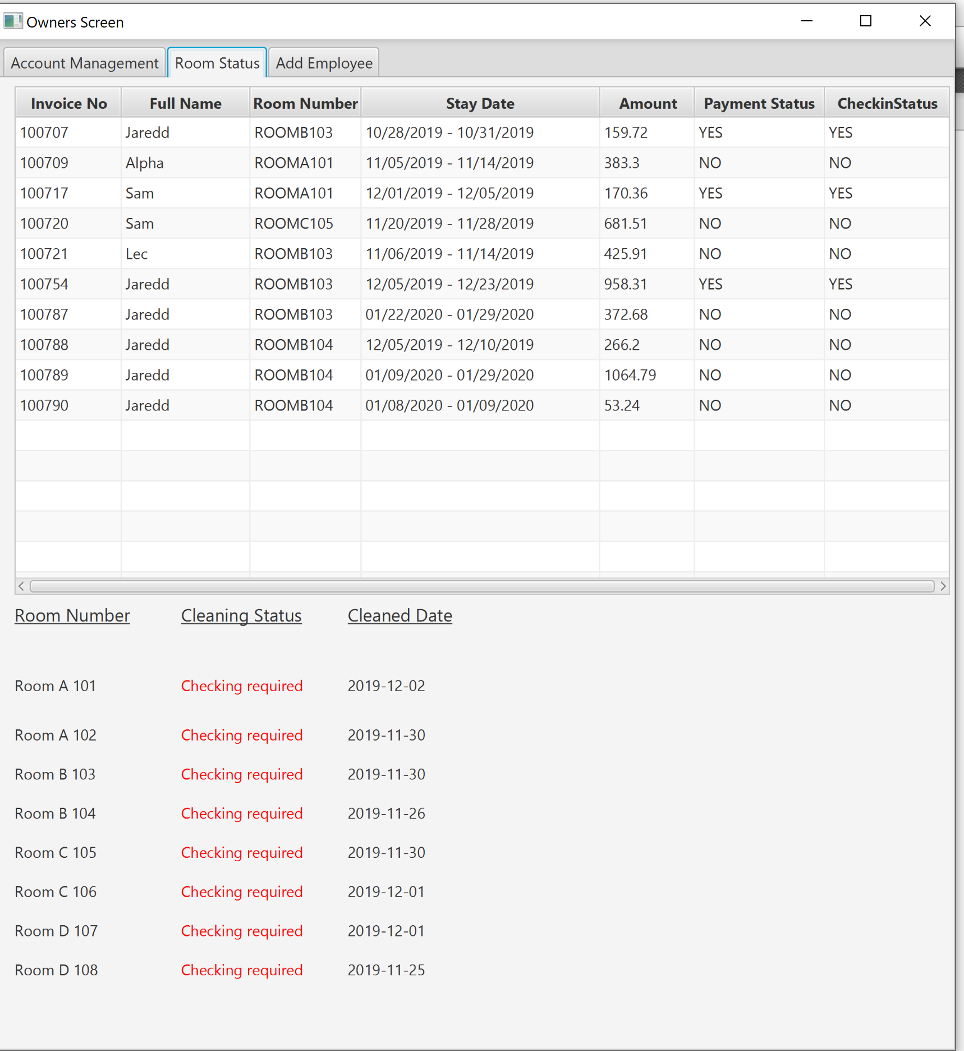

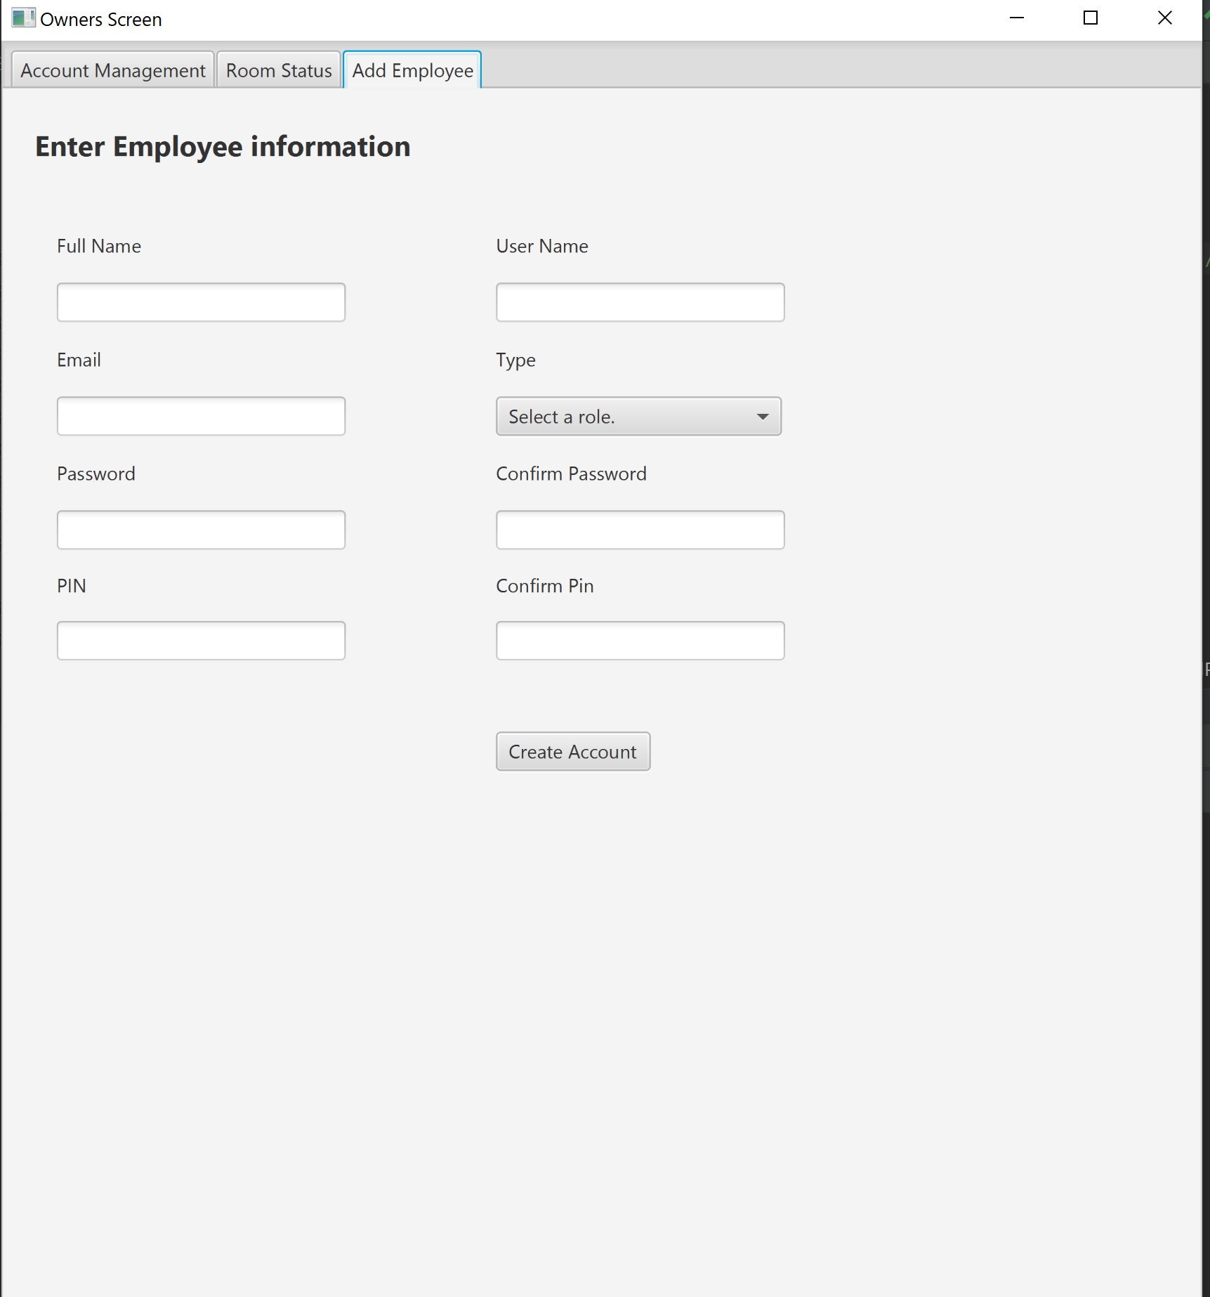

1. Click here to go to Password Reset Screen

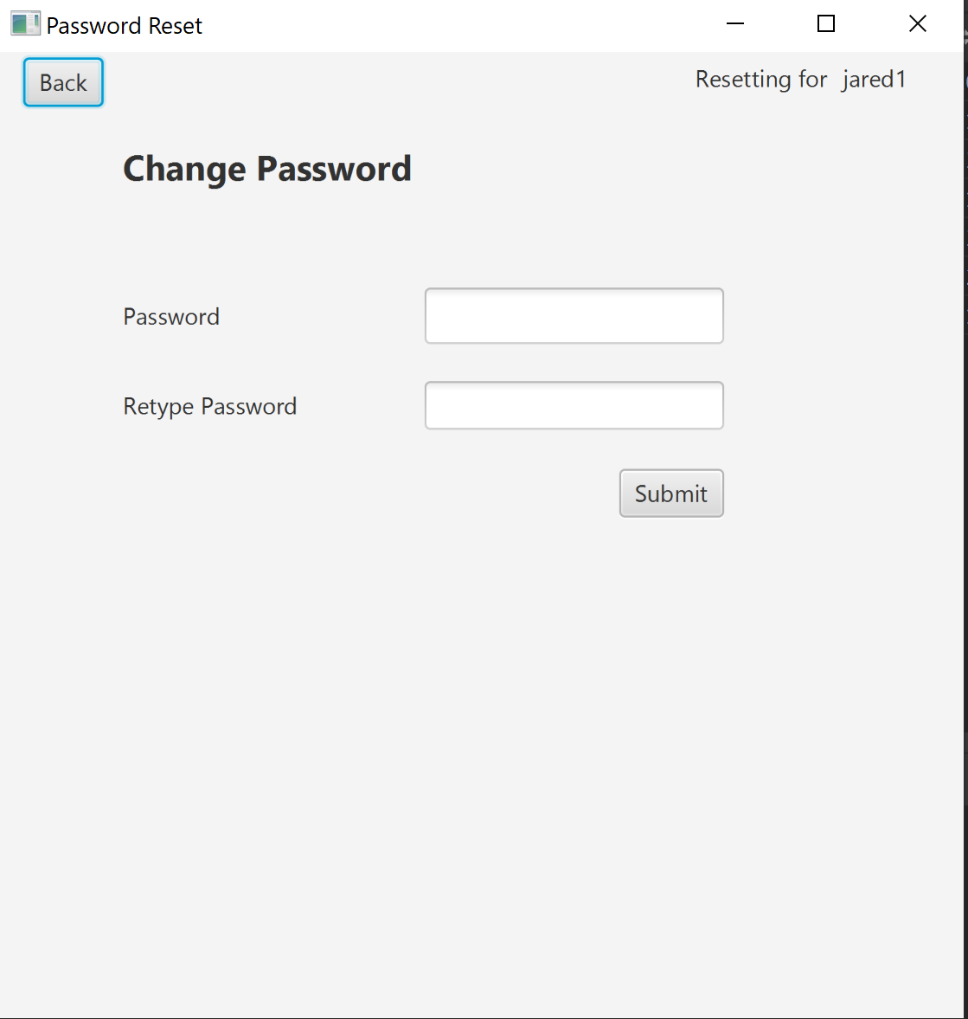

1. Click here to go to Client Interface

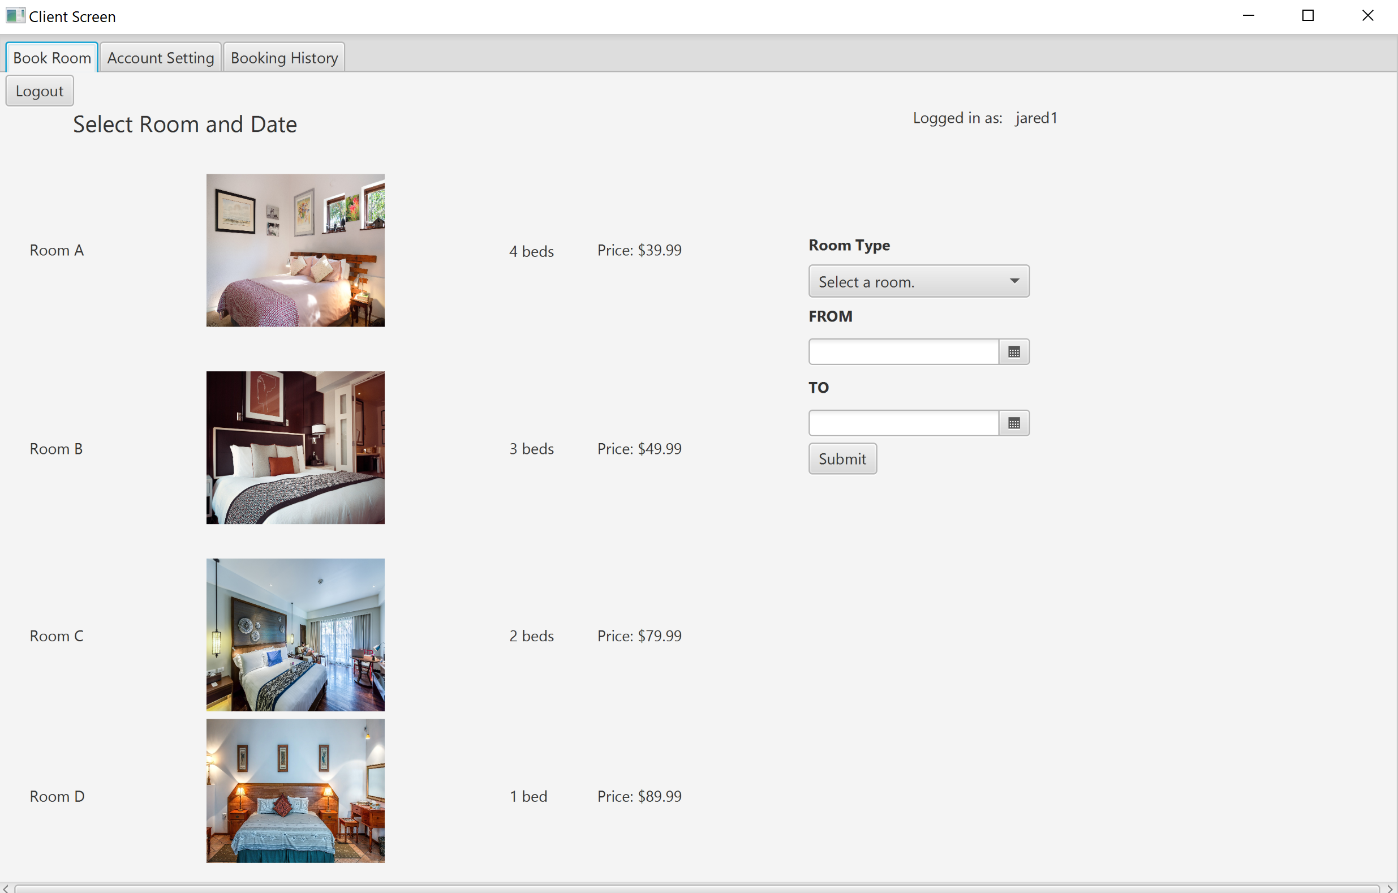

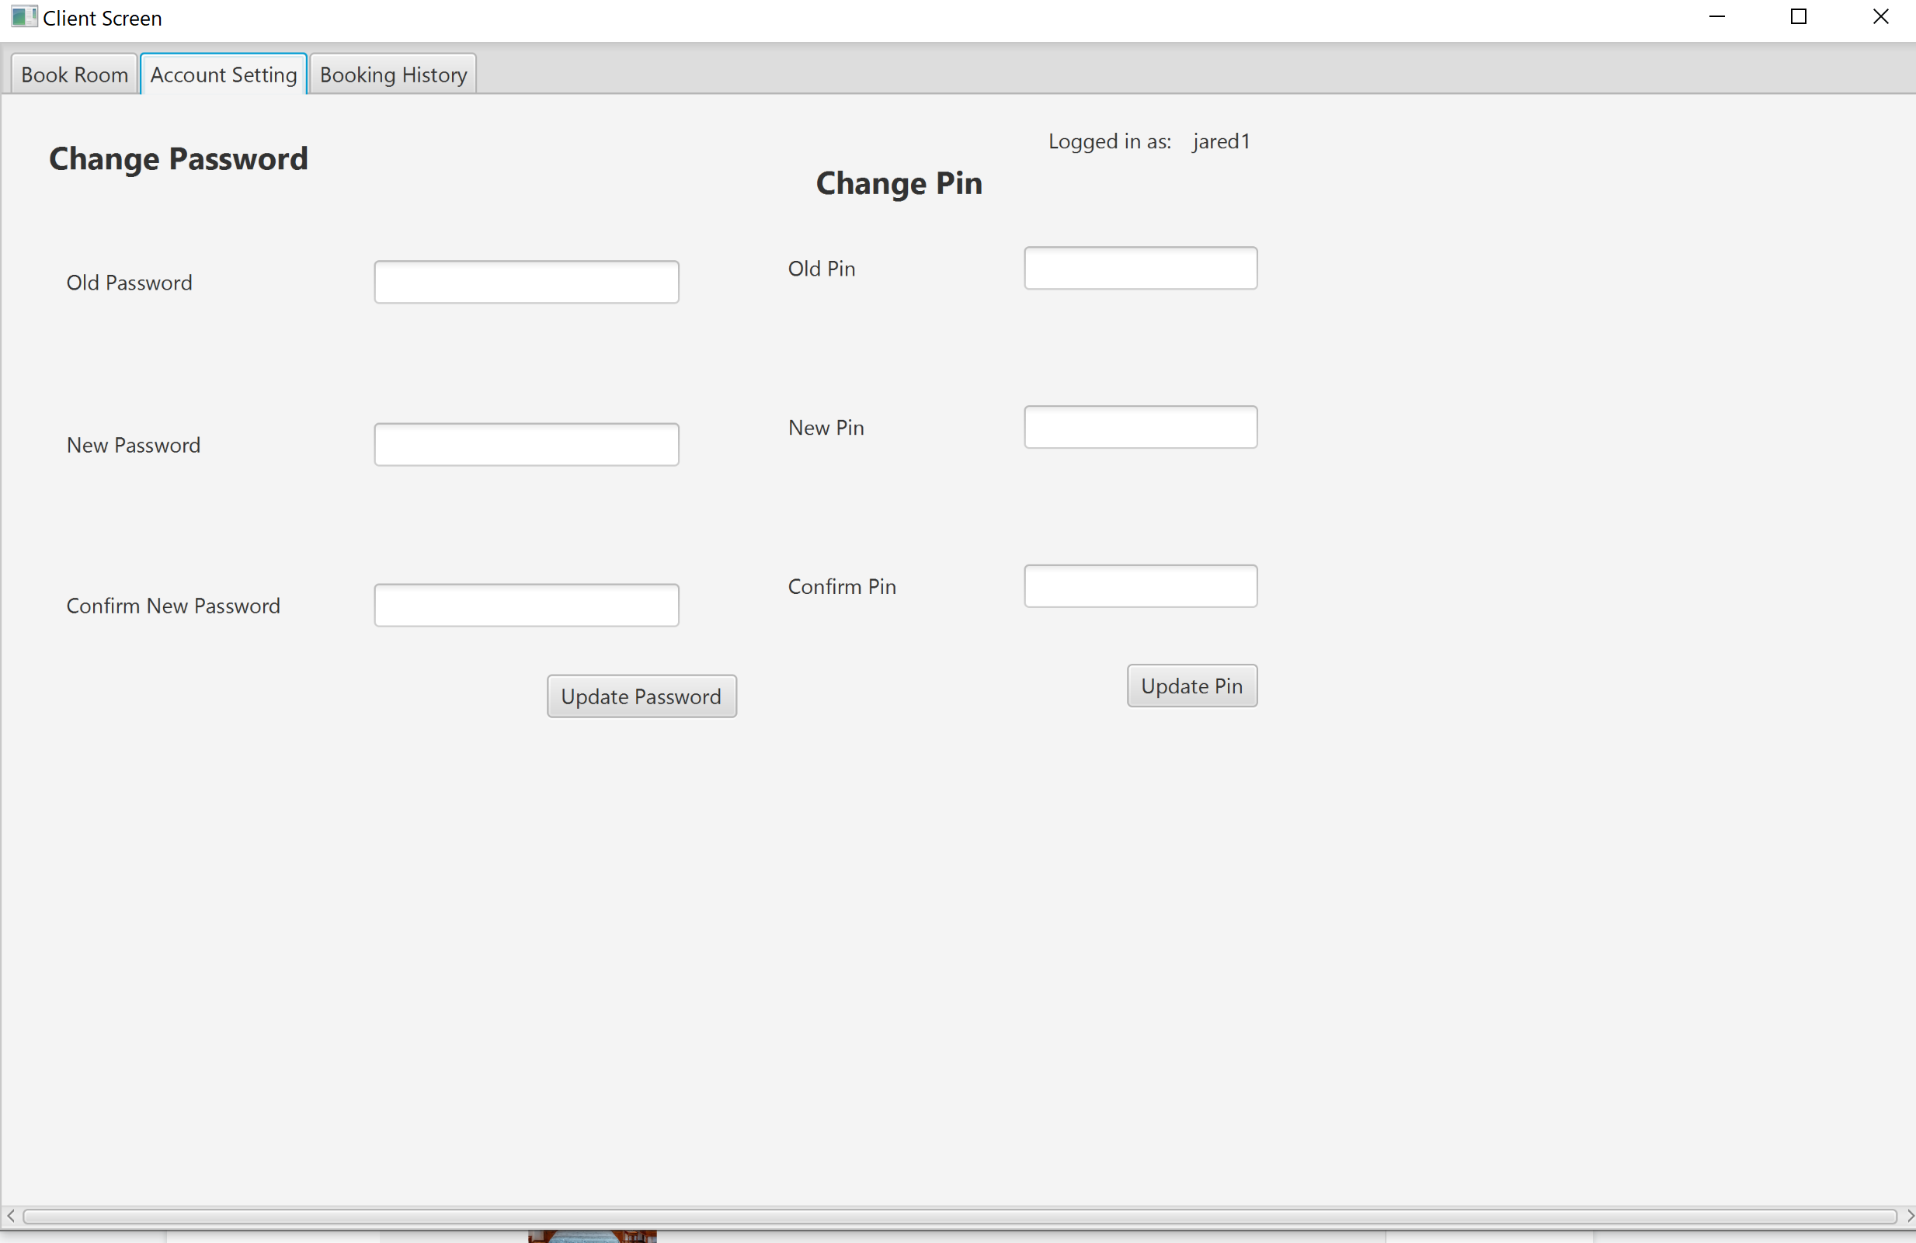

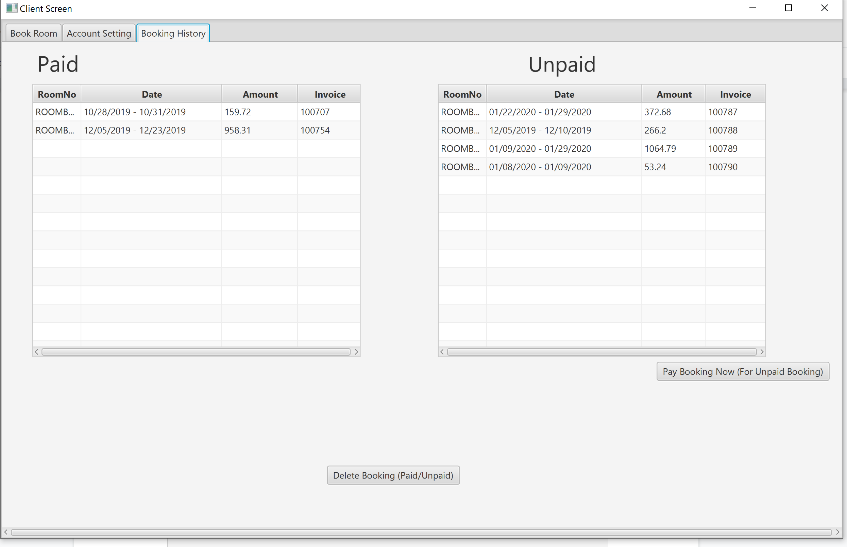

1. Click here to go to Payment Interface

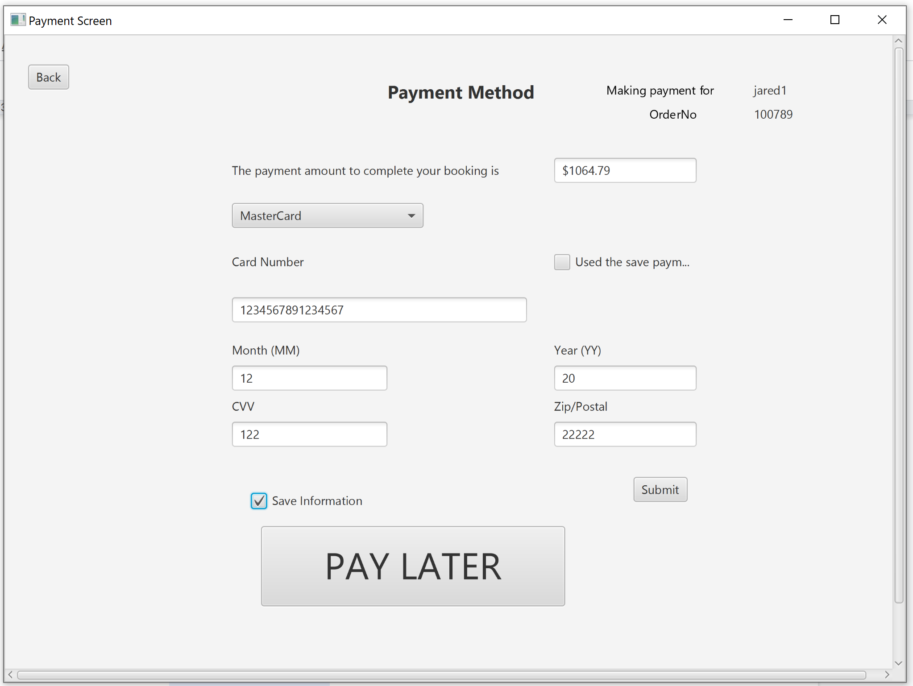

1. Click here to go to Desk Assistant Interface

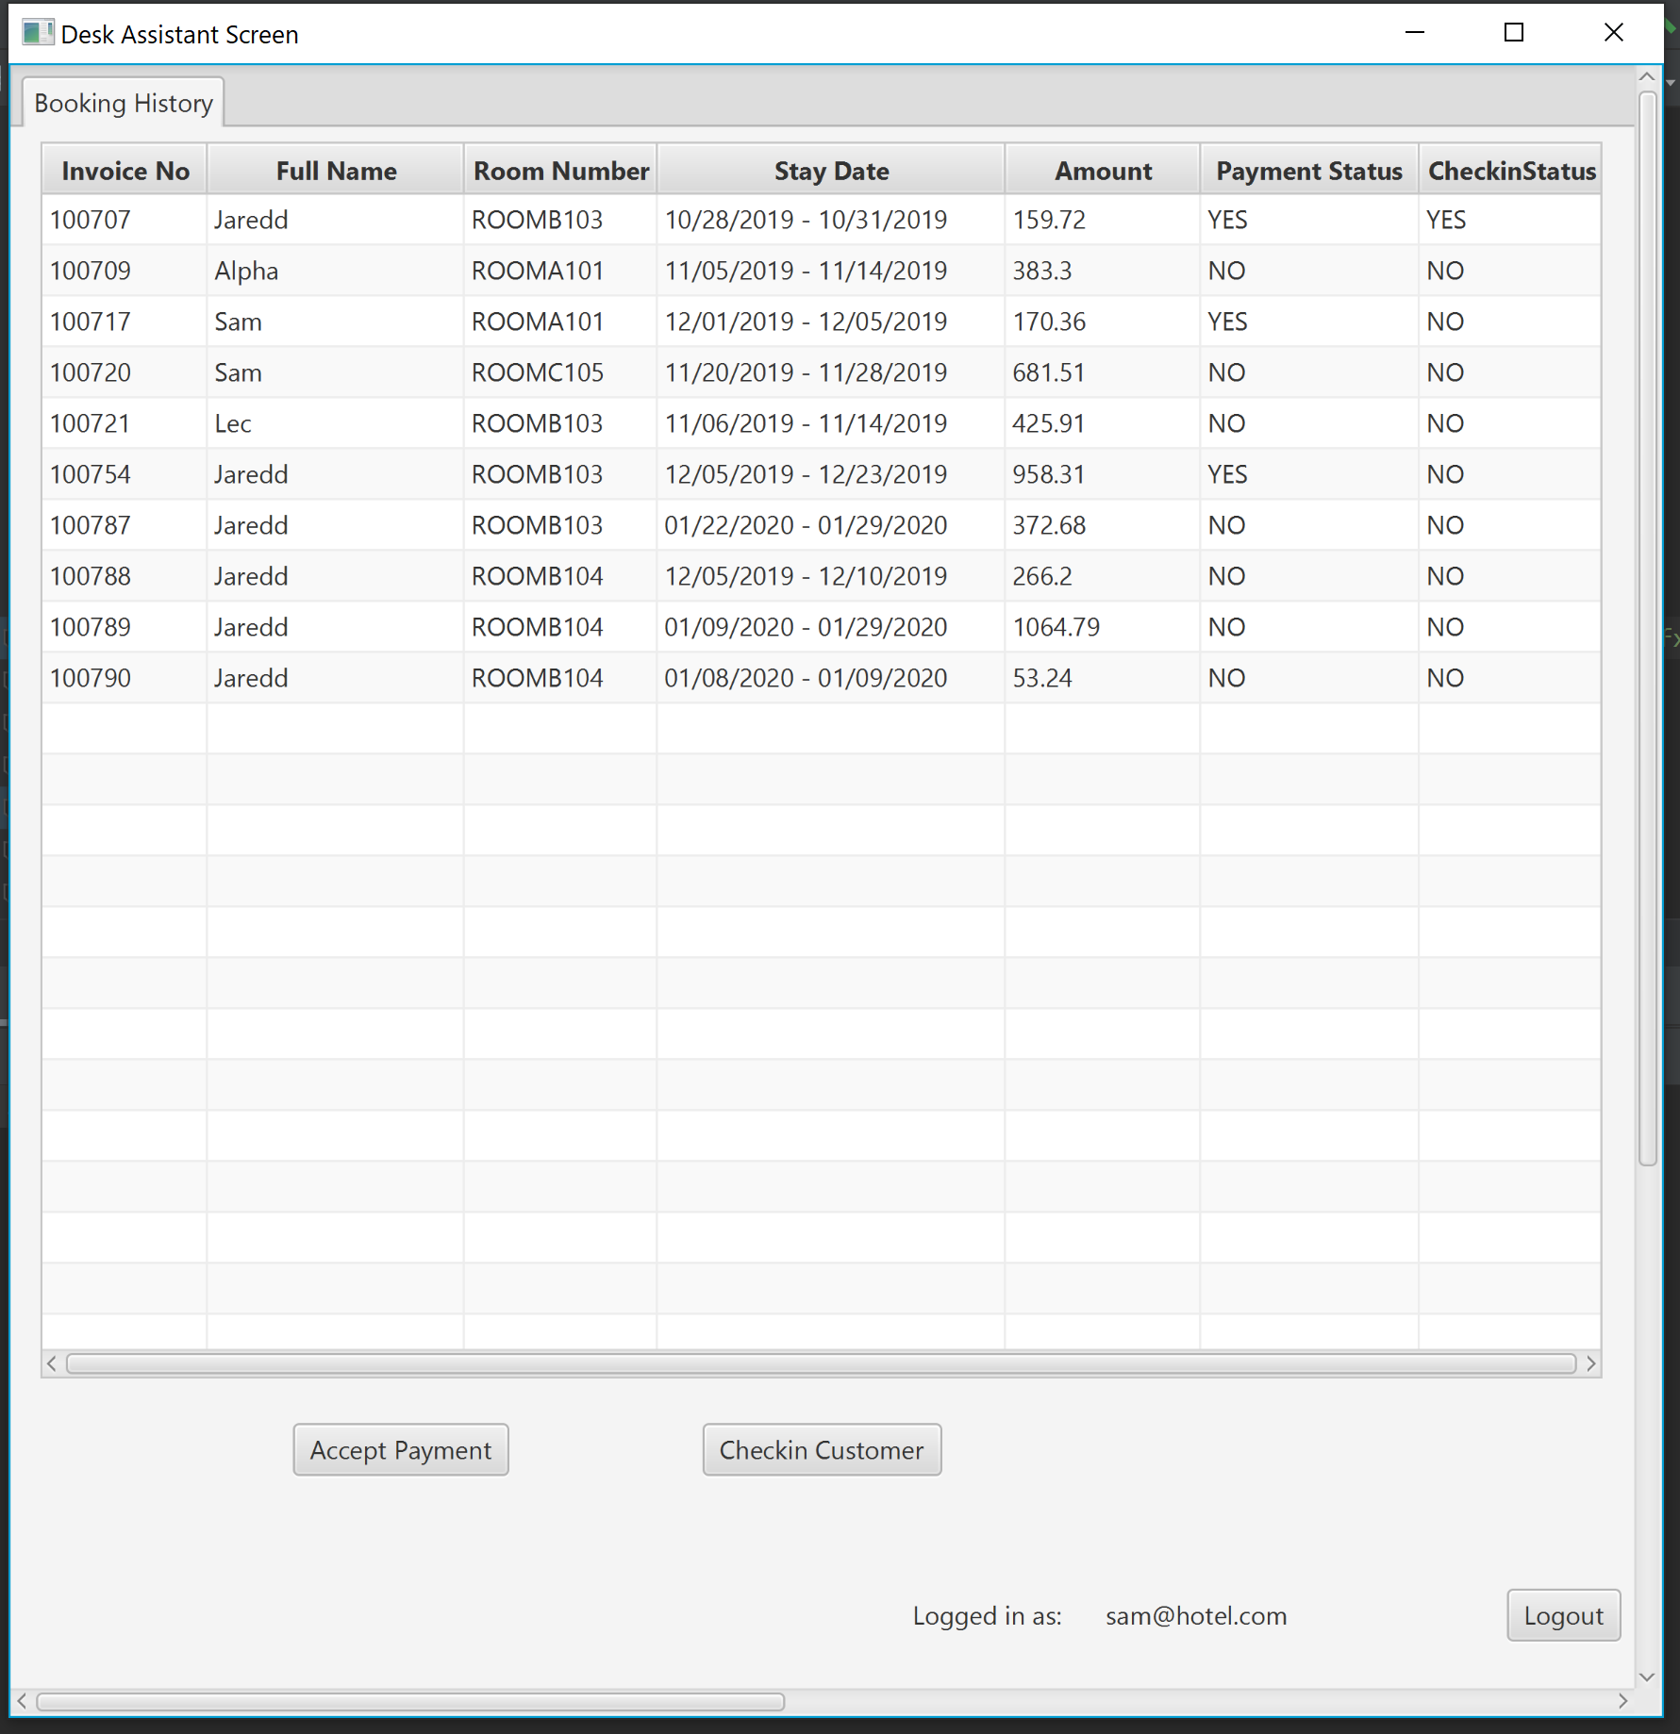

1. Click here to go to Custodian Interface

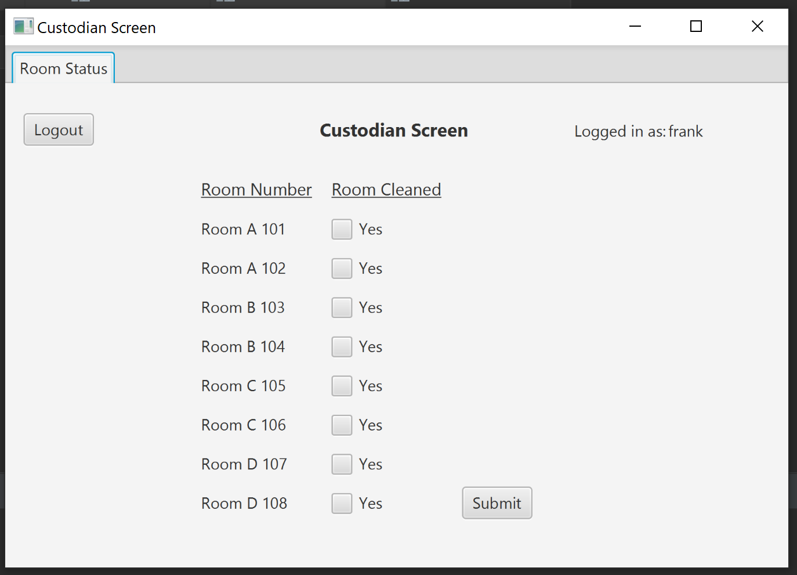

# Software Usage

### **Main menu**

The Main Menu interface is the start of the software. It is used as a welcome screen. It describes the resort that will take place as a strategy to gain the interests of potential customers. The screen is also accompanied by a “login” and a “sign-up” button.

### 

### **Sign-up Interface**

The Sign-up interface can be accessed from the Main Menu interface. As the interface title suggests, it is used to create an account for customers that are interested in joining the resort. The interface expects (Name=”Romanov Andre”, Username=”Manov06”, Email=”romanovandre05@gmail.com”, Phone number=”954-600-0000”, Password=”1234”, Pin=”4321”, Street=”10501 FGCU Lake Pkwy”, City=”Fort Myers”, State=”Florida”, Postal code=”33965”, Country=”USA”) as user input in order to successfully create an account.

### 

### **Sign-in Interface**

The Sign-in interface can also be accessed from the Main interface. As the interface title suggests, it is used to allow owners/customers/desk assistants/custodians to access their account. The interface expects a (Username="Manov05", Password="1234", Role=”Customer”) as user input in order to log-in an account.

### 

### **Owner Interface**

The Owner interface can be accessed from the Sign-in interface. The interface allows an owner to perform several actions. An “Account Management” tab, which can be used to modify a customers’ password, in a scenario where he or she were to forget it. This action requires (Username=”Manov05”, Pin=”4321”, Role=”Customer”) as user input in order to be completed. A “Transaction Details” tab, which provides a detailed report of customers that have joined the resort and booked a room at the hotel. Also, a report status of each room in the hotel, which can be used to keep track of employees to ensure they are on task. Lastly, an “Add Employee” tab, which can be used to create an account for new employees such as (receptionists and custodians). This action requires (Name=”Employee0” Username=”Emp13”, Email=”emp13@gmail.com, Password=”1234”, Role=”Custodian/Desk Assistant”, Pin=”4321”) as user input in order to be completed. The screen is also accompanied by a “logout” button which can be used to sign-out the user.

## Password Reset Screen

Owner can go the password screen by putting the right pin and username and setup a temporary password for the user. User is advised to reset the temporary password right away.

### 

### **Client Interface**

The Client interface can also be accessed from the Sign-in interface. The interface allows a client to perform several actions. A “Book Room” tab, which provides hotel room pictures for a customer to inspect in order to find the best match. Rooms and Date can then be selected based on availability providing (Room Type =”C”, FROM=”12/06/19”, TO=”12/08/19”) as user input. Once provided a client will then be sent to the Payment interface to complete his or her transaction. An “Account Setting” tab, which can be used to modify a client’s password or pin. A (Old Password/Pin=”1234”, New Password/Pin=”5678”, Confirm New Password/Pin=”5678”) provided as user input to complete that action. Lastly, A “Booking History” tab, which can be used to see all the previous bookings made (unpaid and paid). The tab also include two buttons “Pay Booking” and “Delete Booking” buttons. Which as the name suggests, pays and deletes bookings. The screen is also accompanied by a “logout” button which can be used to sign-out the user.

### 

### Payment Interface

The Payment interface allows customers to make a payment for a booking they made. The actions can be completed by providing (Use a saved Card=”No”, Card Type=”MasterCard”, Card Number=”5555333366667777”, Month=”07”, Year=”24”, CVV=”135”, Postal Code=”33021”, Save Card =”No”) as user input. The screen is also accompanied by a “back” button which can be used to navigate the previous screen.

### 

### **Desk Assistant Interface**

The Desk Assistant interface can also be accessed from the Sign-in interface. The interface allows a receptionist to view a detailed report of bookings made by clients. The interface allows receptionists to help clients with issues they may face when trying to make a booking. The screen contains an “accept payment” button which as the name suggests accepts a payment. Also, a “check-in customer” button which can be used by a receptionist to book a hotel for a client and the interface would redirect the receptionist to the Payment interface. Lastly, the screen is also accompanied by a “logout” button which can be used to sign-out the user.

### **Custodian Interface**

The Custodian interface can also be accessed from the Sign-in interface. The interface provides a list of each room in the hotel. A custodian employee is able to change a room’s status after maintenance has occurred.

#### 

Document each interface in this manner – use screenshots where applicable. Every method that is accessible to the user should be documented in clear (no jargon) terms with each step of the process clearly described. Expected user input should be given with an example (i.e. Date = MM/DD/YYYY i.e. “12/02/2015”)

# Glossary

Admin - owner

Guest- customer

Client - customer

Desk Assistant - receptionist

Cardsaved - To save the card information