|  |  |  |  |  |  |
| --- | --- | --- | --- | --- | --- |
| Mean interarrival time ( minutes) | 1.000 | 1.000 | 1.000 | 1.000 | 1.000 |
| Mean service time minutes | 0.300 | 0.400 | 0.500 | 0.600 | 0.700 |
| Mean time an item spends in the system | 0.3*(2-0.3) / 2*(1-0.3) = 0.364 | 0.4*(2-0.4) /2*(1-0.4) = 0.533 | 0.5*(2-0.5) /2(1-0.5) = 0.75 | 0.6*(2-0.6) / 2(1-0.6) = 1.05 | 0.7*(2-0.7) /2(1-0.7) = 1.517 |
| Mean no of items waiting to be served | 0.3*0.3/2(1-0.3) =0.064 | 0.4*0.4/2(1-0.4) = 0.133 | 0.5*0.5/2(1-0.5) = 0.25 | 0.45 | 1.817 |
| Mean waiting time (includes items that have to wait and items with waiting time=0) | 0.3*0.3/2(1-0.3) =0.064 | 0.133 | 0.5*0.5/2(1-0.5) = 0.25 | 0.45 | 1.817 |
| Average delay in queue | 0.064 | 0.133 | 0.250 | 0.450 | 1.817 |
| Average number in queue | 0.064 | 0.133 | 0.250 | 0.450 | 1.817 |

**Assignment #3**

Analytical results: for M/D/1, n=20000 customers

Simulation results:

For M/D/1

|  |  |  |  |  |  |
| --- | --- | --- | --- | --- | --- |
| Mean interarrival time ( minutes) | 1.000 | 1.000 | 1.000 | 1.000 | 1.000 |
| Mean service time minutes | 0.300 | 0.400 | 0.500 | 0.600 | 0.700 |
| Mean time an item spends in the system | 0.3*(2-0.3) / 2*(1-0.3) = 0.364 | 0.4*(2-0.4) /2*(1-0.4) = 0.533 | 0.5*(2-0.5) /2(1-0.5) = 0.75 | 0.6*(2-0.6) / 2(1-0.6) = 1.05 | 0.7*(2-0.7) /2(1-0.7) = 1.517 |
| Mean no of items waiting to be served | 0.3*0.3/2(1-0.3) =0.064 | 0.4*0.4/2(1-0.4) = 0.133 | 0.5*0.5/2(1-0.5) = 0.25 | 0.45 | 0.817 |
| Mean waiting time (includes items that have to wait and items with waiting time=0) | 0.3*0.3/2(1-0.3) =0.064 | 0.133 | 0.5*0.5/2(1-0.5) = 0.25 | 0.45 | 0.817 |
| Average delay in queue | 0.064 | 0.132 | 0.245 | 0.440 | 0.806 |
| Average number in queue | 0.065 | 0.133 | 0.247 | 0.444 | 0.812 |

Program:

/* External definitions for single-server queueing system. */

#include <stdio.h>

#include <math.h>

#include<stdlib.h>

#include "lcgrand.h"

/* #include "lcgrand.h" /* Header file for random-number generator. */

#define Q_LIMIT 100 /* Limit on queue length. */

#define BUSY 1 /* Mnemonics for server's being busy */

#define IDLE 0 /* and idle. */

int next_event_type, num_custs_delayed, num_delays_required, num_events,

num_in_q, server_status;

float area_num_in_q, area_server_status, mean_interarrival, mean_service,

sim_time, time_arrival[Q_LIMIT + 1], time_last_event,

time_next_event[3],

total_of_delays;

FILE *infile, *outfile;

void initialize(void);

void timing(void);

void arrive(void);

void depart(void);

void report(void);

void update_time_avg_stats(void);

float expon(float mean);

int main() /* Main function. */

{

/* Open input and output files. */

infile = fopen("md1.in", "r");

outfile = fopen("md1.out", "w");

/* Specify the number of events for the timing function. */

num_events = 2;

/* Read input parameters. */

fscanf(infile, "%f %f %d", &mean_interarrival, &mean_service,

&num_delays_required);

/* Write report heading and input parameters. */

fprintf(outfile, "Single-server queueing system\n\n");

fprintf(outfile, "Mean interarrival time%11.3f minutes\n\n",

mean_interarrival);

fprintf(outfile, "Mean service time%16.3f minutes\n\n", mean_service);

fprintf(outfile, "Number of customers%14d\n\n", num_delays_required);

/* Initialize the simulation. */

initialize();

/* Run the simulation while more delays are still needed. */

while (num_custs_delayed < num_delays_required) {

/* Determine the next event. */

timing();

/* Update time-average statistical accumulators. */

update_time_avg_stats();

/* Invoke the appropriate event function. */

switch (next_event_type) {

case 1:

arrive();

break;

case 2:

depart();

break;

}

}

/* Invoke the report generator and end the simulation. */

report();

fclose(infile);

fclose(outfile);

return 0;

}

void initialize(void) /* Initialization function. */

{

/* Initialize the simulation clock. */

sim_time = 0.0;

/* Initialize the state variables. */

server_status = IDLE;

num_in_q = 0;

time_last_event = 0.0;

/* Initialize the statistical counters. */

num_custs_delayed = 0;

total_of_delays = 0.0;

area_num_in_q = 0.0;

area_server_status = 0.0;

/* Initialize event list. Since no customers are present, the

departure

(service completion) event is eliminated from consideration. */

time_next_event[1] = sim_time + expon(mean_interarrival);

time_next_event[2] = 1.0e+30;

}

void timing(void) /* Timing function. */

{

int i;

float min_time_next_event = 1.0e+29;

next_event_type = 0;

/* Determine the event type of the next event to occur. */

for (i = 1; i <= num_events; ++i){

if (time_next_event[i] < min_time_next_event) {

min_time_next_event = time_next_event[i];

next_event_type = i;

}

}

/* Check to see whether the event list is empty. */

if (next_event_type == 0) {

/* The event list is empty, so stop the simulation. */

fprintf(outfile, "\nEvent list empty at time %f", sim_time);

exit(1);

}

/* The event list is not empty, so advance the simulation clock. */

sim_time = min_time_next_event;

}

void arrive(void) /* Arrival event function. */

{

float delay;

/* Schedule next arrival. */

time_next_event[1] = sim_time + expon( mean_interarrival);

/* Check to see whether server is busy. */

if (server_status == BUSY) {

/* Server is busy, so increment number of customers in queue. */

++num_in_q;

/* Check to see whether an overflow condition exists. */

if (num_in_q > Q_LIMIT) {

/* The queue has overflowed, so stop the simulation. */

fprintf(outfile, "\nOverflow of the array time_arrival at");

fprintf(outfile, " time %f", sim_time);

exit(2);

}

/* There is still room in the queue, so store the time of arrival

of the

arriving customer at the (new) end of time_arrival. */

time_arrival[num_in_q] = sim_time;

}

else {

/* Server is idle, so arriving customer has a delay of zero. (The

following two statements are for program clarity and do not

affect

the results of the simulation.) */

delay = 0.0;

total_of_delays += delay;

/* Increment the number of customers delayed, and make server

busy. */

++num_custs_delayed;

server_status = BUSY;

/* Schedule a departure (service completion). */

time_next_event[2] = sim_time + mean_service; /*changes here*/

}

}

void depart(void) /* Departure event function. */

{

int i;

float delay;

/* Check to see whether the queue is empty. */

if (num_in_q == 0) {

/* The queue is empty so make the server idle and eliminate the

departure (service completion) event from consideration. */

server_status = IDLE;

time_next_event[2] = 1.0e+30;

}

else {

/* The queue is nonempty, so decrement the number of customers in

queue. */

--num_in_q;

/* Compute the delay of the customer who is beginning service and

update

the total delay accumulator. */

delay = sim_time - time_arrival[1];

total_of_delays += delay;

/* Increment the number of customers delayed, and schedule

departure. */

++num_custs_delayed;

time_next_event[2] = sim_time + mean_service; /* changes here */

/* Move each customer in queue (if any) up one place. */

for (i = 1; i <= num_in_q; ++i)

time_arrival[i] = time_arrival[i + 1];

}

}

void report(void) /* Report generator function. */

{

/* Compute and write estimates of desired measures of performance. */

fprintf(outfile, "\n\nAverage delay in queue%11.3f minutes\n\n",

total_of_delays / num_custs_delayed);

fprintf(outfile, "Average number in queue%10.3f\n\n",

area_num_in_q / sim_time);

fprintf(outfile, "Server utilization%15.3f\n\n",

area_server_status / sim_time);

fprintf(outfile, "Time simulation ended%12.3f minutes", sim_time);

}

void update_time_avg_stats(void) /* Update area accumulators for timeaverage

statistics. */

{

float time_since_last_event;

/* Compute time since last event, and update last-event-time marker.

*/

time_since_last_event = sim_time - time_last_event;

time_last_event = sim_time;

/* Update area under number-in-queue function. */

area_num_in_q += num_in_q * time_since_last_event;

/* Update area under server-busy indicator function. */

area_server_status += server_status * time_since_last_event;

}

float expon(float mean) /* Exponential variate generation function. */

{

/* Return an exponential random variate with mean "mean". */

return -mean * logf(lcgrand(1));

}

/*

float expon(float mean) /* Exponential variate generation function.*/

/*

{

float u;

/* Generate a U(0,1) random variate. */

/*

u = lcgrand(1);

/* Return an exponential random variate with mean "mean". */

/*

return -mean * log(u);

} */

Plot using MATLAB:

x = [0.3,0.4,0.5,0.6,0.7];

y1 = [0.064,0.133,0.25,0.45,0.817];

y2 = [0.064,0.132,0.245,0.44,0.806];

plot(x,y1,x,y2)

legend({'Analytical','Simulation'},'Location','northeast')

title('Delay/Waiting time in queue vs Utilization')

xlabel('Utilization- P')

ylabel('Waiting Time in minutes')

Figure:

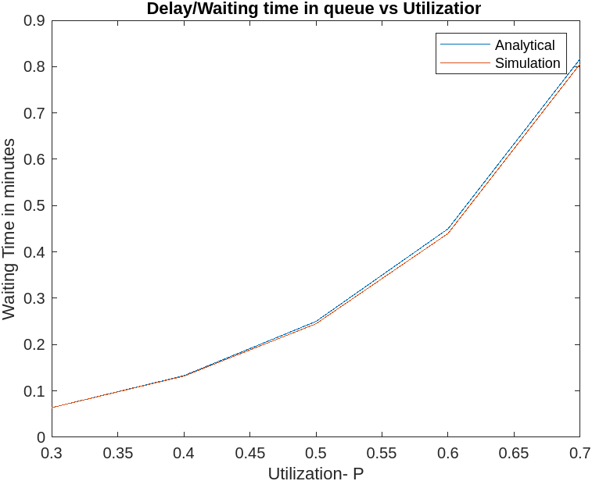

The above figure shows the results for the measures both analytic and from simulation as a function of ρ(utilization) = λ/μ where λ is arrival rate(= inverse of mean interarrival time) and μ is service rate (inverse of mean service time)

***