Assignment #5

Report - Group A

Mohammed Shahzad

[444105788@student.ksu.edu.sa](mailto:444105788@student.ksu.edu.sa)

GROUP A - “A Cooperative Learning Scheme for Energy Efficient Routing in Wireless Networks” and “An Intelligent Routing Approach for Wireless Sensor Networks”

**Summary Review for "A Cooperative Learning Scheme for Energy Efficient Routing in WSN" also “CEERA”**

"A Cooperative Learning Scheme for Energy Efficient Routing in WSN", also “CEERA”, proposed by Dr Sami AlWakeel and Dr Najla AlNabhan is an interesting approach for the development of energy-efficient WSNs that is crucial for sustainable and progressive growth and usability of the Internet of Things (IoT) in the real world.

The paper addresses the primary problem, that is currently being actively researched that is, energy-efficiency in Wireless sensor networks. As the researchers rightly pointed out, Network lifetime and efficiency are the most considered issues in Wireless sensor networks (WSNs) based systems. The scarcest resource being energy.

It is common knowledge in the field of Wireless sensor communication that, the most energy spent on Communication is on two things Route discovery and data transfer.

This Paper then presents a novel design of a cooperative nodes learning scheme called CEERA (Cooperative Energy-Efficient Routing Algorithm) in WSNs. The algorithm efficiently avoids the energy consumption problem as it does not require any prior configuration or routing discovery operations.

The paper describes the underlying network model and other related models, including: deployment, traffic, and energy models. A Network Model where all nodes transmit to control centre or a Base Station (BS). A Deployment Model where Deployment is either random or deterministic. The Traffic Model decides the inter-arrival time between messages and the Energy Model to divide energy requirements for sensing, computation, and communication.

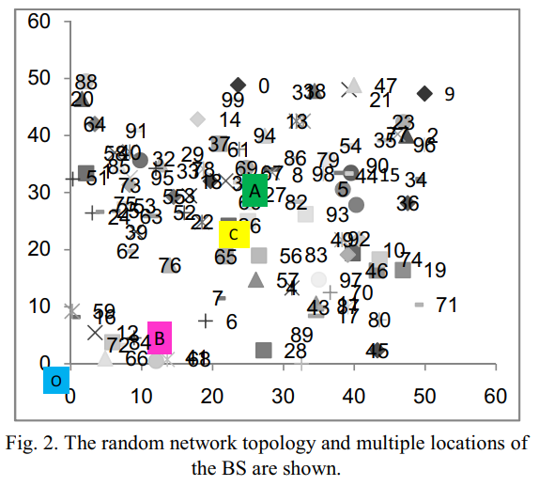

The performance is measured in terms of Throughput, Delay, Delay time jitter, total energy dissipations, no of dead nodes, FND-First node to Die lifetime, Beta pf nodes to die lifetime, and duplicates.

CEERA authors say, nodes cooperate in learning from each other in order to have an efficient delivery of data to the base station. Also, data message is flagged to be transmitted in either source-route mode or cooperative mode. Based on its energy level, a node may not participate in data transmission if its current energy is less than a predefined energy threshold.

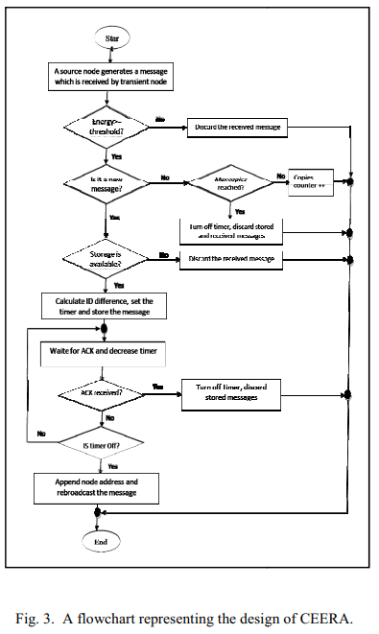The CEERA Algorithm:

The following is the researchers’ algorithm design for CEERA. Each transient node ‘t’ that receives the packet will carry out the following steps:

1) Calculates the ID difference

2) Starts a timer counter

3) Listens to BS’s ACK, and periodically decrements its timer.

If the BS acknowledgment is not received within the timer value, the transient node retransmit message and appends its address to the address list of transient nodes. Upon receiving the ACK, all nodes clear the call and reset their counters.

The researchers implemented their own event-driven simulation written in C++, aimed at studying the impact of varying the scalar factor, Dmax, buffer size, and duplication factor over the collected performance measures. Researchers mention that these included Throughput delay, DTJ, memory occupation per node, energy dissipation, per initial energy, no. of died nodes, FND, BND, HNA, LND, Hop count, congestion/overhead, and duplicated arrivals.

The resultant analysis reiterated a significant improvement in energy usage in routing with CEERA. CEERA outperforms Flooding 15, 27, and 41 times. Also, CEERA achieves over a factor of 1.34 and 1.26 reduction in energy dissipation.

**Methodology of the Research**

The research has been done following the quantitative methodology approach. The research paper presents a model that was developed to address a problem and the results were analysed to determine the efficiency of the proposed improvements.

Quantitatively, the research measured various metrics and compared it with current standards and presented the data using tables, graphs, and charts.

**Results concluded by the article**

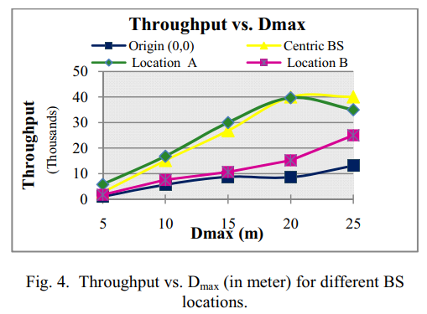The paper evaluated and discussed the results, WSN performance of CEERA with various values of transmission range, Dmax. the WSN throughput in terms of number of messages as a function of Dmax. As shown, the highest recorded throughput is for BS at (A) which has the highest nodes density around BS. Increasing Dmax increases throughput to a certain degree, minimizes delay, delay time jitter and hop count but it maximizes no. of duplicated arrivals.

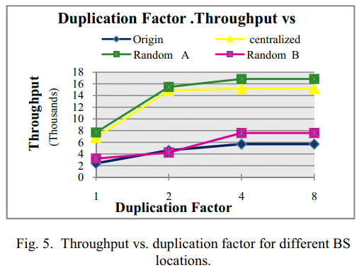For buffer size, it is expected that buffer size is proportional to throughput, and inversely proportional to delay, conjunction, and duplicated arrival. Maximizing buffer size allows more messages to be stored and routed later. We extracted results for buffer size values: 5, 10, 15, and 20.

Simulation shows an increase in delay and DTJ for network “B” and “O”, this is because more messages are able access BS after we increased storage of transient nodes. Simulation shows a minor change in 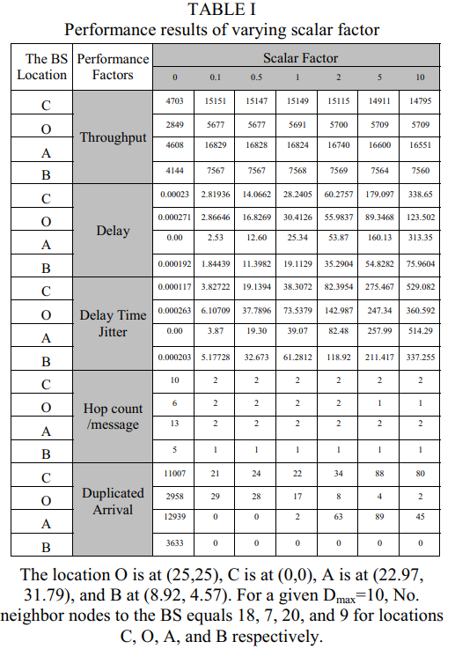throughput for increasing buffer size from 10 to 20, which implies that CEERA‘s efficiency is not restricted that the amount of memory. For all monitored networks, it is sufficient to include a realistic storage area and no need to extra storage.

The goal of introducing duplication factor in this research is to save memory by limiting long message storage while it stored by other neighbours. Duplication factor must be selected so that it avoids message loss and saves the available storage. When duplication factor equals r, it means that a message is discarded by a transient node when it received r times. A small value for duplication factor causes message loss, since message deleted quickly. Fig. 5 shows the impact of maximizing the value of duplication factor from 1 to 4 improves throughput for all networks. This significant improvement does not continue when duplication factor is increased to 8.

The paper studied the performance of CEERA extensively when compared to other algorithms. Simulation shows a significant improvement in energy usage in routing with CEERA. CEERA outperforms Flooding 15, 27, and 41 times.

Also, CEERA achieves over a factor of 1.34 and 1.26 reduction in energy dissipation compared to Minimum Transmission Energy (MTE) scheme for some BSs’ locations.

**Summary Review for “An Intelligent Routing Approach for Wireless Sensor Networks”**

The conference paper titled "An Intelligent Routing Approach for Wireless Sensor Networks" presented by Dr Najla Al-Nabhan, and Dr Sami Al-Wakeel is an interesting read for Wireless sensor networks and IoT researchers alike. The paper brings to light how wireless sensing technology applications faces many challenges, mainly caused by communication failures, storage and computational constraints and limited power supply.

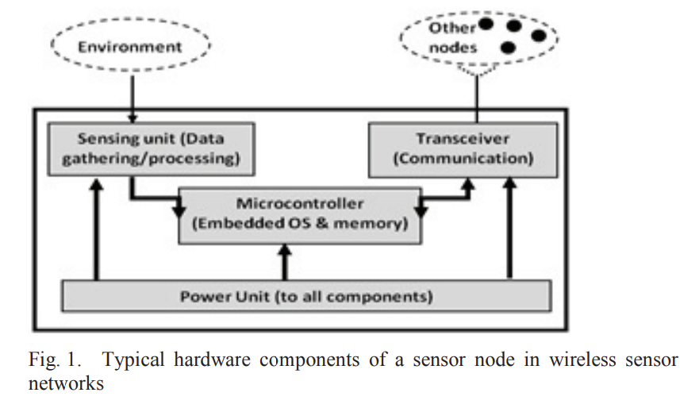

In the five-section paper, they have presented the problem and a fitting solution to counter the problem of energy efficiency. We know that in WSN, data transmission is performed in multi-hop fashion, however this form of communication possibly floods the network with many data packets due the multiple broadcasts.

In section 2 of their paper, the researchers presented the detailed design of how they approached the problem. The paper details how this approach achieves energy efficiency by minimizing packet retransmission caused by transient nodes. It does so, apparently, by allowing the transient sensor nodes to respond intelligently for receiving data packets from source nodes.

In their approach, they intent to maximizes the lifetime of sensor nodes by considering the residual energy level as a major criterion for the participation in the cooperative packet routing. A node may not participate when it is running low on energy.

Their typical network characteristics includes: A fixed Base Station (BS), sensor nodes- homogeneous and energy constrained, sensors have no location information, not all nodes are able to reach BS, symmetric propagation channel, Transmission range, Dmax, depends of number of nodes within this distance to the base station and is a key parameter that has a significant impact on the network operational lifetime.

Performance was measured in terms of throughput, Delay, Delay Time Jitter (DTJ), the Total Energy dissipations, and number of dead nodes.

In their research, the contributors, backed by factual data and analytics, concluded that an intelligent routing scheme as such discussed above is paramount to successful, long lasting, and energy efficient Wireless Sensor Networks.

**Methodology of the Research**

The research has been done following the quantitative methodology approach. The research paper presents a model that was developed to address a problem and the results were analysed to determine the efficiency of the proposed improvements.

Quantitatively, the research measured various metrics and compared it with current standards and presented the data using tables, graphs and charts.

**Results concluded by the article**

In section 4, the simulation results are evaluated and analysed along with detailed discussion. The researchers ran that experiment with input of 40.000 Simulation packets, 20 buffer size, inter-arrival time = 0.5, initial energy per node =101e+7, Duplicate factor=5, and Dmax= 10m, we extract results scalar values: 0, 0.1, 0.5, 1, 2, 5, and 10.

Simulation shows that the zero value for the scalar results a poor performance since the approach behaves similar to Flooding algorithm.

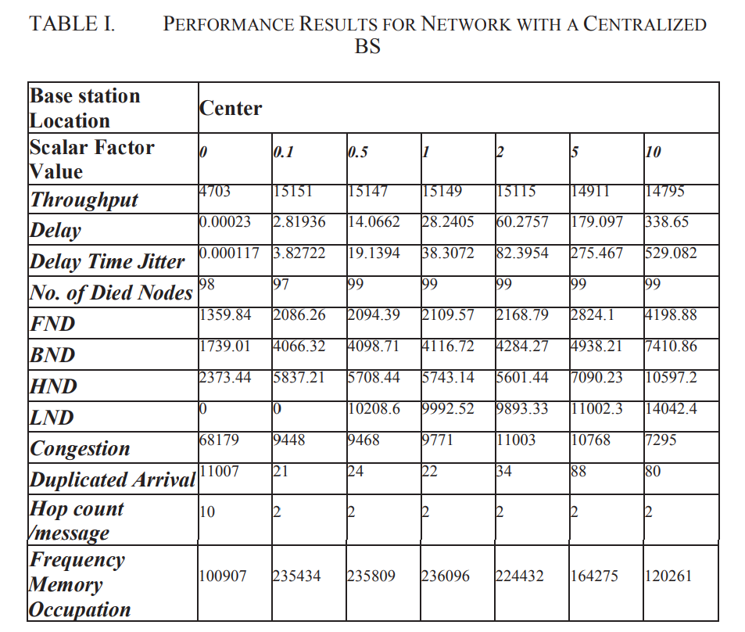The simulation results obtained by the researchers suggest that, a higher scalar value does not always mean higher throughput. It is important when determining scalar value is to balance between our tendencies to save the retransmission energy, minimize delay caused by scalar factor, and utilize the available node resources.

The optimal value for the scalar depends on the underlying network state and type of application. For their simulation, researchers found the best scalar value is between 0.1, 0.5 and 1 as it has the best throughput, increased storage sharing and less delay than other values.

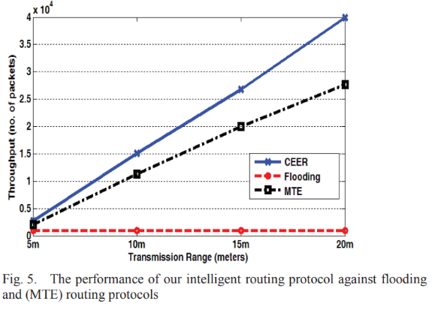The proposed intelligent approach outperforms Flooding 15, 27, and 41 times. Also, the approach achieves over a factor of 1.34 and 1.26 reduction in energy dissipation compared to Minimum Transmission Energy (MTE) routing protocol. Their solution is expected to deliver WSN based applicable improvements including optimizing energy consumption and prolonging the operational lifetime of the network.

In their research, the contributors concluded that an intelligent routing scheme as such discussed above is paramount to successful, long lasting, and energy efficient Wireless Sensor Networks.

The conference paper surely motivates and paves the way for future research in WSNs to counter the power constraints of the system and explore alternatives to message flooding by using intelligent approaches at the network and perception layers in sensor networks.

***