**Task 3**

**1.1**

Hello_world.ipynb:

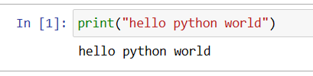

**1.2**

**Typo generates error:**

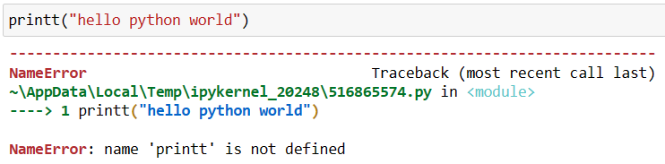

It is because the typo was made in the function name and python doesn’t identify any method called printt. If typo was made inside the “ quoted text” there would’ve been no error.

**2.1:**

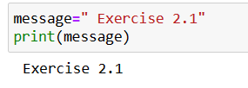

**2.2:**

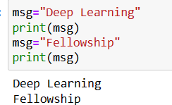

**2.3**

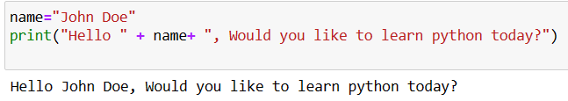

**2.4**

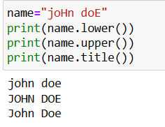

**2.5**

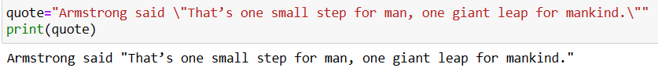

**2.6**

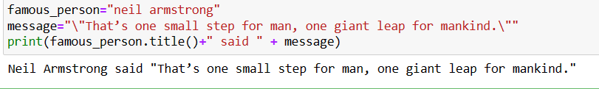

**2.7**

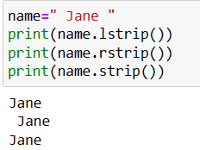

**2.8**

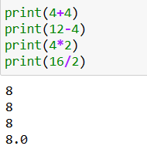

**2.9**

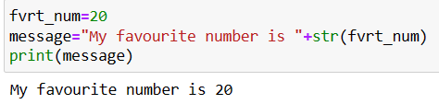

**2.10**

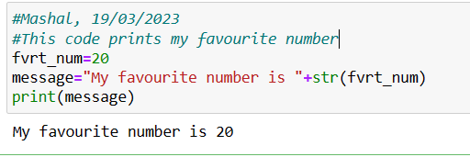

**2.11**

