GOVERNING AI IN SCHOOLS:
FROM POLICY TO PRACTICE

A World-Class Professional Development Programme for K-12 Education Leaders and Staff

“The only course that takes your entire school community — from principal to parent liaison —
from AI awareness to a fully drafted, board-ready AI Policy and Guidance Suite.”

Based on analysis of 60+ authoritative AI policy documents from across the United States
including US Department of Education, TeachAI, Digital Promise, and 30+ State Departments of Education

Prepared by: TechTelligence | April 2026 | Version 1.0

TABLE OF CONTENTS
EXECUTIVE SUMMARY

PHASE 1: DEEP DOCUMENT ANALYSIS
1. Overview of the Document Corpus
• 1.1 Document Corpus — Full Inventory
• 1.2 Document Type Distribution
2. Structural Analysis — Document by Document
• 2.1 US Department of Education — EdLeaders AI Toolkit
• 2.2 TeachAI — AI Guidance for Schools Toolkit
• 2.3 Digital Promise — Review of Guidance from Seven States
3. Cross-Document Content Extraction — Synthesised Findings
• 3.1 Universal Principles — Consensus Across All 60+ Documents
• 3.2 Comprehensive Glossary of AI Terms for Educators
• 3.3 Risk Categories — Comprehensive Taxonomy
• 3.4 Comparative Analysis — Key Policy Positions Across Documents

PHASE 2: TRAINING COURSE ARCHITECTURE
4. Course Identity and Brand
5. Audience Segmentation and Learning Pathways
6. Learning Outcomes — Bloom's Taxonomy Aligned
• 6.1 Whole-Programme Learning Outcomes (All Tracks)
7. Module-by-Module Course Design
• Module 1: The AI Landscape in K-12 Education
• Module 2: Ethical Foundations and Values in AI Governance
• Module 3: Legal and Regulatory Foundations
• Module 4: Understanding AI Policy Architecture
• Module 5: Risk Management and Safeguarding
• Module 6: Stakeholder Roles and Responsibilities
• Module 7: AI and Pedagogy — Integrating AI into Teaching and Learning
• Module 8: Academic Integrity in the AI Age
• Module 9: Implementation, Change Management, and Community Engagement
• Module 10: Equity, Inclusion, and Culturally Responsive AI Governance
• Module 11: Monitoring, Review, and Continuous Improvement
• Module 12: Capstone — Policy Presentation and Governing Body Simulation

EXTENDED CAPSTONE WORKSHOPS
8. Practical Policy-Building Workshops
• Workshop 1: The AI Governance Audit — Where Are We Now?
• Workshop 2: Policy Sprint — Drafting Your School AI Policy
• Workshop 3: Guidance Suite Development and Governing Body Simulation

TEMPLATES AND TOOLS
9. Programme Templates and Tools Suite
• Tool 1: School AI Policy Template
• Tool 2: AI Guidance Templates (Staff / Student / Parent)
• Tool 3: AI Tool Risk Assessment Framework
• Tool 4: AI Readiness Audit Tool
• Tool 5: Stakeholder Consultation Planner
• Tool 6: AI Policy Review Cycle Tracker
• Tool 7: AI Programme Glossary for Educators

ASSESSMENT AND CERTIFICATION
10. Assessment Strategy and Certification Framework
• 10.1 Portfolio of Evidence
• 10.2 Three-Tier Certification Framework

FACILITATION GUIDE
11. Facilitation Guide
• 11.1 Delivery Formats
• 11.2 Facilitator Competency Requirements
• 11.3 Cohort Size and Configuration Recommendations

PHASE 3: COMPETITIVE DIFFERENTIATION
12. Competitive Intelligence and Market Positioning
• 12.1 What Most AI Training for Educators Currently Lacks
• 12.2 Unique Selling Points (USPs)
• 12.3 Positioning Statements by Buyer Persona
• 12.4 Partnership and Endorsement Opportunities
• 12.5 Course Progression Pathway

PHASE 1: DEEP DOCUMENT ANALYSIS

1. Overview of the Document Corpus
This course is grounded in an exhaustive analysis of 60+ authoritative documents on AI in K-12 education, compiled from US federal agencies, 30+ state departments of education, international organisations, policy think-tanks, and practitioner bodies. The corpus represents the most comprehensive collection of K-12 AI governance literature currently available (as of April 2026).

1.1 Document Corpus — Full Inventory
Document / Authority | Jurisdiction / Body | Type | Year
US Dept. of Ed — EdLeaders AI Toolkit | Federal / US DOE | Toolkit | 2024
TeachAI — AI Guidance for Schools Toolkit | International / TeachAI | Toolkit | 2025
Digital Promise — Review of Guidance (7 States) | National / Digital Promise | Comparative | 2024
AI Integration Framework for School Districts | National / ILO Group | Framework | 2024
Framework for Implementing AI in K-12 | National | Framework | 2024
California CDE — Learning with AI / About AI | California DOE | Guidance | 2023
Colorado — Roadmap for AI in K-12 | Colorado DOE | Roadmap | 2024
Washington — Comprehensive AI Guidance | Washington DOE | Guidance | 2024
Oregon — GenAI in K-12 Classrooms | Oregon DOE | Guidance | 2023
Utah — AI Framework v2 & AI Tools Policy | Utah DOE | Framework/Policy | 2024
Nevada — Digital Learning Guide & STELLAR | Nevada DOE | Framework | 2024
New Mexico — AI Guidance (signed) | NM PED | Guidance | 2025
Arizona — NAU GenAI Guide | Arizona / NAU | Guide | 2024
Alaska — K-12 AI Framework | Alaska DOE | Framework | 2024
Georgia — Leveraging AI in K-12 & Ethics | Georgia DOE / PSC | Guidance/Ethics | 2025
Virginia — AI Education Guidelines | Virginia DOE | Guidelines | 2024
North Carolina NCDPI — GenAI Recommendations | NC DPI | Guidance | 2024
Louisiana — AI Guidance | Louisiana DOE | Guidance | 2024
Mississippi — AI Guidance | Mississippi DOE | Guidance | 2024
Kentucky — AI Guidance Brief | Kentucky DOE | Brief | 2024
Oklahoma — AI Guidance and Considerations | Oklahoma DOE | Guidance | 2024
West Virginia — AI Guidance v1 | WVDE | Guidance | 2024
Puerto Rico — AI Guidance (English trans.) | Puerto Rico DOE | Guidance | 2024
Hawaii HIDOE — AI Guidance for Employees | Hawaii DOE | Guidance | 2024
Minnesota — AI in Education | Minnesota DOE | Guidance | 2024
Indiana — AI Guidance Document | Indiana DOE | Guidance | 2024
Ohio — AI Toolkit | Ohio DOE | Toolkit | 2024
Wisconsin — AI Guidance | Wisconsin DOE | Guidance | 2024
Vermont — AI Guidance for Education | Vermont DOE | Guidance | 2024
Delaware — GenAI Guidance | Delaware DOE | Guidance | 2024
Wyoming — Guidance for AI Policy Development | Wyoming DOE | Guidance | 2024
Rhode Island RIDE — AI Guidance | Rhode Island DOE | Guidance | 2025
Alabama — AI Policy Template | Alabama DOE | Template | 2024
GCS AI Policy 2025-26 | Gwinnett County Schools | Policy | 2025
AI Ethics Statement | Multiple / National | Statement | 2024
AI Policies vs. Guidelines Infographic | AI for Education | Explainer | 2024
Defining Generative AI Explainer | AI for Education | Explainer | 2024
Deepfakes Classroom Guide | AI for Education | Classroom Guide | 2024
Top 5 Mistakes Educators Make with AI | AI for Education | Advisory | 2024
5 Questions to Ask Stakeholders | AI for Education | Tool | 2024
AI in Education: What Parents Should Know | AI for Education | Parent Guide | 2025
Parent Council Workshop One-Pager | AI for Education | Workshop Tool | 2024
Prompt Framework PDF | AI for Education | Framework | 2024
AI Adoption Roadmap | AI for Education | Roadmap | 2024
Best Practices | AI for Education | Best Practices | 2024

1.2 Document Type Distribution

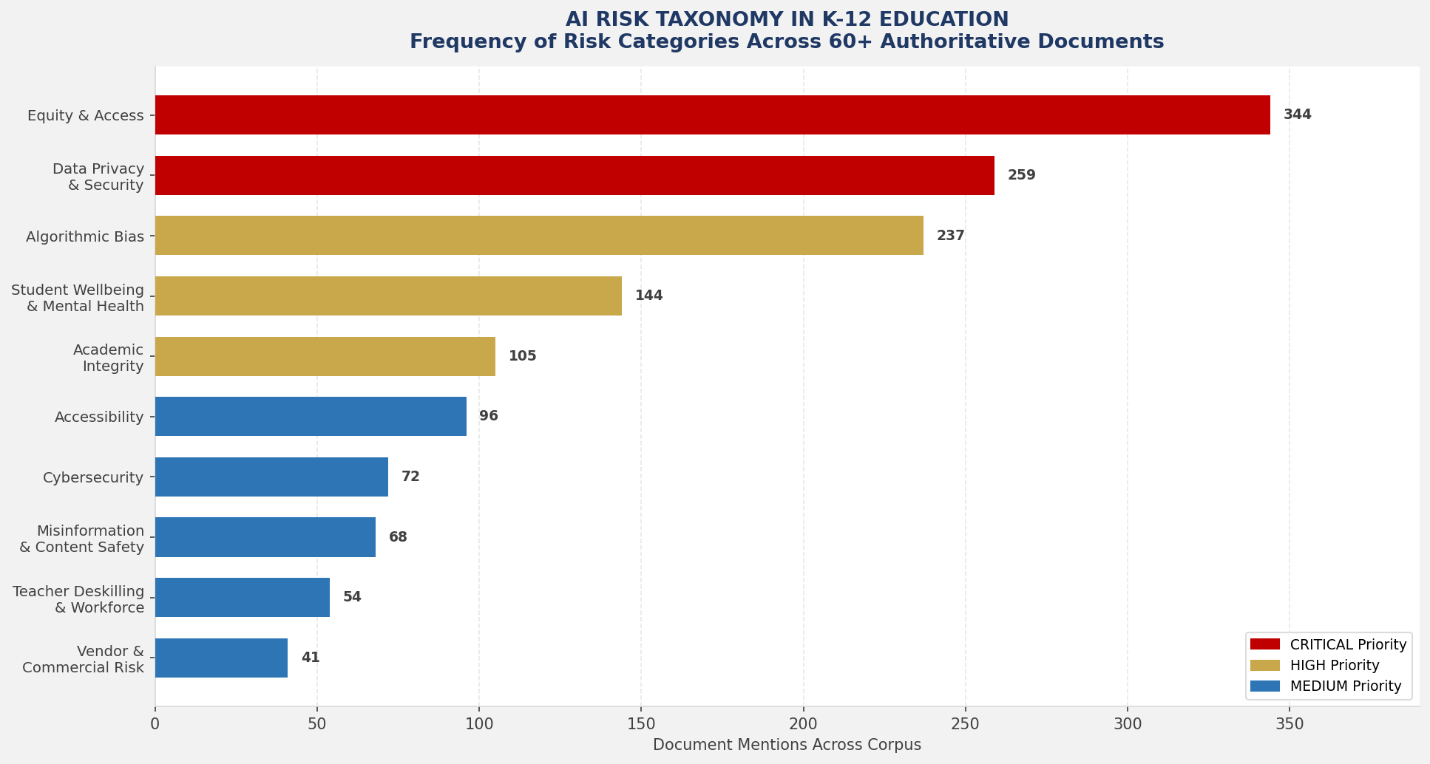
Figure 1: Risk Taxonomy — Frequency of Risk Categories Across 60+ Authoritative Documents
Of the 60+ documents analysed, the corpus comprises: 12 state-level toolkits or frameworks; 22 state guidance documents; 4 national/federal documents; 5 district-level policies; 8 practitioner tools, explainers, and templates; and 3 comparative or synthesis documents. This breadth ensures the training course draws on the full spectrum of current practice — from high-level governance philosophy to ground-level implementation checklists.

2. Structural Analysis — Document by Document
The following section maps the structural architecture of the most authoritative and comprehensive documents in the corpus. References to these documents are used throughout the course design.

2.1 US Department of Education — EdLeaders AI Toolkit (October 2024)
Issuing Authority | US Department of Education — Office of Educational Technology (OET)
Jurisdiction | Federal — United States
Date | October 2024
Audience | School and district leaders, principals, superintendents, school boards
Document Type | Comprehensive Toolkit
Stated Purpose | Provide education leaders with actionable guidance to navigate AI responsibly, equitably, and effectively across their institutions

Structure
The toolkit is organised into nine modules covering: (1) AI Foundations for Leaders; (2) Establishing Vision and Values; (3) Policy Development and Governance; (4) Teaching and Learning with AI; (5) Data Privacy and Security; (6) Equity and Access; (7) Workforce Development; (8) Community Engagement; (9) Continuous Improvement and Future-Readiness.

Key Principles Extracted
- Human agency: AI should augment, never supplant, educator expertise and professional judgement
- Transparency: AI use in schools must be visible, explained, and understandable to all stakeholders
- Equity and civil rights: AI deployment must not perpetuate or amplify existing disparities; civil rights protections apply fully
- Evidence-based adoption: AI tools must demonstrate educational efficacy before institutional adoption
- Privacy by design: Student data protections (FERPA, COPPA, state law) are non-negotiable prerequisites
- Governance first: Policies, roles, and accountability structures must be established before AI deployment at scale
- Workforce readiness: Professional development must precede and accompany all AI implementation

Stakeholder Roles Defined
- Principals/School Leaders: Set vision, enforce policy, lead professional learning, model responsible use
- District Superintendents: Establish district-wide governance structures, resource allocation, equity monitoring
- School Boards/Governors: Approve policy, provide oversight, ensure community accountability
- Teachers: Integrate AI thoughtfully into pedagogy, maintain academic integrity standards, model critical AI use
- IT and Data Staff: Manage procurement vetting, data security, platform compliance
- Parents/Guardians: Participate in policy consultation, receive transparent communication, support student AI literacy
- Students: Develop AI literacy, use AI ethically and transparently, understand risks

Risk Categories Addressed
The EdLeaders Toolkit explicitly addresses: data privacy breaches; algorithmic bias and discriminatory outcomes; academic dishonesty and over-reliance; cybersecurity vulnerabilities; inequitable access (digital divide); vendor lock-in and commercial exploitation; erosion of critical thinking; and workforce displacement anxiety among educators.

Implementation Framework
The toolkit recommends a three-phase implementation model: Explore (building knowledge, establishing governance, assessing readiness); Implement (piloting tools, training staff, engaging community); and Sustain (monitoring outcomes, iterating policy, scaling effective practices). Review cycles are recommended annually at minimum, with trigger-based reviews following any significant AI incident or major technology change.

2.2 TeachAI — AI Guidance for Schools Toolkit (2025)
Issuing Authority | TeachAI (coalition including Khan Academy, Common Sense Media, ETS, ISTE, and others)
Jurisdiction | International — applicable across jurisdictions
Date | 2025 (updated)
Audience | School leaders, boards, teachers, all staff, parents, community stakeholders
Document Type | Comprehensive Toolkit with modifiable templates

Structure
The TeachAI toolkit is structured around four pillars: (1) AI Policy Development; (2) AI in Teaching and Learning; (3) Student AI Literacy; (4) Community Engagement. It provides 12 modifiable templates including AI policy templates, staff guidance, parent guidance, student agreements, risk assessment tools, and readiness checklists. It is the most internationally portable document in the corpus.

Key Principles Extracted
- Principles-based governance: Policies must flow from stated values rather than reactive rule-making
- Learner-centred: Every AI decision must be evaluated by its impact on student learning outcomes
- Inclusive development: Policy must be co-created with input from all community stakeholders including students and parents
- Adaptability: Guidance should be treated as a living document, updated as technology evolves
- Skill-forward: AI literacy is a core 21st-century competency for all learners and educators
- Accountability: Clear lines of responsibility must be established for every AI governance decision

Unique Contributions
TeachAI provides the most comprehensive template suite of any document in the corpus. Its modifiable AI policy template includes 11 named sections: Purpose and Scope; Definitions; Guiding Principles; Permitted Uses; Prohibited Uses; Data Privacy; Academic Integrity; Staff Responsibilities; Student Responsibilities; Parent/Guardian Responsibilities; Review and Amendment Process. These sections directly inform the AI Policy Template provided in this course.
TeachAI also introduces the concept of a tiered permission model — distinguishing between AI uses that are universally permitted, uses that require prior approval, and uses that are categorically prohibited — a framework adopted by multiple subsequent state documents including Colorado, Washington, and New Mexico.

2.3 Digital Promise — Review of Guidance from Seven States (2024)

Key Findings Relevant to Course Design
This comparative document is unique in that it does not itself provide guidance; rather, it analyses the guidance of seven early-adopter states (California, Oregon, Washington, North Carolina, Kentucky, Virginia, and Texas) to identify patterns, gaps, and quality indicators. Its most critical finding, directly quoted in the document, is: 'The gap between what existing guidance recommends and the capacity of most schools to implement it is substantial.'
Key gaps identified across reviewed state documents: lack of specific implementation timelines (86% of documents); absence of resource requirements or budget guidance (91%); weak research base for recommended practices; insufficient teacher input in document development; and inadequate parent communication frameworks.
The document introduces a readiness framework with five dimensions: (1) Leadership Readiness; (2) Instructional Readiness; (3) Technical Readiness; (4) Policy Readiness; (5) Community Readiness. This five-dimension model is incorporated into the AI Readiness Audit Tool provided in this course.

3. Cross-Document Content Extraction — Synthesised Findings

3.1 Universal Principles — Consensus Across All 60+ Documents
The following principles appear — with near-universal frequency — across the entire document corpus. They represent the non-negotiable foundation of responsible AI governance in K-12 education.

Principle | Synthesis of Document Evidence
Human-Centred Design | AI is a tool that augments human capability; it must never replace educator judgement, student agency, or the primacy of human relationships in education. Present in 100% of documents reviewed.
Equity and Justice | AI adoption must actively reduce — not perpetuate — educational disparities. Equitable access, culturally responsive implementation, and bias monitoring are non-negotiable. Equity is the most frequently referenced theme in the corpus (344 mentions across Western state documents alone).
Data Privacy and Security | Student data protections are foundational. All documents reference FERPA compliance as a minimum requirement; many also cite COPPA (for under-13 students), state-level privacy laws, and CIPA. No AI tool may be deployed without a privacy review.
Transparency and Explainability | Students, parents, and staff have a right to know when AI is being used, how it works, and what data it processes. Opaque AI systems must not be used in consequential educational decisions.
Academic Integrity | AI use must be governed by clear, communicated expectations distinguishing legitimate assistance from academic dishonesty. Policies must define AI-permitted, AI-assisted, and AI-prohibited assignment categories.
Professional Development | No AI tool should be deployed without accompanying educator training. Professional development is a prerequisite, not an afterthought. All 60+ documents name it as a critical success factor.
Governance and Accountability | Formal policies, designated accountability roles, documented procedures, and regular review cycles are required. Ad hoc AI use without governance frameworks is explicitly cautioned against.
Inclusive Stakeholder Engagement | Policy development must include the voices of teachers, students, parents, community members, and school boards — not just administrators or IT departments.
Continuous Review | AI guidance must be treated as a living document. Annual review cycles are universally recommended; event-triggered reviews are also required following AI incidents or major technology changes.
Critical Thinking and Independence | AI use must not erode students' capacity for independent thought, creative expression, or foundational skill development. Educators must design AI-integrated tasks that strengthen, not replace, cognitive effort.

3.2 Comprehensive Glossary of AI Terms for Educators
The following definitions are drawn directly from the document corpus and represent the consensus understanding of key terms as used in K-12 AI governance contexts.

Term | Definition
Artificial Intelligence (AI) | The simulation of human intelligence processes by machines, especially computer systems. In K-12 contexts, AI encompasses any technology that uses data-driven algorithms to make decisions, predictions, or recommendations that affect students, staff, or institutional operations.
Generative AI (GenAI) | A category of AI systems capable of generating new content — including text, images, audio, video, and code — in response to prompts. Examples include ChatGPT, Google Gemini, Microsoft Copilot, DALL-E, and MidJourney. Distinguished from earlier AI by its ability to produce novel, human-like outputs.
Large Language Model (LLM) | A type of AI model trained on vast text datasets that can generate, summarise, translate, and analyse text. The underlying technology powering most generative AI writing tools available to students and staff.
Algorithm | A set of rules or instructions used by a computer system to perform calculations, make decisions, or solve problems. In education, algorithms are used in adaptive learning systems, grading tools, and behaviour monitoring platforms.
Algorithmic Bias | Systematic and unfair discrimination produced or amplified by an AI algorithm, often reflecting inequities present in the training data. Can lead to discriminatory outcomes in grading, discipline, or student support decisions.
Machine Learning (ML) | A subset of AI in which systems learn and improve from experience (training data) without being explicitly programmed for every outcome. Powers tools such as adaptive tutoring systems and plagiarism detectors.
Training Data | The datasets used to develop and refine an AI model. The quality, diversity, and representativeness of training data determines the accuracy, fairness, and reliability of the AI's outputs.
Prompt / Prompt Engineering | A prompt is the input (instruction, question, or request) given to a generative AI system. Prompt engineering refers to the skill of crafting effective prompts to elicit accurate, useful, and appropriately scoped AI outputs.
Hallucination | The phenomenon in which an AI system generates information that sounds plausible but is factually incorrect or entirely fabricated. A critical concept for educators and students to understand when evaluating AI-generated content.
FERPA | The Family Educational Rights and Privacy Act — US federal law that protects the privacy of student education records and restricts disclosure of personally identifiable information without consent.
COPPA | The Children's Online Privacy Protection Act — US federal law requiring verifiable parental consent before collecting personal data from children under 13 online.
Data Minimisation | The principle that AI systems should collect and process only the minimum personal data necessary for their stated educational purpose.
Deepfake | AI-generated synthetic media — typically images, audio, or video — that falsely depicts a real person saying or doing something they did not. A significant safeguarding and misinformation risk in school communities.
Academic Integrity | The commitment to honest, fair, and original work in academic settings. In the AI context, academic integrity policies must define when AI assistance is permitted, how it must be disclosed, and what constitutes prohibited use.
AI Literacy | The set of competencies enabling individuals to understand, critically evaluate, and ethically use AI systems. Encompasses conceptual understanding, practical skills, ethical reasoning, and cultural awareness.
Responsible AI | AI systems and practices that are safe, fair, transparent, accountable, and aligned with human rights and social values. Used interchangeably in many documents with 'ethical AI' or 'trustworthy AI.'
Digital Equity | Ensuring all students have equitable access to the devices, connectivity, digital skills, and culturally relevant content needed to benefit from technology, including AI tools.
Adaptive Learning | An educational approach using AI to personalise instructional content, pacing, and assessments to individual student needs based on ongoing performance data.
Procurement Vetting | The formal process of evaluating AI tools before institutional adoption, assessing privacy compliance, educational efficacy, bias risk, accessibility, data security, and vendor accountability.
AI Governance | The policies, structures, procedures, roles, and review mechanisms through which a school or district oversees the responsible use of AI across all institutional functions.

3.3 Risk Categories — Comprehensive Taxonomy
Across all 60+ documents, seven primary risk categories are consistently identified. Risk frequency data below is drawn from the Digital Promise comparative analysis and Western states analysis (combined corpus of 11 state documents).

# | Risk Category | Mentions | Priority | Key Concerns
1 | Equity and Access | 344 | CRITICAL | Unequal access to devices or connectivity; AI widening achievement gaps; culturally irrelevant content; language barriers; special education impacts. States with highest coverage: WA, CA, CO, MN.
2 | Data Privacy and Security | 259 | CRITICAL | FERPA/COPPA violations; unauthorised data collection; vendor data misuse; insecure platforms; biometric data risks; retention and deletion failures.
3 | Algorithmic Bias | 237 | HIGH | Training data reflecting historical inequities; discriminatory grading or discipline decisions; biased adaptive learning pathways; facial recognition bias.
4 | Student Mental Health & Wellbeing | 144 | HIGH | AI replacing human connection; social-emotional development impairment; screen time; AI-generated content causing distress; deepfakes; unrealistic AI relationships.
5 | Academic Integrity | 105 | HIGH | AI-generated plagiarism; assessment validity; over-reliance on AI for original work; inequitable assignment design; inadequate detection capabilities.
6 | Accessibility | 96 | MEDIUM | AI tools not meeting ADA/IDEA/Section 508 requirements; accessibility features inconsistently implemented; marginalised students excluded from AI benefits.
7 | Cybersecurity | 72 | MEDIUM | Malicious use of AI for phishing, impersonation, or cyberattacks; deepfakes used for fraud; AI-enabled social engineering; staff credential theft.
8 | Misinformation and Content Safety | 68 | MEDIUM | AI hallucination presenting false information as fact; inappropriate content generation; deepfakes and synthetic media misuse; filter evasion.
9 | Teacher Deskilling and Workforce Impact | 54 | MEDIUM | Erosion of professional expertise through over-reliance; loss of teacher agency; job displacement anxiety; reduced professional autonomy.
10 | Vendor Accountability and Commercial Risk | 41 | MEDIUM | Vendor lock-in; commercial data exploitation; proprietary tool opacity; service discontinuation; inadequate contractual protections.

3.4 Comparative Analysis — Key Policy Positions Across Documents

3.4.1 Generative AI Use by Students
Documents diverge significantly on the question of student generative AI use. California (2023) takes a cautious, pedagogically conservative position, recommending that AI use by students should not precede explicit AI literacy instruction. Oregon similarly emphasises teacher-mediated introduction. Washington's 11 Principles model permits student use but requires transparency through a student AI use pledge. Colorado advocates a 'teacher-first implementation' philosophy, in which teachers must gain proficiency before student use is normalised. By contrast, North Carolina's assignment framework (AI Resistant / AI Assisted / AI Enhanced / AI Empowered) explicitly embraces a spectrum of student AI use, arguing that blanket prohibition is ineffective and counterproductive. New Mexico's most recent guidance (April 2025) adopts a SAMR (Substitution-Augmentation-Modification-Redefinition) framework, the most pedagogically sophisticated approach in the corpus. The consensus across documents is that context-specificity — rather than blanket permission or prohibition — is the appropriate governance model.

3.4.2 Academic Integrity
All documents address academic integrity, but with varying levels of specificity. The most operationally useful frameworks are found in Georgia (specific disclosure requirements), North Carolina (four-category assignment classification system), Rhode Island (policy amendment template with three-step procedure), and TeachAI (complete academic integrity addendum template). Multiple documents warn explicitly that AI-detection tools (such as Turnitin's AI detector) are unreliable and should not be used as the sole basis for academic dishonesty allegations — a critical safeguarding provision for school leaders.

3.4.3 Prohibited Uses
Across all documents, the following AI uses are categorically prohibited without exception: using AI to generate or distribute sexually explicit material involving minors; using AI for surveillance of students without legal authority; using AI tools not vetted for FERPA/COPPA compliance in instructional settings; using AI-generated content in consequential assessments without disclosure; and using AI to replace legally required human decisions in special education, discipline, or safeguarding processes.

3.4.4 Gaps Identified Across the Corpus
The following gaps were identified across the document corpus and are explicitly addressed in the training course design below. These represent areas where schools must exercise additional judgement and local policy-making.
- Implementation budgets and resource requirements: Fewer than 10% of documents provide any guidance on resource allocation or cost planning for AI implementation.
- Specific timeline guidance: Most documents recommend 'phased implementation' without specifying timeframes, leaving schools without concrete planning anchors.
- AI in special education (IDEA compliance): Despite being a critical area, only Hawaii, Virginia, and TeachAI provide substantive guidance on AI use for students with disabilities.
- Mental health and social-emotional learning: The psychological impact of AI on student wellbeing is addressed superficially in most documents; Nevada and Rhode Island are notable exceptions.
- Non-English speaking communities and ELL students: Few documents address AI governance in multilingual contexts; Puerto Rico's guidance is the notable exception.
- AI in extracurricular and non-academic contexts: Governance of AI use in sports analytics, admissions processes, and school communications is largely unaddressed.
- Deepfake detection and response protocols: Most documents note the deepfake risk without providing response frameworks; the AI for Education Deepfakes Classroom Guide is the primary resource.
- Vendor contract provisions: Fewer than 20% of documents provide specific contract language or vendor audit requirements.

PHASE 2: TRAINING COURSE ARCHITECTURE

4. Course Identity and Brand
Course Title | GOVERNING AI IN SCHOOLS: From Policy to Practice
Subtitle | A Professional Development Programme for K-12 Education Leaders and Staff
Tagline | "Where AI governance meets school reality."
Value Proposition | The only programme that takes school leaders and their entire staff community from AI awareness through to a fully drafted, board-approved AI Policy and Guidance Suite — grounded in 60+ authoritative global documents.
Total Duration | 40 hours (full programme) | Modular delivery available
Format Options | Face-to-face intensive (5 days) | Blended (10 half-days over 5 weeks) | Online asynchronous (self-paced over 8 weeks)
Certification | Three-tier: AI Governance Aware | AI Governance Practitioner | AI Governance Leader
Target Markets | K-12 schools, school networks, multi-academy trusts (MATs), district offices, state education departments

5. Audience Segmentation and Learning Pathways
The programme operates on three differentiated learning tracks. All tracks share a common foundation (Modules 1-3) and a common capstone (Module 12). Modules 4-11 are differentiated by role and responsibility. Participants from different tracks are deliberately mixed in Modules 1-3 and 12 to build shared understanding and cross-role collaboration.

 | TRACK A — SENIOR LEADERS
Roles |  | Principals, Vice-Principals, Superintendents, District Directors, CEO/Principals of Multi-Academy Trusts, School Governors/Board Members
Entry Assumptions |  | May have limited technical AI knowledge; strong leadership and governance experience; responsible for policy approval and institutional accountability
Specific Learning Needs |  | Legal and governance frameworks; policy architecture and board approval processes; risk management; strategic planning; community accountability; budget and resource planning; national and international AI governance context
Policy Responsibilities |  | Approve and own the school AI Policy; establish governance structures; lead community consultation; ensure legal compliance; monitor policy effectiveness; report to governing bodies
Desired Outcomes |  | Leave the programme with a draft AI Policy approved in principle by their governing body, an AI governance action plan with timelines, and the confidence to lead responsible AI adoption across their institution

 | TRACK B — MIDDLE LEADERS
Roles |  | Heads of Department, Year Group Leaders, Curriculum Coordinators, Pastoral Leaders, Literacy/Numeracy Coordinators, SENCO, Safeguarding Leads, Data Protection Officers
Entry Assumptions |  | May have some personal AI tool experience; strong subject or pastoral expertise; role in translating school-wide policies into departmental practice
Specific Learning Needs |  | Translating policy into subject-specific guidance; academic integrity in subject contexts; AI-integrated pedagogy; risk identification at classroom level; student and parent communication; data handling in their role
Policy Responsibilities |  | Implement AI Policy within their department/year group; write or adapt subject-specific AI guidance; manage staff questions and concerns; monitor student compliance; escalate issues to senior leadership
Desired Outcomes |  | Leave with a fully drafted departmental AI guidance document, a subject-specific academic integrity addendum, and a set of AI-integrated lesson plans or workflow examples ready for team deployment

 | TRACK C — ALL STAFF
Roles |  | Classroom Teachers (all subjects/grades), Teaching Assistants, Learning Support Staff, School Counsellors, Librarians, IT Staff, Administrative Staff, Safeguarding Officers, Site/Facilities Staff, Parent Liaison Officers
Entry Assumptions |  | Highly variable AI knowledge (from total novice to enthusiastic early adopter); primary need is practical, role-specific guidance rather than governance theory
Specific Learning Needs |  | What AI is and how it works (demystification); their specific rights and responsibilities under the AI Policy; how to use AI tools ethically in their role; when and how to raise concerns; how to support student AI literacy; data protection in practice
Policy Responsibilities |  | Comply with the AI Policy in all professional activities; disclose AI use appropriately; model responsible AI use for students; participate in AI literacy development; report concerns through proper channels; complete required professional development
Desired Outcomes |  | Leave with confident understanding of their AI-related rights and responsibilities, practical AI skills applicable to their role, and the motivation to engage positively with the school's AI governance journey

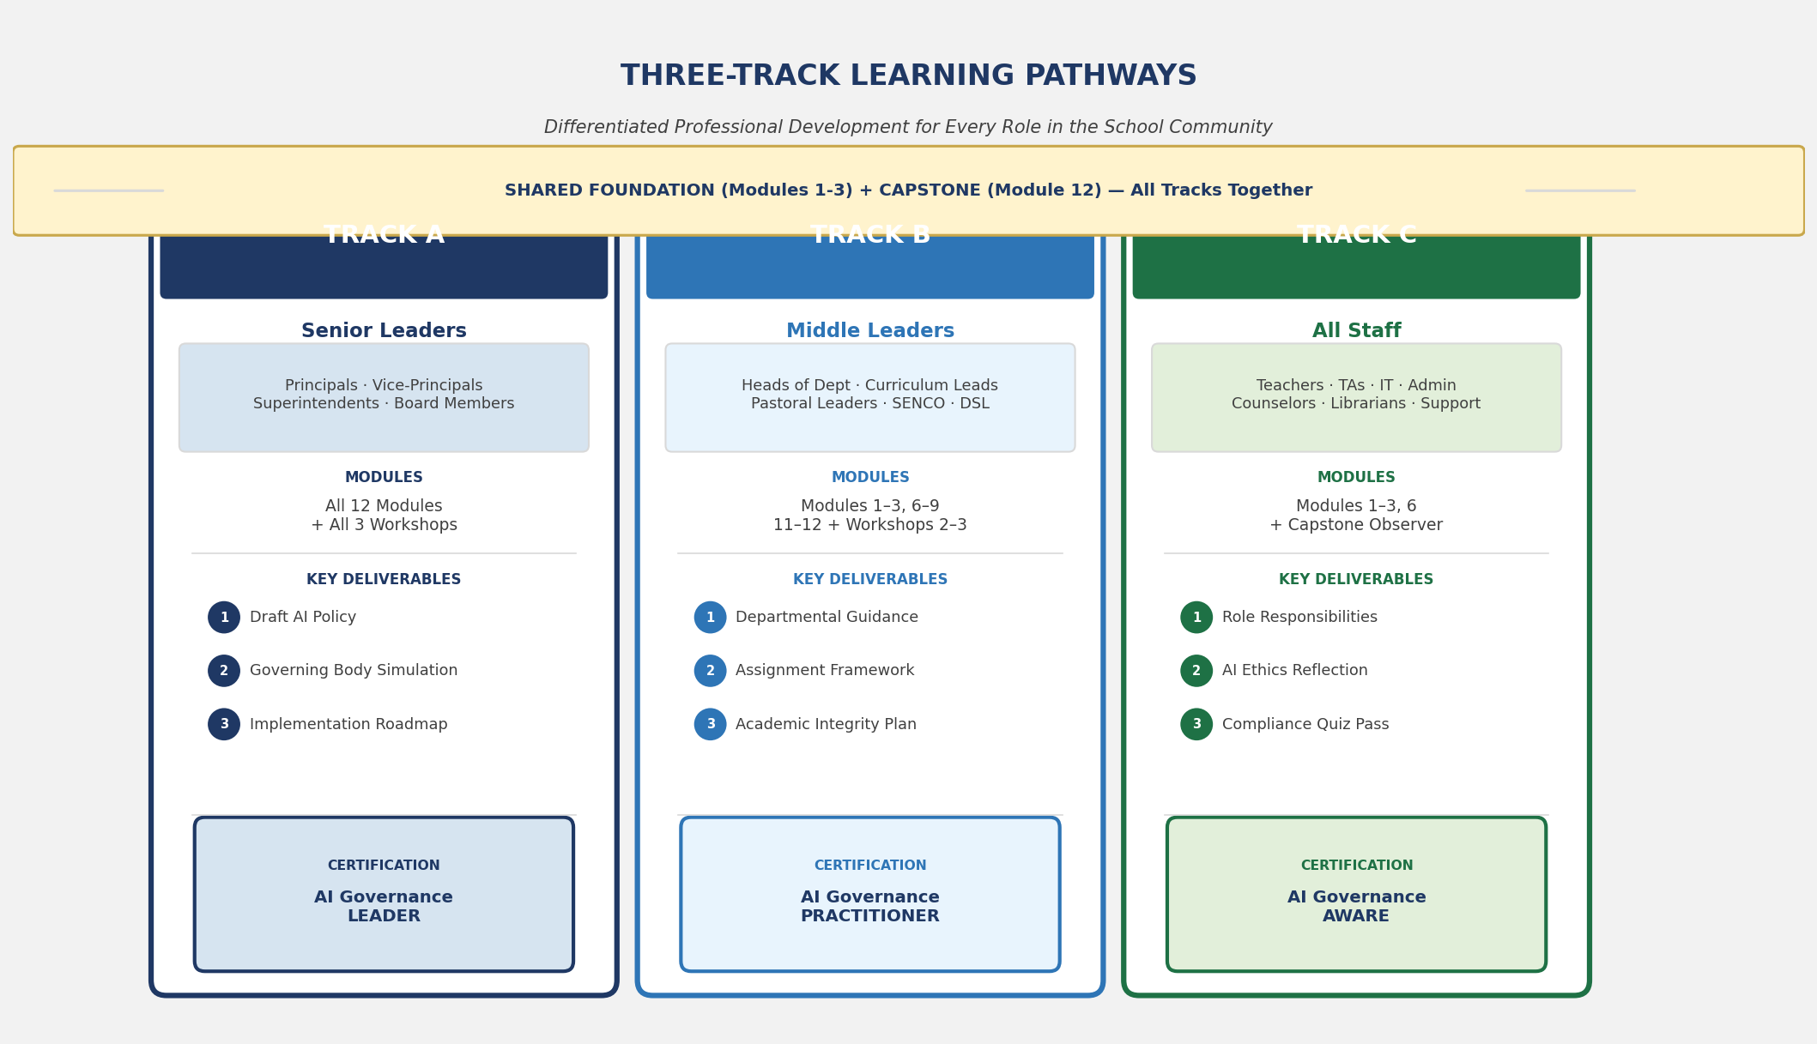
Figure 2: Three-Track Learning Pathways — Differentiated Professional Development for Every Role

6. Learning Outcomes — Bloom's Taxonomy Aligned

6.1 Whole-Programme Learning Outcomes (All Tracks)
All outcomes are written using precise, measurable Bloom's Taxonomy verbs. Cognitive level is indicated for each outcome.

REMEMBER | - Define key AI terminology (artificial intelligence, generative AI, large language model, algorithm, hallucination, training data) as used in K-12 governance contexts  - Identify the major legal frameworks governing AI use in US K-12 schools (FERPA, COPPA, IDEA, ADA, CIPA) and their core requirements  - List the primary risk categories associated with AI in K-12 settings as identified across 60+ authoritative documents  - Name the essential sections of a well-structured school AI Policy

UNDERSTAND | - Explain the distinction between an AI Policy (governance document) and AI Guidance (operational document) and the relationship between them  - Describe the human-centred AI principle and its implications for every AI-related decision in a school  - Summarise the equity implications of AI adoption, including risks of widening the digital divide and perpetuating algorithmic bias  - Interpret state and national AI guidance documents, identifying their key provisions and implications for local school policy

APPLY | - Use a structured AI risk assessment framework to evaluate an AI tool before recommending it for school adoption  - Apply academic integrity principles to classify assigned tasks by AI permission level (AI-Resistant, AI-Assisted, AI-Enhanced, AI-Empowered)  - Implement stakeholder consultation processes that include students, parents, teachers, and governing body members in AI policy development  - Execute a school-based AI readiness audit using the five-dimension framework (Leadership, Instructional, Technical, Policy, Community Readiness)

ANALYSE | - Critically compare AI policy provisions from multiple jurisdictions, identifying areas of consensus, divergence, and local adaptation requirements  - Distinguish between effective and ineffective AI governance language, identifying vague provisions, gaps, and unenforceable rules  - Diagnose the AI governance strengths and weaknesses of their own school or district through structured self-assessment  - Analyse a proposed AI tool or vendor contract for privacy compliance, equity risks, and accountability gaps

EVALUATE | - Evaluate a draft AI Policy against international best practice benchmarks, providing structured written feedback  - Judge the appropriateness of a specific AI use case against the school's stated values, legal obligations, and risk management framework  - Assess the effectiveness of an AI implementation plan, identifying risks, resource gaps, and monitoring blind spots  - Appraise the quality of staff and student AI literacy programmes against evidence-based criteria

CREATE | - Draft a complete, board-ready AI Policy tailored to their school's vision, values, community context, and legal jurisdiction  - Design a suite of role-specific AI Guidance documents for staff, students, and parents that translate the AI Policy into practical, actionable direction  - Construct an AI implementation roadmap with specific milestones, resource requirements, accountability mechanisms, and review triggers  - Build a professional development plan for their school community that progressively develops AI literacy across all roles

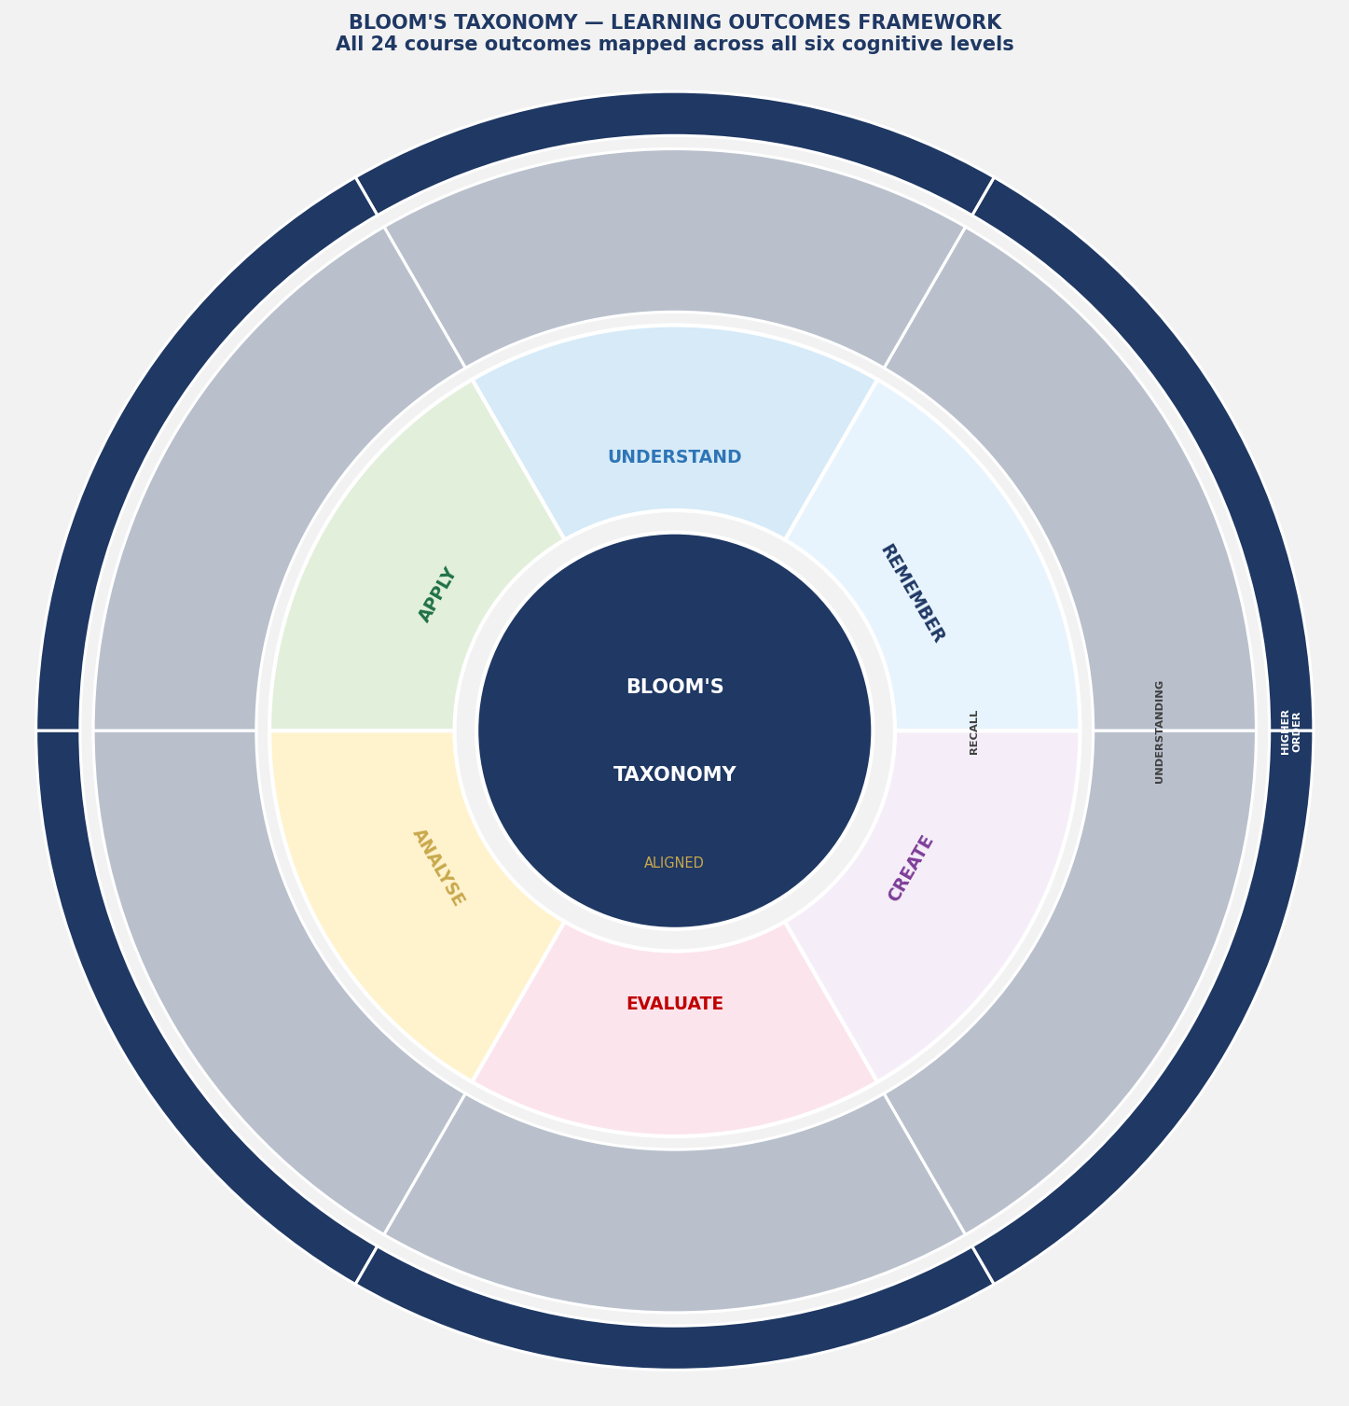
Figure 3: Bloom's Taxonomy Wheel — All 24 Programme Learning Outcomes Mapped Across Six Cognitive Levels

7. Module-by-Module Course Design
The programme comprises 12 modules organised across three phases: Foundation (Modules 1-3, all tracks together); Development (Modules 4-11, differentiated by track); and Capstone (Module 12, all tracks together for cross-role collaboration). Total programme time: 40 hours of facilitated learning plus 10 hours of independent/asynchronous work.

MODULE 1: THE AI LANDSCAPE IN K-12 EDUCATION
Duration: 3 hours | Audience: All Tracks — A, B, C

Purpose and Rationale
This foundational module establishes a shared vocabulary and conceptual framework for all participants, regardless of their prior knowledge. It addresses the reality documented by the RIDE survey that 78% of educators report substantial concerns about AI while only 6% are actively using it — a gap that stems primarily from unfamiliarity. Before any governance discussion can occur, all participants must understand what AI actually is, how it works at a functional level, and what distinguishes responsible from irresponsible use. As TeachAI notes, 'confusion about what AI is and is not' is the primary barrier to productive school-level governance conversations.

Key Questions This Module Answers
- What is artificial intelligence, and what is it not? How does generative AI differ from earlier AI?
- What AI tools are students and staff already using, often without institutional knowledge?
- Why does AI governance in schools matter — what are the real stakes?
- What is already happening nationally and internationally, and what can we learn from it?

Detailed Content Outline
1.1 Demystifying AI: From Science Fiction to Classroom Reality (45 min)
- What AI is: a working definition for educators (drawing from California CDE 5 Big Ideas framework and TeachAI definitions)
- The AI family tree: narrow AI vs. general AI; supervised vs. unsupervised learning; rule-based systems vs. machine learning vs. generative AI
- How large language models work: training data, pattern recognition, probability, and the hallucination problem — explained without jargon
- Live demonstration: ChatGPT / Gemini / Copilot in real time, with educator commentary on strengths, limitations, and risks
- Activity: 'AI or Not AI?' — participants categorise 20 familiar school tools as AI, AI-powered, or not AI
1.2 The AI Reality in Your School Right Now (30 min)
- Data on actual student and staff AI use: RIDE 2025 survey findings (50% of K-12 students use ChatGPT weekly; only 6% of educators use AI regularly)
- The 'shadow AI' problem: AI tools students use without staff knowledge
- Common AI tools in K-12 settings: ChatGPT, Google Gemini, Microsoft Copilot, MagicSchool.ai, Grammarly, Khan Academy Khanmigo, Canva AI, Turnitin — benefits and risks of each
- Small group discussion: 'What AI tools are you aware of in your school right now? What concerns do they raise?'
1.3 The Policy Imperative: Why Governance Cannot Wait (45 min)
- Three real-world scenarios (drawn from document corpus): (a) A student submits an entirely AI-generated essay — what happens? (b) A teacher uses an AI grading tool that produces biased results — who is responsible? (c) A deepfake of the principal circulates among students — how does the school respond?
- The gap between current practice and responsible governance: Digital Promise finding that 'schools are not ready for the practices described in existing guidance'
- What happens when schools have no AI policy: case studies from early-adopter and late-adopter districts
- The urgency argument: workforce data — 62% of employers now expect AI literacy; AI literacy ranked #1 rising skill on LinkedIn 2025
1.4 The National and International Landscape (45 min)
- Overview of the US regulatory environment: FERPA, COPPA, IDEA, ADA, state laws — how they apply to AI
- Survey of state guidance: key themes from 30+ state documents reviewed — what consensus looks like
- International context: UNESCO Recommendation on AI in Education; OECD AI Principles; EU AI Act implications; GDPR for international schools
- The 'regulatory gap' problem: why national guidance is principles-based and schools must fill the operational details

Instructional Strategies
- Live AI demonstration with facilitator narration
- Categorisation activity (AI or Not AI?)
- Three scenario discussions in mixed-track groups
- World café format for national landscape section

Assessment
Exit ticket: participants complete a 10-item AI Terminology Self-Assessment (pre-measures baseline knowledge for portfolio). No pass/fail — used for diagnostic purposes.

Resources Provided
- AI Glossary for Educators (20 terms — drawn from document corpus, Section 3.2 of this document)
- 'AI Tools in K-12: A Reference Card' — one-page overview of 15 common tools with risk ratings
- Facilitated discussion guide: three opening scenarios

Facilitator Notes
Watch for: Participants who are either dismissive ('this doesn't apply to my school') or catastrophising ('AI will destroy education'). Both positions hinder productive policy work. Facilitate toward pragmatic, evidence-based middle ground. Sensitive topic: some teachers may feel threatened by AI implications for their role — address directly using human-centred AI framing from the corpus.

MODULE 2: ETHICAL FOUNDATIONS AND VALUES IN AI GOVERNANCE
Duration: 3 hours | Audience: All Tracks — A, B, C

Purpose and Rationale
Policy without ethical foundation is fragile. This module ensures all participants ground their subsequent policy work in explicitly stated values. As the Washington State AI Guidance (11 Principles) demonstrates, a values-driven governance framework provides the 'why' that gives policy rules their authority and coherence. The module draws heavily on the Georgia PSC Ethical Considerations document, the Nevada STELLAR framework, and the Minnesota five-principle framework as exemplars of values-first governance.

Key Questions
- What values should govern AI use in our school community, and how do we surface them?
- How do we handle the ethical tensions AI creates — between personalisation and privacy, efficiency and equity, innovation and safeguarding?
- What does 'responsible AI' actually mean in practice — not in principle?

Content Outline
2.1 Values Identification Workshop (60 min)
- Frameworks comparison: Washington's 11 Principles; Minnesota's 5 Principles; Nevada's STELLAR acronym; TeachAI's Core Values — what they have in common and where they diverge
- Activity: Values card sort — each table receives 30 value cards (equity, privacy, innovation, safety, autonomy, transparency, etc.) and must rank and justify their top 10 for inclusion in their school's AI Policy
- Gallery walk: groups post their values hierarchies and tour each other's work, noting similarities and differences
- Facilitator synthesis: which values appear across all groups? This becomes the shared foundation for policy work in later modules
2.2 The Ethical Landscape of AI in Schools (60 min)
- Equity as the master principle: why every AI decision is a social justice decision (drawing from Digital Promise, California CDE, and Colorado guidance)
- The privacy paradox: how AI that helps students also collects their data — and the tension this creates
- Algorithmic bias deep-dive: how training data produces discriminatory outcomes; the Georgia PSC evidence on AI bias in grading and discipline systems
- Academic integrity: why this is an ethical issue, not just a rules compliance issue — the student trust dimension
- The deepfake threat: ethical implications of synthetic media for student safety, reputational harm, and democratic information environments (using AI for Education Deepfakes Classroom Guide)
2.3 Ethical Decision-Making Frameworks for School Leaders (60 min)
- The 'Five Questions' framework from AI for Education: (1) Who benefits? (2) Who is harmed? (3) Who decides? (4) What data is used? (5) Can this decision be explained and justified to all stakeholders?
- Case study: A district selects an AI-powered discipline risk-scoring tool — working through the five questions as a leadership team
- Red lines vs. grey areas: identifying absolute prohibitions vs. context-dependent decisions in AI governance
- Building an 'ethical AI culture' — moving from compliance to values-embodiment (Alaska's 'symbiotic AI' vision; Oregon's Design-Dialogue-Implementation model)

Assessment
Written reflection (300 words): 'Describe three AI-related ethical tensions your school currently faces or is likely to face, and how your school's values should guide each decision.' This reflection becomes Part 1 of the participant's portfolio.

Facilitator Notes
This module often produces the most emotionally engaged discussion of the entire programme. Participants frequently arrive with strong pre-existing views on AI. Facilitate from a position of genuine inquiry — avoid prescribing 'correct' values. The diversity of values across the room is an asset, not a problem, and mirrors the diversity of views within school communities that good policies must bridge.

MODULE 3: LEGAL AND REGULATORY FOUNDATIONS
Duration: 3 hours | Audience: All Tracks — A, B, C (with differentiated depth)

Purpose and Rationale
Legal compliance is the non-negotiable floor of AI governance. This module ensures all participants understand the legal obligations that AI policy must reflect — not as a bureaucratic burden but as a genuine protection for students. As the US DOE EdLeaders Toolkit (Module 5) makes clear, FERPA and COPPA violations in AI contexts have already resulted in significant institutional consequences, and the risk is rising. Track A participants need to understand governance-level legal obligations; Track B and C need to understand operational implications.

Content Outline
3.1 FERPA in the AI Age (45 min)
- What FERPA protects: education records, directory information, and personally identifiable information (PII)
- The 'school official' exception and AI vendors: when vendors can access student data and when they cannot
- The DPA (Data Processing Agreement) requirement: what every AI vendor contract must contain
- FERPA violations in AI contexts: case studies from the corpus, including the risks of feeding student work into consumer AI tools
3.2 COPPA: Special Protections for Under-13 Students (30 min)
- Verifiable parental consent requirements and their operational implications
- The school consent mechanism: when schools can act on behalf of parents
- AI tools that cannot be used with K-8 students without special precautions — practical identification framework
3.3 IDEA, Section 504, ADA, and AI Accessibility (30 min)
- Legal obligation to ensure AI tools are accessible to students with disabilities
- AI as an assistive technology: opportunities and oversight requirements
- Avoiding AI-generated discrimination: when adaptive learning systems create inequitable outcomes for SEN students
3.4 State Law Variations (30 min)
- Overview of state-level student privacy laws that go beyond FERPA (California's SOPIPA, Colorado's SB 23-008, Washington's SBITA)
- How state AI guidance documents (Alaska, Colorado, Washington, New Mexico) address state-specific legal requirements
- Practical tool: State Law Reference Checklist — how to identify the laws applicable in your jurisdiction
3.5 Practical Legal Compliance Workshop (45 min)
- Working in groups: participants receive three AI tool descriptions and must identify: (a) applicable laws; (b) required DPA provisions; (c) parental notification requirements; (d) accessibility requirements
- The vendor vetting checklist: 23 questions to ask before approving any AI tool (drawn from Colorado roadmap and TeachAI procurement framework)

Track-Specific Differentiation
TRACK A | Track A participants additionally complete a 30-minute case study on board-level governance of AI legal compliance, including how to brief governors/board members on their legal exposure and oversight responsibilities.

TRACK B | Track B participants receive a subject-specific legal risk briefing covering the particular FERPA/COPPA implications of AI tools commonly used in their subject area (e.g., AI writing tools in English; AI coding assistants in Computer Science; AI image generators in Art).

TRACK C | Track C participants complete a practical 'Data Protection in Your Daily Work' exercise — mapping every AI-related action they currently take or might take against applicable legal requirements.

Assessment
Legal Compliance Quiz (15 questions, multiple choice and short answer). Minimum 80% required for certification. Retake permitted once. Quiz forms Part 2 of the participant portfolio.

MODULE 4: UNDERSTANDING AI POLICY ARCHITECTURE
Duration: 3.5 hours | Audience: All Tracks — primary focus Track A and B

Purpose and Rationale
This module is the architectural heart of the programme. Participants move from understanding why AI governance matters to understanding how effective policies are structured. Drawing on analysis of 60+ documents, this module teaches participants to recognise quality policy architecture and to critique weak or poorly designed policies — skills essential before they begin drafting their own.

Content Outline
4.1 Policy vs. Guidance: A Critical Distinction (45 min)
- The AI for Education 'Policies vs. Guidelines' infographic — what each document type does and does not do
- Why schools need BOTH a Policy (governance) AND Guidance documents (operational) — and what happens when they conflate the two
- The document hierarchy: School AI Policy → Staff AI Guidance → Student AI Guidance → Parent AI Guidance → Subject-Specific Guidance
- Case study: A school with a 3-page 'AI policy' that is actually only guidance — what is missing and why it matters
4.2 Anatomy of a World-Class AI Policy (60 min)
Drawing on analysis of the Alabama AI Policy Template, TeachAI template, GCS Policy 2025-26, and Rhode Island RIDE Guidance, participants learn the 12 essential sections of a complete AI Policy:
Policy Section | Purpose and Critical Requirements
Section 1: Purpose and Scope | Defines the reason the policy exists, what activities it governs, and who it applies to. Must avoid vague language such as 'AI tools' without defining them.
Section 2: Definitions | Operationally defines all key terms used in the policy (AI, generative AI, approved tools, etc.) — aligned with the programme Glossary.
Section 3: Guiding Principles and Values | States the school's foundational values governing AI — derived from Module 2 values work.
Section 4: Governance and Accountability | Names specific roles (by title, not person) responsible for AI oversight, policy enforcement, incident management, and review.
Section 5: Permitted Uses | Explicitly lists permitted AI applications for each stakeholder group — teachers, students, administrative staff, IT.
Section 6: Restricted and Prohibited Uses | Explicitly lists uses that require prior approval and uses that are categorically prohibited.
Section 7: Data Privacy and Security | States data handling requirements, vendor vetting processes, DPA requirements, and FERPA/COPPA compliance mechanisms.
Section 8: Academic Integrity | Defines AI-related academic dishonesty; provides the assignment classification framework; states detection and discipline procedures.
Section 9: Safeguarding and Student Protection | Addresses deepfakes, harmful content, AI-facilitated abuse, and the prohibition on AI replacing human safeguarding decisions.
Section 10: Professional Development | States minimum training requirements for all staff as a condition of AI tool access.
Section 11: Community Communication | Defines how and when parents, students, and the wider community will be informed about AI use and policy updates.
Section 12: Review and Amendment | States the review cycle (minimum annual), trigger events requiring out-of-cycle review, and the approval process for amendments.

4.3 Policy Critique Exercise (60 min)

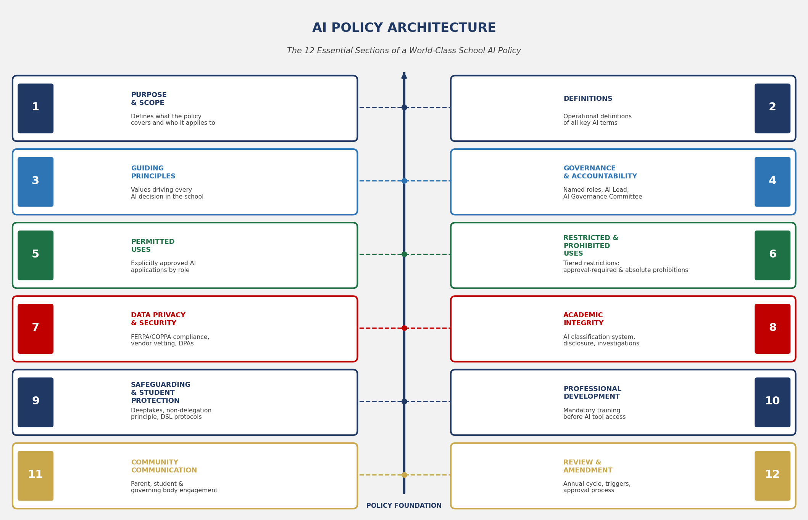
Figure 5: AI Policy Architecture — The 12 Essential Sections of a World-Class School AI Policy
Participants receive three AI policies from the corpus — one strong (Washington), one moderate (Kentucky), and one weak (a composite 'typical' school policy) — and apply a structured critique rubric to each. They assess: completeness against the 12-section framework; clarity and enforceability of language; appropriateness of scope; stakeholder role definition; and review provisions. Groups present their critiques to the room.
4.4 Designing Your Policy's Logical Flow (45 min)
- The rationale-to-review arc: every policy clause must trace back to a stated value or legal requirement
- Writing enforceable policy language: the difference between 'staff should consider' and 'staff must not' — and when each is appropriate
- Avoiding the most common policy writing failures: vagueness, over-restriction, under-restriction, and failure to assign ownership
- Workshop: participants draft the Purpose, Scope, and Guiding Principles sections of their own school policy — first output for the capstone portfolio

Assessment
Policy critique peer-review exercise: written critique of one partner's draft Purpose and Scope section using the rubric. Contributes to Portfolio Part 3.

MODULE 5: RISK MANAGEMENT AND SAFEGUARDING
Duration: 3 hours | Audience: Tracks A and B (adapted version for Track C)

Purpose and Rationale
This module operationalises the risk taxonomy developed in Phase 1 of the document analysis. As the US DOE EdLeaders Toolkit states, 'identifying and mitigating risks is a prerequisite to responsible AI adoption, not an afterthought.' This module provides the practical tools — risk assessment frameworks, safeguarding protocols, vendor vetting checklists — needed to manage AI risk responsibly.

Content Outline
5.1 The AI Risk Landscape — From Theory to Practice (45 min)
- Deep dive into the 10 risk categories (Section 3.3): equity, privacy, bias, wellbeing, academic integrity, accessibility, cybersecurity, misinformation, workforce impact, vendor risk
- Risk probability vs. risk severity matrix: how to prioritise risk mitigation in resource-constrained schools
- The 'known unknowns' of AI risk: why risk registers for AI tools must be treated as living documents updated as technology evolves
5.2 The AI Tool Risk Assessment Framework (60 min)
Participants are introduced to and trained on the programme's AI Tool Risk Assessment Framework (provided as Tool 3 in Section 9 of this document). The framework covers seven assessment dimensions:
- Data Privacy Compliance: FERPA, COPPA, applicable state laws; DPA review; data retention and deletion policies
- Algorithmic Bias and Fairness: training data documentation; bias audit history; disparate impact evidence; developer accountability
- Accessibility: ADA/Section 504 compliance; WCAG 2.1 AA standards; screen reader compatibility; multilingual support
- Educational Efficacy: peer-reviewed evidence of learning impact; vendor claims vs. independent research
- Cybersecurity: penetration testing history; breach notification commitments; encryption standards; API security
- Commercial Risk: vendor financial stability; contractual data rights; product roadmap; service continuity
- Transparency and Explainability: how the AI makes decisions; parent/student right to explanation; appeal mechanisms
5.3 Safeguarding and AI: New Frontiers (45 min)
- Deepfakes as a safeguarding emergency: the 550% increase since 2019; documented harms (fraud, sexual abuse imagery, bullying); response protocol development
- AI-facilitated grooming and exploitation: how generative AI lowers barriers for bad actors; implications for school digital safety education
- The non-delegation principle: AI must never replace human safeguarding decisions — staff cannot delegate child protection judgements to algorithms
- Reporting framework: how AI-related safeguarding concerns should be recorded and escalated (integrating with existing DSL procedures)
5.4 Risk Register Workshop (30 min)
Groups create a risk register entry for one AI tool currently used or proposed at their school, using the framework. They identify the risk level, propose mitigation measures, assign ownership, and set a review date. This output contributes to the school's AI Policy Section 7 (Data Privacy and Security) in the capstone.

Assessment
Individual risk assessment: each participant completes a full AI Tool Risk Assessment for one real tool used in their school. Portfolio Part 4.

MODULE 6: STAKEHOLDER ROLES AND RESPONSIBILITIES
Duration: 2.5 hours | Audience: Differentiated — All Tracks

Purpose and Rationale
Policy is only as effective as the people who implement it. This module operationalises the stakeholder framework extracted from the corpus — translating abstract role descriptions into concrete, role-specific responsibilities that each participant can own and action. A key principle from the TeachAI toolkit is that 'every member of the school community has a role in responsible AI governance — not just the IT department or the principal.'

Content Outline
6.1 The AI Governance Ecosystem (30 min)
- Stakeholder mapping: governors, principal, vice-principal, subject leaders, teachers, TAs, IT, admin, counsellors, librarians, parents, students — all as governance actors
- The accountability chain: who reports to whom on AI matters; escalation pathways; the role of the 'AI Lead' or 'AI Coordinator' position
- Cross-document synthesis: how stakeholder responsibilities are defined across US DOE, TeachAI, Colorado, Washington, and North Carolina documents
6.2 Role-Specific Responsibility Workshops (60 min)
Track-specific breakout sessions:
TRACK A | Senior Leaders: Governance responsibilities — drafting the AI Policy; briefing governors; leading community consultation; ensuring legal compliance; resourcing implementation; setting the cultural tone for responsible AI.

TRACK B | Middle Leaders: Implementation responsibilities — translating policy into departmental guidance; managing staff questions; integrating AI literacy into subject curricula; monitoring student compliance; reporting concerns upward.

TRACK C | All Staff: Compliance and professional responsibilities — personal AI use obligations; student-facing AI communication; data handling duties; professional development requirements; concern-reporting procedures.

6.3 The Student and Parent Roles (30 min)
- Student responsibilities: AI use agreements, disclosure obligations, academic integrity commitments, digital citizenship
- Parent responsibilities: supporting AI literacy at home, participating in consultation, monitoring home AI use
- Designing effective communication: the AI for Education parent guide and 'What Parents Should Know' framework — adapting for your school community
- Activity: Draft three sentences of your school's AI communication to parents — peer review against clarity, tone, and completeness criteria

Assessment
Role-specific responsibility statement: each participant writes a one-page 'My AI Governance Responsibilities' document tailored to their role. Portfolio Part 5.

MODULE 7: AI AND PEDAGOGY: INTEGRATING AI INTO TEACHING AND LEARNING
Duration: 3.5 hours | Audience: Primary: Tracks B and C; Track A — briefing version

Purpose and Rationale
Policy without pedagogical grounding leads to either over-restriction or uncritical permissiveness. This module equips teachers and middle leaders with the evidence-based pedagogical frameworks needed to integrate AI thoughtfully into instruction, assessment, and curriculum design. It draws primarily on the North Carolina NCDPI framework, California's Learning with/about AI distinction, Colorado's teacher-first model, and New Mexico's SAMR application to AI.

Content Outline
7.1 Two Modes of AI in Education: Learning WITH AI vs. Learning ABOUT AI (30 min)
- California CDE distinction: 'Learning with AI' (using AI as a learning tool) vs. 'Learning about AI' (understanding how AI works) — both are essential
- AI literacy as curriculum: not just a computing topic but a cross-curricular competency (reading AI outputs critically; AI ethics in social studies; data bias in mathematics)
- The 5 Big Ideas of AI (California CDE): Perception, Representation and Reasoning, Learning, Natural Interaction, Societal Impact — as a curriculum organiser
7.2 The Assignment Classification Framework (60 min)
Drawing from the North Carolina NCDPI four-category model and TeachAI's tiered permission framework:
Category | Description and Examples
AI-Resistant | Tasks designed to be completed without AI assistance; assesses skills requiring human originality, lived experience, or physical performance. Examples: handwritten in-class essays; verbal oral exams; lab practicals; physical education assessments; presentations based on personal experience.
AI-Assisted | Tasks where AI may be used for specified limited purposes (e.g., checking grammar, researching background information) but the substantive intellectual work is the student's own. Full disclosure of AI use required.
AI-Enhanced | Tasks designed to leverage AI capabilities as part of the learning process. Students use AI as a creative or analytical partner, with their critical evaluation of AI output being part of the assessment.
AI-Empowered | Tasks that could not exist without AI; students develop, prompt, evaluate, and build upon AI capabilities as the primary skill being assessed. Appropriate for advanced AI literacy and computer science contexts.

7.3 Prompting as a Pedagogical Skill (45 min)
- The 5S Prompt Framework (AI for Education): Set (context), Specific (task), Simplify (constraints), Structure (format), Share (audience)
- Live workshop: participants practice prompt writing for three educational scenarios and evaluate the outputs critically
- Teaching prompting to students: age-appropriate prompting instruction from Grade 3 to Grade 12
- The critical evaluation protocol: SIFT method (Stop, Investigate the source, Find better coverage, Trace claims) applied to AI-generated content
7.4 The SAMR Framework Applied to AI (45 min)
- New Mexico's application of SAMR (Substitution-Augmentation-Modification-Redefinition) to AI integration
- Moving from AI as substitution (replacing existing tasks) to AI as redefinition (creating previously impossible learning experiences)
- Practical workshop: groups redesign one existing lesson/assignment to move up the SAMR scale using AI
7.5 AI Literacy Across the Curriculum (30 min)
- Cross-curricular AI literacy map: where AI literacy skills naturally fit into existing subjects
- The 'AI in the Wild' activity: students find AI in media, products, and community life — applied to any subject
- Assessment of AI literacy: how to measure student understanding and critical thinking about AI

Assessment
Lesson/unit redesign: participants submit a redesigned lesson or assessment task demonstrating the assignment classification framework and at minimum one level-up on the SAMR scale. Portfolio Part 6.

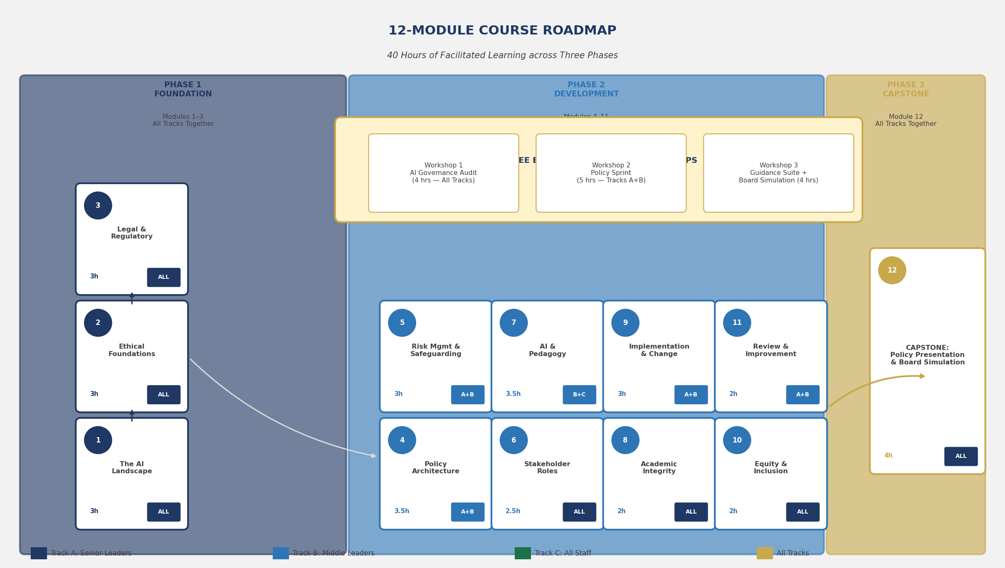
Figure 4: 12-Module Course Roadmap — Three Phases, Three Tracks, 40 Hours of Facilitated Learning

MODULE 8: ACADEMIC INTEGRITY IN THE AI AGE
Duration: 2 hours | Audience: All Tracks

Purpose and Rationale
Academic integrity is the issue that most schools name as their primary AI governance concern. This module provides a comprehensive, practical framework — moving beyond 'ban and detect' toward a values-based, design-led approach. The module draws on Georgia's disclosure requirements, Rhode Island's policy amendment template, and the cross-corpus consensus that AI detection tools must not be used as the sole basis for dishonesty allegations.

Content Outline
- Why the old academic integrity framework is insufficient: how GenAI changes the nature of academic work
- The disclosure model: requiring students to document their AI use as a learning habit, not a punitive compliance measure
- Designing AI-resistant assessments: 12 strategies for maintaining assessment validity in the AI age
- AI detection tools: what they can and cannot do; false positive risk and its safeguarding implications; the NCDPI and multiple state warnings against sole reliance on detection
- Academic integrity procedures: investigation protocols; burden of proof; proportionate consequences; appeals processes
- Student AI use agreements: designing agreements that educate rather than simply prohibit
- Workshop: groups draft their school's Academic Integrity AI Addendum using the Rhode Island template as a starting framework

Assessment
Completed Academic Integrity AI Addendum draft. Portfolio Part 7.

MODULE 9: IMPLEMENTATION, CHANGE MANAGEMENT, AND COMMUNITY ENGAGEMENT
Duration: 3 hours | Audience: Tracks A and B

Purpose and Rationale
A policy approved but not implemented is worse than no policy — it signals that governance is performative. This module addresses the implementation gap identified by Digital Promise as the most critical failure mode in K-12 AI governance. It draws on Colorado's implementation dip planning framework, Alaska's phased adoption model (Investigate → Implement → Innovate), Arizona's five-stage roadmap, and the AI for Education's four-phase adoption roadmap.

Content Outline
9.1 The Implementation Gap — Diagnosing the Real Challenge (30 min)
- Digital Promise finding: 'The gap between what guidance recommends and what schools can implement is substantial' — why this is true and what to do about it
- Change management theory applied to AI governance: Kotter's 8-Step model in an AI context
- The 'implementation dip': Colorado's framework for managing the inevitable productivity decline when new practices are introduced
9.2 The Four-Phase AI Adoption Roadmap (60 min)
Drawing on the AI for Education Adoption Roadmap and Alaska's Investigate-Implement-Innovate model:
- Phase 1: EXPLORE (Months 1-3): Establish AI literacy baseline; conduct readiness audit; review current AI use; identify legal obligations; form AI governance committee; draft initial policy framework.
- Phase 2: DEFINE (Months 4-6): Complete stakeholder consultation; finalise AI Policy; develop guidance documents; establish approval workflows for AI tools; launch staff professional development programme.
- Phase 3: IMPLEMENT (Months 7-12): Roll out approved AI tools with monitored pilots; deliver student AI literacy curriculum; engage parent community; establish reporting and monitoring systems.
- Phase 4: SUSTAIN AND IMPROVE (Year 2+): Annual policy review; impact assessment; scale effective practices; identify new tools and risks; update professional development; report to governing body.
9.3 Stakeholder Consultation Planning (45 min)
- Why consultation matters: TeachAI principle of inclusive policy development; the 5 Questions framework for stakeholder engagement
- Designing a consultation process: who to consult, how, in what sequence, and how to document and respond to input
- Managing resistant stakeholders: the 'Top 5 Mistakes' framework from AI for Education; common staff objections and constructive responses
- Parent engagement: using the Parent Council Workshop One-Pager and parent guide as community engagement tools
- Activity: participants complete the Stakeholder Consultation Planner for their school (Tool 5, Section 9)
9.4 Resourcing and Sustainability (45 min)
- Realistic budgeting for AI implementation: device costs, platform licences, PD time, governance overhead
- The ROI argument for governing bodies: how to make the case for AI governance investment
- Building internal capacity vs. external expertise: when to buy-in AI governance support
- Sustaining momentum: how to keep AI governance active after the initial implementation phase

Assessment
Draft Implementation Roadmap for their school: phased timeline, resource requirements, accountability owners, and stakeholder communication plan. Portfolio Part 8.

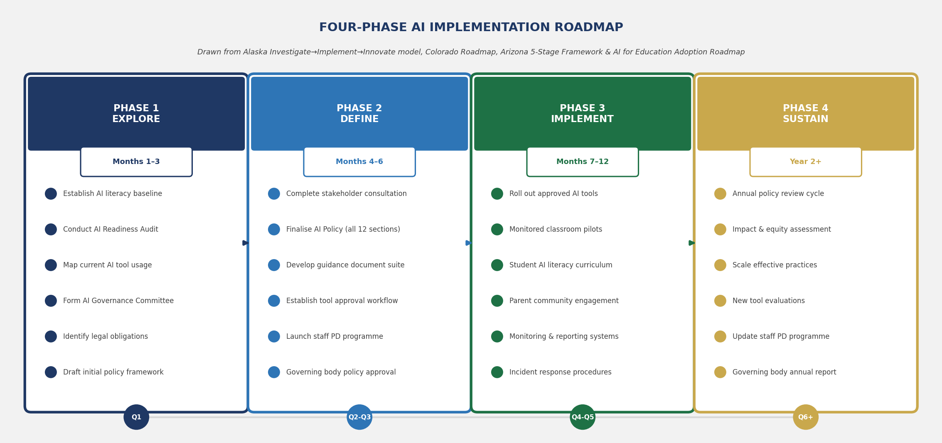
Figure 6: Four-Phase AI Implementation Roadmap — From Exploration Through Sustained Improvement

MODULE 10: EQUITY, INCLUSION, AND CULTURALLY RESPONSIVE AI GOVERNANCE
Duration: 2 hours | Audience: All Tracks

Purpose and Rationale
Equity is the most frequently referenced theme in the entire document corpus (344 mentions in the Western states analysis alone). This module ensures that equity is not merely stated as a value in the AI Policy but operationalised in every decision. It addresses the unique equity considerations for multilingual communities (drawing on Puerto Rico's guidance), students with disabilities (IDEA and Section 504 provisions), rural and low-income communities (digital divide mitigation), and students of colour (algorithmic bias risk).

Content Outline
- Equity vs. equality in AI governance: why identical access to AI tools does not produce equitable outcomes
- The digital divide in the AI age: device equity, connectivity equity, and now AI literacy equity
- Algorithmic bias in education: specific documented cases from the corpus (disciplinary AI scoring; adaptive learning pathway disparities; facial recognition bias in attendance systems)
- Culturally responsive AI: ensuring AI tools reflect and respect the cultural backgrounds and languages of all students
- AI for students with disabilities: IDEA compliance; AI as assistive technology; the accessibility requirement for all deployed tools
- Equity audit protocol: how to assess whether your AI implementation is widening or closing equity gaps
- Workshop: groups conduct a mini equity audit of one AI tool currently used at their school — identifying who benefits, who may be disadvantaged, and what mitigation is needed

MODULE 11: MONITORING, REVIEW, AND CONTINUOUS IMPROVEMENT
Duration: 2 hours | Audience: Tracks A and B

Purpose and Rationale
The corpus is unanimous on one point: AI policy must be a living document. This module establishes the monitoring infrastructure and review culture that prevents policies from becoming obsolete or performative. Drawing on the New Mexico 'living document' model, the TeachAI Review Cycle, and the Rhode Island accountability framework.

Content Outline
- Why AI policy reviews must be more frequent and more substantive than other policy reviews: the pace of technology change
- Establishing the AI Policy Review Committee: composition, authority, meeting frequency, and reporting obligations
- Data-driven monitoring: what to measure — AI tool usage data, equity metrics, academic integrity incidents, staff and student wellbeing indicators, parent satisfaction
- Trigger-based reviews: events that require immediate policy review regardless of scheduled cycle (significant AI incident; major technology change; legislative update; safeguarding concern)
- The annual review process: timeline, stakeholder input, amendment procedures, governing body approval, communication of changes
- Activity: participants complete the AI Policy Review Cycle Tracker for their school (Tool 6, Section 9)
- Future-proofing: how to write policy provisions that remain relevant as AI capability evolves — the principle of technology-neutral language

MODULE 12: CAPSTONE: POLICY PRESENTATION AND GOVERNING BODY SIMULATION
Duration: 4 hours | Audience: All Tracks — Together

Purpose and Rationale
The capstone module is the culmination of the entire programme. Participants from all three tracks come together to present, defend, and refine their completed AI Policy and Guidance Suite in a simulated governing body / school board setting. This module builds the confidence, communication skills, and peer accountability that turn policy documents into living institutional commitments.

Session Structure
Part 1: Portfolio Completion and Final Review (60 min)
- Participants finalise all portfolio components (Parts 1-8) with peer and facilitator feedback
- Cross-track peer review: a Track A participant reviews a Track C participant's portfolio component — and vice versa — ensuring all perspectives are represented
- Final checklist: does your AI Policy cover all 12 sections? Does your Guidance Suite include staff, student, and parent documents?
Part 2: Policy Presentation (90 min)
- Each school/district team presents their AI Policy to a panel of peers playing the role of school governors/board members
- Presentation requirements: (1) rationale for the policy; (2) key provisions and their grounding in national guidance; (3) stakeholder consultation summary; (4) implementation plan and timeline; (5) monitoring and review framework
- Panel questions are drawn from a pre-designed 'Challenging Questions Bank' reflecting common governing body concerns: budget implications, legal compliance, parental opposition, staff resistance, academic integrity enforcement
Part 3: Reflection and Commitment (30 min)
- Individual written reflection: 'What are the three most important actions I will take in the next 30 days to advance AI governance in my school?'
- Commitment cards: participants write one public commitment that they share with their cohort — creating social accountability
- Next steps: programme alumni network; follow-up coaching options; Advanced and Consultant certification pathways

Assessment
Policy presentation assessed against the certification rubric (Section 8). Portfolio submitted for certification review within two weeks of programme completion.

EXTENDED CAPSTONE WORKSHOPS

8. Practical Policy-Building Workshops
Three extended capstone workshops are embedded within the programme. Each workshop is a standalone, structured, facilitated session that produces a tangible deliverable. Workshops may be run consecutively as part of a residential intensive, or spaced across the programme's blended/online delivery modes.

Workshop 1: The AI Governance Audit — Where Are We Now? (4 hours)
Duration | 4 hours (can be split into 2 × 2-hour sessions)
Target Audience | All Tracks — school/district teams work together
Deliverable | Completed AI Readiness Audit Report for the participant's school/district
Pre-Work Required | Participants gather: any existing AI policies or guidance; list of AI tools currently in use; any recent staff/student/parent feedback on AI; relevant legal notices or data-sharing agreements with vendors

Purpose
Before participants can design a policy, they must have an honest, evidence-based picture of their current AI governance reality. This workshop uses the programme's AI Readiness Audit Tool (Tool 4) to generate a structured self-assessment across five dimensions drawn from the Digital Promise comparative framework.

Session Plan
Part A: Current-State Mapping (60 min)
- Teams complete the AI Readiness Audit Tool across five dimensions:
  - Dimension 1 — Leadership Readiness: Does senior leadership have sufficient AI knowledge? Is AI governance included in strategic plans? Is a budget allocation in place?
  - Dimension 2 — Instructional Readiness: Do teachers have the skills to use AI appropriately? Are there AI-integrated curricula? Is there a shared academic integrity framework?
  - Dimension 3 — Technical Readiness: Is infrastructure sufficient for AI tool deployment? Are data security measures in place? Is there a vendor vetting process?
  - Dimension 4 — Policy Readiness: Does a documented AI Policy exist? Is it current, communicated, and enforced? Are roles and responsibilities clearly assigned?
  - Dimension 5 — Community Readiness: Have parents been consulted and informed? Do students understand their AI rights and responsibilities? Is the governing body engaged?
Part B: Gap Analysis (60 min)
- Teams score each dimension (1 = Absent / 2 = Emerging / 3 = Developing / 4 = Established / 5 = Exemplary) and provide evidence for each score
- Radar chart exercise: teams plot their five scores to visualise their governance profile
- Priority identification: which two dimensions will have the greatest impact if improved? These become the focus of the Implementation Roadmap in Workshop 3
Part C: Evidence Triangulation (60 min)
- Peer review: teams exchange audit reports and challenge each other's scoring with probing questions (drawn from facilitator question bank)
- Facilitator debrief: common patterns across the cohort; which dimensions are typically underdeveloped across schools?
- Realism check: are audit scores consistent with the Digital Promise finding that most schools are 'not ready for the practices described in existing guidance'?
Part D: From Audit to Action (60 min)
- Each team produces a one-page 'Current State Summary' — a clear, honest description of where their school currently stands
- Identifying quick wins: what can be done in the next 30 days with no additional resource?
- Identifying structural priorities: what requires investment, leadership decision, or governing body approval?
- Connecting audit findings to policy gaps: each gap identified in the audit becomes a policy requirement in Workshop 2

Facilitator Notes
This workshop frequently produces uncomfortable revelations — schools discovering they have no documentation for AI tools they have already deployed, or that their existing 'policy' is actually a one-paragraph statement that provides no governance. Create psychological safety for honesty by emphasising that the audit is a tool for improvement, not an inspection. Peer challenge must be constructive, not judgmental.

Workshop 2: Policy Sprint — Drafting Your School AI Policy (5 hours)
Duration | 5 hours (best run as a full-day intensive)
Target Audience | Tracks A and B — senior and middle leaders as a school team
Deliverable | Draft AI Policy (all 12 sections) and initial draft of Staff AI Guidance document
Pre-Work Required | Completed Audit Report from Workshop 1; values shortlist from Module 2; legal compliance checklist from Module 3; stakeholder consultation notes (if pre-programme consultation has occurred)

Purpose
This is the heart of the programme — where knowledge becomes institution-specific action. Participants use the AI Policy Template (Tool 1) to draft each of the 12 policy sections in sequence, with facilitator coaching and peer support throughout. The workshop is deliberately timed and structured to prevent overthinking and produce a working draft — recognising that an imperfect draft is infinitely more valuable than a perfect policy that does not yet exist.

Session Plan
Hour 1: Foundation Sections (Purpose, Definitions, Principles)
- Section 1 (Purpose and Scope): Who does this policy apply to? What activities does it govern? What is its relationship to other school policies? Teams draft in 15 minutes; facilitator reviews for scope completeness
- Section 2 (Definitions): Adapting the programme glossary to school-specific language; adding school-specific tool names or local terminology
- Section 3 (Guiding Principles): Transferring values shortlist from Module 2 into policy language; ensuring principles are concrete enough to drive decisions
Hour 2: Governance and Use Provisions (Sections 4-6)
- Section 4 (Governance and Accountability): Assigning named roles (by title); defining the AI governance committee; establishing the escalation pathway; designating the 'AI Lead' position
- Section 5 (Permitted Uses): Creating a practical permitted use list for each stakeholder group — the most debated section in most schools; facilitator provides model language from Alabama template and Washington guidance
- Section 6 (Restricted and Prohibited Uses): Drafting the restriction tier (requires prior approval) and the prohibition list; ensuring prohibitions are legally grounded and operationally enforceable
Hour 3: Data Privacy, Academic Integrity, and Safeguarding (Sections 7-9)
- Section 7 (Data Privacy): Referencing FERPA/COPPA requirements established in Module 3; defining the vendor vetting workflow; naming the Data Protection Officer or equivalent; specifying DPA requirements
- Section 8 (Academic Integrity): Embedding the assignment classification framework; defining the disclosure requirement; establishing the detection-and-investigation procedure with the explicit warning against sole reliance on AI detection tools
- Section 9 (Safeguarding): The deepfake response protocol; the non-delegation principle; content safety provisions; integration with existing DSL procedures
Hour 4: Professional Development, Communication, and Review (Sections 10-12)
- Section 10 (Professional Development): Stating minimum training requirements as a condition of AI tool access; defining the PD pathway by role; specifying annual CPD requirements
- Section 11 (Community Communication): Parent notification protocols; student communication standards; governing body reporting requirements; crisis communication procedure
- Section 12 (Review and Amendment): Setting the review cycle; naming review triggers; defining the amendment approval process; recording version history
Hour 5: Peer Review and Quality Assurance
- Structured peer review: each team exchanges their draft with another team and completes the Policy Quality Rubric (10 criteria, each scored 1-4)
- Feedback session: verbal feedback in dyads, focusing on the three highest-priority improvements
- Revision time: 20 minutes to incorporate priority feedback
- Facilitator sign-off checklist: does the draft meet the minimum standards for a governance-ready policy?

Facilitator Notes
Common sticking points: (1) Scope of 'AI tools' — help teams use the programme definition rather than trying to list every tool by name, which immediately dates the policy. (2) Prohibited uses — teams often under-specify (too vague) or over-specify (too restrictive to be enforceable). (3) Academic integrity procedures — ensure teams do not simply replicate their existing plagiarism procedures without adapting them to AI's specific characteristics.

Workshop 3: Guidance Suite Development and Governing Body Simulation (4 hours)
Duration | 4 hours
Target Audience | All Tracks — full cohort for the simulation
Deliverable | Draft Staff AI Guidance, Student AI Guidance, Parent AI Guidance documents; completed Implementation Roadmap; governing body presentation deck

Session Plan
Part A: Guidance Documents Sprint (90 min)
- Track B leads: draft the Staff AI Guidance document using Tool 2a — translating Policy Sections 4-10 into role-specific, action-oriented language for teachers and support staff
- Track A supports: draft the Student AI Guidance and Parent AI Guidance using Tools 2b and 2c — language appropriate to audience, covering rights, responsibilities, and how to raise concerns
- Track C participants: review draft guidance documents from the user perspective and provide authenticity feedback
Part B: Implementation Roadmap Finalisation (30 min)
- Teams complete their Implementation Roadmap (Tool 6) — Phase 1-4 timeline, resource requirements, accountability matrix, communication plan
- Peer challenge: does the roadmap reflect the audit findings from Workshop 1? Are resource requirements realistic? Are quick wins genuinely achievable within 30 days?
Part C: Governing Body Simulation (90 min)
- Teams present their AI Policy, Guidance Suite, and Roadmap to a simulated governing body panel
- Panel members are drawn from the cohort and given role cards: sceptical governor focused on cost; concerned parent governor; technology-enthusiastic board member; legally cautious chair
- Standard governing body challenge questions (drawn from the Challenging Questions Bank):
  - 'How do we know this policy actually protects students rather than just protecting the school legally?'
  - 'What is the total cost of implementation in Year 1?'
  - 'A parent has complained their child was wrongly accused of AI plagiarism — what is our appeal process?'
  - 'How does this policy ensure we are not falling behind other schools in AI capability?'
  - 'What happens if a teacher uses an AI tool that is not on the approved list?'
Part D: Programme Close and Commitment (30 min)
- Individual commitment cards: three actions in 30 days
- Alumni network introduction and peer support framework
- Certification pathway confirmation for each participant

TEMPLATES AND TOOLS

9. Programme Templates and Tools Suite
The following seven tools are provided to every participant as editable templates. Each tool is described in full below, including all sections, guiding questions, and example language derived from best-practice documents across the corpus.

Tool 1: School AI Policy Template
This template provides the complete architecture for a board-ready AI Policy. All bracketed items are school-specific placeholders. Guiding questions in italics prompt policy writers to consider key decisions. Example language drawn from Alabama template, TeachAI toolkit, Washington guidance, and Rhode Island RIDE document.

 | SECTION 1: PURPOSE AND SCOPE
Purpose |  | States why the policy exists and what it governs.
Guiding Questions |  | - What specific AI activities does this policy govern? (Instruction? Administration? Student use? All three?)  - Who does this policy apply to? (All staff? All students? Contractors? Volunteers?)  - What is the relationship of this policy to existing ICT, data protection, and academic integrity policies?
Example Language |  | This policy governs the use of artificial intelligence tools and systems by all staff, students, and authorised third parties at [School Name]. It applies to AI use in instructional, administrative, and extracurricular contexts. This policy is intended to be read alongside the School's Data Protection Policy, ICT Acceptable Use Policy, and Academic Integrity Policy.

 | SECTION 2: DEFINITIONS
Purpose |  | Provides operational definitions of all key terms used in the policy.
Guiding Questions |  | - How does the school define 'AI tool' broadly enough to capture future tools, not just current ones?  - How is 'approved AI tool' distinguished from 'unapproved AI tool'?  - What counts as 'AI-generated content' for academic integrity purposes?
Example Language |  | For the purposes of this policy: 'Artificial Intelligence (AI)' means any technology that uses algorithms or machine learning to perform tasks that would otherwise require human intelligence, including but not limited to generating text, images, audio, video, code, or recommendations. 'Approved AI Tool' means any AI tool that has completed the School's AI Tool Vetting Process and appears on the School's Approved AI Tools Register.

 | SECTION 3: GUIDING PRINCIPLES
Purpose |  | States the school's foundational values governing AI use.
Guiding Questions |  | - What are the school's non-negotiable values in relation to AI?  - How does the school's AI philosophy connect to its wider educational vision?  - What does 'human-centred AI' mean in the specific context of this school?
Example Language |  | The School is committed to governing AI use in accordance with the following principles: (a) Human Primacy: AI augments rather than replaces human judgement, relationships, and professional expertise; (b) Equity and Inclusion: AI adoption must reduce, not perpetuate, educational disparities; (c) Transparency: AI use will be visible, explainable, and communicated openly to all stakeholders; (d) Safety First: Student safety, wellbeing, and privacy are the paramount considerations in every AI decision.

 | SECTION 4: GOVERNANCE AND ACCOUNTABILITY
Purpose |  | Assigns specific roles and responsibilities for AI governance.
Guiding Questions |  | - Who is the designated AI Lead? What are their specific responsibilities and authority?  - Is there an AI Governance Committee? Who is on it, how often does it meet, and what decisions does it make?  - How do AI governance decisions get reported to the governing body?  - Who handles AI-related incidents and complaints?
Example Language |  | The Principal bears ultimate accountability for AI governance at [School Name]. The [AI Lead/designated role] is responsible for day-to-day implementation of this policy. An AI Governance Committee, chaired by the Vice-Principal and including the Head of IT, SENCO, a teacher representative, and a parent governor, meets [termly/monthly] to review implementation and recommend policy amendments. The AI Lead reports to the Governing Body [annually/termly].

 | SECTION 5: PERMITTED USES
Purpose |  | Explicitly lists AI applications permitted for each stakeholder group.
Guiding Questions |  | - What specific AI applications are permitted for teachers in instructional planning, feedback, and assessment?  - What AI uses are permitted for students — and do these vary by age group or assignment type?  - What AI uses are permitted in administrative and operational functions?  - Is personal AI use on school devices governed by this policy?
Example Language |  | Staff may use Approved AI Tools for: lesson planning and resource creation; generating personalised feedback frameworks; administrative drafting (not for official correspondence without human review); professional development and research. Students may use Approved AI Tools in accordance with the assignment classification designated by their teacher (AI-Resistant / AI-Assisted / AI-Enhanced / AI-Empowered) and the Student AI Use Agreement.

 | SECTION 6: RESTRICTED AND PROHIBITED USES
Purpose |  | Defines uses requiring prior approval and uses that are categorically prohibited.
Guiding Questions |  | - What AI uses require explicit prior approval from a senior leader?  - What AI uses are absolutely prohibited regardless of context?  - Are there age-based restrictions on certain AI tools?  - What happens when an unapproved tool is discovered to be in use?
Example Language |  | The following AI uses are PROHIBITED without exception: (a) Using AI to generate or process any content that depicts, implies, or facilitates harm to minors; (b) Using non-FERPA/COPPA-compliant AI tools with any student personal data; (c) Delegating legally required human decisions (safeguarding referrals, IEP decisions, disciplinary determinations) to AI systems; (d) Using AI-generated content in consequential assessments without disclosure and teacher authorisation; (e) Using facial recognition or biometric AI systems without express governing body approval and parental notification.

 | SECTION 7: DATA PRIVACY AND SECURITY
Purpose |  | States all data protection requirements for AI use.
Guiding Questions |  | - What is the vendor vetting process for AI tools before adoption?  - What must a Data Processing Agreement with an AI vendor contain?  - Who is responsible for maintaining the Approved AI Tools Register?  - What is the data breach response procedure for AI-related incidents?
Example Language |  | No AI tool may be approved for use with student personal data without: (a) a signed Data Processing Agreement meeting FERPA requirements and applicable state law; (b) confirmation of COPPA compliance for tools used with students under 13; (c) completion of the AI Tool Risk Assessment (available from the AI Lead); and (d) inclusion on the School's Approved AI Tools Register. The [Data Protection Officer/IT Director] maintains the Approved AI Tools Register, which is reviewed [annually/termly].

 | SECTION 8: ACADEMIC INTEGRITY
Purpose |  | Defines AI-related academic integrity standards and procedures.
Guiding Questions |  | - How is AI-generated academic dishonesty defined — what exactly is prohibited?  - What is the required disclosure mechanism when students use AI in assignments?  - How are academic integrity investigations conducted when AI misuse is suspected?  - What is the school's position on AI detection tools — their role and limitations?
Example Language |  | Students are required to disclose all AI use in academic work using the School's AI Disclosure Statement. AI-generated content submitted as the student's own original work without disclosure constitutes academic dishonesty. Investigations will follow the School's existing academic misconduct procedure. AI detection tools may be used as one indicator of potential misuse but may NOT be used as the sole basis for an academic dishonesty finding, given their documented inaccuracy. All allegations must be supported by additional evidence.

 | SECTION 9: SAFEGUARDING AND STUDENT PROTECTION
Purpose |  | Addresses AI-specific safeguarding risks.
Guiding Questions |  | - What is the school's deepfake response protocol?  - How does this policy protect students from AI-facilitated harm?  - What is the non-delegation principle and how is it operationalised?  - How are AI-related safeguarding concerns reported and recorded?
Example Language |  | The Designated Safeguarding Lead (DSL) must be notified immediately of any AI-related safeguarding concern, including but not limited to: deepfake material depicting students or staff; AI-facilitated harassment or exploitation; AI-generated harmful content accessed by students. No AI system may replace the DSL's professional judgement in safeguarding decisions. The DSL maintains a record of AI-related safeguarding referrals as part of the School's safeguarding documentation.

 | SECTION 10: PROFESSIONAL DEVELOPMENT
Purpose |  | States minimum training requirements for AI tool access.
Guiding Questions |  | - What training is required before a staff member can use an approved AI tool with students?  - What is the annual CPD requirement for maintaining AI tool access?  - How is compliance with training requirements monitored and recorded?
Example Language |  | All staff must complete the School's foundational AI literacy training before using any Approved AI Tool in an instructional context. Completion is recorded on the School's CPD register. Annual refresher training is required to maintain AI tool access. Staff who have not completed required training may not use AI tools with students. The [AI Lead/HR Director] monitors training compliance.

 | SECTION 11: COMMUNITY COMMUNICATION
Purpose |  | Defines how the school communicates AI governance to stakeholders.
Guiding Questions |  | - How and when will parents be informed about AI tools used with their children?  - What do students need to know about their AI rights and responsibilities?  - How will the governing body be kept informed of AI governance developments?
Example Language |  | Parents will be informed of AI tool adoption through [newsletter/parent letter/school website] at least [two weeks] before a new tool is deployed with students. The School's AI Policy and Approved AI Tools Register are published on the school website. The governing body receives an AI governance report [annually/termly] from the AI Lead.

 | SECTION 12: REVIEW AND AMENDMENT
Purpose |  | Establishes the policy review cycle and amendment process.
Guiding Questions |  | - How often is the policy reviewed under normal circumstances?  - What events trigger an out-of-cycle review?  - Who approves amendments — the AI Lead, the Principal, or the full governing body?
Example Language |  | This policy is reviewed annually by the AI Governance Committee and approved by the Governing Body. An out-of-cycle review is triggered by: a significant AI-related incident; a material change in applicable law; a major change to AI tools used by the school; or a request from the Principal, AI Lead, or a parent/student representative. Amendments are approved by the Principal (for operational changes) or the Governing Body (for changes to principles, prohibited uses, or governance structures).

Tool 2: AI Guidance Templates (Staff / Student / Parent)

Tool 2a: Staff AI Guidance
The Staff AI Guidance translates the AI Policy into day-to-day operational direction for all teaching and non-teaching staff. It must be role-specific, practical, and concise — staff should be able to answer 'What am I allowed to do?' without needing to read the full policy.
- Your Rights: What AI tools you are permitted to use, for what purposes, and under what conditions
- Your Responsibilities: Data handling duties; student protection obligations; disclosure requirements; mandatory training
- Getting AI Tool Approval: Step-by-step process to request approval for a new AI tool
- Academic Integrity: Your responsibilities in designing AI-fair assessments and managing suspected misuse
- Student Use: How to apply the assignment classification framework; how to communicate AI expectations to students
- Data Protection in Practice: Which student data may never be entered into AI tools; what to do if you discover a data breach
- Raising Concerns: How to report an AI-related safeguarding concern, data incident, or policy violation
- Professional Development: Required training; where to access it; how to record completion
- Staying Current: Where to find updates to approved tools, policy changes, and guidance updates

Tool 2b: Student AI Guidance
The Student AI Guidance translates the AI Policy into age-appropriate, clear direction for students at appropriate levels (elementary / middle / high school versions recommended). Key principles: rights and responsibilities in balance; transparency-first culture; learning orientation rather than punitive tone.
- What AI Is and Why It Matters for Your Learning
- What AI Tools Are Available to You at School
- How to Use AI Honestly: The Disclosure Requirement and Why It Matters
- Assignment Types: AI-Resistant, AI-Assisted, AI-Enhanced, AI-Empowered — what each means for how you work
- What You Must Never Do: The prohibited uses explained in student-friendly language
- Your Data: What information AI tools collect about you and how it is protected
- Deepfakes and Harmful Content: What to do if you see AI-generated content that is harmful or deceptive
- Getting Help: Who to talk to if you are unsure, worried, or have witnessed AI misuse

Tool 2c: Parent and Guardian AI Guidance
The Parent AI Guidance, informed directly by the AI for Education parent guide and the RIDE stakeholder engagement framework, addresses parent concerns and empowers families to support their child's AI literacy journey at home. Language must be jargon-free, accessible, and available in translation for multilingual communities.
- What AI Tools Our School Uses and Why: Transparent disclosure of approved tools
- How We Protect Your Child's Data: FERPA, COPPA, and our vendor vetting process explained
- Academic Integrity: What we expect from students, how we handle concerns, why AI is not 'cheating' when used appropriately
- Supporting AI Literacy at Home: Five practical things parents can do to build healthy AI habits
- What AI Your Child May Already Be Using: Common student AI tools and what parents should know
- Your Rights: How to request information about AI tools used with your child; how to raise concerns
- Five Questions to Ask Your Child's Teacher About AI: Drawn from the AI for Education stakeholder engagement framework
- Stay Involved: How to participate in future AI policy consultations

Tool 3: AI Tool Risk Assessment Framework
This framework is completed before any AI tool is approved for school use. It draws on Colorado's procurement checklist, TeachAI's vendor evaluation framework, and the 23-question checklist from the Washington comprehensive guidance. It produces a risk score and a recommended decision (Approve / Approve with Conditions / Do Not Approve).

DIMENSION 1: DATA PRIVACY COMPLIANCE
- Is the vendor FERPA compliant? (Evidence required: signed DPA or FERPA compliant school services agreement)
- Is the vendor COPPA compliant for use with students under 13? (Evidence required: COPPA verifiable consent mechanism or school-directed exception documentation)
- Is the tool compliant with applicable state privacy laws? (Evidence required: legal review or vendor privacy compliance certification)
- What student data does the tool collect? Is data minimised to what is educationally necessary?
- How long is student data retained? Can data be deleted on request?
- Does the vendor share, sell, or use student data for advertising or model training?

DIMENSION 2: ALGORITHMIC BIAS AND FAIRNESS
- Has the vendor conducted or commissioned an independent bias audit?
- Is there documented evidence of disparate impact on protected groups (race, gender, disability, language, socioeconomic status)?
- Does the vendor have a process for identifying and remediating bias?
- Are decisions made by this tool subject to human review before implementation?

DIMENSION 3: ACCESSIBILITY
- Does the tool comply with WCAG 2.1 AA standards?
- Is the tool compatible with assistive technologies (screen readers, text-to-speech, switch access)?
- Is multilingual support available for ELL students and non-English-speaking families?
- Has the tool been independently tested with students with disabilities?

DIMENSION 4: EDUCATIONAL EFFICACY
- Is there peer-reviewed research evidence that this tool improves student learning outcomes?
- Are vendor claims about efficacy supported by independent studies (not only vendor-commissioned research)?
- Has the tool been piloted with a demographically representative student population?

DIMENSION 5: CYBERSECURITY
- Has the vendor undergone third-party penetration testing? When was the last test?
- What encryption standards are used for data in transit and at rest?
- What is the vendor's breach notification commitment? (Must not exceed 72 hours)
- Does the vendor have a SOC 2 Type II certification or equivalent?

DIMENSION 6: TRANSPARENCY AND EXPLAINABILITY
- Can the vendor explain how the AI makes decisions in plain language?
- Can consequential AI decisions (grades, recommendations, flags) be explained to students and parents?
- Is the vendor's AI model documentation publicly available?

DIMENSION 7: COMMERCIAL AND CONTRACTUAL RISK
- What are the vendor's financial stability indicators?
- What happens to school data if the vendor ceases operations?
- Does the contract include adequate indemnification provisions?
- Is there a service continuity commitment?

Tool 4: AI Readiness Audit Tool
This tool enables school leaders to self-assess their institution's current AI governance readiness across five dimensions. Scores (1-5) generate a radar chart profile. The tool is completed in Workshop 1 and forms the evidential basis for the Implementation Roadmap. It is re-administered annually as part of the AI Policy Review cycle to track progress.

Dimension / Indicator | 1 Absent | 2 Emerging | 3 Developing | 4 Established | Evidence / Notes
LEADERSHIP READINESS
Senior leadership has sufficient AI knowledge to make governance decisions | ○ | ○ | ○ | ○
AI governance is included in the school strategic plan | ○ | ○ | ○ | ○
Budget allocation exists for AI implementation and governance | ○ | ○ | ○ | ○
INSTRUCTIONAL READINESS
Teachers have skills to use AI tools appropriately in instruction | ○ | ○ | ○ | ○
AI-integrated curriculum exists across subject areas | ○ | ○ | ○ | ○
Shared academic integrity framework for AI is in place | ○ | ○ | ○ | ○
TECHNICAL READINESS
Infrastructure is sufficient for AI tool deployment | ○ | ○ | ○ | ○
Data security measures meet FERPA/COPPA requirements | ○ | ○ | ○ | ○
Vendor vetting process exists and is followed | ○ | ○ | ○ | ○
POLICY READINESS
A documented, current AI Policy exists | ○ | ○ | ○ | ○
AI Policy is communicated to all stakeholders | ○ | ○ | ○ | ○
Governance roles and responsibilities are clearly assigned | ○ | ○ | ○ | ○
COMMUNITY READINESS
Parents have been consulted and informed about AI use | ○ | ○ | ○ | ○
Students understand their AI rights and responsibilities | ○ | ○ | ○ | ○
Governing body is actively engaged in AI oversight | ○ | ○ | ○ | ○

Tool 5: Stakeholder Consultation Planner

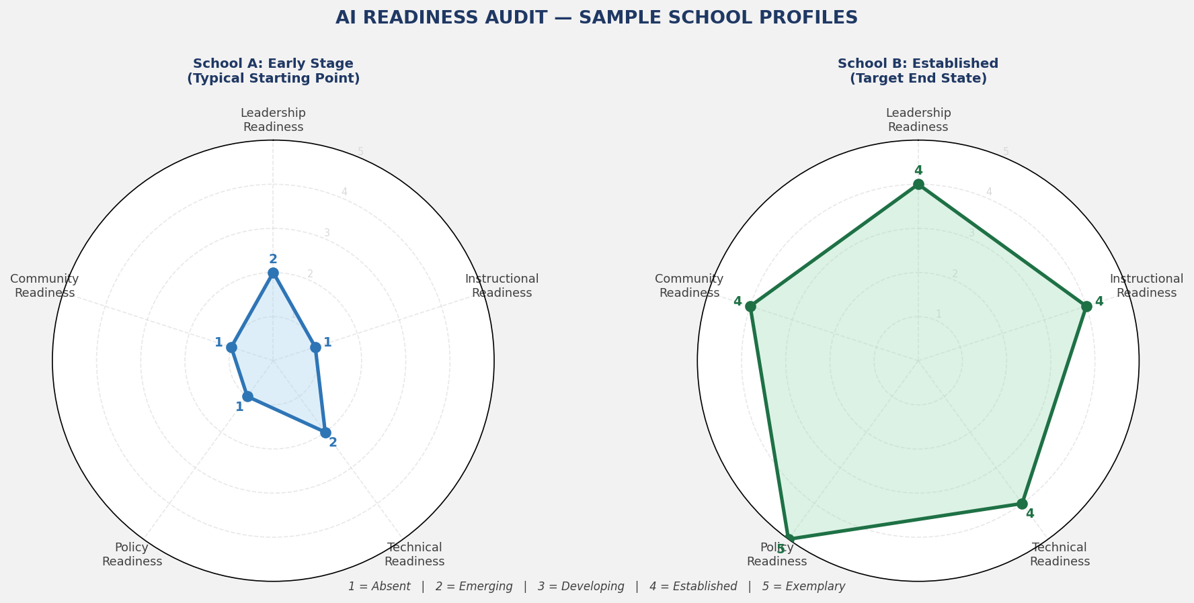
Figure 7: AI Readiness Audit — Sample School Radar Profiles (Early Stage vs. Established)
This tool guides school leaders through a structured stakeholder consultation process for AI Policy development. Drawn from the TeachAI inclusive development principle, the '5 Questions to Ask Stakeholders' framework, and Rhode Island's documented consultation process with 1,252 respondents.

Stakeholder Group | Consultation Method | Key Questions | Timeline | Response Record
Teaching Staff | Staff meeting + anonymous survey + focus group | What AI tools do you currently use? What are your concerns? What training do you need? | Weeks 1-2
Support Staff | Briefing session + written feedback form | How might AI affect your role? What data do you handle? What are your concerns? | Week 2
Students (Secondary) | Student council + year group consultations | What AI tools do you use? What are your concerns about fairness? What guidance do you want? | Weeks 2-3
Students (Primary) | Class discussions with teacher facilitation | Do you know what AI is? Have you used it? What questions do you have? | Week 3
Parents/Guardians | Parent survey + parent forum evening | What do you want to know about AI in school? What are your concerns? How can we communicate better? | Weeks 3-4
Governing Body | Governor briefing + policy workshop | What are our legal obligations? What is our risk exposure? What do we need to approve? | Week 4
Local Community | Open consultation (optional) | Context-specific questions based on community demographics and priorities | Week 4-5

Tool 6: AI Policy Review Cycle Tracker
Annual and trigger-based review record. Each row documents a review event — scheduled or triggered — with outcomes, approvals, and communication actions.
Review Date | Review Type (Annual/Triggered) | Trigger Event (if applicable) | Key Changes Made | Approved By | Communication Sent

Tool 7: AI Programme Glossary for Educators
A standalone, printable glossary of 20 key AI terms for educators — drawn from the definitions in Section 3.2 of this document. Designed for distribution to all staff as part of the foundational training programme. Recommended format: laminated A5 card or PDF download from school AI governance page.

ASSESSMENT AND CERTIFICATION

10. Assessment Strategy and Certification Framework

10.1 Portfolio of Evidence
Assessment in this programme is portfolio-based, reflecting the professional development context and the need to produce real, school-specific deliverables rather than academic exercises. Participants compile a Professional Learning Portfolio comprising eight components, each produced during the programme and tailored to their specific school context.

Part | Module | Component | Description
Part 1 | Module 2 | Written Reflection (300 words) | Three AI-related ethical tensions in the participant's school and how school values should guide each decision
Part 2 | Module 3 | Legal Compliance Quiz | 15-question quiz on FERPA, COPPA, IDEA, and applicable state law (minimum 80% required)
Part 3 | Module 4 | Policy Critique | Written critique of a peer's draft Policy Purpose and Scope section using the Quality Rubric
Part 4 | Module 5 | AI Tool Risk Assessment | Completed risk assessment for one real AI tool used in the participant's school
Part 5 | Module 6 | Role Responsibility Statement | One-page document: 'My AI Governance Responsibilities' — role-specific obligations and commitments
Part 6 | Module 7 | Lesson/Assessment Redesign | Redesigned lesson or task demonstrating the assignment classification framework
Part 7 | Module 8 | Academic Integrity Addendum | Draft Academic Integrity AI Addendum using the Rhode Island template framework
Part 8 | Workshop 2 & 3 | Complete AI Policy and Guidance Suite | 12-section AI Policy + Staff Guidance + Student Guidance + Parent Guidance + Implementation Roadmap

10.2 Three-Tier Certification Framework
Three certification levels reflect varying depths of engagement, appropriate for different roles across the school community.

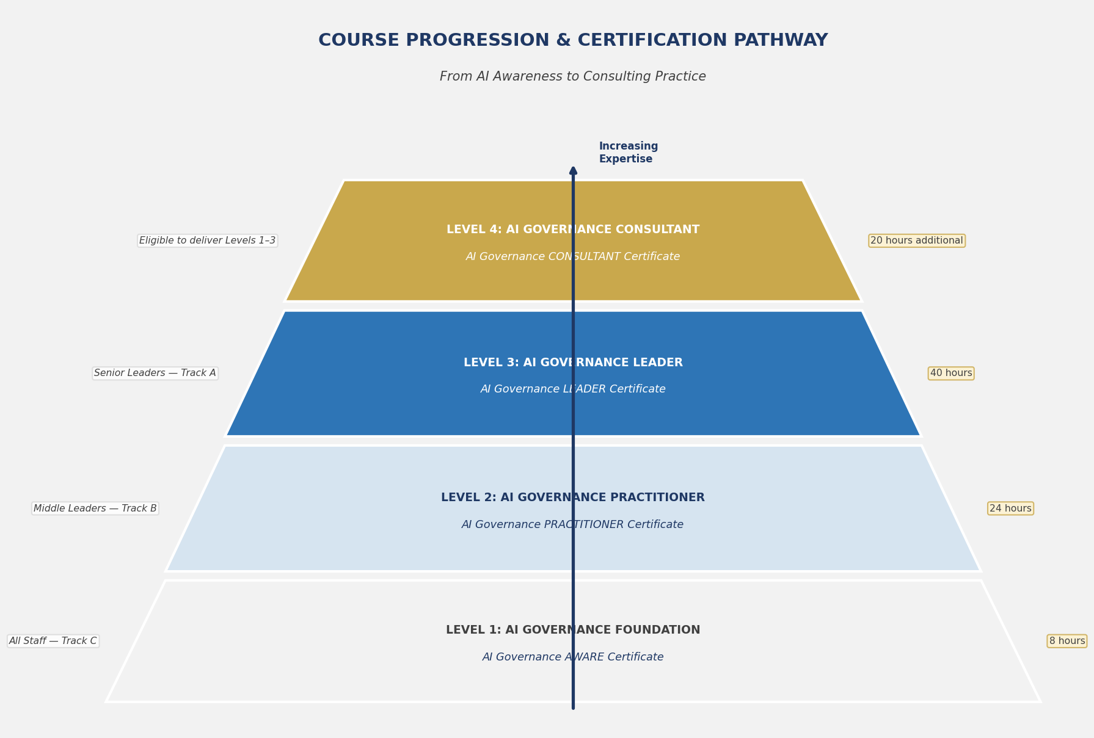
Figure 8: Certification Pathway — From AI Governance Foundation to Consultant Practice

AI GOVERNANCE AWARE
Intended for: Track C — All Staff
Requirements | - Completion of Modules 1, 2, 3, and 6  - Submission of Portfolio Parts 1, 2, and 5  - Minimum 80% on Legal Compliance Quiz  - Attendance at Module 12 Capstone (observer role)
What it demonstrates | Demonstrates that the holder understands AI fundamentals, their legal obligations, and their specific role-based responsibilities under the school AI Policy. Recommended for all non-leadership staff as a condition of AI tool access.

AI GOVERNANCE PRACTITIONER
Intended for: Track B — Middle Leaders
Requirements | - Completion of all Track B modules (1-3, 6, 7, 8, 9, 11, 12)  - Submission of Portfolio Parts 1-7  - Minimum 80% on Legal Compliance Quiz  - Completion of Workshop 2 and 3  - Satisfactory facilitator assessment of Capstone Presentation
What it demonstrates | Demonstrates that the holder can implement AI policy effectively within their department or team, design AI-fair assessments, identify and manage AI-related risks at classroom level, and communicate AI governance principles to students and parents.

AI GOVERNANCE LEADER
Intended for: Track A — Senior Leaders
Requirements | - Completion of all Track A modules (1-12)  - Submission of complete Portfolio Parts 1-8  - Minimum 80% on Legal Compliance Quiz  - Satisfactory governing body simulation assessment  - Submission of complete AI Policy, Guidance Suite, and Implementation Roadmap  - Post-programme peer review: one review of another participant's AI Policy
What it demonstrates | Demonstrates that the holder has the knowledge, skills, and practical outputs to lead responsible AI governance at institutional level — from policy design through governing body approval to full community implementation. This is the flagship certification for principals, vice-principals, and district leaders.

FACILITATION GUIDE

11. Facilitation Guide

11.1 Delivery Formats
Format | Structure | Recommended For
Face-to-Face Intensive | 5 consecutive days: Day 1 (Modules 1-3), Day 2 (Modules 4-5 + Workshop 1), Day 3 (Modules 6-8), Day 4 (Modules 9-11 + Workshop 2), Day 5 (Workshop 3 + Module 12 Capstone). Max cohort: 30 participants. Room configuration: round tables of 5-6 for collaborative work. | School networks, MATs, and districts wanting rapid whole-community policy development. Best for schools facing urgent governance needs or planning major AI deployment. Requires residential or full release from school duties.
Blended (Preferred) | 10 half-day sessions (3.5-4 hours each) over 5-6 weeks. Modules delivered in pairs with 1-2 weeks between session pairs for asynchronous work, tool completion, and school-based inquiry tasks. Workshops embedded within sessions. Online collaboration platform (e.g., Padlet, Miro) used for between-session work. | Most school leadership teams — balances depth of learning with operational reality. Allows time for consultation and data gathering between sessions. Strongly recommended for Track A participants who need governing body engagement time built in.
Online Asynchronous | Self-paced across 8 weeks using a structured LMS (Learning Management System). Video-recorded facilitated content (15-25 min per topic), downloadable tools, and discussion board activities replace live facilitated sessions. Live online cohort calls (90 min × 4) for workshops and capstone. Max cohort: 20 participants for quality of peer learning. | Geographically dispersed participants; individual school leaders without local cohort; international/overseas schools. Lower cost but requires high self-direction. Not recommended for Track C participants without blended elements.

11.2 Facilitator Competency Requirements
This programme requires co-facilitation by two complementary specialists — a design deliberately informed by the complexity and interdisciplinarity of AI governance in schools.

Lead Facilitator: AI Governance Specialist
- Deep knowledge of AI governance frameworks — able to reference specific provisions from US DOE, TeachAI, and state guidance documents with authority
- Working knowledge of FERPA, COPPA, IDEA, and applicable state privacy law in AI contexts
- Demonstrated experience designing AI policies for educational institutions
- Competency in AI tools used in K-12 settings — not just conceptual knowledge but hands-on experience
- Ability to facilitate challenging conversations about algorithmic bias, equity, and safeguarding without deflection

Co-Facilitator: School Leadership Specialist
- Demonstrated senior leadership experience in K-12 settings (minimum 5 years as principal, vice-principal, or district leader)
- Experience in policy design, governing body presentations, and change management in educational institutions
- Credibility with school leader participants — ability to speak from lived experience of governance complexity
- Familiarity with professional development frameworks for educators
- Ability to translate AI governance theory into school-operational reality

Co-Facilitation Model
Sessions alternate lead facilitation roles by topic. The AI Governance Specialist leads on technical content (Modules 1, 3, 5, 7, 8) while the School Leadership Specialist leads on governance and change management content (Modules 2, 4, 6, 9, 10, 11). Both facilitators are present throughout — enabling real-time synthesis and cross-domain challenge. The governing body simulation in Module 12/Workshop 3 is most powerful when the School Leadership Specialist plays the role of the Governing Body Chair, bringing authentic credibility to the challenge questions.

11.3 Cohort Size and Configuration Recommendations
Format | Cohort Size | Configuration | Platform/Room Requirements
Face-to-face intensive | 15-30 participants | Mixed-track cohort; round tables of 5-6 with one participant from each track per table where possible | Room with moveable furniture; wall space for gallery walks; breakout spaces for workshop activities; reliable internet for AI tool demonstrations
Blended | 12-24 participants | Mixed-track cohort; consistent teams of 4-5 maintained across all sessions to build collaborative trust | Hybrid-capable room for live sessions; LMS with asynchronous discussion and tool submission features; shared online workspace (Miro/Padlet/Jamboard)
Online asynchronous | 8-20 participants | Track-specific cohort preferred for online delivery — reduces complexity of differentiation in asynchronous format | Full-featured LMS (Canvas, Moodle, Google Classroom); video conferencing for live cohort calls; shared document collaboration (Google Workspace/M365)

PHASE 3: COMPETITIVE DIFFERENTIATION

12. Competitive Intelligence and Market Positioning

12.1 What Most AI Training for Educators Currently Lacks
Based on analysis of the current training landscape alongside the 60+ policy documents reviewed, the following gaps characterise the majority of existing AI professional development for educators:

Gap | Description
Gap 1: Policy-as-Output | Most courses teach about AI policy — they do not produce one. Participants leave with knowledge but no tangible institutional deliverable. This programme requires participants to submit a board-ready AI Policy as a programme output.
Gap 2: One-Track Design | Most programmes treat all educators identically, ignoring the radically different needs of a principal versus a classroom teacher. This programme's three-track architecture ensures every participant receives role-appropriate, career-stage-appropriate learning.
Gap 3: US Governance Vacuum | The vast majority of generic AI training ignores the specific legal landscape of US K-12 education — FERPA, COPPA, IDEA, state law variations. This programme is grounded in 60+ US-authored documents and treats legal compliance as foundational, not optional.
Gap 4: Equity as Afterthought | AI ethics is addressed in most courses as a brief values module. This programme treats equity as a through-line — embedded in every module, every tool, and every assessment criterion, reflecting the corpus consensus that equity is the paramount concern in K-12 AI governance.
Gap 5: No Community Engagement Framework | Most courses address community communication superficially. This programme provides a complete Stakeholder Consultation Planner, parent guidance template, and student communication frameworks — enabling genuine school community engagement, not just notification.
Gap 6: Shallow Risk Treatment | Risk is typically addressed at a surface level (privacy, academic integrity). This programme's 10-category risk taxonomy, hands-on Risk Assessment Framework, and dedicated safeguarding module provide the depth that school leaders facing real-world accountability actually need.
Gap 7: No Certification Coherence | Many courses award identical certificates regardless of role or demonstrated competence. This programme's three-tier certification framework (Aware / Practitioner / Leader) provides stakeholder-legible credentials that reflect actual governance capability.
Gap 8: No Review Infrastructure | No existing programme equips schools with the infrastructure to sustain governance after training ends. This programme provides a Review Cycle Tracker, trigger-based review protocols, and an annual audit tool — building review into institutional practice.

12.2 Unique Selling Points (USPs)
- USP 1: Grounded in 60+ authoritative documents — more evidence-based than any comparable programme currently available. Every module, tool, and assessment criterion traces directly to a named policy source.
- USP 2: Produces a board-ready AI Policy as a programme output — not just competence, but institutional governance infrastructure.
- USP 3: Three-track differentiated design — the only programme in the market designed simultaneously for principals, middle leaders, and all staff, with role-specific outcomes and assessments.
- USP 4: Full FERPA / COPPA / IDEA / state law integration — the only AI training programme explicitly designed for the US K-12 legal context, with legal compliance as a certification requirement.
- USP 5: Three-tier certification (Aware / Practitioner / Leader) — marketable, role-differentiated credentials that schools can use in professional accountability frameworks.
- USP 6: Complete 7-tool governance suite — AI Policy Template, three Guidance Templates, Risk Assessment Framework, Readiness Audit, Consultation Planner, Review Tracker, and Glossary — all provided as editable school-ready documents.
- USP 7: Equity as master principle — equity considerations embedded across all modules, tools, and assessments, reflecting the overwhelming consensus of the authoritative document corpus.
- USP 8: Governing Body Simulation — the capstone's simulated board presentation is a unique feature that builds the specific communication skills school leaders need to secure governing body approval for AI governance frameworks.
- USP 9: Future-proofed architecture — technology-neutral language guidance and annual review infrastructure ensure policies remain current as AI evolves, not just at time of writing.
- USP 10: Scalable from single school to district/MAT — the programme architecture supports delivery at school, multi-school, district, and state level, with customisation for local legal and community contexts.

12.3 Positioning Statements by Buyer Persona

FOR: SCHOOL PRINCIPAL
Stop managing AI reactively. This programme gives you the policy, the guidance, the training infrastructure, and the governing body presentation you need to lead responsible AI governance — in 40 hours. Leave with a board-ready AI Policy drafted for your specific school, a certified leadership team, and an implementation roadmap grounded in 60+ authoritative documents.

FOR: HR DIRECTOR / PROFESSIONAL DEVELOPMENT LEAD
Your school has an AI tool problem you haven't named yet: staff using AI without policy, without training, without accountability. This programme solves it — with differentiated training for every role, from principal to teaching assistant, three-tier certification, and a full suite of school-ready governance documents. It's the most comprehensive AI professional development investment available for K-12 institutions.

FOR: DISTRICT / MAT CEO
You need every school in your network operating under a coherent, legally compliant AI governance framework — not 30 different ad hoc approaches. This programme delivers a standardised governance foundation with built-in flexibility for school-level customisation. Deployable at district scale. Produces consistent, auditable AI Policy outputs across all schools. Includes governing body-level training to ensure accountability at board level across your network.

FOR: MINISTRY / STATE EDUCATION DEPARTMENT OFFICIAL
This programme operationalises state AI guidance. It takes your department's policy framework and translates it into the school-level knowledge, skills, and institutional documents that determine whether guidance actually shapes practice — or simply gathers dust. Suitable for state-funded professional development delivery across all K-12 institutions in your jurisdiction.

12.4 Partnership and Endorsement Opportunities
Partner / Endorser | Strategic Value
ISTE (International Society for Technology in Education) | Natural alignment with ISTE Standards and AI in Education focus. ISTE endorsement would provide immediate national credibility and access to the US K-12 technology leadership network. Potential for conference presentation and member-rate delivery.
ASCD (Association for Supervision and Curriculum Development) | ASCD's membership spans curriculum directors, principals, and superintendents — the exact Track A audience. ASCD journal publication of a summary article would drive significant awareness. Potential for Whole Child alignment messaging.
CoSN (Consortium for School Networking) | CoSN leads on K-12 technology governance and has an established AI governance programme. Partnership or guest module exchange would strengthen technical credibility and reach CTO/IT director audience.
TeachAI | As a direct reference document in this programme, a formal relationship with TeachAI (and its members: Khan Academy, Common Sense Media, ETS) would validate the programme's evidence base and provide co-marketing opportunities.
University Partnership | Collaboration with a university School of Education (e.g., Harvard Graduate School of Education, Stanford Graduate School of Education, or a state flagship university) to offer optional graduate credit for programme completion would dramatically increase appeal for career-focused participants and provide independent academic validation.
State Departments of Education | Direct partnership with state DOEs to deploy this programme as the implementation vehicle for state AI guidance would provide scale, funding sustainability, and authority. States with recent guidance (Rhode Island, New Mexico, Colorado, Washington) are natural first partners.
National School Boards Association (NSBA) | NSBA endorsement would reach the governing body / school board audience that is typically absent from AI training — a unique angle that directly addresses the governing body simulation module's positioning.

12.5 Course Progression Pathway
The four-level progression pathway positions TechTelligence as the definitive source for AI governance expertise in K-12 education — from foundation awareness through to independent consulting practice.

LEVEL 1 | AI GOVERNANCE FOUNDATION  Target: All K-12 Staff  Track C of this programme — 8 hours. Core AI literacy, ethical foundations, legal obligations, personal role responsibilities. Certification: AI Governance Aware.

LEVEL 2 | AI GOVERNANCE PRACTITIONER  Target: Middle Leaders, Curriculum Coordinators, HODs  Track B of this programme — 24 hours. Full policy understanding, departmental guidance development, academic integrity frameworks, risk identification. Certification: AI Governance Practitioner.

LEVEL 3 | AI GOVERNANCE LEADER  Target: Principals, Vice-Principals, District Leaders  Track A of this programme — 40 hours. Full programme including all three workshops and capstone. Board-ready policy output. Governing body simulation. Certification: AI Governance Leader.

LEVEL 4 | AI GOVERNANCE CONSULTANT  Target: Education leaders seeking to advise others  Advanced programme (20 hours additional). Facilitation skills, programme delivery, cross-school/network governance, policy audit practice, research and continuous improvement skills. Certification: AI Governance Consultant — eligible to deliver Levels 1-3.

EXECUTIVE SUMMARY

GOVERNING AI IN SCHOOLS: FROM POLICY TO PRACTICE
One-Page Executive Summary for School Networks and Training Buyers

The Problem
AI is already in your schools — whether you have a policy or not. Students are using ChatGPT. Teachers are using Copilot. Vendors are deploying AI-powered tools. The question is not whether AI governs your school community, but whether your school governs its AI. Most schools do not. Of the 1,252 educators surveyed by Rhode Island DOE in 2025, 78% reported substantial concerns about AI but fewer than 10% operated under a formal AI policy. The Digital Promise 2024 comparative analysis concluded that 'the gap between what guidance recommends and the capacity of most schools to implement it is substantial.' That gap is what this programme closes.

The Solution
GOVERNING AI IN SCHOOLS: From Policy to Practice is a 40-hour, three-track professional development programme that takes school leaders, middle leaders, and all staff from AI awareness through to a fully drafted, governing-body-approved AI Policy and Guidance Suite. It is the only programme of its kind that: (1) is grounded in analysis of 60+ authoritative documents from US federal, state, and international bodies; (2) requires a board-ready AI Policy as a programme output; (3) differentiates learning across three roles; and (4) provides a complete 7-tool governance suite including Risk Assessment Framework, Readiness Audit, Consultation Planner, and Review Tracker.

What Participants Walk Away With
- A complete, 12-section AI Policy drafted for their specific school — ready for governing body approval
- Staff AI Guidance, Student AI Guidance, and Parent AI Guidance documents — ready for immediate deployment
- A four-phase Implementation Roadmap with timeline, resource requirements, and accountability matrix
- A completed AI Readiness Audit identifying governance strengths and priority improvement areas
- Role-specific professional certification: AI Governance Aware (Track C) | Practitioner (Track B) | Leader (Track A)
- A 20-term AI Glossary, 7-dimension Risk Assessment Framework, and Stakeholder Consultation Planner
- The confidence and evidence base to present responsible AI governance to any governing body, community group, or inspection team

The Evidence Base
Every module, tool, and assessment criterion in this programme traces directly to one or more of the 60+ authoritative documents analysed in Phase 1 — including the US Department of Education EdLeaders AI Toolkit (October 2024), the TeachAI Guidance for Schools Toolkit (2025), the Digital Promise comparative analysis of seven states (2024), and guidance documents from 30+ state departments of education spanning Alaska to Virginia. This is not a generic AI awareness programme repurposed for schools — it is designed from the ground up for K-12 governance reality.

Programme at a Glance
Duration | 40 hours facilitated | 3 delivery formats (intensive / blended / online)
Audience | All K-12 school staff across 3 differentiated tracks
Evidence Base | 60+ authoritative documents: federal, state, international
Modules | 12 modules + 3 extended capstone workshops
Tools Provided | 7 governance tools including AI Policy Template and Readiness Audit
Certification | 3 tiers: Aware | Practitioner | Leader
Unique Feature | Board-ready AI Policy produced as programme deliverable
Scalable To | Individual schools, MATs, district networks, state-level rollout

Investment and Return
The cost of not governing AI is already measurable: FERPA violations; academic integrity crises; safeguarding failures enabled by unvetted AI tools; community trust erosion; governing body exposure. This programme transforms AI from a governance liability into a strategic asset — with a complete, documented, staff-trained governance framework that satisfies legal compliance, parent confidence, and governing body accountability requirements simultaneously.

Contact TechTelligence
To discuss delivery for your school, network, or district:
almashaleh@techtelligence.ae | www.techtelligence.ae
Prepared April 2026 | TechTelligence | Version 1.0

