Here is another Python project I completed, which analyzes the trend of Elective Home Schooling (EHE) across England. EHE refers to the choice by parents to educate their children at home instead of sending them to school full-time.

**Why?**

The primary reason for selecting this dataset is related to my daughter. As a mother of a 2-year-old, I was unsure whether to opt for traditional school education or follow the growing trend of homeschooling. My goal was to understand the reasons behind EHE.

**Dataset:**

The dataset was sourced from the official UK government website (gov.uk). It contains the number of children who were EHE at any point during the 2022/23 academic year in both the autumn and spring terms in England. The analysis covers seven regions of England to examine the proportion of EHE.

**Key Takeaways:**

* The number of homeschooled girls are more in both Autumn and Spring terms as compared to boys
* South East England region has highest number of both male and female homeschooled students
* Inner London region has least ratio of EHE in both male and female students
* First reason for opting EHE is dissatisfaction for SEND students and second biggest reason is bullying in schools in South East England
* Overall, the highest reason is unknown for EHE

**Analysis:**

Now comes the analysis part, I have used pandas and seaborn libraries for the analysis. After loading the csv, by using df.info(), I come to know that this dataset has taken into account 7 regions of England, Class from Reception till Year 11 and 17 reasons for opting EHE.

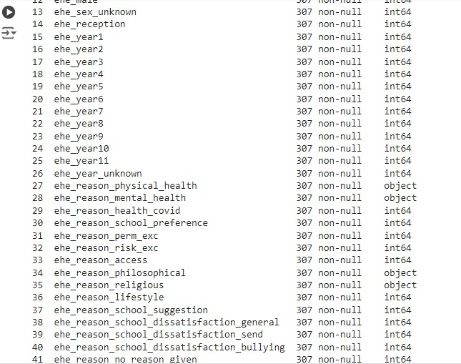

Now comes the data cleaning part, removing unnecessary columns, null values and duplicate data.

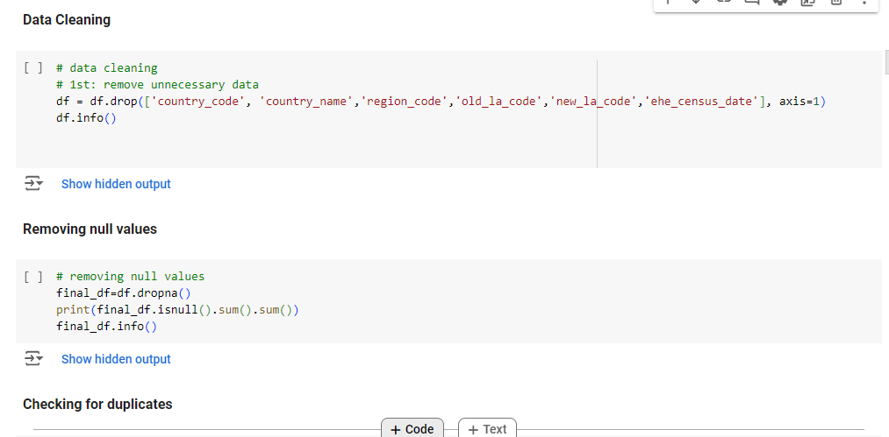

Distribution of male and female students in each term

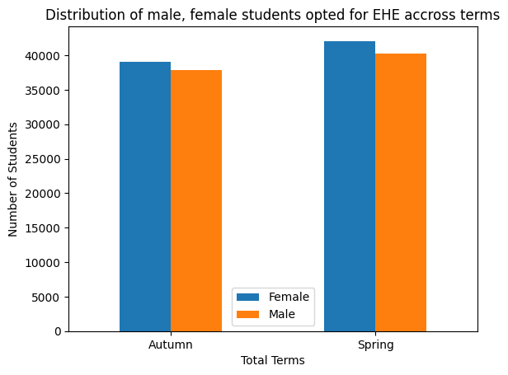

This shows that number of females are higher in both terms. Now we will analyze the number of males and females homeschooled students across regions.

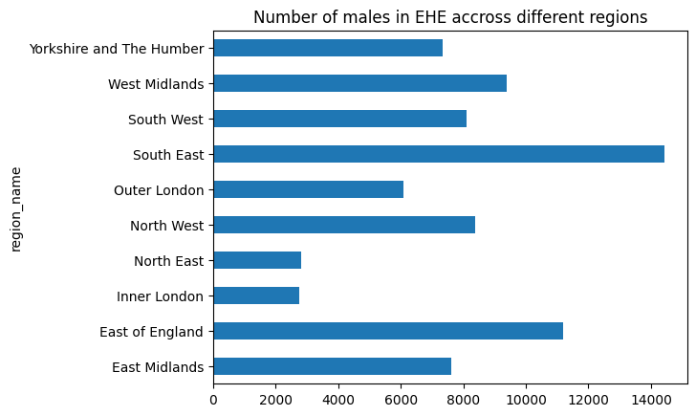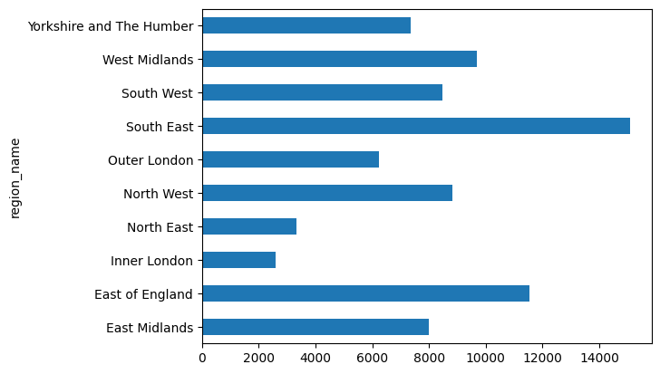

The growth of EHE over the classes from reception till Year 11

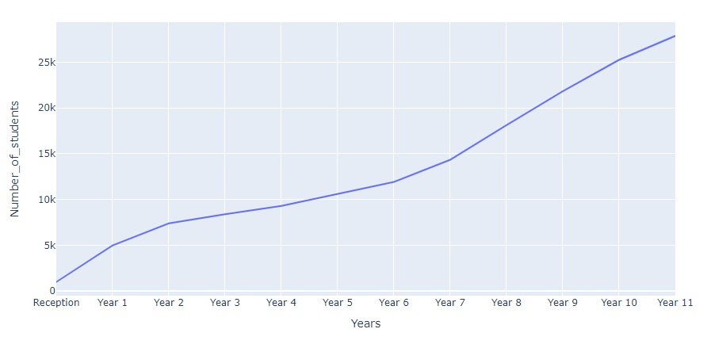

This shows that as the year is progressed, the ratio for opting EHE is increasing.

We will see the overall reasons for EHE. We can deduce that Dissatisfaction for SEND students, Philosophical Reasons, Mental Health, Lifestyle and School Dissatisfaction are key factors for leaving the school and go for homeschooling.

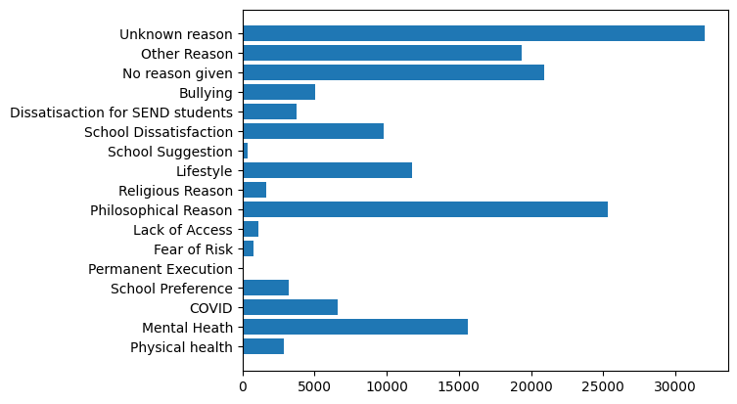

Now analyze the different reasons for electing EHE in different regions.

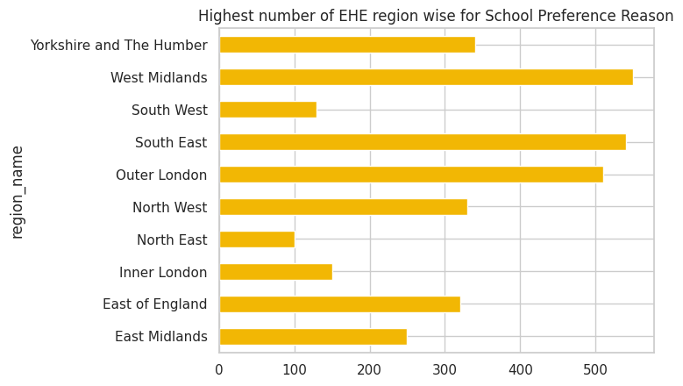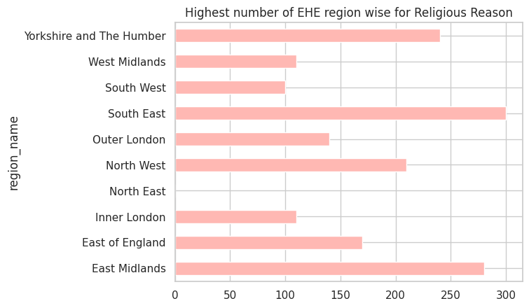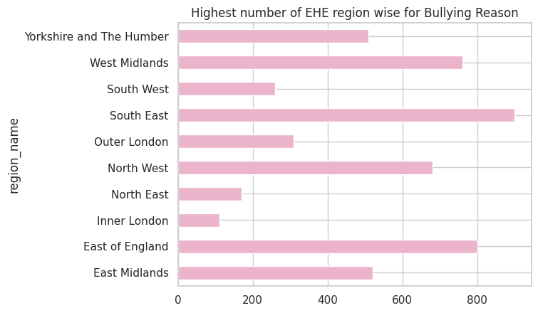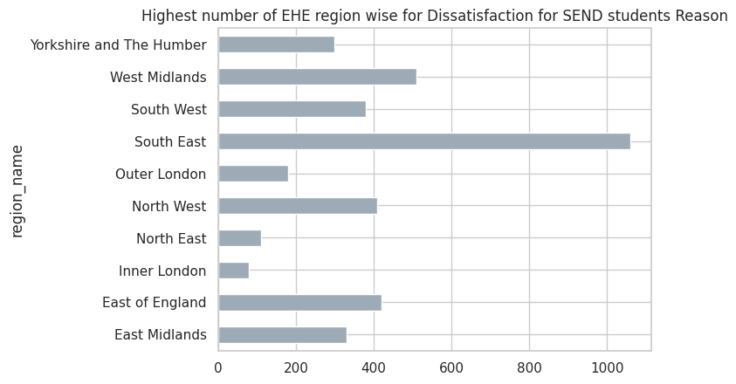

**Conclusion**

This project provides valuable insights into the growing trend of homeschooling across England, highlighting the key factors influencing parents' decisions. The analysis reveals significant regional differences and underscores the importance of understanding the underlying reasons for EHE to make informed choices about children's education.