Mike Shanahan

4/20/18

PK Sentiment Analysis

The tweets used in this assignment were pulled from my friend’s twitter, @katbessey. Please excuse her language.

These are the outputs from the R code with a bit of analysis

This is the one-gram word cloud.

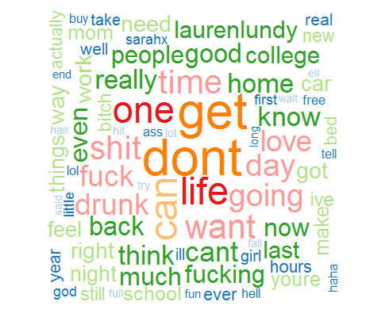

This is the 2-gram word cloud.

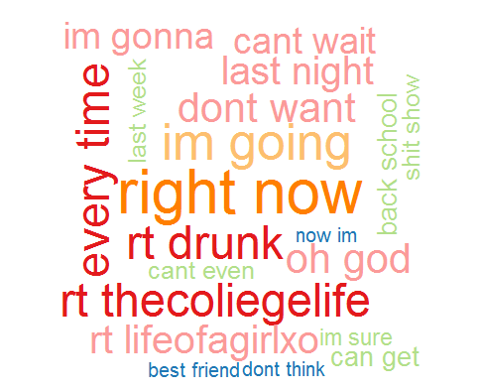

This is the trigram wordcloud.

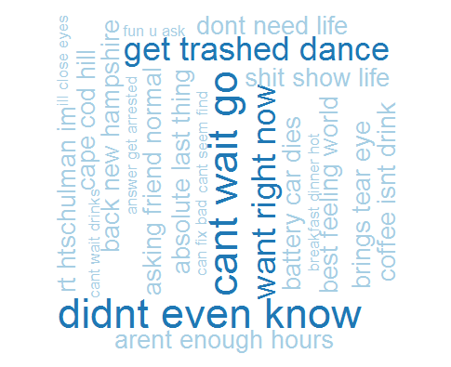

Here is the tf-idf wordcloud. This creates a word cloud but uses different weighting to achieve the value of each word rather than simply counting from the tdm vectors.

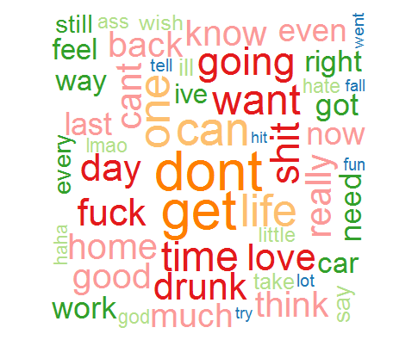

Here is her sentiment over time. This sentiment was found using the afinn lexicon. Please note that the most recent tweet is on the leftwards x-axis.

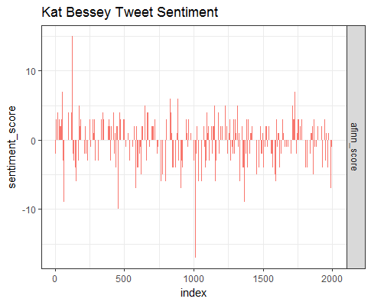

This is a comparison cloud that shows her most often used words in a positive verse a negative tweet.

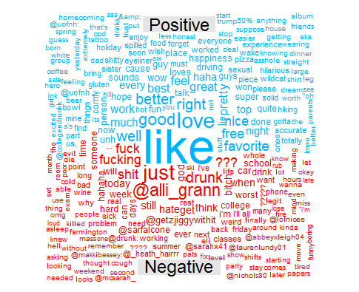

And finally, this is her emotional radial chart. It seems that overall her tweets are mostly centered around trust, anticipation, joy, and anger.

