Faculty Modification
As per your request we have added functions for the students to get list of faculty suggestion based on performance or they can choose manually by seeing ratings and feedback. In below screen modification output
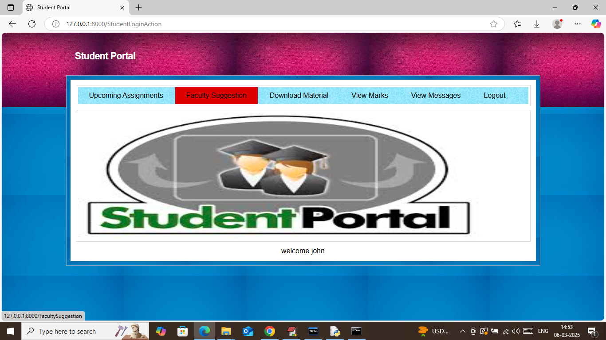
In above screen click on ‘Faculty Suggestion’ link to get below suggestion
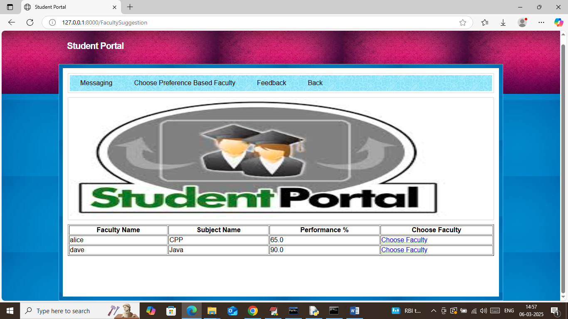
In above screen you can see faculty performance in terms of percentage and can click on ‘Choose Faculty’ link to select that faculty and then will get below page
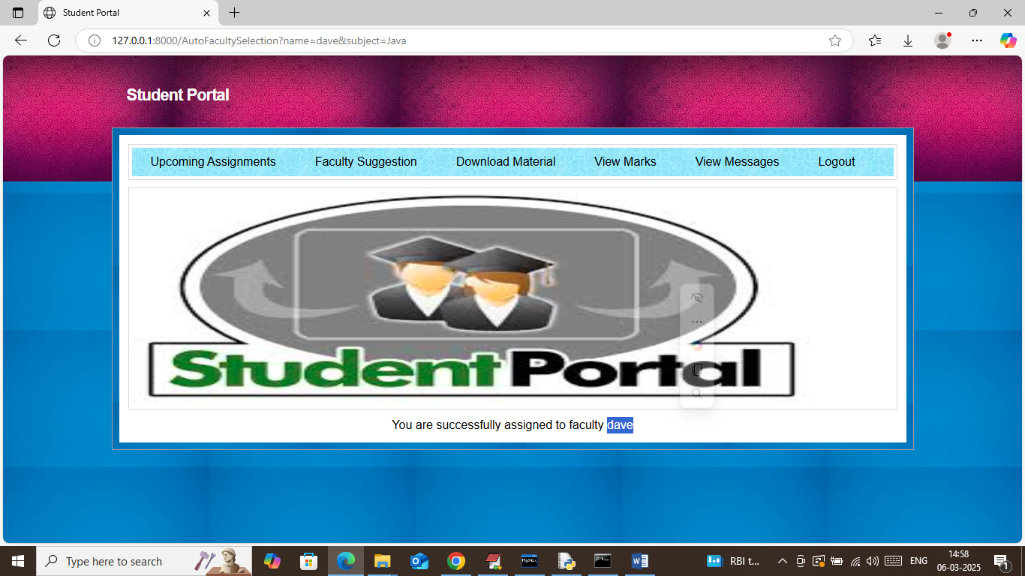
In above screen student successfully assigned to selected faculty ‘Dave’ and only 60 students are allowed per faculty and now click on ‘Faculty Suggestion’ and then click on ‘Choose Preference Based Faculty’ faculty to view list of faculties with ratings and feedback for manual selection
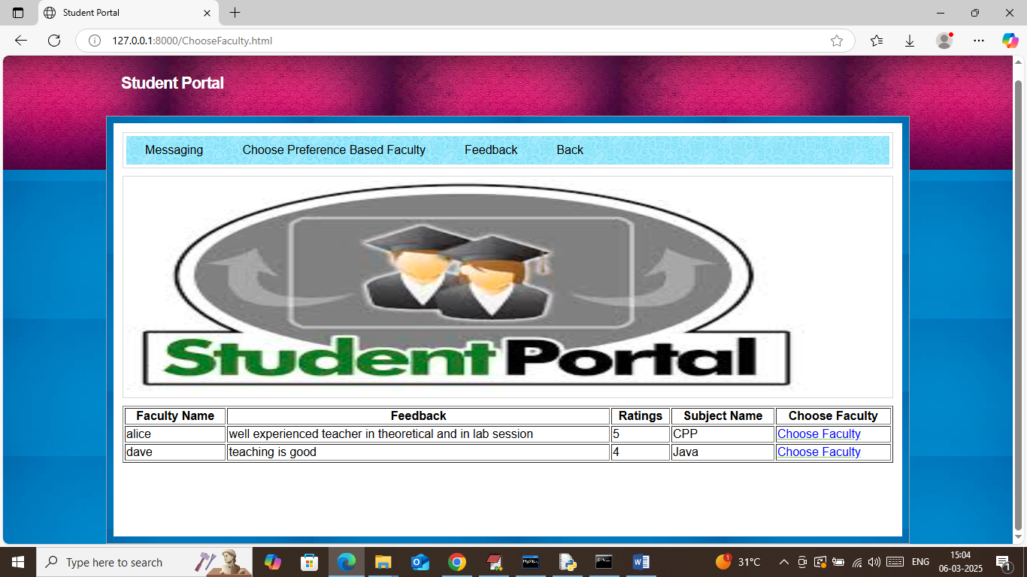
In above screen student can view list of faculties based on Reviews and ratings and can click on ‘Choose Faculty’ link to select that faculty and then will get below page
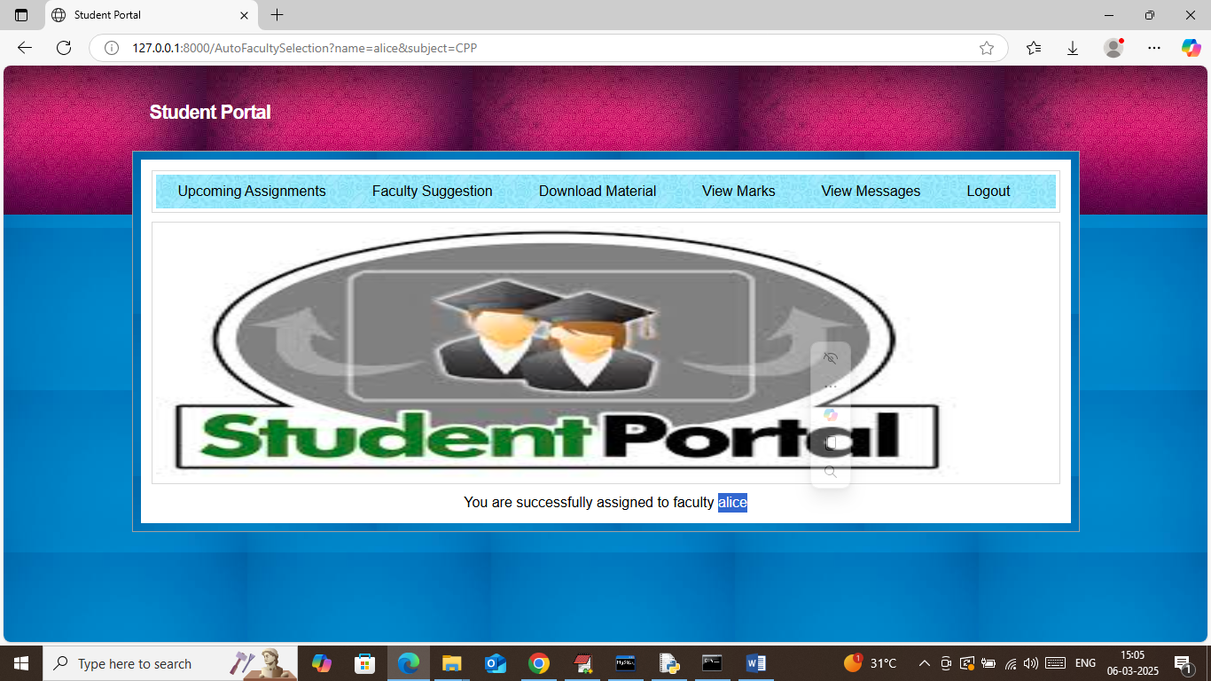
In above screen student successfully assigned to selected faculty and now click on ‘Faculty Suggestion Feedback’ link to give feedback to faculty.
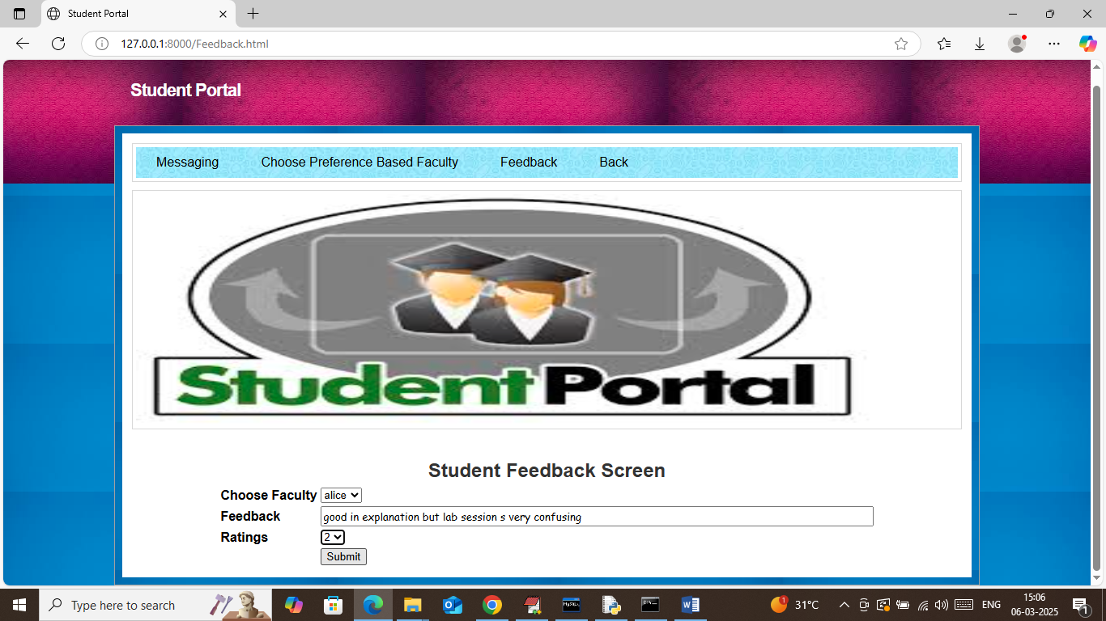
In above screen student can give feedback to selected faculty and then press button to get below page
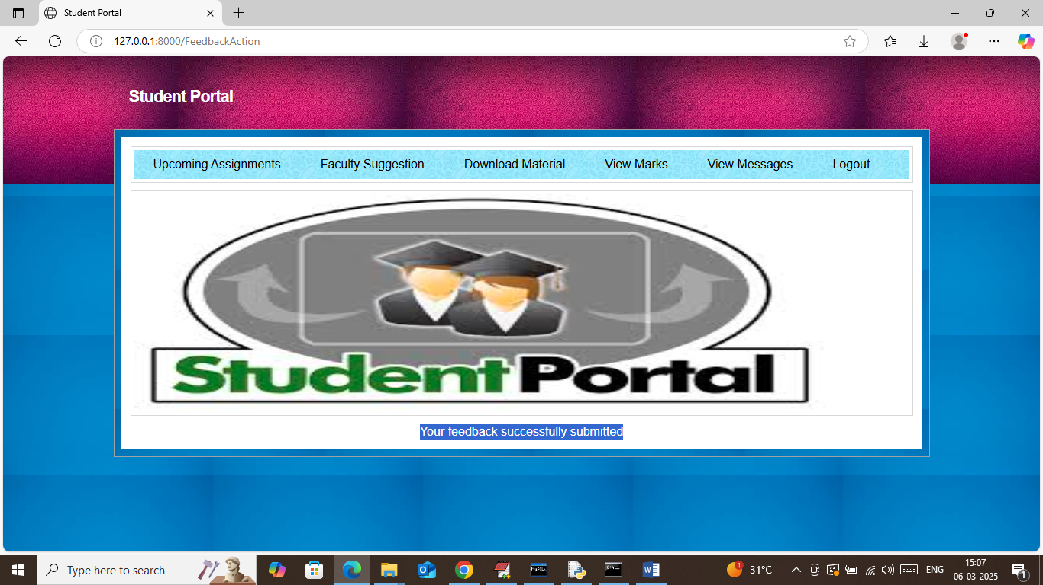
In above screen student feedback successfully submitted.
So in above screens we have completed given changes

