Hamad Music
Background Information
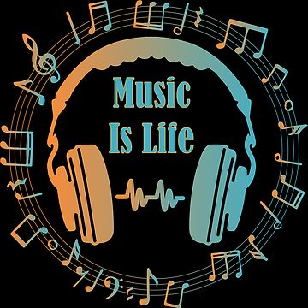
Music plays a significant role in our daily lives. Majority of the people worldwide listen to at-least one type of music. Music serves a wide range of purposes including; entertainment, education, incitement, and worship among other purposes. Music is available in many different genres with each genre being unique in its message, instrumentals, message and occasions when the music is played. Some music is constrained to a specific group of people who share a common religion, culture or nationality. However, other genres of music cut across all cultures, religions and nationalities.
Introduction
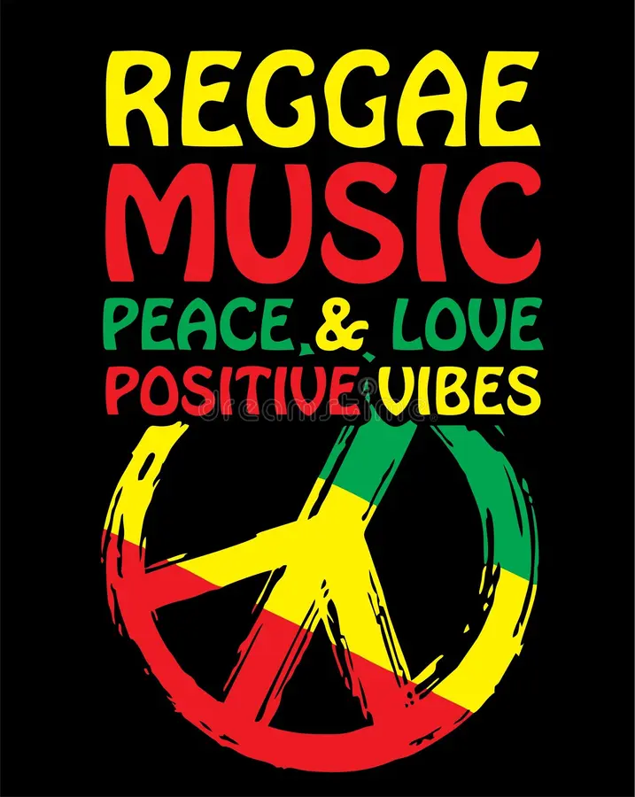
Reggae is a popular genre of music that was first sung in Jamaica in the late 1960s after which it became the dominant music in the country. In 1970s, Reggae music became an international genre popular in the United States, Britain, and Africa. Most listeners at the time viewed Reggae music as the voice of the oppressed. Reggae music is symbolized by the colors; green, yellow and red. Reggae music is a wide genre that serves different purposes such as worship, entertainment, education, teaching about peace and giving hope to the hopeless.
Why Reggae Music
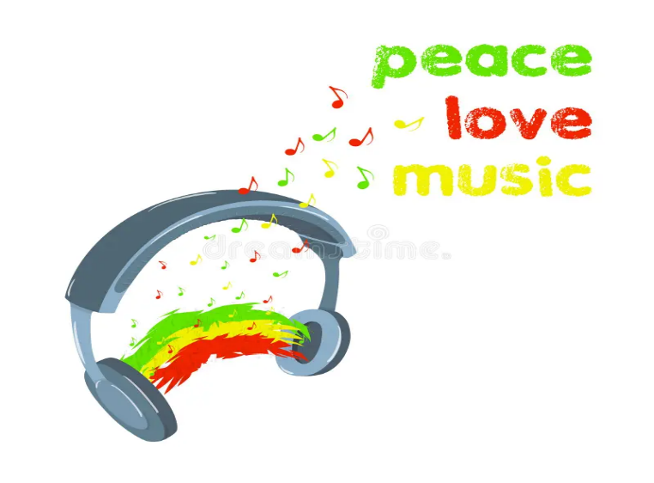
Reggae music has been my favorite genre of music for many years. I always find myself with my headphones on listening to reggae music when I feel low in spirit and it really helps me feel encouraged and motivated to keep pursing my dreams. I am a believer of people living in peace, loving each other and united. No other gerne of music can teach about peace, love and harmony more than Reggae music does. Reggae music offers outstanding teachings about life and about how people should live in a society where we differ in so many ways.
Hamad Playlist
The Hamad playlist highlight just a few of my favorite few Reggae songs from my long list. The playlist includes songs that pass message about peace, encouragement message about not giving up and message about good governance.
- One Love by Bob Marley https://www.youtube.com/watch?v=vdB-8eLEW8g
- Peace Love and Harmony by Joseph Hill https://www.youtube.com/watch?v=oE0_kTf4AqQ
- Never Give Up by Jah Sun https://www.youtube.com/watch?v=GYpLM90NnsE
- Ain’t No Giving In by Chronixx https://www.youtube.com/watch?v=PD-B1uR6IBY
- Serve and Protect by Queen Ifrica https://www.youtube.com/watch?v=R_3vZA3g4G8
- Justice by Nasio Fontaine https://www.youtube.com/watch?v=Dikg_wK1_IY
- Make it if You Try by Everton Blender https://www.youtube.com/watch?v=cae6bVggEY4

Embedded Videos
Personal Reflection

