|  |
| --- |
| Fall-2022 |

**Laboratory Reports**

**Submitted By**

|  |  |
| --- | --- |
| **Name** | **Registration No** |
| **Abdul ur Rahman** | **BS-21-KB-100872** |
| **Asad** | **BS-21-JB-101623** |
| **Umer Afzal** | **BS-21-IB-103167** |

|  |  |
| --- | --- |
| **Semester date: 12 Sep, 2022 to 6 Jan, 2023** | |
| **Section Electronic** | **Group-B** |
| **Batch:**  **BSEE 2021-25** | **Teacher:**  Sir Shahid Nazir |
| **Semester**  3rd | **Lab Engineer:** |

**INTRODUCTION**A stepper motor is an electromechanical device it converts electrical power into mechanical power. Also, it is a brushless, synchronous electric motor that can divide a full rotation into an expansive number of steps. The motor’s position can be controlled accurately without any feedback mechanism, as long as the motor is carefully sized to the application. Stepper motors are similar to switched reluctance motors. The stepper motor uses the theory of operation for magnets to make the motor shaft turn a precise distance when a pulse of electricity is provided. The stator has eight poles, and the rotor has six poles. The rotor will require 24 pulses of electricity to move the 24 steps to make one complete revolution. Another way to say this is that the rotor will move precisely 15° for each pulse of electricity that the motor receives.

The construction of a stepper motor is fairly related to a[DC motor](https://www.elprocus.com/dc-motor-basics-types-application/). It includes a permanent magnet like Rotor which is in the middle & it will turn once force acts on it. This rotor is enclosed through a no. of the stator which is wound through a magnetic coil all over it. The stator is arranged near to rotor so that magnetic fields within the stators can control the movement of the rotor. The stepper motor can be controlled by energizing every stator one by one. So the stator will magnetize & works like an electromagnetic pole which uses repulsive energy on the rotor to move forward. The stator’s alternative magnetizing as well as demagnetizing will shift the rotor gradually &allows it to turn through great control.

A stepper motor can be driven in different techniques. Each technique requires a special circuit because of their complex designing. Some of the methods in which the steeper motor can be operated are:

1. Full step drive (full stepper motor)
2. Half Step drive (Half stepper motor)
3. Single excitation mode
4. Micro stepping mode

The method in which we will operate our motor will be full stepper motor.

# **Objectives\Specifications:**

* The frequency of the motor can be controlled using a potential meter.
* The motor can be operated in both clockwise and anti-clock wise direction.
* The motor designed is a full stepper motor. In this technique, two stators are activated at a time instead of one in a very less time period. This technique results in high torque & allows the motor to drive the high load.

# **Approach and Methodology:**

As previously stated, the stepper motor requires a specific sequence of inputs at its four input pins to complete its revolution with precision; therefore, if we can generate that sequence with a single clock using a basic sequential circuit, our controller will be ready to go; however, a driver will be required to provide specific current to drive the motor after generating a kind of truth table for given 8 steps of stepper motor four different functions are obtained providing input.

After the theoretical analysis the next task was to implement the circuit on a simulation tool to check whether the circuit was working or not. To simulate the circuit, we used the Proteus 8 software because it had all of the necessary component that were necessary to implement the circuit and also it was easy to use. The end results of the simulation and the picture of the circuit are attached below. Each will be explained below.

After all the work we performed that the next and the last task was the real-time implementation of the circuit on the breadboard. The real-time needed only one more component attached at the output that was not present in the simulation and it was the L298N controller which we attached at the output to control the current and a provide a sufficient amount of current to the motor on which it can operate. To check whether our circuit was or not before attaching the motor we checked our result on the oscilloscope.

# **Block Diagram:**

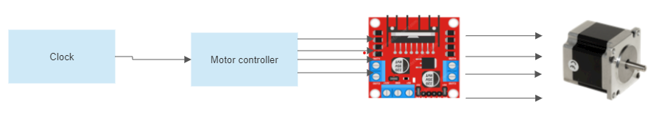

# **Components Used:**

* 4 Input NAND gate/1 7408 IC.
* 2 Input NOT Gate/1 7404 IC.
* LM 555 Time IC.
* 2 JK flip flops/ 1 7478 IC.
* 100k ohms Potential Meter.
* Motor Driver L298N.
* Bipolar Stepper motor.

# **Design and Simulation**

**LM 555 Timer IC:**We used this IC to design a circuit in such a way that it will act as a clock for the stepper motor.

Charging Time = R*C*ln(2)  
Where, R equals the sum of R1 and RV1 ( Potentiometer )

Discharging Time = R*C*ln(2)  
Where, R equals RV1

Total Time ( Time Period ) = Charging Time + Discharging Time

Frequency = 1 / [ Cln2( R1 + 2RV1 )]

Therefore, by changing the value of R2 we can change the frequency of the motor. When the R2 is high the frequency is reduced and when the R2 is low, the frequency gets increased.

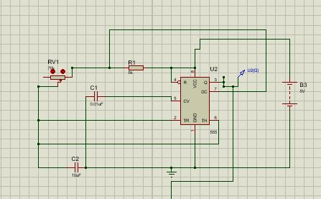

Fig 1 Usage of LM 555 Timer as clock.

**JK Flip Flops:**

The output of the 555 Timer IC was used as the clock of B Flip Flop. We used the output Q’ of the B Flip Flop as the input J and as inverted for input K. The output Q was used as the clock for the A Flip Flop. When clock trigger from 0-1 the output also triggered, depending on its initial state, when initial state is 0 then it will switch to 1, if initial state is 1 then it will switch to 0. Basically the reason we used flip flop is to get perfect 50% duty cycle clock pulse, 555 timer doesn’t generate 50% and also with 555 we can change frequency by changing resistance so, we won’t be having perfect duty cycle clock wave, the drawback of using this configuration is: the output wave will be doubled, the circuit will slowe down and in order to overcome this problem we designed clock pulse of 0.5 Hz to achieve 1 Hz frequency. Firstly we will be getting B clock, this clock will then be divided into two parts, and one will be inserted in inverter while the other one will be inserted into the JK Flip Flop to generate A and other will be inserted in 7404 IC to invert. JK Flip Flop will then generate the clock exactly like we had discussed earlier.

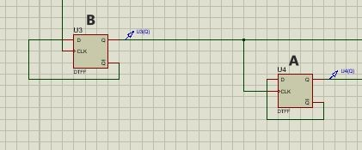

Fig 2 Usage of 7476 IC to generate input A and B.

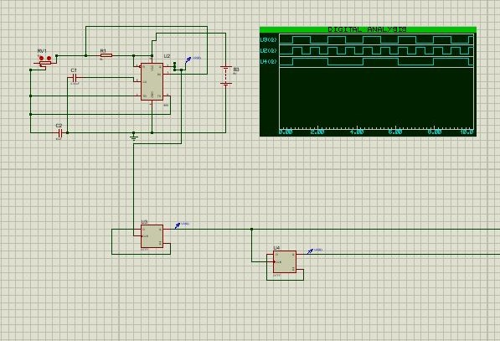

Fig 3 Combined photograph of 555 timer and 7476 IC usage.

**Gates:**We used7408IC(4 AND gates) and 7404 IC (2 NOT gates) to get 4 different combinations of the outputs from A and B Flip Flops to feed to the driver that will turn on the motor. We could have also used a 2 × 4 decoder IC instead of these gates but went with the gates.

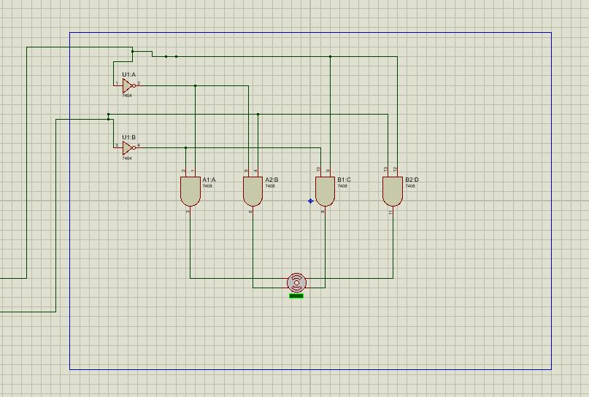

Fig 2 Usage of 7404 IC and 7408 to generate 4 combinations of A and B.

**Conclusion:**

A full step drive applies the maximum rated torque to the motor. The timing sequence in a full step drive also promotes smoother rotation because the next phase is introduced gradually rather than abruptly during rotation. And Stepper Motors offer excellent low speed torque, which means, the motor will drive many loads without having to utilize any additional gearing or gearbox mechanisms. This is one of the best features of the stepper motor. The stepper motor has the ability to return to its original position after completing a full detour. This feature of this type of motors makes them more accurate and most useful motors in applications where precise speed is the priority. If we examine the construction of the stepper motor, we will see that there is no friction in the moving parts except this bearing, so this is the reason the stepper motor survives for a long time. The stepper motor takes a much larger ampere than other types of motor, this makes the stepper motor less efficient and the vibration in the motor is also caused by the same issue. As the motor speed increases, the torque of the stepper motor starts to decrease. No feedback used in stepper motor indicates to miss steps. So if the steps are missed we would never know.