1.Chiziqli algaritmlar
1.masala
#include<iostream>
#include<cmath>

using namespace std;

int main(){
int a,b,c;

cout<<"a= "; cin>>a;
cout<<"b= "; cin>>b;
cout<<"c= "; cin>>c;

float X,W,Y,Z;

X=(2*a+b*pow(c,3));

W=(2*pow(a,2)+32*b)/(c*2+12*a) -(3*X);

Y=(2*X+b*Y);

Z= (pow(a,2)+b*pow(Y,2));

cout<<"X= "<<X<<endl;
cout<<"W= "<<W<<endl;
cout<<"Y= "<<Y<<endl;
cout<<"Z= "<<Z<<endl;
}

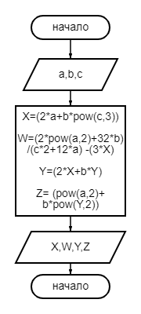
#include<iostream>
#include<cmath>

2.masala
using namespace std;

int main(){
int a,b,c,d;
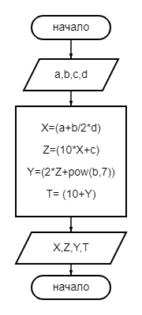
cout<<"a= "; cin>>a;
cout<<"b= "; cin>>b;
cout<<"c= "; cin>>c;
cout<<"d= "; cin>>d;

float X,Z,Y,T;

X=(a+b/2*d);

Z=(10*X+c);

Y=(2*Z+pow(b,7));

T= (10+Y);

cout<<"X= "<<X<<endl;
cout<<"Z= "<<Z<<endl;
cout<<"Y= "<<Y<<endl;
cout<<"T= "<<T<<endl;
}

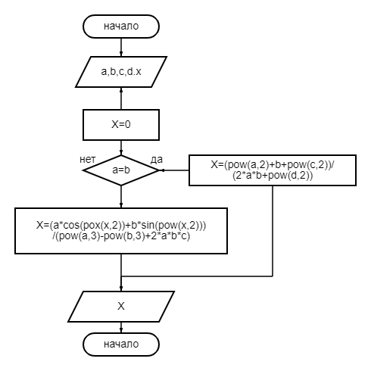
If else

1masala

#include<iostream>
#include<cmath>

using namespace std;

int main(){
int a,b,c,d,x;

cout<<"a= "; cin>>a;
cout<<"b= "; cin>>b;
cout<<"c= "; cin>>c;
cout<<"d= "; cin>>d;
cout<<"x= "; cin>>x;

float X=0;

if(a!=b){
X=(a*cos(pow(x,2))+b*sin(pow(x,2)))/(pow(a,3)-pow(b,3)+2*a*b*c);
cout<<"a!=b"<<endl;
}

else {
X=(pow(a,2)+b+pow(c,2))/(2*a*b+pow(d,2));
cout<<"a=b"<<endl;
}

cout<<"X= "<<X<<endl;

}

2malasa
#include<iostream>
#include<cmath>

using namespace std;

int main(){
int a,b,c,x;

cout<<"a= "; cin>>a;
cout<<"b= "; cin>>b;
cout<<"c= "; cin>>c;
cout<<"x= "; cin>>x;

float Y=0;

if(a>b){
Y=(a*b*x+pow(c,2))/(pow(a,2)-pow(b,2));
cout<<"a>b"<<endl;
}

else {
Y=(log(pow(x,2))-log(a*x))/(2*a*b+pow(c,2));
cout<<"a<=b"<<endl;
}

cout<<"Y= "<<Y<<endl;

}
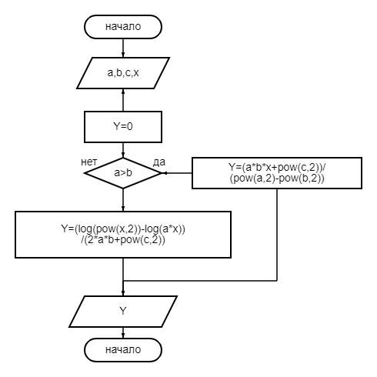

For
1masala
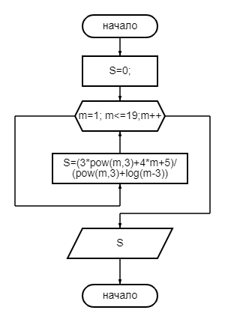

#include<iostream>
#include<cmath>

using namespace std;

int main(){

float S=0;

for(int m=1; m<=19; m++){
cout<<"m = "<<m<<endl;
S=(3*pow(m,3)+4*m+5)/(pow(m,3)+log(m-3));
}

cout<<"S= "<<S<<endl;

}

2masala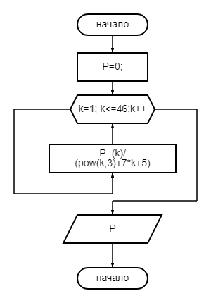

#include<iostream>
#include<cmath>

using namespace std;

int main(){

float P=0;

for(int k=1; k<=46; k++){
cout<<"k = "<<k<<endl;
P=(k)/(pow(k,3)+7*k+5);
}

cout<<"P= "<<P<<endl;

}

Do while
1.misol
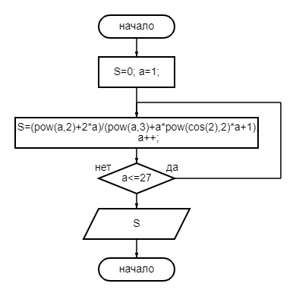

#include<iostream>
#include<cmath>

using namespace std;

int main(){

float S=0;

int a =1;

do{
cout<<"a= "<<a<<endl;
S=(pow(a,2)+2*a)/(pow(a,3)+a*pow(cos(2),2)*a+1);
a++;
}while(a<=27);

cout<<"S= "<<S<<endl;}

2masala

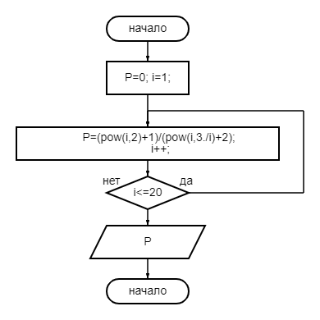

#include<iostream>
#include<cmath>

using namespace std;

int main(){

float P=0;

int i =1;

do{
cout<<"i= "<<i<<endl;
P=(pow(i,2)+1)/(pow(i,3./i)+2);
i++;
}while(i<=20);

cout<<"P= "<<P<<endl;

}

While
1.misol
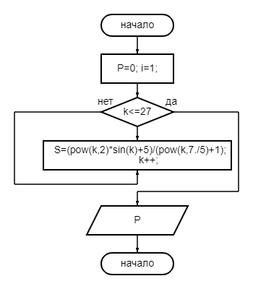

#include<iostream>
#include<cmath>

using namespace std;

int main(){

float S=0;

int k =1;

while(k<=27){
cout<<"k = "<<k<<endl;
S=(pow(k,2)*sin(k)+5)/(pow(k,7./5)+1);
k++;
}

cout<<"S= "<<S<<endl;}

2.misol
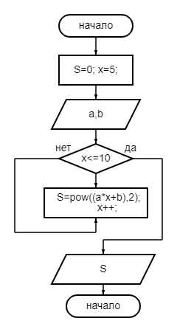

#include<iostream>
#include<cmath>

using namespace std;

int main(){
int a,b;
cout<<"a= "; cin>>a;
cout<<"b= "; cin>>b;

float S=0;

int x =5;

while(x<=10){
cout<<"x = "<<x<<endl;
S=pow((a*x+b),2);
x++;
}

cout<<"S= "<<S<<endl;

}

Massivlar
1.misol
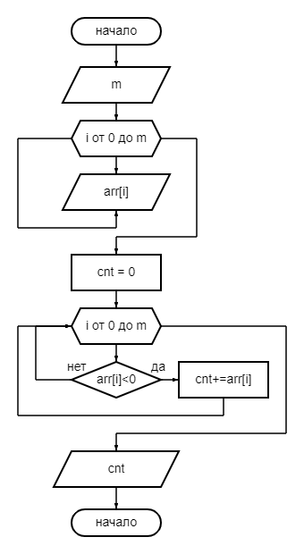

#include <iostream>
#include<ctime>

using namespace std;

int main() {
int m;
cout<<"m = "; cin>>m;

int arr[m] = {3, -5, 7, -2, 8};

int cnt = 0;

for (int i = 0; i < m; ++i) {
if (arr[i] < 0) {
cnt += arr[i];
}
}
cout << "cnt " << cnt <<endl;

return 0;
}

2.misol

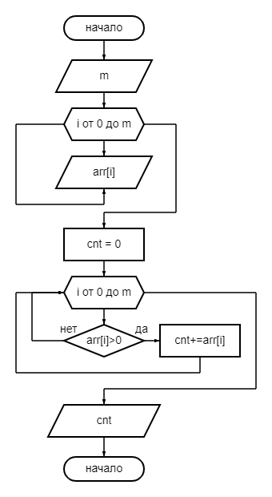

#include <iostream>
#include<ctime>

using namespace std;

int main() {
int m;
cout<<"m = "; cin>>m;

int arr[m] = {3, -5, 7, -2, 8};

int cnt = 0;

for (int i = 0; i < m; ++i) {
if (arr[i] > 0) {
cnt += arr[i];
}
}
cout << "cnt " << cnt <<endl;

return 0;
}

Char
- Misol
#include <iostream>
#include <string>

using namespace std;

int main() {
cout << "Matnni kiriting: ";
string matn;
getline(cin, matn);

int a = 0;
int y = 0;

for (char harf : matn) {
if (harf == 'A' || harf == 'a'&& harf == 'Y' || harf == 'y') {
a++;
y++;
}
}

cout << "A harfi: " << a << endl;
cout << "Y harfi: " << y << endl;

return 0;
}

- Misol

#include <iostream>
#include <string>

using namespace std;

int main() {
cout << "Matnni kiriting: ";
string matn;
getline(cin, matn);

size_t f = matn.find('$');
while (f != string::npos) {
matn.erase(f, 1);
f = matn.find('$');
}

std::cout << "matn: " << matn << std::endl;

return 0;
}

