

**American International University- Bangladesh**

**Faculty of Science and Technology**

**Department of Computer Science**

**SOFTWARE ENGINEERING**

**Spring 20-21**

**Section: G**

***Group: 9***

|  |  |
| --- | --- |
| **NAME** | **ID** |
| ABU SUFIAN | 18-38659-3 |
| M. A. SHALAH | 19-40489-1 |
| MD. MASAYEAKH ISLAM | 19-40506-1 |
| MD. ABU TORAB IBNUL BAKI | 18-38814-3 |

**Course Teacher: FARZANA BENTE ALAM (**farzana.alam@aiub.edu)

**Project Proposal**

**Section: G**  
**Group No:9**

**THANA MANAGEMENT SYSTEM**

Our project name is Thana Management System and we are providing these kind of system in Bangladesh for the first time. This project is all about solving problems in technical way happing in police station.

When a victim uses our system he/she can give some information about that criminal and after that we will track that criminal and try to find out that criminal.

But before doing these process, we need some basic information like (name, national ID card, address (City, Country), contact number) of the victim/Complainant. Then the complainant will be sent in THANA. As in Bangladesh, there are lots of thanas/police station and each police station will have some unique identity(ID). That complainer will send his/her complainant to his/her nearest Thana and this Thana also have some basic information like (Thana _ID card, Thana _name address (City, Country), complain type).

After that, Thana assign an Inspector officer who will be handling these particular case. He also has some basic information like (ID card, name, his post, his joining date). After receiving this case that officer will start his investigation. In Thana there can be so many cases and that why every cases have some (id, crime name, opening date and closing date). After doing lots of processing if that officer does not get any proof against that person he would be considered as innocent and he will be released otherwise that person will be arrested and considered as a criminal , that inspector office assigns some unique information (id, address (city, country), crime name) so that, that criminal can be found very easily.

This project is for the people of our country and any kind of people of our country can get easily access from this system. In day to day life, we all having many problems like as (stealing, losing something, when you see some illegal things happening, someone might be harming you or someone does something to you)-one can easily and without any kind of fear write it down in the system and easily get immediate help from the police or thana. Actually by this system police also get benefited cause by this system they can easily track down anyone, there duties will be easier, those who committed any kind of crimes it will be in there files and anyone can see his or her crimes. By this system we mainly trying to reduce crime in our country. We make our country more digitalized and make our thanas more efficient and more effective.

The solution of this problems is to use a FIR (First Information Report) Management System. Through using this management system police officers can keep the detail of most wanted criminals, victims who have been arrested, to be arrested, or escaped. The main entities in the whole process include the petitioner (the person who files a First Incident Report (FIR)), victim, accused or criminal, case, and investigating officer. For maintaining privacy of any citizen of a country on police officers can login to this FIR Management System. This FMS keeps records of the petitioner, victim, accused, FIR, case and investigation officer entities. The system can take multiple data of its attributes ( PUser, Password, Criminal, Address, NID, Biometric Information, Mobile Number, Complain Types, Complaint Infos, BOD and so on ). National Identification and Biometric Information are the main tools of this management system. This will help the police department in enhanced management of information.

Many people in our country rent a house. But the owner has to stay in the fog because there is no accurate information about the tenant. As a result, if any citizen of the country goes to any police station and shows proper reason, the police officer will be able to give him information about the tenants. In addition, there are many companies in the country (such as mobile operators, Internet Service Provider, Bank, Educational Institutions and so on) that provide customer service or hire as an employee, authority can go to the nearest police station as soon as possible to check if they have any criminal record or not. FIR Management System assists in the criminal justice process. The cops can commence the investigation only after registration of the FIR. This database can be designed for Case File Management System also. There is no proper distinction between an accused and the criminal in the system, there is no generation of crime analysis and report. The proposed system can be used in police stations over a city where notifications are sent to the police when the criminal is released from the jail.

Yes, this FIR Management Since it is a record of all criminals. So it will play an important role in solving any case which are mentioned above.

':.....FUNCTIONALAITIES OF OUR SYSTEM......:'

REGISTRATION MODULE:

The policeman have to register using the sign up option.

The registration from consists of police details such as police id,name,

designation, date of birth, National ID card number and to which police station they belong.

Once they sign up they are authorized to use the application.

LOGIN MODULE:

Validate user login details and ensure user-level privileges to information.

FIR MODULE:

1) VICTIM INFORMATION :

This module contains the information of the victim such as

victim's name, address, telephone number, father's name, mother's name, FIR number and nationality.

2)CRIME INFORMATION :

This module contains the details about the crime.

It contains the date and time,police station where it is recorded,

name of the police who records the complaint,nature of crime,

location of crime and the name of suspects.

PERFROM SEARCH FUNCTIONS BASED ON SOME SPECIFIED CRITERIA'S :

This system conatins the details of the criminal,

it contains criminal number,

crimianal name , age , occupation,crime type, date of entering the jail and address.

LOCATIONWISE CRIME RATING :

It will only used by police stations.If anybody needs any kind of information about

any places where they wanna visit or wanna stay over,they can easily know and decide

where they should go or not.

CRIMINAL MODULE:

This module contains the details of the criminal.

It contains criminal number, criminal name,

age, occupation, crime type, date of entering jail, release date, address.

CALENDAR :

In this system there will be a function called calender

where police officer can give the date of next meeting with the victim .

in calander function victim can see the date

when he/she will have to meet with the police officers.

CLASS DIAGRAM: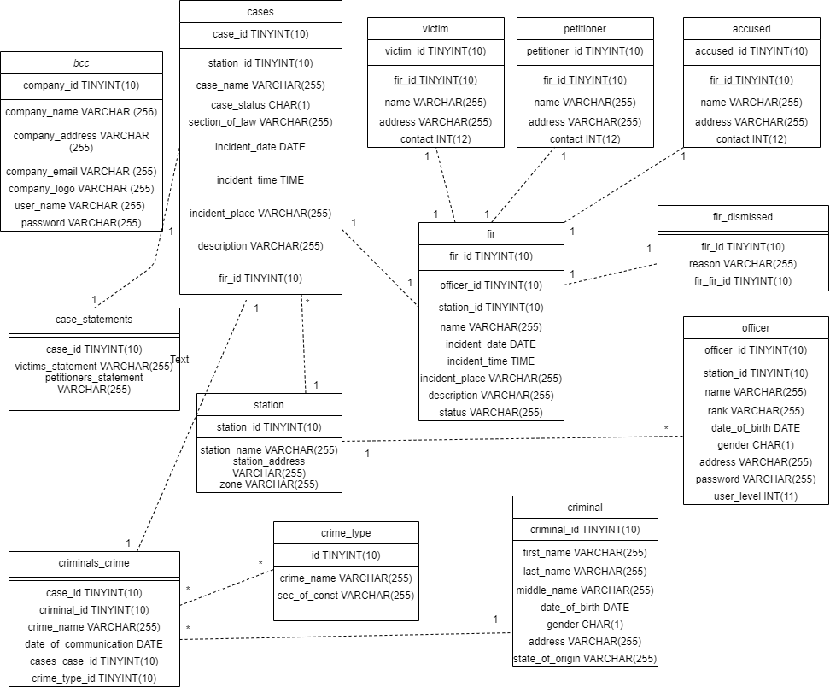

USE CASE:

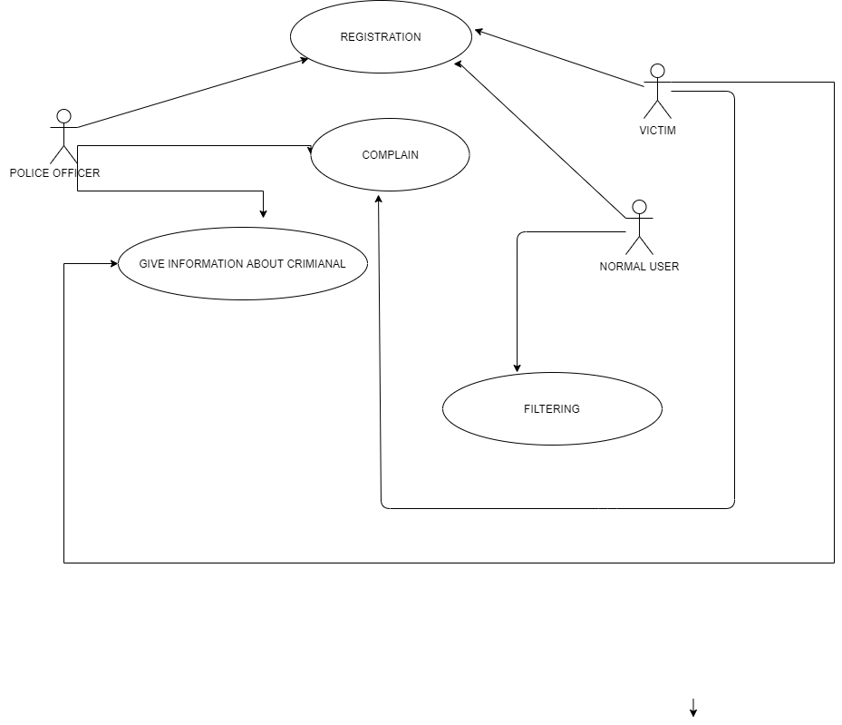

**ACTIVITY DIAGRAM:**

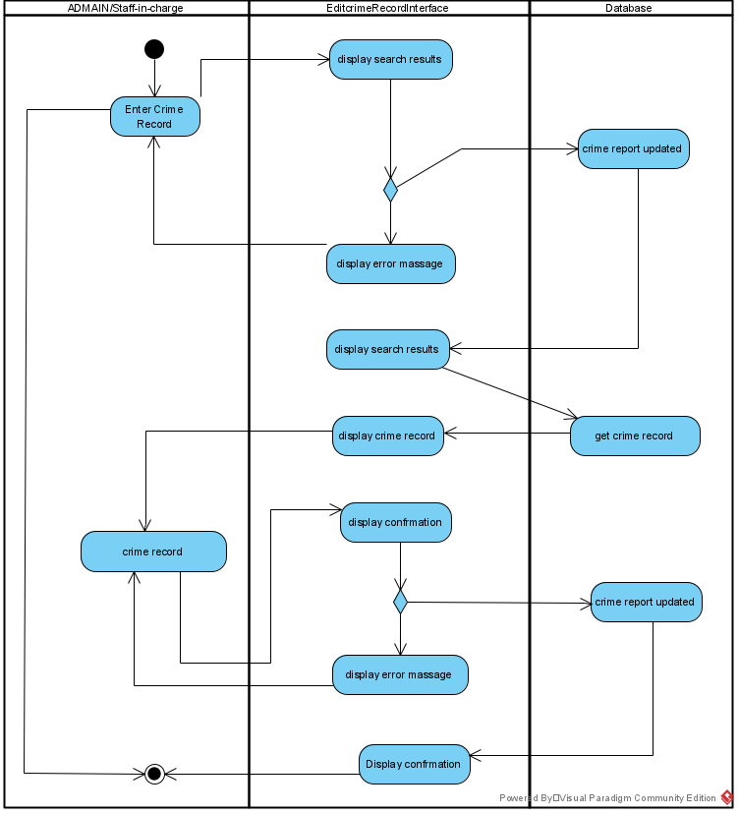

**State Diagram:**

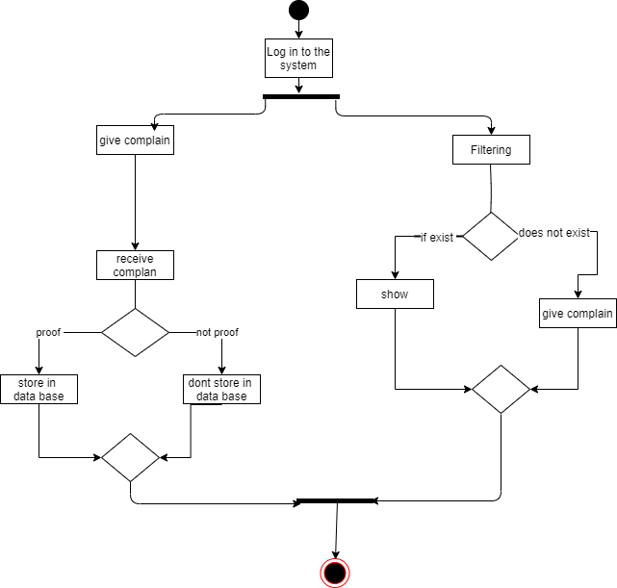

***We are selecting V-model for our project.***

***1***

When to use the V-model:

The formation model ought to be used for little to medium sized comes wherever necessities square measure clearly outlined and stuck.

The formation model ought to be chosen once ample technical resources square measure offered with required technical experience.

High confidence of client is needed for selecting the formation model approach. Since, no prototypes square measure created, there's a awfully high risk concerned in meeting client expectations.

***2***

**We have selected V-model software development for my process system**.

# ***The reason of selecting V-model is***:

1-> V-model is easy to manage due to the rigidity of the model. Each phase of V-Model has specific deliverables and a review process.

2-> V-model provides testing activities like planning, test designing happens well before coding. This saves a lot of time.

3->V-model provides Proactive defect tracking – that is defects are found at early stage

4->this model focuses on verification and validation activities early in the life cycle thereby enhancing the probability of building an error-free and good quality product.

5->Works well for small projects where requirements are easily understood.

6->this model is not so much expensive. Even small projects can be able to afford this model

**As we are dealing with such a project which will be using for solving our practical problem.That’s why we want to use V-model.**

***Why we are not using other models::***

1->we are not using **Waterfall model.**

This model is just like the one-way street. Once phase X is completed and next phase Y has started then there is no way to going back on the previous phase. No back tracking is possible here.This is one of the issues not to use the waterfall model.

The waterfall model does not support delivery of system in pieces. After a development process starts, changes cannot accommodate easily. This model is very time consuming.

2->We are also not using **Agile model.**

When someone creates small projects, this model will not be useful for them. This is model is mainly useful for big projects. In this model, there is a lack of intensity on necessary designing and documentation. This model requires an expert project member to take crucial decisions in the meeting. Without experience members this model will work properly. Cost of Agile development methodology is slightly more as compared to V-model development methodology.

In this model, the project can quickly go out off track if the project manager is not clear about requirements and what outcome he/she wants.

3-> We are also not using **Spiral model.**

This model is very expensive so not every project can be able to afford this model. This model is much more complex than other SDLC models. Process is complex. Too much dependable on Risk Analysis and requires highly specific expertise.

Difficulty in time management. As the number of phases is unknown at the start of the project, so time estimation is very difficult. May be hard to define objective, verifiable milestones. Large numbers of intermediate stages require excessive documentation.

4->We are also not using **Evolutionary Prototyping.**

This model has poor documentation because of continuously changing customer requirements. Too much variation are available in this model. Customers sometimes demand the actual product to be delivered soon after seeing an early prototype. This model is also very expensive and that’s why not every project can be able to afford this model.

***3***

Roles:

1. Registration: The admin will register here using the signup option. Also in the registration process they need to submit personal information’s.

2. Login: In the login module within a username and password user can log in to the system.

3. Victim and crime information all are includes in the FIR module.

4. In search function we take details of the criminals (Name, age, DOB, Nationality)

5. Mapping for crime rating (only used by police station)

6. Time schedule for meeting dates

7. Perform search function in some specific criteria.

8. Perform crime analysis and statistics as well as to generate adequate reports.

9. Generate criminal’s case report.

10. Only accessed by police station authority.

*Police station authority can manage the system.

* Authority can give control to others.

* Authority can give privilege to others.

* Authority can make backlog list visible to others.

* Authority is responsible for the project.

*Authority take the final decisions to make the system perfect.

* Authority is selected by the team who created this system.

*The Thana Management system where we created the necessary actions to organizes the systems of the model, we created the backlog of the system and there we removed suggesting impediments which is alarming for the project. The main goal is to achieve each sprint/role that we have promised.

• Victim will take a part where backlog items are being developed or enhanced. There they can use new features, take the updates and they can give suggestions too.

• Authority management

It can give arguments, standards, can give final statements.

Also participates in requirements and future planning of this project.

**4**

**THANA MANAGMENT FINAL RUBRIC**:

This describes the rubric we’ll use while making this system.

The points given reflect the importance of each element of our report.

In the rubric are not all independent (only authority have the main access towards the system).

**1)Overall System Design:**

• We describe all components of our design/model

• Model meets the functionality requirements.

• Design meets the constraints of the system.

• Design addresses the additional requirement, either by solving it or explaining where our system breaks down.

• System addresses the security thought-experiment.

•Model addresses all of the issues specifically.

**2)Design Justification and Evaluation :**

• Model is being explicit about choices and justifies them throughout the system.

• Includes any additional system which is appropriate for our system.

• Gives context for including different methods and how various design and decisions affect the user experience.

**3)Overall Presentation :**

• System is organized according to the structure (intro, design, analysis).

• Explanations are clear and concise.

• Use of methods are appropriate; every basic thing are clarify the text rather than add confusion.

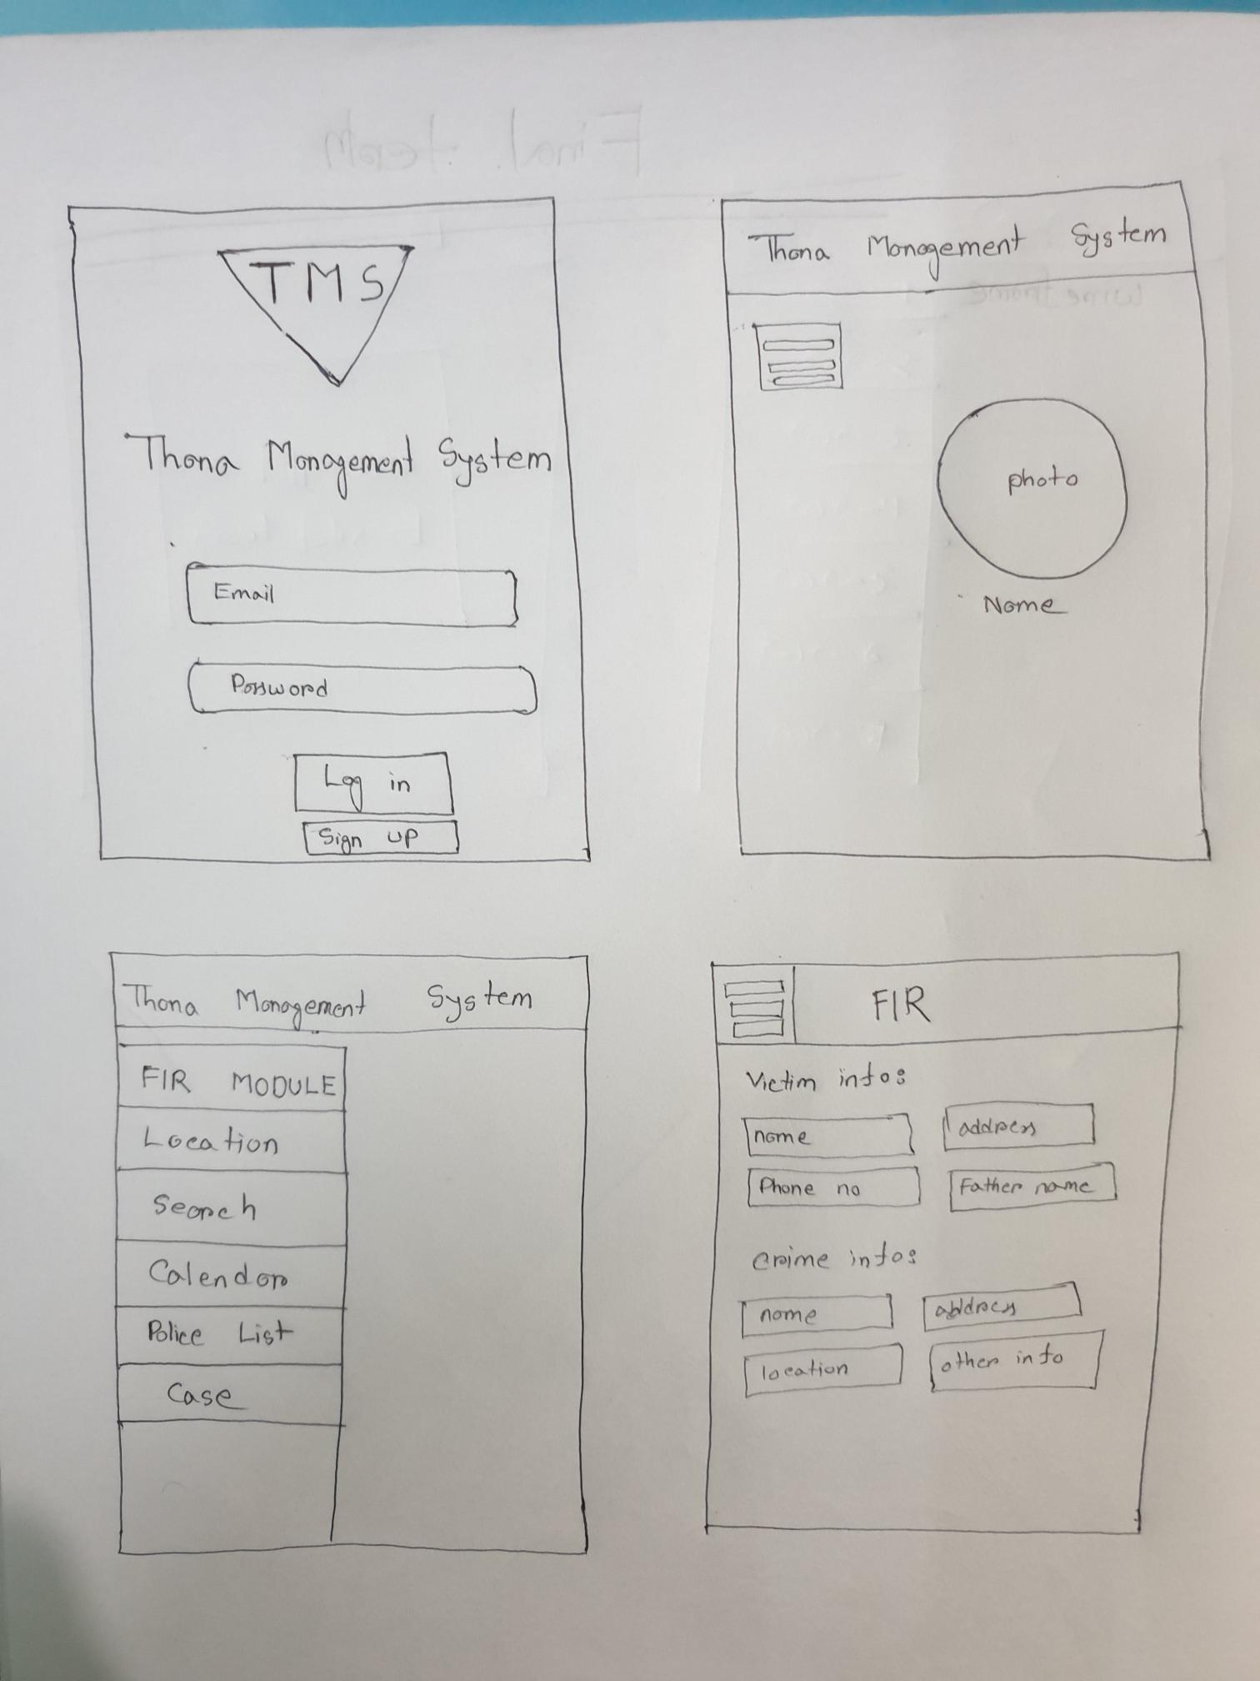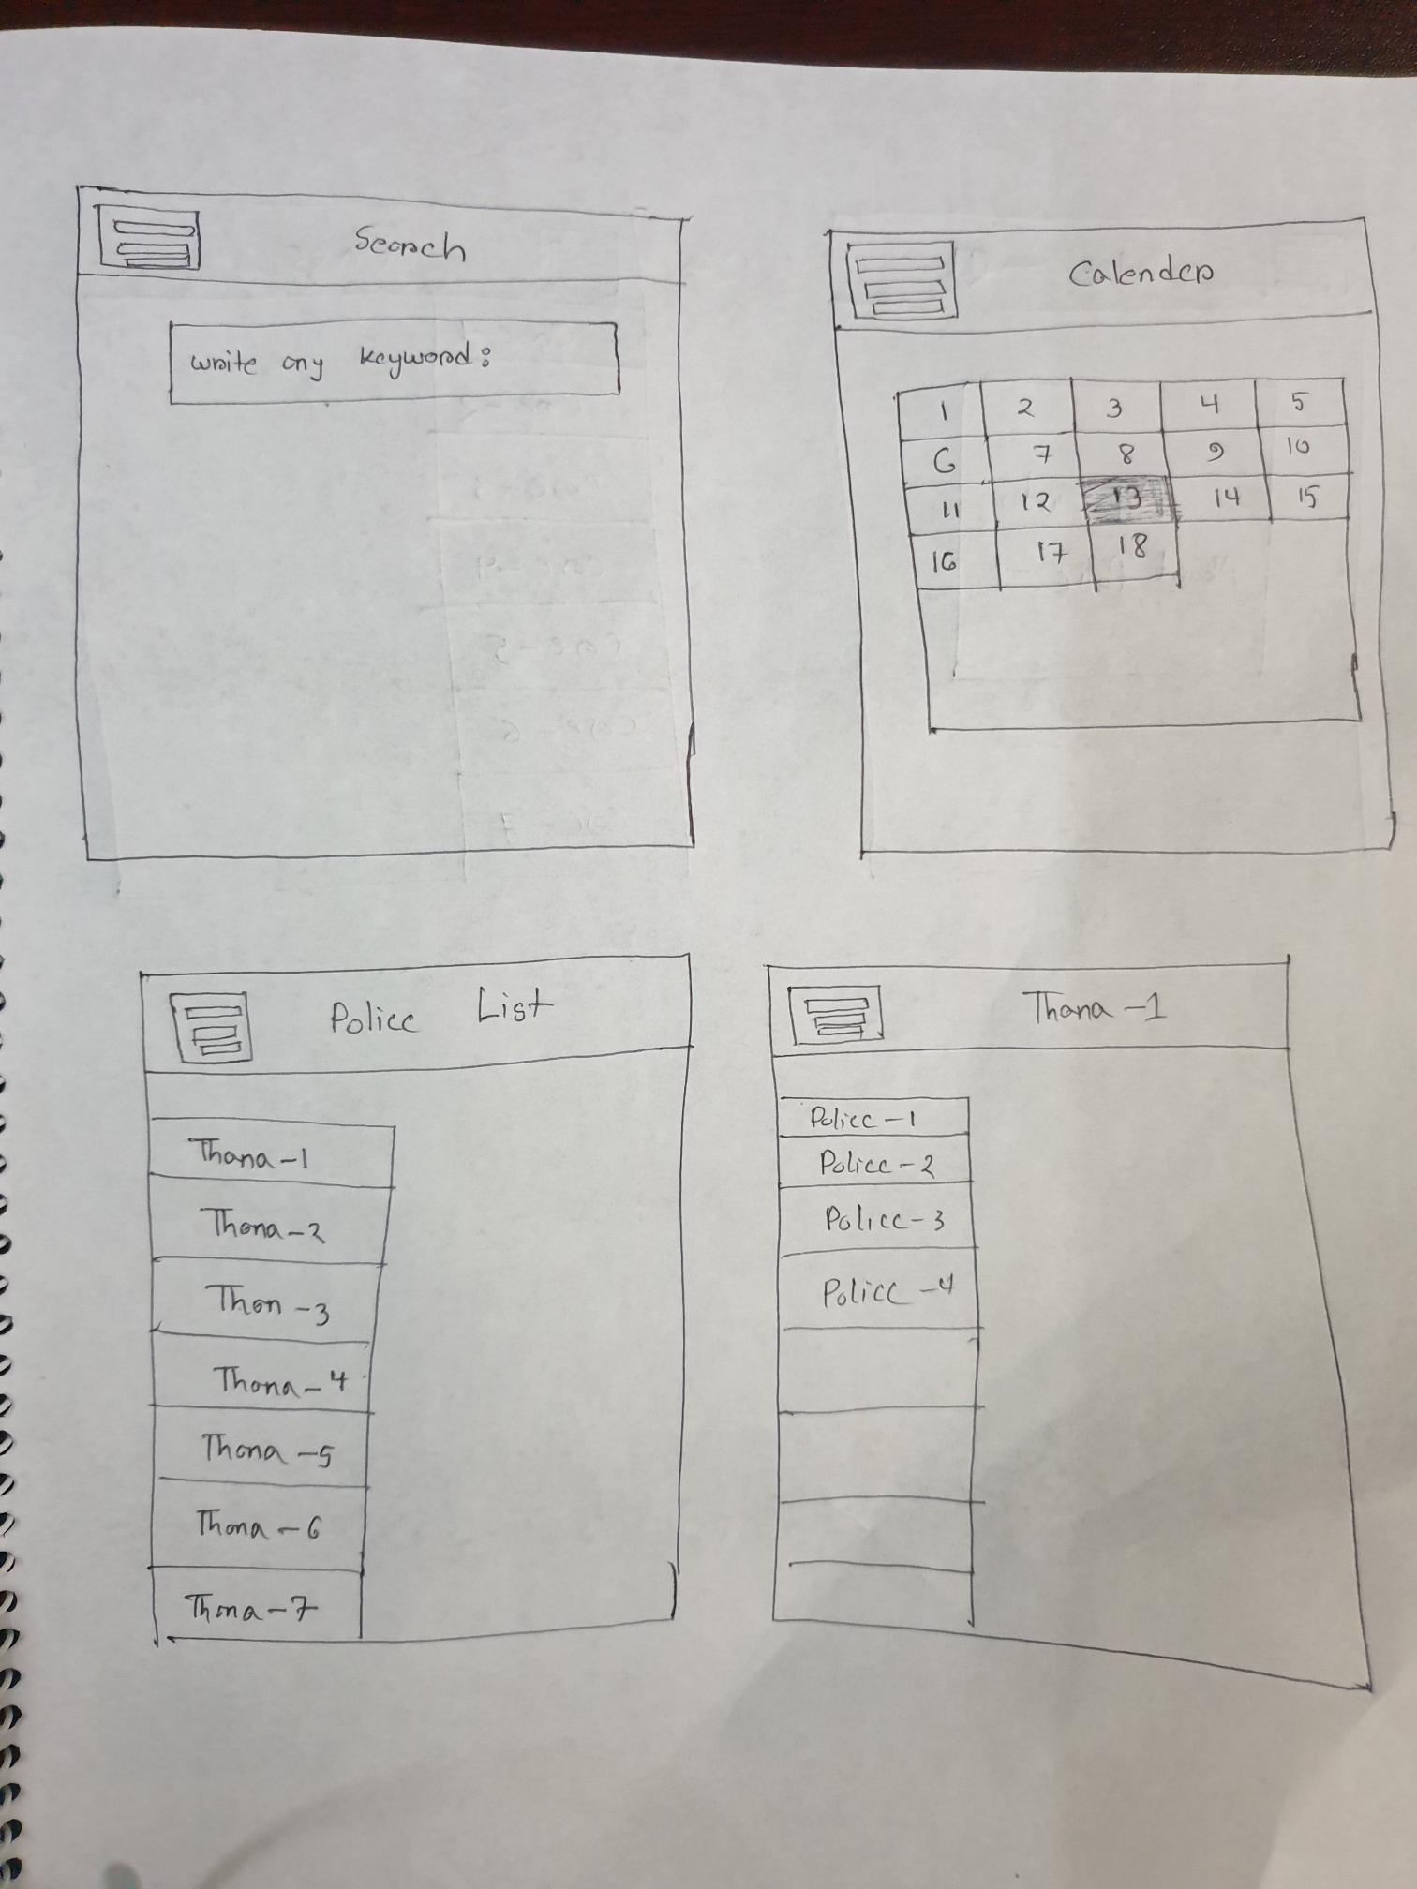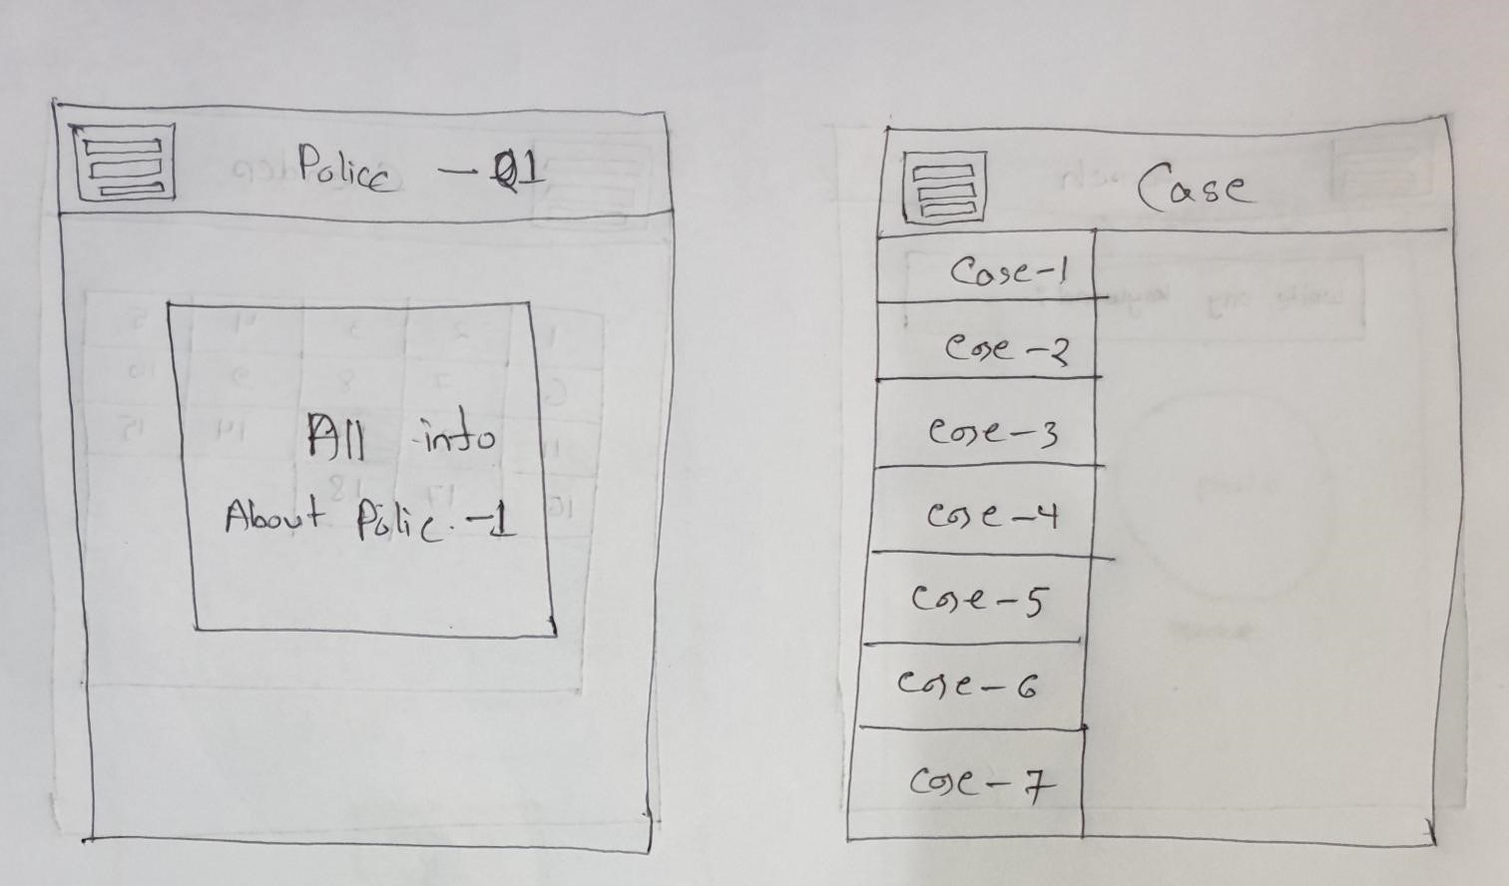

**Test Planning:**

|  |  |  |  |  |  |
| --- | --- | --- | --- | --- | --- |
| Test Case ID: 110 | | | Test Designed date: | | |
| Test Priority (Low, Medium, High): Medium | | | Test Executed by: | | |
| Module Name: Login Session | | | Test Execution date: | | |
| Test Title: verify login with valid username and password | | | | | |
| Description: Test website login page | | | | | |
| Precondition (If any): User must have valid username and password | | | | | |
| Test Steps | Test Data | Expected Results | | Actual Results | Status (Pass/Fail) |
| 1. Go to the website 2. Enter username 3. Enter password 4. Click submit | Username: 99999999999  Password: 321 | User should login into the application | | As expected, | Pass |
| Post Condition: User is validated with database and successfully login to account. The account session details are logged in the database. | | | | | |

1)

|  |  |  |  |  |  |
| --- | --- | --- | --- | --- | --- |
| Test Case ID: 112 | | | Test Designed date: | | |
| Test Priority (Low, Medium, High): Medium | | | Test Executed by: | | |
| Module Name: Search. | | | Test Execution date: | | |
| Test Title: Search by using existing keyword. | | | | | |
| Description: Testing Search page | | | | | |
| Precondition (If any): User must enter any keyword. | | | | | |
| Test Steps | Test Data | Expected Results | | Actual Results | Status (Pass/Fail) |
| 1. Go to the website 2. Login the System 3. Enter keyword 4. Click search | Keyword : XYZ | User should have some information. | | As expected, | Pass |

2)

|  |  |  |  |  |  |
| --- | --- | --- | --- | --- | --- |
| Test Case ID: 111 | | | Test Designed date: | | |
| Test Priority (Low, Medium, High): Medium | | | Test Executed by: | | |
| Module Name: FIR | | | Test Execution date: | | |
| Test Title: Provide all victim information. | | | | | |
| Description: Test fir login page | | | | | |
| Precondition (If any): User must provide victim information. | | | | | |
| Test Steps | Test Data | Expected Results | | Actual Results | Status (Pass/Fail) |
| Fill up all the text box. | Name:ABC  Address :XYZ  Phone Number:017******05 | User should hit the submit button. | | As expected, | Pass |
| Post Condition: User is validated with database and successfully login to account. The account session details are logged in the database. | | | | | |

3)

|  |  |  |  |  |  |
| --- | --- | --- | --- | --- | --- |
| Test Case ID: 112 | | | Test Designed date: | | |
| Test Priority (Low, Medium, High): Medium | | | Test Executed by: | | |
| Module Name: Search. | | | Test Execution date: | | |
| Test Title: Search by using existing keyword. | | | | | |
| Description: Testing Search page | | | | | |
| Precondition (If any): User must enter any keyword. | | | | | |
| Test Steps | Test Data | Expected Results | | Actual Results | Status (Pass/Fail) |
| 1. Go to the website 2. Login the System 3. Enter keyword 4. Click search | Keyword : XYZ | User should have some information. | | As expected, | Pass |
| Post Condition: User is validated with database and successfully login to account. The account session details are logged in the database. | | | | | |

3)

|  |  |  |  |  |  |
| --- | --- | --- | --- | --- | --- |
| Test Case ID: 113 | | | Test Designed date: | | |
| Test Priority (Low, Medium, High): Medium | | | Test Executed by: | | |
| Module Name: Calendar Session. | | | Test Execution date: | | |
| Test Title: Show the perfect date OR not. | | | | | |
| Description: Testing the calendar page | | | | | |
| Precondition (If any): User must go to the Calendar page. | | | | | |
| Test Steps | Test Data | Expected Results | | Actual Results | Status (Pass/Fail) |
| 1. Go to the website 2. login the website 3. go to Calendar page | No data. | User should get accurate date. | | As expected, | Pass |
| Post Condition: User is validated with database and successfully login to account. The account session details are logged in the database. | | | | | |

4)

|  |  |  |  |  |  |
| --- | --- | --- | --- | --- | --- |
| Test Case ID: 114 | | | Test Designed date: | | |
| Test Priority (Low, Medium, High): Medium | | | Test Executed by: | | |
| Module Name: Case module. | | | Test Execution date: | | |
| Test Title: Show all the case list. | | | | | |
| Description: Test into case page. | | | | | |
| Precondition (If any): | | | | | |
| Test Steps | Test Data | Expected Results | | Actual Results | Status (Pass/Fail) |
| 1. Go to the website 2. Go to Login page 3. Go to Case page | No Data. | User should see list of all cases. | | As expected, | Pass |
| Post Condition: User is validated with database and successfully login to account. The account session details are logged in the database. | | | | | |

5)

**Procedure:**

1. We are selecting Mobile Phone system.
2. For testing purpose, we need to use both testing level(Black-Box Testing and White-Box Testing)

***White-Box Testing***: It is used by programmer.

Black box testing, involves testing from an external or end-user type perspective. On the other hand, White box testing in software engineering is based on the inner workings of an application and revolves around internal testing.

Why did we choose white-Box Testing:

**White box testing** is a type of testing where the tester can see the code. The main purposes of this type of testing are to test the inner workings of the software, as well as strengthen its security, and improve its usability and design

***Black-Box Testing***: It is used by user.

This is a software testing method in which the functionalities of software applications are tested without having knowledge of internal code structure, implementation details and internal paths. Black Box Testing mainly focuses on input and output of software applications and it is entirely based on software requirements and specifications. It is also known as Behavioral Testing.

Project Planning:

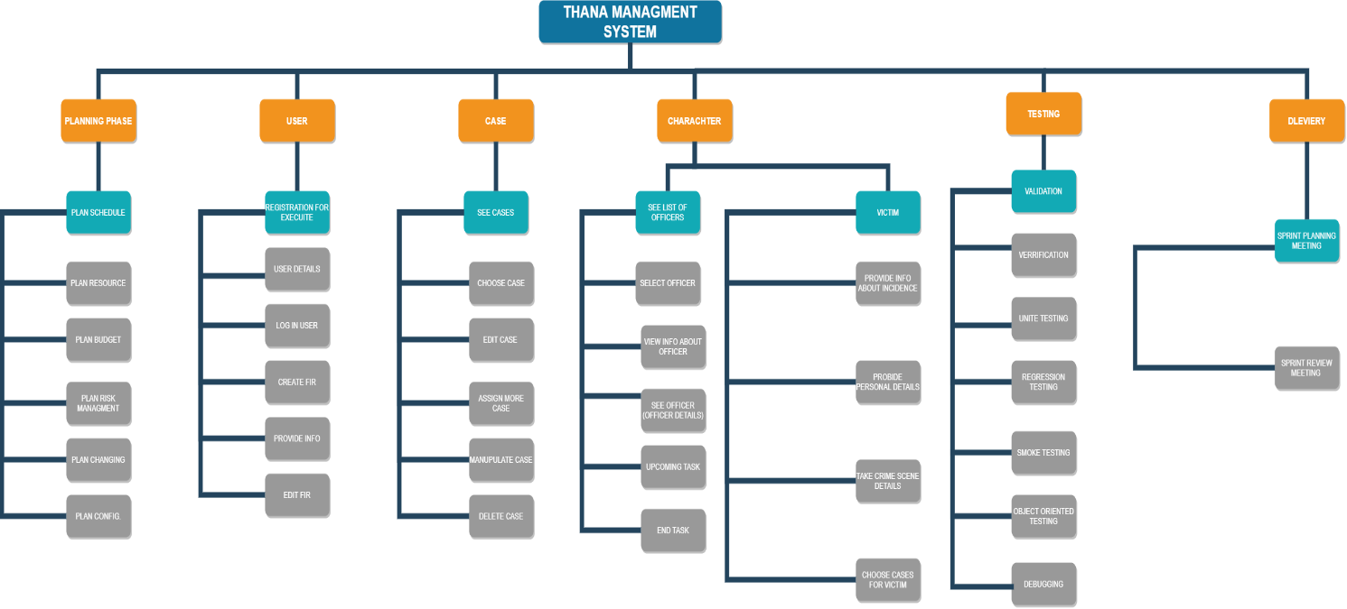

**COCOMO Model:**

Effort=PM= Coefficient<Effort Factor> *(SLOC/1000)^P

= 2.4* (8150/1000)^1.05 = 21.72 ≃ 22 person months

Development time

= DM =2.50*(PM)^T = 2.50*22^0.38 ≃ 8.1 week days

Required number of people

= ST = PM/DM = 2.72 ≃ 3 Persons

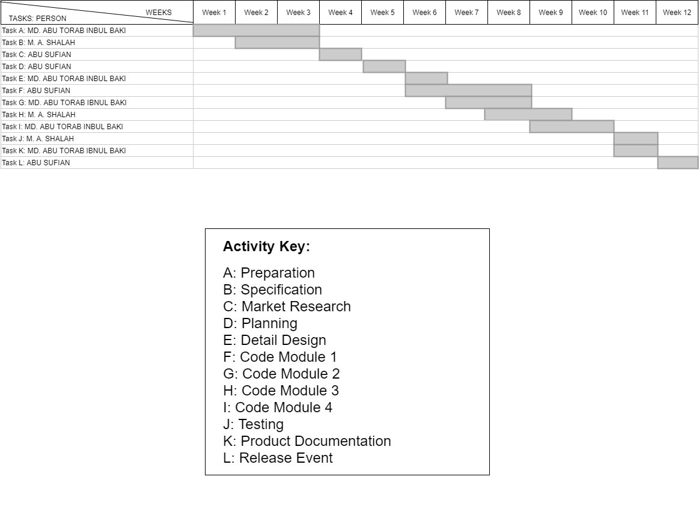

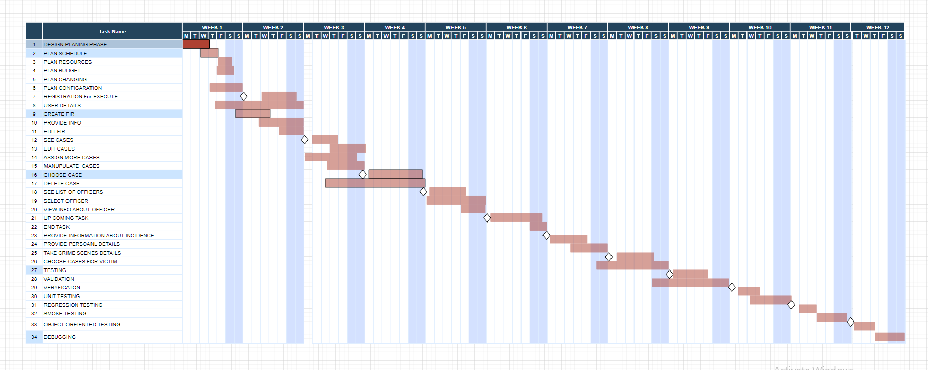

Risk Management:

|  |  |  |  |  |
| --- | --- | --- | --- | --- |
| Risks | Category | Probability | Impact | RMMM |
| Size estimate may be significantly law  In experienced Staff  User interface is not friendly to somebody  Technology will not meet expectations  Development environment  Wrong process has been taken  Complaint/Victim will change his/her arguments  Failure to meet the requirement would result in mission failure  Real-time performance shortfails | PS  ST  BU  TE  DE  PR  PS  PS  TE | 60%  40%  40%  20%  25%  30%  80%  30%  10 | 2  2  3  1  3  1  3  2  1 |  |

1- Catastrophic

2- Critical

3- Marginal

4- Negligible