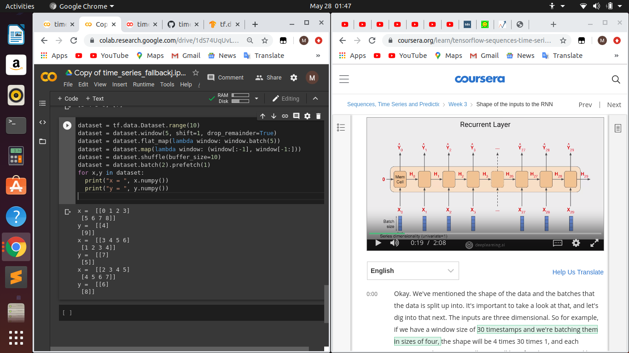
In the left side,batch size=4,series dimensionality=1(univariate) and timestamps=2
So,x0=[0 1 2 3],x1=[ 5 6 7 8]
y0=[4],y1=[9]
Input shape=4,2,1
We do expand dims because of the last 1.
x0,x1 are each fed to the mem cell and the RNN does it’s thing.

