**Design Specification**

|  |  |
| --- | --- |
| **Team:** | **Team 3** |
| **Team Members:** | **Walidah Thomas, Rainish Vora, Paul Lopez, Joshua Deleon, Tobiasz Gala** |
| **Date:** | **9/20/2017** |
| **Project Title** | **Williams Specialty Company E-Commerce Web Site** |

# Scope

This section defines the scope of the project including description of the system, major functions of the application, and the database.

## System Description

Williams Specialty Company (WSC) is a small print and engraving organization. They need website to be developed in order to enable their customers to provide order information including:

* Type of job (print or engraving)
* Media (plaque or trophy)
* Media catalog number
* Content into the print/engraving request database
* Billing or payment on delivery

WSC wants to provide a webs site so that their clients can provide the order information through a website. In addition, WSC wants to provide their entire catalog on the website.

Only customers with valid customer numbers and passwords are able to enter the customer’s area.

## Major Software Functions

Main function of the website should include following:

* Creation, modification, storage, and retrieval of order request information.
* Creation, modification, storage, and retrieval of catalog information.
* Creation, modification, storage, and retrieval of purchase order information.
* Creation, modification, storage, and retrieval of user access information.
* Allows a customer to enter an order request into the database.
* Allows a customer to retrieve order request information.
* Allows the operations manager to retrieve an order information from the database.
* Allows the operations manager to validate the purchase order.
* Allows the operations manager to close out the print request.
* Allows a customer to update their personal and billing information.

Event decomposition diagram demonstrates major software functions which are included in WSC E-commerce project.

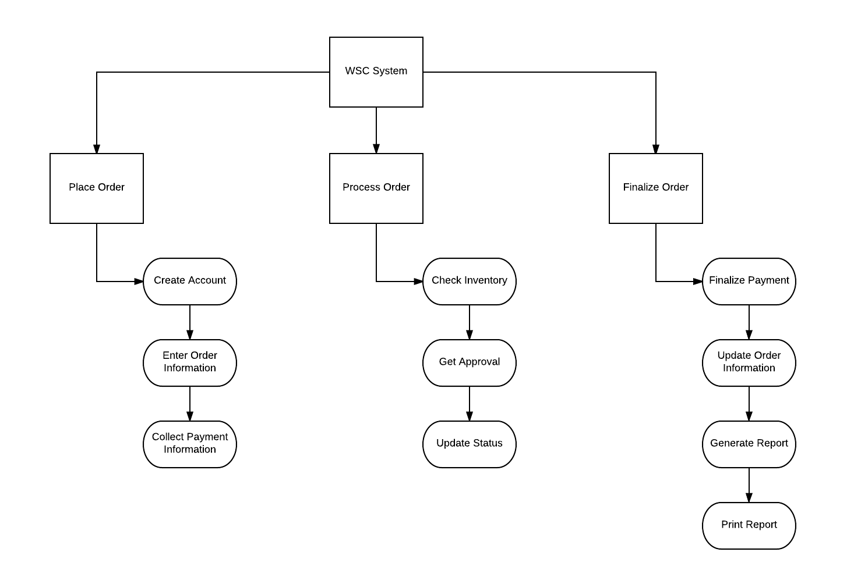

## Database Description

Entity-Relationship diagram shows a structure of database including relationship between tables.

// ERD Diagram here

### Design Constraints and Limitations

One design constraint that will be put on the user is the type of data they may enter in. Only authorized data types may be entered in for proper order processing, if an incorrect data type is entered, an error message will be displayed after the user clicks to go to the next phase to complete the order. The user will then be prompted to re-enter data for that field.

# Design Description

Design will consist of a web view that will be set in a primary container where the main browsing will occur of the products. A navigation bar will be setup to allow for navigating the website as well as showing the user profile name and access to the user/manager profile page. This is a standard in web design and has been seen as a standard for most modern web pages. The overall design will be customer focused to allow for a great user experience, since keeping the customers is a focus that the WSC Company would want.

The main focus on the design is to keep the layout simple so that the customer can easily select from the catalog to quickly and easily get to the checkout process. Multiple options will be enabled so that the customer can use third party payment merchants such as PayPal along with the standard option to pay with their own credit card. The website should be built out to be customer focused first and then configured for the use of the in house representatives.

## Data Description

Data will be organized primarily in the database and the images will be saved to a directory that is only accessible by the http service account. This will be configured primarily for the safe keeping of intellectual property of the WSC Company. Any and all interaction with data will be done through programming where each data access function will be coded through methods and properties that are stringent in access to preserve the safety and integrity of the data. Only manager roles of the website will have extended access to make changes to the data uploaded the website, customer interaction is only set for the viewing and ordering of a product.

## Data Flow

Data will flow back and forth from the company database comprised of the users, managers, orders, and catalog tables. Data will moved between the end user only if it is a customer or manager. This will occur once the end user is logged and verified as a user of the website. Once the end user has gone the through the authentication process then they will have extended access to the company data depending on the role that is assigned (customer or manager).

## Program Architecture

The program architecture will be composed of HTML and CSS for the front end of the website. The backend will a mixture of ASP.net and MS Access database all running on the IIS web server.

Asp.net will handle all the requests coming from the web files and will process each depending on what the various functions are. These functions can vary from linking one page to another (HTML, CSS), user session handling and database interaction (ASP.net, Access).

## Component Interfaces

The component interfaces/classes that will be used for the processing of the requests and navigation are as the following classes: User, Customer, Order, Manager, Orders, and Order Details.

# Detailed Design (one section for each component)

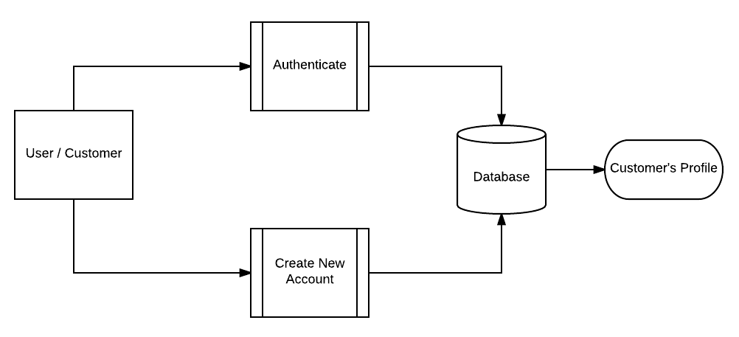

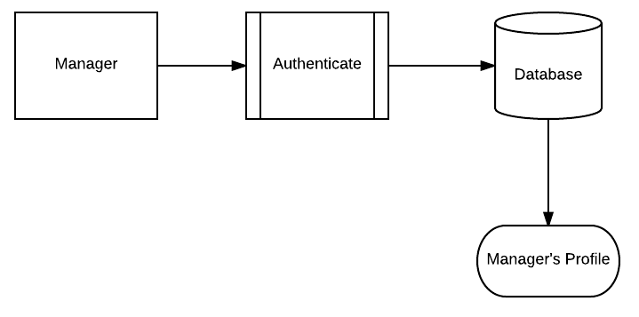

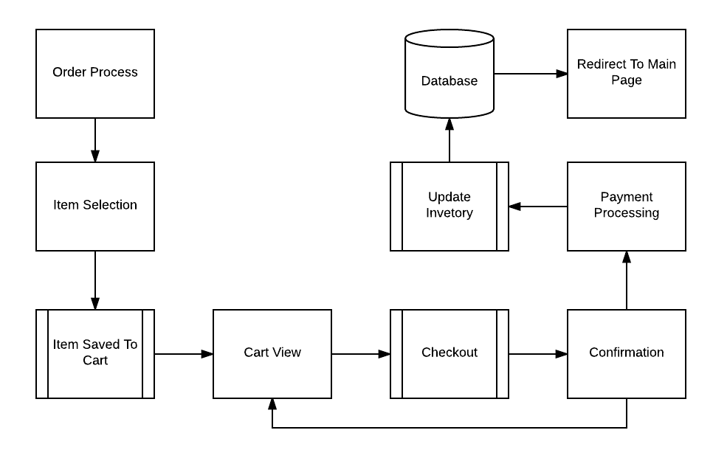

## Processing Description

Processing will be done through the classes built to handle the interaction from both the end user, customer, and manager roles. Depending the role that is accessing the site will determine what type of process will be allowed. If the user is the typical internet user looking through the site then they will be shown the standard user experience.

Once the end user is registered and/or verified as a specific user of the website, then the user will be be set up with specific permission to have a designated amount of access to the site. If the user is a managerial role then they will be given an additional layer of access where changes can be made to the inventory of the website.

## Interface Description

Interface of the site will be configured through the programming of Team 3 where the end user role will be given the absolute minimal amount of access to the site and progressively increased depending on the amount of information that the end user will give to the site. This would consist of the end user creating an account and inputting a valid credit card or third party payment service to allow for ordering products of the site.

Manager users of the site will be given full access to the site where they can adjust the amount of product that is in inventory to account for accurate data to the site. Orders will be able to be taken by phone by manager users in case the that end user is unable to use the site for ordering.

## Pseudocode

**Landing Page**

While not authenticated

Browse website as anonymous user

IF order is needed

Redirect to Customer Login page

Else

Redirect to create account

**Customer login page**

IF redirected to Login page

IF not authenticated

Request username & password

IF username || password is incorrect

Display “Username and password is incorrect!”

ELSE

Display “Successfully created user profile”

Redirect to user profile

**User Profile**

While authenticated

Allow user to make selections

Save selections to shopping cart

IF checkout == true

Redirect to Order page

ELSE

Save items to shopping cart

**Order Page**

While selection >= 1

Summarize quantity and Price

IF Submit Order clicked == True

Summarize order and redirect to Order Confirmation

IF selection == 0

Redirect to User Profile || show 0 items available in shopping cart

**Order Confirmation**

While quantity is >= 1

Get credit card info

If change to quantity is reset to 0

Then redirect to Order Page

**Confirm Submission**

If confirm submission == true

Then update database with purchase order

Send email confirmation to user

Send email of order to company

**Manager login**

IF user login >= Manager

Give access to administrator rights

While manager

Enable access to read, write, delete customer database

End while

Else

Echo “Username and password is incorrect”

## Modules Uses

Each module will configured to allow the limited amount of access depending on the role of the user. If the user is a casual browser then they will only have the basic view access to see what the site has to offer, any past this will involve the end user to create an account which is purposely configured this way. Once the end user is set up as a customer user then they will have the ability to create their own profile to enter credit card information.

This customer module will only give enough access to the end user to create an account, enter personal user information, and allow for entering personal credit card information. If the end user has a role of a manager user then an additional amount of access will be granted through the manager class. This will enable the employees to read, write, or delete inventory data to keep the website updated as needed.