# ­­­Leeds Urban Catchment Analysis

**What data do I have?**

* FEH Catchment Descriptors (ALTBAR, AREA, BFIHOST, DPSBAR, FARL, LDP, PROPWET, SAAR, URBEXT200)
* Easting and Northing from catchment location
* FEH13 catchment rainfall for durations between 0.25 and 96h at 0.25h intervals, and for return periods of 2,5,10,20,30,50,75,100,250, 200, 500, 1000, 10000 years.
* Direct runoff (ml) and peak flow (m3/s) for both rural and urbanised scenarios for durations between 1h and 39h at 1h intervals, and for return periods of 2, 5, 10, 30, 50, 75, 100, 200 and 1000 years.
* Critical storm duration (derived from above peak flow data) for each of the return periods
* The number of cells in each catchment with risk of flooding from surface water from rainfall with a 30, 100 and 1000 year return period.
* The number of cells in each catchment with risk of flooding from surface water from rainfall with a 30, 100 and 1000 year return period, for certain bands of depth, velocity and hazard.

|  |  |  |  |  |  |  |  |  |  |
| --- | --- | --- | --- | --- | --- | --- | --- | --- | --- |
| **Catchment** | **Catchment descriptors** | | | **2 year RP…** | | | **1000 year RP…** | | |
| **Area** | **Altitude** | **Steepness** | **0.25h** | **10h** | **96h** | **0.25h** | **10h** | **96h** |
| **1** |  |  |  |  |  |  |  |  |  |
| **2** |  |  |  |  |  |  |  |  |  |
| **3** |  |  |  |  |  |  |  |  |  |
| **4** |  |  |  |  |  |  |  |  |  |

* 20 Catchments
* 11 main catchment descriptors
* 384 durations
* 13 return periods
* 4992 return period duration combinations

**General Aim**

To understand:

* How sensitive catchments are to different duration rainfall events and how much this varies across Leeds
* What might be driving this variation in catchment sensitivity (e.g. physical characteristics, rainfall variability)

In order to inform what durations and events from UKCP18 are relevant to this analysis.

**General Research Questions**

* How are the catchment descriptor values spatially distributed?
* How much between catchment variation is there in:
  + Rainfall
  + Peak flow
  + Critical duration
  + RoFSW
* Is there a relationship between catchment descriptors and:
  + Rainfall
  + Runoff
  + Critical duration
  + RoFSW
* Is there a relationship between RoFSW extent and:
  + FEH13 rainfall
  + Peak flow
* Is there a relationship between peak flow and:
  + FEH13 rainfall
* For each catchment: how does peak flow and catchment critical duration vary with (i) the seasonality of the storm profile and with (ii) whether an urbanised or rural modelling scenario is used?
* How is this variation related to catchment descriptors?
* Are above relationships constant for different durations and return periods?

**How sensitive catchments are to different duration rainfall events and how much this varies across Leeds**

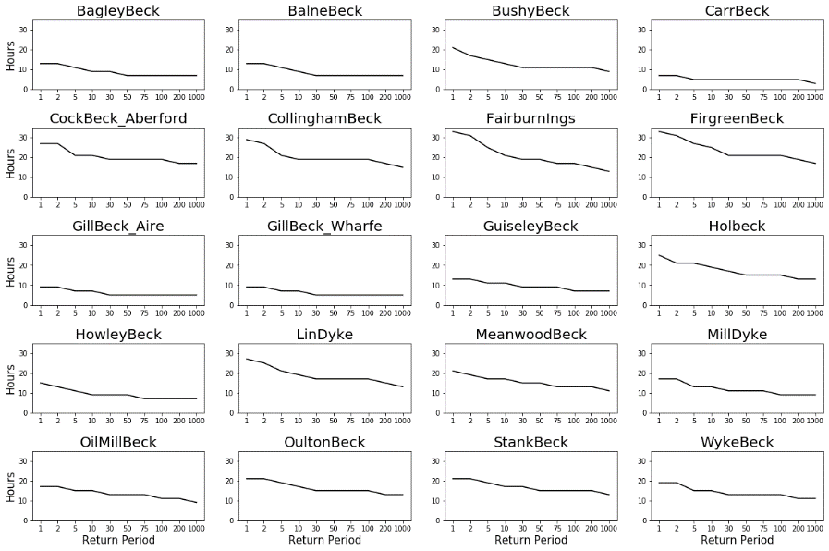­­The critical storm duration (duration with highest peak flow) is generally associated with the widest flood extent and is of great importance for surface water flooding. Understanding a catchment's critical storm duration is important in order to understand the kinds of storms which are most likely to lead to surface water flooding in the catchment. In Figure 15 the critical storm duration at each return period for each catchment is plotted.

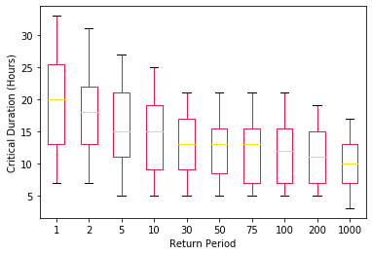

The critical storm duration decreases at longer return periods, ranging between 7 and 33 hours for a 1 year return period, and 3 and 17 hours for a 1000 year return period. This is true considering the mean critical storm duration across all the catchments, and also on an individual catchment basis.

* The highest critical durations are generally towards the east of the City. The Pearson’s R correlation coefficient between Easting and ­Critical Duration varies between 0.74 and 0.83

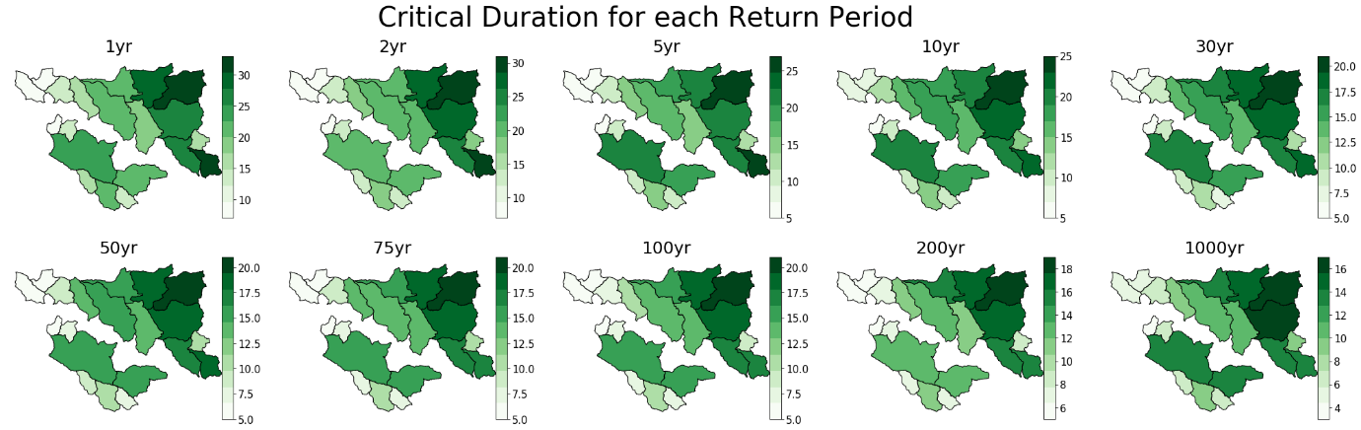

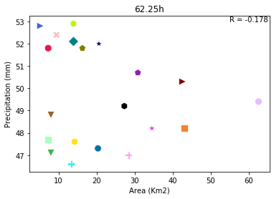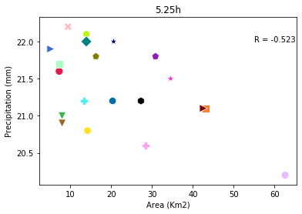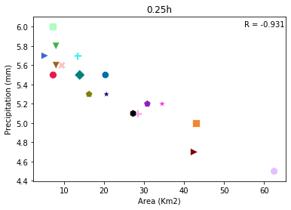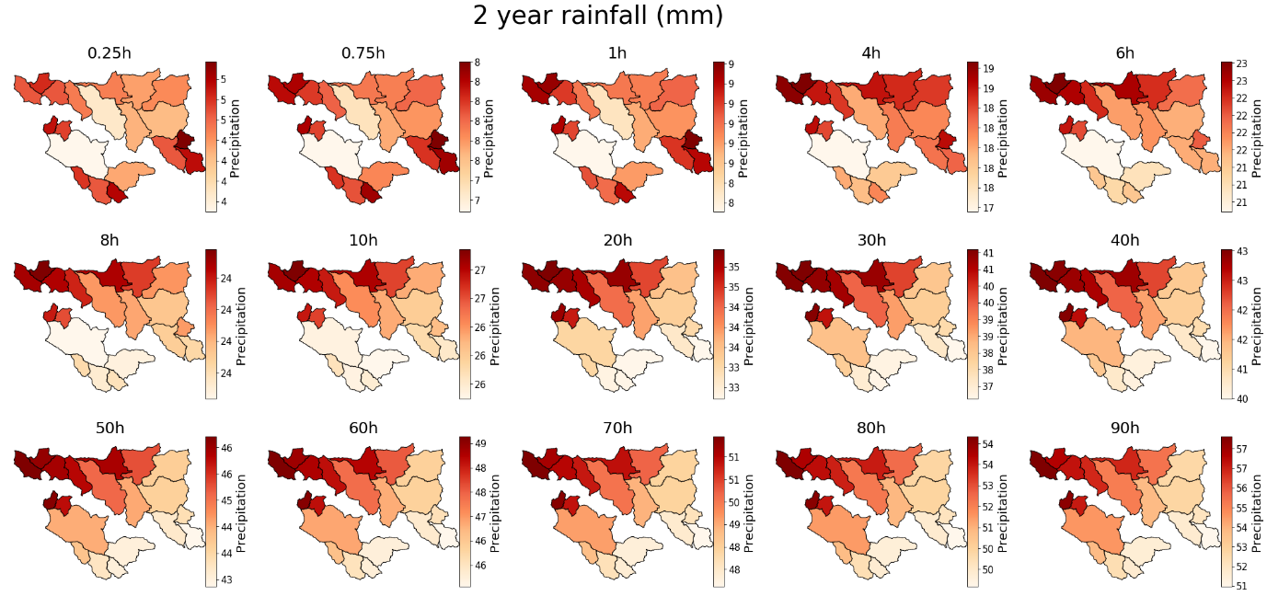 **Area (2 year return period)**

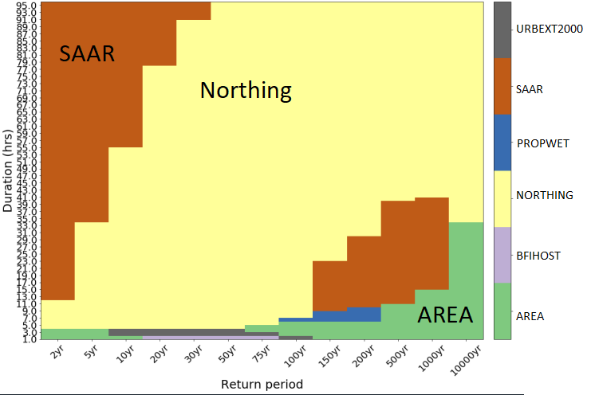­­

**Conclusions from the data**

How much between catchment variation is there in rainfall?

Between catchment variation in rainfall:

* + For 1h duration:
    - 2 year RP, varies from 8.7mm/h to 10.2mm/h (15.8% difference)
    - 50 year RP, varies from 27.9 mm/h to 34.6mm/h (21.4% difference)
  + For 51h duration:
    - 2 year RP, varies from 43.9mm/h to 49.7mm/h (12.4% difference)
    - 50 year RP, varies from 82.6mm/h to 93.8mm/h (2.7% difference)

The greatest between catchment variation in FEH13 rainfall is for the shortest duration (0.25h). For a 2 year return period there is a 28.6% difference between the lowest and highest values, a 30.6% difference for 5 year return period, a 32.8% difference for 20 year return period and a 33.5% difference for a 50 year return period. The percentage difference is lowest for duration around 11h, and then starts to increase again moving to longer durations. However, for these longer durations there is less clear variation between return periods.

Which catchment descriptors best predict FEH13 rainfall?

Is the relationship between FEH13 rainfall and catchment descriptors constant for different durations of rainfall?

Is the relationship between FEH13 rainfall and catchment descriptors constant for different return periods?

* At different durations and return periods, there are different relationships between catchment descriptors and rainfall.
* The catchment descriptor with the highest correlation with rainfall for each return period and duration combination is shown below.
* For durations of over 10h at return periods up to 200 years, either SAAR or Northing are most strongly correlated with rainfall.
* For very short duration rainfall (<3h), other factors including Area, BFIHOST and Urban Extent become the most highly correlated (Area??)
* The correlations are generally strongest for the longest durations and shortest return periods
* Durations < 10hs there is a different relationship between rainfall and the catchment descriptors. Durations >10h, we see same correlations as in the first section when comparing the SAAR to catchment descriptors. For shorter duration events, there is like an opposite relationship, or no relationship.
* Long duration rainfall events, catchments with higher SAAR have higher rainfall amounts predicted by FEH13. But at durations <10h there is the opposite relationship or no correlation. Catchments don’t move along x axis, as SAAR values are fixed. Only catchments sensitive to duration length are those to left hand end of plots. Catchments above >750mm don’t move much, ones to the left are high in short durations and low in longer durations. These are catchments to the East.

