**FRONT-END DOCUMENTATION**

1. **General Requirements**
   1. **Accessible**
   2. **Adaptive**
   3. **Multilanguage system**
   4. **SEO optimization**
   5. **Speed of the first site rendering**
2. **Advanced Functionality**
   1. **Support database ( MongoDB )**
   2. **JWT authorization by sessions**
   3. **Support cross platform**
3. **API Design**
   1. **In project use only classic REST method**
4. **Render And Requests Architecture**

First rendering ( by SSR, SSG, ISR )

**CLIENT**

Back-End

**Request**

1. **Optimization**

**OPTIMIZATION METHODS**

**Prerender site by SSR, SSG, ISR**

**Cache Some Data**

**Bundle**

**Preconnect non critical resources**

**Compression Of Code**

**Component Code**

**Optimization Images Load By Next**

1. **Accessability**
   1. **Rem And Em Utils – scalable when user change browser settings**
   2. **Color Schemas ( Light And Dark Modes )**
   3. **HTML Semantic Tags**
   4. **Images have an alt attribute**
2. **Architecture in the APP**
   1. **An FSD project consists of layers, each layer consists of slices and each slice consists of segments**
   2. **Layers are standardized across all projects and arranged vertically. Modules on one layer can only interact with modules located on layers strictly below. There are currently seven layers (from top to bottom)**
      1. **app — app-wide settings, styles and providers.**
      2. **processes — complex inter-page scenarios.**
      3. **pages — compositional layer to construct full pages from entities, features and widgets.**
      4. **widgets — compositional layer to combine entities and features into meaningful blocks**
      5. **features — user interactions, actions that bring business value to the user**
      6. **entities — business entities**
      7. **shared — reusable functionality, detached from the specifics of the project/business. (e.g. UIKit, libs, API)**

**FRONT-END SYSTEM DESIGN**

1. **UI-components**
   1. **AreaField – It’s the text-area component, but with some upgrades**

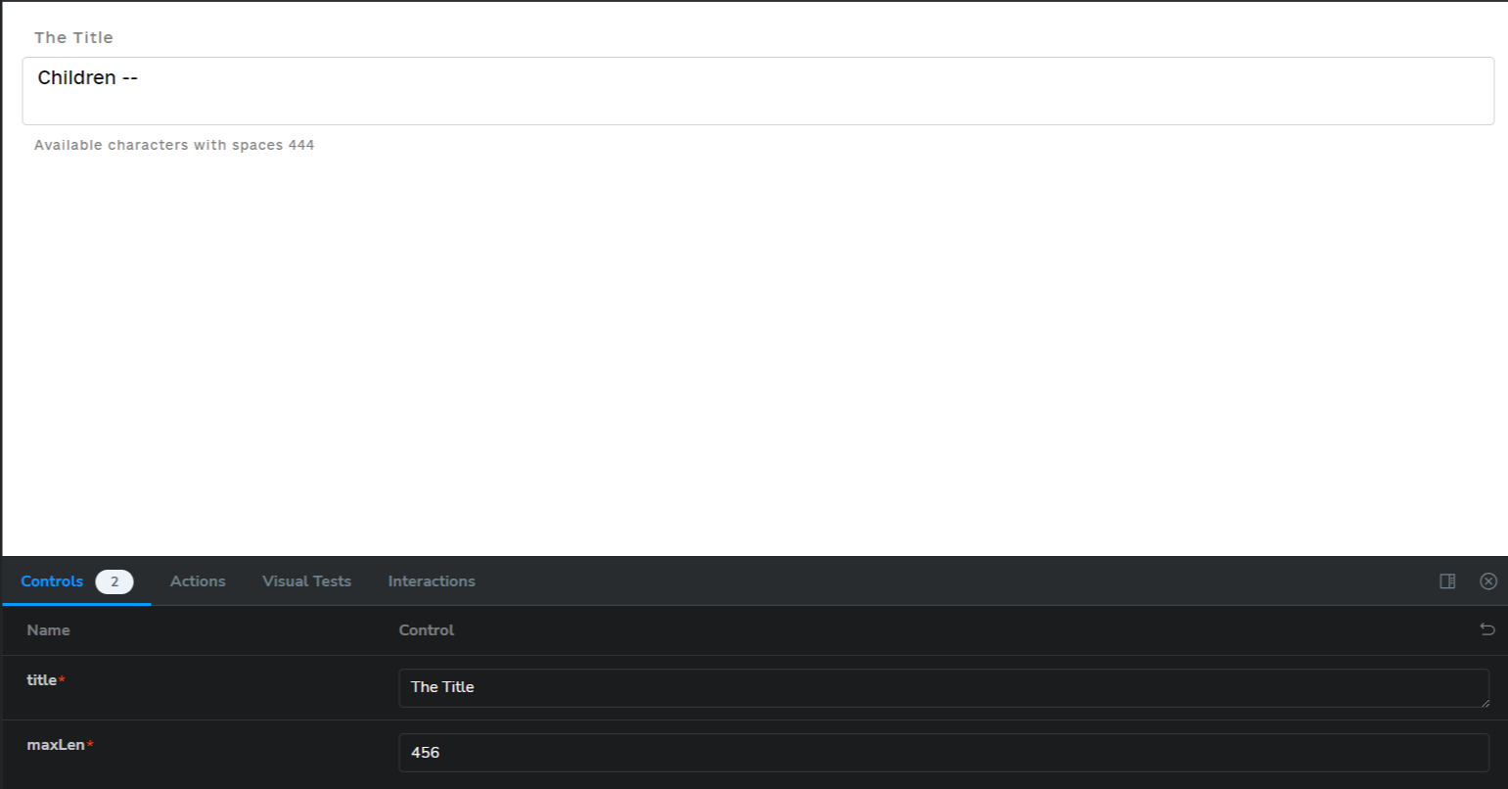

* 1. **BackBtn – Component for return history of router on 1 step**

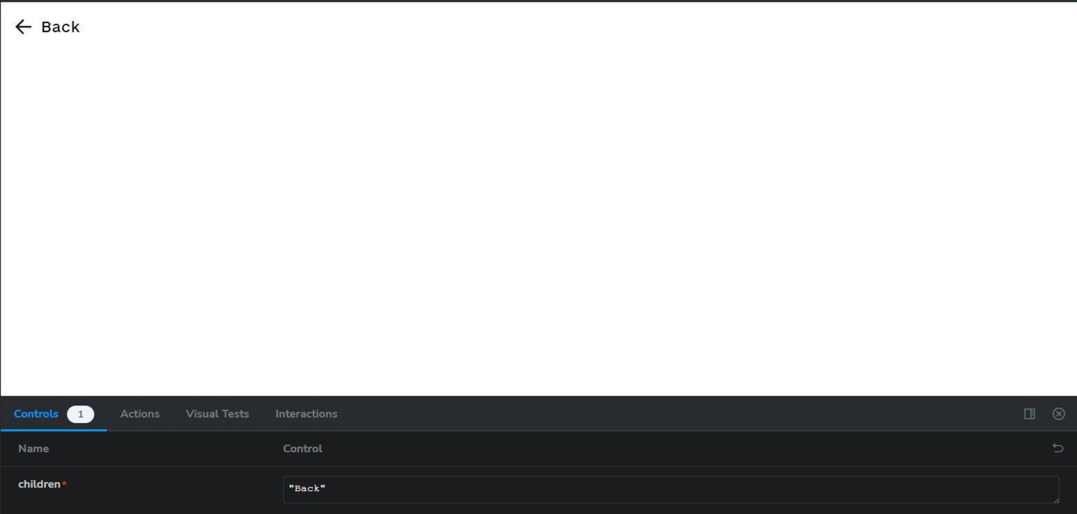

* 1. **BgImg – bg component which rotating**



* 1. **BlurButton – button which bluring on the right on hovering**

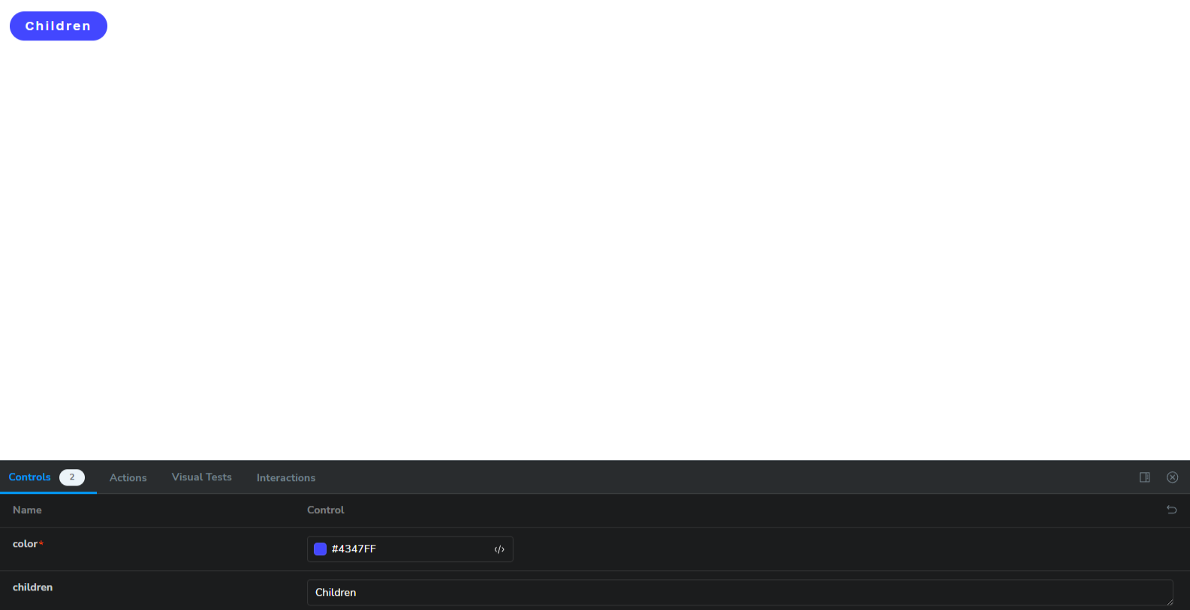

* 1. **Info – component for info from site**

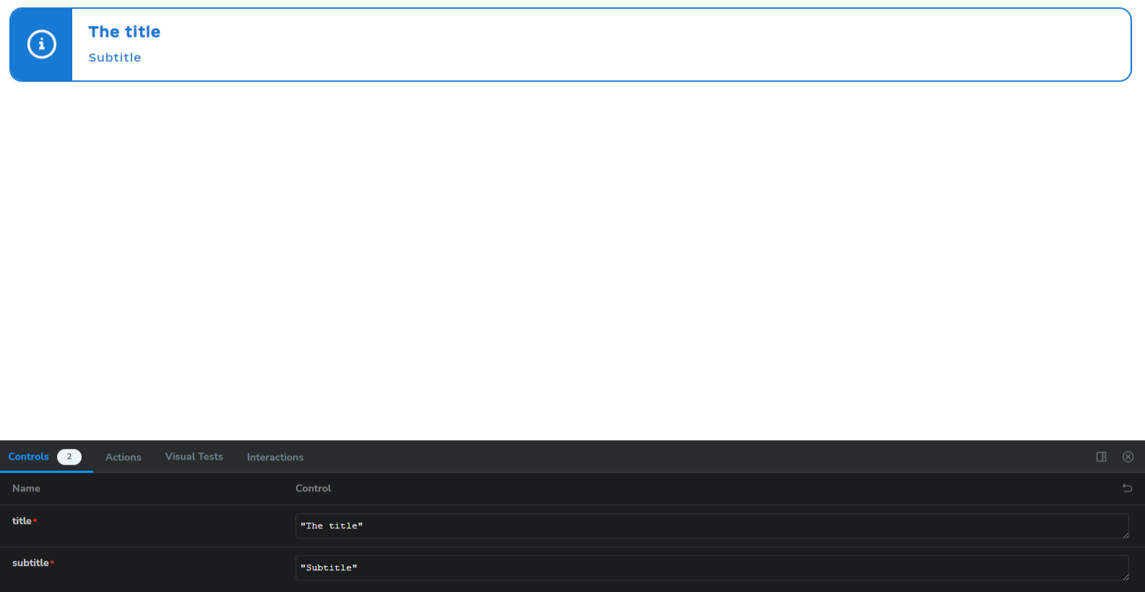

* 1. **LinearDivider – Its linear divider!**

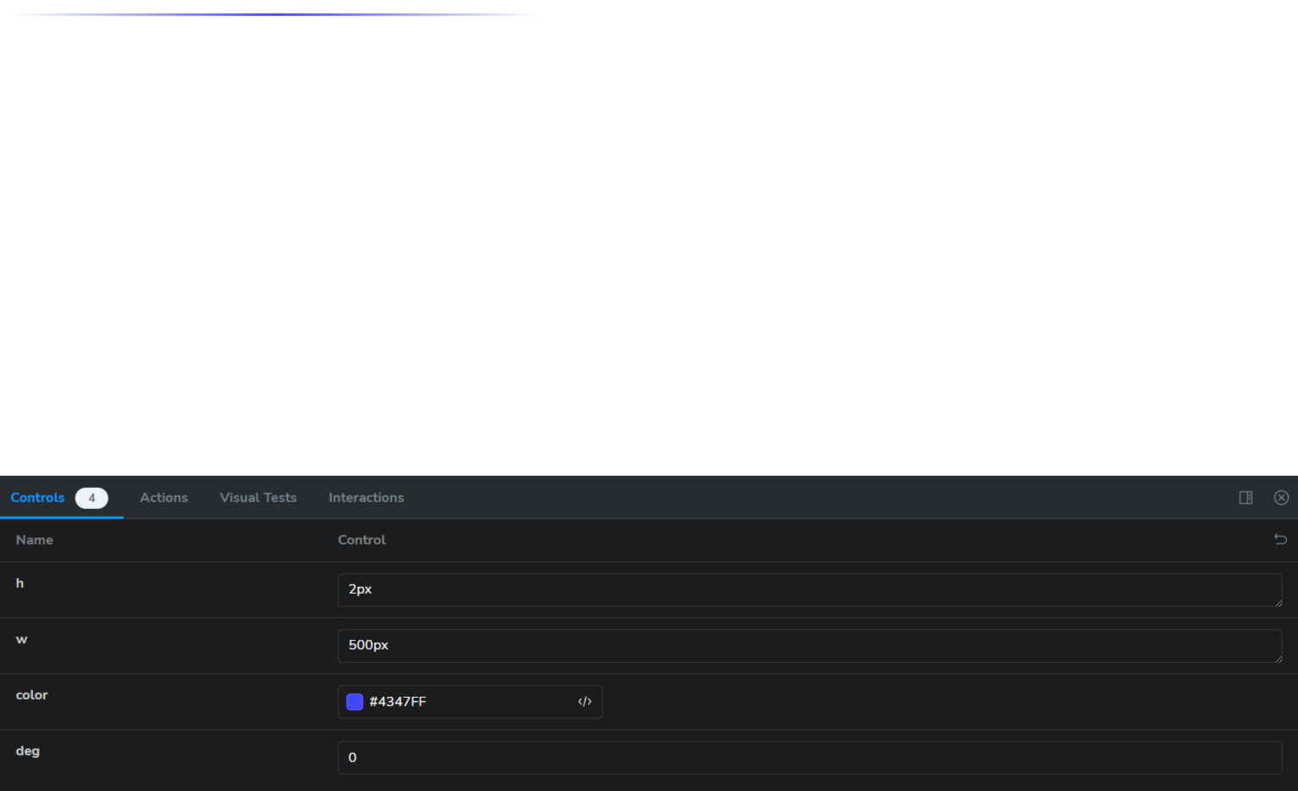

* 1. **LinkBtn – Its link which we can use “active props” which activating if her href equals site href**

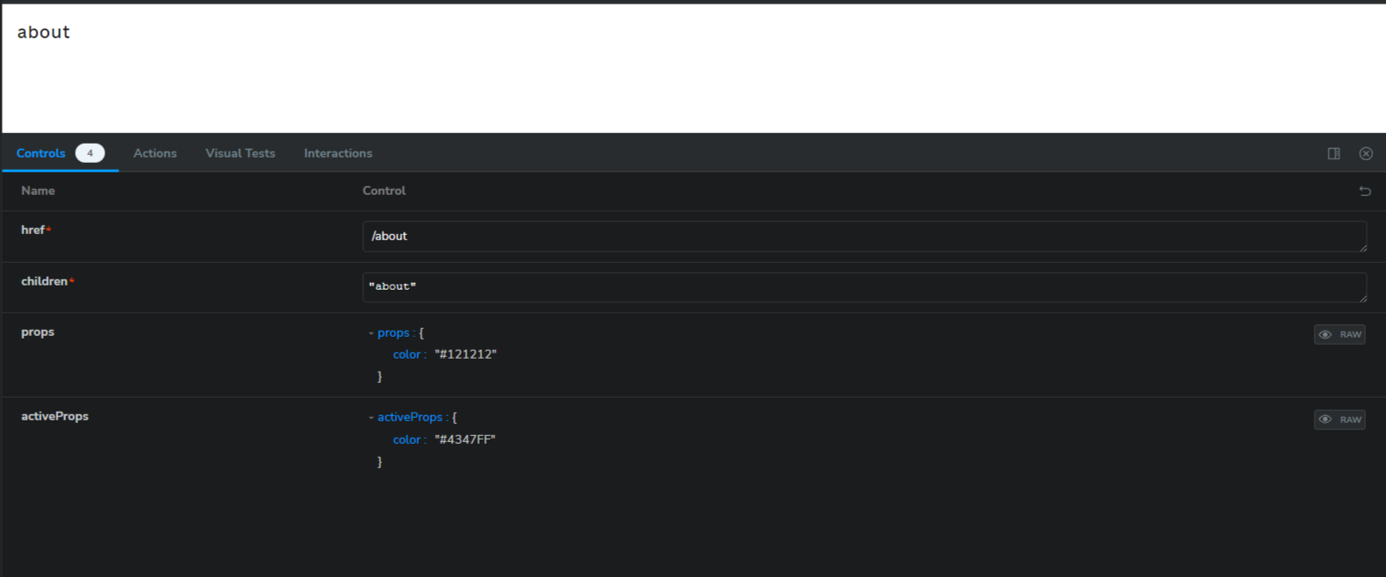

* 1. **Logo – its logo of site**

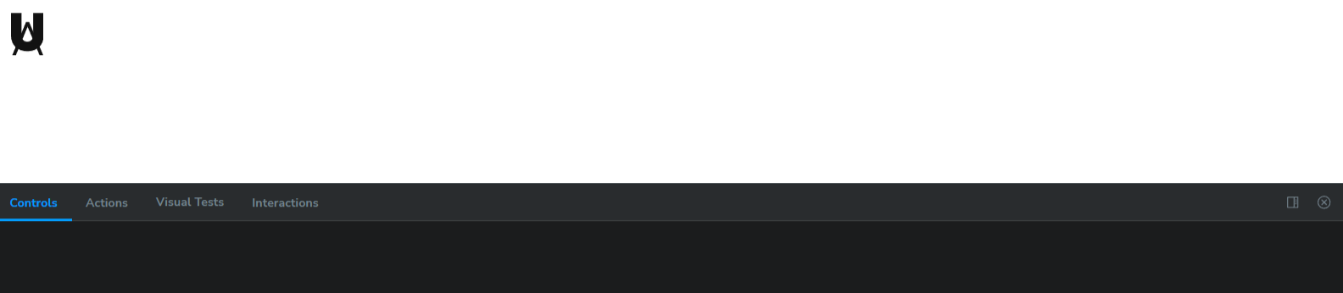

* 1. **MultiselectField – Its multi-select input**

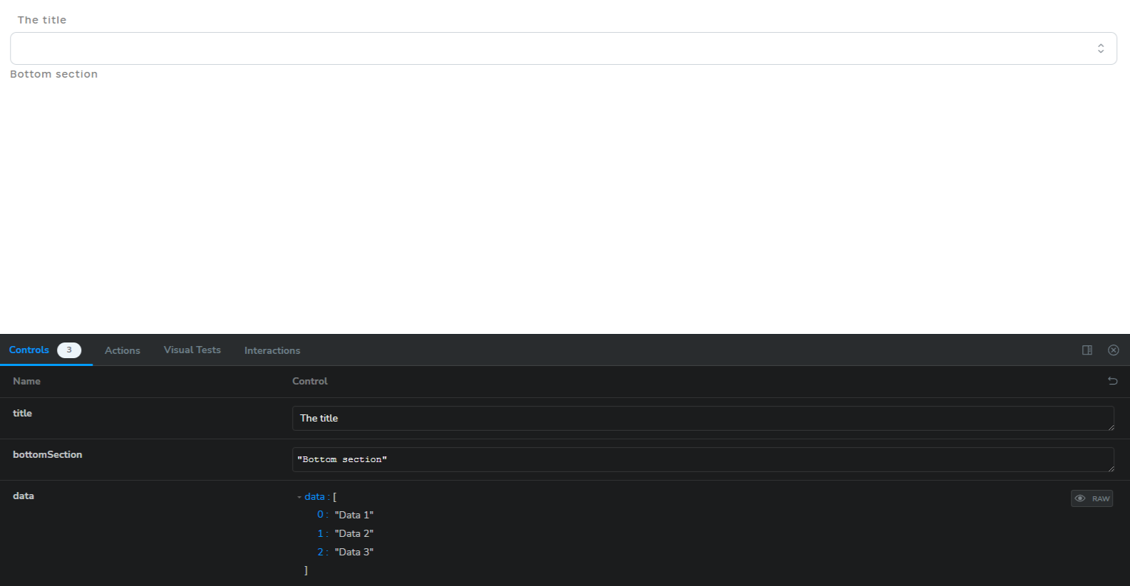

* 1. **NextBtn – Its btn with disabled prop**
  2. **PasswordField**

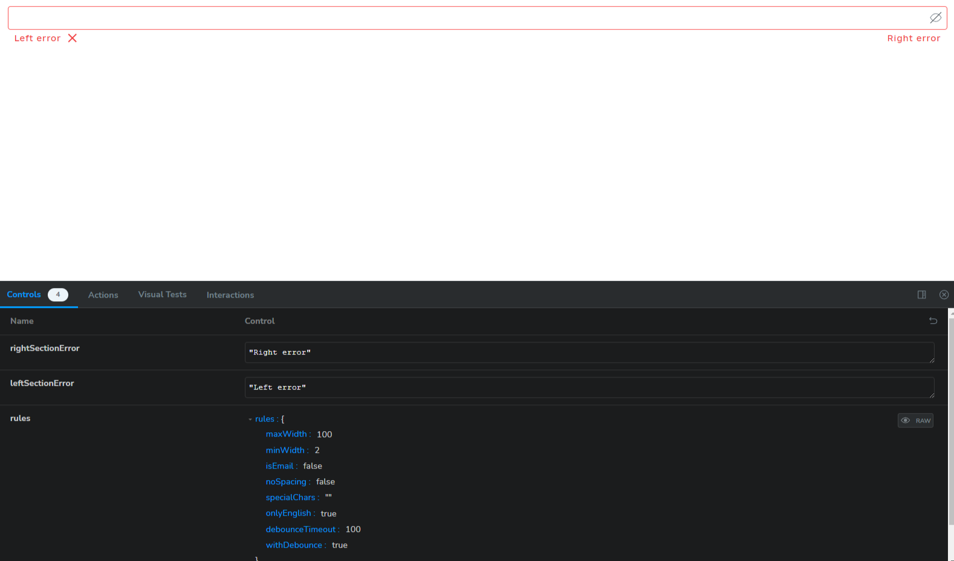

* 1. **RgbaBgLayout – its layout for the some pages. Her bg is rotating!**

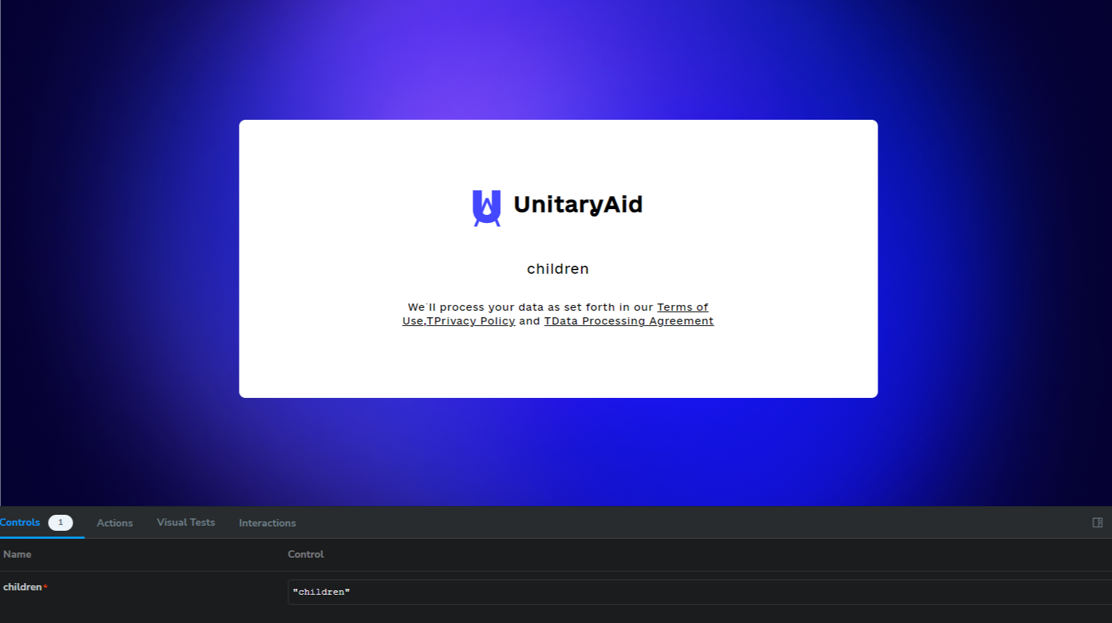

* 1. **SearchInput – its input with “search” design**

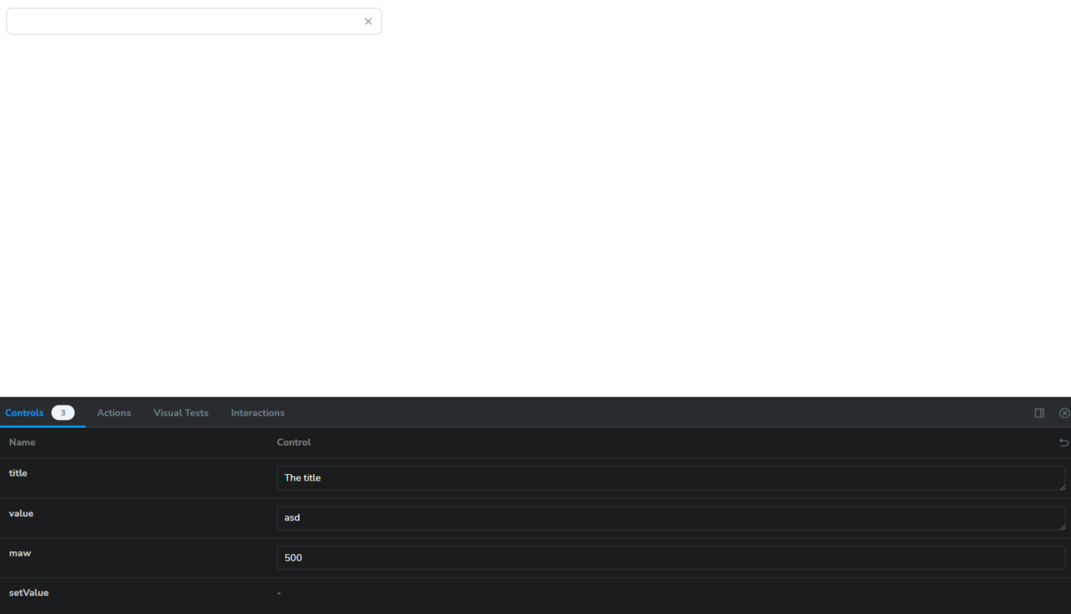

* 1. **ShadowBox – its box with shadow border**

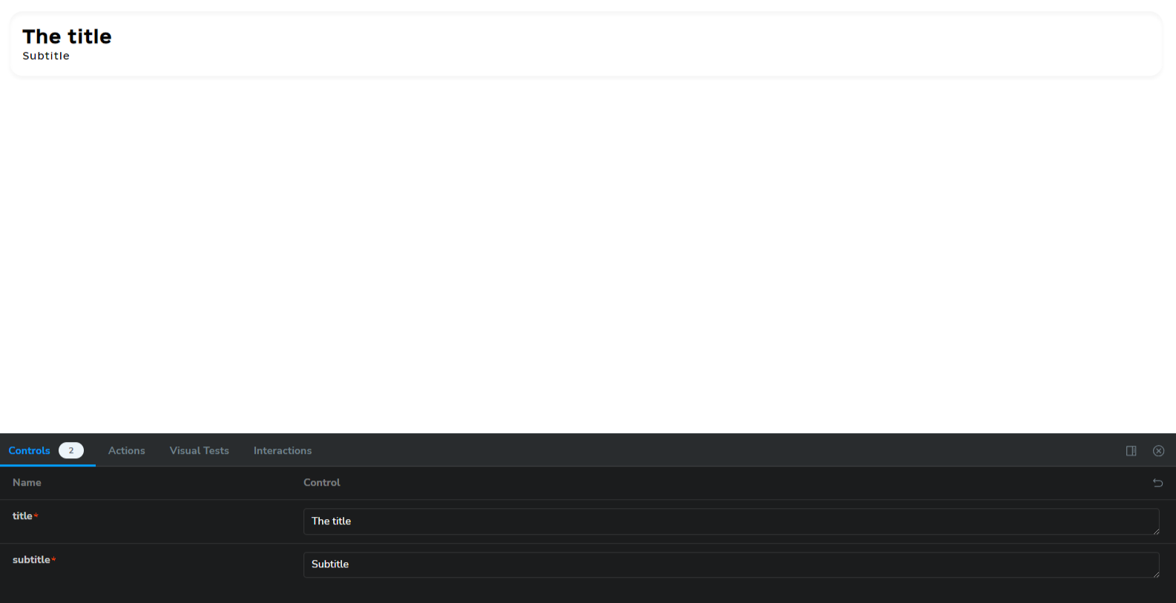

* 1. **ShadowBtn – its button with also shadow border**

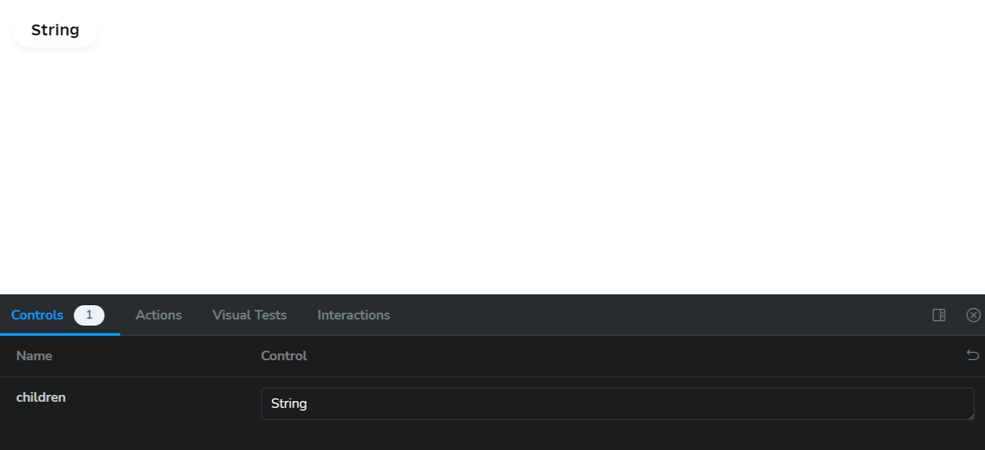

* 1. **SuperTitle – it’s the biggest title styles for site**

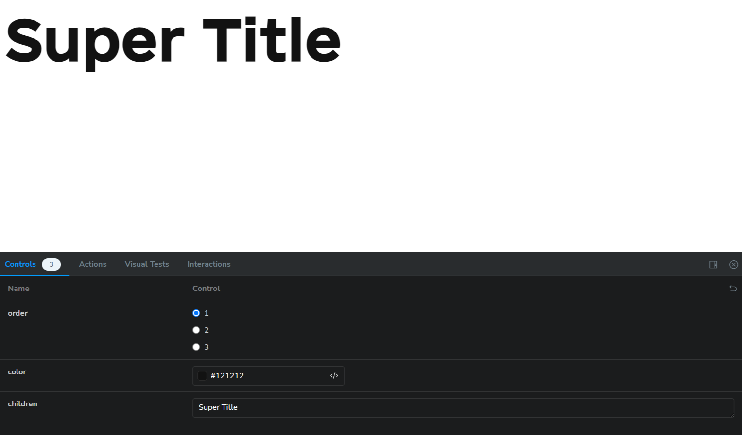

* 1. **Table - its styled table**

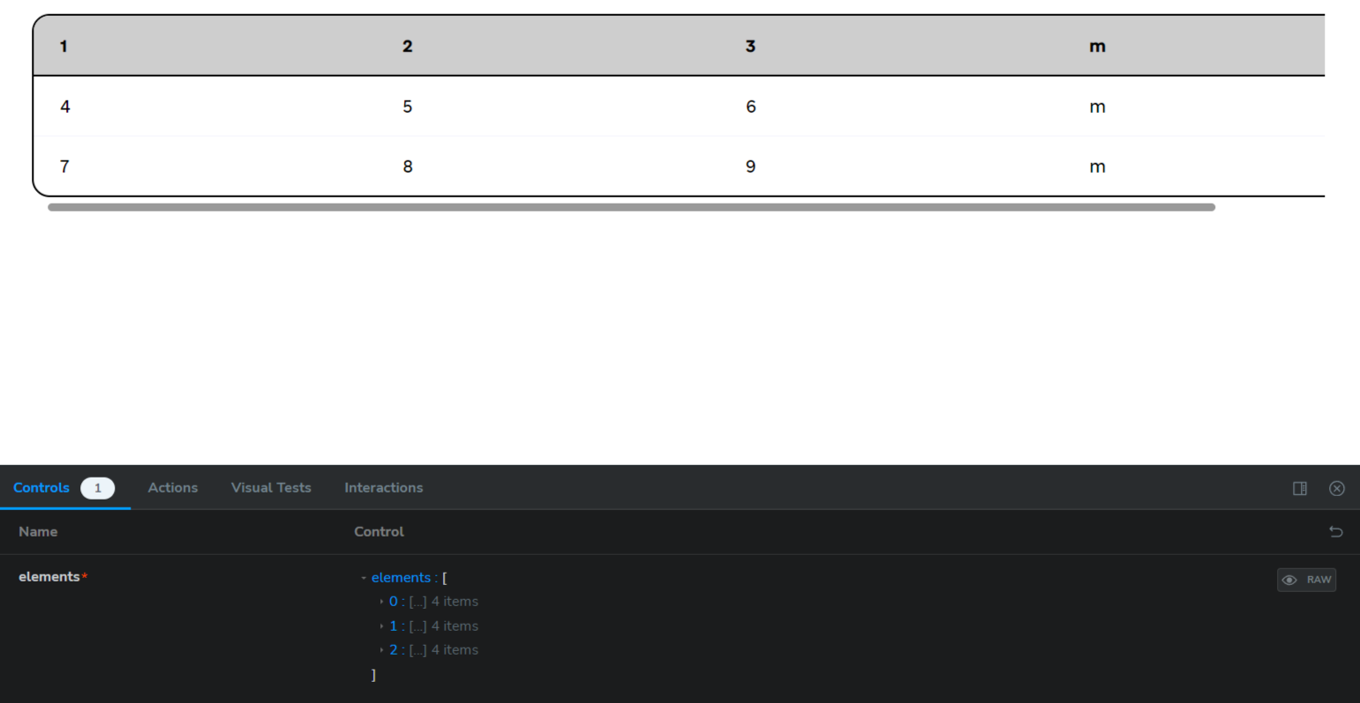

* 1. **Warning – warning component**

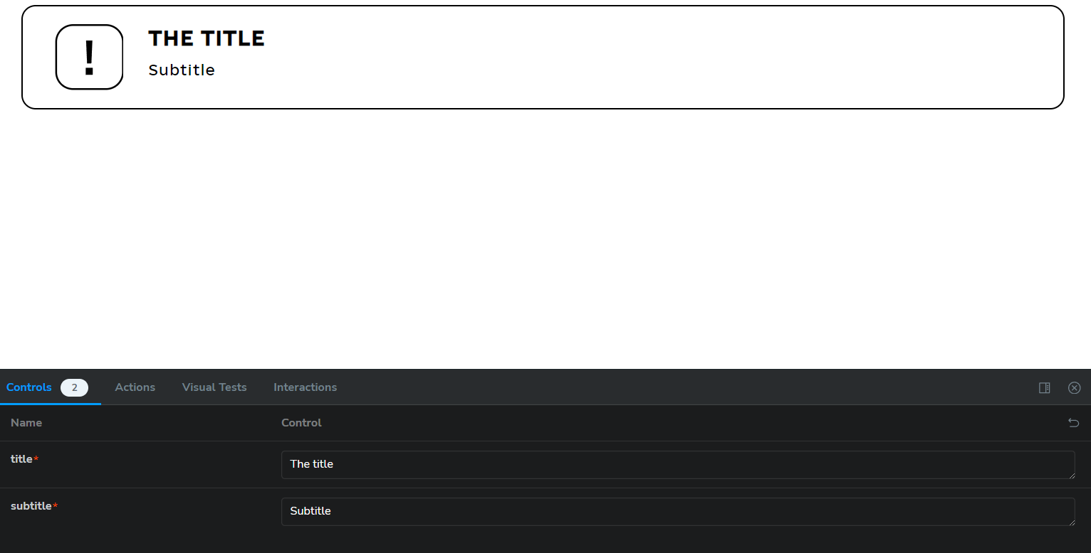

* 1. **1**