PF LAB 4 (DECISION STRUCTURES)

# ASSIGNMENT

MASHHOOD RIAZ

24K-0530

SECTION 1D

Q1)

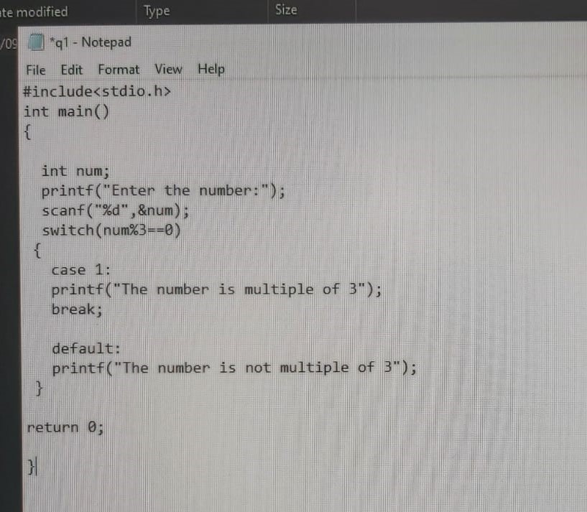

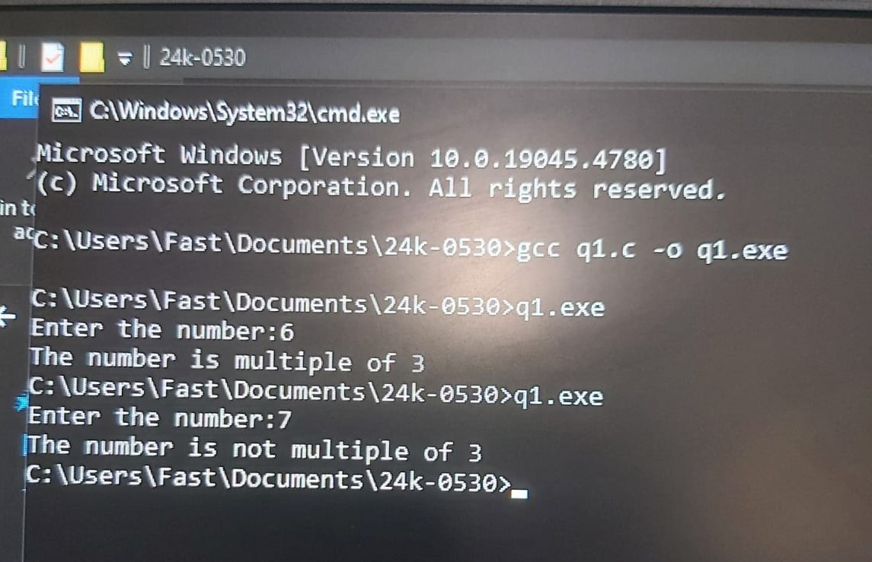

Q2)

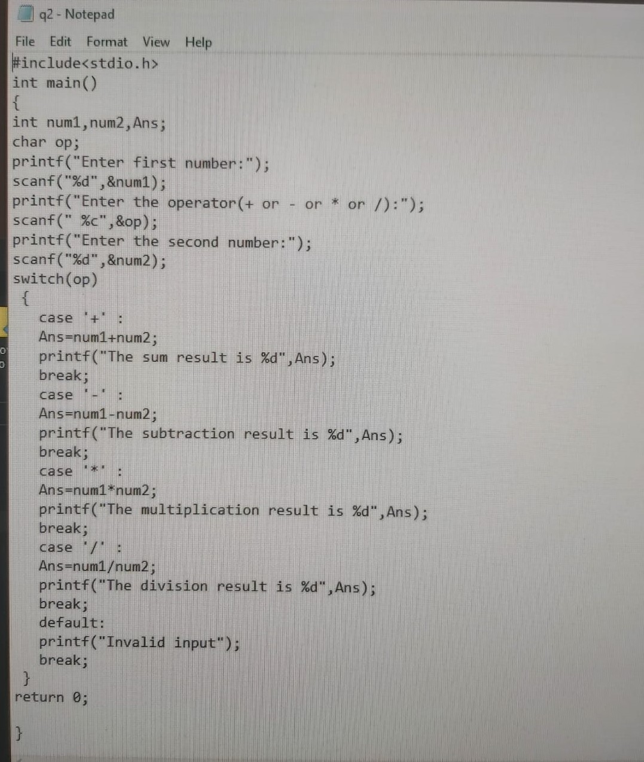

Q3)

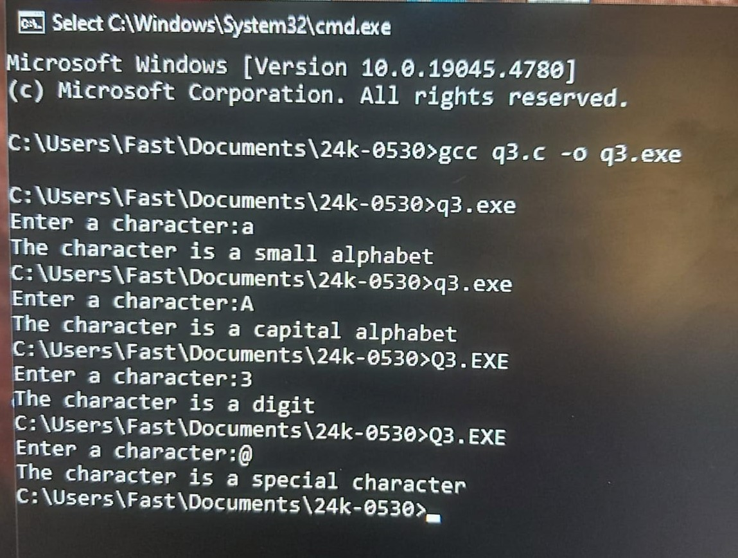

Q4)

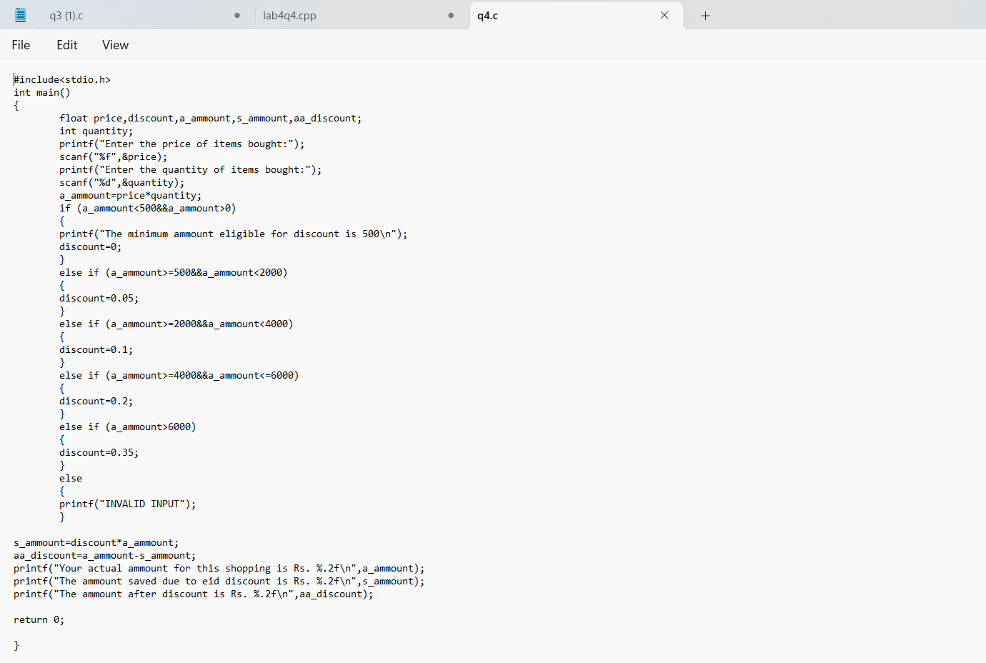

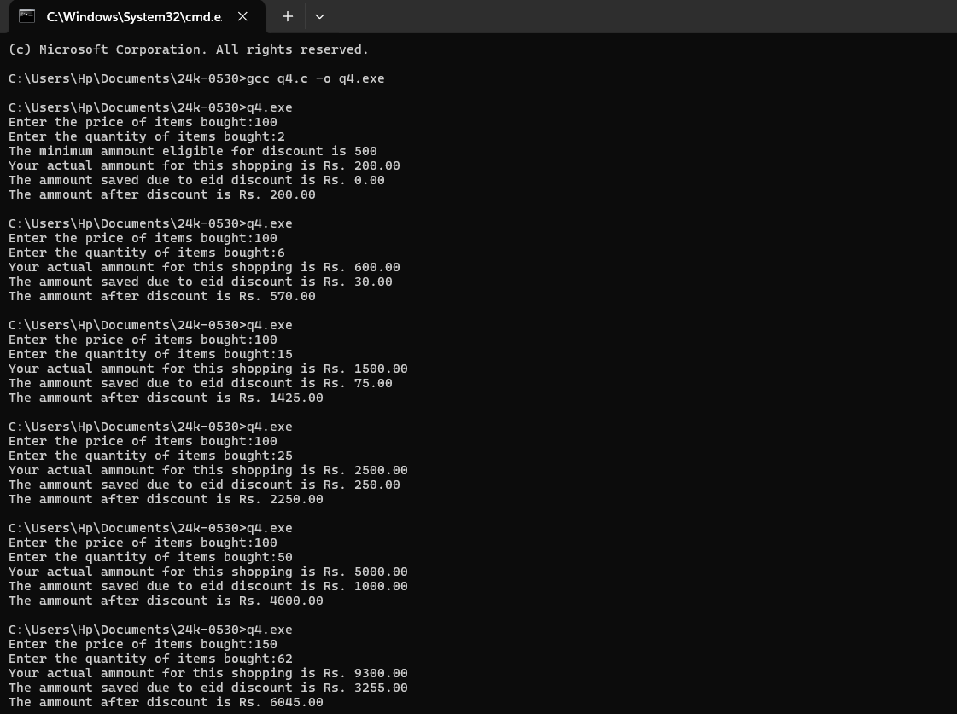

Q5)

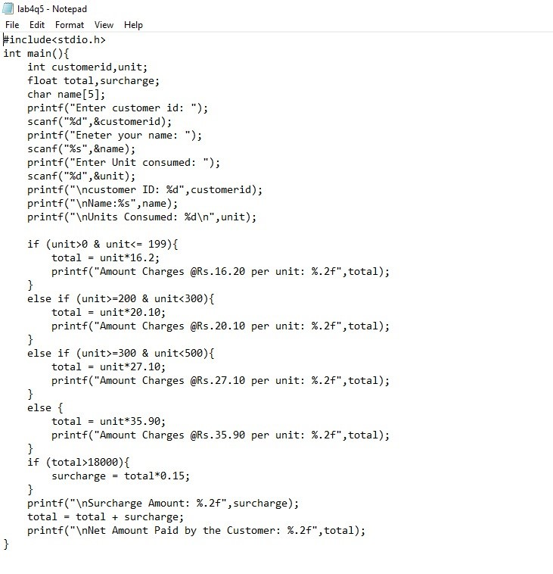

Q6)



