NAME: MASHHOOD FARQALEET
CLASS : BSCS -5 -B

ROLL NO.: 233807

COURSE : FULL STACK WEB DEVELOPMENT

SUBMITTED TO : SIR RASHAF JAMIL

Project structure
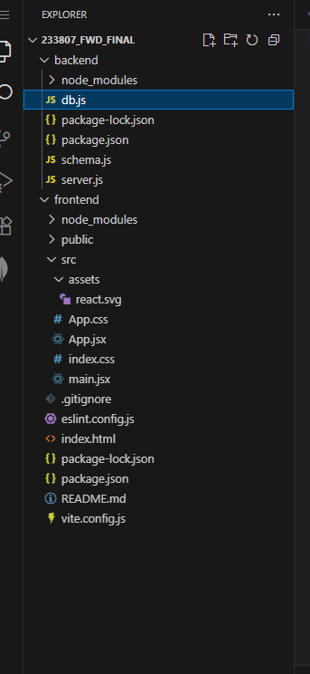

QUESTION # 1

FITNESS TRACKER APPLICATION

Frontend screen
1.

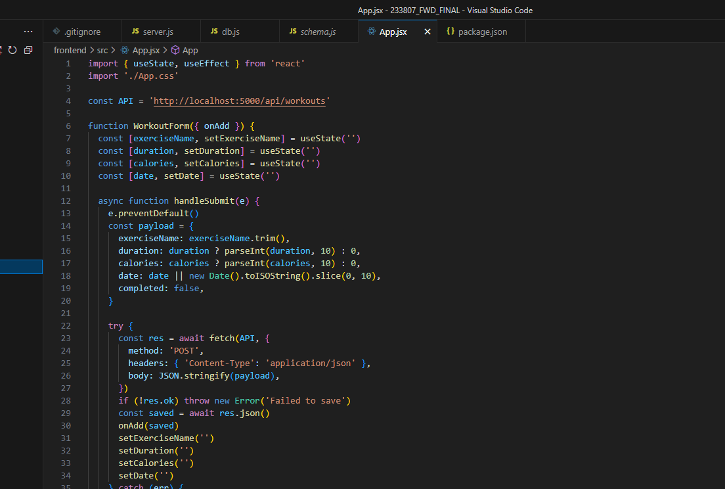
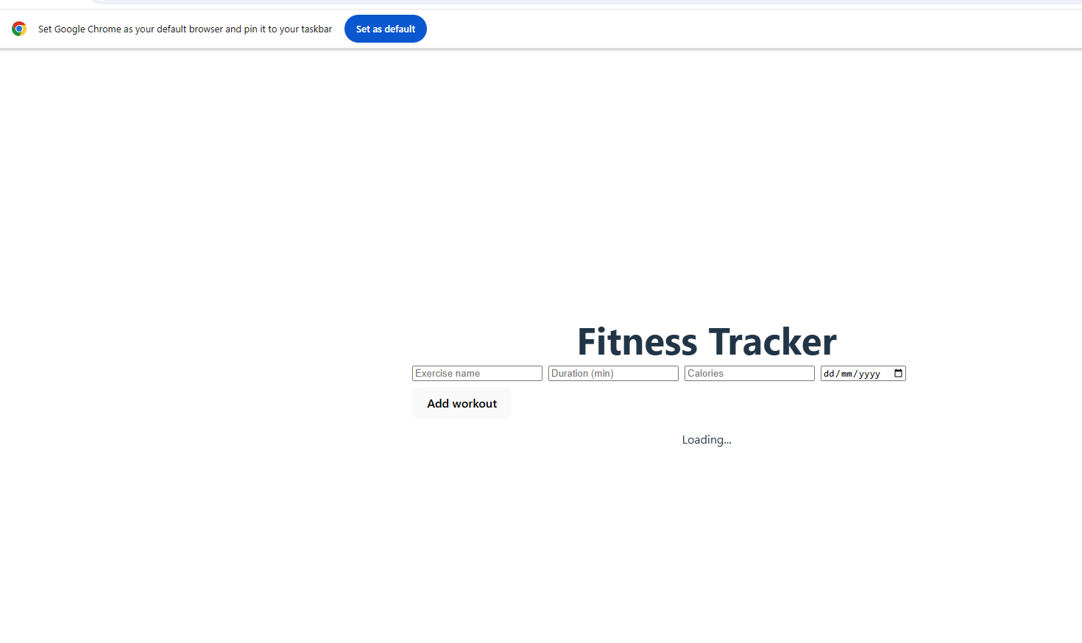

Db connection

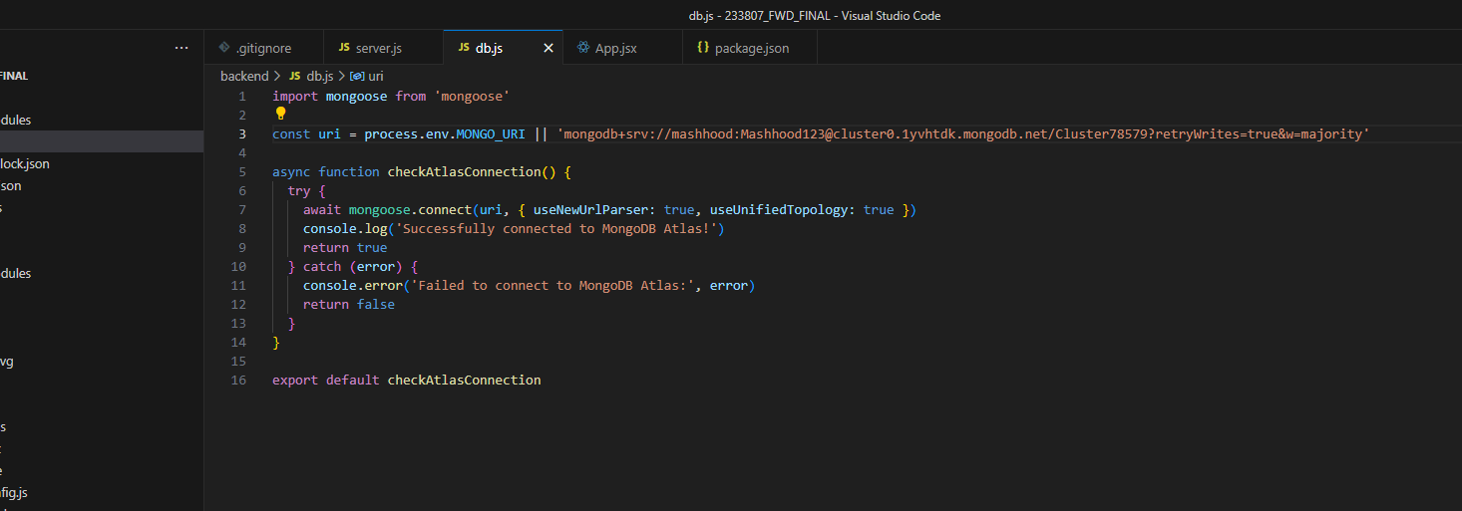

Schema

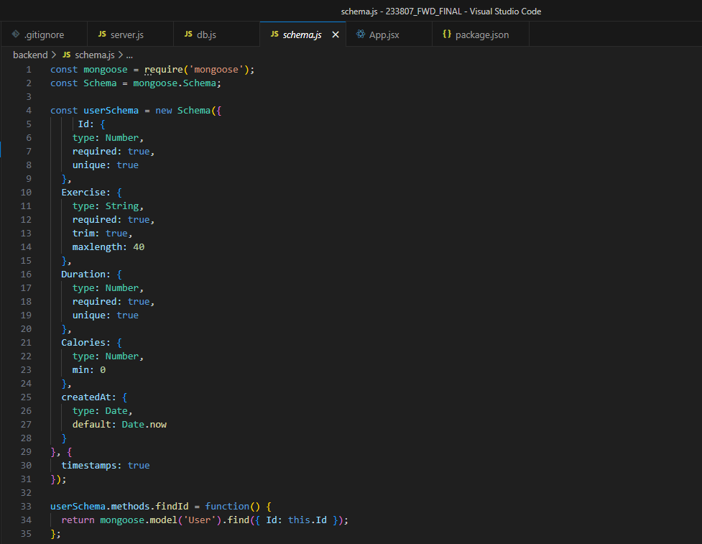

Backend
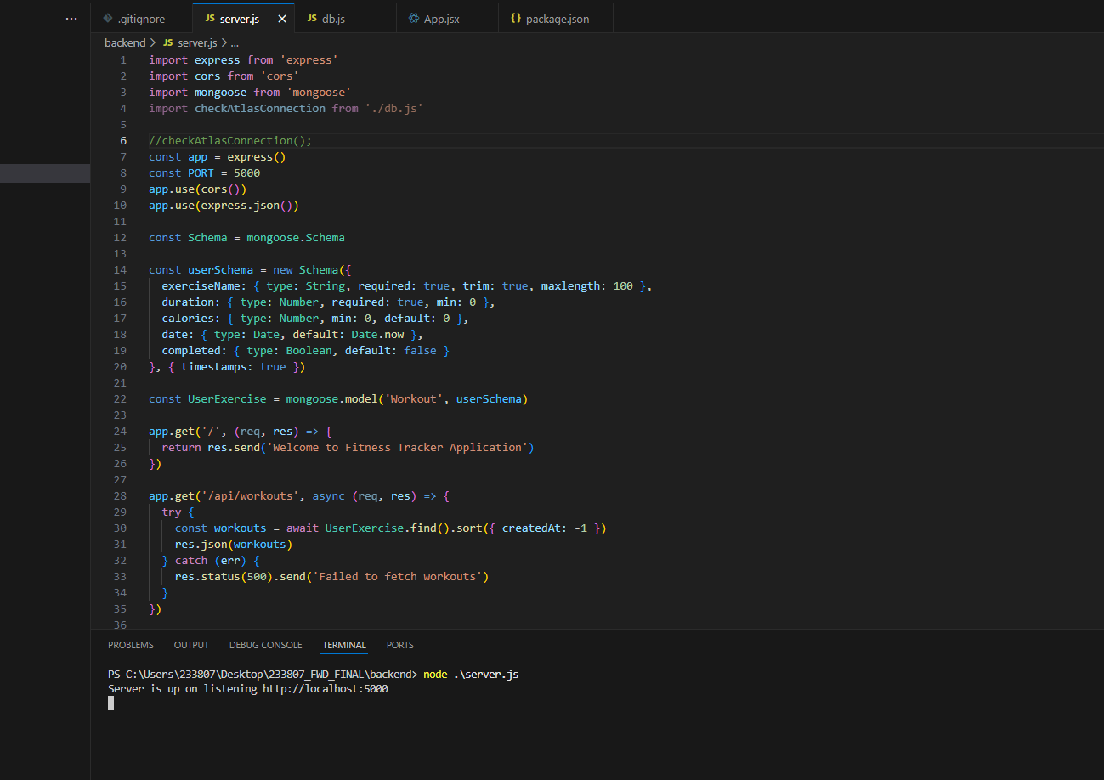

Backend in browser
