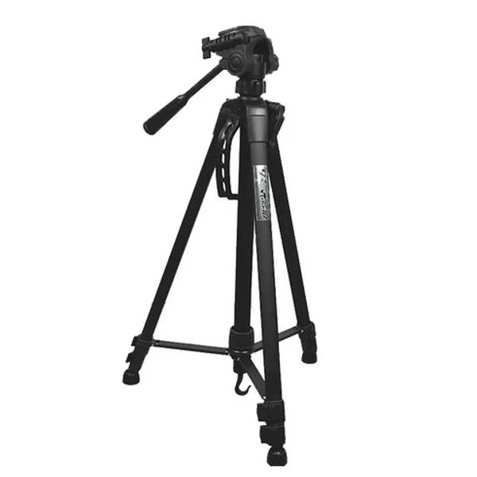**Weifeng WF-6663A Tripod Price in Pakistan**

**Model:WF-6663A**

**Weight:1.87kg**

**Material:Aluminium alloy**

**Max Load weight:8kg**

**Height of the contraction:535mm**

**Max height:1430mm**

**Minimum altitude:595mm**

**Largest pipe diameter:26mm**

**Model:WF-6160H**

**Camera cradle head height:85mm**

**Camera cradle head weight:0.47kg**

**Load weight:8kg**

**Model:WF-6663A**

**Weight:1.87kg**

**Material:Aluminium alloy**

**Max Load weight:8kg**

**Height of the contraction:535mm**

**Max height:1430mm**

**Minimum altitude:595mm**

**Largest pipe diameter:26mm**

**Model:WF-6160H**