Abstract
The fitness industry has seen exponential growth in recent years, driven by an increasing awareness of the importance of maintaining a healthy lifestyle. This trend has been further accelerated by the global pandemic, which has heightened public awareness about the benefits of physical fitness. The demand for fitness products, from home gym equipment to nutritional supplements, has surged as people look for ways to stay active and healthy. In response to the rising trend in health and wellness, this project aims to develop a state-of-the-art online application focused on selling fitness products. The app will serve as a one-stop-shop for fitness enthusiasts, offering a comprehensive range of products and a seamless shopping experience. By leveraging modern technologies and user-centric design principles, this app will address the diverse needs of fitness-conscious individuals, providing them with a convenient and efficient platform to purchase fitness-related items.The proposed online app will cater to this growing market by offering a wide variety of fitness products, including equipment, apparel, supplements, and accessories. The app will be designed to provide an intuitive and visually appealing user interface that enhances the shopping experience, making it easy for users to find and purchase the products they need.

  - About the Project

• Enhance User Experience: Develop a user-friendly interface that is easy to navigate, visually appealing, and accessible to a wide audience.
• Diverse Product Offering: Curate a comprehensive range of fitness products to cater to different customer preferences and needs.
• Secure Transactions: Implement advanced security protocols to ensure all financial transactions are safe and secure.
• Mobile Optimization: Ensure the app is fully functional on mobile devices, providing a seamless shopping experience on-the-go.
• Efficient Order Fulfillment: Establish a streamlined order processing system to ensure timely delivery and customer satisfaction.

1.1.1Key features
- Comprehensive Product Listings: Detailed descriptions, high-quality images, and user-generated reviews for each product.
- User-Friendly Shopping Cart and Checkout: Simplified process for adding items to the cart and completing purchases securely.
- Multiple Payment Options: Support for various payment methods including credit/debit cards, digital wallets, and installment plans.
- 24/7 Customer Support: Provide continuous customer support via chat, email, and phone.

Use Case Diagram

Let us understand how users would interact with the application

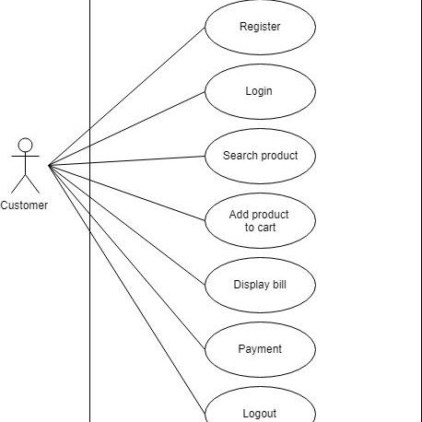

Fig Use case diagram

