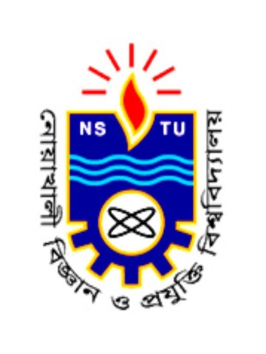**Department of Computer Science and Telecommunication Engineering**

Noakhali Science and Technology University

**Assignment On:** Short notes on Hypermedia, MIME, DMMS, MPEG-4, MP3

**Course Code:** CSTE 4203

**Course Title:** Multimedia Communication.

|  |  |
| --- | --- |
| **Submitted to:**  A.Q.M. Salauddin Pathan  Lecturer  Department of Computer Science and Telecommunication Engineering | **Submitted by:**  Md. Ashikur Rahman  Roll no: ASH1701001M  Year: 04, Term: 02  Session: 2016-2017 |

Date of submission: 15.01.2022