SERVICE FLOW
An AI-Powered Internet Service Help-Desk Triage Agent
WEEK 4 DELIVERABLES: Tools and Function Calling
BY
GROUP F

1. Tool Catalogue
Two explicit tools were defined and implemented behind the orchestration layer, one read-only and one side-effecting, matching the project's minimum scope for this week.
Field | Tool 1: check_outage_status | Tool 2: create_support_ticket
Purpose | Read-only lookup of simulated outage/incident status for a service area. | Create a simulated support ticket/draft record for an issue that needs human follow-up.
Input schema | { area_code: string, format XXX-NN } | { customer_id: string, category: enum, description: string, priority: low|medium|high }
Output schema | { status: outage_confirmed|no_known_outage|area_not_found, area_code, eta_minutes: int|null, incident_id: string|null } | { ticket_id: string, status: pending_approval|created|rejected, created_at: timestamp }
Authorization | None required — read-only, exposes no customer-specific data. | Caller must present a verified customer_id matching the active session; refused otherwise.
Side effects / risk level | None — low risk. | Side-effecting — higher risk. Ticket is created in pending_approval state and never auto-progresses to created.
Human approval | Not required. | REQUIRED. A separate approve_ticket() call (a human/deterministic action) is the only way a ticket moves from pending_approval to created.
Failure behaviour | Missing/malformed area_code -> validation_error. Simulated backend down -> unavailable (caller retries once, then tells customer to try later). | Missing required field -> validation_error. Category not in approved set -> validation_error. customer_id mismatch -> unauthorized.

2. Updated Architecture Diagram
The tool layer sits after classification (Week 2) and RAG-grounded troubleshooting (Week 3): if the customer's issue is classified as a possible outage, the orchestration layer calls check_outage_status; if the issue remains unresolved after grounded troubleshooting, it calls create_support_ticket, which is held behind a human approval gate before it is ever treated as created.
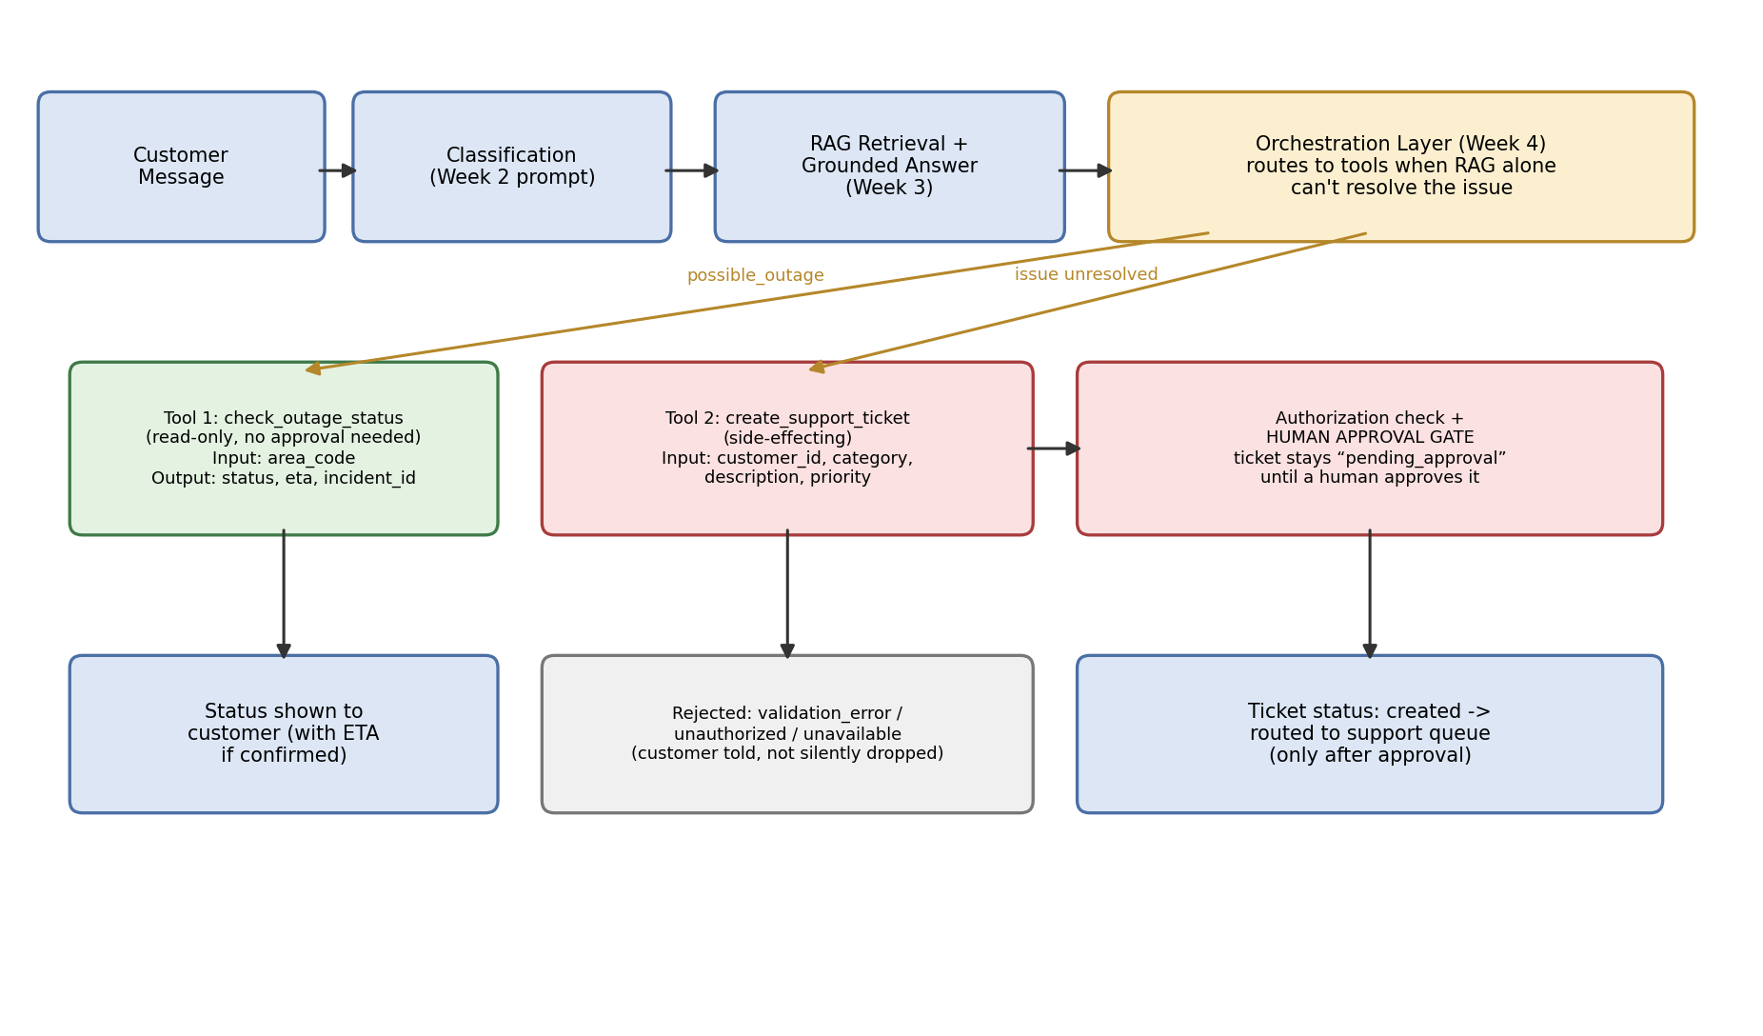

3. Working Demonstration of Both Tools
Implemented in tools.py (submitted alongside this document). Both tools, the orchestration router (call_tool), and the human-approval step (approve_ticket) are real, runnable, offline code — no API key is needed for this layer, so every result below was actually produced by running the script, not projected.
- check_outage_status — demonstrated against a confirmed outage, a clear area, and an unknown area (Cases 1–3).
- create_support_ticket — demonstrated end to end: a valid request is accepted into pending_approval, then a separate approve_ticket() call moves it to created (Case 6, detailed in Section 4).

4. Failure / Authorization Test Evidence
10 test cases were run covering normal use, missing parameters, an unauthorized request, a simulated unavailable service, and an unsupported tool name.
# | Test case | Category | Actual result (real run)
1 | Outage check — confirmed outage in area | Normal | status: outage_confirmed, eta_minutes: 90, incident_id: INC-2031 — Pass
2 | Outage check — no known outage | Normal | status: no_known_outage — Pass
3 | Outage check — unknown area code | Edge case | status: area_not_found — Pass
4 | Outage check — missing area_code parameter | Missing parameter | error_type: validation_error, “area_code is required and must match format XXX-NN.” — Pass
5 | Outage check — simulated backend service down | Unavailable service | error_type: unavailable, “Outage-status service did not respond (simulated).” — Pass (see failure note below — this case initially failed for the wrong reason and was fixed)
6 | Create ticket — valid request, authorized | Normal | status: pending_approval, ticket_id issued — Pass. Ticket does NOT reach “created” until separately approved (see Section 4).
7 | Create ticket — missing description field | Missing parameter | error_type: validation_error, “Missing required field(s): description.” — Pass
8 | Create ticket — invalid category (“billing_dispute”) | Invalid input | error_type: validation_error, “'billing_dispute' is not an approved category.” — Pass
9 | Create ticket — customer_id does not match verified session | Unauthorized request | error_type: unauthorized, request refused — Pass
10 | Call an undefined tool (“cancel_service”) | Unexpected/unsupported request | error_type: not_found, “Unknown tool 'cancel_service'.” — Pass

Genuine failure found and fixed during testing
Case 5 (simulated service unavailable) initially failed for the wrong reason: the mock “service down” area code did not match the area_code format check, so it was rejected as a validation_error before the code ever reached the outage-status lookup that was supposed to raise “unavailable.” This masked the failure path we actually needed to test. The fix was to give the simulated-down area a code in the correct format (DWN-99) so it passes validation and correctly reaches the unavailable branch. This is left in as documented evidence rather than silently corrected, since it demonstrates a real class of bug: validation order can accidentally hide the failure case you meant to test.

Human-approval flow, demonstrated end to end
After Case 6 creates a ticket (status: pending_approval), calling approve_ticket(ticket_id, approved_by="human_agent_dennise") is the only way its status becomes created. No code path in create_support_ticket itself can set status to created — the approval step is a structurally separate function, not a flag the AI or the customer can set.

WEEK 4 PROGRESS REPORT
ServiceFlow: An AI-Powered Internet Service Help-Desk Triage Agent
Group / Project Name | Group F — ServiceFlow
Week Ending | 25 September 2026

1. Work completed against weekly objectives
- Defined two tools (check_outage_status, create_support_ticket) with full input/output schemas, authorization rules and failure behaviour.
- Implemented tool/function calling through an orchestration layer (call_tool) that routes by tool name and returns structured, typed errors.
- check_outage_status retrieves current (simulated) application data; create_support_ticket performs a low-risk simulated side effect (a draft ticket record).
- Tested missing parameters, an unauthorized request, a simulated unavailable service, and an unsupported/unexpected tool name — 10 cases in total, all run for real.
- Added a human-approval gate before any ticket is treated as created — the higher-impact action required by this week's brief.
- Updated the architecture diagram to show the new tool layer alongside Week 2's classification and Week 3's RAG layer.

2. Key engineering decisions and why they were made
Engineering decision | Reason
Every ticket is created in “pending_approval”, never directly in “created” | Matches the project's AI Boundary Matrix and the closing rule that high-impact actions stay behind human approval — applied unconditionally rather than only for high-priority tickets, since a wrong low-priority ticket still wastes staff time.
Authorization checked against a verified customer_id in context, not the request body alone | Prevents a customer (or a compromised prompt) from creating a ticket under someone else's identity by simply naming a different customer_id in the arguments.
Structured error_type on every failure (validation_error / unauthorized / unavailable / not_found) | Lets the orchestration layer and the final customer-facing message react differently to each failure type instead of showing one generic error.
Outage-status tool kept strictly read-only with no approval gate | Matches the recommended-use-case boundary: “no remote control of infrastructure or automatic service disconnection/reconnection” — a status lookup carries no such risk and would over-restrict the flow if gated.

3. Failures / challenges and current response
A validation-order bug initially hid the “service unavailable” failure path behind a formatting rejection (see Section 4) — fixed by using a correctly formatted simulated-down area code. No other defects found in this week's 10-case run; further adversarial testing of the tool layer (e.g. prompt-injection attempts to call create_support_ticket with a forged customer_id) is planned for Week 7's evaluation pass.

4. Links to repository and task evidence
GitHub Repository: https://github.com/mashimwe/GROUP-F-Capstone-
ClickUp Board / Tasks: https://app.clickup.com/1200420000004230/v/s/1200420000006102
GitHub Commit(s)/Tag/PR: [to be updated with the Week 4 commit, tag or pull request]

5. Individual contribution summary
Member | Task owned | Evidence (commit/file/task link)
Buyinza Samuel | [task owned this week] | [GitHub / ClickUp link]
Bahati Brenda Kizito | [task owned this week] | [GitHub / ClickUp link]
Aruho Priscillah | [task owned this week] | [GitHub / ClickUp link]
Andimashimwe Rhoda | [task owned this week] | [GitHub / ClickUp link]
Nuwahereza Dennise | Tool Catalogue, tool schemas, authorization/failure test design, updated architecture diagram | [GitHub / ClickUp link]

Note: add specific GitHub commit IDs or ClickUp task links where available.

6. Plan for next week (Week 5: Agent Architecture and Bounded Autonomy)
- Define one task that genuinely benefits from multi-step decision making (e.g. triage -> retrieve -> decide whether to check outage or create a ticket -> stop).
- Design the Sense/Context -> Plan/Decide -> Act/Tool -> Observe -> Stop/Re-plan loop using the Week 3 and Week 4 building blocks.
- Set maximum iterations, the approved-tool allow-list, stop conditions, and human hand-off conditions.
- Capture at least three execution traces, including one failure/recovery case.

Overall Week 4 Status
ON TRACK — two tools are implemented, tested and demonstrated with genuine failure evidence, and the higher-impact action (ticket creation) is structurally behind a human-approval gate rather than a policy note. Week 5 will wire these tools into a bounded multi-step agent loop.

