Q1. A use case diagram is used to represent the dynamic behavior of a system. It encapsulates the system's functionality by incorporating use cases, actors, and their relationships.

Consider the example of UML Diagram of use case of Banking System

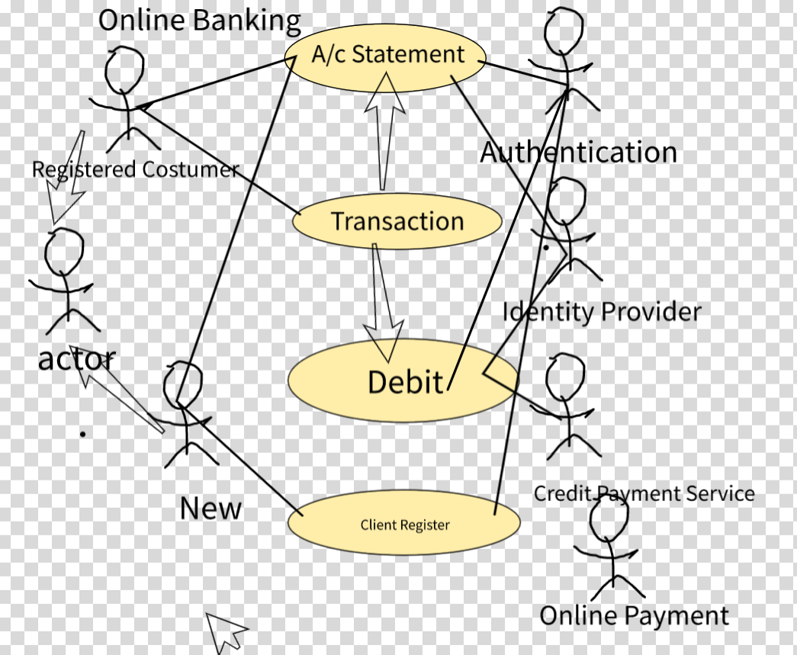

Q2.We can create abstract class and after inheritance to child class.

a.I have created abstract class with abstract methods and I have created string name for input and output.

b.Secondly,I have created a child class which inherit the properties of abstract class.

c.For calling the class string name we have encapsulated the property of the Animal.