iOS Remote QA
Simple README-style guide
This guide explains how to run the Remote QA stack and manually configure QuickTime, OBS, Xcode/WebDriverAgent, and Tailscale sharing.

What this project uses
- QuickTime Player: mirrors the real iPhone/iPad screen on the Mac.
- OBS: captures the QuickTime window and sends it to MediaMTX.
- MediaMTX: exposes the OBS stream as WebRTC.
- Appium + WebDriverAgent: sends taps and swipes to the real device.
- Tailscale: lets another account/device open the browser UI remotely.

1. Install dependencies
Run this once on the host Mac:
chmod +x install-remote-qa-deps.sh
./install-remote-qa-deps.sh
The installer checks/installs Node, Appium, the XCUITest driver, MediaMTX, OBS, Tailscale, and iOS device tools.
At the end, it should try to open WebDriverAgent in Xcode automatically.

2. Configure WebDriverAgent in Xcode
When Xcode opens WebDriverAgent, configure signing before running tests.
1. Select the WebDriverAgentRunner target.
2. Select your real iPhone/iPad as the destination.
3. Open Signing & Capabilities.
4. Enable Automatically manage signing.
5. Select your Apple Developer Team.
6. Use a valid Bundle Identifier, for example com.yourname.webdriveragent.
7. Run Product > Test, or press Cmd + U.
Target: WebDriverAgentRunner
Destination: your real iPhone/iPad
Signing: Automatically manage signing
Team: your Apple Developer Team
Action: Product > Test / Cmd + U
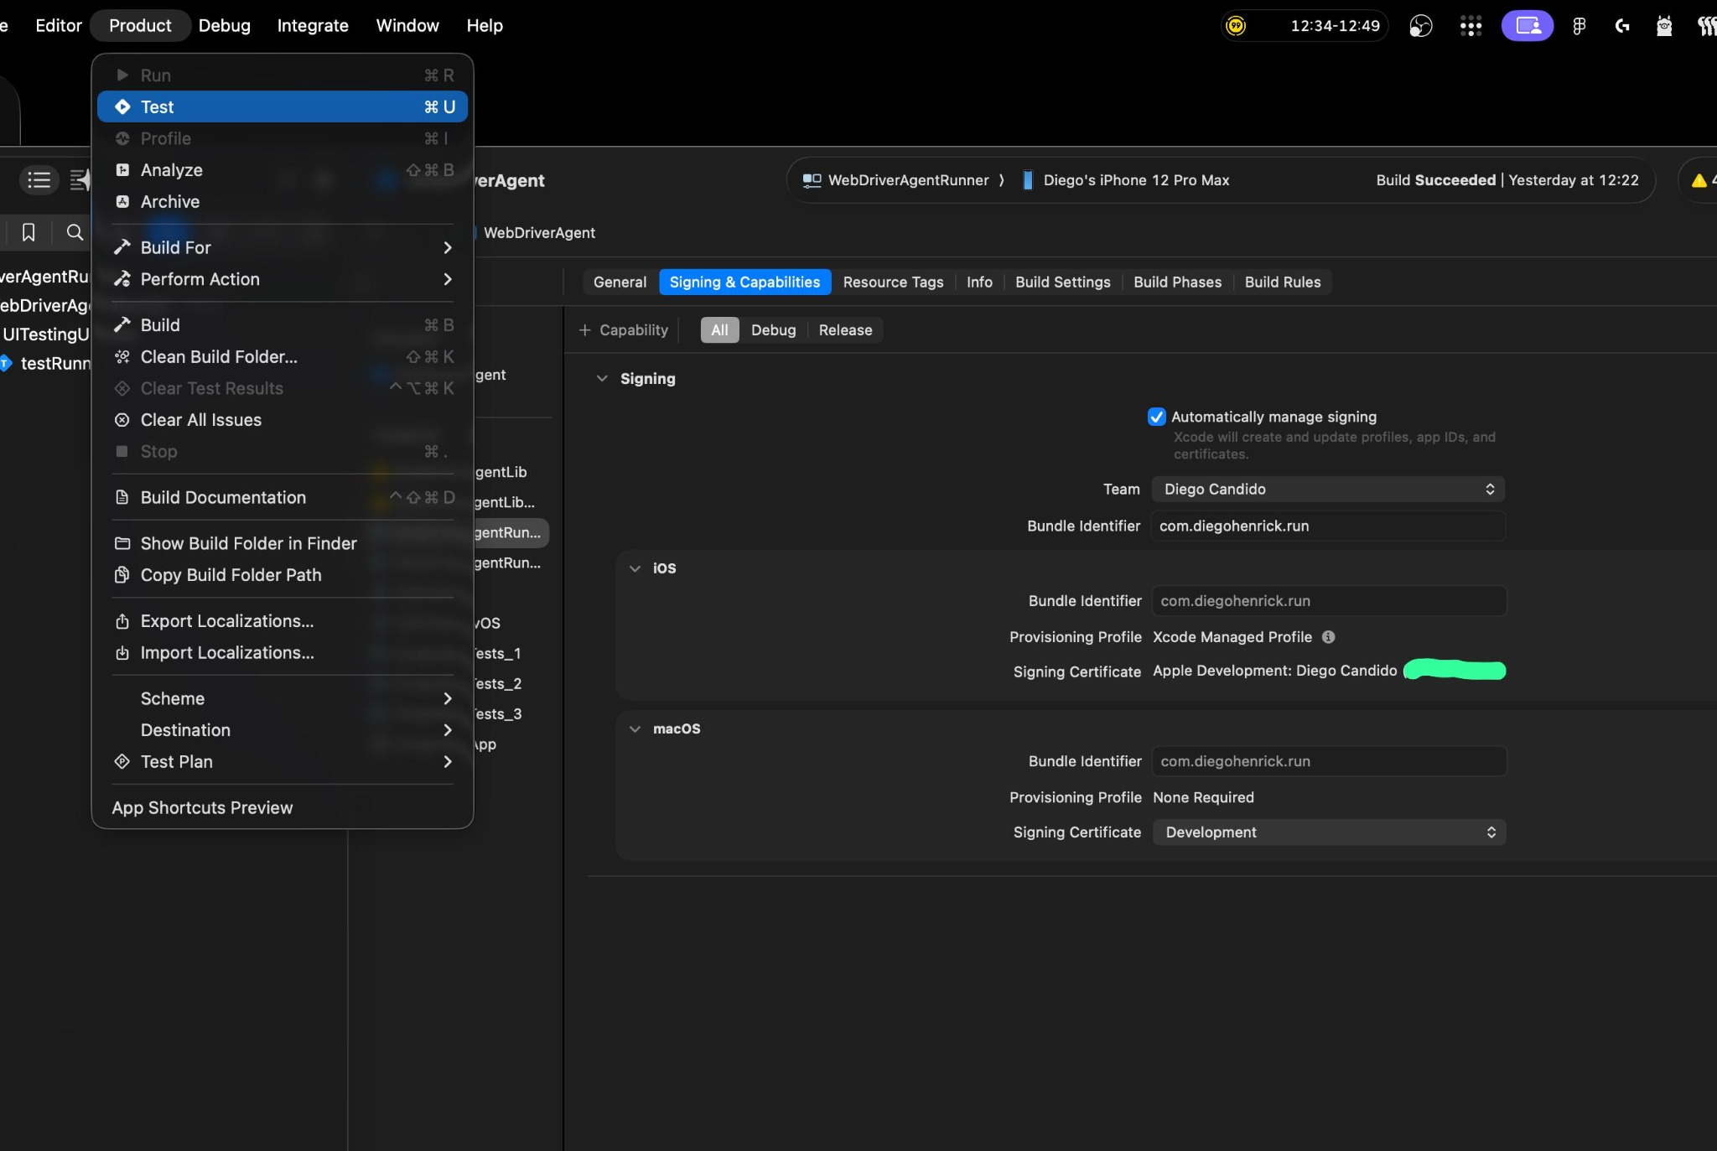
Xcode: select WebDriverAgentRunner, choose the real device, configure Signing & Capabilities, then run Product > Test.
If the iPhone asks to trust the developer profile, open Settings > General > VPN & Device Management and trust it.

3. Share the host Mac with Tailscale
Use this when another account/device needs to access the stream.
1. Open the Tailscale admin page.
2. Go to Machines.
3. Find the host Mac, for example diegos-macbook-pro.
4. Click Share.
5. Share by email or copy the share link.
6. Accept the share from the second account/device.
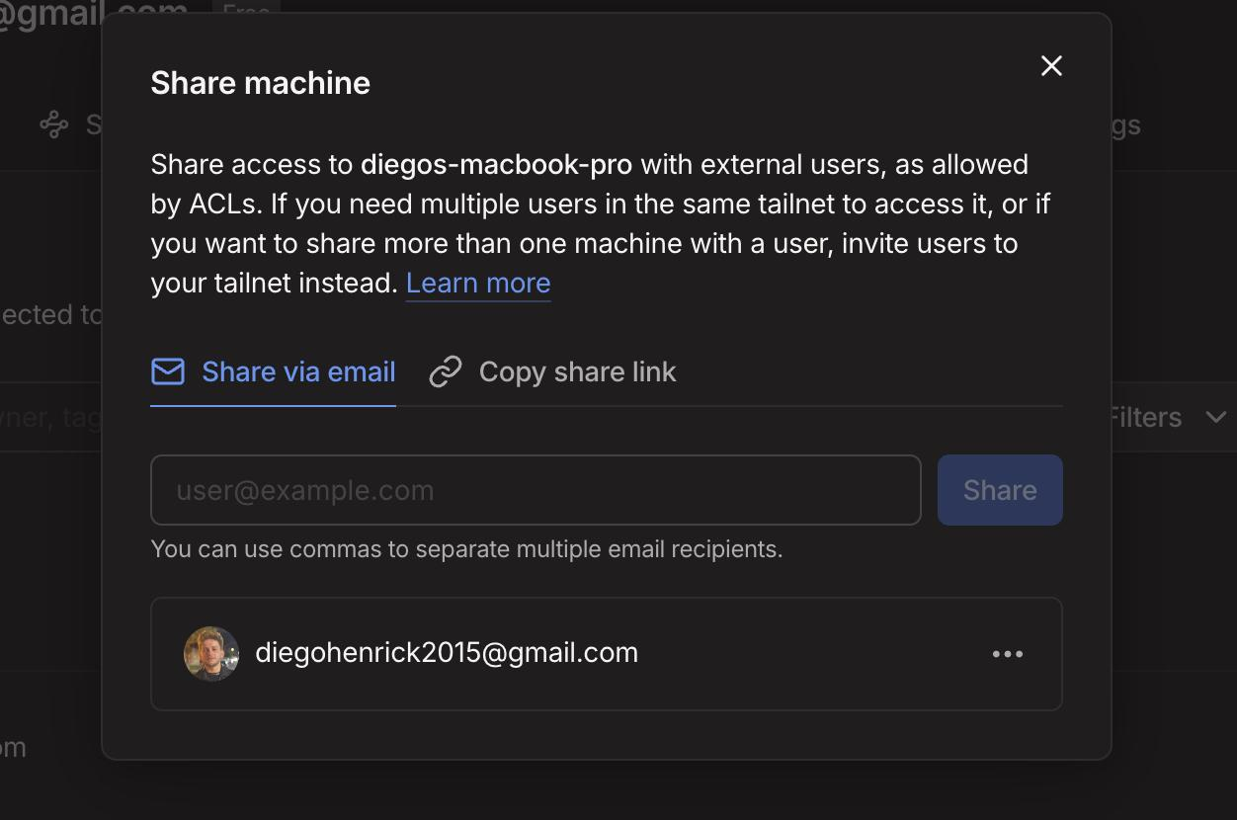
Tailscale: share the host Mac with the other account or copy the share link.
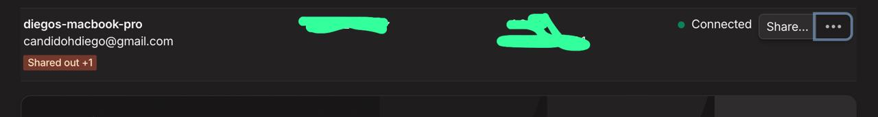
After sharing, the host Mac shows as shared out in Tailscale.
Check the host Mac Tailscale IP:
tailscale ip -4
Remote users should open the browser UI using the Tailscale IP:
http://TAILSCALE_IP:3000
Important: OBS still publishes locally to localhost. Only the remote browser uses the Tailscale IP.
OBS WHIP URL:
http://localhost:8889/simulator/whip

Remote browser UI:
http://TAILSCALE_IP:3000

Remote video URL:
http://TAILSCALE_IP:8889/simulator

4. Open QuickTime manually
QuickTime is not opened by the startup script. Open it manually before running the stack.
1. Connect the iPhone/iPad by USB.
2. Unlock the device and trust this Mac if prompted.
3. Open QuickTime Player.
4. Go to File > New Movie Recording.
5. Click the small arrow next to the record button.
6. Under Screen, select your iPhone/iPad.
7. Under Speaker, select your iPhone/iPad if you want device audio.
8. Keep the QuickTime window open. You do not need to press record.
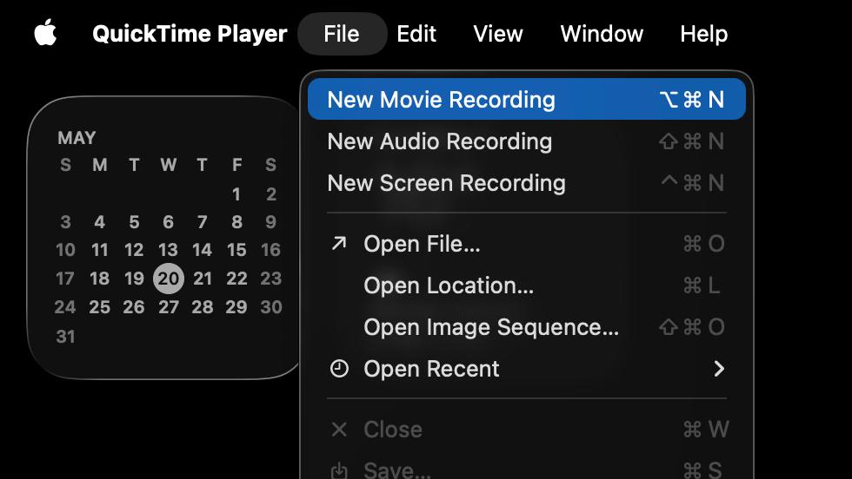
QuickTime: File > New Movie Recording.
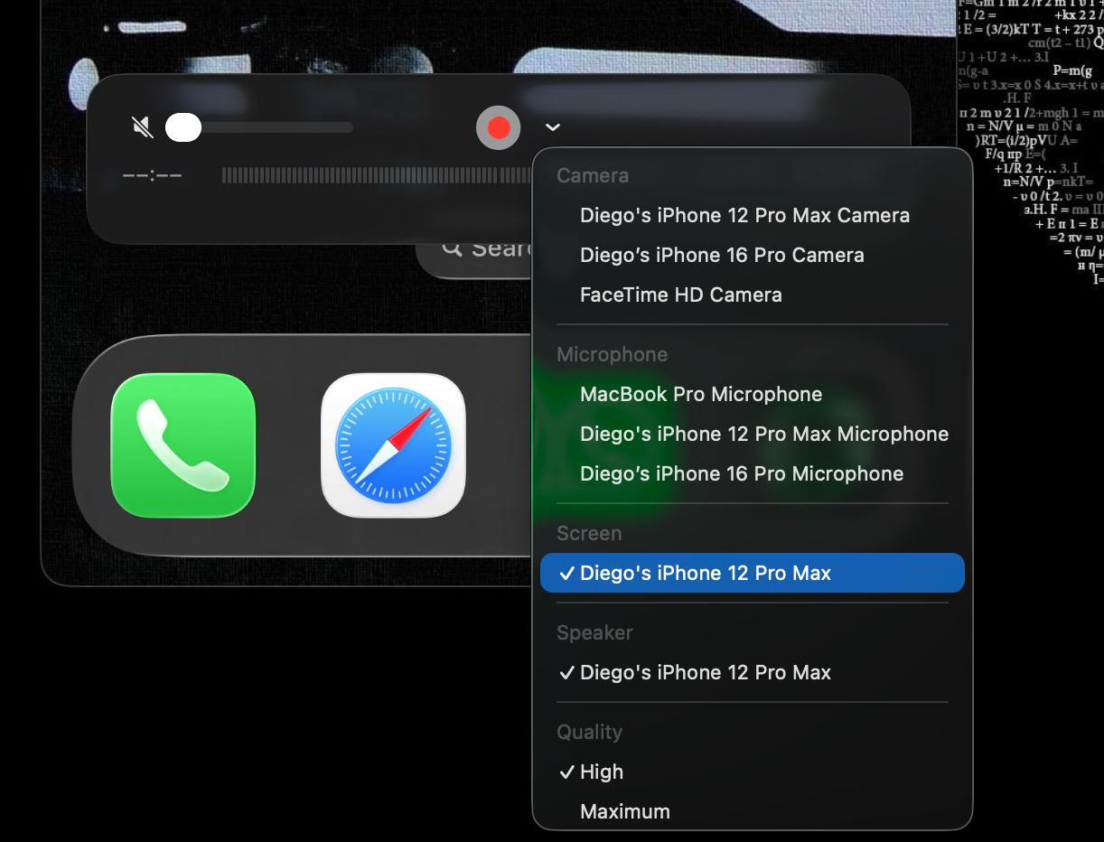
QuickTime: select the device under Screen, and optionally select it under Speaker for audio.
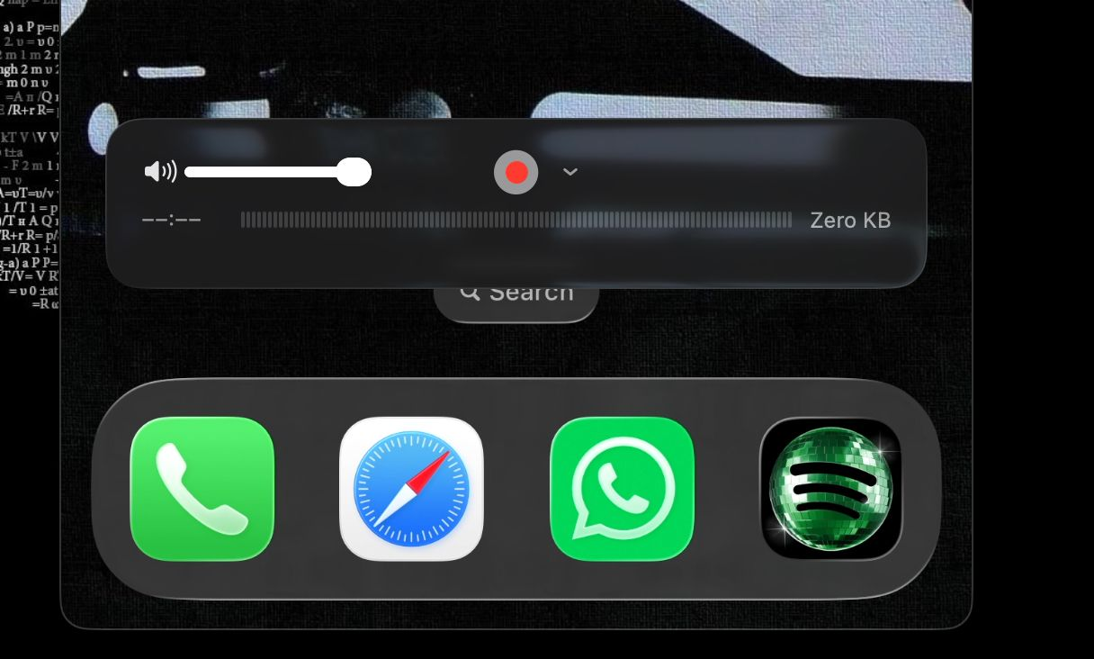
QuickTime: use the volume control if you need audio from the mirrored device.

5. Configure OBS manually
Open OBS after QuickTime is already showing the device screen.
1. Use the RemoteQA-iPhone or RemoteQA-iPad profile.
2. In Sources, select macOS Screen Capture.
3. Open Properties.
4. Set Method to Window Capture.
5. Set Window to [QuickTime Player] Movie Recording.
6. Click OK.
7. Resize/crop the source so only the device screen appears.
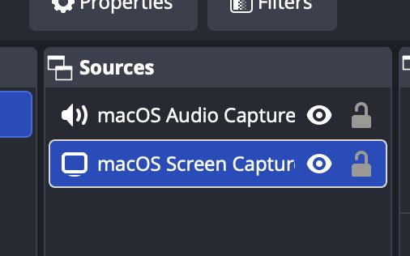
OBS: select the macOS Screen Capture source.
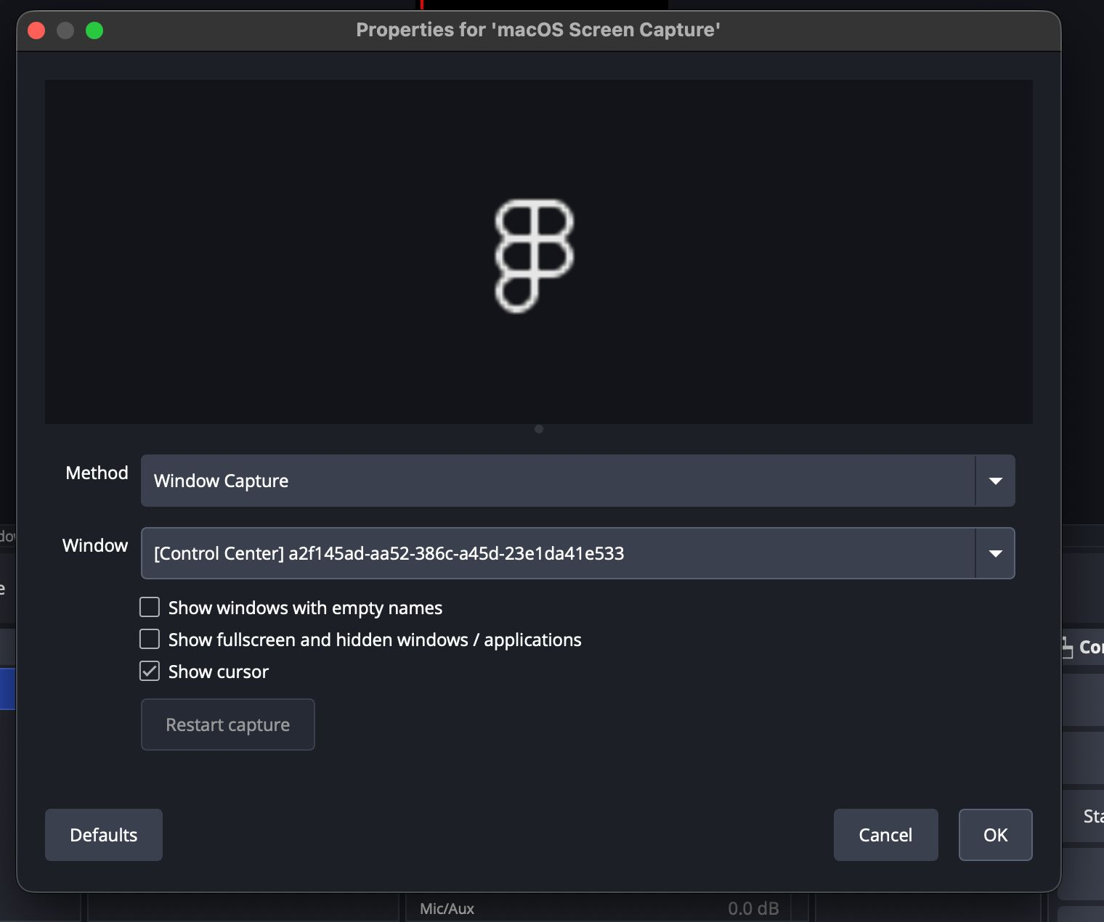
OBS: set Method to Window Capture.
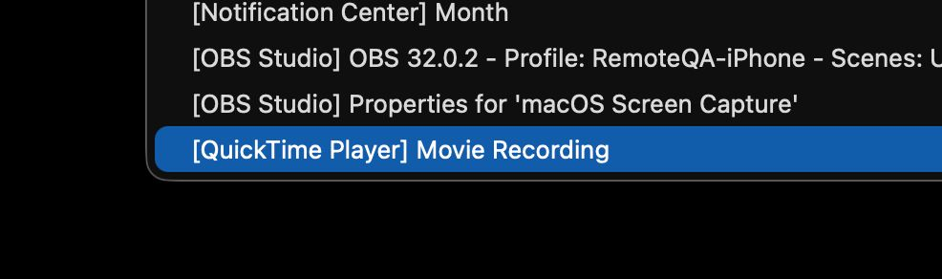
OBS: choose [QuickTime Player] Movie Recording as the window.
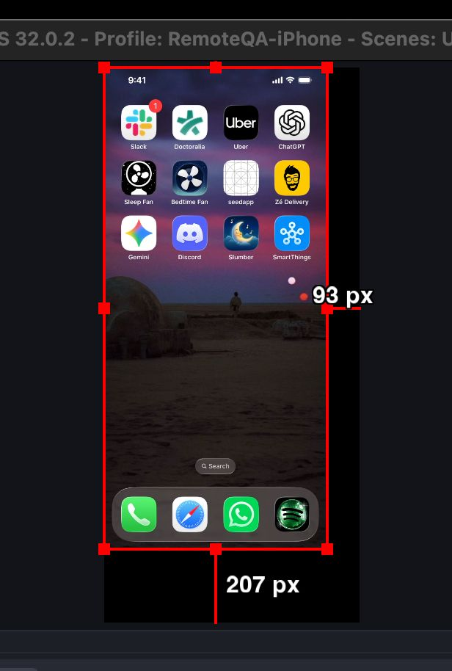
OBS: crop/resize the source to remove black borders.
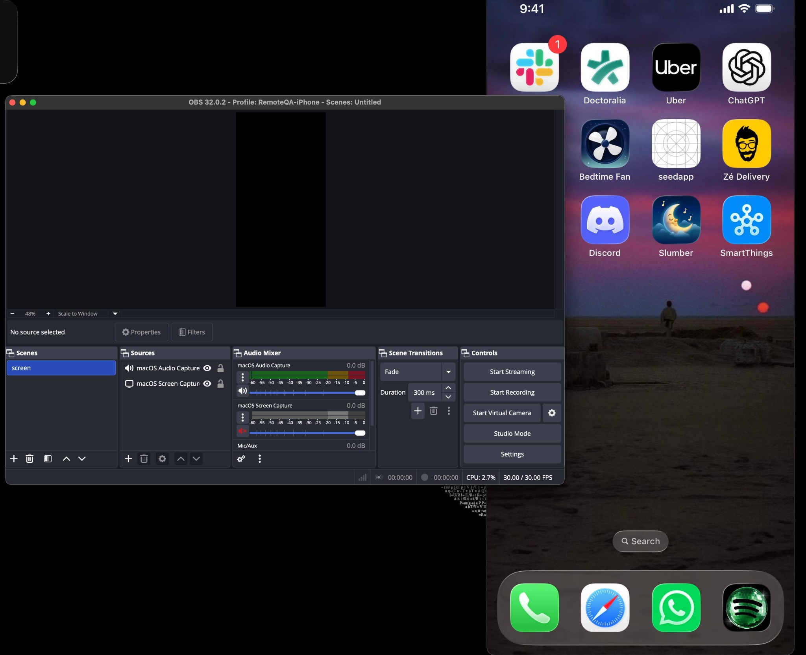
OBS: final scene with QuickTime captured and audio source present.
The OBS stream target should stay local:
http://localhost:8889/simulator/whip

6. Start the Remote QA stack
For iPhone:
./run-remote-qa.sh iphone
For iPad:
./run-remote-qa.sh ipad
The script starts MediaMTX, Appium, the Node web server, and the OBS launch script. QuickTime must already be open manually.

7. Open the browser UI
On the same Mac:
http://localhost:3000
From another device through Tailscale:
http://TAILSCALE_IP:3000
In the web UI:
- Click Load OBS Video to load the stream.
- Click Start Appium Session to enable device control.
- Tap and swipe inside the phone frame to control the real device.
- Click Control Player if you need to unmute or interact with the video player.
- Click Control iPhone to return to device control.

8. If something stops working
If device control stops working:
1. Click Stop Session.
2. Click Start Appium Session again.
If the video freezes:
1. Click Load OBS Video again.
2. If needed, restart OBS.
3. Make sure QuickTime is still showing the device screen.
If everything is stuck, stop the stack and start again:
./kill-remote-qa.sh
./run-remote-qa.sh iphone

9. Useful logs
tail -f logs/mediamtx.log
tail -f logs/appium.log
tail -f logs/node-server.log
tail -f logs/obs.log

10. Quick URL reference
Local web UI:
http://localhost:3000

Local MediaMTX stream:
http://localhost:8889/simulator

OBS WHIP publish URL:
http://localhost:8889/simulator/whip

Remote web UI through Tailscale:
http://TAILSCALE_IP:3000

Remote stream through Tailscale:
http://TAILSCALE_IP:8889/simulator

