### Solving analytical queries on RedShift Cluster

Here, you have to write the query used for solving the question and the screenshots of the table which is outputted after the query is run on the AWS RedShift Query editor UI.

1. **Top 10 ATMs where most transactions are in the ’inactive’ state**

select R.atm_number, R.atm_manufacturer,

S.location, Q.total_transaction_count, Q.inactive_count, (Q.total_transaction_count*100/Q.inactive_count) as count_percent

from ( select atm_id, count(*) total_transaction_count,

sum(case when atm_status = 'Inactive' then 1 else 0 end) inactive_count

from bankatm_schema.atm_trans

where atm_status = 'Inactive'

group by atm_id

order by total_transaction_count desc limit 10) Q,

bankatm_schema.atm R,

bankatm_schema.location S

where Q.atm_id = R.atm_id and R.atm_location_id = S.location_id

order by total_transaction_count desc;

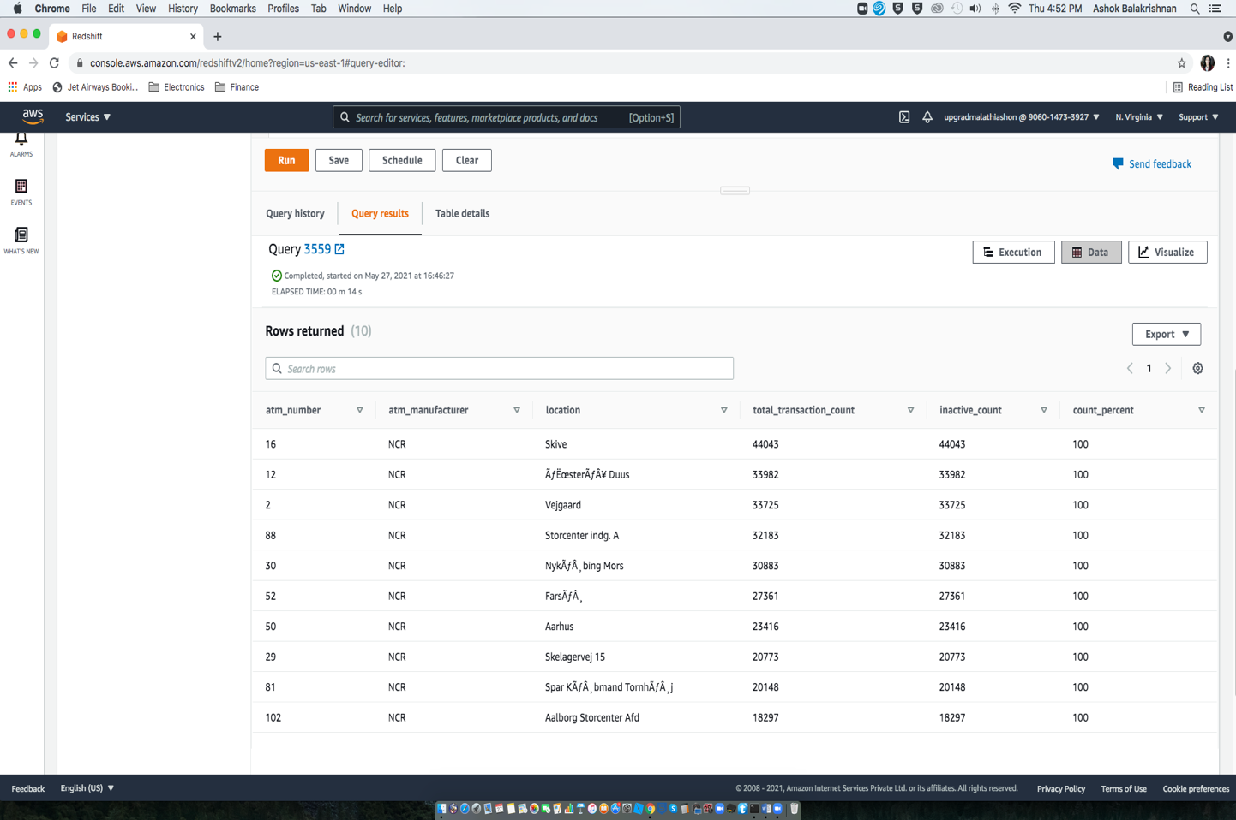

1. **Number of ATM failures corresponding to the different weather conditions recorded at the time of the transactions**

select Q.weather_main, count(*) as total_transaction_count,

sum(case when Q.atm_status = 'Inactive' then 1 else 0 end) as inactive_count, CAST(inactive_count*100.0/total_transaction_count as decimal(5,2)) as count_percent

from bankatm_schema.atm_trans Q, bankatm_schema.atm R

where Q.atm_id = R.atm_id and Q.weather_main != ''

group by Q.weather_main

order by count_percent desc;

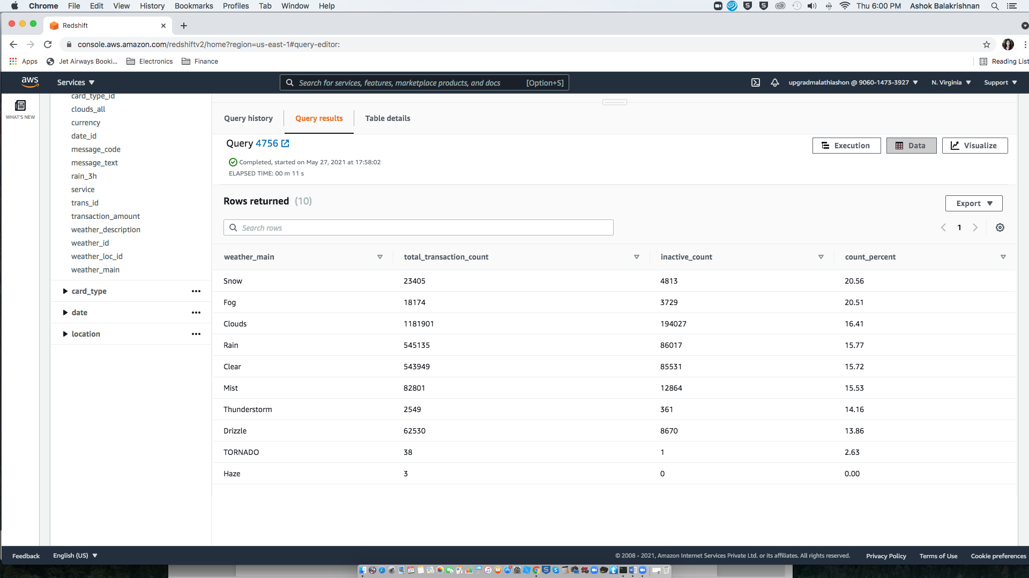

1. **Top 10 ATMs with the most number of transactions throughout the year**

select R.atm_number, R.atm_manufacturer, S.location,

count(*) total_transaction_count

from bankatm_schema.atm_trans Q, bankatm_schema.atm R, bankatm_schema.location S

where Q.atm_id = R.atm_id and R.atm_location_id = S.location_id

group by R.atm_number, R.atm_manufacturer, S.location

order by total_transaction_count desc;

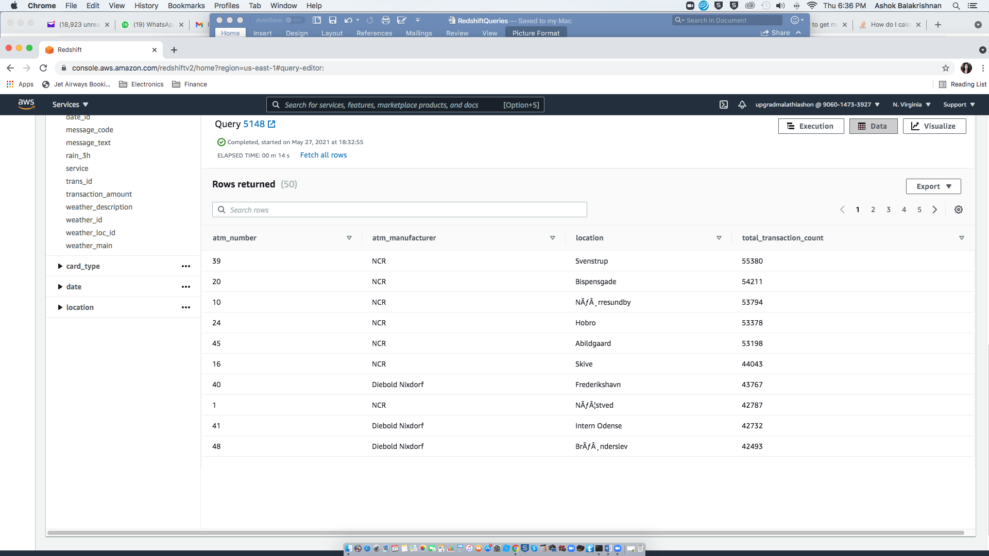

1. **Number of overall ATM transactions going inactive per month for each month**

select Q.Year, Q.month, count(P.*) total_transaction_count,

sum(case when P.atm_status = 'Inactive' then 1 else 0 end) inactive_count, CAST(inactive_count*100.0/total_transaction_count as decimal(5,2)) as inactive_count_percent

from bankatm_schema.atm_trans P, bankatm_schema.date Q

where P.date_id = Q.date_id

group by Q.Year, Q.month

order by Q.Year, Q.month

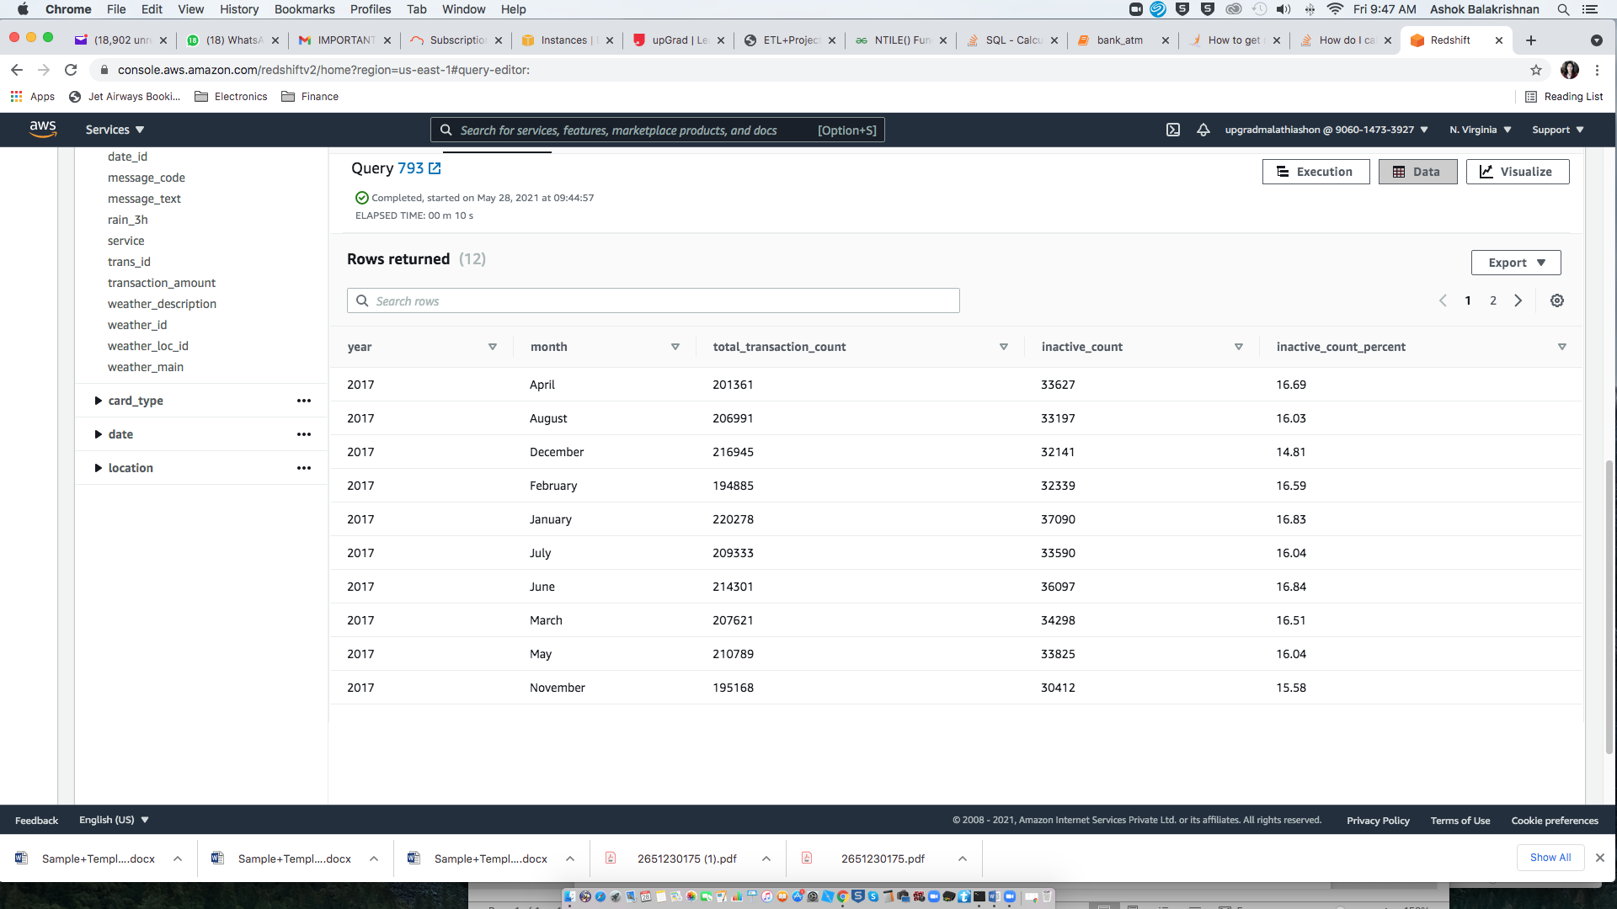

1. **Top 10 ATMs with the highest total withdrawn amount throughout the year**

select R.atm_number, R.atm_manufacturer, S.location, Q.total_transaction_amount

from (select atm_id, sum(transaction_amount) total_transaction_amount

from bankatm_schema.atm_trans

group by atm_id

order by total_transaction_amount desc limit 10) Q, bankatm_schema.atm R,

bankatm_schema.location S

where Q.atm_id = R.atm_id and R.atm_location_id = S.location_id

order by total_transaction_amount desc;

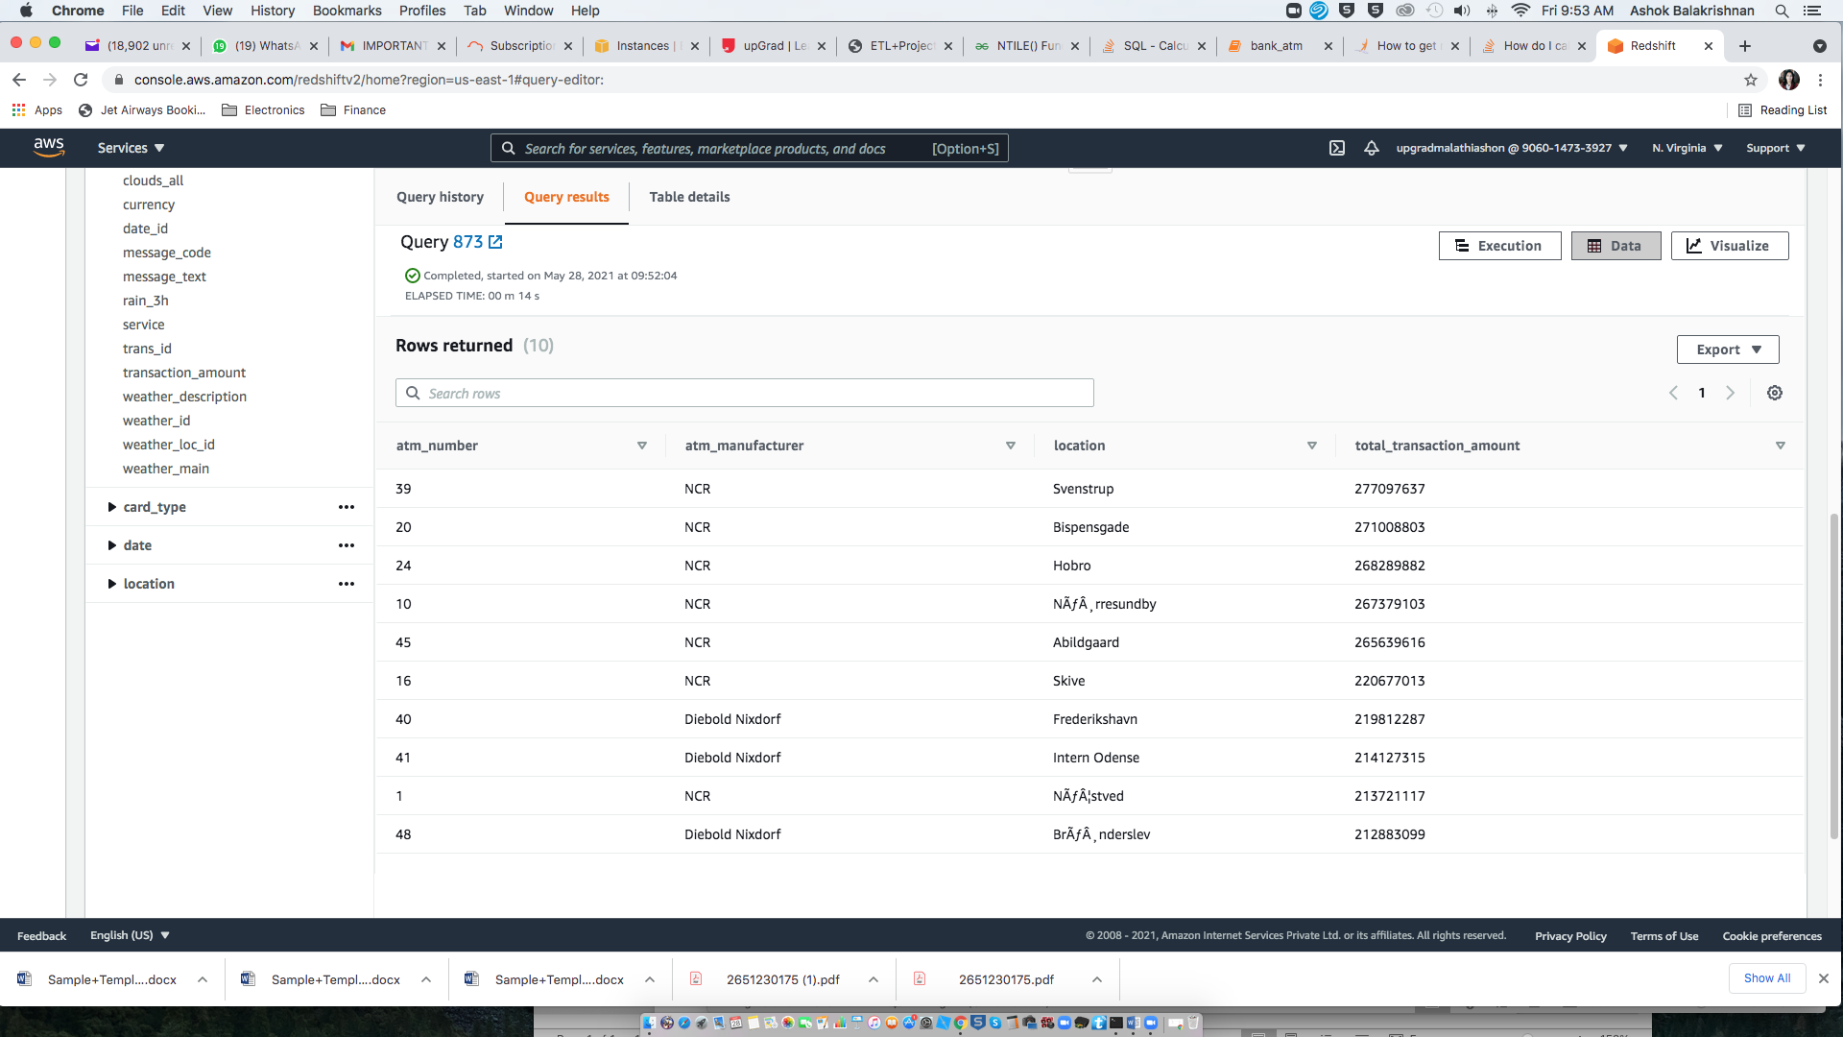

1. **Number of failed ATM transactions across various card types**

select Q.card_type, count(P.trans_id) total_transaction_count,

sum(case when P.atm_status = 'Inactive' then 1 else 0 end) inactive_count, CAST(inactive_count*100.0/total_transaction_count as decimal(5,2)) as inactive_count_percent

from bankatm_schema.atm_trans P, bankatm_schema.card_type Q

where P.card_type_id = Q.card_type_id

group by Q.card_type

order by inactive_count_percent desc limit 10

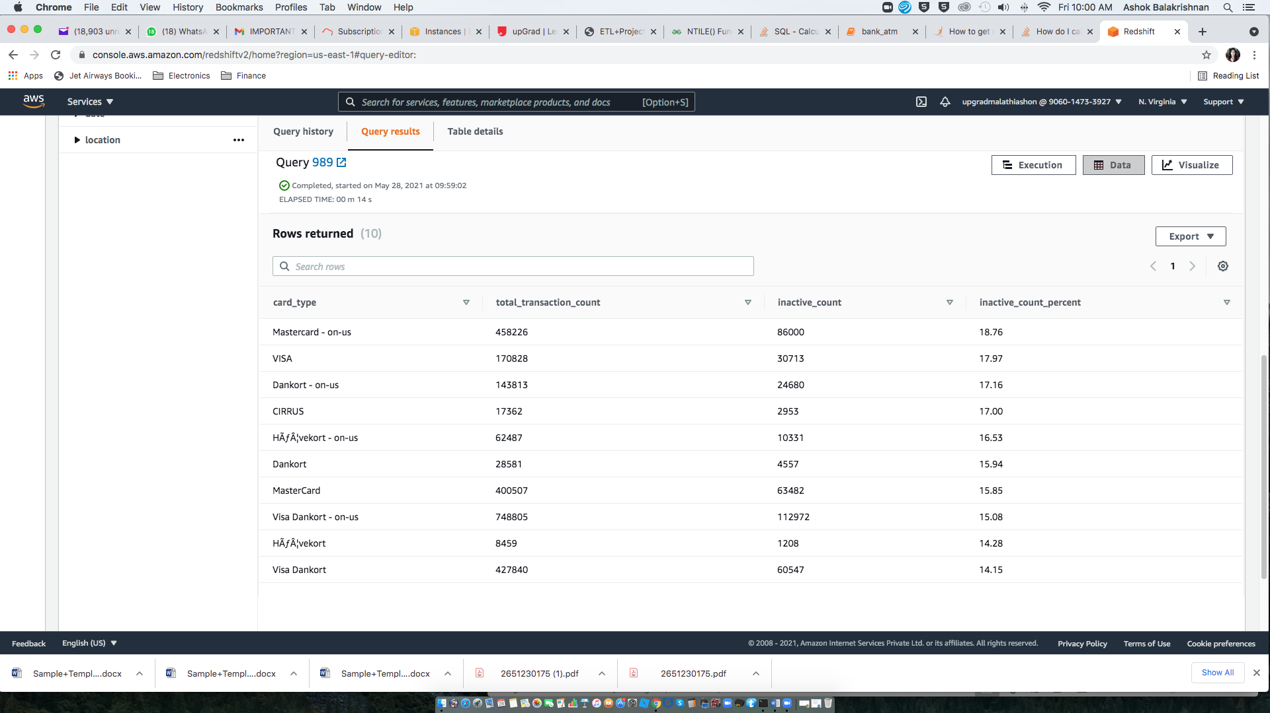

1. **Number of transactions happening on an ATM on weekdays and on weekends throughout the year. Order this by the ATM_number, ATM_manufacturer, location, weekend_flag and then total_transaction_count**

(select C.atm_number, C.atm_manufacturer, D.location, ( case when B.weekday = 'Saturday' or B.weekday = 'Sunday' then 1 else 0 end ) Weekend_flag, count(trans_id) transaction_count

from bankatm_schema.atm_trans A, bankatm_schema.date B, bankatm_schema.atm C, bankatm_schema.location D

where A.date_id = B.date_id and B.weekday in ('Saturday','Sunday') and A.atm_id = C.atm_id and A.weather_loc_id = D.location_id

group by C.atm_number, C.atm_manufacturer, D.location, Weekend_flag

order by C.atm_number)

union

(select C.atm_number, C.atm_manufacturer, D.location, ( case when B.weekday != 'Saturday' or B.weekday != 'Sunday' then 0 else 1 end ) Weekend_flag, count(trans_id) transaction_count

from bankatm_schema.atm_trans A, bankatm_schema.date B, bankatm_schema.atm C, bankatm_schema.location D

where A.date_id = B.date_id and B.weekday not in ('Saturday','Sunday') and A.atm_id = C.atm_id and A.weather_loc_id = D.location_id

group by C.atm_number, C.atm_manufacturer, D.location, Weekend_flag

order by C.atm_number)

order by atm_number

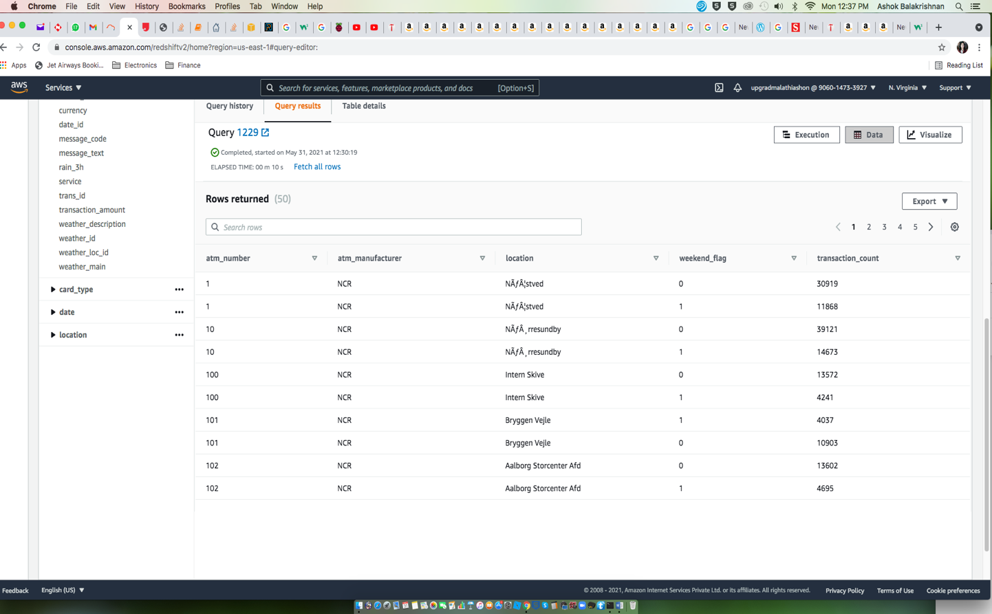

1. **Most active day in each ATMs from location "Vejgaard"**

WITH summary AS

(select Q.atm_number, Q.atm_manufacturer, R.location, S.weekday, count(*) as total_transaction_count,

ROW_NUMBER() OVER(PARTITION BY Q.atm_number

ORDER BY total_transaction_count DESC) AS rank

from bankatm_schema.atm_trans P, bankatm_schema.atm Q, bankatm_schema.location R, bankatm_schema.date S

where P.atm_id=Q.atm_id and R.location = 'Vejgaard' and R.location_id = P.weather_loc_id and P.date_id = S.date_id

group by Q.atm_number, Q.atm_manufacturer, R.location, S.weekday

order by Q.atm_number desc

)

SELECT atm_number, atm_manufacturer, location, weekday, total_transaction_count

FROM summary

WHERE rank = 1

order by total_transaction_count asc

