### Creation of a RedShift Cluster

**Screenshots of the configuration of the RedShift cluster that you have created:**

### 

### 

### Setting up a database in the RedShift cluster and running queries to create the dimension and fact tables

**Queries to create the various dimension and fact tables with appropriate primary and foriegn keys:**

**create table bankatm_schema.card_type(**

**card_type_id SMALLINT not null distkey sortkey,**

**card_type VARCHAR(50),**

**);**

**create table bankatm_schema.atm(**

**atm_id SMALLINT not null distkey sortkey,**

**atm_number VARCHAR(50),**

**atm_manufacturer VARCHAR(100),**

**atm_location_id INTEGER**

**);**

**create table bankatm_schema.location(**

**location_id SMALLINT not null distkey sortkey,**

**location VARCHAR(80),**

**streetname VARCHAR(255),**

**street_number VARCHAR(20),**

**zipcode INTEGER,**

**latitude DECIMAL(10,3),**

**longitude DECIMAL(10,3)**

**);**

**create table bankatm_schema.date(**

**date_id SMALLINT not null distkey sortkey,**

**full_date_time TIMESTAMP,**

**year INTEGER,**

**month VARCHAR(20),**

**day SMALLINT,**

**hour SMALLINT,**

**weekday VARCHAR(20)**

**);**

**create table bankatm_schema.atm_trans(**

**trans_id BIGINT not null distkey sortkey,**

**atm_id INTEGER,**

**weather_loc_id INTEGER,**

**date_id INTEGER,**

**card_type_id INTEGER,**

**atm_status VARCHAR(20),**

**currency VARCHAR(10),**

**service VARCHAR(20),**

**transaction_amount INTEGER,**

**message_code VARCHAR(255),**

**message_text VARCHAR(255),**

**rain_3h DECIMAL(10,3),**

**clouds_all INTEGER,**

**weather_id INTEGER,**

**weather_main VARCHAR(50),**

**weather_description VARCHAR(255)**

**);**

### Loading data into a RedShift cluster from Amazon S3 bucket

**Queries to copy the data from S3 buckets to the RedShift cluster in the appropriate tables**

copy bankatm_schema.card_type

from ‘s3://reshift-mashok-upgrad/card_type_dim/part-00000-e61d5a27-2118-43d8-9a16-0193cd74d712-c000.csv’

iam_role 'arn:aws:iam::906014733927:role/Redshift0s3_fullaccess'

delimiter ','

region 'us-east-1'

csv

IGNOREHEADER 1;

Listing the top 10 rows of the ‘bankatm_schema.card_type’ table

select * from bankatm_schema.card_type order by card_type_id limit 10;

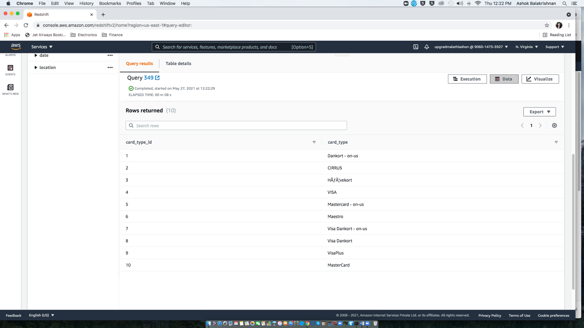

copy bankatm_schema.atm

from ‘s3://reshift-mashok-upgrad/atm_dim/part-00000-d2480681-cbac-4bef-ae8f-fc60928780c4-c000.csv’

iam_role 'arn:aws:iam::906014733927:role/Redshift0s3_fullaccess'

delimiter ','

region 'us-east-1'

csv

IGNOREHEADER 1;

Listing the top 10 rows of the ‘bankatm_schema.atm’ table

select * from bankatm_schema.atm order by atm_id limit 10;

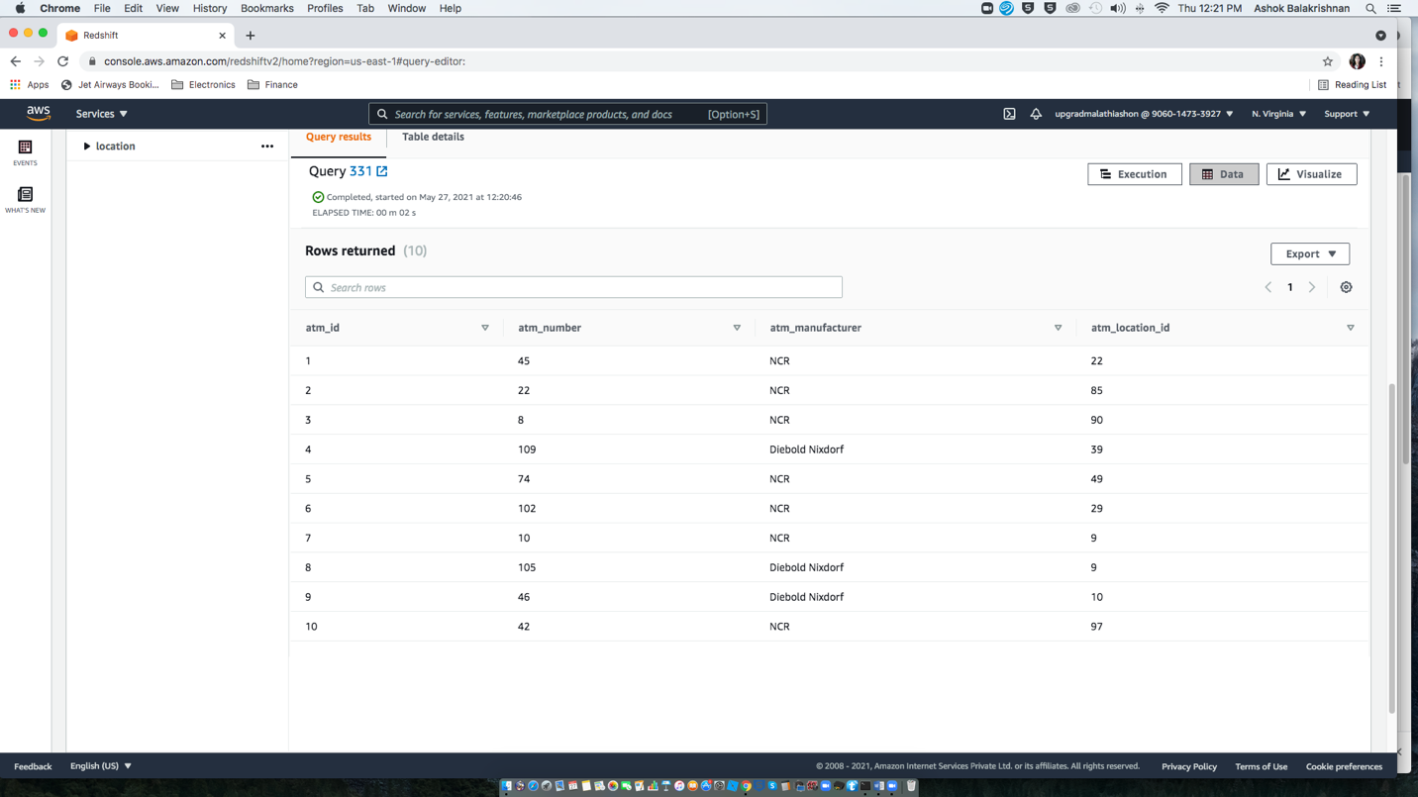

copy bankatm_schema.location

from ‘s3://reshift-mashok-upgrad/location_dim/part-00000-54cf7ea6-bcd3-4172-af8b-15797df04977-c000.csv’

iam_role 'arn:aws:iam::906014733927:role/Redshift0s3_fullaccess'

delimiter ','

region 'us-east-1'

csv

IGNOREHEADER 1;

Listing the top 10 rows of the ‘bankatm_schema.location’ table

select * from bankatm_schema.location order by location_id limit 10;

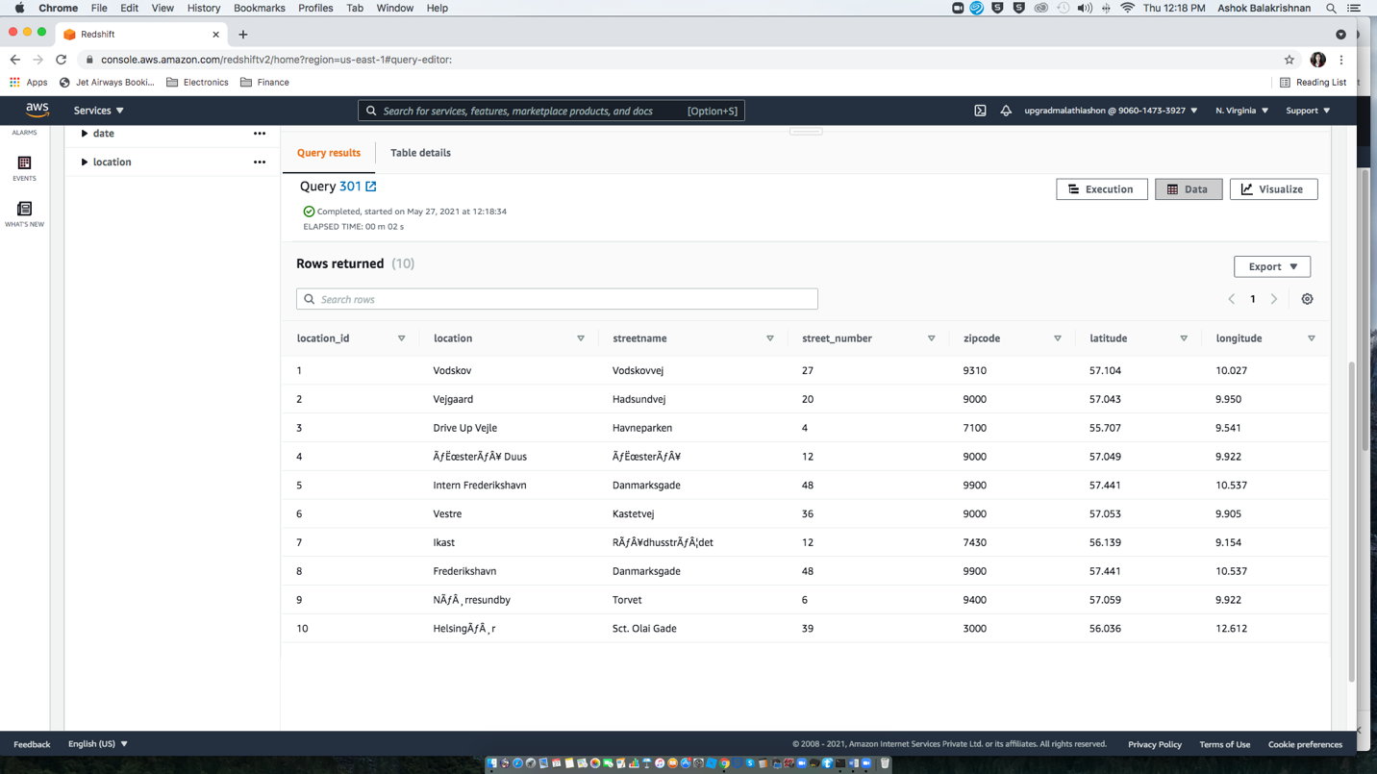

copy bankatm_schema.date

from 's3://reshift-mashok-upgrad/date_dim/part-00000-d185c6ea-caf0-4c11-a01d-81816505c4af-c000.csv'

iam_role 'arn:aws:iam::906014733927:role/Redshift0s3_fullaccess'

delimiter ','

region 'us-east-1'

csv

IGNOREHEADER 1

TIMEFORMAT ‘auto’;

Listing the top 10 rows of the ‘bankatm_schema.date’ table

select * from bankatm_schema.date order by date_id limit 10;

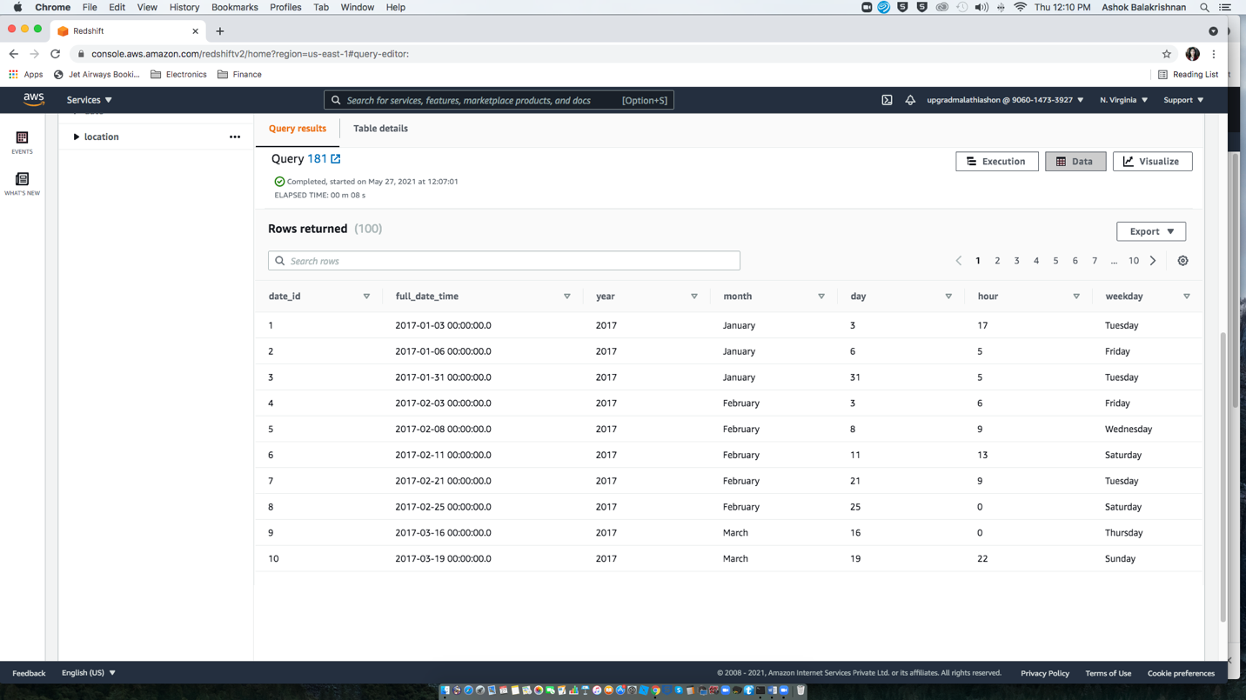

copy bankatm_schema.atm_trans

from 's3://reshift-mashok-upgrad/bank_fact/part-00000-fcd3f184-bb58-4bee-b5d8-f033cc37b86b-c000.csv'

iam_role 'arn:aws:iam::906014733927:role/Redshift0s3_fullaccess'

delimiter ','

region 'us-east-1'

csv

IGNOREHEADER 1;

Listing the top 10 rows of the ‘bankatm_schema.atm_trans’ table

select * from bankatm_schema.atm_trans order by trans_id limit 10;

