### Data Ingestion from the RDS to HDFS using Sqoop

**Sqoop Import command used for importing table from RDS to HDFS:**

sqoop import **\**

--connect jdbc:mysql://upgraddetest.cyaielc9bmnf.us-east-1.rds.amazonaws.com/testdatabase **\**

--table SRC_ATM_TRANS **\**

--username student --password STUDENT**123** **\**

--target-dir /user/root/spar_nord_bank_atm **\**

-m **1**

**Command used to see the list of imported data in HDFS:**

hadoop fs -ls /user/root/spar_nord_bank_atm

**Screenshot of the imported data:**

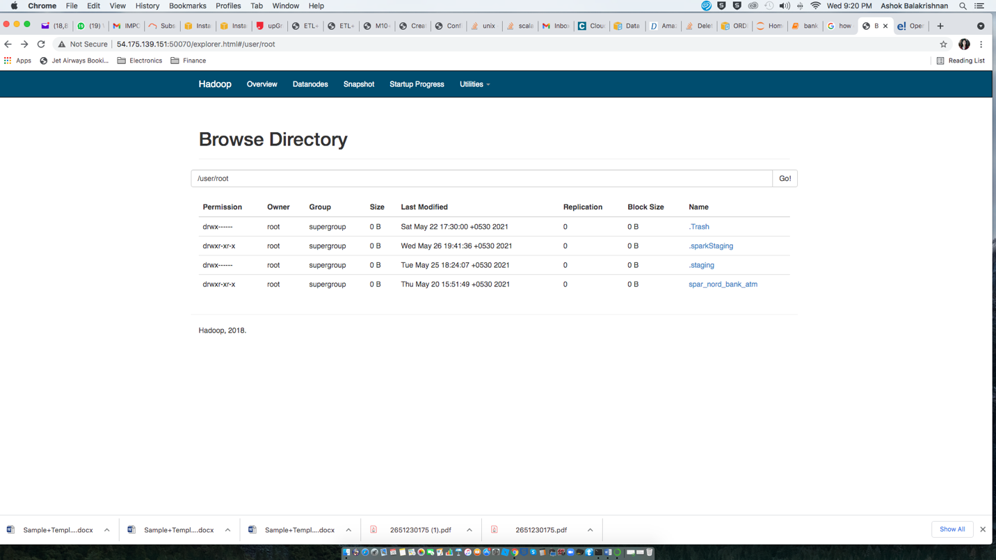

If you go inside spar_nord_bank_atm/ directory, you see two file _SUCCESS and part-m-00000

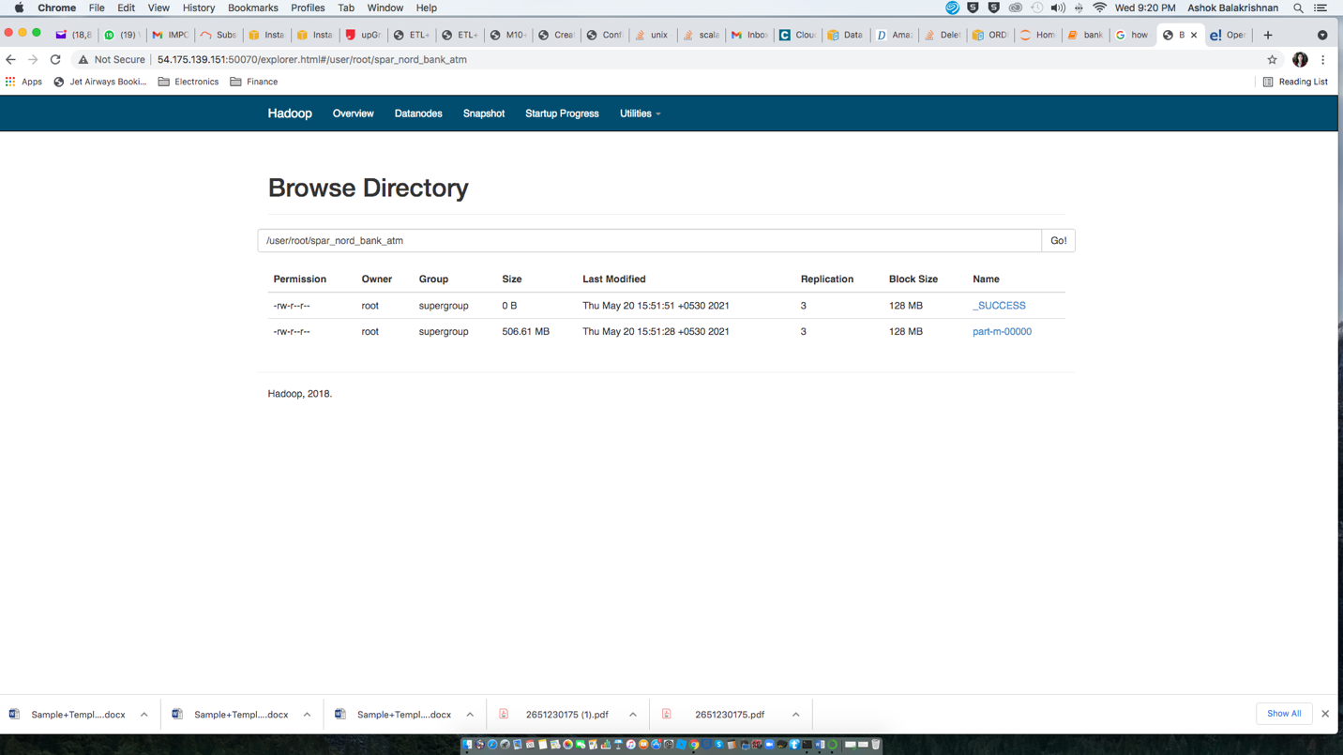

The Contents of the part-m-00000 file are as follows. So the Data from RDBMS has been successfully imported to HDFS. This completes the import exercise through sqoop .

