The Twilight Zone
Game Design Document
Year 9 Computing Technology – Assessment 1

1.0 Research

1.1 Underwater Cave Aesthetics & Inspiration
Visual research into how underwater caves appear in existing games informed several core design decisions for The Twilight Zone.
- Overall shape: Caves are large and open, predominantly horizontal in layout
- Wall surfaces: Cave walls are rough and irregular, which creates challenges for collision detection
- Subnautica thermal vents: Players begin taking heat damage when close to a vent, and take additional damage from above when it occasionally erupts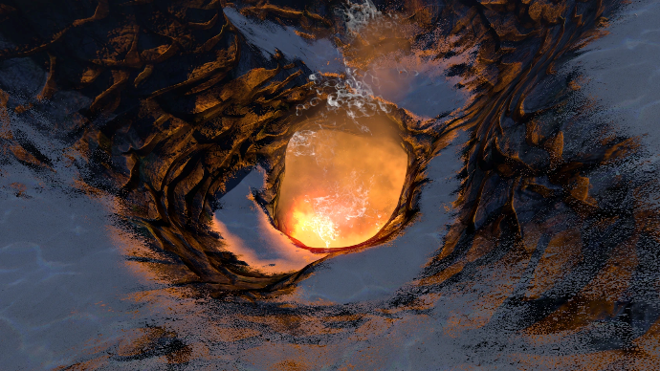

1.1.1 Geological and Physical Characteristics
- Formation Types: Formed primarily by two processes: dissolution of limestone (karst caves) or volcanic activity (lava tubes)
- Distinct Features: Contain speleothems (stalactites, stalagmites) that can continue growing while submerged
- High Complexity: Often maze-like with narrow tunnels, deep shafts, and vast cathedral-like chambers
- Water Types: Can hold freshwater (cenotes), saltwater (coastal caves), or mixed anchialine systems
- Structural Stability: Floors range from solid bedrock to soft sediment; walls show erosion including rounded rocks from water flow

1.1.2 Environmental Conditions
- High Stability: Environmentally stable with consistent cool temperatures, though sensitive to small changes
- Nutrient-Poor: Limited food sources and low oxygen create an extreme, hostile environment
- Unique Water Chemistry: Feature chemically distinct zones: thermoclines (sudden temperature changes) and haloclines (sudden salinity changes)
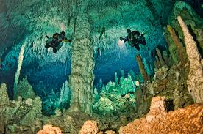

1.1.3 Biological Features
- Specialised Fauna: Inhabited by unique, often colourless or blind organisms: specialised crustaceans, sponges, and rare fish species
- Fragile Ecosystems: Low-nutrient environments are delicate and easily disturbed
- Refuge Areas: Many species use caves as safe havens from open-water predators
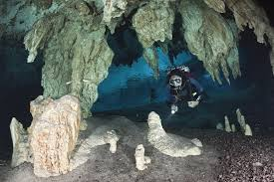

1.1.4 Dangers and Exploration
- No Direct Ascent: An overhead environmentdivers cannot swim directly to the surface in an emergency
- Low Visibility: Disturbing sediment causes instant silt-outs that produce complete disorientation
- Currents: Strong tidal currents in sea caves make navigation dangerous
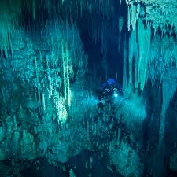

1.2 UI / Inventory Reference - Subnautica
The Subnautica Pause & Inventory Manager served as a reference UI. Key observations:
- Hot bar: Displayed at the bottom of the screen for quick-access items
- Design decision: The game will use a simplified five-slot hotbar system without a large storage grid to keep item management fast and readable while still allowing players to reorganise items
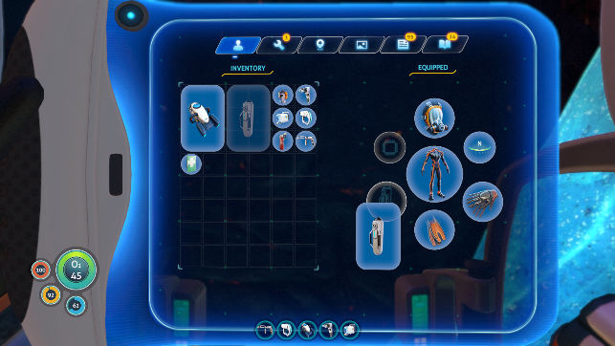

1.3 Core gameplay - Hill Climb Racing
The core gameplay loop is based on Hill Climb Racing. In the game, you manage a fuel bar while covering as much distance as possible. Coins and gems are replaced with equipment and medkits (less frequently).
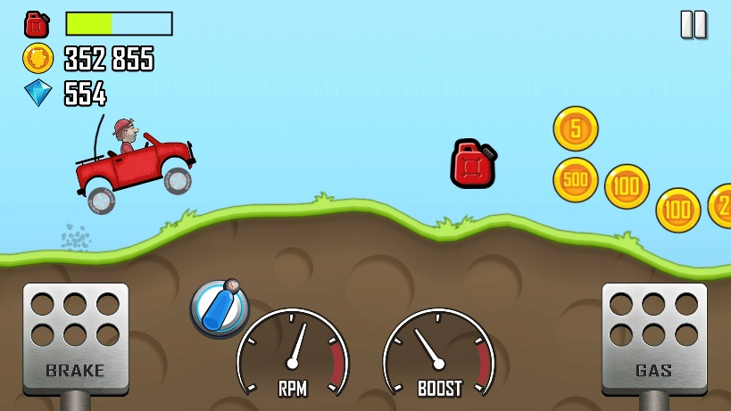

1.4 Colour Palette

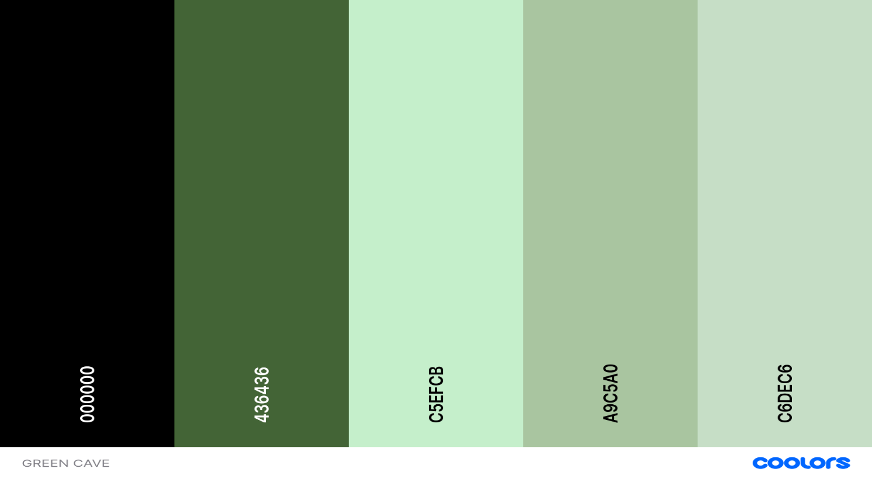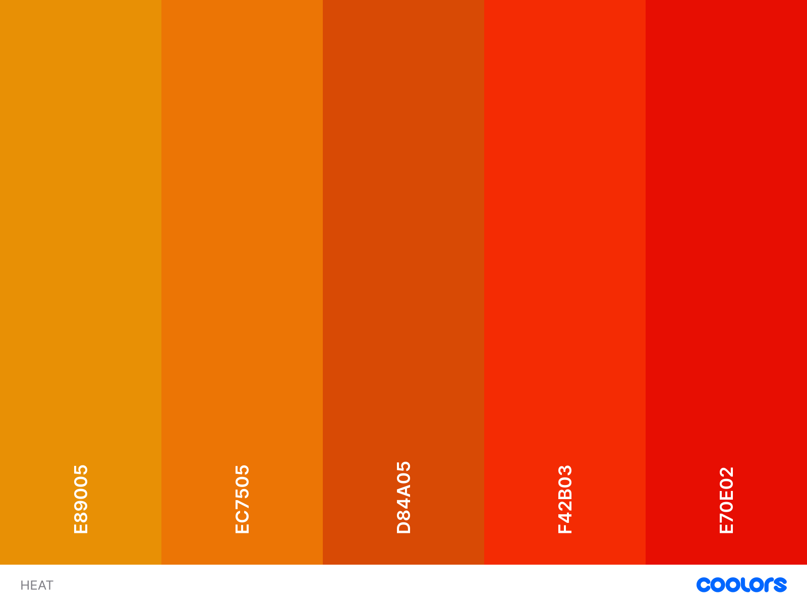

1.5 Sketches

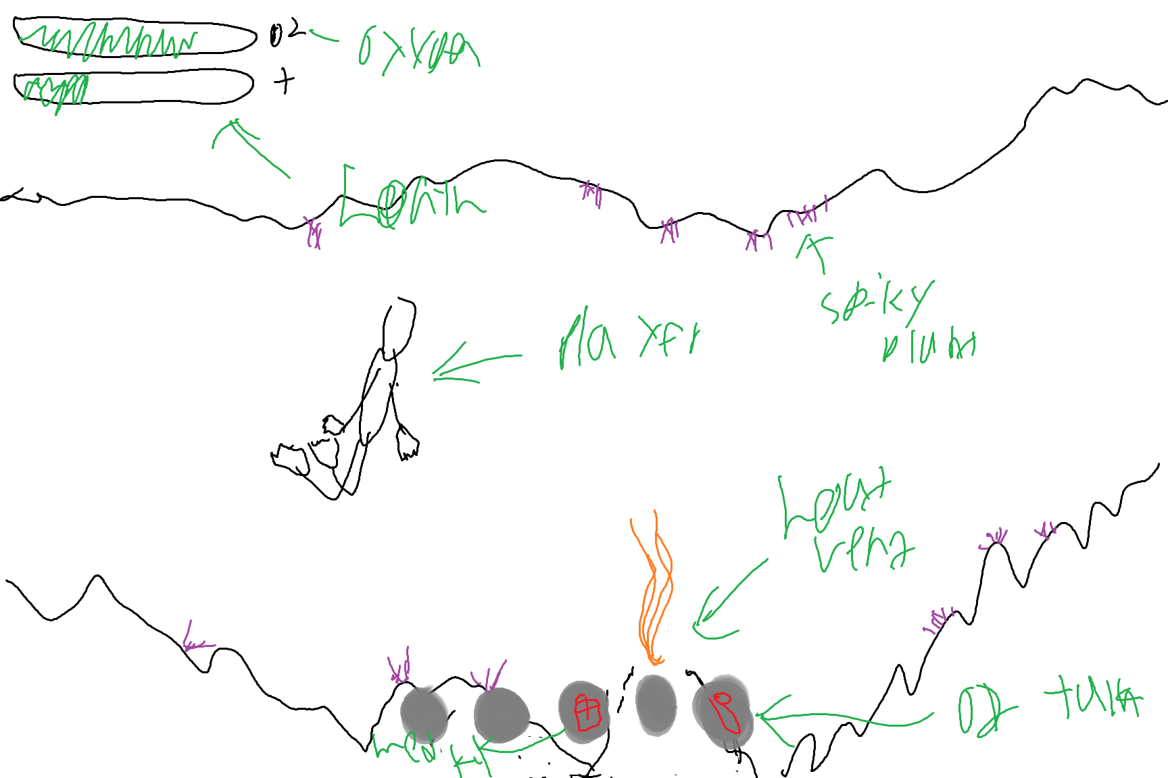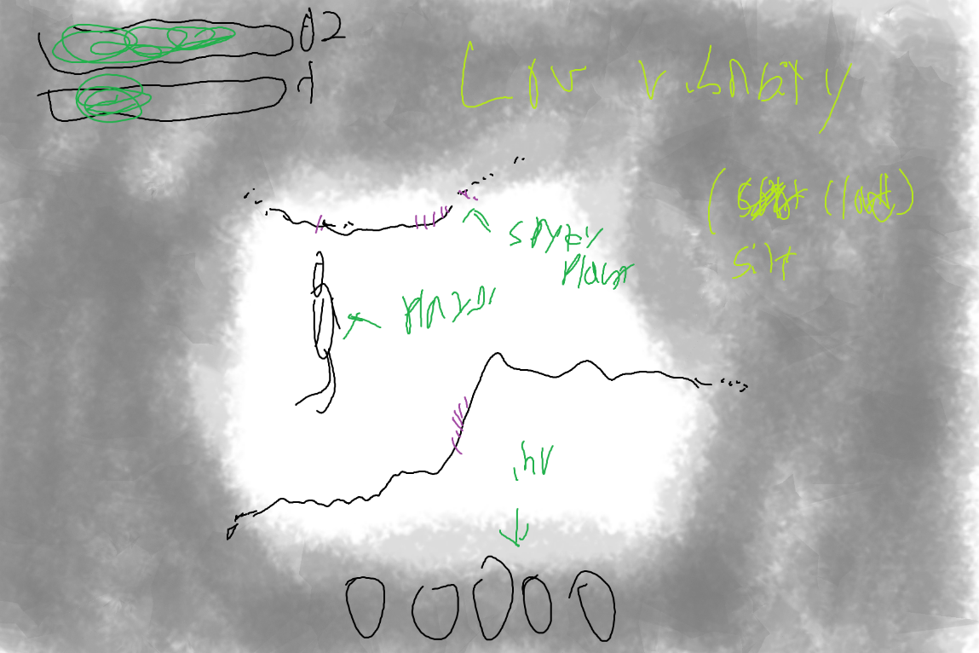

2.0 Game Description

2.1 Purpose of the Game
The Twilight Zone is a 2D underwater cave exploration and survival game. The player takes on the role of a diver who has been sucked into an underwater cave network following unexpected volcanic activity. The game is built around managing two survival meters, health and oxygen, while navigating through hazardous cave environments filled with hostile fauna, environmental traps, and resource pickups. The player must travel as far as possible while collecting resources to get them farther until they die.

2.2 Rules of the Game
- Health reaching zero causes instant death; health is lost by contact with hostile fish, spiky plants, and thermal vents
- Oxygen depletes passively while in water; if oxygen reaches zero the screen fades to black over 3 seconds before the player dies.
- Cave walls block all movement and cannot be passed through; contact causes a screen nudge and a scraping sound effect.
- Items are auto-collected when the player is within proximity range and a hotbar slot is free; dropped items cannot be picked up again for three seconds.
- Oxygen tanks can be carried in the hotbar and used to restore oxygen like a consumable. Once used, the tank is discarded onto the ground to vanish.
- The Pause & Inventory Manager pauses gameplay and allows players to Hold shift then select 2 slots to switch items
- Death permanently ends the current run. The death screen displays the total distance travelled and cause of death before allowing the player to restart or return to the Main Menu.

2.3 Description of Game Controls
- WASD / Arrow Keys: Swim in all four directions on the 2D plane
- Q or Z: Use the currently active item in the hotbar (eg: toggle a light source)
- Esc: Open the Pause & Inventory Manager to reorder the five hotbar slots
- Keys 1–5: Directly select a specific hotbar slot
- Scroll Wheel: Cycle forward or backward through the five hotbar slots

2.4 Hardware and Software Requirements
- Operating System: Pygame runs on any platform supporting Python 3, so no platform-specific build is needed
- Processor: Pygame is CPU-rendered (no GPU required), so the CPU handles all drawing calculations directly
- Memory: Pygame loads sprites and audio entirely into RAM, which is why 4 GB is the target
- Storage: approximately 50 MB for Python + Pygame, with the remainder for game assets
- Display: Pygame opens a fixed-size window rendered at 1024×768
- Input: Pygame's event system and the specific MOUSEWHEEL event used for hotbar scrolling
- Software: Python 3.10+ and Pygame 2.x as explicit requirements, with the pip install pygame install command
https://www.pygame.org/docs/

3.0 Game Loops (Storyboards)
Game loop 1
Game: Level
Mental model
- Subnautica
underwater cave
- Hill Climb Racing
2d side scroller
Action
WASD / Arrows - Swim in all directions
Hazard zones - Thermal vents, currents, silt
Death – start new run

Rules
Solid cave walls block all movement
Thermal Vents deal heat damage when they erupt and you’re nearby
Spiky plants cause damage on contact
Fog reduces visibility to near zero
Strong currents push the player
Death ends the run immediately
Harder sections will get more common as the player gains distance

Feedback
Colliding with a wall
Screen nudge + scraping sound effect
Thermal vent erupting
Screen flashes warm orange, animated wavy sprite overlay above vent
Entering a silt cloud
Vignette darkens at edges
Caught in a current
Bubble stream shows direction, player wobbles
Death / respawn
Fades to black, do death data flow

Game loop 2
Game: Player
Mental model
- Subnautica
what does my health and o2 bar do?
WASD / Arrows - Swim on the 2D plane
Esc - Open inventory
Q / Z - use item
1–5 / Scroll - Switch hotbar slots

- Rules
HP reaching zero causes instant death
O₂ depletes passively over time while in water
Screen fades to black when O₂ hits zero
3-second recovery before a full black screen
Fish and spiky plants deal HP damage on contact
Med kits restore HP; O₂ tanks refill oxygen
Insulated suit items slow heat gain from vents
Feedback
Taking damage (HP)
Red flash at screen edges.
O₂ running low
O₂ bar flashes
Low HP warning
Heartbeat sound loops, health bar flashes
O₂ fully depleted
Screen fades to black over 3 seconds

Game loop 3
Game: Items
Mental model
- Minecraft
the way you pick them up
- Subnautica
what the items are
Action
Q / Z – Use active item
1–5 - Select hotbar slot directly
ESC - Open Pause & Inventory Manager
Hold shift then select 2 slots to switch items in those slots
Scroll - Cycle between hotbar slots

Rules
Must be within proximity range to pick up
Inventory must have a free slot available
Pickup is automatic when in range
Dropped items are locked for 3 seconds
Pause & Inventory Manager pauses gameplay while open
5 quick slots via keys 1–5 or scroll wheel
Inventory manager lets you change the order of items in 5 slots
- Oxygen tanks are consumable items that restore oxygen when used. Empty tanks are discarded automatically after use

Feedback
Switching hotbar slots
Slot highlights, item name shown briefly at screen bottom
Picking up an item
Item flies to hotbar slot with a metal/priming sound

4.0 Functional Requirements

4.1 User Interface Requirements
- Visual Design: A consistent dark, atmospheric visual style is used across all screens. Cave environments use a deep blue-green palette with deliberate warm orange and red accents for thermal hazards, establishing clear contrast between safe and dangerous zones. Menus and UI panels use muted dark backgrounds with bold white or teal text. Consistency is enforced by reusing the same icon set, font, and layout grid across the HUD, Inventory screen, Pause & Inventory Manager, death screen, and menu system similar to Subnautica.
- Pause and Inventory Manager Interface: Pressing Escape opens the Pause & Inventory Manager overlay. The overlay contains a close button (“X”) in the corner used to resume gameplay. The bottom of the interface displays the five hotbar slots, and players can Hold shift then select 2 slots to switch items to reorganise equipment. Selecting “Quit” opens an additional confirmation overlay asking the player if they are sure they want to leave the session.
- Feedback and Alerts: Every critical gameplay event triggers a layered feedback response. Damage causes a red vignette flash; low O₂ causes the oxygen bar to pulse; thermal vents produce a warm orange screen wash when the player is taking heat damage. Confirmation overlays darken the background slightly to clearly indicate that the player must confirm their choice before continuing.

4.2 User Experience Requirements
- Engagement: Maintains engagement by introducing new biomes with visually distinct environments. Lore fragments are revealed through text overlays at hidden parts of the map. The game maintains engagement through a personal high-score loop, hidden lore rooms, and randomly stitched pre-built cave sections, creating variation between runs without requiring full procedural generation.
- Performance and Stability: The game must maintain a stable 60 fps on mid-range hardware during all standard gameplay scenarios. Visual effects have been reduced or removed to improve stability and keep rendering lightweight. Crashes during gameplay must not corrupt save data.

4.3 Player Interactions
- Input Methods and In-Game Actions: Gameplay movement and item usage are primarily controlled through keyboard input. WASD or arrow keys control swimming direction. Q/Z uses the item in hand. ESC opens the Pause & Inventory Manager overlay, pausing the game world. Keys 1–5 and the scroll wheel switch hotbar slots.
- Reward Systems: The game rewards exploration through hidden rooms and optional lore areas in addition to the personal distance high-score loop. Killing hostile fauna is not possible, keeping the incentive on exploration and scavenging over combat.

Gameplay Functional Requirements Table

Requirement | Description
Omnidirectional Swimming | The player can swim up, down, left, and right using WASD or arrow keys on a 2D plane at all times.
Solid Wall Collision | Cave walls use simple polygon collision boundaries. Contact blocks movement and triggers a screen nudge and scraping sound effect.
HP System | Player has a health bar. Reaching zero triggers instant death.
Oxygen (O₂) System | O₂ depletes passively in water. At zero, screen fades to black over 3 seconds, then death occurs.
5-Slot Hotbar | Players have 5 quick-access slots selectable via keys 1–5 or scroll wheel.
Auto-Pickup & Pause & Inventory Manager | Items auto-collect when in proximity if a slot is free. ESC opens a full Pause & Inventory Manager. Dropped items cannot be picked up for 3 seconds
Consumables | Med kits restore HP; O₂ tanks restore oxygen when consumed and are discarded after use.
Thermal Vents | Vents deal heat damage when they erupt and you’re nearby, with a warm orange screen flash indicating the source of damage.
Silt Clouds & Low Visibility | Silt clouds reduce visibility to near zero, darkening screen edges with a vignette.
Water Currents | Strong currents push the player; a bubble stream indicates direction and the player wobbles visually.
Flora & Fauna Hazards | Spiky plants and hostile fish deal HP damage on contact. Fish mostly move in simple straight-line patrol paths until the player enters a nearby detection range.

Mode Functional Requirements Table

Requirement | Description
Game Mode | Arcade run aiming for maximum distance. Selecting Play opens a confirmation overlay asking the player to start a new run. Death ends the run immediately and displays the distance travelled and cause of death.
Death Screens | Death screens display both the distance travelled and cause of death before offering restart or Main Menu options.
Pause & Inventory Manager | Opening the Pause & Inventory Manager pauses gameplay and displays five hotbar slots at the bottom of the screen. Players can hold shift then select 2 slots to switch items. An “X” button resumes gameplay, while selecting Quit opens a separate confirmation overlay.
Quit Confirmation | Selecting Quit from the Pause & Inventory Manager opens a confirmation overlay asking the player if they are sure they want to quit. Selecting “Yes” returns to the Main Menu, while selecting “No” returns to the Pause & Inventory Manager.
Settings Menu | Allows the player to enable or disable colourblind mode and adjust audio categories including Master, Ambience, Menu, and Game volume levels.
Persistent Menu Layout | The Main Menu displays Play and Exit buttons. Settings are shown on the main menu by default, there is no separate Settings button. Confirmation overlays temporarily appear above the interface and pause interaction with the background menus.

5.0 Non-Functional Requirements

5.1 Performance
Must maintain a stable frame rate of at least 60 fps on mid-range consumer hardware during all normal gameplay scenarios, including multiple hostile fauna on screen simultaneously and lighting-based low-visibility effects. Input-to-movement latency must remain under 50 ms to ensure swimming controls feel tight and predictable. Level assets are loaded fully from disk into memory at level start. The game uses a library of pre-built cave sections that are loaded and stitched together during gameplay to eliminate loading interruptions between segments.
To meet these targets, visual effects have been reduced or removed to keep performance stable. Performance will be profiled on the school laptop throughout development.

5.2 Privacy
Does not require an account, login, or network connection to play. No personally identifiable information is collected from the player. All save data and high scores are stored locally on the player’s device in a dedicated save file. This data does not leave the device and is not transmitted to any server.

5.3 Quality
- Code Quality and Architecture: The game will be built using a component-based architecture separating the core engine (physics, rendering, input) from game-specific logic (survival systems, level data, hazard behaviour). This ensures new biomes, fauna types, or hazards require only new data and component definitions, not rewrites to engine code. Cave sections are designed as modular chunks with standardised entry and exit points so they can connect reliably during runtime. All survival system parameters, O₂ drain rate, heat damage threshold, enemy speed by biome, will be stored in editable data files, allowing difficulty tuning without code changes.
- Testing and Bug Prevention: Each system (HP, O₂, inventory, collision) will be unit-tested individually before integration to catch logic errors early. Full playthroughs of each level section will be conducted to verify that new hazard placements do not produce unwinnable states or softlocks.
- Player-Facing Quality: The game will go through playtesting rounds with players who have not been in development (classmates). Feedback will focus on whether new players understand core controls without instruction by the end of a run, and whether the HUD communicates both survival meters clearly under visual stress.
- Asset Quality and Consistency: All visual assets will conform to a consistent pixel-art resolution and colour palette established in pre-production. Audio effects will be mixed to a common loudness standard so hazard cues are clearly audible at default system volume without being jarring. Font usage, icon size, and layout spacing will follow a documented style guide to ensure the UI looks intentional and professional across all screens.

Non-Functional Requirements Table

Requirement | Description
Stable Frame Rate | The game must maintain at least 60 fps on mid-range hardware during normal gameplay.
Responsive Controls | Input-to-movement latency must remain under 50 ms to ensure swimming feels tight and predictable.
Fast Load Times | Must fully load within 5 seconds on typical consumer hardware. All assets are loaded from disk into memory at level start; asset files should be kept compact where possible.
HUD Readability | HP, O₂, bars must remain legible at all times, including during silt-out and heat-flash visual events.
Intuitive | A new player should understand core controls and at least two hazard types within the first play.
Multi-Channel Feedback | Every critical gameplay event (damage, O₂ depletion, death) must provide both a visual and an audio cue.
Biome Extensibility | The level architecture must support adding new biomes, flora, fauna, and hazards without requiring rewrites to the core engine.

6.0 Data Flow

6.1 Game Launch
When the player launches, the game executable is the only required input. Pygame initialises its display, audio mixer, and input event system, then loads all shared assets, sprite sheets, sound effects, and font files from the local installation directory into memory. Any existing high-score data is read from a local save file on disk. The output is the main menu screen rendered at the configured resolution, with background music playing and all menu buttons active and ready for input.

6.2 Main Menu Navigation
The input is the player clicking one of the two main menu buttons: Play and Exit. Pygame’s event loop captures the mouse click event and checks which button’s bounding rectangle contains the cursor position. All menu categories remain persistently visible on the left side of the screen during navigation.
When Play is selected, a confirmation overlay appears asking the player if they would like to start a new run. Selecting “Yes” loads the starting cave section and begins gameplay. Selecting “No” closes the overlay and returns to the Main Menu.
Settings are shown directly on the main menu by default. There is no separate Settings button, the player can toggle colourblind mode and adjust Master, Ambience, Menu, and Game audio sliders directly from the main menu. Updated settings are written to a local configuration file when changed.
The output in each case is the corresponding menu transition or gameplay transition, with confirmation overlays temporarily darkening the background interface until a selection is made.

6.3 Gameplay
During gameplay, the primary inputs are keyboard key-press and key-release events captured each frame by Pygame’s event loop: WASD or arrow keys for movement direction, Q/Z to use or swing the active item, ESC to open the Pause & Inventory Manager, keys 1–5 to select a hotbar slot directly, and the scroll wheel to cycle between slots. Environmental inputs also feed into the game state each frame, the player’s proximity to thermal vents, hostile fauna, spiky plants, and collectible items is checked against their positions. Item auto-pickup is triggered when the player’s hitbox overlaps an item’s pickup radius and a hotbar slot is free. The outputs are the updated game frame rendered to the display, with the player sprite, cave background and enemy sprites drawn in layer order, and the HUD updated to reflect the current values of the survival meters and the active hotbar slot.

6.4 Pause & Inventory Manager
The Pause & Inventory Manager is opened by pressing Escape during gameplay. Pygame detects the KEYDOWN event and sets the game state to paused, halting gameplay logic updates while still processing menu and mouse input events. The overlay contains a close button (“X”) in the corner which resumes gameplay immediately when selected.
The lower section of the overlay displays the five hotbar slots. Players can hold Shift then select 2 slots to switch items and reorganise their equipment. Item positions are updated in memory instantly after placement.
The player may also select a Quit button. Choosing Quit opens a confirmation overlay asking “Are you sure?” Selecting “Yes” discards the current session’s temporary state, clears loaded level data from memory, and returns the player to the Main Menu. Quitting records the distance travelled if it exceeds the current saved high score. Selecting “No” closes the confirmation overlay and returns the player to the Pause & Inventory Manager.
The output is the darkened overlay rendered above the frozen gameplay frame, with interactive inventory slots, quit controls, and confirmation overlays.

6.5 Death Screen
The death screen is triggered automatically when the player’s HP reaches zero, or when the O₂ recovery window expires. No player input is required to enter this screen. Pygame fades the display to black over 3 seconds, then renders the death screen showing the player’s cause of death.
The death screen displays the total distance travelled during the run. The player is then shown the same restart prompt:
• Yes - starts a fresh run
• No - returns to the Main Menu
If the distance travelled exceeds the stored high score, the new value is written to the local save file immediately before the next transition occurs.
Pygame processes the selected button input and transitions to the corresponding state while discarding temporary gameplay data from the previous run.

6.6 IPO Diagram

Input | Process | Output
Game executable launched by player | • Pygame initialises display system  • Audio mixer loads  • Input manager starts  • Shared textures, sounds, and fonts load from disk  • Save file data is read | Main Menu rendered with music and active buttons
Mouse click on Play button | • Play menu state loaded  • Confirmation overlay generated | “Start new run?” overlay displayed
Mouse click on “Yes” in Play overlay | • Random pre-built cave section selected  • Cave section loaded into memory  • Survival stats reset | Gameplay begins
Mouse click on “No” in Play overlay | • Overlay removed  • Menu interaction restored | Return to Main Menu
Settings loaded on main menu by default (no Settings button) | • Settings displayed directly on main menu  • Config file values read | Settings panel displayed
Toggling colourblind mode | • Setting value updated  • Display palette conversion applied  • Config value updated in memory | Colourblind visuals enabled or disabled
Adjusting audio sliders | • Slider value updated  • Mixer volume recalculated  • Config values updated | Master, Ambience, Menu, or Game audio volume changes
Adjusting settings on main menu | • Settings updated in memory • Config file written | Return to Main Menu
WASD or Arrow key held during gameplay | • Movement vector calculated  • Velocity updated  • Collision detection checked each frame | Player swims through cave
Collision with cave wall | • Collision box overlap detected  • Movement cancelled  • Camera nudge effect triggered  • Scraping sound played | Player stopped by wall with visual/audio feedback
Thermal vent eruption triggered | • Heat damage applied  • Orange warning overlay displayed | Vent eruption visual effect displayed
Player enters silt cloud | • Visibility reduction effect enabled  • Vignette darkness increased | Near-zero visibility effect displayed
Player enters water current | • Current direction applied to velocity  • Player wobble animation enabled | Player pushed through cave
Hostile fish collides with player | • Enemy collision detected • HP reduced  • Damage feedback triggered | Player takes damage
Spiky plant collision | • Hazard collision detected  • HP reduced | Damage effect displayed
HP drops below warning threshold | • Heartbeat audio loop enabled  • HP bar flashing effect enabled | Low-health warning activated
Oxygen naturally depletes underwater | • O₂ timer updated each frame  • HUD O₂ bar updated | Oxygen bar slowly decreases
Oxygen reaches warning threshold | • O₂ flashing animation enabled | Low oxygen warning displayed
Oxygen reaches zero | • Black fade sequence started  • Recovery timer started | Screen fades toward black
Recovery timer expires | • Death state triggered  • Cause of death recorded | Death screen opened
Player moves away from heat source | • HP drain disabled | Stop dying
Item enters pickup range | • Pickup radius overlap detected • Free slot check performed | Item ready for collection
Auto-pickup succeeds | • Item added to hotbar  • Pickup sound played  • Inventory updated | Item appears in hotbar
Attempt pickup with full hotbar | • Free slot check fails | Item remains in world
Scroll wheel moved | • Active slot index updated | Hotbar selection changes
Key 1–5 pressed | • Corresponding hotbar slot selected | Active item changed
Q or Z pressed with usable item equipped | • Use animation triggered  • Item logic executed | item activation occurs
Escape key pressed during gameplay | • Game state paused  • Physics halted  • Pause overlay rendered | Pause & Inventory Manager displayed
Clicking “X” on Pause & Inventory Manager | • Pause state removed  • Gameplay logic resumed | Return to gameplay
Hold shift then select 2 slots to switch items | • 2 slots recognised  • Slot contents swapped on release | Hotbar reorganised
Clicking Quit in Pause & Inventory Manager | • Quit confirmation overlay opened  • Background interaction disabled | “Are you sure?” overlay shown
Clicking “No” in quit confirmation | • Overlay closed  • Pause & Inventory Manager restored | Return to Pause & Inventory Manager
Clicking “Yes” in quit confirmation | • Current gameplay state cleared  • Endless score checked for PB | Return to Main Menu
HP reaches zero | • Death state triggered  • Cause of death stored  • Gameplay halted | Death screen displayed
Death screen opened | • Distance travelled calculated  • High score checked  • Cause of death displayed | Endless death summary shown
Endless death screen “Yes” selected | • New pre-built cave sections loaded and stitched together  • Stats reset | New run begins
Endless death screen “No” selected | • Gameplay state cleared | Return to Main Menu
Run beats previous high score | • Save file opened  • New distance written to disk | High score updated
Game window closed by player | • Save file flushed• Audio stopped• Pygame shutdown sequence executed | Application closes cleanly

7.0 Wireframe

