Customer Behavior Analysis Project Report

Project Overview
This project analyzes customer shopping behavior using a multi-tool workflow. The data was cleaned and prepared using Python, analyzed using SQL (PostgreSQL), and visualized through an interactive Power BI dashboard.

1. Data Preparation with Python (Pandas)
The initial dataset was processed using Python's Pandas library to ensure data quality and prepare it for relational analysis. Key steps included:
- Column Standardization: Standardized all column names to snake_case for improved compatibility with SQL and Python workflows.
- Renaming: Renamed 'purchase_amount_(usd)' to 'purchase_amount' for concise query syntax.
- Data Quality (Median Imputation): Handled missing values in the 'review_rating' column by calculating and imputing the median rating grouped by 'category', preserving the statistical distribution.
- Feature Engineering (Age Segmentation): Segmented the customer base into four distinct age groups using 'pd.qcut' (quartiles): 'Young Adult', 'Adult', 'Middle-Aged', and 'Senior'.
- Feature Engineering (Frequency Mapping): Converted categorical purchase frequencies into numerical 'purchase_frequency_days'.
- ETL Workflow: The final cleaned DataFrame was exported directly to a PostgreSQL database for advanced analytical querying.

2. SQL Analysis & Key Insights
The following SQL queries were executed in PostgreSQL to extract strategic insights from the dataset. Each section includes the query logic and space for results.

Q1. Revenue by Gender
SELECT gender, SUM(purchase_amount) as revenue FROM customers GROUP BY 1;
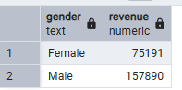

Q2. High-Spending Discount Users
SELECT customer_id, purchase_amount FROM customers WHERE discount_applied='Yes' AND purchase_amount>=(SELECT AVG(purchase_amount) FROM customers);
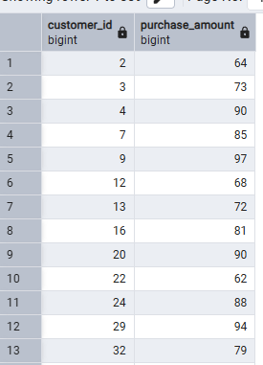

Q3. Top 5 Products by Average Review Rating
SELECT item_purchased, ROUND(AVG(review_rating::numeric),2) average_rating FROM customers GROUP BY item_purchased ORDER BY 2 DESC LIMIT 5;
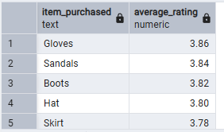

Q4. Shipping Type Impact on Spend
SELECT shipping_type, ROUND(AVG(purchase_amount::NUMERIC),2) average_purchase_amount FROM customers WHERE shipping_type IN ('Express', 'Standard') GROUP BY shipping_type;
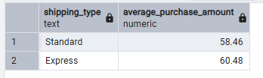

Q5. Subscriber vs. Non-Subscriber Performance
SELECT subscription_status, COUNT(customer_id) total_customers, ROUND(AVG(purchase_amount),2) average_purchase_amount, SUM(purchase_amount) total_revenue FROM customers GROUP BY 1 ORDER BY 3,4 DESC;
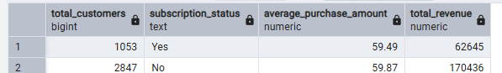

Q6. Highest Discount Adoption Rate per Product
SELECT item_purchased, ROUND(100.0 * SUM(CASE WHEN discount_applied = 'Yes' THEN 1 ELSE 0 END)/COUNT(*),2) AS discount_rate FROM customers GROUP BY item_purchased ORDER BY discount_rate DESC LIMIT 5;
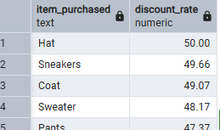

Q7. Customer Segmentation (Loyalty)
WITH customer_type AS (SELECT customer_id, previous_purchases, CASE WHEN previous_purchases = 1 THEN 'New' WHEN previous_purchases BETWEEN 2 AND 10 THEN 'Returning' ELSE 'Loyal' END AS customer_segment FROM customers) SELECT customer_segment, COUNT(*) AS "Number of Customers" FROM customer_type GROUP BY customer_segment;

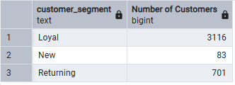

Q8. Top 3 Most Purchased Products per Category
WITH ranked_items AS(SELECT category, item_purchased, COUNT(*) AS total_orders, ROW_NUMBER() OVER(PARTITION BY category ORDER BY COUNT(*) DESC) AS item_rank FROM customers GROUP BY 1, 2) SELECT * FROM ranked_items WHERE item_rank <= 3;
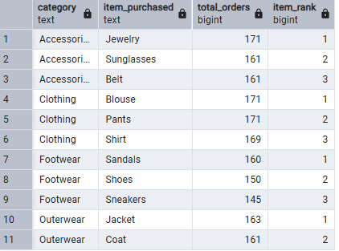

Q9. Repeat Buyer Subscription Likelihood
SELECT subscription_status, COUNT(customer_id) AS repeat_buyers FROM customers WHERE previous_purchases > 5 GROUP BY subscription_status;
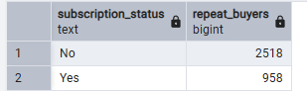

Q10. Revenue Contribution by Age Group
SELECT age_group, SUM(purchase_amount) AS total_revenue FROM customers GROUP BY age_group ORDER BY total_revenue DESC;
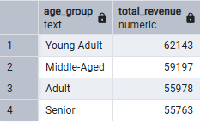

3. Power BI Visualization (Awesome Dashboard)
To provide an interactive reporting experience, an 'Awesome Dashboard' was built in Power BI. It visualizes key metrics like total revenue, customer segments, and product performance.
