Vagnant
https://portal.cloud.hashicorp.com/vagrant/discover/bento/ubuntu-22.04 => install ubuntu VM
https://portal.cloud.hashicorp.com/vagrant/discover/eurolinux-vagrant/centos-stream-9 => install centos
eurolinux-vagrant/centos-stream-9 is:
- Maintained
- Clean
- Lightweight
- Frequently updated
- Works properly with VirtualBox
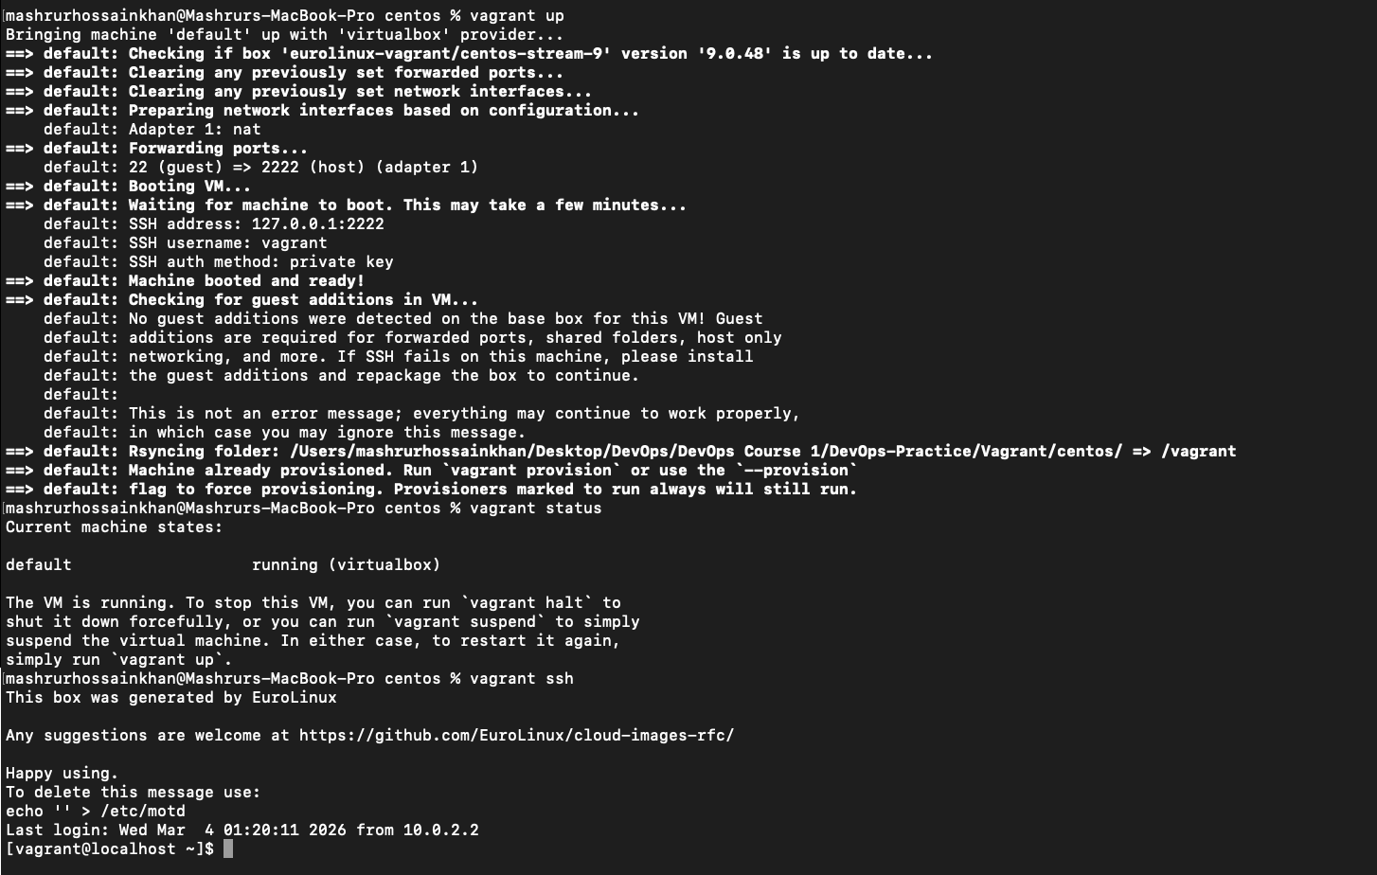

Linux
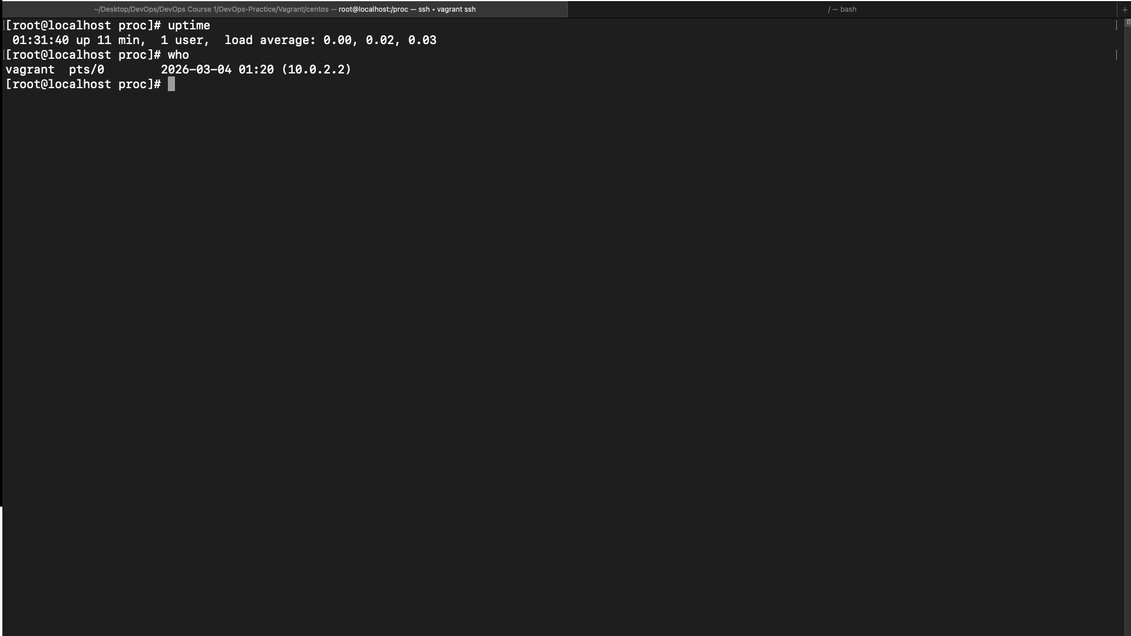
checking the uptime and the users are in it(centos)
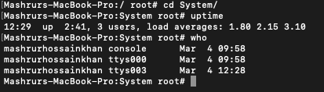
MAC
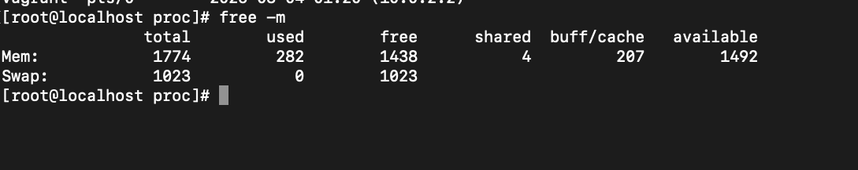
checking ram in centos
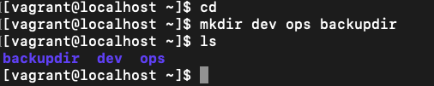
creating dir
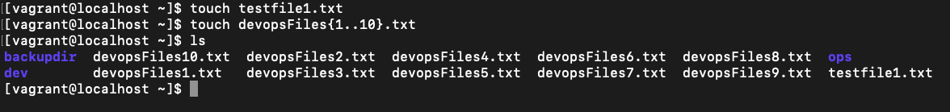
creating files
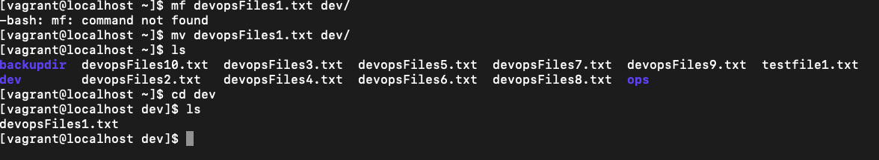
moving files
copy dev fdir to backup dir

