**PROG2240: Java Web Tech**

Driver: Gyeonglim Seo

Observer: Yougsun Chang

1. A new admin JSP page

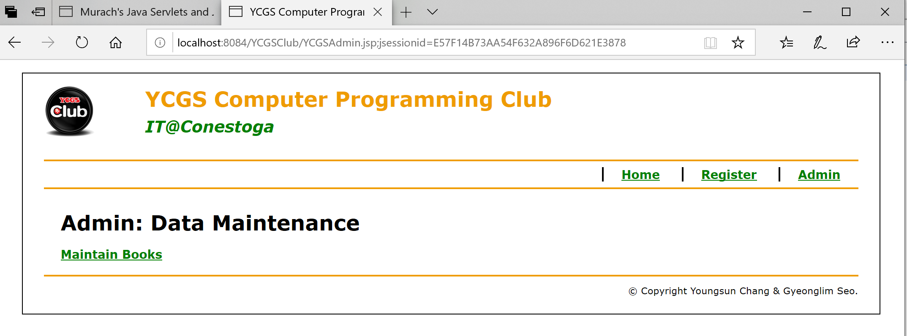

2. A JSP page to display books

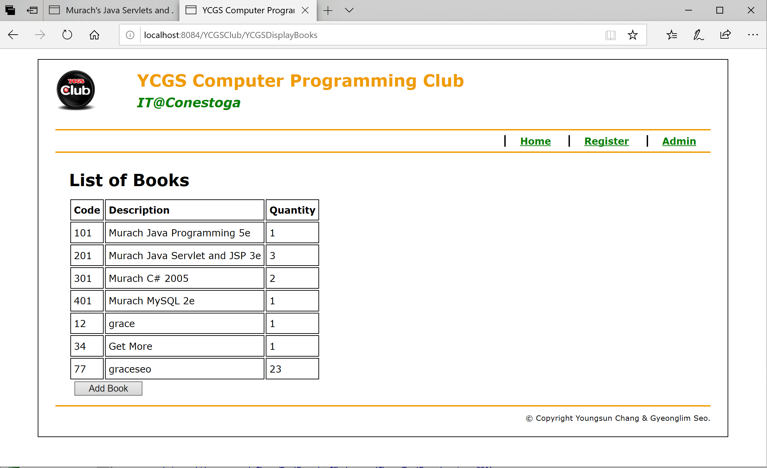

3. A JSP page to add book

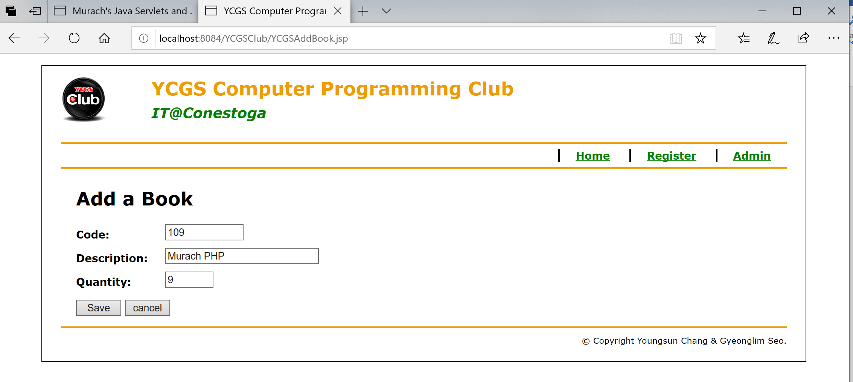

4. Messages if there are validation errors in a same page as YCGSAddBook.jsp

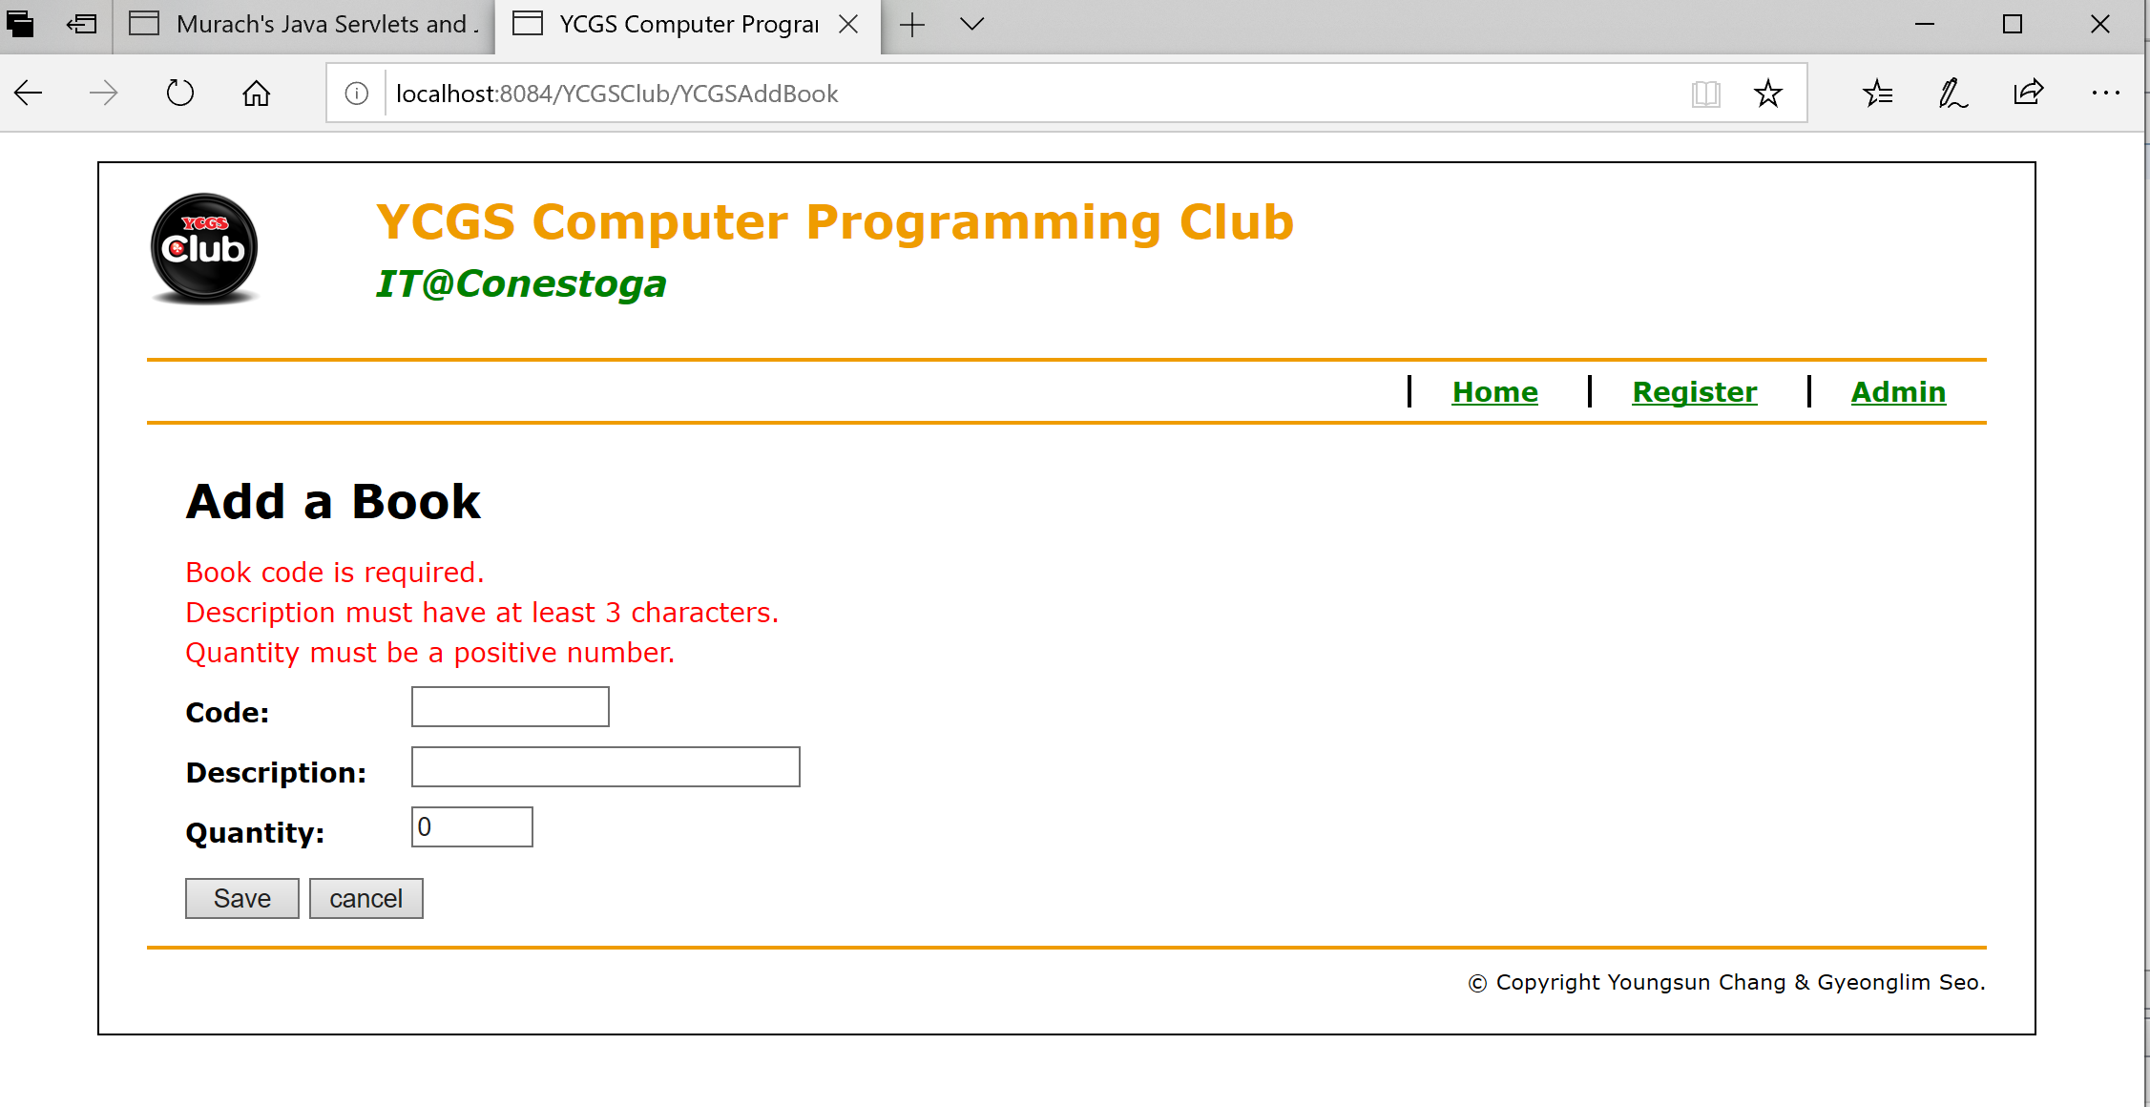

5. A error JSP page

