Contributed/Standard Article

**Undergraduate IT Education in China**

**Ming Zhang and Long Zhang**

**Leader**

To prepare students with the skillsets required by industry, China has been adjusting its IT education programs at the bachelor-degree level. IT majors (i.e., first-level disciplines) are no longer limited to computer science and technology as well as software engineering. In this article, the authors introduce the developments for eight IT programs with different emphases that the Ministry of Education recently updated or newly established. For each program, we elaborate on their current status as well as their educational objective and curricula. The IT Undergraduate education in China is becoming a big tent.

# ==========================

The world is changing at an ever-increasing pace, where information technology (IT) is playing an increasingly critical role from infrastructure to applications to security. IT covers a wide range of industries such as hardware, software, electronics, semiconductors, internet, telecom equipment, e-commerce, and unlimited computing services. Therefore, IT education in universities must keep pace with the times and reflect the characteristics of the current digital age. Information technology instills creative problem solving capabilities in IT students, preparing them to recognize and exploit opportunities for technical innovations that can lead to a broad range of career paths such as in high tech companies, government agencies, and healthcare industries. Hence, IT programs have gone beyond computer science and technology (CST) and software engineering (SE) with a “big tent” atmosphere that blends numerous educational opportunities and prepares students for various roles.

This article systematically introduces recent developments of IT undergraduate education in China. Firstly, it provides an overview of the current state of education system and IT industry in China. Secondly, it describes a general picture of IT programs at national key universities such as Peking University and Tsinghua University. And thirdly, it introduces the latest trends in IT education beyond traditional boundaries, including core courses, curricula, and knowledge systems.

**Context and Overview**

There are three important factors that mold the destiny of education in China. There are the national entrance examination, undergraduate program related to information technology, and the gap that exists between current education and the prospects of employment. We now address these three issues.

***National College Entrance Examination***

China has limited education resources for its large population, reaching over 1.354 billion people by the end of 2012 [17] and approximately 1.361 billion people by the end of 2013. Therefore, the notoriously tough National College Entrance Examination, or Gaokao for short, becomes a milestone for young Chinese students. Since its establishment in 1952, except for an interruption by the Cultural Revolution, the two-day exam has placed colossal pressure on test-taking students. The Gaokao is a departure from America's SAT and ACT exams. Whereas American universities consider test scores as merely a portion of admissions decisions, among extra-curricular, leadership, service and more, the score of Gaokao is almost the exclusive factor in Chinese college admission [19].

The number of students applying for admission and actually obtained admission appears in Figure 1; the admission rates is given in Figure 2. For example, in the year of 2012, 9.15 million students participated in the Gaokao and 6.85 million were admitted (6.99 million were admitted in 2013, up 4.31%). Although the admission rate seems high (74.86% in 2012), note that it is extremely competitive for top-tier universities. For example, nationwide in 2012, Peking University admitted only 3,715 students while Tsinghua University admitted only 3,380 students [13].

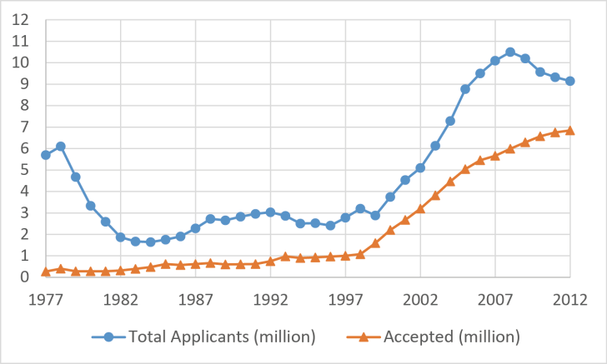

Figure 1: National College Entrance Examination in China: Applying and Admissions

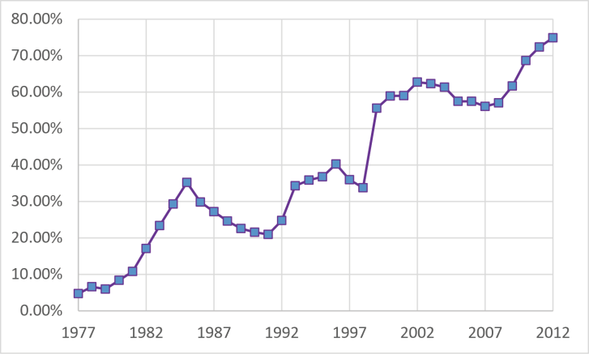

Figure 2: National College Entrance Examination in China: admission rates

***IT Related Undergraduate Programs***

In this context, the development of IT-related undergraduate education has been a boom in China. By the end of 2012, China had doubled the number of colleges and universities to 2,409, most of which have established their own IT institutions. As a result, the IT major has become the most popular major in terms of total enrollment. For example, in the year of 2010, the total enrollment for all engineering majors was 1.172 million; IT majors alone accounted for as high as 28% [20].

Let's take a close look at some top-tier universities. In the School of Computer Science and Engineering of Beihang University [1], the undergraduate disciplines include next generation internet collaborative environments, new generation network architecture, parallel computing, virtual reality and multimedia, information security, e-commerce, e-government, and big data. At the Department of Computer Science and Technology of Tsinghua University, undergraduate disciplines include computer architecture, microcomputer systems, parallel computing, software engineering, artificial intelligence, computer graphics, computer aided design, and computer science theory.

***The Education – Employment Gap***

Notwithstanding the promises mentioned above, tens of thousands of young IT college graduates have to face a tough start in the tight job market. With a slowdown in the economic growth rate, China faces a glut of college graduates with high expectations and limited opportunities. In the year of 2013, nearly seven million new graduates in China were set to graduate and hit the job market. This number is the highest since the People's Republic of China was founded in 1949. However, we learned that more than 70% new graduates had not signed any offer by May 2013 [9], normally more than 40% of them should got offers by May, and 85% employed by July. Even IT graduates who found jobs do not really have “good” jobs and settled for low wages. In the 2012 annual report by MyCOS Research Institute [14], IT majors were given a “red card” for a fourth year in a row. A red card indicates a large number of unemployment and low employment rates.

The employment pressure is not due to a decreasing demand for the labor. As a matter of fact, China’s IT industry shows robust growth although economic growth wanes. For example, Chinese software companies garnered 2.48 trillion Yuan ($399.55 billion) revenue in 2012, a rise of 31.5 percent from the previous year [4]. IT industry's contribution in GDP reached 6.3 percent in 2012, and the talent need for IT professionals is increasing at a rate of 1 million per year. Gross output value in IT related industry [16] appears in Figure 3. We see that IT related industry is growing at a fast rate. Besides, IT services industry revenue is expected to total $100.4 billion in 2013, growing at an annualized rate of 6.8% over the past five years [10]. Unfortunately, companies’ recruiters are complaining that they cannot fill vacancies, while there are growing pools of untapped talent. The link between education and jobs seems to be breaking down and there is growing skill gap between business needs and talent supply.

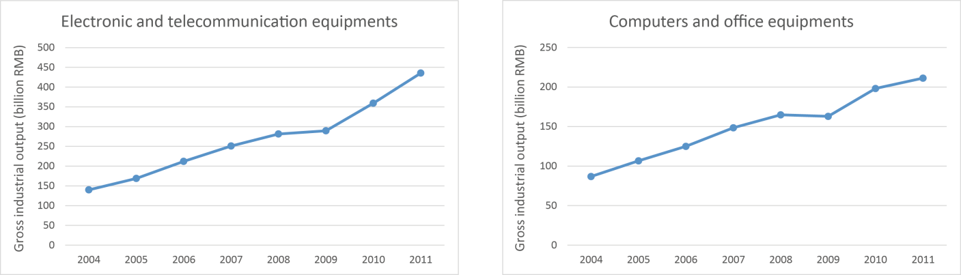

Figure 3: Gross output value in IT related industry (values in y-axis are measured in billion RMB)

**Filling the Gap Between Education and Industry**

Universities and colleges have to sync their course systems with employer needs. Under this scenario, China is adjusting its IT related educational system, to make sure students do learn the job skills required by employers.

Traditional IT education in China emphases more on the CS theory, but industry pays more attention to practical skills. To align with the industry needs, we now elaborate on eight IT degree programs that were recently updated or newly designed. There are four sub-disciplines within the discipline of computing, and four interdisciplinary programs related to information technology. Besides the traditional major of CST and SE [23], IT related majors (i.e., first-level disciplines) in China National Higher Education Catalog 2012 are as listed in Table 1.In the ID column, if the ID ends with T, it is a specialized major; and if the ID ends with K, its establishment is under state control.

Table 1: IT related majors in China National Higher Education Catalog, besides CST and SE

|  |  |
| --- | --- |
| ID | Major |
| **Programs in Computer Science** | |
| 080903 | Network Engineering |
| 080904K | Information Security |
| 080905 | Internet of Things Engineering |
| 080906 | Digital Media Technique |
| **Interdisciplinary Programs** | |
| 080711T | Health informatics |
| 071003 | Bioinformatics |
| 070504 | Geographic Information Science |
| 120102 | Information Systems Management |

Table 2: Common Core Required Courses of the four majors in Computer Science

|  |
| --- |
| **Core Requisites Courses (excerpt)** |
| Discrete Mathematics  Data Structures  Circuits and Electronics  Advanced Programming Languages  Computer Architecture  Networks Technology  Communication Principles |

**Programs in Computer Science**

Table 3: Curriculum of Network Engineering, Information Security and Internet of Things (excerpt)

|  |  |  |
| --- | --- | --- |
|  | **Category** | **Courses (excerpt)** |
| **Network Engineering** | **Specialized Courses** | Signal and System  Operating Systems  Database Principles & Methods  Microcomputer Interface  Network & Information Security  Network Wiring |
| **Program Electives** | Principles of Switches  Web Information Technology  Network Management  Network Performance Analysis  AI and Expert Systems  Visual Programming Technology |
| **Information Security** | **Specialized Courses** | Principles of Information Security  Information Security Mathematics  Circuits and Electronics  Cryptography  Web Security |
| **Program Electives** | Smart Card  Information Hiding Techniques  Computer Virus  Embedded System  Linux System  Electromagnetic Protect Technology |
| **Internet of Things (IOT)** | **Specialized Courses** | Electronic Systems  Circuit Analysis  Signal Processing  Introduction to IOT  RFID Technology  Sensor Technology  Automatic Control |
| **Program Electives** | IOT Database Technology  Intelligent Information Processing  Cloud Computing  ZigBee Network |

The first three CS sub-disciplines, Network Engineering, Information Security and Internet of Things Engineering share several traditional core courses shown in table 2, with specialized courses and program electives shown in table 3. In the following sections, we will address the curriculum of each discipline respectively.

Network Engineering

Network engineering officially became a bachelor's program in 1998, according to the list of programs promulgated by the Ministry of Education of the Republic of China (MOE China). The program grew over time to include more and more universities. By the end of 2011, more than 270 colleges and universities, including “985 project”[1] and “211 project”[2] key universities, have set up a network engineering program. In 2013, more than 300 universities are involved in, with nearly 20,000 graduates each year, which is a great support for the development of networking industry.

The objective of the baccalaureate network engineering program is to provide preparation for the field of information technology with a concentration in network engineering. Through a combination of theory, labs, and optional field experience, students enrolled in a network engineering program study a variety of subjects centered on TCP/IP technologies that are not limited to network theory, network administration, network maintenance, network management, network security and network application development. Students also gain advanced networking knowledge through a capstone course or graduation project. The curriculum system [7] design reflects the industry's latest developments and practices as listed in Table 3.

Information Security

In 1999, four universities such as Xidian University [22] have added information countermeasure in the bachelor's degree program. In 2001, Wuhan University [21] established the first undergraduate major in information security. From that time on, the information security major entered a stage of rapid development. To date, well over seventy universities and colleges have set up the major, most of which are at top-tier universities such as Tsinghua University and Xidian University.

The objective of the information security program is to teach students a wide range of technical skills in information security and risk management. Graduates with baccalaureate degrees in information security are able to assess risks to the security of proprietary information and have the ability to explore strategies for securing data and applications. Graduates are encouraged to work in various areas such as dot-com, telecommunications, e-commerce, e-government, and e-finance.

Information security program is intended to cover a broad range of topics, including reliability, and governance issues such as privacy, audits, business continuity and disaster recovery. Prior to the close of the program, students are required to demonstrate their skills in designed and building their course projects, as an individual, or in teams. The curriculum[8] appears in Table 3.

Internet of Things Engineering

The term “internet of things” (or IOT) refers to current attempts to translate the success of online network effects into the inclusion of everyday objects. Physical sensors and real-time communication on the network have enabled the connection of the objects, people, and services. The emergence of IOT will have a transformative effect on the business, society, and governance. Therefore, it requires universities to rethink how to educate the coming generation of engineers and computer scientists [12].

Under this scenario, China has embarked on a program to revamp its undergraduate IT education. In July of 2010, the “Internet of Things Engineering” was officially approved as baccalaureate program by MOE China. Currently, more than thirty Chinese colleges and universities have set up undergraduate programs designed around IOT engineering. This program is a new area of undergraduate education. The objective of the program is to help students deeply understand the IOT and master the technologies that will support the area’s development. Students who become enrolled in the program will acquire the skills and expertise necessary to innovate in this emerging field, and become familiar with the design process and development technologies to create a fully functional system for an IOT. The program covers topics such as business concepts, technologies and useful software. More specifically, the courses vary from algorithms to networks, from hardware architectures to big data. Table 3 illustrates its core courses [6].

Digital Media Techniques

Digital media is a form of electronic media where data are stored in digital (as opposed to analog) form by processing and converting data such as text, sound and graphics. The area of digital media techniques refers to the technical aspect of collection, processing, storage, transmission, management, security, and output. Typical techniques include streaming media technology based on network transmission and digital compression, animation technology based on computer graphics, virtual reality based on human-computer interaction and graphical display, as well as game technology based on physics and artificial intelligence.

In 2004, the digital media techniques program was officially approved as a baccalaureate program by MOE China. Currently, over a hundred Chinese colleges and universities have set up an undergraduate program designed around digital media techniques. As a matter of fact, there are many more universities that aim to develop students' abilities in digital media. To implement the development strategy of animation industry, in 2008, the Ministry of Education and the Ministry of Culture jointly issued a document to fund the “Expert Committee of Animation Textbook Construction in Higher Education.” From an intergraded view of art, technology and industry, the committee has compiled a comprehensive series of digital media textbooks.

The undergraduate program covers a wide range of critical and technical issues that encompass a full range of digital media industry. Students utilize the industry standard software to study and practice in interactive media development. The program consists of a workforce that stretches across various areas in the creative media industries. Graduates can apply their skills to a number of careers such as animation production, digital video production, digital audio engineering, web design and development, corporate communications, and graphic arts. The core courses of the curriculum system [18] appear in Table 4.

Table 4: Curriculum of Digital Media Technique (excerpt)

|  |  |
| --- | --- |
| Category | Courses |
| **Core Requisites** | Introduction to Digital Media  Digital Audio  Digital Illustration  Digital Video  Digital Art  Animation  Game Development  Digital Image Processing  Computer Graphics  Graphics Engine  Artificial Intelligence |
| **Program Electives** | Virtual Reality Technology  Streaming Media  Human-Computer Interaction  Mobile App Development |

## Interdisciplinary Programs

Health Informatics

Health informatics is a discipline at the intersection of information science, computer science, and health care. Nowadays, information and communication technology are integral to all areas of health care and there is a growing demand for health informatics professionals in healthcare organizations, technology corporations, and consulting firms.

Health informatics education in China began in 1985 as the Medical Library and Information Science in Bethune University of Medical Sciences (today's Jilin University [11]). Currently, more than forty universities have added associate degrees or undergraduate majors in health informatics, and the number of enrollment is around fifty students per year per university. The program is always affiliated with either a medical school or a school of information.

The bachelor's program in health informatics aims at helping students become the “glue” between the IT enterprise and the clinical leadership. In addition to the prestigious on-campus program, students also benefit from an internship component in hospitals, emergency rooms, clinics, or other healthcare facilities. The internship experience helps students integrate conceptual understanding with a strong ability to recognize requirements of end users. Moreover, students are able to develop their technical skills by interacting with actual health information systems. The program includes coursework mainly related to information systems, information technology, and medical intelligence. The core courses of the curriculum [1] appear in Table 5.

Table 5: Curriculum of Health Informatics (excerpt)

|  |  |
| --- | --- |
| Category | Courses |
| **Core Requisites** | Intro to Basic Medicine  Intro to Preventive Medicine  Intro to Clinical Medicine  Information Retrieval  Healthcare Information Systems  Health Informatics Case Study  Medical Statistics  Database Principles & Applications |
| **Program Electives** | Data Mining  Web Development  Advanced Programming Language  Multimedia Technology |

Bioinformatics

Bioinformatics is a new and rapidly-expanding field at the intersection of biology, information technology, and applied mathematics. Information technology plays an important role in storing, retrieving, organizing and analyzing biological data. Computational methods provide computing support, data infrastructure, and bioinformatics analysis to solve biological problems such as genome sequencing and reconstruction the tree of life.

Bioinformatics has grown quickly in China in the last decade. In 1996, Peking University founded the first Center for Bioinformatics [3] in China, housing several computing labs with strong computer hardware and software facilities and a molecular biology lab. Currently, more than 150 colleges and universities have added bioinformatics in their bachelor's programs.

The purpose of the bioinformatics undergraduate program is to prepare students with abilities to analyze biological data with novel informatics and computer-aided methods, tools, and algorithms. The Bachelor of Science in Bioinformatics degree provides students with a skillset of biology and computational techniques. In addition to the general education courses required of all majors, BS in Bioinformatics majors take courses related to biology and computer science. The curriculum [5] is listed in Table 6.

Table 6: Curriculum of Bioinformatics (excerpt)

|  |  |
| --- | --- |
| Category | Courses |
| **Core Requisites** | Calculus  General Biology & Experiments  Probability & Statistics  Sequences & Genome Analysis  Computational Biology  Data Structures  Image Processing  Simulation |
| **Program Electives** | Biological Database  Biological Network Modeling  Microarray Data Analysis  Visualization |

Geographic Information Science

Geographic information science (GIS) is a rapidly developing discipline that focuses on spatial information, including its collection, analysis, storage, distribution and application, and it requires much of computer science technology. China added GIS to baccalaureate offerings in 1998. Currently, GIS is now offered in more than 180 colleges and universities as of the end of 2011.

The objective of GIS is to prepare students with the capability of assembling, storing, manipulating, and displaying geographical information. Graduates could apply their skills in various areas such as a GIS engineer, spatial data engineer, or a 3D engineer. The curriculum appears in Table 7.

Table 7: Curriculum of GIS (excerpt)

|  |  |
| --- | --- |
| Category | Courses |
| **Core Requisites** | Geoinfomatics  Introduction to GPS  Introduction to GIS  Digital Image Analysis  Map Design and Production  GIS Database  Advanced Programming  GIS Programming |
| **Program Electives** | Computer Cartography  GIS 3D Visualization  Geospatial Analytics  Spatial Quantitative Analysis |

Information Systems Management

Information systems management is inherently interdisciplinary, requiring aspects of computer science, economics and management. It develops students' abilities to conceptualize and manage the design and implementation of high-quality information systems (IS) used in supporting administrative operations, decision-making, and overall strategic initiatives. Graduates may qualify for positions such as IT manager, human resource manager or marketing manager.

Currently, over a hundred colleges and universities in China offer the program at a baccalaureate level. The curriculum covers fundamentals in information technology, human resources and project management, as listed in Table 8.

Table 8: Curriculum of Information Systems Management (excerpt)

|  |  |
| --- | --- |
| Category | Courses |
| **Core Requisites** | Principle of Management  Advanced Programming Language  Data Structure  Database Technology  Operation Analysis  IS Analysis & Design  Mathematical Modeling  E-commerce |
| **Program Electives** | Information Security Technology  Multimedia Technology  Economic Predication & Decision  Enterprise Resource Planning |

# Conclusion

With China emerging as one of the most dynamic information technology markets in the world, IT education has become a high priority area for the Chinese government. Furthermore, IT programs in the higher education sectors have experienced remarkable growth in recent decades with different emphases and career objectives.

In this article, we introduced the progress, objectives and curricula of eight IT-related programs at the baccalaureate level. They include network engineering, information security, internet of things engineering, digital media technique, health informatics, bioinformatics, geographic information science and information system management.

It is too early to know employment results since all these programs were recently updated or newly established by the Ministry of Education in China. However, the purpose to prepare strong students for the job market has been obviously achieved. In the 2014 Bluebook by MyCOS [15] , the average employment rate in six months after graduation is 91.8% in 2013 ( 91.5% in 2012 and 90.8% in 2011). The top five specialties are:

* Architecture (98.3%)
* Nursing (98.3%)
* Engineering (95.3%)
* Information Management and Information System (94.9%)
* E-commerce (94.9%)

The new programs are working well because more well-trained IT students are now obtaining jobs; previously, they had difficulty in obtaining special jobs commensurate with their education. We consider this a great success.

Despite all this progress and despite China's need for IT talents to transform its economy, IT undergraduate education still requires further improvement. For example, to solve the problem of low employment rates, universities and IT industries need to collaborate better with on-campus coursework and work experience programs such as internships, part-time jobs, or employer mentorship programs. In this way, higher education institutions can take a further step to narrow the gap that still exists between educational attainment and job requirements. Notwithstanding, we believe that China is well on its way to produce competent and competitive graduates to fulfill the growing and expected expansion of information technology nationally and globally.

# References

1. BeiHang University. <http://ev.buaa.edu.cn/>. Accessed 2014 May 27.
2. Cai, X.; Zhao, Z.; Xie, D. and Deng, W. Discussion on knowledge system construction of health informatics (in Chinese). Basic Medical Education, 15(2), 2013.
3. Center for Bioinformatics of Peking University. <http://www.cbi.pku.edu.cn/>. Accessed 2014 May 27.
4. China's software industry growth quickens**.** <http://news.xinhuanet.com/english/sci/2013-05/15/c_132384327.htm>. Accessed 2014 May 27.
5. Guidance Committee of Bioinformatics in the Ministry of Education. Teaching System and Specification of Bioinformatics in Universities [In Chinese]. Higher Education Press, Beijing, China, 2004.
6. Guidance Committee of Computer Science and Technology in The Ministry of Education. Teaching System and Specification of Internet of Things Engineering in Universities (Trial Version) [In Chinese]. Higher Education Press, Beijing, China, 2012.
7. Guidance Committee of Computer Science and Technology in The Ministry of Education. Teaching System and Specification of Network Engineering in Universities (Trial Version) [In Chinese]. Higher Education Press, Beijing, China, 2012.
8. Guidance Committee of Information Security in The Ministry of Education. Specification Guidance of Information Security Professional in Universities [In Chinese]. 2009.
9. Having a look at the employment from the entrance profession: profession that employment prospects poor in 2013. <http://career.eol.cn/zhuanye_jiuye_4657/20130609/t20130609_959850.shtml>. Accessed 2014 May 27.
10. IBIS world. It services in china: Market research report, 2013.
11. Jilin University. <http://en.jlu.edu.cn/University/>. Accessed 2014 May 27.
12. Kortuem,G.; Bandara,A. K.; Smith,N.; Richards, M. and Petre, M. Educating the internet-of-things generation. Computer, 46(2):53–61, 2013.
13. Ministry of Education of the People’s Republic of China. The 2012 plan of subordinates’ colleges of higher education admission.
14. MyCOS Institute. Chinese College Graduates' Employment Annual Report 2012. Social Science Academic Press, January 2012.
15. MyCOS Institute. 2014 Bluebook of Chinese College Graduates Employment. Social Science Academic Press, June 2014.
16. National Bureau of Statistics. China Statistics Yearbook on High Technology Industry 2012. China Statistics Press, 2012.
17. National Bureau of Statistics of China. China’s economy achieved a stabilized and accelerated development in the year of 2012.
18. Specialists on Digital Media Technology Professional Specification from The Ministry of Education. Digital Media Technology Professional in Universities (Solicit Opinion Draft) [In Chinese]. Higher Education Press, Beijing, China, 2011.
19. University entrance exams testing times. <http://www.economist.com/blogs/analects/2012/06/university-entrance-exams>. Accessed 2014 May 27.
20. Survey: Enrollment of structural engineering to be adjusted. <http://edu.china.com.cn/gaokao/2013-03/04/content_28122588.htm. Accessed 2014 May 27>.
21. WuHan University. <http://en.whu.edu.cn/>. Accessed 2014 May 27.
22. XiDian University. <http://old.xidian.edu.cn/English/>. Accessed 2014 May 27.
23. Zhang, M. and Lo, V. M. Undergraduate computer science education in china. In Proceedings of the 41st ACM technical symposium on Computer science education, SIGCSE ’10, pages 396–400, 2010.

**Ming Zhang**

Member of ACM Education Council, Professor of Computer Science, Peking University

Schoolof EECS, No. 5 Yiheyuan Road

100871, Beijing, China.  
[mzhang@net.pku.edu.cn](mailto:mzhang@net.pku.edu.cn)

**Long Zhang**

Director of Computer Science Division, Higher Education Press

20th floors of Fusheng Building, No. 4 East Huixin Street, Chaoyang District

100029, Beijing, China

[zhanglong@hep.com.cn](mailto:zhanglong@hep.com.cn)

**Categories:**  K.3.2 Computer and Information Science Education

**General Terms:** Human Factors

**Keywords:** Information Technology, Computing Curriculum, Core Courses

1. Project 985 was first announced by CPC General Secretary and Chinese President Jiang Zemin at the 100th anniversary of Peking University on May 4, 1998 to promote the development and reputation of the Chinese higher education system. There are only 39 top universities listed in “985 project”, with 250,000 enrollments, 1% of the total enrollments in China.
2. Project 211 is a project of National Key Universities and colleges initiated in 1995 by MOE China, with the intent of raising the research standards of high-level universities and cultivating strategies for socio-economic development. There are 112 universities including all the 39 “Project 985” universities are supported by the “Project 211”, with 5% of the total enrollments in China.