**INFO6210 - Data Management and Database Design**

**Lab – 1**

**- Ashwin Muthiah Murugappan**

**Part – 2**

* Make the original key attributes mandatory, whenever a tuple is entered into enrollment we must make sure to enter StudentID, CourseID and TermID.
* Set up referential integrity for the original key attributes, whenever an original key attribute is entered we must look at the related parent entity to make sure that the value is a valid.
* combination of original attributes (StudentID, CourseID and TermID) are unique. We can insert unique indexes for the combination of all the three key attributes to enforce it.

**Part – 3**

MongoDB Document - 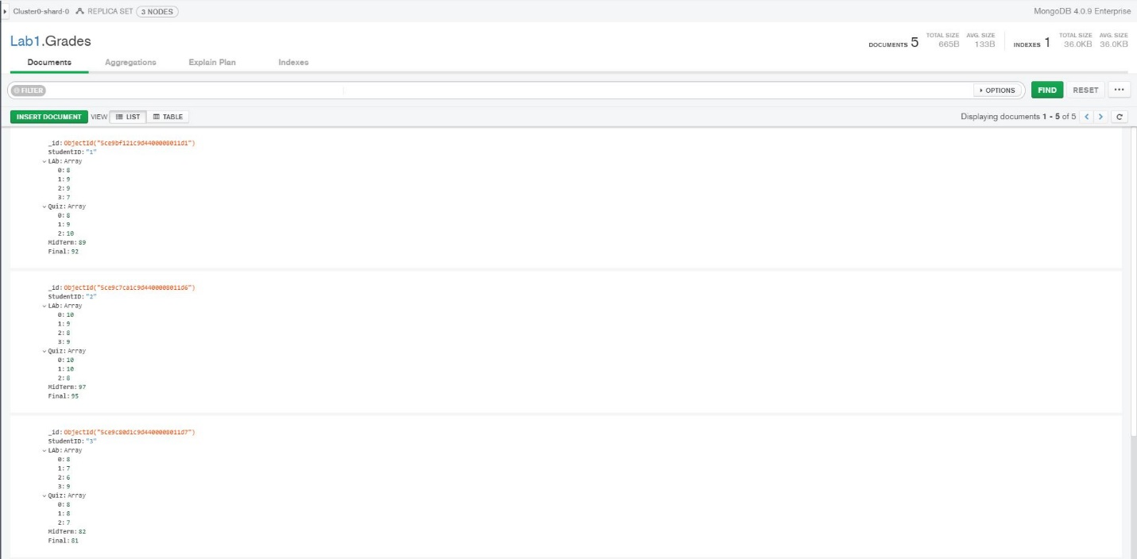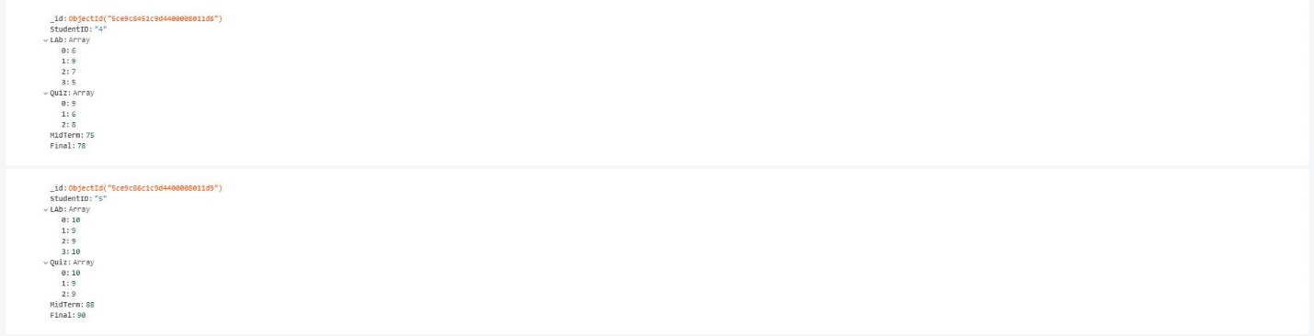

Code –

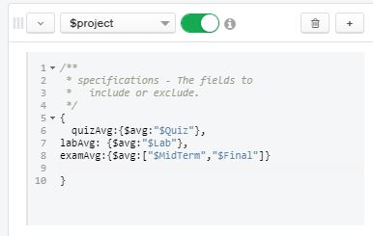

Results –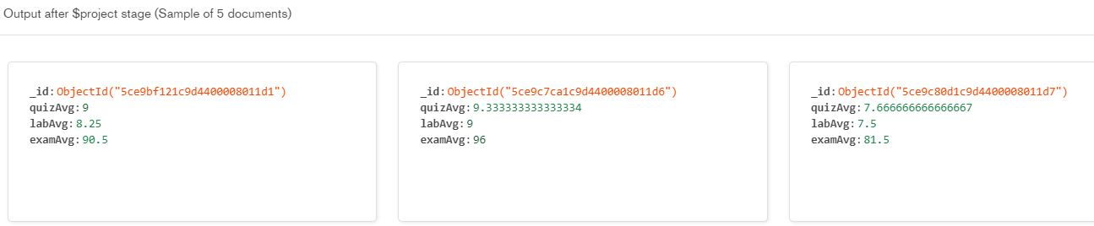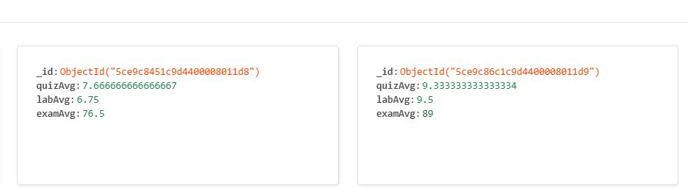

**\*incase the above images are not clear**

Code –

*{*

*quizAvg:{$avg:"$Quiz"},*

*labAvg: {$avg:"$LAb"},*

*examAvg:{$avg:["$MidTerm","$Final"]}*

*}*

Results –

StudentID: ”1”

QuizAvg :9

labAvg:8.25

examAvg:90.5

StudentID: ”2”

quizAvg:9.333333333333334

labAvg:9

examAvg:96

StudentID: ”3”

quizAvg:7.666666666666667

labAvg:7.5

examAvg:81.5

StudentID: ”4”

quizAvg:7.666666666666667

labAvg:6.75

examAvg:76.5

StudentID: ”5”

quizAvg:9.333333333333334

labAvg:9.5

examAvg:89