**MULTI-PLATFORM CONTACT TRACING WITH QR VERIFICATION SYSTEM FOR BARANGAY SABANG**

**CAVITE STATE UNIVERSITY**

**Imus Campus**

Imus City

**Department of Computer Studies**

**MATHEW AGUSTIN O. BELLA**

**JOHN MICHAEL S. DENISA**

**PATRICK FAELDONEA**

January 2022

**MULTI-PLATFORM CONTACT TRACING WITH QR VERIFICATION SYSTEM FOR BARANGAY SABANG**

A Capstone Project

Submitted to the Faculty of

Department of Computer Studies

Cavite State University – Imus Campus

Cavite

In partial fulfilment

of the requirements for the degree of

Bachelor of Science in Computer Science

**MATHEW AGUSTIN O. BELLA**

**JOHN MICHAEL S. DENISA**

**PATRICK FAELDONEA**

January 2022

January 2022

Republic of the Philippines

**CAVITE STATE UNIVERSITY**

Cavite City Campus

1

2

3

**DEPARTMENT OF COMPUTER STUDIES**

1

2

3

Authors: **MATHEW AGUSTIN O. BELLA**

**JOHN MICHAEL S. DENISA**

**PATRICK FAELDONEA**1

Title: **MULTI-PLATFORM CONTACT TRACING WITH QR VERIFICATION SYSTEM FOR BARANGAY SABANG**

2

3

4

5

6

7

**A P P R O V E D:**

1

2

3

4

5

Instructor

**MULTI-PLATFORM CONTACT TRACING WITH QR VERIFICATION SYSTEM FOR BARANGAY SABANG**

**Mathew Agustin O. Bella**

**John Michael S. Denisa**

**Patrick A. Faeldonea**

|  |
| --- |
| A capstone project presented to the faculty of the Department of Computer Studies, Cavite State University-Imus Campus, Cavite in partial fulfilment of the requirements for the degree Bachelor of Science in Computer Science with the Contribution No.____________. Prepared under the supervision of Lerio Batula. |

**INTRODUCTION**

The computer nowadays is a basic need for businesses or companies. It helps a lot in such a way that it makes work more progressive and productive. It is an important thing that a company or small business should have because it helps a lot in many ways such as organizing, storing and manipulating data. Having computer programs may help a company grow bigger and be competitive in the flow of the business world. The companies nowadays use computer literate and very competitive in the business. (Brian Thomas, 2004).

Contact tracing is a key strategy for interrupting chains of transmission of SARS-CoV-2 and reducing COVID-19-associated mortality. This document provides updated guidance on how to establish contact tracing capacity for the control of COVID-19, and how to prioritize contact tracing activities in different settings. (World Health Organization).

QR code is a type of barcode that can be read easily by a digital device and which stores information as a series of pixels in a square-shaped grid. QR codes are frequently used to track information about products in a supply chain and – because many smartphones have built-in QR readers – they are often used in marketing and advertising campaigns. More recently, they have played a key role in helping to trace coronavirus exposure and slow the spread of the virus.

The first QR code system was invented in 1994 by the Japanese company Denso Wave, a Toyota subsidiary. They needed a more accurate way to track vehicles and parts during the manufacturing process. To achieve this, they developed a type of barcode that could encode kanji, kana, and alphanumeric characters.

Standard barcodes can only be read in one direction – top to bottom. That means they can only store a small amount of information, usually in an alphanumeric format. But a QR code is read in two directions – top to bottom and right to left. This allows it to house significantly more data.

The development team behind the QR code wanted to make the code easy to scan so that operatives did not waste time getting it at the right angle. They also wanted it to have a distinctive design to make it easy to identify. This led them to choose the iconic square shape that is still used today. (Kaspersky).

**Statement of the Problem**

The aim of this study was to develop a Multi-Platform Contact Tracing with QR Verification System for Barangay Sabang. Specifically, it aims to answer the following question;

Barangay Sabang are having a hard time handling the rapid spread of the virus within their vicinity. It also not easy for them to track the PUI’s and the Confirmed cases.

The contact tracers are having difficulty getting information from their barangay and tracing people throughout the barangay’s establishments. *How can the Contact Tracing function of the System assist in giving important information to the relevant units of Barangay Sabang?*

The people of Barangay Sabang are having too much time on filling-out forms when visiting or entering establishments, and it takes a long time to fill-out so there is a possibility of being exposed to viruses. *How will the System help people of Barangay Sabang save time on filling out forms?*

People of Barangay Sabang nowadays having difficulty on carrying vaccination card when entering establishments in case of:

a. loss of vaccination cards,

b. damaged vaccination cards,

c. dismisses of bringing a vaccination card;

Avoiding these problems requires a system that can provide a solution. *How will the system be able to provide a better alternative for a physical vaccination card?*

**Objectives of the Study**

The objective of the study was to develop a Multi-Platform Contact Tracing with QR Verification System

Specifically, the study aims to:

1. to determine how can the Contact Tracing function of the system assist in giving important information to the relevant units of Barangay Sabang;

2. to determine how will the system help people of Barangay Sabang save time on filling out forms;

3. To determine how to create a system that can be a better alternative for a physical vaccination card;

**Significance of the Study**

The Multi-Platform Contact Tracing with QR Verification System will be advantageous to the following:

Moderator. It will help them to moderate users to avoid unnecessary account creation, dummy account, bot accounts and the one that will process user verification that will determine if the account is valid.

Relevant units of the government. The system will help them to easily keep all the data information that’s necessary stored in the database. It will also make their work much easier in tracking and contacting the person they need to find, and it will be more convenient and less work to the employees that are assigned to that kind of task.

Tracer. It will help them to log all the users coming and leaving their place(s) including the date, time in and out. It will also take a less hassle in signing the contact tracing form.

User. It will help the users to see the event log of their places they went to, and generate a Virtual Vaccination card and QR Code to be presented to the Tracers.

**Teacher/Academics**

The primary significance of this research is to help the teachers to check the papers of their students. That they will be able to verify their students' originality work.

**Students**

The study also benefits the student so that they can verify their work to be original and avoid committing plagiarism. Also, to improve their paraphrasing skills.

**Writers/Creators**

The system will help the writers/creators when it comes to publishing their works either online or physical. It is important to a writer/creator to be able to publish a purely original work to avoid the unethical act of literary work.

**Future researchers**

This system will provide baseline data needed for future research and studies related to this one and develop their own. They can learn about the proponents’ system and at the same time develop a greater system with the help of the proponents’ study.

The developers gained more knowledge and experience in terms of developing the system. This system also helped the developers to enhance their skills in communicating with the group, time management and teamwork.

**Time and Place of the Study**

The making of the system was conducted at the developers own place located at Dasmariñas City, Imus City and Bacoor City, Cavite during the period of September 2021 and expected to end in June 2022.

**Scope and Limitation**

**User Module.** It has different subjects that are needed to show in the system. This module has sub-modules that include all the different information and function that will be displayed in the system.

**User Registration sub-module** is the 1st module that can be accessed by anyone who has the privilege to create an account as a normal user. In this sub-module, users can apply the information required in the form which such as name, email, proof of vaccination, address and etc.

The **2nd sub-module is User module**. This sub-module can only access by a user account. In this sub-module User can edit their profile, track their activities, check the status of offices, generate their QR and download their virtual card.

In the **3rd sub module is User Login Module**. This sub module can be access by anyone that have user account to logged in their account and proceed to User module and view their profile.

**Scanner & Tracer Module**. It depends on the person if the user who logged in as a provider using Mobile device or a Desktop device, Provider that has logged in through mobile devices will trigger the Scanner module which allows them to scan user QR code and add time-in to the database. Provider that has been logged in via Desktop will go to Tracer module which allows the user provider have access to specific or important normal user information to track them, in this module, tracer has the privilege to see the time in, date, name, contact number and email of the users who got scanned by the Scanner module.

**Administrator Module.** It only has one type of module. This module has the privilege to manipulate all the data inside the User, Scanner, and Tracer module. The Administrator has the privilege to add, modify, and archive any data of a Provider or a User, Admin also has access to ban and verify the normal user.

**Limitations**

- Can't access or navigate without internet

- Desktop/Laptop Users cannot access user dashboard, Mobile device supported only.

- Scanner only works on mobile devices that supports modern browsers and has mid-tier camera

- Provider can only be created by an IT directly to the database server for security purposes

- Admin do not have the ability to create Provider but only modify information of provider and users

- User Admin type can only be set by an IT directly to the database server for security purposes

- User cannot login or access the user dashboard if the account is not yet reviewed by an Admin

**Definition of Terms**

**QR code.** Quick Responsecode that is holding more information.

**Email.** Electronic mail that can send text.

**Archive.** a collection of historical documents or records.

**Virtual Card**. Digital based vaccination card.

**Module.** It presents the features of the system.

**Provider.** Providing information to relevant units of the barangay.

**Internet.** A global electronic communications network that links computer networks and organizational computer facilities.

**Conceptual Framework**

**INPUT PROCESS OUTPUT**

**Planning**

• Preliminary investigation of the study

**System Design**

• Screen layout design, process flow and other documentation related on how the system will work.

**Development**

• Coding/Programming

**Testing**

• Testing the project on a live environment (initial and final testing)

**Evaluation**

• System Evaluation

**Multi-Platform Contact Tracing with QR Verification System**

**A. Knowledge Requirements**

* Database
* API

**B. Software Requirements**

* MySQL
* HTML
* PHP 5+
* JavaScript
* CSS/ SCSS
* JSON

**C. Hardware Requirements**

* Computer

-Atleast 4GB ram

-i3 1st Gen or equivalent

-Atleast GT210 or

equivalent

* Smart Phone

-has average quality of camera

-2GB RAM

- Android Kitkat V4.4

**Figure 1**. Conceptual Framework of the Multi-Platform Contact Tracing with QR Verification System.

**CHAPTER 2**

**REVIEW OF RELATED LITERATURE**

This chapter summarizes the relevant literature and studies that the researchers evaluated while determining the significance of the ongoing study. It also includes a summary of the art in order to completely comprehend the research and have a better understanding of the study.

**Review of Related Literature**

**(Local)**

**CONTACT TRACING**

A study conducted by Medel, Darwin A. et al., (2021) says that, contact tracing is a method of preventing the transmission of illnesses such as COVID-19, which was formerly handled manually in most parts of the Philippines. Better solutions have evolved from technological techniques such as Quick Response (QR) Codes and Bluetooth. However, these solutions necessitate the use of smartphones, which might be a concern in countries with low smartphone adoption, such as the Philippines. Radio Frequency Identification (RFID) Technology is used in contactless smart cards and is used in a range of applications, including transaction automation, personal identification verification, and contact tracing in hospitals.

Moreover, Pangan, Zachary (2021) emphasizes that contact tracing is an important component of interventions aimed at slowing the spread of the disease. The next critical step is to use network analysis to assess the disease's spread after determining the rate of transmission. Active tracing includes testing suspect cases to locate and isolate positive cases from identified close contacts, whether using manual or digital approaches. Citizens can report symptoms to approved local health authorities through passive tracing. The majority of COVID-19 contact tracing operations carried out by local government units follow typical manual contract tracing methods. Traditional contact tracking procedures, however, are insufficient to stop the spread of the disease due to the outbreak's rapid acceleration.

**(Foreign)**

Ekong et al. (2020) have discussed COVID-19's enhanced contact tracing technology and the use of flexible location data from Nigeria's information security guidelines Regardless of modern contact tracing's capabilities, it frequently clashes with comprehending security. They also discovered that Nigeria's reaction is consistent, and that contact detail information might be used to enhance present approaches. According to their findings, mobile location information contact tracing is useful for scourge control as long as it adheres to information security requirements.

**(Foreign)**

**Emerging technologies and COVID-19 digital vaccination certificates and passports**

Mbunge, Elliot, et al., COVID-19 immunization certificates create significant ethical issues that must be clearly recognized and handled. To overcome the constraints of traditional vaccination cards, secure COVID-19 electronic-based vaccination certificates or passports are required. COVID-19 digital vaccination certificates should be tamper-proof, remotely accessible, safe, and protect people's privacy. These technologies could be used to perform various activities in the context of COVID-19 electronic vaccination certificates. To proceed, artificial intelligence could be used to detect forged COVID-19 vaccination certificates, quickly identify and map non-vaccinated regions or populations for strategic planning, cluster migrants' migration patterns based on data stored in the verification app(s), and assist in contact tracing.

**RISK OF MANUAL CONTACT TRACING**

According to Zirbes et al, (2021) contact tracing, as well as proper testing and preventing of high-risk contacts, play critical roles in controlling the virus by disrupting infection chains. This strategy is especially essential in the hospital context, when physical distance is frequently impossible to achieve. Furthermore, because health care workers (HCWs) come into touch with a wide range of susceptible persons, it's critical to detect infections among frontliners as soon as possible to prevent SARS-CoV-2 from spreading rapidly across the facility.

Insights from [Bernard Lo, MD](https://www.acpjournals.org/doi/full/10.7326/M20-5834) (2021) manual contact tracing involves public health officials contacting people who have been exposed to an infected person and asking them to get tested and self-quarantine to prevent future spread. Because of the enormous number of affected people, the shrinking of public health offices, the shortage of competent contact tracing workers, mistrust of government, and lack of cooperation by contacts, manual tracing has not been successful with COVID-19.

Added to the definition presented, Jacob, Steve (2020) contact tracing is the process of identifying and tracking everyone who has come into contact with an infected person (Perscheid et al. 2018). Manual contact tracing, which was first devised to counter syphilis at the end of the 1930s, is critical for slowing the spread of an epidemic (McLachlan et al. 2020). Interviews with patients and those with whom these patients have come into contact are used to identify them. Traditional contact tracing's effectiveness is restricted by low response due to the human tracing method, limited data processing, respondent oversights or exclusions, and the inability to identify individuals in a crowd (Alsdurf et al. 2020; Watts 2020).

**(Foreign)**

**PAPER BASED VACCINATION CERTIFICATE**

As stated by Mbunge, Eliot et al., (2021) By vaccinating communities and targeting priority groups to reduce secondary transmission, the effective development of COVID-19 vaccines has accelerated worldwide post-pandemic recovery. This allows imposed limits on international and regional travel, tourism, education, and other aspects of social life to be relaxed. To decrease secondary transmission and uncertainty caused by developing COVID-19 variations, the immunization process targets priority groups. Those who have been vaccinated are given certificates (cards) that contain information about the COVID-19 vaccination and the health facility. These conventional vaccination cards can be faked, manipulated, and issued in a corrupt manner. They can also be difficult to read by non-health professionals and easily torn and misplaced.

Study shows about Gelb, Alan and Mukherjee, Anit (2021) Some countries proposed "immunity passports" for those who had recovered from COVID-19 during the early stages of the pandemic, however none of the suggestions have been implemented due to differences in scientific and public health opinion. The CVC, on the other hand, would reflect vaccination status in the same way as the paper-based International Certificate of Vaccination or Prophylaxis, or Yellow Card but it would need to incorporate digital technology to boost its amount of certainty. The Yellow Card offers minimal protection against counterfeit or tampering, nor does it guarantee that the person named on the card is the one who holds it.

**(Local)**

**ISSUANCE OF DIGITAL VACCINATION CERTIFICATE**

According to Adam Ang (2021), the Philippines to issue digital vaccination certs for overseas workers from September. The certs will be issued through the mobile and web-based VaxCertPH portal which has already gone live. Developed by the DICT for the Philippine Health Department, the VaxCertPH is an online portal for the issuance of vaccination certificates, which are said to be compliant with the technical specifications set by the World Health Organization for vaccination certificates.

**COVID-19 Antibody Test/Vaccination Certification: There's an App for That**

Eisenstadt, Marc, et al., (2020) Coronavirus Pandemic unfolds, a COVID-19 'Immunity Passport' has been proposed as a mechanism to allow people to return to work. While research into the quality of antibody testing, vaccine availability, and the likelihood of ever attaining COVID-19 immunity continues, we look at the challenges of providing tamper-proof and privacy-preserving certification for test findings and injections. To assist quick verification of tamper-proof test findings, we created a prototype mobile phone app and the necessary decentralized server architecture.

**(Foreign)**

**Ticket Verification and Passenger Authentication using Encrypted QR Code for Airport Verification System**

Vishwashree, Karhadkar et al., (2021) We can enhance our Airport Security System to a higher degree by applying the Encrypted QR code approach for verification and authentication. Verification and authentication become more reliable when this Security System is used. It is safe and accurate to use encrypted QR code technologies for security purposes. We can prevent many serious crimes, such as identity document forgery and human trafficking, by applying this approach. This method will allow for paperless travel and eliminate the need for numerous identity checks. This would also assist the aviation system in addressing challenges such as terrorism threats to passenger in addition to aircraft safety.

**(Foreign)**

**Impact of Progressive Web Apps on Web App Development**

As for Tandel, Sayali Sunil et al., (2018) To overcome limitations such as going to other platforms to download an app and requiring a strong internet connection for the app to work properly, or requiring a web browser to actually visit the information, Google has provided a solution called Progressive Web App (PWA), which combines the best of web and mobile apps to give us a rich experience that is comparable to native apps. It's a website that works like an app and is developed with web technologies. PWA stands for Progressive Web App, which is a website that operates like an app but does not require installation like a native app.

Sharma, Varsha et al., (2019) Added that we have a new approach called progressive web application, which can be deployed using a variety of cutting-edge technologies. This program may then be run on nearly any platform and they argue in this study that progressive web applications will eliminate the necessity for native apps because it has a add to home screen function and requiring a medium amount of internet connection for it to run.

**(Foreign)**

**PROMOTING THE USAGE OF A COVID-19 CONTACT TRACING APP**

Based on the study of Munzert, Simon et al., (2021), globally, digital contact tracing tools have been created as a tool to prevent the COVID-19 pandemic. However, confidentiality by design makes it difficult to evaluate these technologies and employ evidence-based initiatives to increase use. They also use an online panel poll and mobile tracking data to assess actual use of Germany's official contact tracing app, and found out that respondents with a greater risk of severe sickness use it more frequently, while those with a higher risk of COVID-19 exposure use it less frequently. There are findings from a second intervention, on the other hand, demonstrate that even minor monetary incentives can boost utilization and make digital contact tracing a more valuable tool.

**Mobile technologies for contact tracing and prevention of COVID-19 positive cases: a cross sectional study**

According to S. Prabu et al, (2020). With so much improvement in technological breakthroughs and mobile technologies, everyone can combat hazardous diseases like coronavirus and prevent it from spreading further. Although it collects information from clients, no one may misuse the information. One of the best ways to avoid information from being misused is to keep it with just higher-ups, and they should not have consented to share it with anyone. If we follow all of the precautions and utilize the following mobile applications, we will have a chance to win and prevent the spread of this fatal disease.

**Authentication and Transaction Verification Using QR Codes with a Mobile Device**

Chow, Yang-Wai et al., the identification of users and the verification of online transactions conducted on an untrusted computer or device is a significant and difficult subject. This paper describes a method for authentication and transaction verification that uses a trusted mobile device with a camera and QR codes. Because the essential information is obtained by the mobile device through its camera, i.e. exclusively through the visual channel, the mobile device does not require an active connection (e.g., Internet or cellular network). An initial user authentication phase is followed by a transaction verification phase in the suggested approach.

**A QR Code–Based Contact Tracing Framework for Sustainable Containment of COVID-19**

Nakamoto, Ichiro et al., (2020) In contrast to the GPS-based technique, symptom-based QR telemedicine does not track users' locations, hence the vulnerability associated with the former can be avoided. The main goal is to assess how the technique can be used as an immediate response to the COVID-19 problem, as well as a routine tool for restoring normal rhythms in businesses, vacation destinations, and communities. QR scanning site accounts are customizable and adaptable. Local statistics might be reported to government agencies for further analysis.

**QR based Contact Tracing Application**

Varghese, Alwin, et al., This document is compiled to improve the requirements for tracking down persons who come into touch with the virus and developing procedures to maximize the data and use it for the advantage of the residents, particularly the health authorities and the government. Countless pieces of information must be checked and authenticated with only the necessary persons present, and the crowd must be informed correctly. The purpose of the document is to fulfill the needs of people who are affected at a certain point in time and to support the government in taking effective action to deal with the problem.

**METHODOLOGY**

This chapter explains various methodologies that were used in gathering data and analysis which are relevant to the research. It outlines the approaches and tactics employed by researchers in the field of information, as well as the materials and procedures used to achieve the intended outcome. The research methodology and research method used in this research is acknowledged and discussed.

**Requirement Specifications:**

**Functional Requirements**

* Login access for Admin, User, Provider and Scanner.
* Admin is in charge of (accepting user request, add, and modify any data of a Provider or a User).
* Provider is capable of (Modifying provider information, Sort by date user activities and export user activities).
* Scanner does have (camera permission, Scan user's QR and approve or cancel time in request).
* Users can (update user information, request card update, register a user account, confirm email address).
* A system that generates a User QR Code.
* A system that shows the total confirmed cases/ deaths / recover of Covid-19 in the Philippines
* A system that provides a list of time-in records.

**Hardware Requirements**

**Table 3.1**

**Admin & Provider System Requirements**

|  |  |  |
| --- | --- | --- |
| **ITEM** | **MINIMUM SPECIFICATION** | **RECOMMENDED SPECIFICATION** |
| **Laptop** | **At least 2GB ram**  **i3 1st Gen or equivalent**  **At least GT210 or**  **equivalent** | **i3 4th gen or higher**  **4gb ddr3 or higher**  **intel graphics hd or higher** |
| **Desktop** | **At least 2GB ram**  **i3 1st Gen or equivalent**  **At least GT210 or**  **equivalent** | **i3 4th gen or higher**  **4gb ddr3 or higher**  **intel graphics hd or higher** |

**Table 3.1 Admin & Provider System Requirements**

**Table 3.2**

**User & Scanner System Requirements**

|  |  |  |
| --- | --- | --- |
| **ITEM** | **MINIMUM SPECIFICATION** | **RECOMMENDED SPECIFICATION** |
| **Mobile Phone** | **3MP camera front/back**  **2GB RAM**  **Android KitKat V4.4** | **15MP camera front/back or higher**  **3GB or higher**  **Android KitKat V4.4 or higher** |

**Table 3.2 User & Scanner System Requirements**

**Software Requirements**

1. **XAMPP (v** **3.3.0)**



It is a free open-source cross-platform web server solution stack package developed by Apache Friends. XAMPP stands for Cross-Platform (X), Apache (A), MariaDB (M), PHP (P) and Perl (P). It is a simple, lightweight Apache distribution that makes it extremely easy for developers to create a local web server for testing and deployment purposes. Everything needed to set up a web server – server application (Apache), database (MariaDB), and scripting language (PHP) – is included in an extractable file.

1. **MySQL (v** **7.4.29)**



It is an open-source relational database management system.MySQL is an Oracle-backed open-source relational database management system (RDBMS) based on Structured Query Language (SQL). Although it can be used in a wide range of applications, MySQL is the most often associated with web applications and online publishing.

1. **Visual Studio Code (v** **1.67.1)**



Visual Studio Code is a lightweight but powerful source code editor which runs on your desktop and is available for Windows, macOS and Linux. It comes with built-in support for JavaScript, TypeScript and Node.js and has a rich ecosystem of extensions for other languages (such as C++, C#, Java, Python, PHP, Go) and runtimes (such as .NET and Unity). Begin your journey with VS Code with these introductory videos.

1. **Color Cop (v** **1.0.3)**



Color Cop is a multi-purpose color picker for web designers and programmers. It identifies and represents colors in various hex color code formats. Simply drag the eyedropper control to any location on the screen and release. The hex color code for the selected color will be automatically copied to the clipboard. See other features.

1. **Icons8 Pichon Desktop (v** **9.6.1.0)**



Pichon Icons8 is an offline app to search for icons and drag to any app. All icons are done by a single designer, so your work will look consistent. Vector icons are not merged and have preserved shapes. Pick only the icons you need and build your own font. Get a code to paste an icon right into your HTML.

1. **GitHub Desktop (v** **3.0.0)**



GitHub Desktop is an application that enables you to interact with GitHub using a GUI instead of the command line or a web browser. GitHub Desktop encourages you and your team to collaborate using best practices with Git and GitHub. You can use GitHub Desktop to complete most Git commands from your desktop with visual confirmation of changes. You can push to, pull from, and clone remote repositories with GitHub Desktop, and use collaborative tools such as attributing commits and creating pull requests.

1. **FileZilla FTP (v** **2.55.1)**



FileZilla is a utility for transferring files to or from a remote computer by a standard method known as FTP (File Transfer Protocol). FileZilla is open-source software that is installed and runs on Windows and Linux computers in the college; a Mac OS version is available.

**For Desktop browser testing**

1. **Chrome Windows (v 101.0.4951.54)**



Google Chrome is a fast, easy to use, and secure web browser. Designed for Android, Chrome brings you personalized news articles, quick links to your favorite sites, downloads, and Google Search and Google Translate built-in. Download now to enjoy the same Chrome web browser experience you love across all your devices.

1. **Edge Windows (v** **101.0.1210.39)**



Microsoft Edge is a cross-platform web browser created and developed by Microsoft. It was first released for Windows 10 and Xbox One in 2015, for Android and iOS in 2017,[6][7] for macOS in 2019,[8] and for Linux in 2020,[9][10] and can replace Internet Explorer on Windows 7, Windows Server 2008 R2 and later versions but unlike IE, this browser does not support Windows Vista or earlier versions

1. **Brave Windows (v** **1.38.117)**



Brave is a free and open-source web browser developed by Brave Software Inc. based on the Chromium web browser. Brave is a privacy-focused browser, which automatically blocks online advertisements and website trackers in its default settings. It also provides users the choice to turn on optional ads that pay users for their attention in the form of Basic Attention Tokens (BAT) cryptocurrency. Users can then send contributions to websites and content creators, which support BAT in the form of tips along with the ability to keep the cryptocurrency they earned.

1. **Opera Windows (v** **86.0.4363.23)**



Opera is a Web browser that provides some advantages over other browsers from Mozilla or Microsoft. Much smaller in size, Opera is known for being fast and stable. Opera is available for a number of operating systems, including BeOS, Symbian OS, Linux, Mac OS, OS/2, Solaris, and Windows. It offers the same capabilities of the more popular browsers including integrated searches and instant messaging, support for JavaScript, cascading style sheets and E-mail. Because Opera is so compact, it has been promoted for use in hand-held Internet devices, including smartphones that use the Windows Mobile operating system.

**For Mobile browser Testing**

1. **Chrome Android (v** **101.0.4951.61)**



Google Chrome for Mobile is a mobile internet browser that makes it easy for users to surf the web at rapid speed on a mobile device. The Google Chrome Mobile web browser brings some of the original browser’s most popular features to mobile, such as tabs and incognito mode.

1. **Brave Android (v 1.38.113)**



Brave is available as a fast, free, secure web browser for your mobile devices. Complete with a built-in ad blocker that prevents tracking, and optimized for mobile data and battery life savings. Get the Brave Browser (mobile) for Android or iOS.

1. **Opera (v 63.3.3216.58675)**



1. **Safari iOS (v 15.4)**

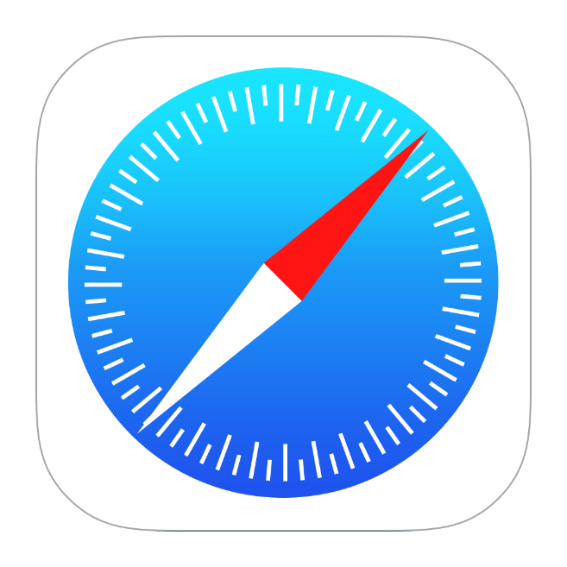

Safari is a Web browser developed by Apple, Inc., and is the default browser of the operating systems used in its product lines such as OS X for the Mac and MacBook computers and iOS for the iPhone and iPad mobile devices.

**Research Method**

The method of research used in this study is descriptive research approach. The researchers/developers will use this strategy to define the demands of the barangay and provide answers to their problems.

This method presents the materials and method together with the sequence of project development. It also shows the requirements needed to be able to build the application and its specification. The researchers used Agile Model to elaborate and furthermore analyze the step-by-step procedure in developing their system application.

To be able to develop the proposed system, the researchers had minimum computer specification requirement; Operating System: Windows 10 Pro 64 Bit, Intel (R) Core (TM) i3-10105F CPU @4.40GHz processor, 16.00GB of Ram and AMD RX580 8.00GB.

**Research Design**

In Multi-Platform Contact Tracing with QR Verification System, the researchers used Agile Method in developing the system. Agile is a development methodology in which as model is quickly constructed phase by phase in a time allocated manner to test and illustrate design features and ideas, in order to gather user feedback. Subsequent models are created by refining earlier versions, with the aim of convergence on the desired end product. In this design, methodology is sometimes known as iterative to release the mini-increment of new functionality. It is consisting of requirements analysis, planning, design, develop, testing and evaluate phases.

**Agile method model**

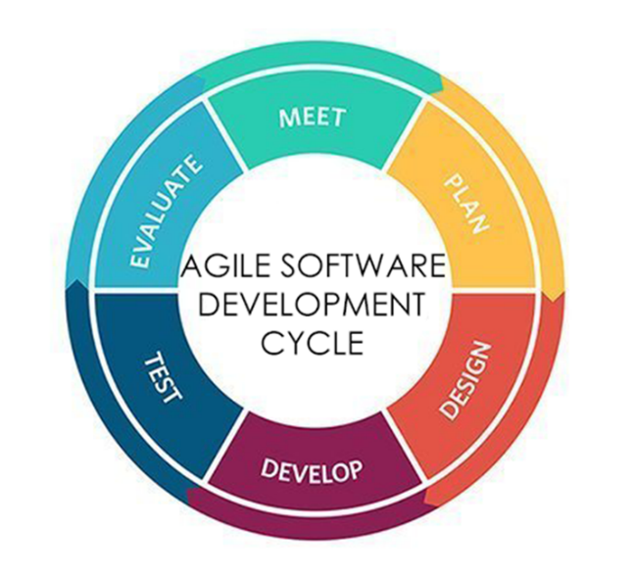

**Figure 2**. Agile Software Development Cycle

**Initial requirements**

. In this phase the researchers started collecting some information about the study by reading some articles, thesis and other materials that helped the researcher. Also, the researcher gathered essential data by interviewing people with relevance to their study. The initial planning was conducted to make the system possible.

**Planning**. In this phase, the researchers' aim was to work to realize the common objective and minimize misunderstanding and omissions. The researcher decided on the goal of the project and its major components or categories. The researchers scheduled regular meetings from the outset, to keep the project on time and avoid costly delays.

**Design**. After finalizing the plan, the researchers began to work on designing the system. This part of the development is mainly focused on scheming the overall system process, functionality and user interface design.

**Develop**. The coding period of the system development life cycle. This is the most crucial part of the development since the researchers experience errors and difficulty. This is the longest stage of the cycle. Tests are being conducted after development of certain features.

**Test**. In this phase, the researchers checked if the objectives are met through a sequence of system evaluation and checking, system adjustment was executed in order to meet the quality of the user requirements complied by the proposed system.

**Evaluate**. This is the releasing period of the study, where in the developed application is tested by the client and evaluated afterwards. This is the phase where the clients will use the instrument whether the system meet the certain conditions and conform the desired result.

**Data Gathering Instruments and Procedure**

**Data Gathering Instruments**

**Interview**

The target interviewees for the proposed system, the Multi-Platform Contact Tracing with QR Verification System, was given a set of questions to the Barangay officials and residents from Barangay Sabang by the interviewers.

**Evaluation Form**

The respondents were given an evaluation form on which they may record their experiences throughout the usage of the system. The purpose of the study and the hypothesis were also indicated.

**Documents, Journals, and Articles**

The study's documents, publications, and papers were utilized. The internet provided the researchers with information by delivering softcopies of the data and information they required.

**Procedures Used in the Study**

**Interview**

The proponents had a formal interview with Barangay Sabang Officials and its residents. It is simpler to acquire more precise information in a formal interview, which will aid in the creation and design of the proposed system.

Barangay Captain granted permission and signed the proposal letter, allowing the researchers to collect data from the Barangay Officials and its residents for the benefit of the system. The Barangay Captain and its Council were able to voice their struggles with paper-based contact tracing and residents on filling out forms. As a result, the researchers and developers devised a system that would help both residents and Barangay Officials. It is critical that proponents of the system base their arguments on the requirements and wishes of clients.

**Barangay Survey**

The developers of the Multi-Platform Contact Tracing with QR Verification system visited the Barangay and performed a survey with the end-users, the Barangay Officials and residents, to see if the system met their expectations and needs. It would also assist the developers in determining the system's benefits.

**Evaluation**

The researchers will test the system they designed with the help of the Barangay Captain, the Barangay Council, and the residents. This will serve as the foundation for adding features to the system that will aid in its future evaluation. The system will be graded on its performance where: 1 = poor, 2 = fair, 3 = good, 4 = very good, and 5 = excellent.

**Online Research**

The researchers based their study on web articles and related studies.

**Software Design**

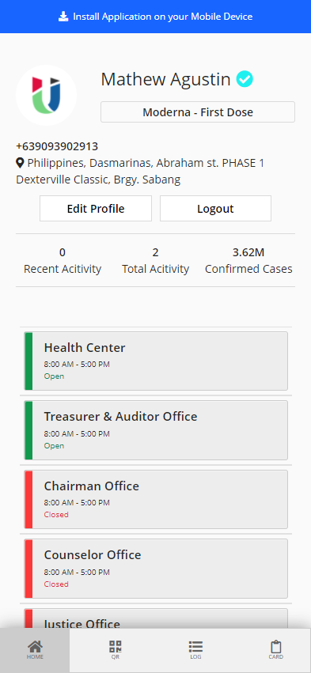

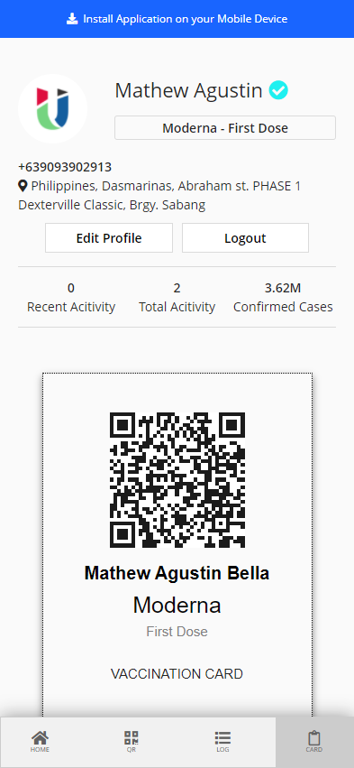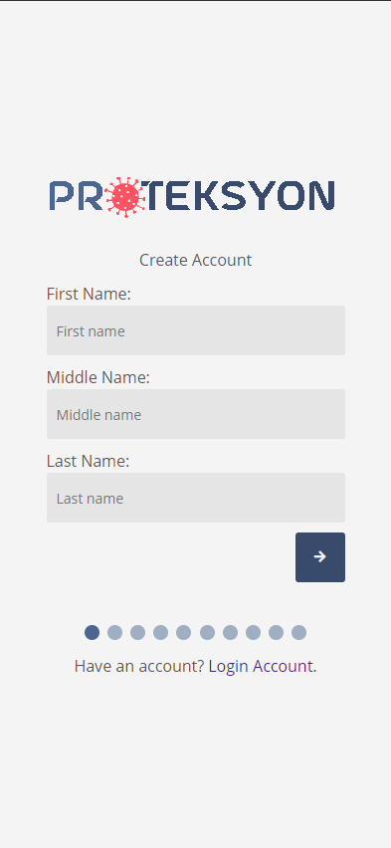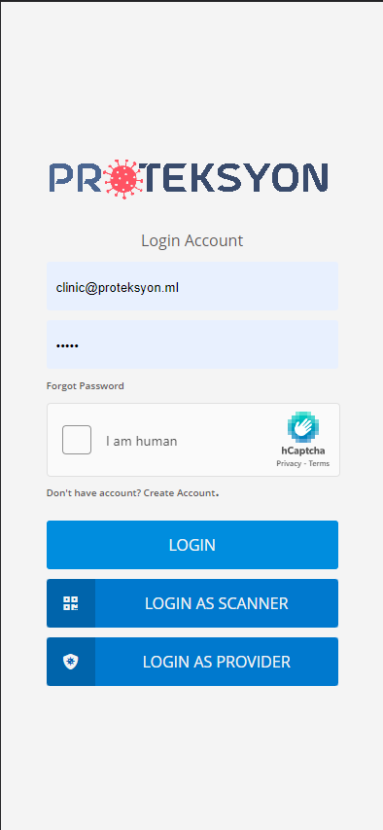

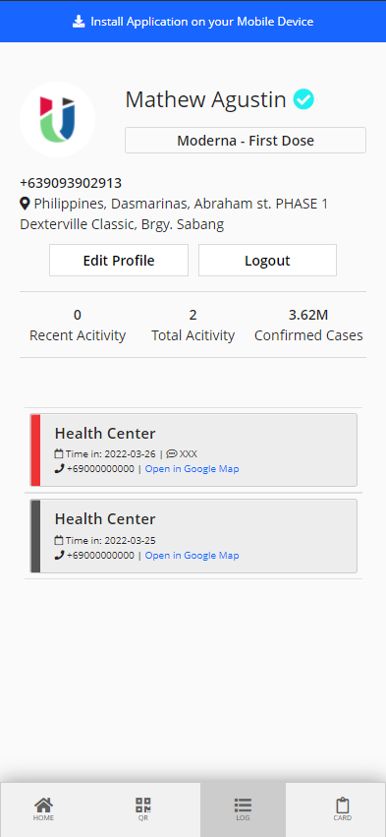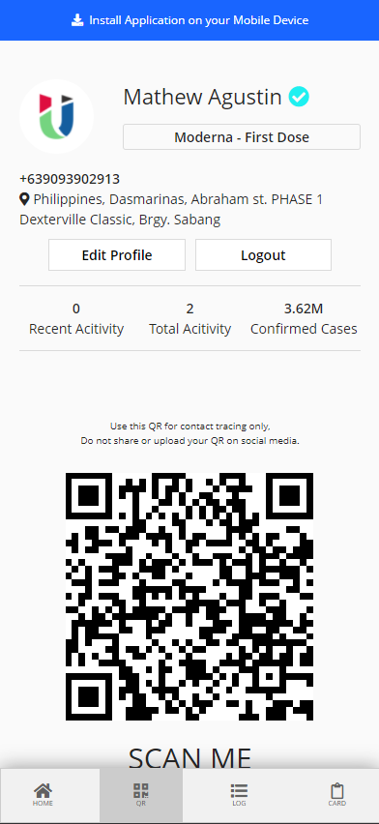**Figure 3. User Module**

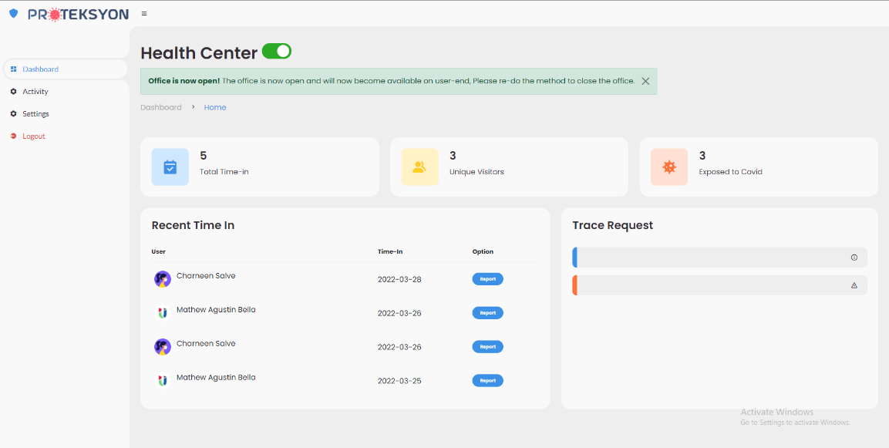

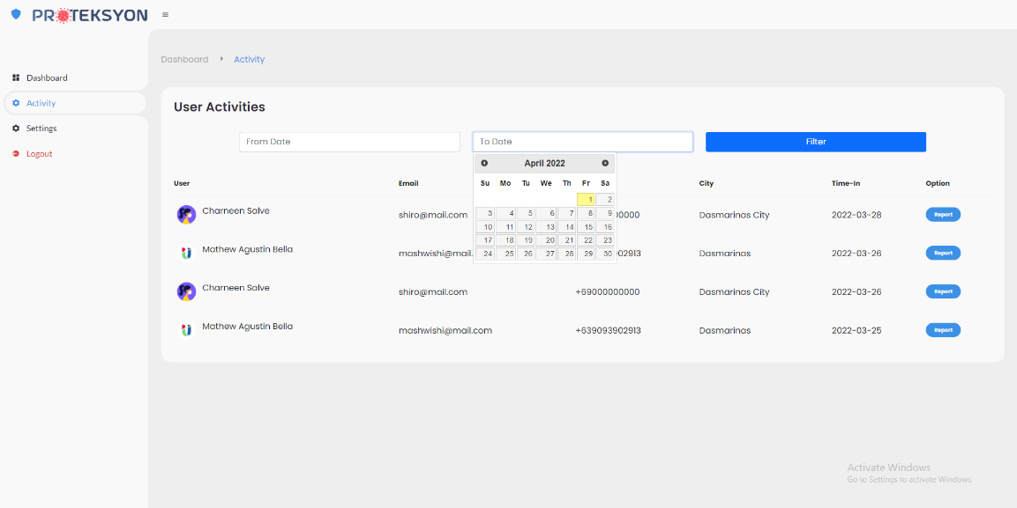

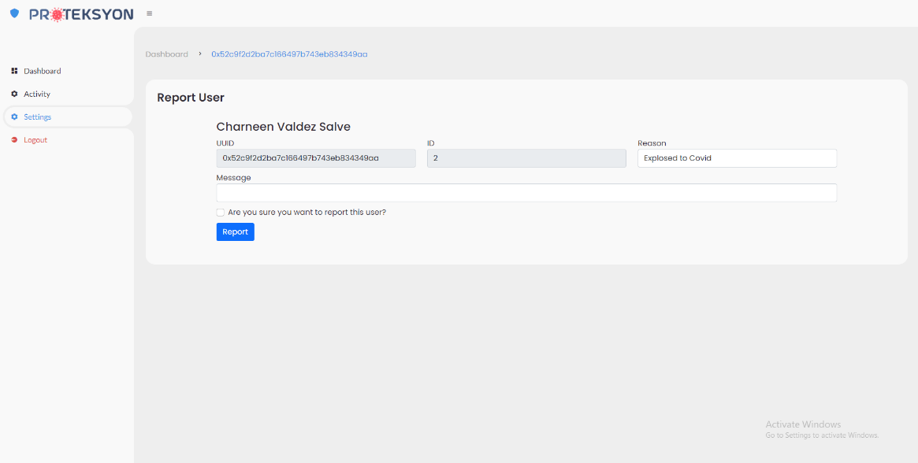

**Figure 4. Tracer Module**

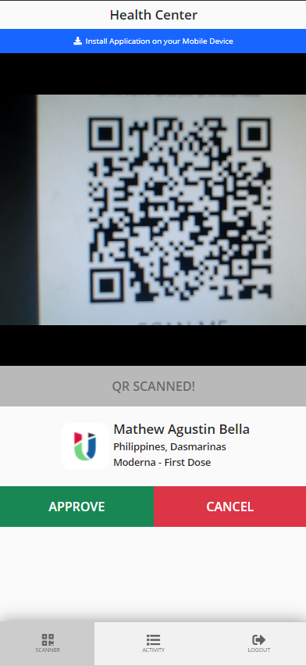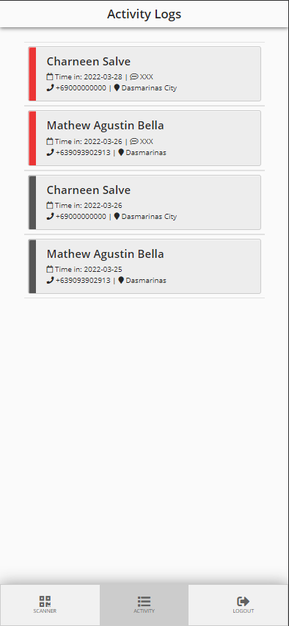

**Figure 5. Scanner Module**

**Figure 6: Admin Module**

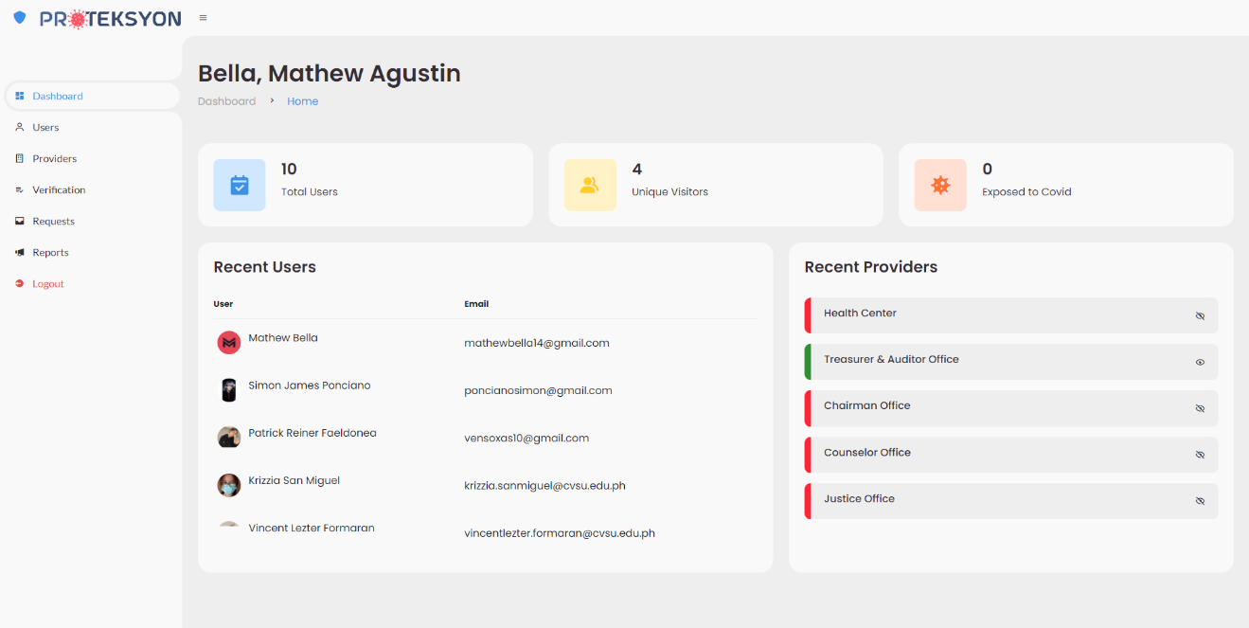

**Figure 6.1. Admin dashboard**

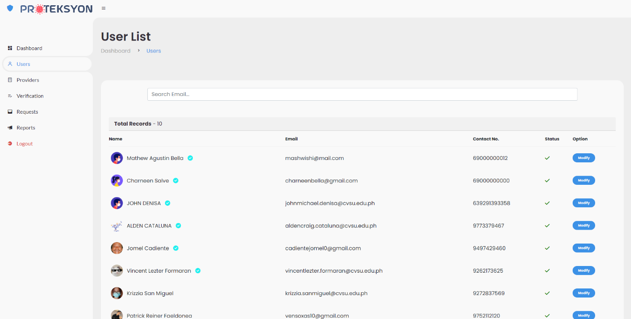

**Figure 6.2. Admin User List**

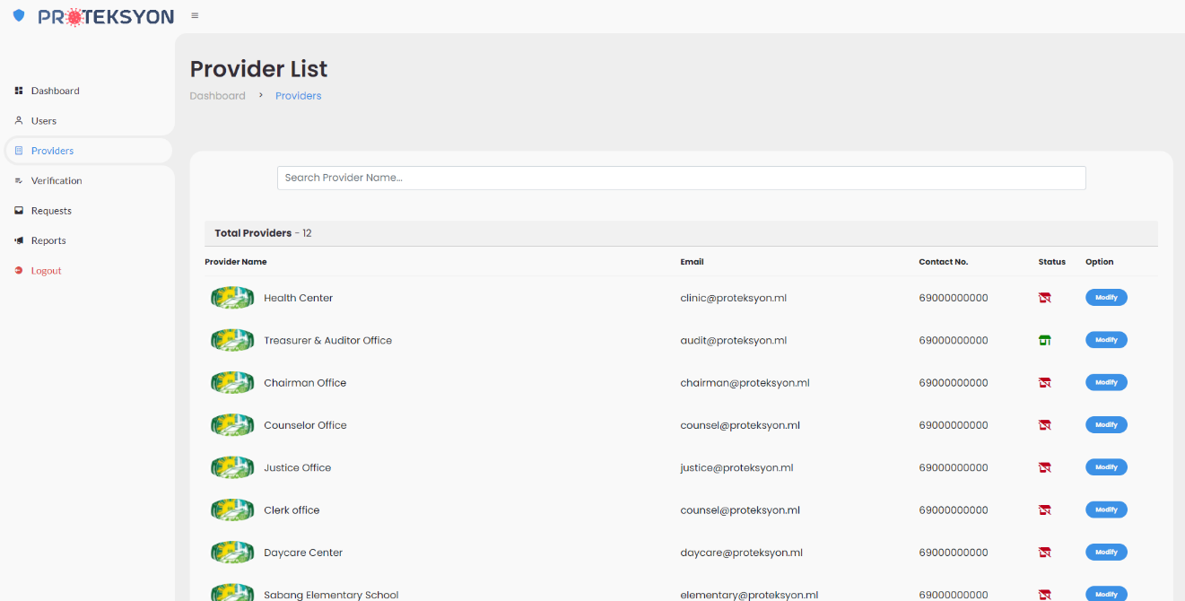

**Figure 6.3. Provider List**

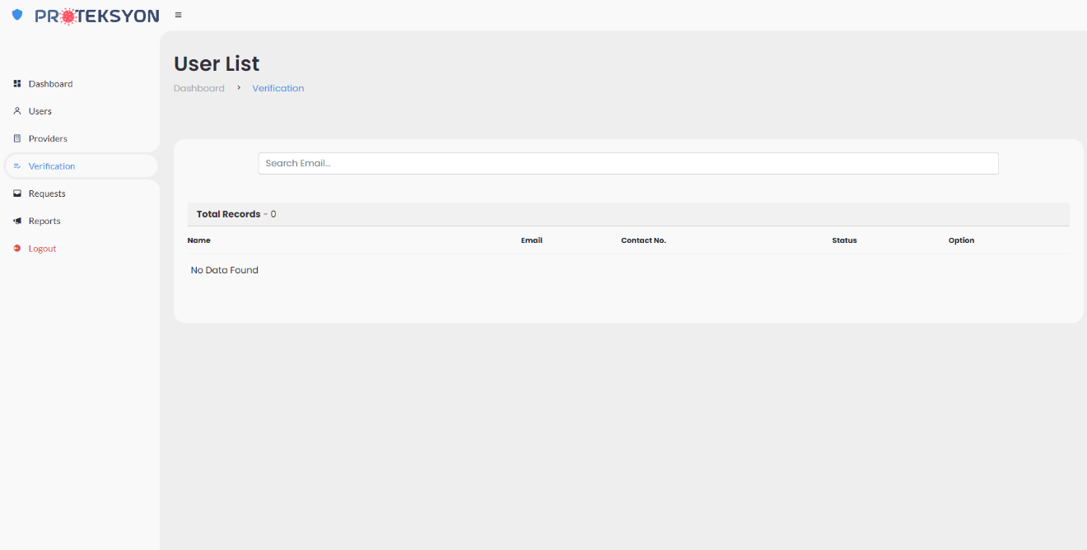

**Figure 6.4. User Verification**

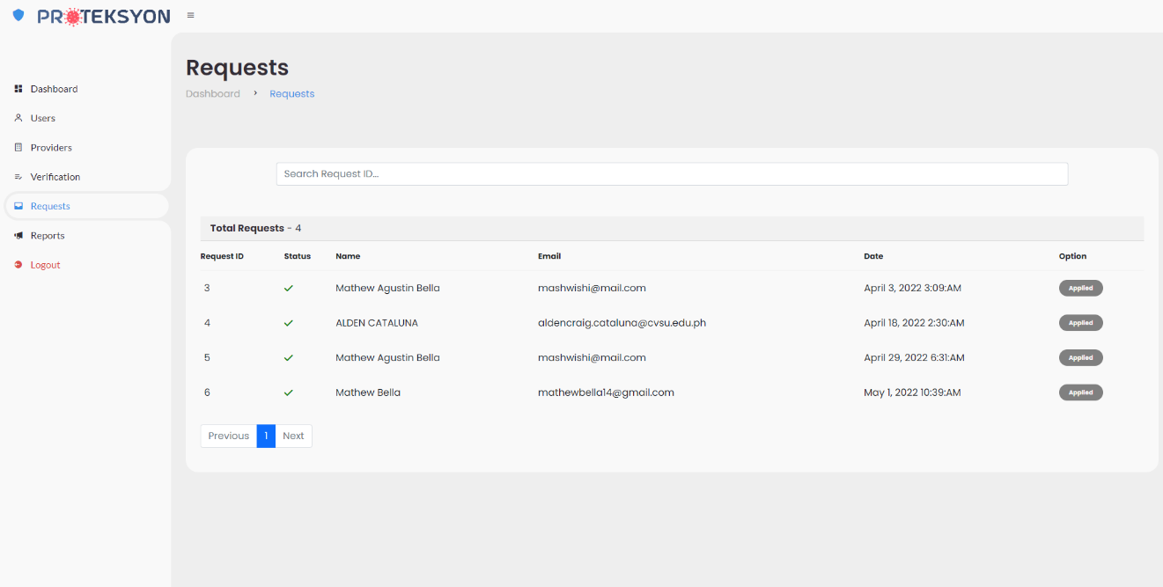

**Figure 6.5. User Card Update Request**

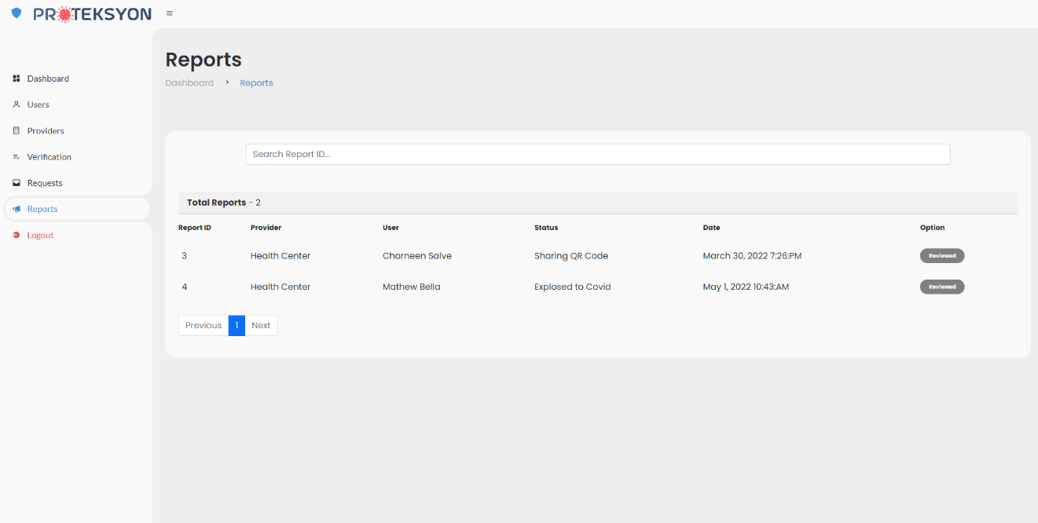

**Figure 6.6. Admin Provider Reports**

**Data Schema**

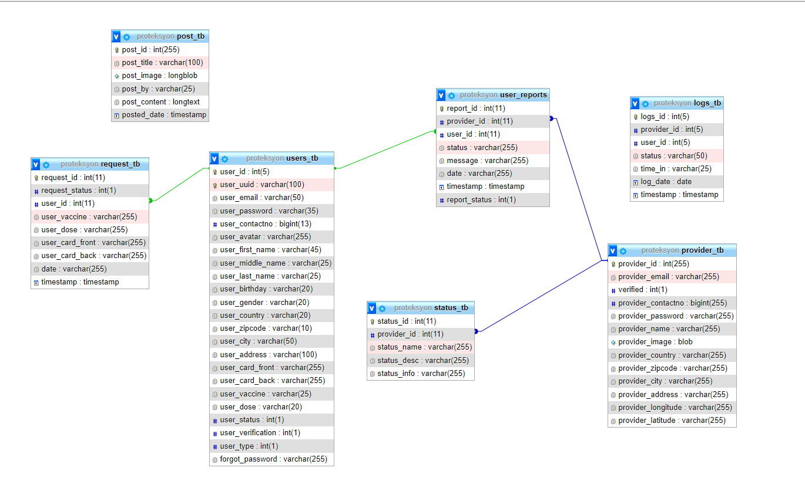

**Technical Design**

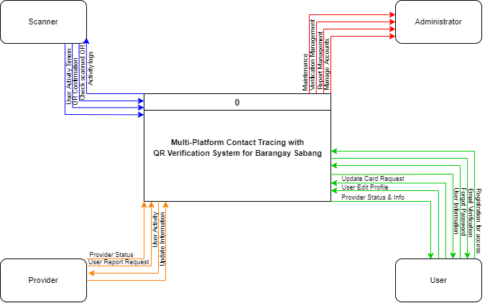

**Data Flow Diagram**

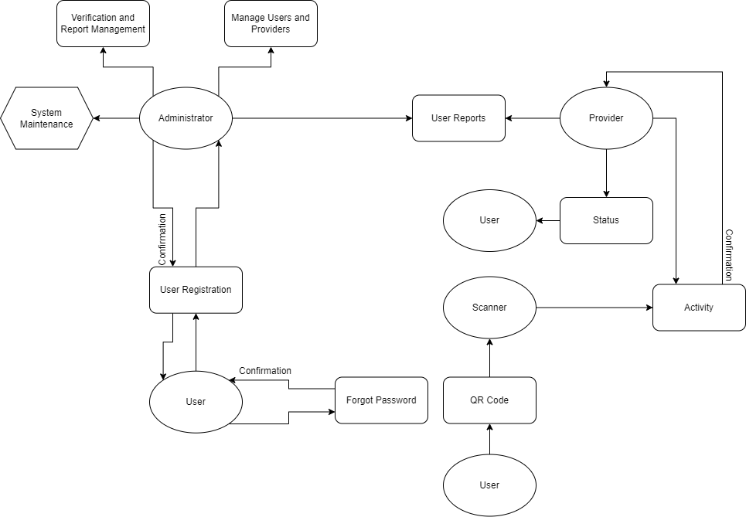

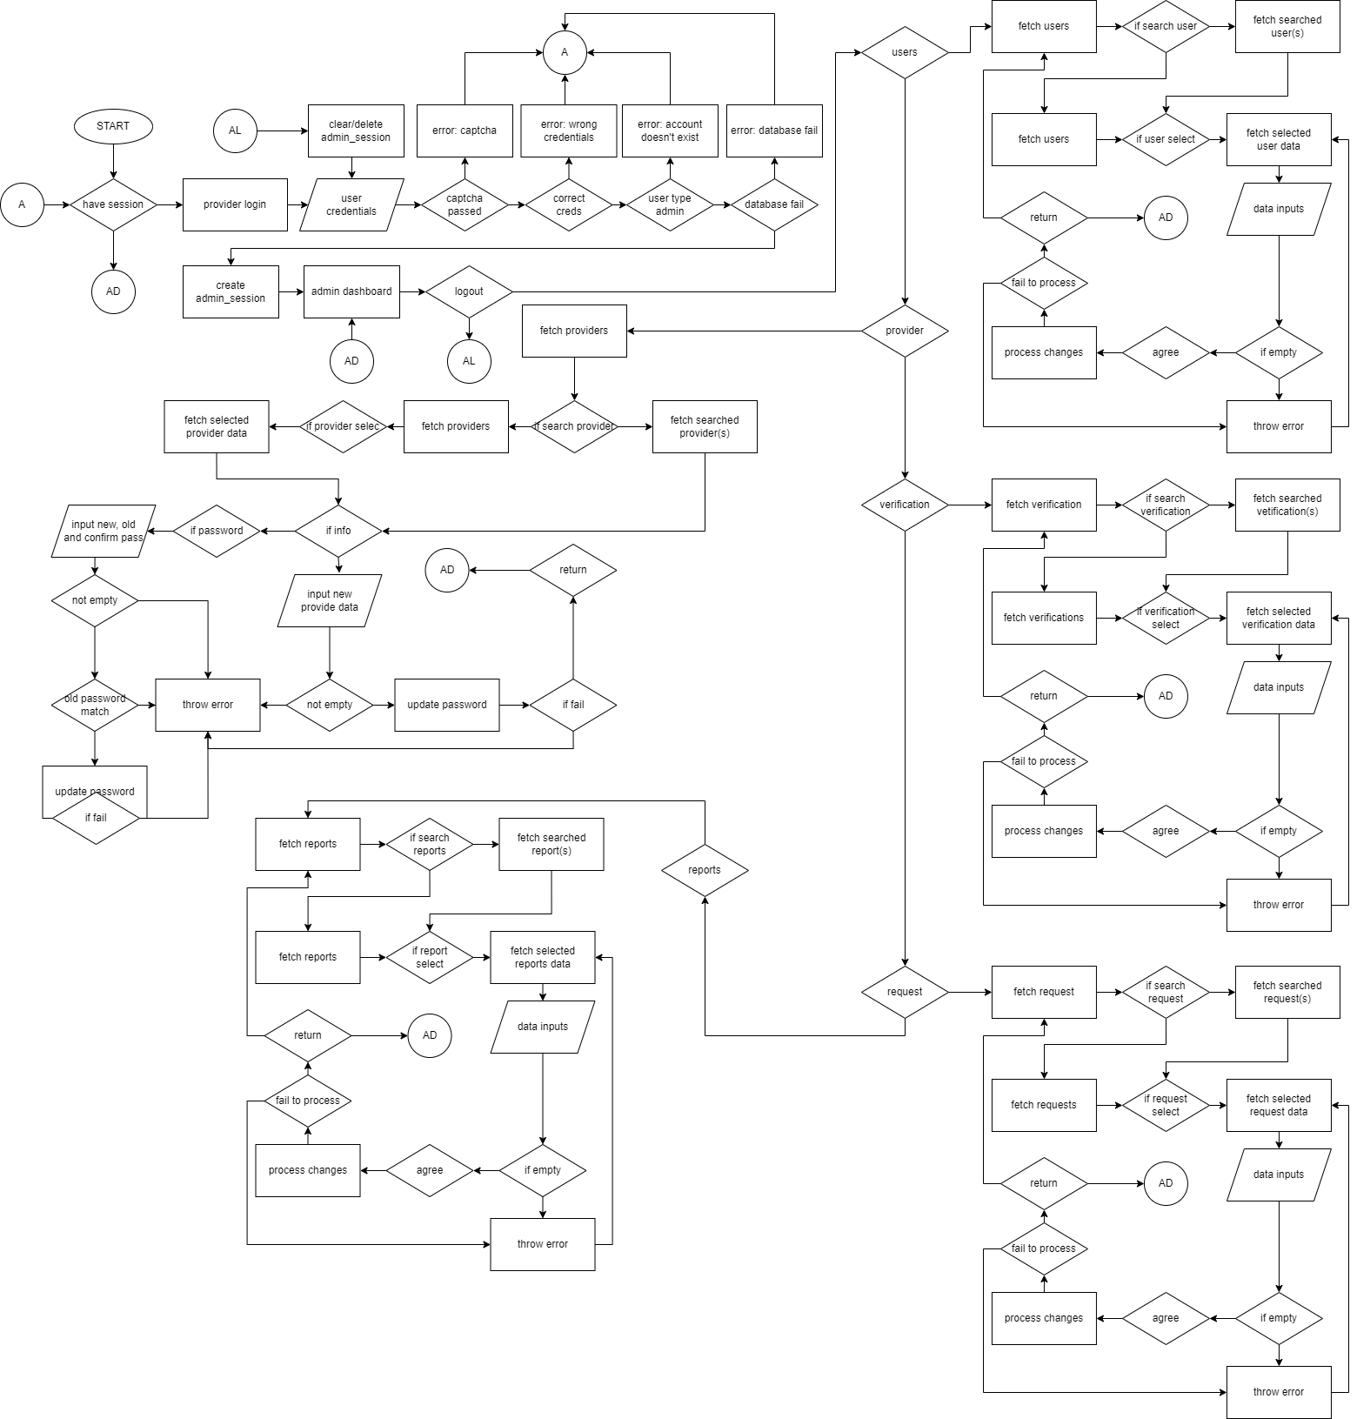**ADMIN**

**USER**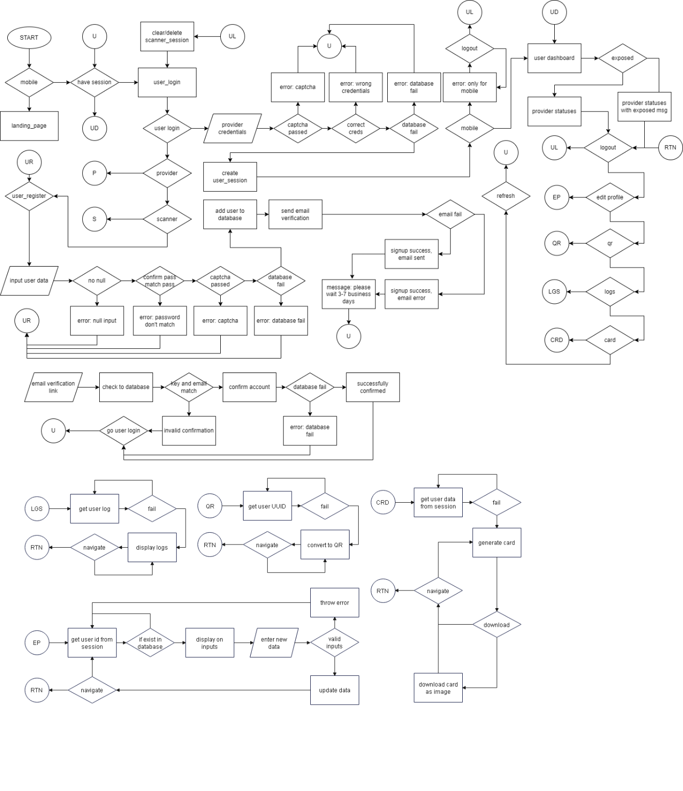

**PROVIDER**

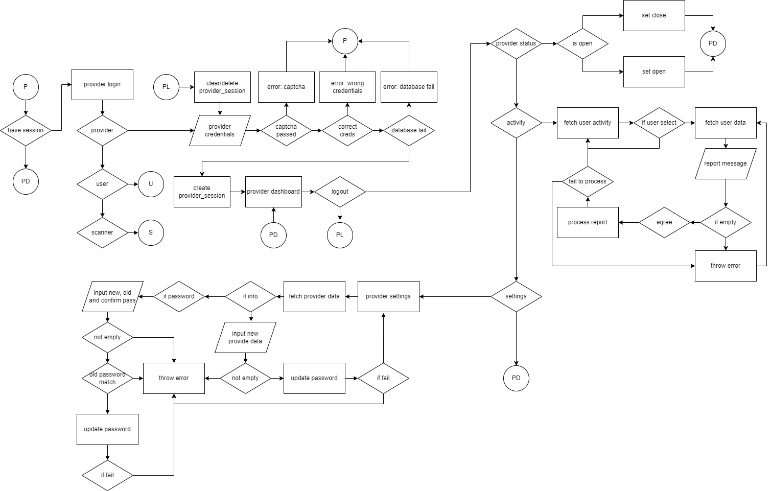

**SCANNER**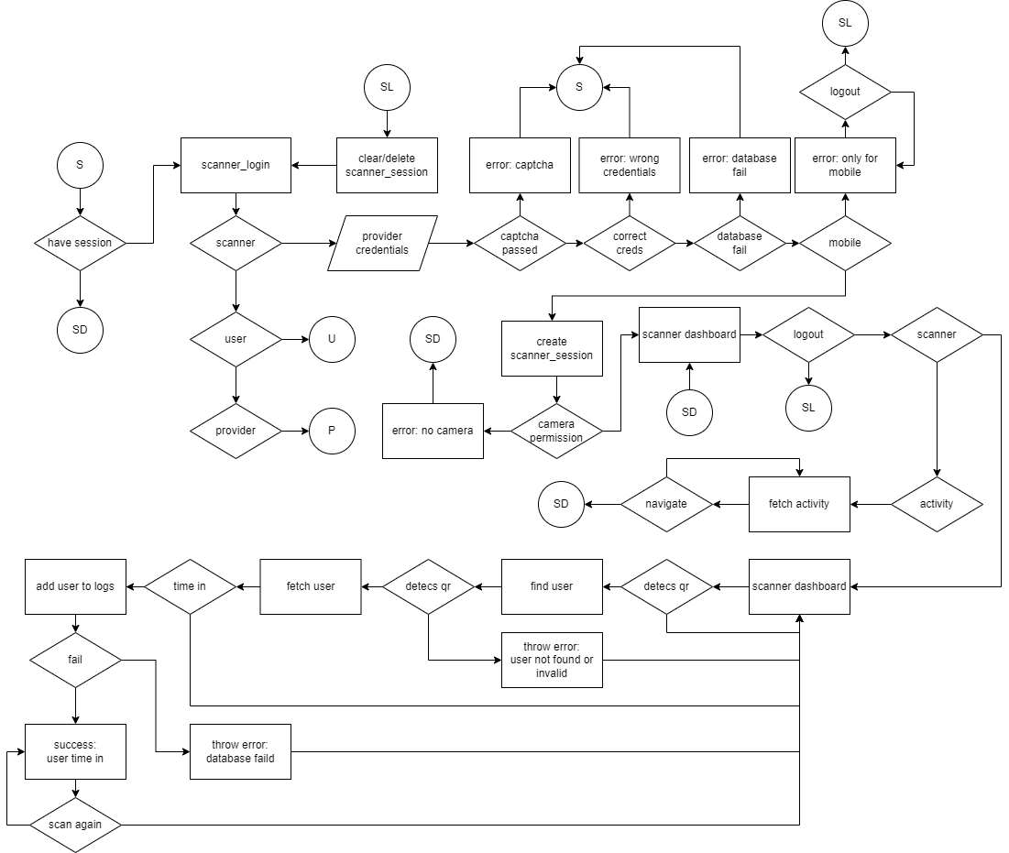

**Development and Testing**

**Project Schedule**

**Table 1. Gantt Chart for First & Second Semester**

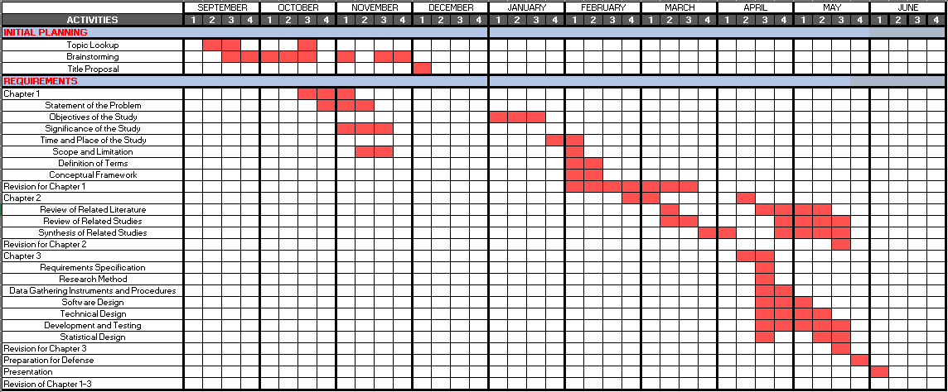

Table 1. represents the projected timeline for the whole project from the First to Second semester. It displays anticipated activity developments as well as the amount of time allotted to each activity (Shaded Red). Each month's period is represented in weeks by the numbers 1, 2, 3, and 4, and each phase (colored light blue) is divided into sub activities.

**Table 2. Gantt Chart for System Development Phase**

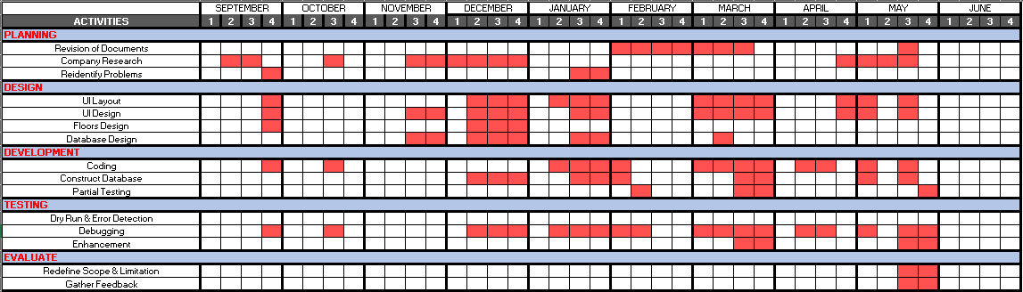

**Table 2.** illustrates the projected timeline for the whole project for the First and Second Semester, which mostly comprises of the system creation. It displays the future events as well as their duration (colored red). Each month's period is represented in weeks by the numbers 1, 2, 3, and 4, and each phase (colored light blue) is broken into sub activities. The capstone project started in the month of September and expected to end in June.

**Evaluation criteria**

**Functionality -** if the functions cover all the specified tasks and user objectives.

**Usability -** if the system can be used by specified users to achieve specified goals with effectiveness, efficiency and satisfaction in a specified context of use.

**Reliability -** if the system performs specified functions under specified conditions for a specified period of time.

**Efficiency -** if the system performs relative to the number of resources used under stated conditions.

**Portability** - if the system protects information and data so that users have the degree of data access appropriate to their types and levels of authorization.

**Table. Numerical Scale and Interpretation**

|  |  |
| --- | --- |
| **Numerical Scale** | **Interpretation** |
| 1 | Poor |
| 2 | Fair |
| 3 | Good |
| 4 | Very Good |
| 5 | Excellent |

Table ___ shows the numerical scale and interpretation that will be used for evaluation form to determine if the application succeeds or fails to accomplish its goal.

**Table. Likert Scale**

|  |  |
| --- | --- |
| **Numerical Scale** | **Interpretation** |
| 1.00 -1.50 | Poor |
| 1.51 – 2.49 | Fair |
| 2.50 – 3.49 | Good |
| 3.50 – 4.49 | Very Good |
| 4.50 – 5.00 | Excellent |

**Evaluation Procedure**

After the system has been finished, numerous people were requested to review it. The procedures below were followed:

* The system was assessed by fifty persons from Barangay Sabang who were chosen by the developers.
* The responders were instructed to test the Contact Tracing Application's functions on their position using a pre-determined account.
* An Evaluation Form was then presented to each responder.

The data was tallied and averaged to see if the system accomplished its goals and received feedback from users.

**3.7 Statistical Design**

**Sampling**

The System was evaluated by Barangay Captain, Barangay Council and Residents of Barangay Sabang. The respondents is composed of 43 random residents and 6 Barangay officials and a Barangay Captain from Barangay Sabang.

Table ____ Respondents

**Number Percentage**

Residents of Barangay Sabang 43 86%

Barangay Officials 6 12%

Barangay Captain 1 2%

**Total 50 100%**

**Statistical Method**

The following statistical methods were employed in the study's data presentation and analysis.

**Statistical Treatment of Data**

The statistical tool used in this study was the weighted mean to determine the effectiveness of the system. The formula is (Weighted mean)

Σfx

wm = ----------

N

Where: wm = the weighted mean

f = the frequency of each item

x = the assigned weight

N = the total number of respondents

Σfx = the sum total of the frequency times by the assigned weight

The scale values, assigned weight, and verbal interpretation are as follows:

|  |  |  |
| --- | --- | --- |
| **Scale** | **Assigned Weight** | **Verbal Interpretation** |
| 4.50 – 5.00 | 5 | Excellent |
| 3.50 – 4.49 | 4 | Very Good |
| 2.50 – 3.49 | 3 | Good |
| 1.50 – 2.49 | 2 | Fair |
| 1. – 1.49 | 1 | Poor |

**RESULTS AND DISCUSSION**

The survey was conducted utilizing survey questionnaires to measure the system's efficiency.

**TABLE 1**

**Functionality of the System**

|  |  |  |
| --- | --- | --- |
| **Statements** | **Weighted**  **Mean** | **Verbal**  **Interpretation** |
| 1. **Ease of operation** | **3.70** | **Very Good** |
| 1. **Provisions for comfort and convenience.** | **3.70** | **Very Good** |
| 1. **User-friendliness** | **3.75** | **Very Good** |
| **Average Weighted Mean** | **3.72** | **Very Good** |

**Table 1.** shows that the weighted mean in statement 1 in terms functionality is 3.70 with a verbal interpretation of "Very Good"; the weighted mean in statement 2 in terms functionality is 3.70 with a verbal interpretation of "Very Good"; and the weighted mean in statement 3 in terms functionality is 3.75 with a verbal interpretation of "Very Good". The average weighted mean is 3.72 which means that the respondents are satisfied with the functionality of the system.

**TABLE 2**

**Usability of the System**

|  |  |  |
| --- | --- | --- |
| **Statements** | **Weighted**  **Mean** | **Verbal**  **Interpretation** |
| **1. Displays clarity of interface.** | **3.91** | **Very Good** |
| 1. **Provides help guide to user.** | **3.91** | **Very Good** |
| 1. **Easy to learn by the user.** | **4.03** | **Very Good** |
| **Average Weighted Mean** | **3.95** | **Very Good** |

**Table 2.** shows that the weighted mean in statement 1 in terms of usability is 3.91 with a verbal interpretation of "Very Good"; the weighted mean in statement 2 in terms of usability is 3.91 with a verbal interpretation of "Very Good"; and the weighted mean in statement 3 in terms of usability is 4.03 with a verbal interpretation of "Very Good". The average weighted mean is 3.95 which means that the respondents are satisfied with the usability of the system.

**TABLE 3**

**Reliability of the System**

|  |  |  |
| --- | --- | --- |
| **Statements** | **Weighted**  **Mean** | **Verbal**  **Interpretation** |
| 1. **Conformance to the desired result.** | **3.81** | **Very Good** |
| 1. **Absence of failures.** | **3.68** | **Very Good** |
| 1. **Updated contents.** | **3.77** | **Very Good** |
| 1. **Accuracy in performance.** | **3.79** | **Very Good** |
| **Average Weighted Mean** | **3.76** | **Very Good** |

**Table 3.** shows that the weighted mean in statement 1 in terms of reliability is 3.81 with a verbal interpretation of "Very Good"; the weighted mean in statement 2 in terms of reliability is 3.68 with a verbal interpretation of "Very Good"; the weighted mean in statement 3 in terms of reliability is 3.77 with a verbal interpretation of " Very Good"; and the weighted mean in statement 4 in terms of reliability is 3.79 with a verbal interpretation of " Very Good". The average weighted mean is 3.76 which means that the respondents are satisfied with the reliability of the system.

**TABLE 4**

**Efficiency of the System**

|  |  |  |
| --- | --- | --- |
| **Statements** | **Weighted**  **Mean** | **Verbal**  **Interpretation** |
| **1. Performs according to specification** | **3.91** | **Very Good** |
| 1. **Provisions for security**   **requirements.** | **3.87** | **Very Good** |
| 1. **Completeness of the system.** | **3.89** | **Very Good** |
| **4. Updated contents.** | **3.89** | **Very Good** |
| **5. Accuracy in performance** | **3.89** | **Very Good** |
| **Average Weighted Mean** | **3.89** | **Very Good** |

**Table 4.** shows that the weighted mean in statement 1 in terms of efficiency is 3.91 with a verbal interpretation of "Very Good"; the weighted mean in statement 2 in terms of efficiency is 3.887 with a verbal interpretation of "Very Good"; and the weighted mean in statement 3 in terms of efficiency is 3.89 with a verbal interpretation of "Very Good"; and the weighted mean in statement 4 in terms of efficiency is 3.89 with a verbal interpretation of "Very Good"; and the weighted mean in statement 5 in terms of efficiency is 3.89 with a verbal interpretation of "Very Good". The average weighted mean is 3.89 which means that the respondents are satisfied with the efficiency of the system.

**TABLE 5**

**Portability of the System**

|  |  |  |
| --- | --- | --- |
| **Statements** | **Weighted**  **Mean** | **Verbal**  **Interpretation** |
| **1. Easy to install application.** | **3.94** | **Very Good** |
| 1. **Adaptability hardware requirements.** | **3.85** | **Very Good** |
| **Average Weighted Mean** | **3.90** | **Very Good** |

**Table 5.** shows that the weighted mean in statement 1 in terms of portability is 3.94 with a verbal interpretation of "Very Good"; and the weighted mean in statement 2 in terms of portability is 3.85 with a verbal interpretation of "Very Good". The average weighted mean is 3.90 which means that the respondents are very satisfied with the portability of the system.

**TABLE 6**

**Effectiveness of the System**

|  |  |  |
| --- | --- | --- |
| **Criteria** | **Weighted**  **Mean** | **Verbal**  **Interpretation** |
| **1. Functionality** | **3.72** | **Very Good** |
| **2. Usability** | **3.95** | **Very Good** |
| **3. Reliability** | **3.76** | **Very Good** |
| **4. Efficiency** | **3.89** | **Very Good** |
| **5. Portability** | **3.90** | **Very Good** |
| **Average Weighted Mean** | **3.84** | **Very Good** |

**Table 6.** shows that the average weighted mean in terms of functionality is 3.72 with a verbal interpretation of "Very Good"; the average weighted mean in terms of usability is 3.95 with a verbal interpretation of "Very Good"; the average weighted mean in terms of reliability is 3.76 with a verbal interpretation of "Very Good"; the average weighted mean in terms of efficiency is 3.89 with a verbal interpretation of "Very Good"; and the average weighted mean in terms of portability is 3.90 with a verbal interpretation of "Very Good". The average weighted mean of the effectiveness of the system is 3.84 which means that the respondents are satisfied with the effectiveness of the system.

**SUMMARY, CONCLUSIONS AND RECOMMENDATIONS**

This chapter summarizes the study's findings in order to reach accurate and credible conclusions achieving specific recommendations.

**Summary of Findings**

The entitled MULTI-PLATFORM CONTACT TRACING WITH QR VERIFICATION SYSTEM FOR BARANGAY SABANG was beneficial for the officials and residents who deals to facilitate COVID 19 measures. These participants, that served as the evaluators of the application, used it as a tool and help them to monitor.

In terms of level of satisfaction, the respondents are very satisfied with the functionality of the system based on the average weighted mean of 3.72; they are satisfied with the usability of the system based on the average weighted mean of 3.95; they are satisfied with the reliability of the system based on the average weighted mean of 3.76; they are satisfied with the efficiency of the system based on the average weighted mean of 3.89; and they are very satisfied with the portability of the system based on the average weighted mean of 3.90.

As a whole, the respondents are satisfied with the effectiveness of the system based on the average weighted mean of 3.84.

**Conclusions**

The researchers concluded that the MULTI-PLATFORM CONTACT TRACING WITH QR VERIFICATION SYSTEM FOR BARANGAY SABANG based on the summary of findings, that the system is very effective in terms of its usability, efficiency and portability. It is effective in terms of its functionality, and reliability. In general, according to the respondents, the system is effective since it is usable, efficient, portable, functional, and reliable. As a result, this research study is deemed accepted by all.

**Recommendations**

The following suggestions will help to improve the study's outcomes.

are based on the following findings and conclusions:

**APPENDICES**

**REFERENCES**

**RRL LOCAL**

(RRL 1) <http://www.ieomsociety.org/singapore2021/papers/595.pdf>

(RRL 2) <https://archium.ateneo.edu/discs-faculty-pubs/249/>

(RRL 3) <https://www.healthcareitnews.com/news/asia/philippines-issue-digital-vaccination-certs-overseas-workers-september>

**RRL FOREIGN**

(RRL1) Zirbes, Julian, Sterr, Christian M., Steller, Marcus, Dapper, Laura, Nonnenmacher-Winter, Claudia, Günther (2021). Frank Development of a web-based contact tracing and point-of-care-testing workflow for SARS-CoV-2 at a German University Hospital. <https://aricjournal.biomedcentral.com/track/pdf/10.1186/s13756-021-00971-2.pdf>

(RRL 2) <https://www.acpjournals.org/doi/full/10.7326/M20-5834>

(RRL 3) <https://www.tandfonline.com/doi/full/10.1080/25741292.2020.1850404>

(RRL 4) <https://www.jstor.org/stable/pdf/resrep29636.pdf>

(RRL 5) Mbunge, Elliot and Fashoto, Stephen G and Batani, John, COVID-19 Digital Vaccination Certificates and Digital Technologies: Lessons from Digital Contact Tracing Apps (March 16, 2021). <https://papers.ssrn.com/sol3/papers.cfm?abstract_id=3805803>

(RRL 6) Ekong I, Chukwu E, Chukwu M, COVID-19 Mobile Positioning Data Contact Tracing and Patient Privacy Regulations: Exploratory Search of Global Response Strategies and the Use of Digital Tools in Nigeria JMIR Mhealth Uhealth 2020;8(4): e19139. <https://mhealth.jmir.org/2020/4/e19139/>

(RRL 7) Publication, I. J. R. A. S. E. T. (2021). Ticket Verification and Passenger Authentication using Encrypted QR Code for Airport Verification System. International Journal for Research in Applied Science & Engineering Technology. <https://doi.org/10.22214/ijraset.2021.34094>

(RRL 8) Elliot Mbunge, Tafadzwa Dzinamarira, Stephen G. Fashoto, John Batani

Public Health Pract (Oxf) 2021 Nov; 2: 100136. Published online 2021 May 7. doi: 10.1016/j.puhip.2021.100136 <https://www.ncbi.nlm.nih.gov/pmc/articles/PMC8103710/>

(RRL 9) <https://ieeexplore.ieee.org/stamp/stamp.jsp?tp=&arnumber=9105054>

(RRL 10) Tandel, Sayali & Jamadar, Abhishek. (2018). Impact of Progressive Web Apps on Web App Development. 10.15680/IJIRSET.2018.0709021. <https://www.researchgate.net/profile/Sayali-Tandel-2/publication/330834334_Impact_of_Progressive_Web_Apps_on_Web_App_Development>

(RRL 11) Varsha Sharma, Rajat Verma, Vaishali Pathak, Muskan Paliwal, Priya Jain (2019). Progressive Web App (PWA) – One Stop Solution for All Application Development Across All Platforms. <https://www.academia.edu/44805332/Progressive_Web_App_PWA_One_Stop_Solution_for_All_Application_Development_Across_All_Platforms>

**RRS**

(RRS 1) Munzert, S., Selb, P., Gohdes, A., Stoetzer, L. F., & Lowe, W. (2021). Tracking and promoting the usage of a COVID-19 contact tracing app. Nature Human Behaviour, 5(2), 247–255. doi:10.1038/s41562-020-01044-x <https://sci-hub.se/10.1038/s41562-020-01044-x>

(RRS 2) S., Prabu., Velan, B., S., C.N., F.V., J., P., V. and K., J. (2022), "Mobile technologies for contact tracing and prevention of COVID-19 positive cases: a cross- sectional study", International Journal of Pervasive Computing and Communications, Vol. 18 No. 2, pp. 226-235.<https://sci-hub.se/10.1108/IJPCC-07-2020-0086>

(RRS 3) Chow, Yang-Wai; Susilo, Willy; Yang, Guomin; Au, Man Ho; and Wang, Cong, "Authentication and transaction verification using QR codes with a mobile device" (2016). Faculty of Engineering and Information Sciences - Papers: Part A

.6175<https://www.academia.edu/65764753/Authentication_and_Transaction_Verification_Using_QR_Codes_with_a_Mobile_Device>

(RRS 4) Nakamoto I, Wang S, Guo Y, Zhuang W A QR Code–Based Contact Tracing Framework for Sustainable Containment of COVID-19: Evaluation of an Approach to Assist the Return to Normal Activity JMIR Mhealth Uhealth 2020; <https://mhealth.jmir.org/2020/9/e22321>

(RRS 5) <https://www.academia.edu/50932201/IRJET_QR_based_Contact_Tracing_Application>