|  |  |
| --- | --- |
| **Name** | Muhammad Asad |
| **Reg.#** | 2019-EE-383 |
| **Marks** |  |

Experiment no. 18

Synchronisation Procedure and Motor Operation of a 3-Phase Synchronous Machine

# Objectives:

* Synchronising a three phase synchronous generator

# Apparatus:

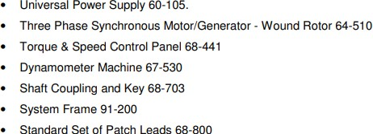

**Theory:**

## Synchronising Procedure

When a synchronous ac generator is connected in parallel with a supply it may be used to demonstrate the characteristics of a large generator connected to the bus bars of a power system. In order to run a generator in parallel with a supply it is necessary to synchronise the generator to the supply. Hence the following conditions must be fulfilled.

* The generated EMF must be the same as that of the supply.
* The frequency of the generated EMF must be the same as that of the supply.
* The generated EMF must be in phase with the supply.

## The Synchronous Machine as a Generator and Motor

If the speed of a synchronous generator is increased or decreased, at constant excitation current, the ac output voltage and frequency will increase or decrease accordingly. To run the machine as a synchronous motor, it is first necessary to run it as a generator. The speed must first be adjusted to be the same as the supply frequency ("synchronisation") using an instrument such as the

synchronising lamps 68-120. Next the dc excitation current must be increased to its rated value, so that when run as a motor there is sufficient field strength for the motor to be able to develop adequate torque. When the above operations have been carried out, the supply to the machine is switched in, whilst at the same time the supply to the motor driving the machine is reduced to zero. The machine is now running as a motor, synchronised to the supply.

# Circuit Diagram:

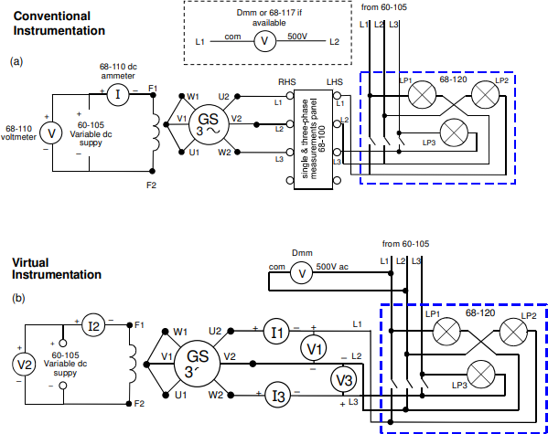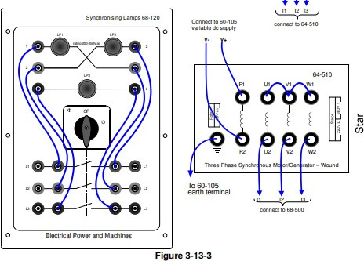

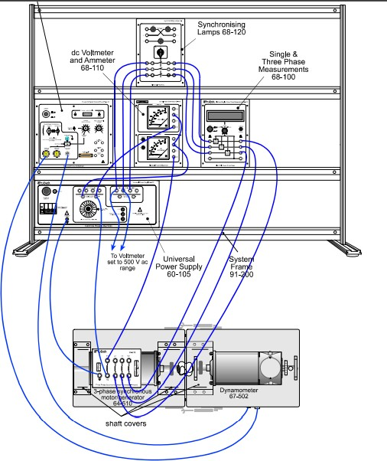

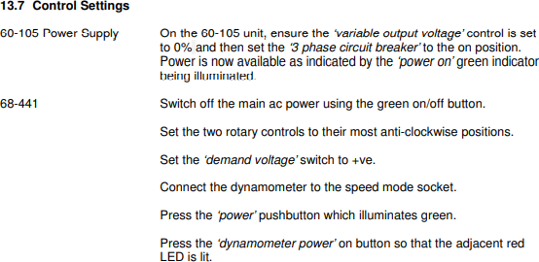

**Procedure:**

* + On the 60-105 unit, set the ‘3 phase circuit breaker’ to the on position. Power is now available as indicated by the ‘power on’ green indicator being illuminated.
  + Set the dc field voltage by rotating the ‘variable output voltage’ control on the 60-105 such that the output voltage from the generator is the same value as that of the three phase supply that it will be connected to when the synchronising switch is closed. This voltage is measured on an external Digital Multimeter DMM for virtual, or on conventional instrumentation 68-117 voltmeter.
  + You will notice that the synchronising lamp pattern on the 68-120 appears to rotate.
  + Decrease the speed by a small amount. If the lamps appear to rotate faster, then increase the speed by a small amount. Adjust the speed until the lamps appear to rotate at their slowest possible speed. At this point the generator output voltage is at the same frequency as the supply.
  + On the 68-120 synchronising lamps panel when only the lamps LP1 and LP2 are of equal brightness and lamp LP3 is out, turn on the 68-120 switch.
  + Slowly reduce the ‘constant speed control on the 68-441 to zero. The machine is now operating as a motor, and will be rotating at a speed synchronised to the supply frequency.
  + Switch off the 68-441 Torque & Speed Control Panel by pressing the green ‘power’ button, and then connect the dynamometer to the ‘torque mode connection’ socket.
  + Switch on the 68-441 by pressing the green ‘power’ button again and press the ‘dynamometer power’ on button so that the red led is illuminated.



    
    
    

