Electric Machinery Fundamentals Lab

|  |  |
| --- | --- |
| **Name** | Muhammad Asad |
| **Reg.#** | 2019-EE-383 |
| **Marks** |  |

Experiment - current characteristics

In this experiment a block-shaped current characteristic for the three motor inputs is to be examined along with its associated operating states.

Set up the experiment as follows:

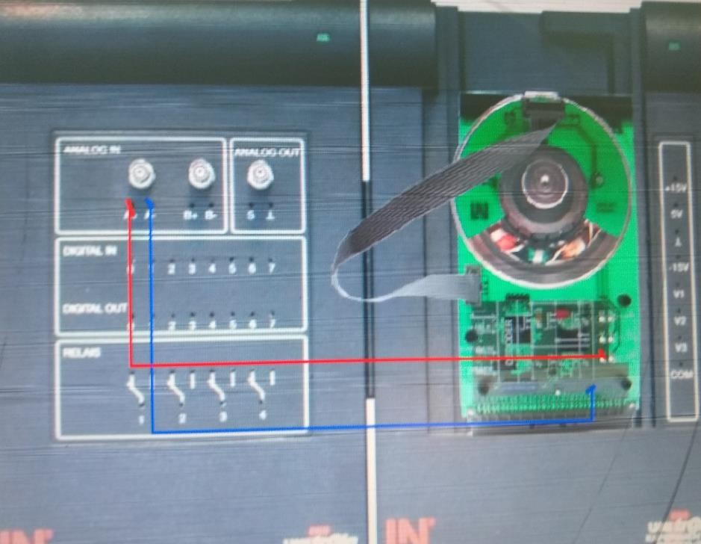

Open *Voltmeter A* from the Instruments menu.



|  |  |
| --- | --- |
| Instrument: | Voltmeter |
| Operating mode: | RMS |
| Meas. range | 50V |
| Coupling | DC |

Open the *Servo drive* instrument from the Instruments menu.



|  |  |
| --- | --- |
| Instrument: | Servo drive |
| Operating mode: | Torque |
| Value %: | 30% approx. |

1. **|** P a g e

Electric Machinery Fundamentals Lab

|  |  |
| --- | --- |
| Brake: | Off |
| CW | Off |

Click on **Power**

Complete the table and determine the voltage at the three outputs U, V and W for each operating state.

Enter a "1" for voltages greater than 20 V, "-1" for 0 V and "0" for values in between.

Start with the state previously entered and turn the rotor clockwise.

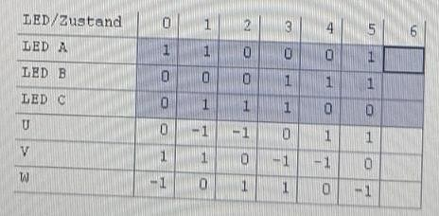

Click on **Power** again to switch off.

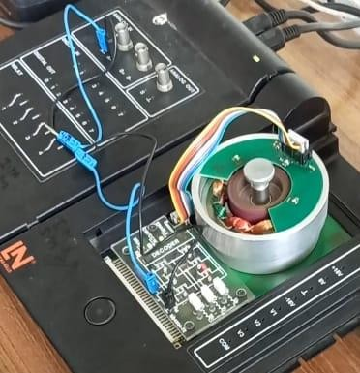

1. **|** P a g e

Electric Machinery Fundamentals Lab

How often are the individual operating states passed through in the course of one rotor revolution?

|  |  |
| --- | --- |
|  | Since the number of pole pairs is 3 (3 north and 3 south poles p=3), all six states must be passed through three times. |
|  | All six states must be passed through four times. This matches the animation on the course page. |
|  | Each position is passed through once per rotor revolution, since the number of pole pairs is p = 6. |
|  | Each position is passed through six times per rotor revolution, because the number of pole pairs is p = 6. |

Does one rotor revolution also correspond to an electrical revolution (one rotation of the magnetic flux)?

|  |
| --- |
| Yes |
| No |

Which of the following equations is correct? Here f stands for the clock frequency, with which the 6 individual states are switched, n stands for the rotor speed:

|  |
| --- |
| n = f/p |
| n= f*p |
| p= n*f |

According to the equation above does the motor speed increase or decrease with a larger number of pole pairs?

|  |
| --- |
| It increases because it is not possible to reach all the states in a single revolution. |
| It decreases. All states must be passed through p- times per rotor revolution. |

1. **|** P a g e

Electric Machinery Fundamentals Lab

|  |  |  |
| --- | --- | --- |
|  | **Name** | Muhammad Asad |
| **Reg.#** | 2019-EE-383 |
| **Marks** |  |

**Connection and starting of Synchronous Machine**

In this experiment we will be examining the conditions needed for a synchronous machine to start rotating.

Set up the following experiment:

|  |  |
| --- | --- |
|  | Open the virtual instrument *3-phase Power Supply* from the *Instruments Power Supplies* menu. Carry out the following settings   * U = 11 V * f = 50 Hz * Press the POWER button |

Observe the rotor:

|  |
| --- |
| The rotor rotates rapidly |
| The rotor starts humming, but remains stationary |
| The rotor starts humming and slowly begins to turn |
| The rotor runs up gradually (ramps up) and reaches synchronous speed |

Switch off the three-phase power supply by pressing the POWER button. Add the following leads to the setup.

Switch back on the three-phase power supply by pressing the POWER button and observe the rotor:

1. **|** P a g e

Electric Machinery Fundamentals Lab

|  |
| --- |
| The rotor rotates at a rapid rate |
| The rotor hums but remains stationary |
| The rotor hums and slowly rotates |
| The rotor runs up gradually (ramps up) and reaches synchronous speed |

Switch the three-phase power supply off by pressing the POWER button and then close the virtual instrument.

|  |  |
| --- | --- |
|  | Open the virtual instrument *U/f Motor Control Unit* from the *Instruments Motor Controls* menu. Carry out the following settings:   * f = 50 Hz * Ramp time = 30 s   Press the U/F button so that the characteristics window opens and enter the following settings for the characteristic:   * Starting voltage 6 V * Cut-off frequency 75 Hz * Switch on the three-phase power supply by pressing the POWER button |

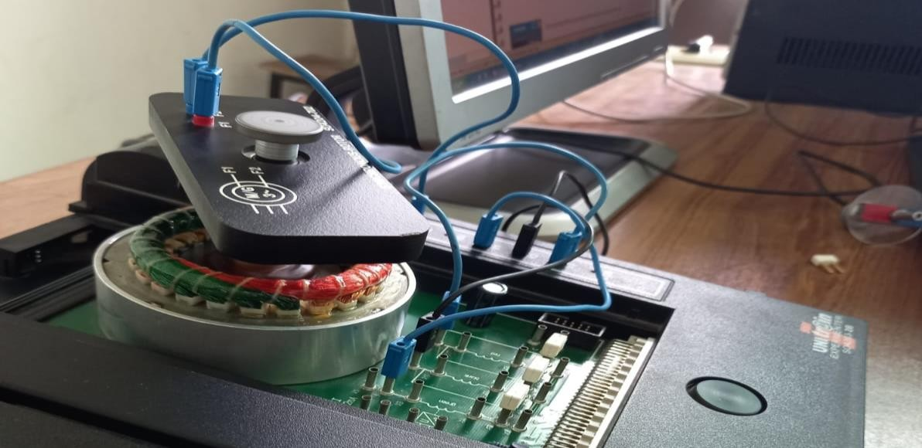

1. **|** P a g e

Electric Machinery Fundamentals Lab

Observe the rotor:

|  |
| --- |
| The rotor rotates at a rapid rate |
| The rotor hums, but then comes to a halt |
| The rotor hums and then rotates slowly |
| The rotor runs up (ramp like) gradually and reaches synchronous speed |

What are the reasons for the different responses?

|  |  |
| --- | --- |
|  | No torque can be generated without short-circuiting |
|  | No torque can be generated without an exciter voltage |
|  | The machine cannot run up asynchronously |
|  | The machine can run up asynchronously |
|  | The synchronous machine must run up slowly on a . ramp |
|  | Synchronous machines can run up as fast as desired |
|  | The synchronous machine can easily be connected into a constant voltage, constant frequency power system |
|  | The synchronous machine can be connected into a constant voltage, constant frequency system without any aids |

1. **|** P a g e

Electric Machinery Fundamentals Lab

|  |  |
| --- | --- |
| **Name** | Muhammad Asad |
| **Reg.#** | 2019-EE-383 |
| **Marks** |  |

**Voltage and current measurement in Synchronous Machine**

In this experiment the conductor currents and the line voltage as well as the phase angle are measured and the cos  factor are calculated.

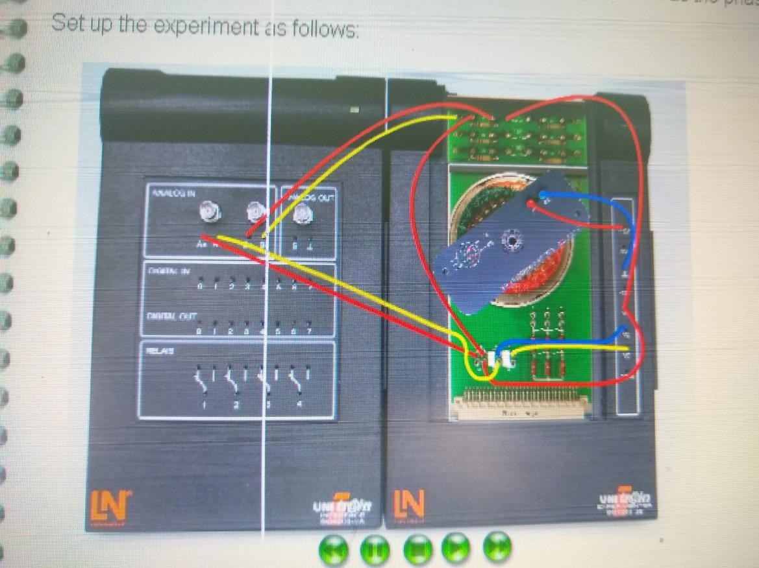Set up the experiment as follows:

|  |  |
| --- | --- |
|  | Open the virtual instrument *U/f Motor Control Unit* from the *Instruments Motor Controls* menu. Carry out the following settings:   * f = 50 Hz * Ramp time = 15 s   Press the U/F button so that the characteristics window opens and make the following settings to the characteristics:   * Starting voltage 6 V * Cut-off frequency 75 Hz * Switch on the three-phase power supply by turning on the POWER button |
|  | Open the virtual instrument *Oscilloscope* in the *Instruments Meters* menu. Carry out the following settings:   * Channel A: 10V/DIV, DC, zero line 2 divisions from the top * Channel B: 0.5 V/DIV, DC, zero line 3 divisions from the bottom * Time base: 2 ms * Trigger: channel A |

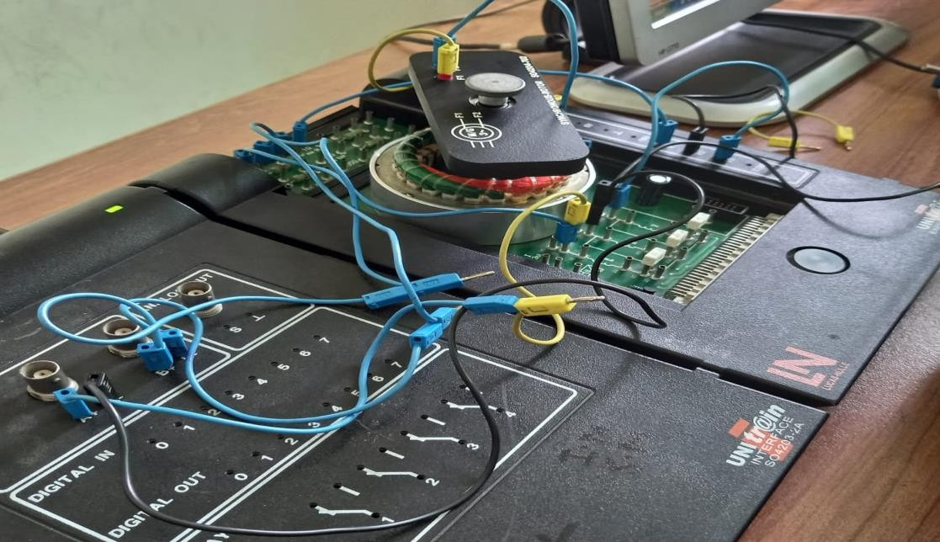

Copy the oscilloscope trace into the grid.

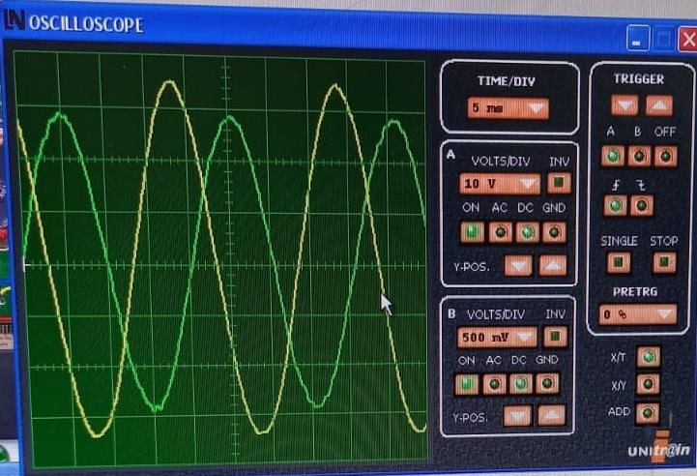

Read off the peak values for the two voltages, then calculate the rms values and enter these into the appropriate boxes:

|  |  |
| --- | --- |
| Channel A: stator voltage V1 = V Channel B: shunt voltage Vshunt = V  Stator current I1 = A | Hint:  The current can be calculated by I=U/R, with R = 1  . |

|  |  |
| --- | --- |
| φ = o  cos φ = | Hint: One grid square corresponds  to 360 in this case |

Read off the phase shift between the voltage and the current for the screen and calculate cos φ

|  |
| --- |
| The angle φ is close to 90 O and cos φ is close to 1 |
| The angle φ is small and cos φ is close to 1 |
| For synchronous machines cos φ is always 1 |

Compare the cos φ factor with the one determined for a squirrel-cage machi