**Certificate of Originality**

It is to certify, that the assignment for Signals and Systems submitted by **Umar Hayyat, Reg#: 2019-EE-360** is my original work. This work is free from any plagiarism, if copying of this work is detected I should be awarded **zero** marks.

Signature Umar Hayyat

**Problem 1:**

Let u[n] and v[n] are two signals and m = length (u) and n = length (v). Then w is the vector of length (m+n-1) whose kth element is

http://www.mathworks.com/help/matlab/ref/eqn1253800330.png

MATLAB index cannot be zero. Hence, there is +1 in the formula i.e. for j=1, we will get the first term of output.

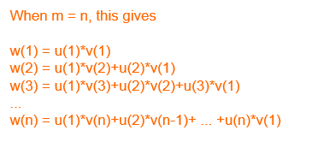

*Input function*: $x[n]=n$; where *n=0:R R=your registration number*

*Impulse response*: $h[n]=ones(1,10);$

* **Convolute** x[n] with h[n] using for loop and plot x[n], h[n] and y[n] in same window using subplot.
* Also verify your answer using conv command, also plot the output using conv command in the same window

**Code:**

n=0:360;

x=n;

h=ones(1,10);

n1=length(x); %Find the length of a signal

n2=length(h);

N=n1+n2-1; %find the length of y(n)

x=[x,zeros(1,N-n1)]; %zero padding to make the length=N

h=[h,zeros(1,N-n2)];

y=zeros(1, N); %Initialize the output with zero

%perform linear convolution

for n=1:N

for k=1:n

y(n)=y(n)+x(k)*h(n-k+1);

end

end

disp(y);

%plot the inputs and outputs.

ny=0:N-1;

subplot(4,1,1);

stem (ny,x);

title ('First sequence');

subplot (4, 1, 2);

stem (ny,h);

title('Second sequence');

subplot (4, 1, 3);

stem (ny,y);

title('Convoluted Signal');

a=conv(x,h); % Convolutio by using conv command

subplot (4, 1, 4);

stem (a);

title('Convoluted Signal by using conv');

**Waveform:**

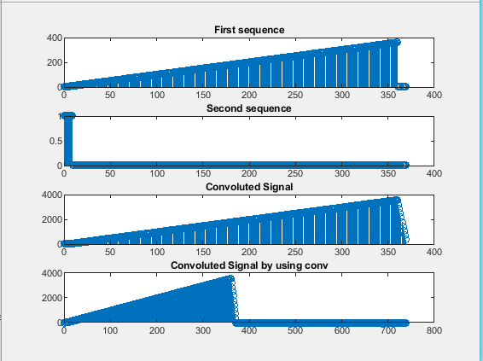

**Problem 3:**

One of the applications of signal compression and expansion is to fast forward/slow forward of sounds. Expansion of signal slows down the playing of a sound and compression of signal makes signal play fast.

**Design** an LTI system to compress/expand the time of a sound file. Show code and waveforms.

*Hints:*

*Check* ***audioload*** *and* ***sound*** *commands in MATLAB for audio file*

*Compression mean increasing the speed by increasing the sampling frequency.*

**Code:**

[x,fs]=audioread('Original.wav'); %read audio file

N=length(x);

vlcplayer=audioplayer(x,fs);

vlcplayer.play

t=fft(x,N);

X=fftshift(t);

f=-fs/2:fs/N:(fs/2-fs/N); %frequency boundry

figure(1)

plot(f,abs(X))

title ('original Signal')

Xr=zeros(1,N);

Xr((N*((60/100)/2))+1:N*(1-(60/100)/2))=X((N*((60/100)/2))+1:N*(1-(60/100)/2));

figure(2)

plot(f,abs((Xr)));

xr=real(ifft(fftshift(Xr)));

audiowrite('60%compressed.wav',xr,fs);

title('60% compressed audio')

xlabel('Freq'); ylabel('Magnitude');

**Waveform:**

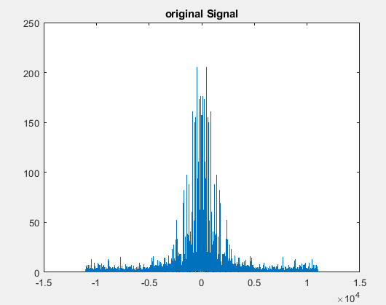

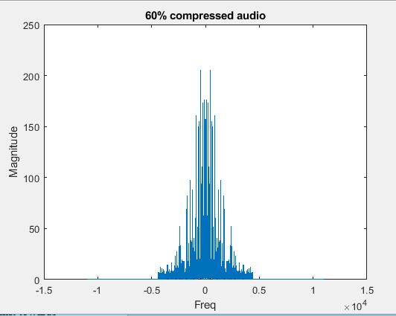

**Problem 4:**

You are required to implement below shift system in MATLAB, t0 is the amount of shift towards left or right.



Implement MATLAB code, where shift should be taken as an input from the user. Show code and waveforms.

**Code:**

%Implementation of y(t)=X(t-to)

t=0:5;

x=[2 1 3 5 7 2];

subplot(2,1,1);

stem(t,x); % plot in discrete sequence

xlim([-5 10]);

title('Original Signal');

to=input('Enter a Number to shift signal: '); %Get the valhue of to from user

if to>0

a=-to;

b=0;

elseif to<0

a=0;

b=-to;

else

a=0;

b=0;

end

subplot(2,1,2);

stem(t-to,x);

xlim([a-5 b+10]);

title('Shifted Signal');

**Waveform:**



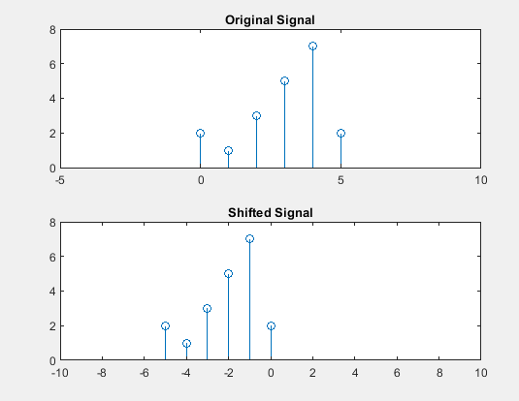

**Conclusion:**

I have learnt how we use Matlab to perform different tasks. I also learnt that if we do not have the information of any function that how it use or what is its syntax then we can use help command. I also observed that if we do not know the name of any command then we can use lookfor command.