**Problem 1:**

**Code:**

n=0:409;

p=n;

v=ones(1,10);

a1=length(p); %Find the length of a signal

A2=length(v);

N=a1+A2-1; %find the length of y(n)

p=[p,zeros(1,N-a1)];

v=[v,zeros(1,N-A2)];

y=zeros(1, N); %Initialize the output with zero

%perform convolution

for n=1:N

for k=1:n

y(n)=y(n)+p(k)*v(n-k+1);

end

end

disp(y);

%plot the inputs and outputs.

b=0:N-1;

subplot(4,1,1);

stem (b,p);

title ('First sequence');

subplot (4, 1, 2);

stem (b,v);

title('Second sequence');

subplot (4, 1, 3);

stem (b,y);

title('Convoluted Signal');

x=conv(p,v); % Convolutio by using conv

subplot (4, 1, 4);

stem (x);

title('Convoluted Signal by using conv');

**Output:**

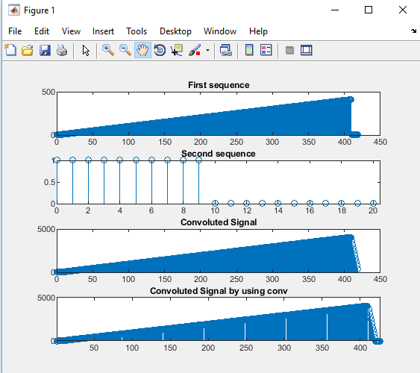

**Problem 2:**

**Code:**

subplot(2,1,1);

sys=tf(1,[1,2]);

impulse(sys)

subplot(2,1,2);

t=0:0.01:10;

p=t>=0;

x=5*(exp(3*t)).*p;

y=lsim(sys,x,t);

plot(t,y)

**Output:**

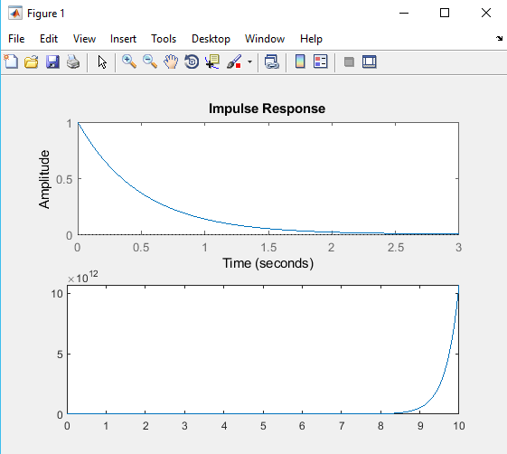

**Problem 3:**

**Code:**

[x,fs]=audioread("original.wav");

N=length(x);

vlcplayer=audioplayer(x,fs);

vlcplayer.play

t=fft(x,N);

X=fftshift(t);

f=-fs/2:fs/N: (fs/2-fs/N);

figure(1)

plot(f,abs(X))

title("Original signal")

Xr = zeros(1,N);

Xr((N/4)+1: (3*N/4)) = X((N/4)+1:(3*N/4));

figure(2)

plot(f,abs((Xr)));

xr=real (ifft(fftshift(Xr))); %Reconstruction

audiowrite('50%compressed.wav',xr,fs);

title("50%compressed audio");xlabel("Freq(Hz)"); ylabel("Magnitude");

%%changing ratio to 60,70,80,90,95%, just change line 15 to:

%Xr((N*((60/100)/2))+1 : N*(1-(60/100)/2))= X((N* ((60/100)/2))+1 : N*(1-(60/100)/2));

%Xr((N*((70/100)/2))+1 : N*(1-(70/100)/2))= X((N* ((70/100)/2))+1 : N*(1-(70/100)/2));

%Xr((N*((80/100)/2))+1 : N*(1-(80/100)/2))= X((N* ((80/100)/2))+1 : N*(1-(80/100)/2));

%Xr((N*((90/100)/2))+1 : N*(1-(90/100)/2))= X((N* ((90/100)/2))+1 : N*(1-(90/100)/2));

%Xr((N*((95/100)/2))+1 : N*(1-(95/100)/2))= X((N* ((95/100)/2))+1 : N*(1-(95/100)/2));

%%changing each one to a diff wav file to be heard on desktop:

%audiowrite("60 compressed.wav",xr,fs);

%audiowrite("70 compressed.wav",xr,fs);

%audiowrite("80 compressed.wav",xr,fs);

%audiowrite("90 compressed.wav",xr,fs);

%audiowrite("95 compressed.wav",xr,fs);

**Output:**

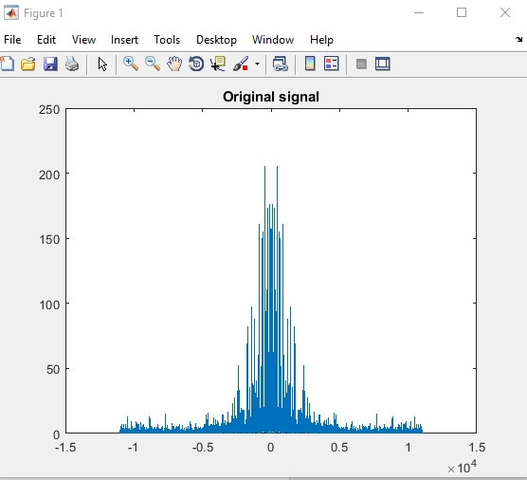

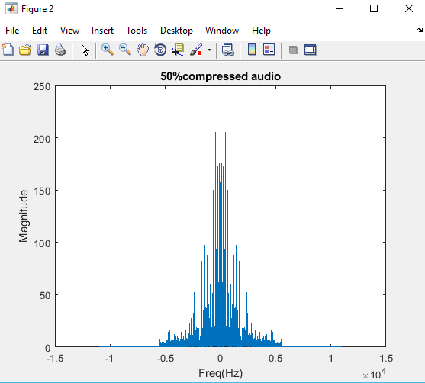

**Problem 4:**

**Code:**

%Implement y(t)=X(t-to)

t=0:7;

x=[4 5 1 2 5 8 3 6];

subplot(2,1,1);

stem(t,x);

xlim([-5 10]);

title('Original Signal');

to=input('Enter a Number to shift signal: ');

subplot(2,1,2);

stem(t-to,x);

xlim([-to-5 -to+12]);

title('Shifted Signal');

**Output:**

