**EE-453 Power System Operation & Control**

**Complex Engineering Problem**

|  |  |  |  |  |
| --- | --- | --- | --- | --- |
| **CLO4** | **Carryout steady state and transient stability studies for a power system using numerical techniques.** | **PLO3** | **Cognitive** | **C4**  **Medium** |

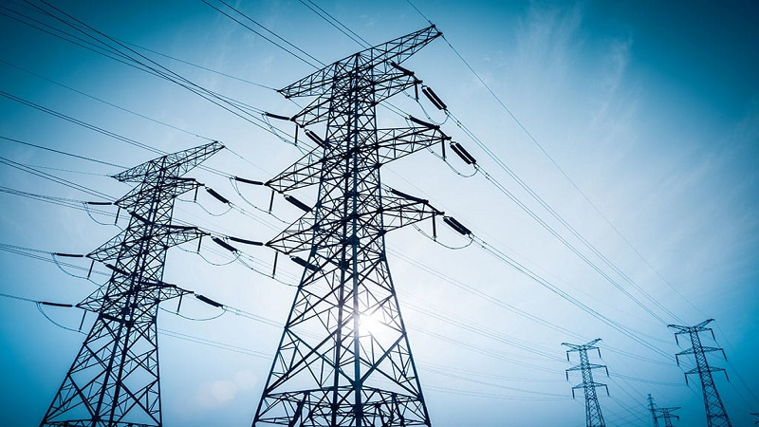

* **Submitted By:**

Faizan Azam, Muhammad Asad

2019-EE-381, 2019-EE-383

* **Submitted To:**

Muhammad Rameez Javed

* **Literature Review:**

Power system stability is a critical aspect of power systems engineering, ensuring that the power grid remains stable and reliable under different operating conditions. Transient stability is one of the key aspects of power system stability, and it is concerned with the ability of the power system to maintain synchronism during and after a disturbance, such as a fault. One of the most significant challenges in power system stability is finding the critical clearing angle and time of transient stability. The critical clearing angle is the minimum angle at which the system can clear a fault and maintain synchronism, while the critical clearing time is the time it takes for the system to clear the fault and maintain synchronism. These two parameters are important for ensuring that the power system remains stable and reliable, especially under different operating conditions and disturbances. In order to calculate the critical clearing angle and time, an in-depth understanding of power system stability and the equations involved is necessary. The equations involved include the power angle equation (PAE) and the swing equation, which describe the dynamics of the synchronous generators in the power system.

Different types of generators have different behaviors when it comes to power system stability. Synchronous generators, which are commonly used in power systems, have different stability characteristics compared to induction generators and doubly fed induction generators (DFIGs). The behavior of these different types of generators under the same type of faults must be analyzed in order to determine the critical clearing angle and time for each type of generator.

Power system stability is a critical issue in the design and operation of modern power systems. It refers to the ability of a power system to maintain a stable operating state in the presence of disturbances or fluctuations, such as sudden changes in demand, faults, or equipment failures. A stable power system is one that can quickly and reliably respond to these disturbances and maintain a balanced and steady supply of electrical energy. One of the most important aspects of power system stability is transient stability, which refers to the ability of a power system to maintain stable operation during the period immediately following a disturbance, typically lasting up to a few seconds. During this time, generators in the system must continue to provide the necessary amount of electrical energy while also maintaining the correct frequency and voltage levels. To ensure transient stability, it is important to calculate the critical clearing angle (CCA) for the system. The CCA is the minimum angle through which a generator's rotor must oscillate in order to maintain stability after a disturbance. The CCA can be calculated using various methods, including the equal-area criterion, the energy function method, and the Lyapunov function method. The equal-area criterion is a graphical method that involves plotting the electrical power versus rotor angle curve and finding the area under the curve for the period of oscillation. The CCA is the angle at which the area under the curve becomes equal to zero. The energy function method is a mathematical approach that involves deriving a differential equation for the energy function of the system and analyzing its behavior after a disturbance. The CCA can be determined by finding the angle at which the energy function reaches a minimum value. The Lyapunov function method is another mathematical approach that involves analyzing the stability of a power system by deriving a Lyapunov function and analyzing its behavior after a disturbance. The CCA can be calculated by finding the angle at which the Lyapunov function reaches a minimum value. In addition to the methods for calculating the CCA, there are also various techniques for improving power system stability, such as the use of power system stabilizers (PSSs), which are control devices that can be installed on generators to dampen rotor oscillations and improve transient stability.

In conclusion, power system stability and the critical clearing angle are critical aspects of power systems engineering, ensuring that the power grid remains stable and reliable under different operating conditions. In-depth knowledge and understanding of power system stability and the equations involved are necessary to calculate the critical clearing angle and time for different types of generators. Ongoing research on this topic is essential for developing new and more effective methods for ensuring power system stability and reliability.

* **Simulation of techniques:**
* **Synchronous Generator**

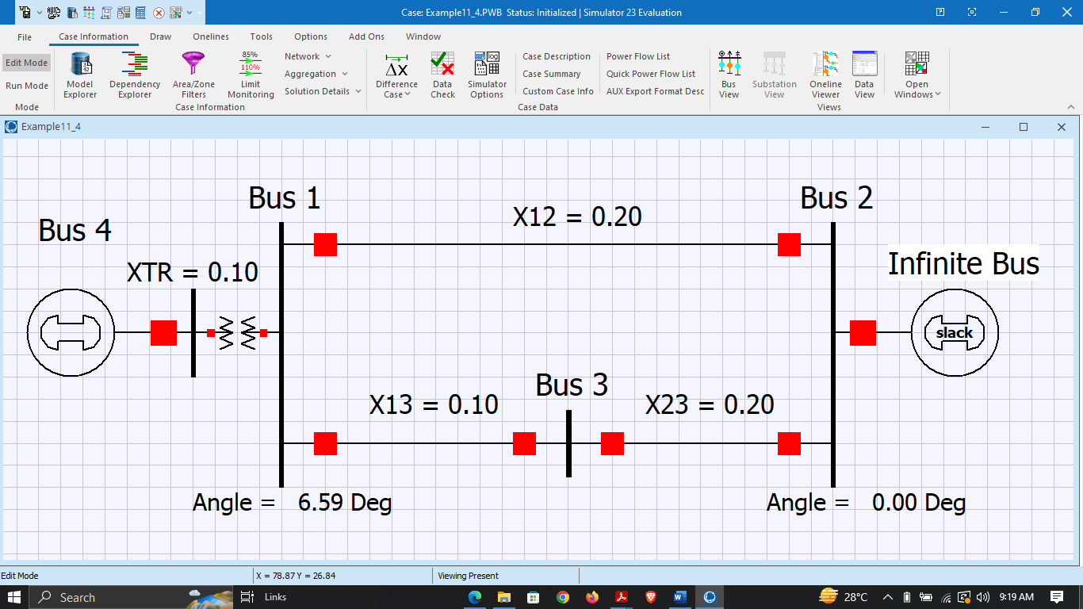

**Figure 1: Three Bus Synchronous Generator Power System in Edit Mode**

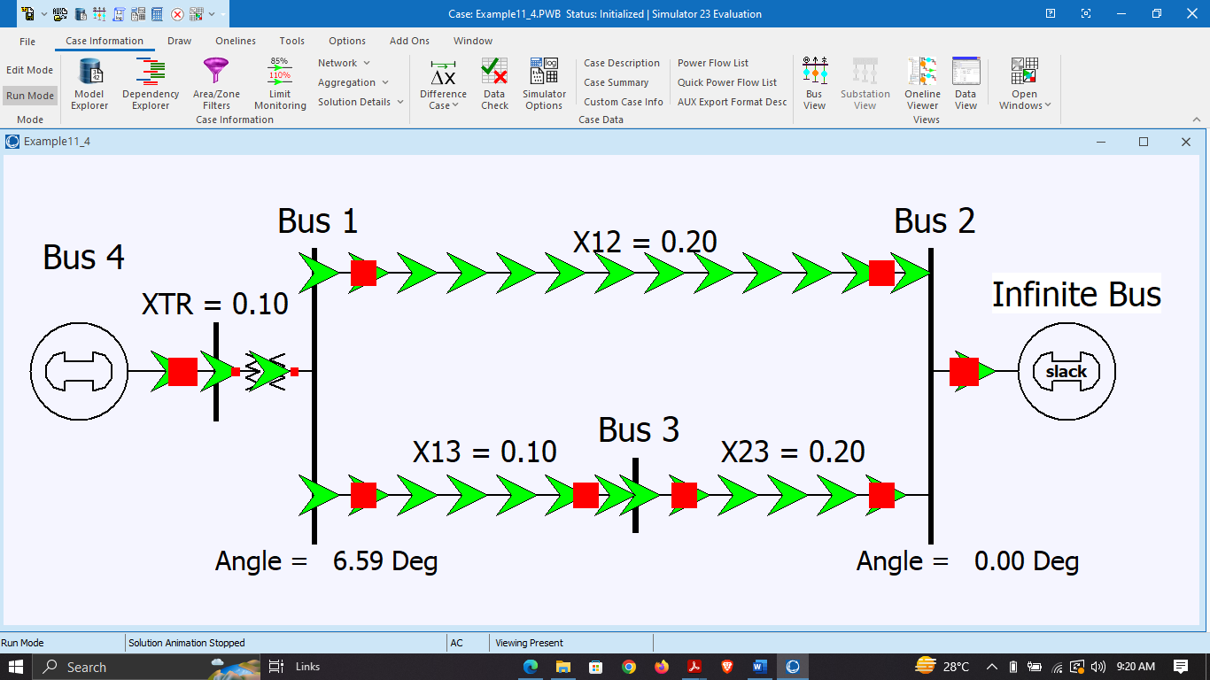

**Figure 2: Three Bus Synchronous Generator Power System in Run Mode**

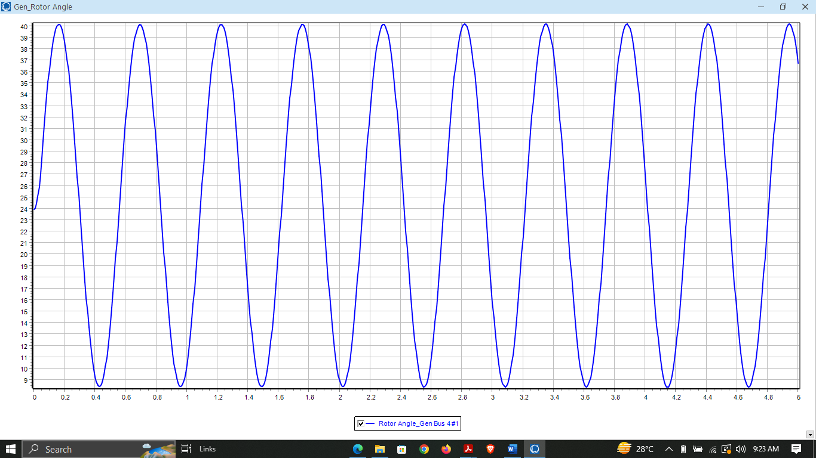

**Figure 3: Transient Stability at normal mode**

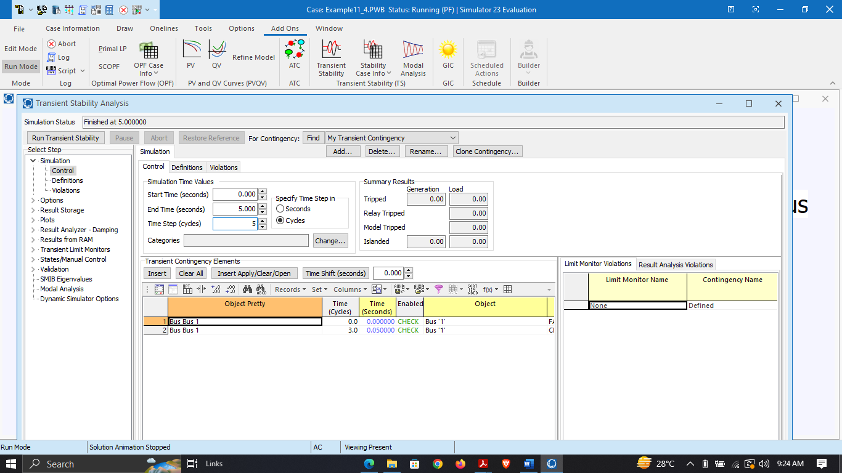

**Figure 4: Set Parameters of Power System**

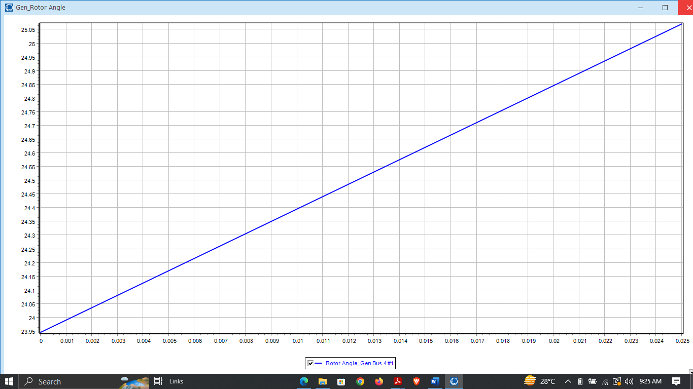

**Figure 5: Stability Graph of Power System**

* **Induction Generator**

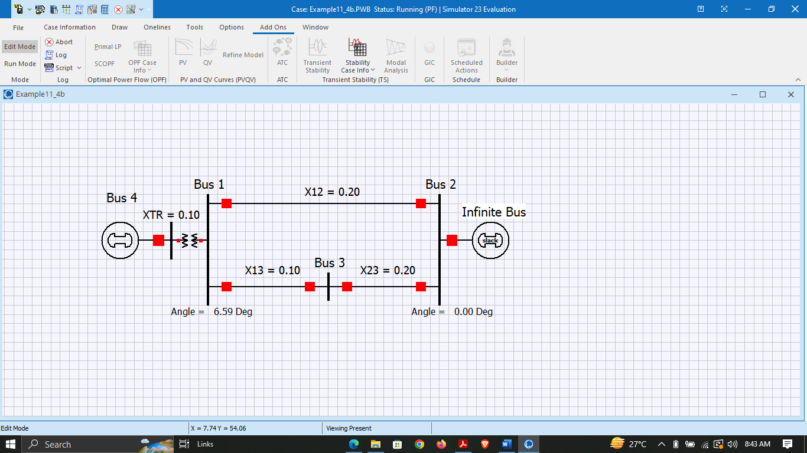

**Figure 6: Three Bus Induction Generator Power System in Edit Mode**

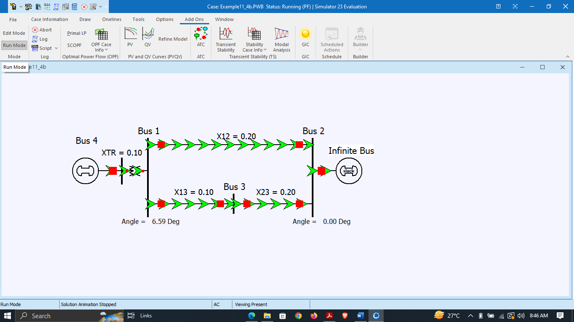

**Figure 7: Three Bus Induction Generator Power System in Run Mode**

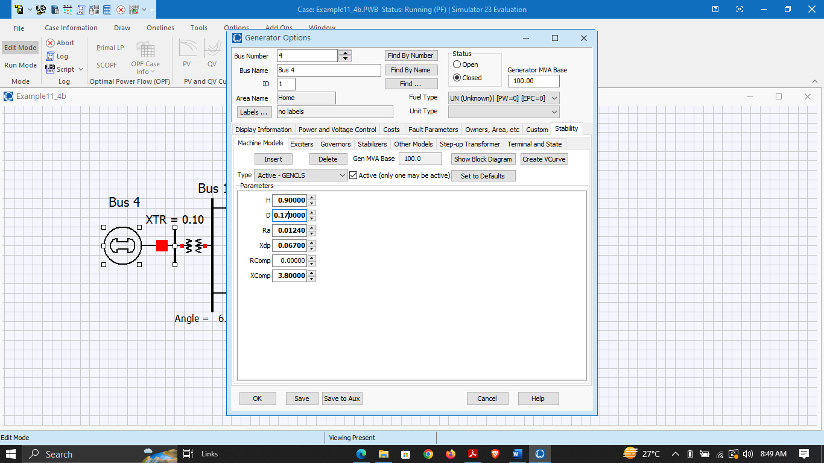

**Figure 8: Setting the parameters of Induction Generator**

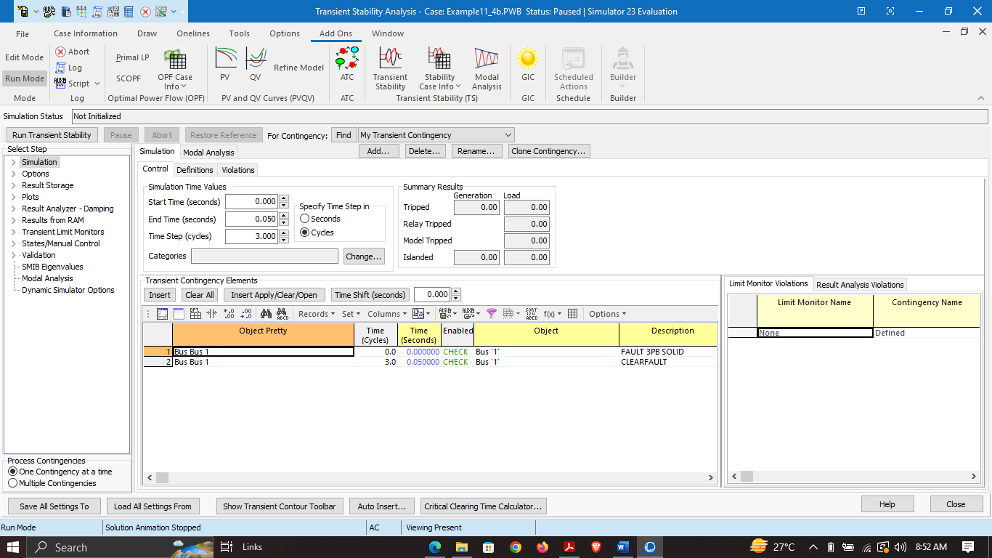

**Figure 9: Set the time and number of cycles towards system stability**

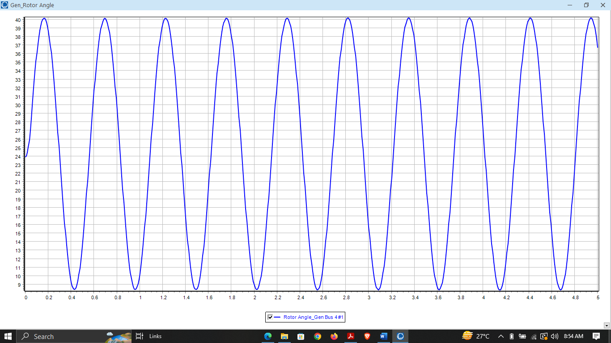

**Figure 10: Three Bus Synchronous Generator Power System towards stability**

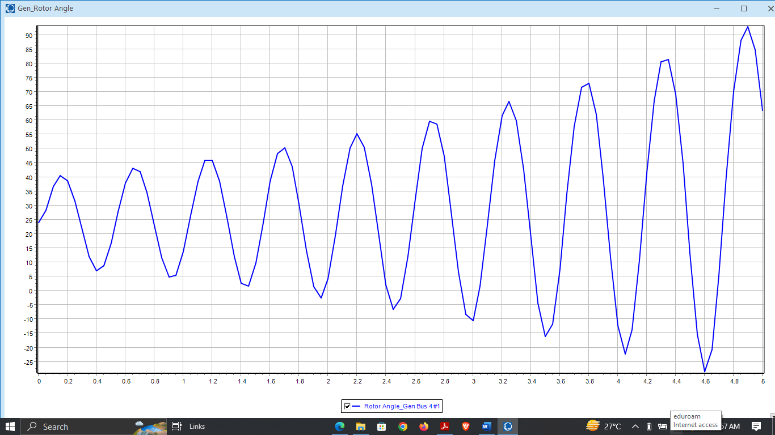

**Figure 11: Three Bus Induction Generator Power System during fault condition**

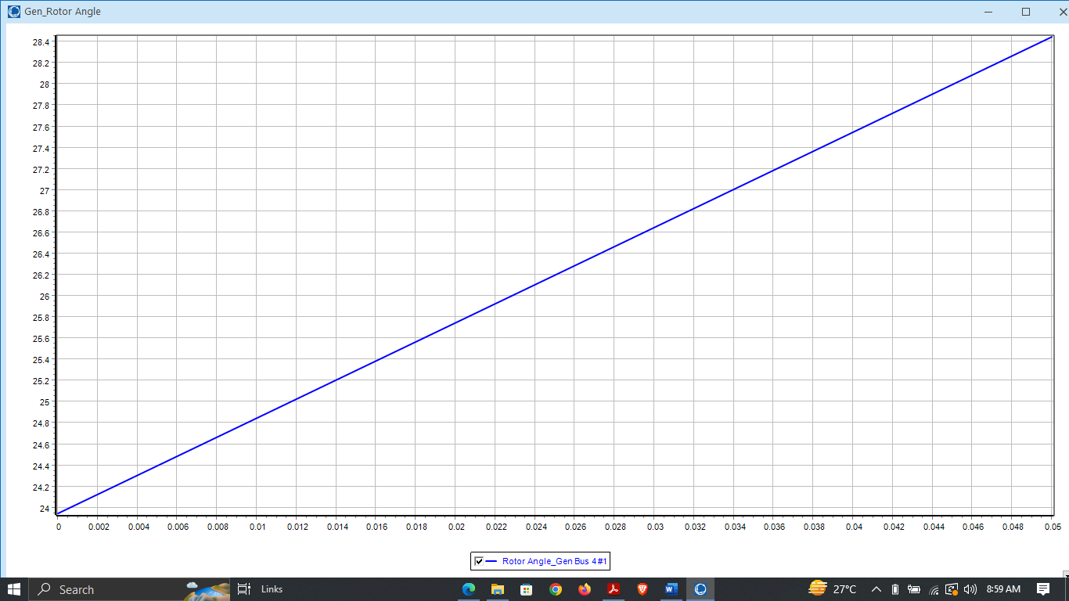

**Figure 12: Three Bus Induction Generator Power System achieved stability after 3 cycles**

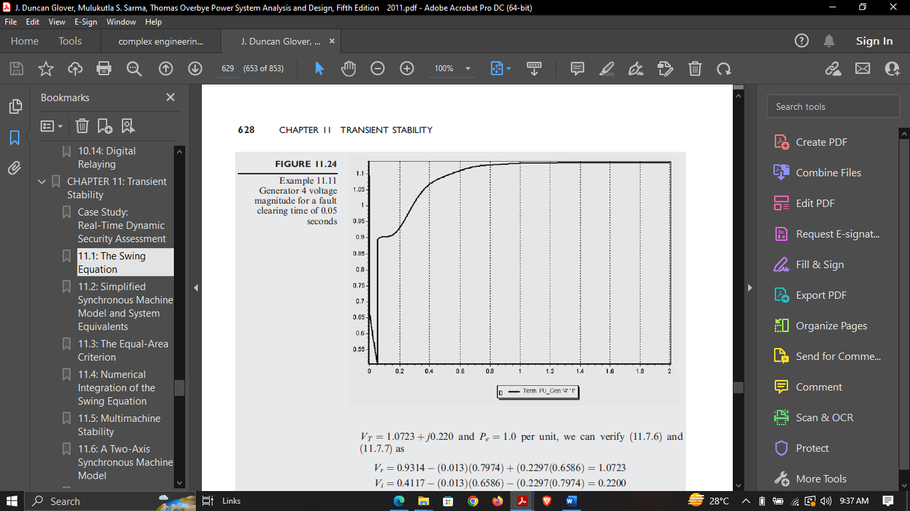

**Figure 13: Generator 4 voltage magnitude for a fault clearing time of 0.05 seconds**

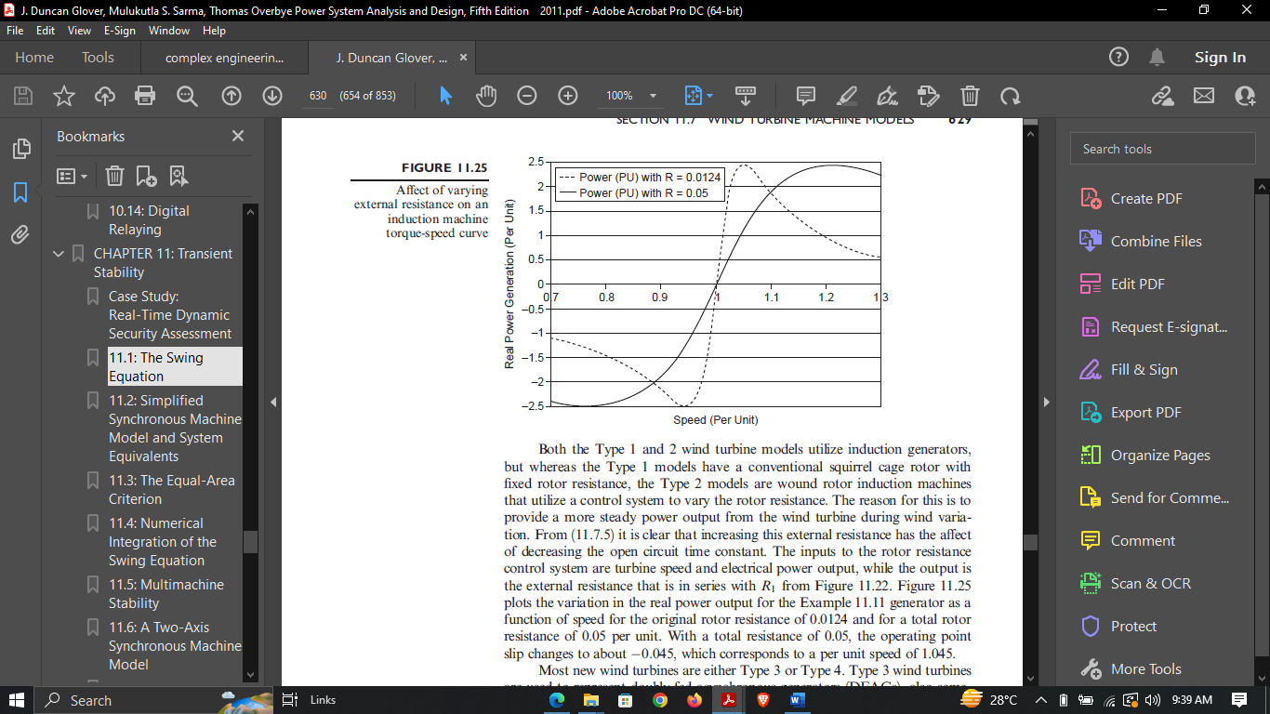

**Figure 14: Affect of varying external resistance on an induction machine torque-speed curve**

* **DFIG Generator:**

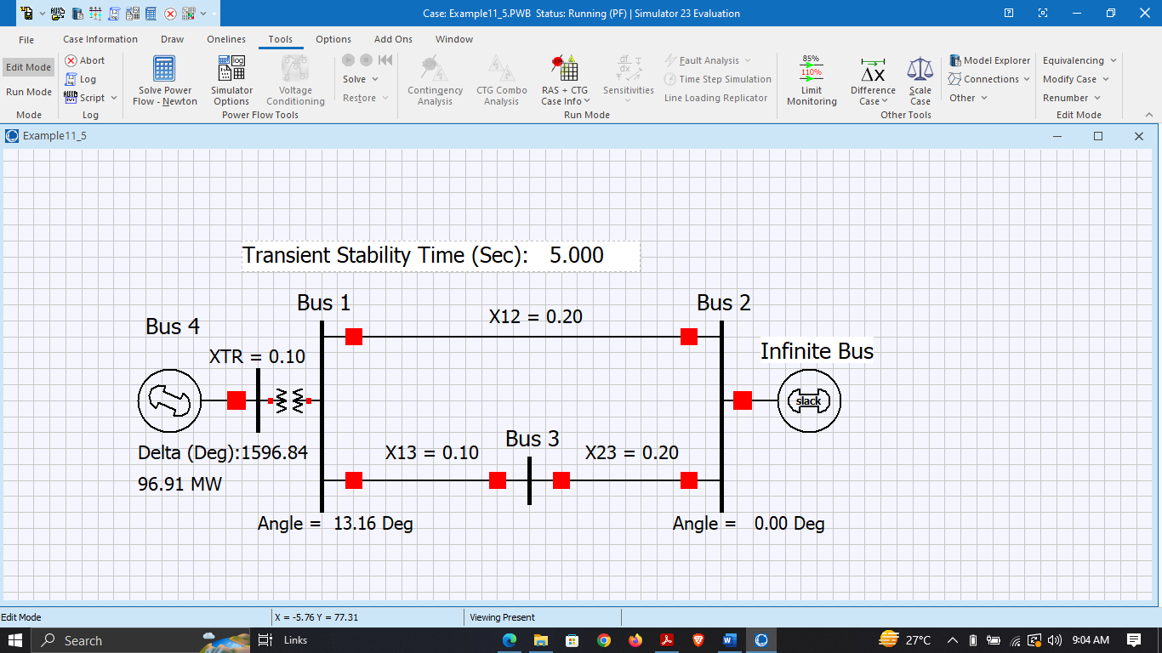

**Figure 15: Three Bus DFIG Generator Power System in Edit Mode**

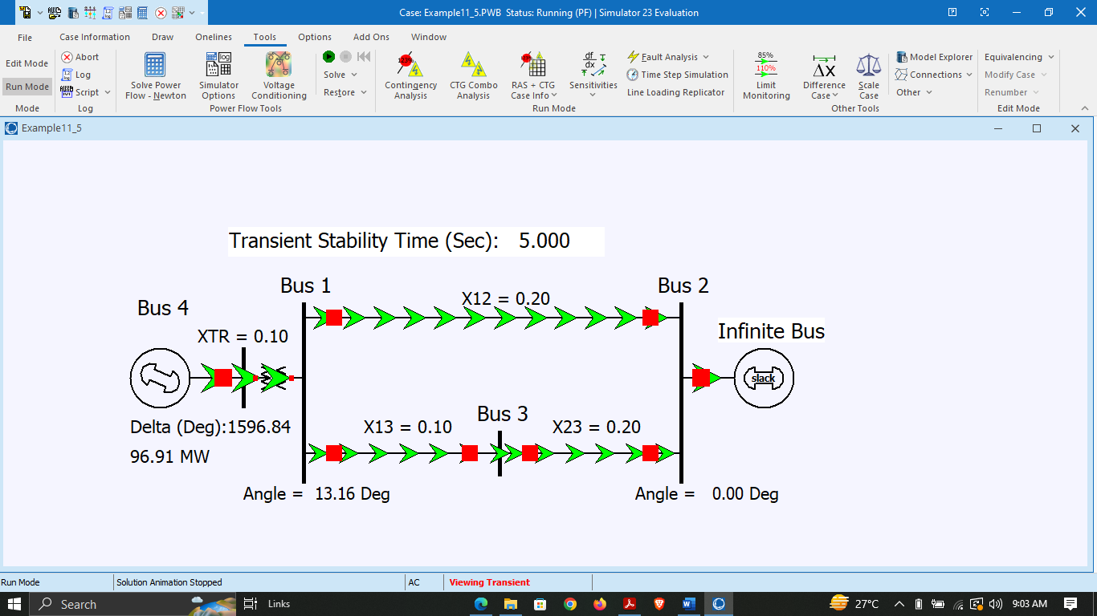

**Figure 16: Three Bus DFIG Generator Power System in Run Mode**

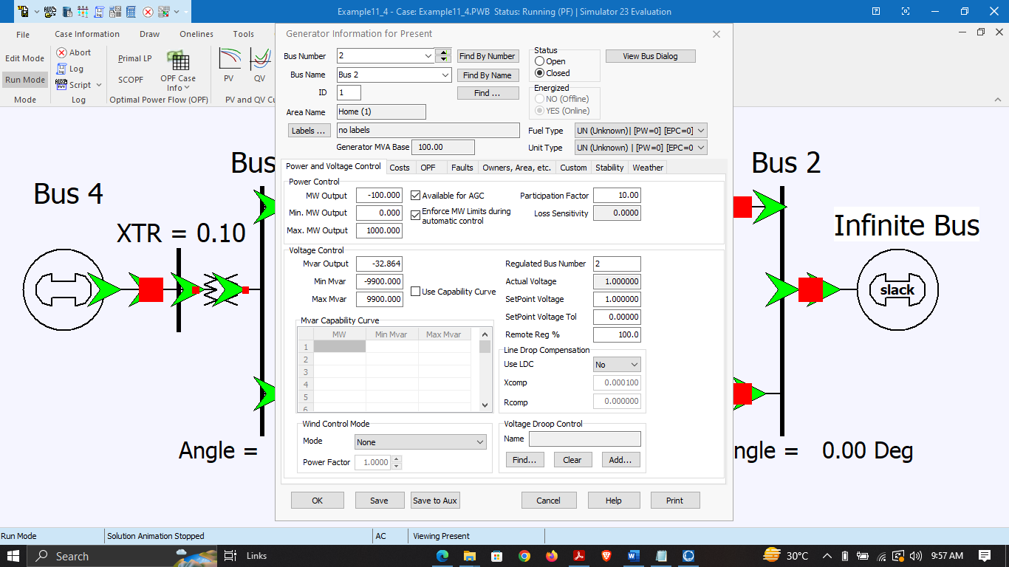

**Figure 17: Parameters of DFIG Power system at infinite Bus**

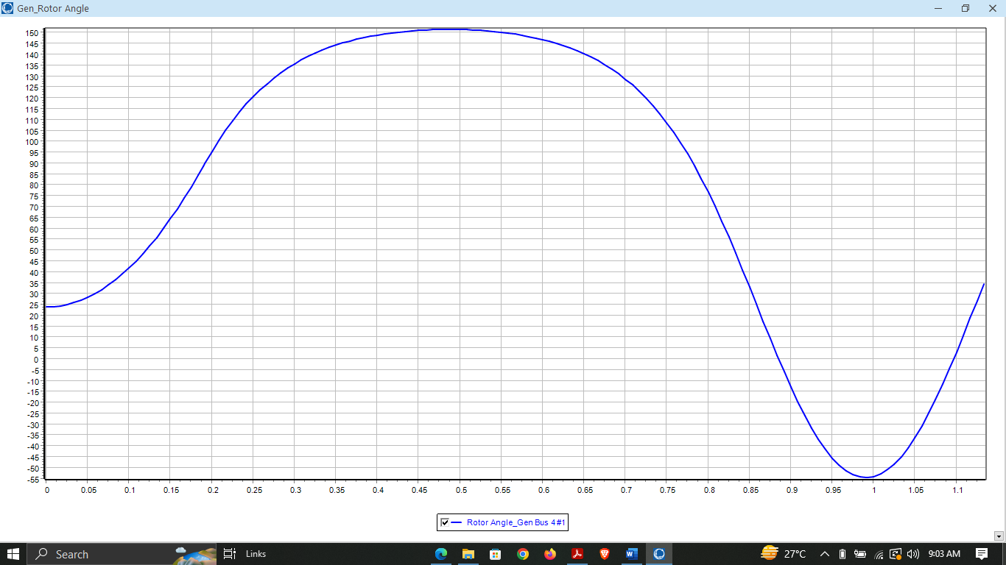

**Figure 18: Three Bus DFIG Generator Power System towards Stability**

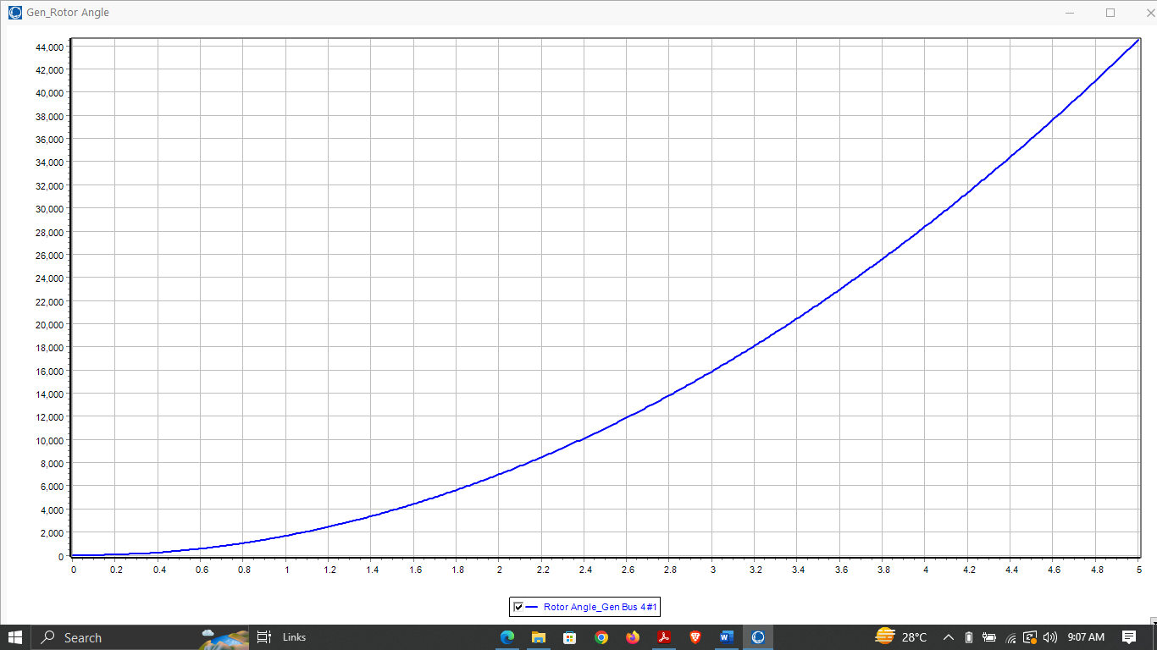

**Figure 19: Three Bus DFIG Generator Power System under fault condition**

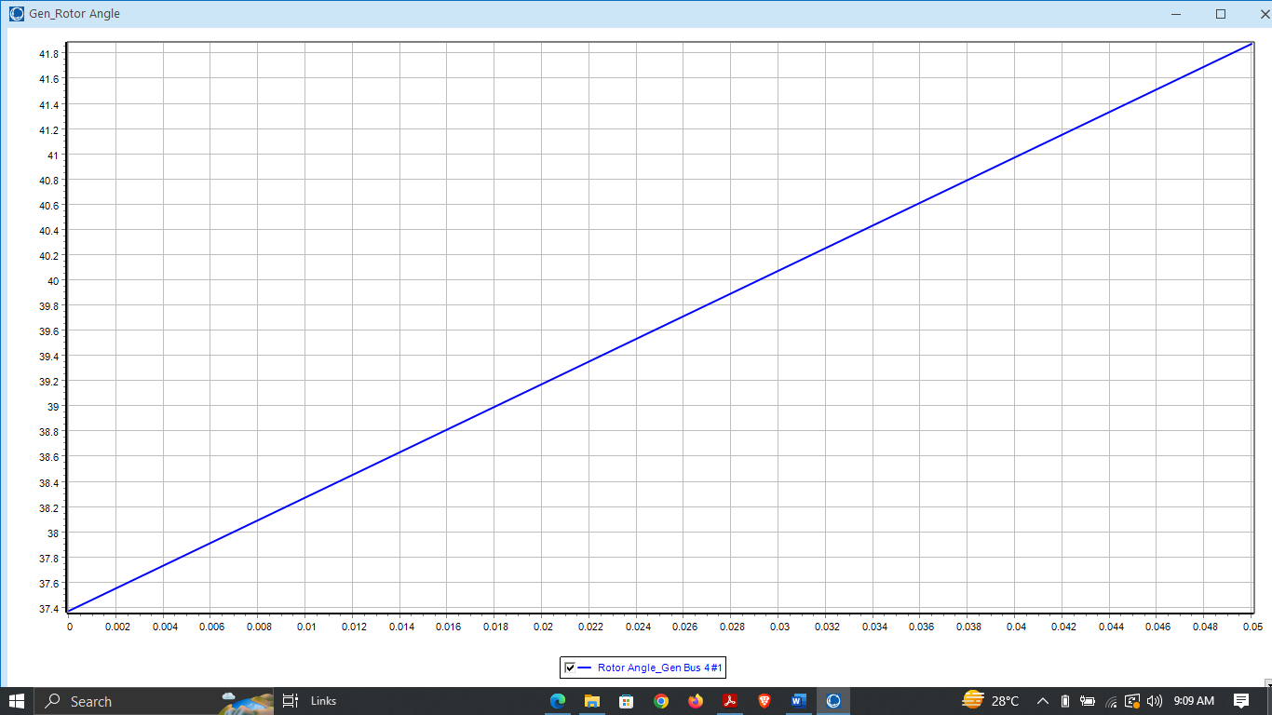

**Figure 20: Three Bus DFIG Generator Power System achieved stability after 3 cycles**

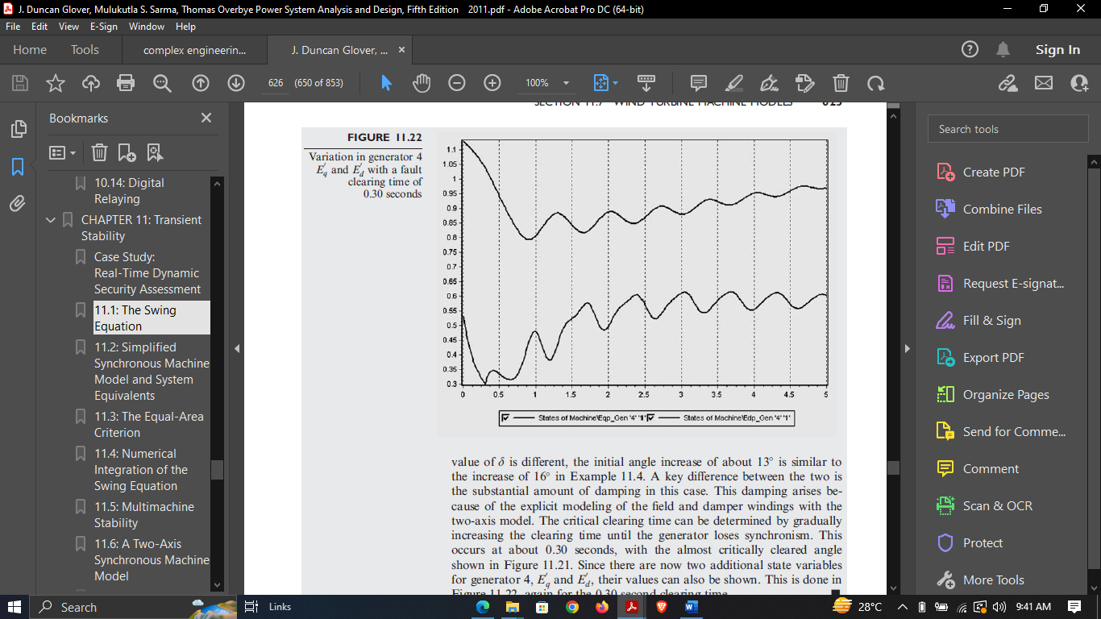

**Figure 21: Variation in generator Eq and Ed with a fault clearing time of 0.05 seconds**

* **Comparison Table:**

|  |  |  |  |  |  |  |
| --- | --- | --- | --- | --- | --- | --- |
| **Sr no.** | **Power World Simulator** | | | **Mathematical Calculations** | | |
| **Type of Generators** | Synchronous  Generator | Induction  Generator | DFIG  Generator | Synchronous  Generator | Induction  Generator | DFIG  Generator |
| **Critical Clearing Time** | 0.1960s | 0.035s | 0.05s | 0.1897s | 0.0286s | 0.070s |
| **Critical Clearing Angle** | 86.78° | 94.36° | 115.16° | 88.784° | 96.25° | 113.5° |

**Table 1: Comparing the values in different techniques and different generators**

* **Procedure:**

1. Calculate the pre-fault voltage magnitude and angle at the generator terminals using the given information about the infinite bus and the transmission line impedances.
2. Determine the post-fault voltage magnitude and angle at the generator terminals based on the fault location and type.
3. Calculate the change in rotor angle and speed during the fault using the swing equation for the given generator type. For synchronous generator, the swing equation is 𝑑2𝛿/𝑑𝑡2 = (1/𝐽) (𝑃𝑚 − 𝑃𝑒 − 𝐷(𝑑𝛿/𝑑𝑡)), where 𝑃𝑚 is the mechanical power input, 𝑃𝑒 is the electrical power output, 𝐽 is the moment of inertia, 𝐷 is the damping coefficient, and 𝛿 is the rotor angle. For induction generator and DFIG, the swing equation is different and depends on the generator model used.
4. Determine the critical clearing time, which is the maximum time that the fault can persist before the generator loses synchronism. This is usually determined by finding the time at which the rotor angle reaches its maximum deviation from the pre-fault value. The critical clearing time can be calculated using the swing equation and a numerical integration method.
5. Calculate the critical clearing angle, which is the minimum angle by which the rotor must be displaced during the fault in order for the system to lose synchronism. This can be calculated using the pre-fault and post-fault voltage angles and the critical clearing time.
6. Repeat the above steps for the other type of generator and compare the results.
7. Finally, interpret the results and draw conclusions about the behavior of the two generator types under the same fault conditions.

* **Observations:**

The critical clearing angle is a key parameter in determining the transient stability of a power system. It is defined as the minimum angle by which the generator rotor needs to be displaced from the steady-state position in order to reach the point of instability. The critical clearing time is the time it takes for the system to recover from a fault and return to a stable state. It is determined by the dynamic response of the generator rotor to the fault and the subsequent control actions taken to restore stability. In order to calculate the critical clearing angle and time for a given power system, it is necessary to model the system using appropriate equations and parameters. These equations may include the swing equation, the power-angle equation, and various other equations that describe the behavior of the generators, transformers, and transmission lines in the system. The critical clearing angle and time can vary depending on the type of generator used in the system. Synchronous generators, induction generators, and doubly fed induction generators all have different characteristics that affect their transient stability performance. During a fault in the power system, the generator rotor experiences a sudden change in mechanical torque, which causes it to oscillate about its steady-state position. The amplitude and frequency of these oscillations depend on the system parameters and the control actions taken to dampen them. One way to improve the transient stability of a power system is to use advanced control techniques such as power system stabilizers (PSS) or flexible AC transmission systems (FACTS) devices. These devices can provide additional damping and control to the system to help it recover from disturbances more quickly. In order to validate the results of a power system stability analysis, it is important to compare the calculated critical clearing time and angle with actual measurements from the system. This can be done using field data or by conducting simulations with more advanced models and control systems.